REVISION NOTICE TABLE
DATE | DESCRIPTION OF REVISION
18 March 2025 | Updated channel names & formats in TOB file. G.G.
4 July 2023 | Conductivity format changed in CTD and CHE files. G.G.

PROCESSING NOTES
Cruise: 2022-070
Agency: Ocean Sciences Division (OSD)
Location: Juan de Fuca Strait & Strait of Georgia
Project: Salish Sea Biophysical Survey
Party Chief: Young K.
Platform: Vector
Date: 5 October 2022 – 12 October 2022

Processed by: Germaine Gatien
Date of Processing: 20 February 2023 – 2 March 2023
Number of original HEX files:
Number of CTD files: 81 Number of CTD casts processed: 81
Number of bottle files: 29 Number of bottle casts processed: 29
Number of TSG files: 1 Number of TSG files processed: 1

INSTRUMENT SUMMARY
An SBE911+ CTD #0506 was mounted in a rosette and attached were a Wetlabs CSTAR transmissometer (#983DR), a SBE 43 DO sensor (#997), a SeaPoint fluorometer (#3950 for casts 1-7 and #3949 for casts 8-100), an SBE pH sensor (#0692), a Biospherical PAR sensor (#4565) and an altimeter (#76341). (There were also 2 LISST-200x sensors, but they were processed elsewhere and were not included in this processing job.)
Seasave version 7.26.7.121 was used for acquisition.
The salinometer used at IOS was a Guildline model 8400B Portasal, serial # 73274.
An IOS rosette with 24 10L bottles was used.
A thermosalinograph (SeaBird 45 S/N 3411) was in use.

SUMMARY OF QUALITY AND CONCERNS
The Science Log was in digital format. The header page had complete information about participants and equipment. There were good notes in the comments sections of both the CTD and Sampling logs about problems encountered.

Waits before firing bottles were 60s or longer and the bottle comparisons suggest this was effective in improved flushing of Niskin bottles, especially in Juan de Fuca Strait.

Something went badly wrong with the firing of Niskin bottles from 20db to the surface during cast #1. There is a large gap in CTD data in the hex file but scan numbers do not indicate a skip. With some manipulation of the BL file it was possible to retrieve CTD data for the 1.6db bottles, but not for those at 11db and 5.5db. Pressures for those bottles are taken from the confirmed pressure value recorded in the sampling log. All other CTD channels were padded for those 2 bottles. The sample values strongly suggest that the bottles did close at the recorded levels.

The fluorometer was changed after cast #7 because of spiky data and the discovery that the exhaust joint was broken. Despite the replacement the spiky data continued until the cruise entered the Strait of Georgia. Extracted chlorophyll values were higher in Juan de Fuca Strait than in the Strait of Georgia. The spikiness may well reflect real conditions.

The 2 CTD salinity channels differed by about 0.007psu. That is close to the results towards the end of cruise 2022-069 when the sensors were last used. In all previous uses since the T and C sensors were last serviced at the factory, the primary salinity has been very close to bottle samples.

The SBE DO sensor has a fairly long response time so data accuracy is not as high when it is in motion as it is during stops for bottles. This will be especially true when vertical DO gradients are large. To get an estimate of the accuracy of the SBE DO data during downcasts (after recalibration) a rough comparison was made between downcast SBE DO and upcast titrated samples. Some of the difference will be due to problems with flushing of Niskin bottles and/or analysis errors and small mismatches in depth in the presence of large DO gradients, so the following statement likely underestimates SBE DO accuracy.

Downcast (CTD files) Oxygen:Dissolved:SBE data for this cruise are considered, very roughly, to be:
±0.50 mL/L from 0-3db except in areas of very large DO gradients
±0.20 mL/L from 30db-100db
±0.10 mL/L from 100db-200db
±0.05 mL/L below 200db

The Thermosalinograph performed well. There was no flow meter, intake thermistor or loop sampling. A proxy for intake temperature was derived by subtracting 0.4C° from the lab temperature and salinity was recalibrated by adding 0.055psu based on comparisons with CTD data. The CTD data mostly come from a little lower in the water column than the TSG intake at 2db, so the corrected data better reflect conditions around 2.5db.

PROCESSING SUMMARY
GENERAL

Seasave
This step was completed at sea; the raw data files have extension HEX.

Preliminary Steps
- The digital daily log and rosette log sheets were obtained and checked for comments.
- Salinity, Chlorophyll, Nutrient and Dissolved Oxygen data were obtained in QF spreadsheets.
- The cruise summary sheet was completed.
- The history of the pressure sensor, conductivity and dissolved oxygen sensors were checked.
- The calibration control files were obtained; there were no errors in parameters. The fluorometer was changed after cast #7. File 2022-070-ctd1.xmlcon was created for casts #1 to #7 and 2022-070-ctd2.xmlcon for casts #8 to #100.

BOTTLE FILE PREPARATION
The ROS files were created using files 2022-070-ctd1.xmlcon and 2022-070-ctd2.xmlcon.
The ROS files were converted to IOS format; the hysteresis correction was not selected since there were no very deep casts; the Tau correction was selected.
The files were put through CLEAN to create BOT files.
Temperature and salinity were plotted for all BOT files to check for outliers. Salinity:T1:C1 was cleaned lightly for bottle #5 at 50db.
The output file was copied to *.BOT.

A preliminary header check was run and no problems were found.

The BOT files were bin-averaged on bottle number and the output was used to create file ADDSAMP.csv. First, the file was sorted on event number and Bottle Position order. Then sample numbers were added based on the rosette logs.
A serious problem was found for event #1. The data said to be from bottle #9 contain data from 20db and 1.8db, No data were found for bottles #10, 11 AND 12. The BL file does contain scan #s for those bottles but there are no scan #s that high in the full file. It is likely there were scans lost but the scan # did not skip the lost records.

Sometimes it is possible to fix problems by editing the BL file, but there just are no scans associated with 10db, and 5db. The scan #s in the BL file look right for Bottles #7 and #8 but not for #9.
The scan #s for bottles were adjusted (#9 to match 20m in the upcast of the full file and data from the end of the file for Bottle #12). There are no suitable data for bottles #10 and #11. The file was converted again. After the comparisons with bottle data are done, this file will be examined closely.

The ADDSAMP file was then sorted on event number & then sample number.
It was used to add sample numbers to the BOT files – output *.SAM.
The SAM files were bin-averaged on bottle # and called SAMAVG.
The addsamp.csv file was converted to CST files, which will form the framework for the bottle files.

Next, the analysis spreadsheets were examined to see what comments the analysts wanted included in the header file. These were saved in file 2022-070-bot-hdr.txt.

DISSOLVED OXGYEN
Dissolved oxygen data were provided in spreadsheet QF2022-070_OXY*.xlsx which includes flags, comments and a precision study. Draw temperatures are available. The spreadsheet page with the final data was simplified and saved as 2022-070oxy.csv. That file was converted into individual *.OXY files.
There was 1 sample in the DO file that had comments starting with “ALL:”. The only other samples affected are nutrients.
EXTRACTED CHLOROPHYLL
Extracted chlorophyll and phaeo-pigment data were obtained in file QF2022-070_CHL*.xlsx. The file included comments and flags and a precision study. A simplified version of the spreadsheet was prepared and saved as 2022-070chl.csv. The csv file was then converted to individual CHL files.
SALINITY
Salinity analysis was obtained in file QF2022-070 SAL*.xlsx. The analyses were carried out in a temperature-controlled lab within 30-34 days of collection. The files were simplified and saved as 2022-070sal.csv. That file was then converted to individual SAL files.
NUTRIENTS
The nutrient data were obtained in spreadsheet QF_NUTS_2022-070*.xlsx. This includes a precision study. The file was simplified, saved as 2022-070nuts.csv and converted to individual NUT files.
Flag 3 was added to samples 317.
The file was then converted to individual files.

The SAL, CHL, OXY and NUT files were merged with CST files in 4 steps.
The files were then put through CLEAN to reduce the headers to File and Comment sections only.
These files are ordered on sample number, but the SAMAVG files are ordered on bottle number, so the MRGCLN1 files were reordered on Bottle_Number and saved as *. MRGCLN1s.
The MRGCLN1s files were then merged with SAMAVG files using merge channel Bottle_Number.

The output of the MRG files were exported to a spreadsheet and compared to the rosette log sheets to look for omissions. None were found.
The minimum CTD Salinity in the spreadsheet was <25psu so the correction to silicate samples is required.
A header check was run and no problems were found.

Compare
Salinity
This cruise had salinity sampling from 19 casts, mostly 1 bottle at least 10m above the bottom of the cast.
Using bottles from 200db down excluding one outlier the primary salinity is low by an average of 0.0006psu and the secondary is low by 0.0079psu; standard deviations were 0.0024 and 0.0025psu. Those values are in line with results for these sensors from previous cruises; there was a decrease in differences during the previous cruise which was thought to be due to calibration drift in the secondary CTD salinity.

What is surprising is that near the mouth of Juan de Fuca all primary CTD data values are higher than bottles. Some of those bottles were at the bottom of casts where this is expected since flushing errors have the opposite sign to those taken on the upcast. But why are the bottles higher in the water column reading higher? One possible explanation is that the waits before firing bottles was 60s, so flushing may be more effective than traditionally seen. The vertical gradients are also very low at the depths sampled which would reduce flushing errors. So the differences left may be random errors due to noise in the CTD data and analysis errors. There were some shifts in CTD data during stops. If these are real variations it could also explain some scatter. The standard deviation in the CTD files during the 10s window are high for many of the shallow bottles, but generally not below 200m. The results in the Strait of Georgia look as expected with very small differences or, if large, ones with CTD reading lower than bottles. The deep vertical salinity gradients are larger there than in Juan de Fuca and descent rates steadier, so flushing errors would be expected to produce higher bottle values relative to CTD salinity.

When all casts below 200m are included (except for one extreme outlier), the fit against pressure is reasonably flat and the average is close to expectations based on earlier cruises.

The one large outlier is associated with a local reversal in salinity a little below the bottle closing level. There is no evidence to suggest the bottle value is faulty.

For more detail see file 2022-070-sal-comp1.xls.

Dissolved Oxygen
COMPARE was run with pressure as the reference channel.

There were a few extreme outliers in the initial fit. 3 were associated with very large standard deviations in the CTD DO data, another had no CTD value available at the specified depth. 3 of the 4 were from Saanich Inlet where very large vertical gradients usually lead to results out of line with other casts. There are many cases where the CTD DO is higher than the titrated sample values. This is usually found to be evidence of poor flushing of Niskin bottles in areas of high vertical DO gradients. Excluding cases where differences are >0 and forcing the fit through 0 leads to a slope of ~1.02. The deep samples from Saanich Inlet do establish that the offset is small, so using fits through the origin is appropriate.

There are no notable outliers that look like cases of problems with samples; they all appear to be due to noisy CTD DO data or large vertical gradients leading to real differences between bottle contents and CTD readings due to physical offsets or flushing errors.

When outliers were removed based on residuals, the fit was:
CTD DO Corrected = CTD DO * 1.0204 R² = 0.93
Varying how outliers were identified made little difference in the fits.

Other recent uses of this sensor had the following fits:
CTD DO Corrected = CTD DO * 1.0381 + 0.014 R² = 0.97 (2022-035)
CTD DO Corrected = CTD DO * 1.0311 R² = 0.98 (2022-069)
2022-035 was in open ocean so flushing is expected to be good. 2022-069 had a mix of conditions, so some flushing errors are expected.

There is good reason to expect a lower slope to the fit for this cruise because incomplete flushing leads to bottle values being lower than ambient conditions, though waits for bottles were 60s, so this should not be as big a problem as noted in the past. One check is to look at casts where sea states are likely to lead to better flushing – at stations 102, 75 and 72 near the mouth of Juan de Fuca Strait. For those the fits were:
CTD DO Corrected = CTD DO * 1.0293 - 0.003 R² = 0.61
or CTD DO Corrected = CTD DO * 1.0283 R² = 0.89

The slope was slightly higher if only stations 102 and 75 are included, but there are so few bottles available that this is likely of no significance. These fits are much closer to 2022-069, though still lower than 2022-035. However, the vertical gradients are much lower for this cruise than in the 2 earlier ones, so the slow response time of the sensor is less significant; it would be able to “keep up” better. While 60s stops should allow for the sensors to equilibrate during bottle stops, they may still have a problem adjusting to temporal changes during the stops. The 3 cruises that have used this sensor lately covered very different regions.

The initial DO plot for cast #5 had a large DO reversal between 110 and 120db and cast #8 has a very unusual profile with a spike in DO at about 100db in the downcast and 85db in the upcast. Temperatures are also very unusual. These features may introduce some randomness in the fits.

A complicating factor for this cruise is that the DO gradients are very large in the top 20 to 50m for many casts, with little variation below that. Excluding the top 30m from a made little change to the slope, possibly because many near-surface bottles had been excluded as outliers in the general fit.

For more details see document 2022-070_dox-comp1.xls.

Plots of Titrated DO and CTD DO against CTD salinity were examined. No further significant outliers were found.

Fluorescence
COMPARE was run with extracted chlorophyll and CTD Fluorescence using pressure as the reference variable. There were no values flagged as <MLD. During cast #1 there were 2 CTD fluorescence values that looked to be off-scale. In one case a CHL sample confirms this is likely the case.

When cast #1 was removed from the comparison the fit of CTD fluorescence versus extracted chlorophyll splits into 2 groups. Plotting only Strait of Georgia casts produces a fairly tight fit with a slope of 0.34, while the Juan de Fuca group is even tighter with a slope of 0.69. For fluorescence <3ug/L the fit would be closer to 1 for SoG.

The fit of ratio FL/CHL versus CHL shows the usual pattern of the CTD fluorescence generally reading higher than CHL for CHL<2 and then dropping to about 40% of CHL when CHL is >2ug/L.
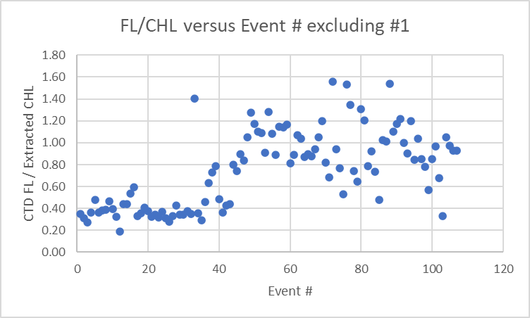
It seems unusual to have higher chlorophyll values in Juan de Fuca than in the Strait of Georgia. Below are the data from this cruise for all casts except Saanich Inlet.
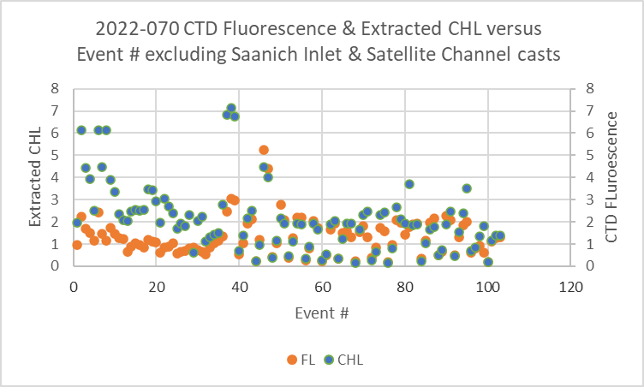
In October 2020 the same sites were visited in roughly the same order except there were extra stations in Vancouver Harbour and Indian Arm. Below is a 2020-031 plot showing the stations visited in both years.
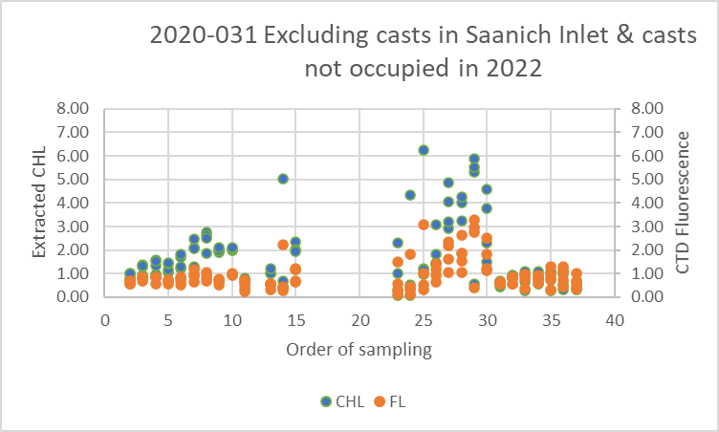
It shows that extracted CHL was much higher near the mouth of Juan de Fuca than in 2020 but lower in the Strait of Georgia. There are many more very low CHL values in 2022, most in the Strait of Georgia; this explains the very different FL/CHL ratios in the 2 regions for 2022, since at very low CHL values, CTD fluorescence tends to read higher than CHL.

Fluorescence data were reported to be very spiky until about event #48. The fluorometer was changed after cast #7, but the spikiness remained. This comparison suggests this was not due to equipment problems but real conditions.
For more details see file 2021-070-fl-chl-comp1.xls.

Study of bottle file #1
At this point a return was made to the bottle file for cast #1 as the data from 20m to the surface were created using a fabricated BL file, so may not be reliable. The following adjustments were made:
- Bottle #9: The DO bottle comparison suggests that the 20m CTD data are good. No edit needed.
- Bottle #10: The CTD data in the file contain an average of data from 20m and 1m and should be removed. The sampling log indicates a confirmed pressure of 11db, so we can keep the bottle data, with CTD pressure and depth entered but all other CTD data were padded.
- Bottle #11: These data seem are out of line in profile. They are said to be from 5.5db in the log, and the bottle data would look reasonable for that level. The CTD data were padded except for pressure and depth which were based on the sampling log confirmed pressure.
- Bottle #12: Both CTD and bottle data look good. However, the CTD data were captured using a fabricated BL file; they are definitely from a time when the CTD was stopped at 1.6m, but may not be from the exact time the bottle was closed.
File 2022-070-0001.samavg was edited, merged with the MRGCLN1s file and put through CLEAN.

Conversion of Full Files from Raw Data
All files were converted using files 2022-070-ctd1.xmlcon (1-7) and 2022-070-ctd2.xmlcon (8-100).
The Tau function was selected but not the hysteresis function as there was no deep sampling).
A few casts were examined and all expected channels are present.
- Cast #1 is missing data between 20db and 1.8db on way up. Also fluorescence is off scale at top, both down and upcast.
- As usual there was a lot of small-scale noise in the temperature and conductivity channels during upcasts.
- The Dissolved Oxygen traces look reasonable with some reversals and highly variable vertical gradients..
- The transmissivity traces look reasonable.
- Fluorescence had a dark value of ~0.09ug/L. The profiles were extremely noisy early in the cruise and it was found that the exhaust joint was broken, so it was replaced with another sensor. The spikiness continued. At cast #48 there is a note that fluorescence was no longer so spiky. Given the results of the comparison with extracted chlorophyll noted in the previous section, it seems likely that the spikiness is real. It is also possible that there was some issue with a cable.
- As noted in the log the buffer bottle was left on for some casts. Channel will need removing.
- The altimetry looks excellent near the bottom.

WILDEDIT
Program WILDEDIT was run to remove spikes from the pressure, conductivity & temperature only in the
full cast files (*.CNV).
Parameters used were: Pass 1 Std Dev = 2 Pass 2 Std Dev = 5 Points per block = 50
The parameter “Keep data within this distance of the mean” was set to 0 so all spikes would be removed.

ALIGN DO
A selection of casts were examined; the temperature profiles were more complex than usual so the tests were not easy to interpret, but using +2.5s certainly improves the alignment and overall looks like a good choice for the DO sensor. ALIGNCTD was run on all casts using +2.5s.

CELLTM
CELLTM was run using the default settings (α = 0.0245, β=9.5) for both the primary and secondary conductivity. A few casts were checked and those parameters appear to have worked well.

DERIVE and Channel Comparisons
Program DERIVE was run on all casts to calculate primary and secondary salinity and dissolved oxygen concentration.
The differences between the channel pairs was examined:
Cast # | Press | T1-T0 | C1-C0 | S1-S0 | Descent Rate
2021-078-0038 | 300 | -0.0005 | -0.00068 | -0.0063 | High, Steady
2021-078-0076 | 350 | -0.0005 | -0.00064 | -0.0061 | High, Steady
“ | 650 | -0.0005 | -0.00062 | -0.0059 | “
2022-035-0010 | 350 | -0.0002 | -0.00070 | -0.0078 | High, Moderate
2002-035-0023 | 350 | -0.0001 | -0.00077 | -0.0088 | High, Moderate
 | 1000 | -0.0001 | -0.00074 | -0.0090 | “
2022-035-0027 | 350 | -0.0003 | -0.00080 | -0.0090 | High, F Steady
 | 2500 | -0.0003 | -0.00077 | -0.0088 | “
2022-069-0030 | 350 | -0.0004 | -0.0011 | -0.0126 | High, Mod
2022-069-0101 | 350 | -0.0003 | -0.0010 | -0.0115 | High, F Steady
2022-069-0130 | 350 | -0.0005 | -0.0010 | -0.0004
2022-069-0136 | 210 | -0.0010 | -0.0006 | -0.0065
2022-069-0144 | 350 | -0.0012 | -0.0007 | -0.0068 | High, F Steady
2022-069-0145 | 350 | -0.0011 | -0.0007 | -0.0070 | High, Mod
2022-070-0061 | 375 | -0.0009 | -0.00074 | -0.0069 | High, Steady
2022-070-0069 | 400 | -0.0004 | -0.00075 | -0.0069 | High, Steady
2022-070-0100 | 330 | -0.0006 | -0.00074 | -0.0071 | High, Mod
The temperature differences are small and within the range seen during 2020-069. Salinity and conductivity differences are similar to those seen in the latter part of cruise 2022-069 and similar to those during 2022-035.
The salinity differences are very close to those found during the comparison with bottles, 0.0073psu.

Conversion to IOS Header Format
The IOSSHELL routine was used to convert SEA-Bird 911+ CNV files to IOS Headers.
CLEAN was run to add event numbers and to replace pad values in the pressure channel with interpolated values based on record number.

Checking Headers
A header check was run.
There are no negative fluorescence values. The fluorescence maximum value was very high and likely off-scale, but was found to be at the end of a cast. However, there are also apparent off-scale values at the beginning of cast #1, so checks will be made later.

A cross-reference list was checked and there are problems with casts 40 and 41; they should be 41 and 42.
There are 2 errors in the log. Cast #38 should be at station 61, not 60, and cast #41 should be at station 47, not GI-01. The log was corrected and saved as version FEB2023.
The track plots look good and were added to the end of this report.

Pressure was negative at the end of cast #71 at -0.12db with conductivity still high, but pumps off.
During cast #54 the cast was left running out of the water and minimum pressure was -0.028db. So pressure appears to be very accurate.

A check was made of the water depths entered in the file headers by adding the maximum depth sampled plus the altimetry reading when the CTD was at the bottom of the cast. We usually expect to get values close within ± 5m. Cases outside that limit were investigated.
For most there was no obvious reason to change the header depth. The altimetry values looked ok for all casts though there was some movement at the bottom that suggests a difference of a few metres is possible. Four casts needed some change:
- 42 – Log depth 235, header 226- station 47, Alt + Max depth=217; near shore so shoaling may be a factor. No change made.
- 48 – Log entry works well. Header entry probably accidental repeat from previous cast. Use log depth.
- 75 – Water depth missing in header – use log depth.
- 96 – Station 19 – Altimetry was spiky, but header altimetry entry looks appropriate. Area where shoaling likely. Use calculated value 268 instead of 280.
Adjustments were made to IOS and CLN files for events 48, 75, 96 to the MRG,SAM and SAMAVG files for event 75.

Shift
Fluorescence
SHIFT was run on the fluorescence channel with an advance of 24 records. Plots showed this setting was appropriate.
Dissolved Oxygen
The Dissolved Oxygen voltage channel was aligned earlier. No further alignment is needed for the DO concentration channel.
Conductivity
Tests were run on the 3 casts to determine the best setting to align conductivity and temperature by judging the effect on salinity as seen in T-S space. Using -0.75 records was best for the primary as it has been in other recent uses of this equipment. The secondary looked best using -0.5 records which is a change from last use when it was -0.8.
SHIFT was run on all casts using -0.75 records for the primary conductivity and -0.5 records for the secondary. Salinity was recalculated for both channels.

DELETE
The following DELETE parameters were used:
Surface Record Removal: Last Press Min
Maximum Surface Pressure (relative): 10.00
Surface Pressure Tolerance: 1.0 Pressure filtered over 15 points
Swells deleted. Warning message if pressure difference of 2.00
Drop rates < 0.30m/s (calculated over 11 points) will be deleted.
Drop rate applies in the range: 10db to 10db less than the maximum pressure
Sample interval = 0.042 seconds. (taken from header)
COMMENTS ON WARNINGS: The only warning concerned a spike at the end of the upcast of cast #1.

Other Comparisons
Previous experience with these sensors –
The sensors had been used on 7 other cruises since they were last recalibrated except for the DO sensor which was used on only 3 other cruises..
- 2022-017 – No calibration sampling. Problems in secondary channels. TSG data good except for a big gap.
- Problems were noted during cruises 2022-048 and 2022-033 on the Franklin, suggesting pressure was too high by 1.5db or more. There were only 2 casts on the 2nd of those cruises. A lab test had a pressure of 1.25db. Cruise 2021-078 was on the Vector with the CTD stored on deck. Acquisition began early, included the 10m soak and sometimes included out-of-water values, so there was good evidence from both the beginning and end of the casts and pressure looked very good for both. Pumps were turned on and off at about 0.1 to 0.5db and the data look appropriate for being in water. Storage of the CTD in a warm lab may account for Franklin observations.
- 2022-018 & 2022-078 (Vector) had salinity sampling with only 5 samples from 2021-078 that found the primary low by 0.0002 and the secondary low by 0.0065psu.
- From 2022-035 the primary was found to be low by about 0.0002psu and secondary low by 0.0093psu.
- The dissolved oxygen sensor was recalibrated in October 2021. It was used for only a few casts on 2022-001 because of problems in the data that were actually due to a cable problem. There was calibration sampling from that cruise with a correction found to be slope=1.0168, offset=0.0437.
- From cruise 2022-035 the DO correction found was slope=1.0381, offset=0.014.
- From cruise 2022-069 Salinity:T0:CO was not recalibrated. 0.0124psu was added to Salinity:T1:C1 (used for 2 casts only). Late in the cruise the difference between sensors decreased to ~0.007psu; the change was thought to be in the secondary, with the biggest change after cleaning of conductivity cells. DO was corrected using the 2022-035 correction.

Historic ranges The only excursions from the climatology were in salinity. For cast #31 values were high below 100db; if the GULF climatology were used rather than SSOG (as is the case for cast #32) it would be well within the climatology. At cast #90 salinity was very slightly low at a few levels between 80 and 100db. All temperature values were within the climatology. There is no indication of calibration problems.
Repeat Casts – The were no repeat casts.
Post-Cruise Calibration – There were no post-cruise calibrations available.

DETAILED EDITING
The primary T-S pair were chosen for editing and eventual archiving because primary salinity was closer to bottles than the secondary salinity and the primary sensors were chosen during previous uses.
All DEL files were copied to *.EDT.

CTDEDIT was used to remove records that appear to be corrupted by shed wakes. Salinity was cleaned to remove spikes that appear to be due to small misalignments. Where both salinity and temperature were affected by spikes the record was generally removed. Most files required editing near the top and bottom of casts.
Casts #23, 28, 36, 38 and 39 required no editing.
The edited files were copied to *.EDT.

After editing T-S plots were examined for all casts; there remain many small unstable features but they are in areas when they may well reflect real conditions. No further editing was applied.

Fluorescence Processing
A median filter, size 11, was applied to the fluorescence channel. It worked well to reduce noise.

Recalibration
There was salinity <25psu, so silicate was corrected using file 2022-070-recalsil.ccf.
Pressure appears to be accurate and will not be recalibrated.
Based on the comparison with bottles Salinity:T0:C0 is low by an average of 0.0006psu below 200db, but there was a lot of noise in the comparison. On other recent cruises it was found to be very close to bottles. Salinity:T0:C0 will not be corrected.

Dissolved oxygen clearly needs recalibration though it is not clear what fit to apply.
First, a calibration was run using the fit from 2022-035:
CTD DO Corrected = CTD DO * 1.0381 + 0.0140
COMPARE was run and showed DO values were high by an average of 0.066mL/L for the whole data set (excluding the same outliers as in the original fit). For the 3 outer Juan de Fuca casts it was high by 0.033mL/L which is also higher than expected. A 2nd run using the 2022-070 fit looked much better.

File 2022-070-recal1.ccf was prepared using the fit based on the outer Juan de Fuca casts. This was run on all MRG and SAM files to apply a correction as follows:
CTD DO Corrected = CTD DO * 1.0283

COMPARE was run and the results show that this correction was better. The CTD DO is higher than bottles by an average of 0.022mL/L (stdev 0.021mL/L) excluding the same bottles as in earlier comparisons. When only the casts from the outer Juan de Fuca are included the CTD was high by an average of by 0.0005mL/L with a standard deviation of 0.028mL/L.

CALIBRATE was run on the *FIL files.

Final Calibration of DO
The initial recalibration of dissolved oxygen corrects for sensor calibration drift. Alignctd corrects for transit time errors. Those 2 steps may partly correct for response time errors, but to see if a further correction is needed, a comparison is made of downcast CTD data to bottle data from roughly the same pressure. Small differences are expected due to ship drift, temporal changes, incomplete flushing of Niskin bottles and delayed response and noise in CTD data.

Downcast files were bin-averaged to 0.5m bins for the casts with DO bottle samples. Those files were then thinned and compared to the bottle values in the MRG files. COMPARE was run to study the differences between the downcast CTD DO data and the titrated samples from upcast bottles.

The CTD DO was higher than the titrated samples by an average of 0.061mL/L but the standard deviation was 0.170mL/L. The recalibration was obviously effective, but there is a lot of noise. The large differences are mostly in the top 10m, where flushing errors are most likely to be seen and lead to the CTD DO looking high. There is also an error due to the DO sensor’s slow response which also leads to CTD DO looking high. This result shows that the recalibration was effective and that CTD DO values are not reading too low.

Downcast (CTD files) Oxygen:Dissolved:SBE data for this cruise are considered, very roughly, to be:
±0.50 mL/L from 0-3db except in areas of very large DO gradients
±0.20 mL/L from 30db-100db
±0.10 mL/L from 100db-200db
±0.05 mL/L below 200db
For more detail see file 2022-070-dox-comp3.xls.

BIN AVERAGE of CTD files
The following Bin Average values were applied to the FIL files (output AVG):
Bin channel = pressure Averaging interval = 1.000 Minimum bin value = .000
Average value will be used. Interpolated values are NOT used for empty bins.
On-screen T-S plots were examined.
Profile plots were examined to see if there any problems. No problems were noted.

Final CTD File Steps (REMOVE and HEADEDIT)
- For all casts REMOVE was run to remove the following channels:
Scan_Number, Temperature:Secondary, Conductivity:Secondary, Oxygen:Voltage:SBE, Descent_Rate, Status:Pump, Altimeter, Salinity:T1:C1 and Flag.
- For casts #2, 12, 26, 52 and 90 channel pH:SBE was also removed.
- A second SBE DO channel (with umol/kg units) was derived.
- Oxygen saturation was calculated and surface values varied from 60% to 120% with values mostly <70% in Juan de Fuca Strait, between 70% and 90% in Haro Strait and the southern Gulf Islands area, ~120% in Saanich Inlet and generally between 100% and 120% in the Strait of Georgia. This pattern is typical for this region and offers no evidence about the quality of the DO recalibration.
- HEADER EDIT was used to fix formats and channel names and to add comments to the headers.
- The Standards Check routine was run and no problems were found.
- The Header Check was run; no problems were found.
- Profile and T-S plots were examined and no problems were found.
- The sensor history was updated.

Final Bottle Files
- The MRGCOR1 files were put through SORT to order on increasing pressure.
- For all casts REMOVE was run to remove the following channels:
Scan_Number, Temperature:Secondary, Salinity:T1:C1, Conductivity:Secondary, Oxygen:Voltage:SBE, Transmissivity, Altimeter, Status:Pump, Descent_Rate and Flag.
- For casts 2, 12, 26 and 52 channel pH:SBE was also removed.
- A second SBE DO channel with mass units was added for both the CTD DO and REORDER was run to get the pair of DO channels together.
- HEADER EDIT was run to ensure formats and units are correct, change the channel name Bottle_Number to Bottle:Firing_Sequence and the name Bottle:Position to Bottle_Number and to add a comment about quality flags and analysis methods and a few notes about the CTD data processing. A special note was added to cast #1 to explain the lack of CTD data.
- Standards check was run and no problems were found..
- Bottle data were exported to a spreadsheet and no problems were found.
- A header check were run. No problems were found.
- Plots of each file were examined and no problems were found.
- A cross-reference listing was produced for the CHE files.

Thermosalinograph processing
There was 1 thermosalinograph file.
There were no loop samples, flow meter or intake thermistor. The intake is at about 2m. The only method to check calibration is to compare with the CTD casts.

a.) Checking calibrations
The configuration file parameters were checked and are correct.

b.) Conversion of Files
The file was converted to CNV format.
The file was converted to IOS HEADER format.
CLEAN was run to add End times and Longitude and Latitude minima and maxima to the headers.
ADD TIME CHANNEL was used to add Time and Date channels.
A time-series plot was produced. The temperature and salinity look spike-free and have good resolution.
The track plot looks fine and was added to the end of this report.

c.) Checking Time Channel
- The CTD files were thinned to reduce the files to a single point from the downcast within 0.5db of 2db. These were exported to a spreadsheet which was saved as 2022-070-tsg-ctd-comp.xlsx. There were 24 CTD casts with data available that overlapped with TSG data.
- The TSG ATC files were bin-averaged over 5 records (2 minutes) with standard deviations included and then opened in EXCEL. The files were reduced to the times of CTD casts. Those data were added to 2022-070-ctd-tsg-comp.xls.
- To check for problems in the TSG clock or bad matches of TSG and CTD data, the differences between latitudes and longitudes were found. The median differences were both 0.0000º with a maximum difference of 0.0013º. So the TSG clock worked well.

d.) Comparison of Temperature and Salinity from TSG and CTD data
 | Median | Std Dev | Median | Std Dev
 | Ttsg-Tctd | Ttsg-Tctd | SALtsg-SALctd | SALtsg-SALctd
All Data | 0.4138 | 0.2350 | -0.0578 | 0.3937
15 lowest Std Dev in SAL | 0.3957 | 0.1494 | -0.0548 | 0.0374
15 lowest Std Dev in TEMP | 0.3976 | 0.1169 | -0.0548 | 0.0500

When all casts were included the TSG temperature was higher than the CTD temperature by a median of 0.0.4138Cº (std dev 0.2350Cº). When the data set was reduced to the 15 casts with the lowest standard deviation in the TSG temperature over 2 minutes, the TSG read higher by a median of 0.3976Cº (std dev 0.1169Cº). We expect the lab temperature to be higher than the CTD due to heating of water in the loop.

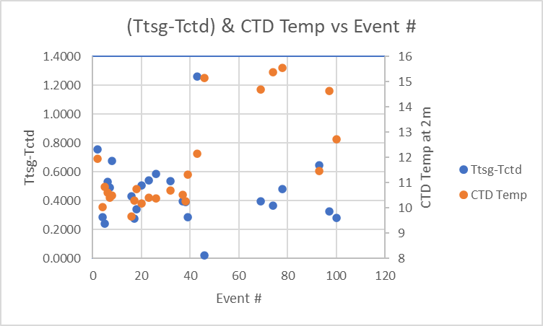

The amount of heating is roughly proportional to the intake temperature, with typical amounts ranging from 0.15Cº to 0.30Cº for the Vector, so 0.4Cº seems high. The difference from previous cruises could be due to lower intake temperatures but they don’t seem significantly different from October 2020. Another possible factor is that the CTD data did not sample as close to the surface as during the 2020 cruise. Most casts started close to 2.5db while the loop is situated at ~2m and may well be drawing water from shallower than that. So the intake temperatures may really be a little higher than those from the CTD. The cast at the mouth of Juan de Fuca is likely to be quite well mixed at the surface given the sea state there, and it has a difference from the TSG in the usual range. At other sites there may be a layer of warmer water at the surface, though there is no evidence to confirm that is the case. Another explanation is that conditions on the Vector have changed so that water warms more in the loop, either due to the ambient ship temperature being higher or the flow rate in the loop being reduced. There is no flow meter for this system. Calibration drift is the least likely explanation for such large differences.

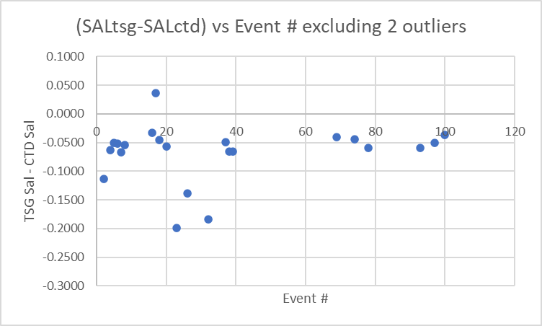

The TSG salinity was lower than CTD salinity by a median of 0.0578psu (std dev 0.3937psu). Outliers come from Haro Strait and the Gulf Islands area. When the 15 casts with the lowest standard deviation in TSG salinity over 2 minutes, the TSG salinity was found to be low by a median of 0.0548psu (std dev 0.0374psu). This lower salinity is generally seen by all TSG systems and is presumed to be mostly due to small bubbles in the loop water. Supporting that idea are the very low TSG salinity values in the areas of active mixing. Another reason is having deeper CTD values to compare with due to those casts starting below the loop intake, as noted in the discussion of temperature. If the TSG temperature is actually reading too high, that would also contribute to salinity looking lower, but such significant drift is unlikely.

Historically, this TSG has had salinity low by between 0.015 and 0.03psu with the larger difference being from autumn cruises. However, the history of this TSG is not of great help since all the Vector cruises lack good calibration sampling at 2db.

The goal is to remove the effect of bubbles from salinity and produce an estimate of intake temperature. There is no flow meter, no loop sampling and no very shallow CTD data available. So recalibration is problematic. Since the salinity differences are quite consistent through the cruise, adding 0.055psu will bring TSG Salinity into reasonable agreement with the CTD, but is likely to produce values that are a little too high for 2db. Reducing the correction might be justified, but there is insufficient evidence to pick a number. For temperature there is a desire to create a proxy for intake temperature and only the comparison with the CTD temperature is available. These values may be too low for 2db.

See 2022-017-ctd-tsg-comp.xls for details.

Calibration History
This TSG has been used on 4 previous cruises. For all 4 a proxy for intake temperature was created by subtracting 0.2C from the lab temperature. The only cruise with sufficient sampling to estimate salinity calibration was from 2022-017 in June 2022 when salinity was estimated to be low by 0.02psu.

Conclusions
1. The TSG clock worked well.
2. The TSG lab temperature was higher than the CTD temperature by roughly 0.4Cº. Historically Vector cruises have experienced loop heating estimated to be between ~0.15Cº and 0.03Cº, with 0.02Cº being the estimate chosen most often. The CTD temperature sensor could be reading low, but calibration drift in these sensors is likely to be very slight and the COMPARE results indicate no significant drift in either CTD temperature or conductivity. The loop is likely drawing from a level where temperatures are a little higher than those in the CTD casts. The TSG flow rate may have been slower than in the past or ambient conditions on the Vector may have changed. Given so much uncertainty and so little information, recalibration will be applied by subtracting 0.4 Cº to create a proxy for intake that is close to CTD temperatures.
3. The TSG Salinity is low by ~0.055psu. This could be partly due to the TSG drawing water from higher in the water column than the CTD measurement and bubbles likely account for some of the difference. Adding 0.055psu to salinity will bring the TSG into better correspondence to CTD salinity. This may better reflect 2.5m than the actual depth from which the water was drawn, but is the best we can do.

f.) Editing
No editing was needed.
REMOVE was used to remove the following channels: Scan Number and Flag channels.

g.) Recalibration
Add Channels was used to add Channel Temperature:Lab with values set equal to Temperature:Primary.
Calibrate was run using file 2022-070-tsg-recal1.ccf to subtract 0.40 from Temperature:Primary and to add 0.055psu to Salinity.

h.) Preparing Final Files
HEADER EDIT was used to change the DATA DESCRIPTION to THERMOSALINOGRAPH and add the depth of sampling to the header and to change channel names to standard names and formats.
The TSG sensor history was updated.
As a final check plots were made of the cruise track and time-series and all look fine.
The cruise plot was added to the end of this report.

Particulars (notes from logs of concern in processing plus few remarks on processing)
1. HEX file corrupted. No upcast data acquired between 20.8db and 1.0db. Data in ROS file for bottle #9 contain both 20db and 1db. BL file adjusted to capture 10.8 and 1.6db CTD data.
1. Fluorescence off scale to 4m downcast and looks bad above 20m upcast.
2. Looks like pH bottle left on.
7. Sal sensors consistently differ by 0.007 even after soak. Fluorescence very spiky- exhaust joint broken. Fluorometer replaced. No sounder, bottom depth from bridge.
9. Start time missed.
12. pH bottle left on.
12. Bottle 4 ran out of water from bot 14 so moved CHL and NUT to 13; no duplicate for DA.
25. Bottle 4 ran out of water, no lugols or chl-a.
26. pH buffer vial left on.
40. File saved as #40 should have been #41.
41. Log saved as #41 should have been #42. Log End time missing.
46. Bottom time in log few minutes late. Rosette had to rise 15m for stop due to A-Frame malfunction. Resumed 15m later.
48. Fluorescence not as spiky anymore.
49. Took ROS to 20m for soak to settle sensors.
50. Took ROS to 20m for soak to settle sensors.
52. pH bottle left on.
54. CTD left running at end to get out-of-water pressure.
57. 30s wait >200m, 60s<=200m before firing bottle.
64. Fired bottle without wait time.
69. Sample numbers out of order.
71. Sample numbers out of order.
73. Sample numbers out of order.
75. No depth in CTD header since no reading at start of cast. Some spikes when CTD stops during soak, doesn’t seem to do it during cast.
90. Looks like pH bottle left on.
100. repeat cast at station 27 (1st was cast 64) to pick up DIC.

CRUISE SUMMARY – CTD & TSG
CTD# | Make | Model | Serial# |  | Used with Rosette? |  | CTD Calibration Sheet Competed?
1 | SEABIRD | 911+ | 0506 |  | Yes |  | Yes
3 | SEABIRD | 21 | 3353 |  | n/a |  | Yes
Calibration Information - 0506
Sensor |  |  |  | Pre-Cruise |  |  |  | Post Cruise
Name |  | S/N |  | Date |  | Location |  | Date | Location
Temperature |  | 2374 |  | 3Feb2021 |  | Factory
Conductivity |  | 3184 |  | 3Mar2021 |  | Factory
Secondary Temp. |  | 4883 |  | 4Feb2021 |  | Factory
Secondary Cond. |  | 4395 |  | 3Mar2021 |  | Factory
Transmissometer |  | 983DR |  | 28Apr2021 |  | IOS
pH:SBE |  | 0692 |  | 14Jan2020 |  | Factory
SBE 43 DO sensor |  | 997 |  | 15Oct2021 |  | Factory
PAR |  | 4565 |  | 24Feb2021 |  | Factory
SeaPoint Fluor. |  | 3950 (1-7) |  | ? |  | Factory
SeaPoint Fluor. |  | 3949 (8-100) |  | ? |  | Factory
Pressure Sensor |  | 0506 |  | 29Jan2021 |  | Factory
Altimeter |  | 76341 |  | 2Oct2021 |  | Factory

Calibration Information – TSG 3363
Sensor |  | Pre-Cruise |  | Post Cruise
Name | S/N | Date | Location | Date | Location
Temperature | 3411 | 1Dec2019 | Factory
Conductivity | 3411 | 1Dec2019 | Factory

