**Revision Notice Table**

|  |  |
| --- | --- |
| **Date** | **Description of Revision** |
| 14 July 2023 | DO Saturation converted to DO Concentration. SH. |

**RBR CTD DATA PROCESSING NOTES**

Cruise: 2022-063

Agency: OSD

Locations: WCVI, Barkley Sound

Project: Clayoquot Sound Weather Station Network

Party Chief: Cooper G.

Platform: CME Anderson

Date: Jun. 8 2022 – Jun. 13, 2022

Processed by: Hana Hourston

Date of Processing: Feb. 12, 2023 – Mar. 23, 2023

Number of Raw files: 1 Number of Processed Files: 47

**Instrument Summary**

Equipment: RBR Maestro CTD (s/n 208765) with a Turner Cyclops Fluorometer (s/n 2110792), a JFE Advantech Rinko III oxygen sensor (s/n 0447), and a Seapoint turbidity sensor (s/n 208765).

Sampling frequency was at 8Hz. The fluorometer gain setting was set to “autorange”. Descent and recovery rates were about 1 m/s.

**Summary of Quality and Concerns**

A cast list of times and locations was provided, so this was cross-referenced against the dates and times in the RSK files. The dates and times in the RSK files match the dates and times in the cast list.

There were small negative oxygen saturation values at the bottom of a few casts that were in anoxic conditions. Fluorescence had regular spikes in a few casts corresponding to gain changes of the fluorometer, which was set to “autorange” instead of a fixed range. Gain changes are recorded in the events log in the .rsk file. The “autorange” setting is known to be sluggish in choosing ranges and to yield noisy data. Spikes were removed using a graphical editor before bin-averaging.

The rest of the data overall look good.

**Processing Summary**

1. **Conversion to IOS Headers**

There was one .rsk file from this cruise containing 47 events. All casts were extracted using the Python function READ_EXCELrsk().

A single file (2022-063_CTD_Data.csv) with all the data including event numbers and a single line of headers was prepared using the Python function MERGE_FILES().

A 6-line header was inserted using the Python function Add_6Lineheader_2().

File “2022-063_header-merge.csv” was created, based on the information provided by the chief scientist.

* Column “File_Name”: entries were derived from the event number.
* Column “LOC:LATITUDE”: latitude was provided and reformatted to “XX XX.XXXX N !(deg min)”.
* Column “LOC:LONGITUDE”: longitude was provided and reformatted to “XX XX.XXXX W !(deg min)”.
* Column “LOC: Event Number”: entries were event numbers.
* Column “LOC: STATION”: all stations were set to those provided in the cruise log.
* Column “LOC: Water Depth” was set to the water depth provided in the cruise log.

The sampling site was mapped (Figure 1) using from “2022-063_header-merge.csv” using the Python function Plot_Track_Location() to check the location of all casts.

Prior to conversion to IOS header format, the presence of zero-order holds were checked using the Python function Plot_Pressure_Diff() (Figure 2). It was unclear if there were zero-order holds from the output figure, so a differential was calculated on pressure in 2022-063_CSV_DATA-6linehdr.csv. Holds were found to occur at regular intervals in the file. A correction was applied using the Python function CORRECT_HOLD() and the pressure of the corrected data were plotted (Figure 3).

CONVERT Spreadsheet Files was run to produce files with IOS Header format. Header entries of “Administration”, “File” and “Instrument” were filled in this step.

Raw data were plotted and examined:

* Conductivity looks good. There is a small spike at the surface of casts 9, 15, and 33, and at the bottom of cast 34. During cast 34’s spike, temperature is steady.
* Salinity looks good. There is a spike at the bottom of cast 34.
* Oxygen looks okay, but there are a few casts (8, 10, 27) that go negative at the bottom of the cast. There is a more noticeable negative spike at the bottom of cast 8.
* Fluorescence has a spike of 450 mg/m^3 in cast 12 at the end of the upcast and a spike of about 45 mg/m^3 near the surface of the downcast in casts 17, 25-28, and 47. In casts 24, 32, 33, and 34 there is a positive spike at the bottom of the cast possibly due to the CTD stirring up sediment on the bottom. This channel otherwise looks okay.
* Temperature looks good. There is a small spike at the bottom of cast 23.

There is a pressure spike at the surface of cast 35.

T-S plots were also made.

The routine “Merge:CSV Files to headers” was run to add location headers to the IOS files.

Next CLEAN was run to add a start time and event numbers to headers.

A CALIBRATE step was needed here to replace negative oxygen saturation values with zero. These negative values were small and occurred only at the bottom of casts in anoxic conditions.

Then REORDER was run to reorder the channels in all files.

1. **Data processing**

* No correction to pressure was needed for this cruise.
* CLIP: Pressure is steady for a few of the first scans in all casts. Initial records were removed until the downcast began using file “2022-063_CLIP.csv”. Bottom records were also removed from casts 24, 32, 33, and 34 since fluorescence had positive spikes there, possibly due to the CTD stirring up sediment on the bottom.
* T-S plots were made after CLIP to check for spikes or unreal unstable features.
* Filter: a Gull-winged filter, size 3, was applied to temperature, conductivity, fluorescence, and pressure. Salinity will be recalculated after the shift steps.
* SHIFT: Based on suggested values in document “Guidelines for processing RBR CTD profiles”, the alignment of temperature and conductivity was corrected by applying a shift of -2 scans in conductivity. Salinity was recalculated after this step. Salinity profile plots before and after alignment were compared.
* SHIFT: Better alignment with Oxygen profiles was found by advancing it by 11 scans. The advice given in document “Guidelines for processing RBR CTD Profiles” was that an advance between 2 and 3 seconds is appropriate. T-O plots before and after alignment were compared.
* Delete was run to remove records with a descent rate lower than 0.3m/s over 8 points. This was not applied in the top 10m to avoid loss of surface records as the CTD began its descent, nor in the bottom 10m.
* Profile plots were examined after DELETE and confirm that plots show reasonable values for salinity, conductivity and fluorescence. Fluorescence still spikes near the surface of casts 17 and 45 to about 35 mg/m^3, and at the surface of casts 25-28 and 47 to about 40 mg/m^3. DO saturation levels at the surface ranged from about 90% to 140%. There was no calibration sampling and no climatology to enable a judgement about the data reliability.
* The graphical editor CTD Edit was used here to manually pad remaining fluorescence spikes in casts 17, 25-28, and 47.

1. **Final checks and header editing**

* REMOVE was run to remove the following channels from all casts: Date, Time:UTC and Event.
* BIN AVERAGE was used to average the data by pressure into 1 dbar bins.
* CALIBRATE was run to convert conductivity units to S/m using file 2022-063-recal2.ccf.
* CLEAN was run to reset the Maximum and Minimum values in the Header.
* Header Edit was used to fix channel names and format as listed below:
* Depth: meters ==> metres
* Temperature: deg C(ITS90) ==> deg C (ITS90)
* Salinity:CTD ==> Salinity
* Fluorescence ==> Fluorescence:URU
* Conductivity: F10.5 ==> F10.6
* Oxygen:Dissolved ==> Oxygen:Dissolved:Saturation:RBR, format F11.4 ==> F8.2
* Header Check was run. A few minor concerns were that casts 6 and 33 had cruising speeds between 10 and 15 knots, and cast 4 only had 1 record in its bottom bin. Standards check was run and no problems were found.
* Final profile and T-S plots were made. A track plot was also made.

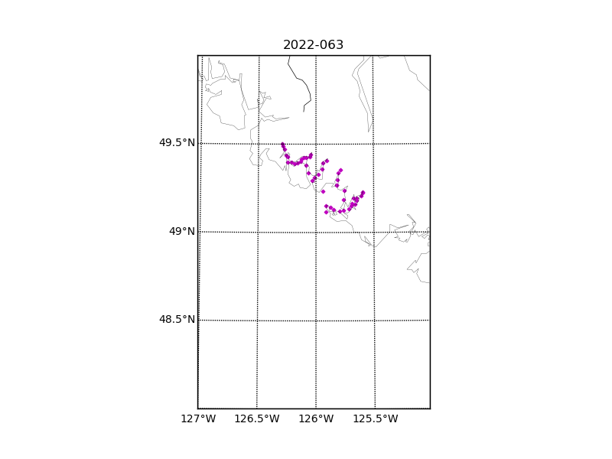Figure 1 – Location of casts for cruise 2022-063.

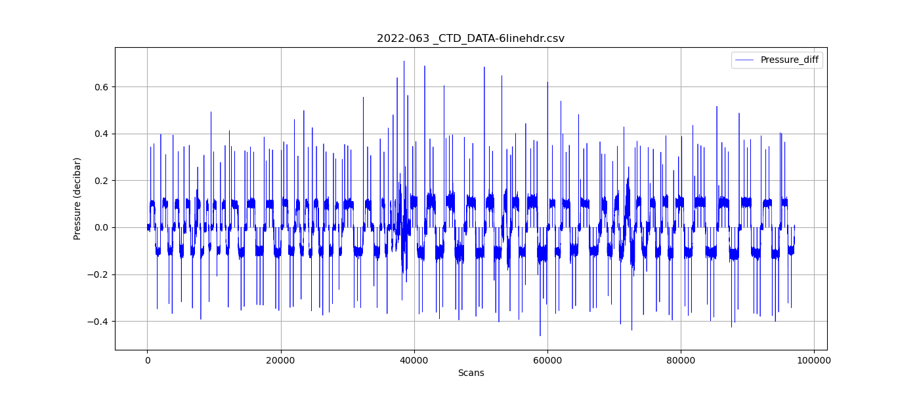

Figure 2 – Zero-order holds prior to correction.

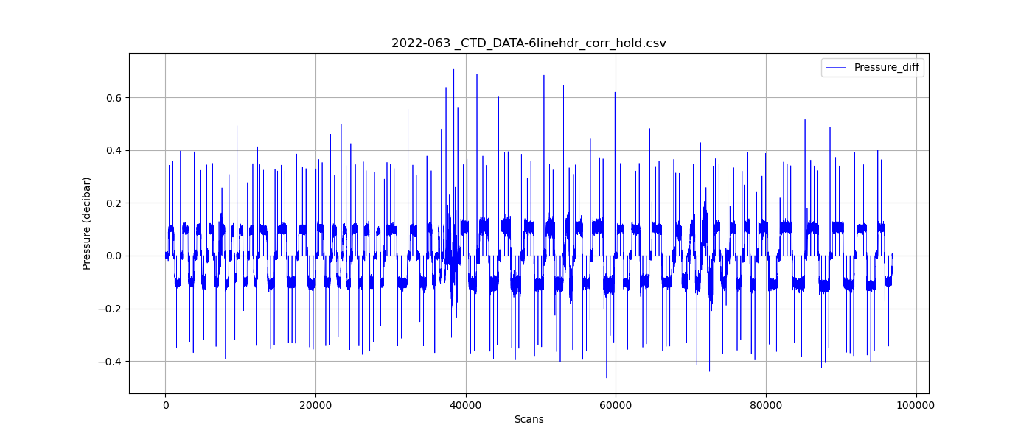

Figure 3 – Pressure differentials after the zero-holds correction.