**REVISION NOTICE TABLE**

|  |  |
| --- | --- |
| **Date** | **Description of Revision** |
| 25 July 2023 | Re-detected the casts in Ruskin and re-processed from scratch following the steps below except had to do a Pressure Calibration because -ve pressures were seen once the surface values were available. Also had to add a CLIP to remove records where surface was steady.  All changes made in CDT EDIT by Hana Hourston were done manually in a text editor and copied exactly.  DO Saturation converted to DO Concentration. SH. |

**RBR CTD DATA PROCESSING NOTES**

Cruise: 2022-042

Agency: IOS, Ocean Sciences Division, Sidney, B.C.

Locations: Canadian Arctic Archipelago South

Project: CBS-MEA, MPA Survey

Party Chief: Majewski A.

Platform: Frosti

Date: Aug. 2 2022 – Sept. 5, 2022

Processed by: Hana Hourston

Date of Processing: Mar. 16, 2023 – Mar. 24, 2023

Number of Raw files: 2 Number of Processed Files: 71

**A note about the cruise:** The CBS-MEA cruise ran from Aug. 2-30. A MPA Survey cruise ran directly after using the same equipment and no cruise number was assigned to this cruise, so the data from the MPA Survey have been processed together with the data from the CBS-MEA cruise and been marked with the same cruise number, 2022-042.

**Instrument Summary**

Equipment: RBR Concerto CTD (s/n 66024) with a Turner Cyclops Fluorometer (s/n 2102849), and a JFE Advantech Rinko III oxygen sensor (s/n 0300). Sampling frequency was at 6 Hz. The fluorometer gain setting was set to “autorange”.

**Summary of Quality and Concerns**

A cast list of times and locations was provided, so this was cross-referenced against the dates and times in the RSK files. The first cast time on Aug. 28th was incorrectly recorded as occurring on Aug. 19th, so the times in this cast were corrected during processing. The 70 casts from Sept. 1-4 matched the dates and times in the cast list.

There was an issue in the top 50 m of a few of the casts where fluorescence would spike when the fluorometer’s gain would change, so the spikes were removed using a graphical editor before bin-averaging. Gain changes are recorded in the events log in the .rsk file. The “autorange” setting is known to be sluggish in choosing ranges and to yield noisy data. Conductivity, salinity, temperature, and oxygen were a bit spiky in a few casts. The rest of the data overall look good.

**Processing Summary**

1. **Conversion to IOS Headers**

There were two .rsk files from this cruise with the first containing 1 event and the second containing 74. The first four casts in the second file took place on Aug. 31, 2022, and were test casts that were not processed. The remaining 71 casts were extracted using the Python function READ_EXCELrsk().

A single file (2022-042_CTD_Data.csv) with all the data including event numbers and a single line of headers was prepared using the Python function MERGE_FILES().

A 6-line header was inserted using the Python function Add_6Lineheader_2().

File “2022-042_header-merge.csv” was created, based on the information provided by the chief scientist.

* Column “File_Name”: entries were derived from the event number.
* Column “LOC:LATITUDE”: latitude was provided and reformatted to “XX XX.XXXX N !(deg min)”.
* Column “LOC:LONGITUDE”: longitude was provided and reformatted to “XX XX.XXXX W !(deg min)”.
* Column “LOC: Event Number”: entries were event numbers.
* Column “LOC: STATION”: all stations were set to those provided in the cruise log.
* Column “LOC: Water Depth:” was set to the water depth provided in the cruise log.

The sampling site was mapped (Figure 1) using from “2022-042_header-merge.csv” using the Python function Plot_Track_Location() to check the location of all casts.

Prior to conversion to IOS header format, the presence of zero-order holds was checked using the Python function Plot_Pressure_Diff() (Figure 2). It was unclear if there were zero-order holds from the output figure, so a differential was calculated on pressure in 2022-042_CSV_DATA-6linehdr.csv. Holds were not found to occur at in the file, so no correction was needed.

The test casts were manually removed from 2022-042_CSV_DATA-6linehdr.csv at this step.

CONVERT Spreadsheet Files was run to produce files with IOS Header format. Header entries of “Administration”, “File” and “Instrument” were filled in this step.

Raw data were plotted and examined:

* Conductivity spikes at the bottom of casts 227, 242, 245, 246, 257, 258, 269, 279, 280, 282, 287, and 292-296. This channel otherwise looks fine.
* Salinity spikes in the same locations as conductivity but otherwise looks fine.
* Oxygen spikes at the bottom of casts 242, 245, 269, 292, 295, and 296, but otherwise looks fine.
* Fluorescence spikes to 70 mg/m^3 at the surface of casts 220, 226, 228, 233, 242, 248-251, 254, 268, 272, 274-278, 280-282, 284, 285, 287, 288, and 290-292, and at the bottom of casts 242, 292, and 296. Fluorescence spikes to 750 mg/m^3 at the surface of casts 238, 273, 283. Fluorescence has smaller spikes at the bottom of casts 245, 246, 261, 269, 279, 282, 287, and 293-295.
* Temperature spikes at 12 dbar in cast 273, at 10 dbar in casts 231, 242, 248, 262, 269, 280, and 288, and at 8 dbar in cast 257. This channel otherwise looks okay.

T-S plots were also made.

The routine “Merge:CSV Files to headers” was run to add location headers to the IOS files.

Next CLEAN was run to add a start time and event numbers to headers.

The routine “Add Time Channels” was run to correct the time in the first cast and to add record numbers to all casts. The record in the first cast (event 220) was at 2022-08-19 00:01:57 UTC and it was advanced 230.20 hours to 2022-08-28 14:14:00 UTC.

Then REORDER was run to reorder the channels in all files.

1. **Data processing**

* No correction to pressure was needed for this cruise.
* Record number was plotted against pressure to confirm that none of the casts included a soak below the surface, so clip didn’t need to be run.
* Filter: a Gull-winged filter, size 3, was applied to temperature, conductivity, fluorescence, and pressure. Salinity will be recalculated after the shift steps.
* SHIFT: Based on suggested values in document “Guidelines for processing RBR CTD profiles”, the alignment of temperature and conductivity was corrected by applying a shift of -2 scans in conductivity. Salinity was recalculated after this step. Salinity profile plots before and after alignment were compared. A spike appeared in the upcast of casts 231 and 280, but these will be removed by the delete step later.
* SHIFT: Better alignment with Oxygen profiles was found by advancing it by 15 scans. The advice given in document “Guidelines for processing RBR CTD Profiles” was that an advance between 2 and 3 seconds is appropriate. T-O plots before and after alignment were compared.
* Delete was run to remove records with a descent rate lower than 0.3m/s over 8 points. This was not applied in the top 10m to avoid loss of surface records as the CTD began its descent, nor in the bottom 10m.
* Profile plots were examined after DELETE and confirmed many plots showed reasonable values. There were fluorescence spikes remaining at the bottom of casts 238, 245, 269, 282, and 287. There were conductivity/salinity spikes at the bottom of casts 242, 245, 269, 279, 282, 287, 292, 295, and 296, and a salinity spike near the surface of cast 288. There were also some temperature and oxygen spikes remaining. DO saturation levels at the surface ranged from about 90% to 115%. There was no calibration sampling and no climatology to enable a judgement about the data reliability.
* CTD Edit was used to remove spikes from fluorescence, salinity, conductivity, oxygen, and temperature.

1. **Final checks and header editing**

* CLEAN was run to update the start and end times in the header of file 2022-042-0220.
* REMOVE was run to remove the following channels from all casts: Date, Time:UTC, Event, and Record Number.
* BIN AVERAGE was used to average the data by pressure into 1 dbar bins.
* CALIBRATE was run to convert conductivity units to S/m using file 2022-042-recal2.ccf.
* CLEAN was run to reset the Maximum and Minimum values in the Header.
* Header Edit was used to correct the chief scientist from Williams W. to Majewski A., to correct the agency name from “IOS” to “IOS, Ocean Sciences Division, Sidney, B.C.”, and to fix channel names and format as listed below:
* Depth: meters ==> metres
* Temperature: deg C(ITS90) ==> deg C (ITS90)
* Salinity:CTD ==> Salinity
* Fluorescence ==> Fluorescence:URU
* Conductivity: F10.5 ==> F10.6
* Oxygen:Dissolved ==> Oxygen:Dissolved:Saturation:RBR, format F11.4 ==> F8.2
* Header Check was run and no problems were found. Standards check was run and no problems were found.
* Final profile and T-S plots were made. A track plot was also made of the MPA Survey part of the cruise.

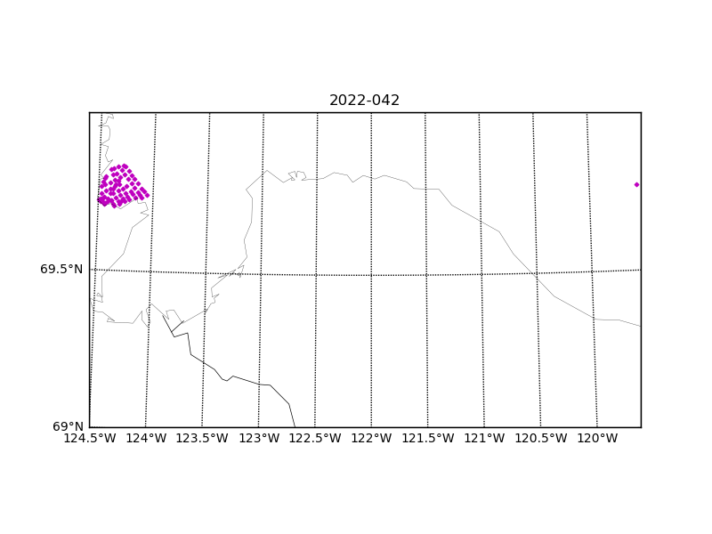

Figure 1 – Location of casts for cruise 2022-042.

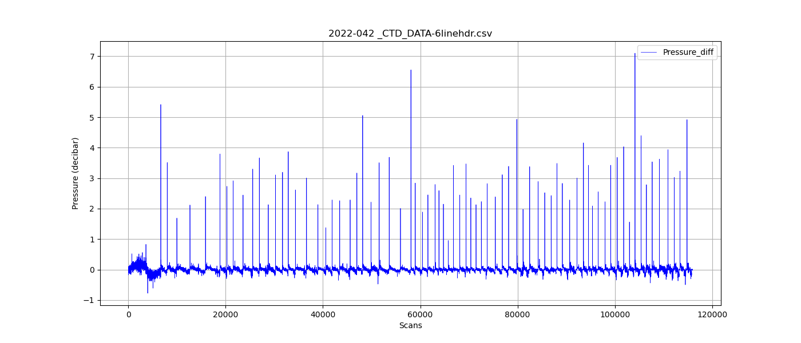

Figure 2 – Raw pressure differentials.