**RBR CTD DATA PROCESSING NOTES**

Cruise: 2022-031

Agency: OSD

Locations: Juan de Fuca, Strait of Georgia, WCVI

Project: Passive Acoustics Mooring Cruise

Party Chief: O'Neill C.

Platform: Richardson Point (charter)

Date: Mar. 3, 2022 – Mar. 18, 2022

Processed by: Hana Hourston

Date of Processing: Feb. 10, 2023 – Feb. 15, 2023

Number of Raw files: 12 Number of Processed Files: 12

**Instrument Summary**

Equipment: RBR Concerto CTD (s/n 204848). Sampling frequency was at 8Hz.

**Summary of Quality and Concerns**

Events were not numbered in the cruise log, so the RBR casts were numbered sequentially from 1 to 12. A cast list of times and locations was provided so the dates and times in the RSK files were cross-referenced against this list and were confirmed to match.

All water depths are approximate.

The data overall look good.

**Processing Summary**

1. **Conversion to IOS Headers**

There were originally two .rsk files from this cruise containing a total of 12 events. 10m soaks were done before each cast and these were recorded in the .rsk files. The two .rsk files were split into separate .rsk files for each event by the chief scientist. Four of the 12 .rsk files were renamed to follow the order of events. All casts were extracted without the 10m soaks using the Python function READ_EXCELrsk().

A single file (2022-031_CTD_Data.csv) with all the data including event numbers and a single line of headers was prepared using the Python function MERGE_FILES().

A 6-line header was inserted using the Python function Add_6Lineheader_2().

File “2022-031_header-merge.csv” was created, based on the information provided by the chief scientist.

* Column “File_Name”: entries were derived from the event number.
* Column “LOC:LATITUDE”: latitude was provided and reformatted to “XX XX.XXXX N !(deg min)”.
* Column “LOC:LONGITUDE”: longitude was provided and reformatted to “XX XX.XXXX W !(deg min)”.
* Column “LOC: Event Number”: entries were event numbers.
* Column “LOC: STATION”: all stations were set to those provided in the cruise log.
* Column “LOC: Water Depth:” was set to the water depth provided in the cruise log.

The sampling site was mapped (Figure 1) using coordinates from “2022-031_header-merge.csv” and the Python function Plot_Track_Location() to check the location of all casts.

Prior to conversion to IOS header format, the presence of zero-order holds were checked using the Python function Plot_Pressure_Diff() (Figure 2). It was unclear if there were zero-order holds from the output figure, so a differential was calculated on pressure in 2022-031_CSV_DATA-6linehdr.csv. Holds were found to occur at regular intervals within the file, so a zero-hold correction was carried out, with the output file having name “2022-031_CTD_DATA-6linehdr_corr_hold.csv”. The pressure data from this file were plotted in Figure 3.

CONVERT Spreadsheet Files was run to produce files with IOS Header format. Header entries of “Administration”, “File” and “Instrument” were filled in this step.

Raw data were plotted and examined:

* Conductivity spikes a miniscule amount at the bottom of cast 6, but otherwise looks okay.
* Salinity spikes a miniscule amount at the bottom of cast 6, but otherwise looks okay.
* Temperature looks fine.
* Pressure looks fine.

T-S plots were also made.

The routine “Merge:CSV Files to headers” was run to add location headers to the IOS files.

Next CLEAN was run to add a start time and event numbers to headers.

Then REORDER was run to reorder the channels in all files.

1. **Data processing**

* No correction to pressure was needed for this cruise.
* CLIP: Pressure is steady for a few of the first scans in some of the casts. Initial records in these casts were removed until the downcast began using file “2022-031_CLIP.csv”. Records at the bottom of cast 6 where conductivity and salinity spiked were also removed using this file.
* T-S plots were made after CLIP to check for spikes or unreal unstable features.
* Filter: a Gull-winged filter, size 5, was applied to temperature, conductivity, and pressure. Salinity will be recalculated after the shift steps.
* SHIFT: Based on suggested values in document “Guidelines for processing RBR CTD profiles”, the alignment of temperature and conductivity was corrected by applying a shift of -2 scans in conductivity. Salinity was recalculated after this step and plots of salinity profiles before and after alignment were compared.
* Delete was run to remove records with a descent rate lower than 0.3m/s over 8 points. This was not applied in the top 10m to avoid loss of surface records as the CTD began its descent, nor in the bottom 10m.
* Profile plots were examined after DELETE and confirm that plots show reasonable values for salinity, conductivity, and temperature. There was no calibration sampling and no climatology to enable a judgement about the data reliability.

1. **Final checks and header editing**

* REMOVE was run to remove the following channels from all casts: Date, Time:UTC and Event.
* BIN AVERAGE was used to average the data by pressure into 1 dbar bins.
* CALIBRATE was run to convert conductivity units to S/m using file 2022-031-recal2.ccf.
* CLEAN was run to reset the Maximum and Minimum values in the Header.
* Header Edit was used to fix channel names and format as listed below:
* Depth: meters ==> metres
* Temperature: deg C(ITS90) ==> deg C (ITS90)
* Salinity:CTD ==> Salinity
* Conductivity: F10.5 ==> F10.6
* Header Check was run and no problems were found. Standards check was run and no problems were found. A cross-reference table was made.
* Final profile and T-S plots were made. A track plot was also made using IOS Shell.

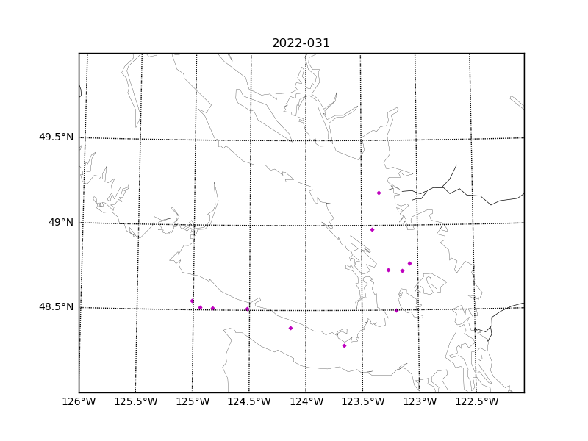Figure 1 – Location of casts for cruise 2022-031.

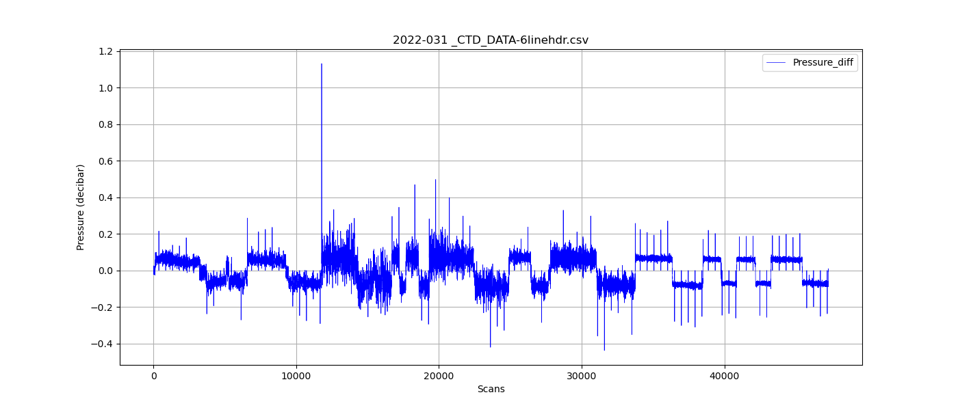

Figure 2 – The first differential of pressure in cruise 2022-031.

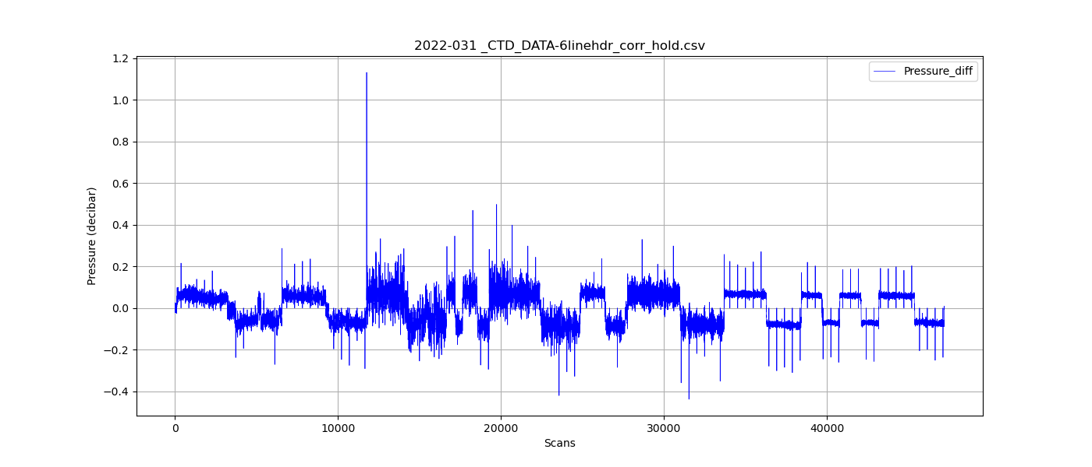

Figure 3 – The first differential of pressure from cruise 2022-031 after applying a zero-holds correction.