REVISION NOTICE TABLE
DATE | DESCRIPTION OF REVISION
2 Apr 2024 | CHL that was originally thought to be lost was added to casts 1, 4, 5, 8 & 10

PROCESSING NOTES
Cruise: 2022-030
Agency: IOS, Ocean Sciences Division, Sidney BC
Chief Scientist: Young K. Platform: Other Vessel
Location: Barkley Sound Project: Barkley Sound Euphausiid Study
Date: 2 March 2022 –11 November 2022

Processed by: Germaine Gatien
Date of Processing: 16 May 2023 – 29 May 2023
Number of original HEX files: 19 (1 had no useful data)
Number of CTD files: 18 Number of BOT files: 48

INSTRUMENT SUMMARY
Two SeaBird Model SBE-19 CTDs were used:
1. s/n 4345 was mounted with a Wetlabs ECO Fluorometer #4185 and dissolved oxygen sensor #3234.
2. s/n 5299 was mounted with a Wetlabs ECO Fluorometer #2214 and dissolved oxygen sensor #1592.

SUMMARY OF QUALITY AND CONCERNS
This program involved repeat visits to 5 sites in March, April, May, June, July, August, October and November 2022. CTD #1 was used for all casts except those in July when CTD #2 was used. At 2 of the sites there was near-bottom sampling during a CTD cast and at all sites there was surface sampling. On one occasion one of the other sites included a deep bottle because it had been missed at another site.

The pressure range of the CTDs used for most of the cruise was ~1000db and the one used in July was ~600db; these are much better choices for shallow water sampling than the 3500db used for similar areas in previous years, so pressure resolution was good. Fluorescence traces had much more detail in July than in the other months.

Two types of bottle files were prepared. Where there was only surface sampling the files contain an estimate of pressure, 0db, and the analysis results. Where there was an accompanying CTD cast, CTD data from the 2 levels of the samples were combined in a single file which was given the event number of the CTD cast. Samples from events #4, 8, 10 and 83 were all lost, but BOT files were still prepared.
Nutrient data from all casts were lost before analysis, so no nutrient channels are included in BOT files.

This was a new program with many legs and participants; sorting out the records was a challenge. There were many separate logs, a paper log for the first few months and separate digital ones after June. For an overview, see document 2022-030 Master List_Nov2022.xlsx which was prepared after the last leg of the program.

Calibration samples were available for comparison with CTD salinity and fluorescence. The CTD salinity was reading a little lower than samples, but it is likely reading higher than it appears given delayed analysis of samples. For the samples that were analyzed promptly, the CTD appears to be reading slightly high. The CTD fluorescence agreed very well with extracted chlorophyll samples. Pressure appears to be well within expected accuracy.

PROCESSING SUMMARY

1. Seasave
This step was completed at sea.

2. Preliminary Steps
A variety of logs and records were obtained, but the most useful records were in file 2022-030 Mater List_Nov2022.xlsx.
The deep bottles were taken using a Niskin bottle mounted approximately 1m above the CTD.
Surface samples were taken using a Niskin bottle just below the surface.
The cruise summary sheet was completed.

3. Conversion of Raw Data
The configuration files used at sea were correct. They were saved as SBE19plus_4345.xmlcon (used for events 1-37 and 53-90) and SBE19plus_5299.xmlcon (used for events 41-52).
Test plots were made.
The deployment scheme varied through the program.
For events #1-28 there was a soak at the surface that lasted about 35s to 110s after the pumps came on. It is best to wait at least 2 minutes.
For events #32-90 there was a 10m soak which is a better approach as it clears the plumbing of bubbles. Those soaks generally lasted about 2 minutes with one exception that was only about 35 seconds.

All expected variables are present. Pressure looks quite smooth.
Temperature, conductivity, dissolved oxygen and fluorescence profiles look normal.
The minimum fluorescence was ~0.08ug/L and there were no negative values.

4. WILDEDIT
The only spikes noted in the data occurred at the beginning or end of the casts or included many points, and will be removed in the normal course of editing. So WILDEDIT was not run.

5. FILTER
The resolution of this instrument appears to be good so the pressure does not obviously need filtering. A test showed no major effect but there was a very slight improvement in salinity so it was run.
Filter was run using a low-pass filter, size 1s on pressure.
The temperature and conductivity were examined and the usual approach of applying a cosine filter size 8 in routine WFILTER did a good job of removing small reversals.

6. ALIGNCTD
Based on tests run for other cruises using similar equipment, ALIGNCTD was run on all casts to advance the DO channel by 2.5s. Plots were examined after this step and the results looked fine on oxygen voltage. But when the oxygen concentration was derived the DO appeared to be over-corrected.
A return was made to this step and using a 1.5s advance worked better for both sensors.

The reason for a better response in DO is unknown.
To see if it might be a result of filtering temperature one cast was put through ALIGNCTD and DERIVE without running the filter steps but that did not change the result.
A comparison of DO voltage and DO concentration shows a slightly closer alignment with temperature in the concentration without running ALIGNCTD.
Next plots were examined versus scan #. This also shows some improved alignment that happens in the derivation of dissolved oxygen. This is not usually seen, but it is possible that the deck unit was set to make achieve some alignment in the derivation. Whatever the reason, an advance of 1.25s produced the best result.

7. CELLTM
CELLTM was run on all casts using the SeaBird recommended parameters, (α, 1/β) = (0.04, 8).

8. DERIVE
Program DERIVE was run to calculate salinity and dissolved oxygen concentration (tau correction included).
Plots were examined to see if steps 5, 6 and 7 had worked well. It was found that while oxygen voltage alignment looked good, the concentration was overcorrected by ALIGNCTD. A return was made to step 6 and adjustments made until the result looked good. Step 7 and 8 were then repeated.

9. Conversion to IOS Headers
The IOSSHELL routine was used to convert the CNV files to IOS Headers.
CLEAN was run to add event numbers and replace pad values in the pressure channel with interpolated values.

Time of casts is confusing. The logs sometimes have local time, sometimes UTC and local time changed from PDT to PST for the November leg. The file headers don’t usually agree with the logs.
Fortunately, the master summary document does appear to have correct local times.

All files were copies to *.ATC. Then ADD TIME CHANNEL was run to add 7 hours to files 1-5 and 8 hours to all other files.
A cross reference list was checked and the times of the initial CTD cast for each month increase gradually until July and then decrease. This makes sense if the timing is based on sunset as the July cast was the closest to the summer solstice. So the times are likely correct.
The time zone changed between the October and November legs.

10. Checking Headers
A cross-reference list was produced and no problems were found.
Track plots are not informative for the CTD casts since they only occurred at 3 sites.

Surface Check was run and the average was -0.16db with a range from -0.25 to 0 to -0.01b. All files were put through REVERSE and another run of Surface Check gives an average for the upcast of -0.13db with a range of -0.27db to +0.14. Conductivity was near zero, so the CTD was clearly at the surface.
These checks come from 2 different CTDs but the results are very similar for the downcast while the upcast surface readings from CTD #5299 are very slightly positive rather than slightly negative.

The pressure sensor has a resolution of ~1db so these readings are well within expectations. No recalibration will be applied.

HEADER CHECK was run. There were some negative values in pressure, conductivity and fluorescence. This will be checked again after CLIP removes soak data.

11. CLIP and CALIBRATE
The next step is to remove the data collected during soaks either at the surface or at 10m.
Plots were made to see how many records needed to be removed and those data were put in file clip.csv.
CLIP was run removing the records based on clip.csv. Then plots were made to identify casts that needed a different choice and CLIP was run on those individually, until plots showed an appropriate number of scans had been removed. made.

12. SHIFT
Conductivity
Tests were run to see what shift to conductivity made the best improvement to stability in T-S space. A shift of +1.9 records made a sufficient improvement. That setting was applied to all casts.
Fluorescence
The fluorometer was not pumped, so a shift in alignment is expected to be small or unnecessary. Profile plots of temperature and fluorescence were examined and confirm that the alignment is ok.
Dissolved Oxygen
This channel was aligned earlier, but checks were made by examining plots of temperature and dissolved oxygen. No further adjustment was made.

13. DELETE
DELETE was run on all casts using the following parameters:
Surface Record Removal: Last Press Min. Surface Swell Pressure Tolerance: 1.0
Swells deleted. Warning message if pressure difference of 2.00
Drop rates < 0.3m/s (calculated over 5 points) was deleted from 10db to 10db above the maximum pressure.
COMMENTS ON WARNINGS: There were no warnings.

14. DETAILED EDITING
All DEL files were copied to *.EDT so there will be a complete set of files even if some need no editing.

CTDEDIT was used to do some light editing of all files except #28; this was limited to removal of a few records near the top and records corrupted by shed wakes near the bottom.
Cast #28 needed no editing.
Notes of editing details were made in the headers.
T-S plots were examined after this step and the results look good.

The EDT files were bin-averaged in 1db bins.

15. Initial Bottle Data Steps
There was no rosette available for this cruise. There were surface bottles fired at all sites; the surface bottles were given separate event numbers from the CTD casts, . At 3 of those sites there was also a Niskin mounted about 1m above the CTD to collect near-bottom samples.
BOT files were prepared with the sample data plus CTD gathered at the same site.
The event numbers will be those of the CTD cast at the site.

Each of the analysis spreadsheets were examined to see what comments the analysts wanted included in the header file. These were used to create file 2021-030-bot-hdr.txt which will be updated as needed during processing.
- Chlorophyll analysis was obtained in spreadsheet QF 2022-030_CHL*.xlsx. Some samples were lost.
- Salinity analysis was obtained in 2 spreadsheets QF 2022-030_SAL_pt_1*.xlsx and QF 2022-030 SAL_pt2*.xlsx. There is some confusion in sample numbers in the files. The samples taken in March were missing because 2 sets of samples were both said to be from July. After a variety of checks it is believed that the samples are now associated with the correct events.
- Nutrient analysis was obtained in spreadsheet QF2022-030_NUTS..xlsx but all samples were lost.

Spreadsheet 2021-030-bottles_plus_CTD_6linehdr. csv was created using entries from the event log relevant to Niskin sampling plus bottle data. Space was made for CTD data.

The binned CTD files were thinned to the 1db (shallowest reliable data available) and the level of sampling (Max pressure – 1db). Those data were extracted to a spreadsheet and added to the workbook. This left many blanks where there were no CTD data available. Those will be filled with pad values in conversion.

Where there are no CTD data available at the surface, pressure and depth values were entered as 0 which should be considered nominal values.

Casts #4. 8, 10 and 83 contain no sample data because all samples were lost before analysis. Files were prepared so that there is a record of what happened; comments in headers indicate what samples were planned but lost.

The spreadsheet was converted to individual BOT1 files.
CLEAN was used to add start time and positions. The only way to do that also added Stop times and positions which just repeat the start entries, so those will be removed later.

16. Compare
Salinity Comparison
File 2012-030-salinity-comp.xlsx was prepared to compare CTD and bottle data. The results were divided according to which CTD was in use and the results look good for both. There were 15 deep samples for CTD #1 and 3 for CTD #2. CTD #1 had 6 samples flagged 4 and 1 outlier.

 | all deep samples |  |  | deep samples excluding flag 4 & 1 outlier
CTD #4345 | median |  | -0.0030 | 0.0018
 | stdev |  | 0.1199 | 0.0158
CTD #5299 | median |  | -0.0004 | no flag 4 or outliers
 | stdev |  | 0.0024

Those are remarkably small differences. The salinity analysis was delayed so we might expect samples to be reading high which might mean the CTD is possibly reading higher than it appears to be. There is some evidence that this might be the case since there is a slight trend towards CTD reading higher relative to bottles later in the program, when samples got analyzed quicker so that errors due to evaporation/desorption of samples are expected to be smaller. There is no indication of a problem with CTD calibration.
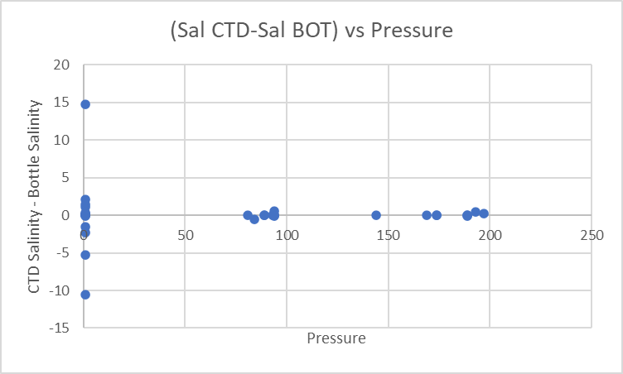

For shallow samples the differences were larger, with the CTD reading high in most cases, likely because
the CTD data comes from a little lower in the water column and surface salinity gradients are often large.
 | all surface samples |  | surface samples not flagged 4
CTD #4345 | median | 0.0734 | 0.1186
 | stdev | 1.2585 | 1.3299
CTD #5299 |  | -0.5025 | only 1 sample

Fluorescence vs extracted chlorophyll
The comparison of CTD fluorescence versus extracted chlorophyll was surprisingly close with a median for ratio FL/CHL = 1.02ug/L (std dev 0.51). The comparison included one sample from 174db where both the fluorometer and chlorophyll values were 0.08ug/L. The values were low in general. The one outlier was from a July reading which was the highest for both during this program, FL=5.15 and CHL=2.12ug/L. The difference in that case may be due to a high vertical gradient. There were very high temperatures at the time after an extremely warm late June.
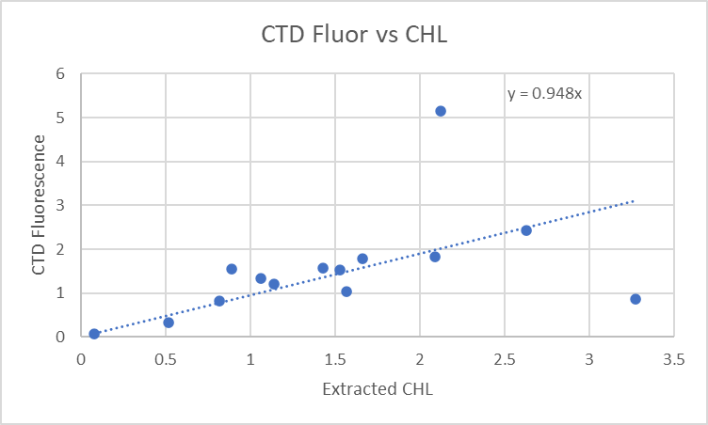

17. Other calibration checks
Sensor History – The pressure, conductivity and dissolved oxygen sensors for CTD #2 were used on 1 other cruise since last being serviced but there was no useful calibration sampling. No history was found for CTD #1.
Historic Ranges – There was no local climatology available, but all temperatures fell within a climatology for a large area around Barkley Inlet. Most salinity fell with that wider climatology as well except that salinity was lower near the average in spring and some bottom values were also lower than the historic range.
Post-cruise calibrations – None were available.

18 CALIBRATE
Pressure does not require recalibration.
There was no dissolved oxygen calibration sampling.
Salinity calibration sampling was available but the limited numbers of samples and delays in analysis mean the results are only useful in judging whether the sensor worked properly. They do show that the CTD values from near the bottom are generally close to the bottle samples.
No recalibration was applied to these files.

19. Fluorescence Filter
The fluorescence data do not require editing.

20. Bin Average, Remove, Derive DO in mass units, Reorder
The files were bin averaged using 1db bins.
REMOVE was run to remove Scan_Number, Oxygen:Voltage, Descent Rate and Flag channels.

Dissolved Oxygen was derived in mass units and that was used to calculate DO saturation. Plots of near-surface saturation show a range of 85% to 130%, with the lowest values in November.
REORDER was used to get the 2 dissolved oxygen channels together.

21. HEADER EDIT and final checks of CTD files.
Header Edit was used to fix headers, fix formats and to add comments about processing.
A cross-reference listing was produced.
A header check and standards check were run on the CTD files and no errors were found.
The sensor history was updated.
Plots of CTD casts were examined and no problems were found.

2. Final BOT file preparation
The CLN files do not include SBE DO in mass units, so Change Units was run to add that channel. This will only work where there are CTD data as Temperature:Primary and Salinity:T0:C0 are required.

Change Units was run to derive mass units for the Oxygen:Dissolved:SBE channel. Empty channels were removed except for events 4, 8, 10 and 83 in order to maintain CHL data that were padded with flag 1.
*For those 4 events REMOVE was used to delete other empty channels.

REMOVE was run to remove the DATE, TIME:UTC. Latitude and Longitude channels.*
REORDER was run to get the 2 DO channels together.
SORT was not needed since the data were already in pressure order.

Header Edit was run to add comments and to remove END TIME (same as START TIME), TIME ZERO, Latitude2 and Longitude2.
There were 2 header files since the comments vary for casts with and without CTD data.
Finally, the instrument serial number entry in the headers of events 41-52 was changed using a text editor.
The final files have extensions BOT.

A map was produced with station positions occupied in July. There was some variation in positions among the different legs. The map is at the end of this report.
The standards check was run until all errors had been corrected.
A cross-reference list and header check were run on the BOT files and no further problems were found.
There are 4 BOT casts with no CTD and no samples analyzed. They were saved but will not be archived.

Plots were made of all BOT casts. With just 1 or 2 levels these were not very useful.
Finally all data from BOT files were extracted to a spreadsheet and compared to the event log; no problems were found.

The header analysis comments in the BOT files for March were adjusted to reflect the fact that salinity samples were analyzed 8 months after collection.

Particulars
ALL: All nutrient data were lost before analysis, so those channels were not included in BOT files.
4, 8, 10, 83. No CTD data and no samples analyzed. BOT files were prepared with sample #s, nominal pressure and depth and pad values and 1 flags for CHL.
41. Tubing left on CTD – no CTD data acquired.
52. Additional CTD cast with bottom bottle taken due to missing cast #41.
85. Time change from PDT to PST.

CRUISE SUMMARY

Cruise ID#: 2022-030
Dates: Start: 2 February 2022 End: 11 November 2022
Location: Barkley Sound
Chief Scientist: Young K.
CTD# | Make | Model | Serial# | Used with Rosette? | CTD Calibration Sheet Competed?
1 | SEABIRD | 19+ | 4345 | No | Yes
2 | SEABIRD | 19+ | 5299 | No | Yes

CTD CALIBRATION INFORMATION
Make/Model/Serial#: SEABIRD/SBE19+/4345 Cruise ID#: 2022-030
Calibration Information
Sensor |  | Pre-Cruise |  | Post Cruise
Name | S/N | Date | Location | Date | Location
Temperature | 4345 | 3Feb2022 | Factory
Conductivity | 4345 | 3Feb2022 | Factory
ECO Fluorometer | 4185 | 11Dec2019 | Factory
SBE43 Oxygen | 3234 | 6Dec2019 | Factory
Press | 4345 | 20Jan2022 | Factory
Make/Model/Serial#: SEABIRD/SBE19+/5299 Cruise ID#: 2022-030
Calibration Information
Sensor |  | Pre-Cruise |  | Post Cruise
Name | S/N | Date | Location | Date | Location
Temperature | 5299 | 3Feb2022 | Factory
Conductivity | 5299 | 3Feb2022 | Factory
ECO Fluorometer | 2214 | 19Jan2019 | Factory
SBE43 Oxygen | 1592 | 19Feb2021 | Factory
Press | 5299 | 20Jan2022 | Factory

Station positions are approximate as they varied among different legs of the program.
