**REVISION NOTICE TABLE**

|  |  |
| --- | --- |
| **Date** | **Description of Revision** |
| 25 July 2023 | Recalculated Salinity and then re-converted Oxygen. SH Bad data removed from casts 1, 3, 5, 19. SH |
| 19 July 2023 | DO Saturation converted to DO Concentration. SH. |

**RBR CTD DATA PROCESSING NOTES**

Cruise: 2022-020

Agency: OSD

Locations: Quatsino Sound, Holberg Inlet and Neroutsos Inlet

Project: Quatsino ADRCP

Party Chief: Cooper, G.

Platform: Blackie

Date: February 15, 2022 – February 17, 2022

Processed by: Samantha Huntington

Date of Processing: January 4, 2023 – February 24, 2023

Number of Raw files: 27 Number of Processed Files: 27

**Instrument Summary**

Equipment: RBR Concerto CTD (s/n 204694) with a Turner Cyclops Fluorometer (s/n 21101282) and a JFE Advantech Rinko III oxygen sensor (s/n 411).

Sampling frequency was at 8Hz.

**Summary of Quality and Concerns**

A cast list of times and locations was provided, “2022-020CTDLogFile_Final.xlxs”.

The data overall look good. There is some bad data at the bottom of casts 1, 3, 5 and 19 for all variables and also at the bottom of casts 11, 17 and 26 for Temperature.

The dates and times in the RSK file do not match the dates and times in the log file.

**Processing Summary**

1. **Conversion to IOS Headers**

Multiple profiles were found in 204694_20220217.rsk w_1538.rsk file.

File 204694_20220217.rsk w_1538.rsk was found to contain the profiles contained in the previous files, as well as profiles from previous cruises. After discussion with the chief scientist the required profiles were identified by date and extracted using python function READ_EXCELrsk().

A single file (2022-020_CTD_Data.csv) with all the data including event numbers and a single line of headers was prepared using python function MERGE_FILES().

A 6-line header was inserted using python function Add_6Lineheader_2().

File “2022-020_header-merge.csv” was created, based on the information provided by the chief scientist.

* Column “File_Name”: entries were derived from the event number.
* Column “LOC:LATITUDE”: latitude was provided and reformatted to “XX XX.XXXX N !(deg min)”.
* Column “LOC:LONGITUDE”: longitude was provided and reformatted to “XX XX.XXXX W !(deg min)”.
* Column “LOC: Event Number”: entries were event numbers.
* Column “LOC: STATION”: all stations were set to those provided in the log file. .
* Column “LOC: Water Depth:” was set to the water depth provided in the log file.

The sampling site was mapped (Figure 1) using from “2022-020_header-merge.csv” using python function Plot_Track_Location() to check the location of all casts.

Prior to conversion to IOS header format, the presence of zero-order holds were checked using Python function Plot_Pressure_Diff(). While it looks like there are zero-order holds, a differential was calculated on Pressure on the 2022-002_CSV_DATA-6Linedr.csv and there was only one instance of a zero-order hold. No correction was applied.

CONVERT Spreadsheet Files was run to produce files with IOS Header format. Header entries of “Administration”, “File” and “Instrument” were filled in this step.

The routine “Merge:CSV Files to headers” was run to add location headers to the IOS files.

Raw data were plotted and examined:

* Salinity looks good with some bad data at the bottom of casts 1, 3, 5 and 19, and a spike in casts 15 and 19.
* Oxygen looks good with some bad data at the bottom of casts 1, 3, 5, 19 and 26. There is a fluctuation in the middle of cast 19.
* Fluorescence looks good with some bad data at the bottom of casts 1, 3, 5 and 19.
* Conductivity looks good with some bad data at the bottom of casts 1, 3, 5 and 19, and a spike in casts 15 and 19.
* Temperature looks good with some bad data at the bottom of casts 1, 3, 5, 11, 17 and 26. There is a spike in casts 15 and 19.

ADD TIME CHANNELS was used to correct the time in all casts. Each cast was done separately using the start time from the event log.

Next CLEAN was run to add a start time and event numbers to headers.

Then REORDER was run to reorder the channels in all files.

1. **Data processing**

* No correction to pressure was needed for this cruise.
* Data despiking: spikes in Temperature, Salinity and Conductivity were found in two casts.
* Cast 15 , 5 records from 28.1-28.2Db inclusive for Temperature, Conductivity and Salinity - were padded
* Cast 19, records for Temperature, Conductivity and Salinty were padded from 37.8-41.5Db inclusive, Oxygen from 39.1-42.7Db inclusive was also padded.
* CLIP: Pressure is steady for a few of scans. Initial records were removed until the downcast began using file “2022-020_CLIP.csv”.
* Filter: a Gull-winged filter, size 7, was applied to temperature, conductivity, and pressure. Salinity will be calculated in the next step.
* SHIFT: Based on suggested values in document “Guidelines for processing RBR CTD profiles”, the alignment of temperature and conductivity was corrected by applying a shift of -2 scans in conductivity.
* SHIFT: Better alignment with Oxygen profiles was found by advancing it by 11 scans. The advice given in document “Guidelines for pro24cessing RBR CTD Profiles” was that an advance between 2 and 3 seconds is appropriate. T-O plots before and after alignment were compared.
* Delete was run to remove records with a descent rate lower than 0.4m/s over 8 points. This was not applied in the top 10m to avoid loss of surface records as the CTD began its descent.
* Profile plots were examined after DELETE and confirm that plots show reasonable values for salinity and conductivity and fluorescence. However, there was still some bad data at the bottom of casts 1, 3, 5, 17, 18, 19 and for Salinity and Conductivity. The RBR remained at the bottom of the cast for a while and the bad data was not removed after DELETE. Various final records from each of these casts was removed in a text editor at this point. DO saturation levels at the surface ranged from 81% to 100%. However there was no calibration sampling and no climatology to enable a judgement about the data reliability.

1. **Final checks and header editing**

* REMOVE was run to remove the following channels from all casts: Date, Time:UTC and Event.
* BIN AVERAGE was used to metre-average data.
* CALIBRATE was run to convert conductivity units to S/m using file 2020-020-recal2.ccf.
* Header Edit was used to fix channel names and format as listed below:
* Pressure: format F11.2 ==> F7.1
* Salinity:CTD ==> Salinity
* Fluorescence==> Fluorescence:URU
* Conductivity: F10.5 ==> F10.6
* CLEAN was run to reset the Maximum and Minimum values in the Header.
* Header Check was run and no problems were found.

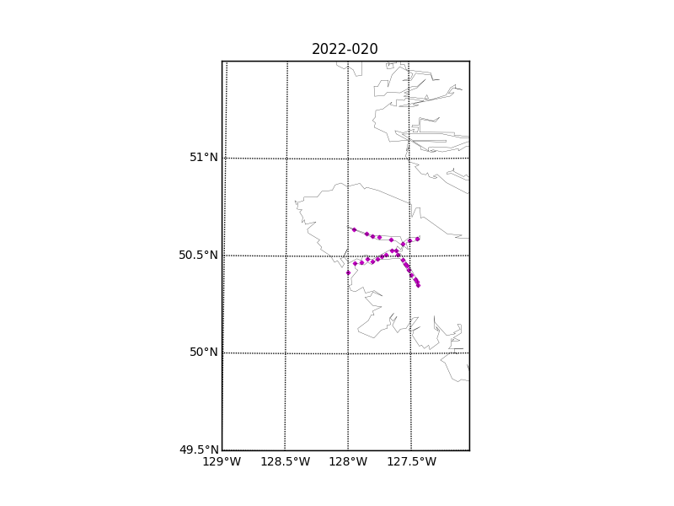

Figure 1 – location of casts. 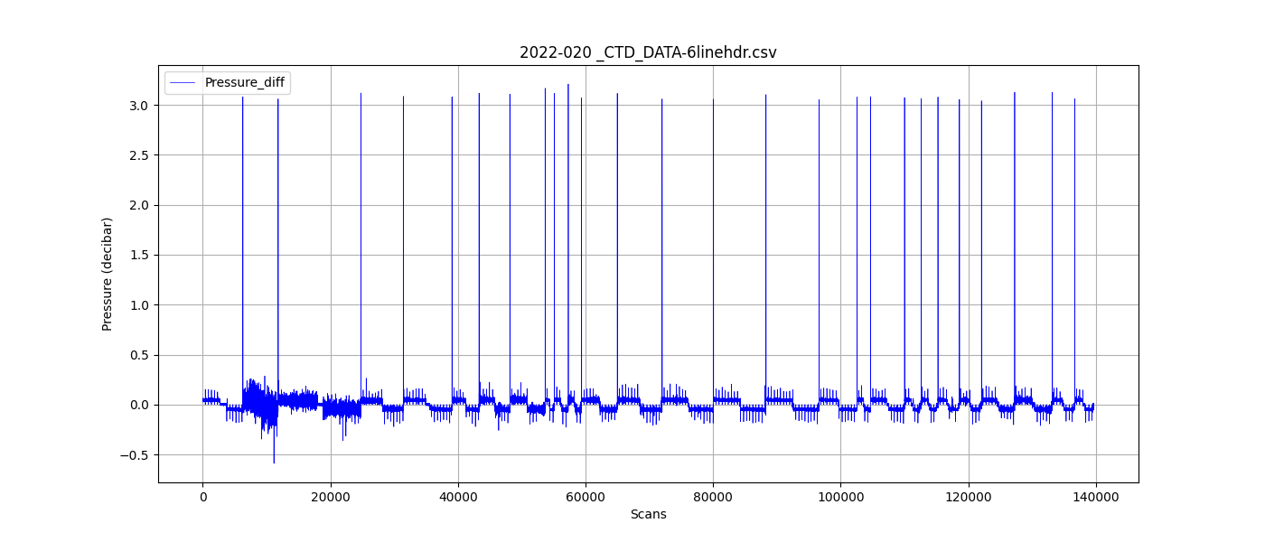

Figure 2 – zero-order holds