REVISION NOTICE TABLE
DATE | DESCRIPTION OF REVISION
18 March 2025 | Updated channel names & formats in TOB files. G.G.

PROCESSING NOTES
Cruise: 2022-019
Agency: OSD
Location: Strait of Georgia, Juan de Fuca Strait, WCVI
Project: Acoustic Moorings
Chief Scientist: O’Neill C.
Platform: Vector
Date: 12 October 2022 – 18 October 2022

Processed by: Germaine Gatien
Date of Processing: 5 May 2023 – 9 May 2023
Number of HEX files: 34 Number of CTD files processed: 34
Number of original TSG files: 2 Number of TSG files processed: 2

INSTRUMENT SUMMARY
CTD #1453 was mounted in a rosette and attached were a Seapoint Fluorometer (#3949), a SBE 43 DO sensor (#3038) and an altimeter (#73171).

Seasave version 7.26.7.121was used for acquisition.
The data logging computer was Vector Thinkcenter.
The TSG was a SeaBird SBE21 (#3411).

SUMMARY OF QUALITY AND CONCERNS
The digital Daily Science Log Book was in good order with useful comments about the CTD but none about the Thermosalinograph.

There was no calibration sampling for the salinity or dissolved oxygen sensors. The 2 salinity channels were close in value and recently recalibrated, so drift was likely small. The SBE DO sensor was also serviced and recalibrated shortly before the cruise, but values are likely a little low since some drift towards lower values is usually observed in these sensors.

The Thermosalinograph performed well while it was running but there is a 3-day gap in the record. It started on October 13th, but likely got turned off when the ship had to return to port for repairs. It was not turned on again until October 16th. Recalibration of salinity was based on the results of cruise 2022-070 which immediately preceded this cruise.
There are two temperature channels in the thermosalinograph files:
- Temperature:Primary - Temperature data from the lab were recalibrated by subtracting 0.4C° based on comparison with CTD data from 2022-070 to serve as a proxy for intake temperature.
- Temperature:Lab - Uncorrected temperature data from the TSG.

PROCESSING SUMMARY

Seasave
This step was completed at sea; the raw data files have extension HEX.

Preliminary Steps
- The pressure, temperature, conductivity and dissolved oxygen sensors had all been serviced and recalibrated since their late use.
- The digital Log Book was obtained.
- The cruise summary sheet was completed.
The configuration file used at sea had the latest calibration parameters. No changes were made during the cruise. The file was saved as 2022-017-ctd.xmlcon.

Conversion of Full Files from Raw Data
All files were converted using file 2022-019-ctd.xmlcon.
The Tau function was selected but not the hysteresis function since there was no deep sampling.
A few casts were examined. The T and C pairs were close during downcasts with upcasts a little further apart and noisy, but not as much as usual due to the absence of a rosette. Fluorescence looks normal; the dark value is ~0.065ug/L. Dissolved oxygen look normal. Altimetry data look excellent.

WILDEDIT
Program WILDEDIT was run to remove spikes from the pressure, depth, conductivity & temperature only in the full cast files (*.CNV).
Parameters used were: Pass 1 Std Dev = 2 Pass 2 Std Dev = 5 Points per block = 50
The parameter “Keep data within this distance of the mean” was set to 0 so all spikes would be removed.

ALIGN DO
A few casts were examined; both temperature channels were noisy during upcasts, so the tests were not easy to interpret, but using +2.5s certainly improves the alignment and overall looks like a good choice for both sensors. That setting has worked well for many SBE DO sensors in recent years.
ALIGNCTD was run on all casts using +2.5s.

CELLTM
CELLTM was run using (α = 0.0245, β=9.5) for both the primary and secondary conductivity.

DERIVE and Channel Comparisons
Program DERIVE was run on all casts to calculate primary and secondary salinity and dissolved oxygen concentration.
Tests were done to ensure the previous steps had worked well. The DO alignment looks reasonably good.

There were no deep casts, but differences are small at about 200 to 300db with secondary lower than primary in all cases. ∆ Temperature ~0.0004, ∆ Salinity ~0.003psu, ∆ Conductivity ~0.0003.

Conversion to IOS Header Format
The IOSSHELL routine was used to convert SEA-Bird 911+ CNV files to IOS Headers.
CLEAN was run to add event numbers and to replace pad values in the pressure channel with interpolated values based on record number.

Checking Headers
- The cross-reference check and header check were run and turned up no problems.
- Surface check was run and found an average of 2.4db which is reasonable for the Vector when many casts were in areas where conditions were likely rough.
- Cruise tracks were plotted and no problems were found. The track with event numbers was added to the end of this report. The one with station names was too crowded to be useful.

The altimeter and water depth readings from the headers of the CLN files were exported to spreadsheets.
A check value was calculated as follows:
CHECK VALUE = Max Depth Sampled + Altimetry Header - Water Depth from Header
Only 3 casts had a check value >3m and the 3 were all >7m, so they were investigated.
- Cast #55 – Log notes that the ship drifted into deeper water during the cast. Replaced header entry with calculated value*.
- Cast #57 – The header entry for depth was 358 – log says 58. Obviously a typo. Changed to 58.
- Cast #61 – Header says 48, log 50, calculated value=55. Likely drifting. Replaced header entry with calculated value*.
*Calculated value = Max Depth Sampled Altimetry Header

Shift
Fluorescence
SHIFT was run on the SeaPoint fluorescence channel in all casts using the usual advance of +24 records. Plots show that the vertical offset between downcast and upcast for fluorescence is reasonably close to that for temperature after this step.
Dissolved Oxygen
The Dissolved Oxygen voltage channel was aligned earlier. A few casts were checked to see if the alignment looked good, and it did. No further alignment is needed for the DO concentration channel,
Conductivity
Tests were run on a few casts to assess what settings are best to align conductivity with temperature (as judged by the effect on salinity as seen in T-S space). The best settings were -0.9 and -0.3 records for the primary and secondary, respectively.
SHIFT was run twice on all SBE911 casts using -0.9 records for the primary and -0.3records for the secondary conductivity. Salinity was recalculated.

DELETE
The following DELETE parameters were used:
Surface Record Removal: Last Press Min
Maximum Surface Pressure (relative): 10.00
Surface Pressure Tolerance: 1.0 Pressure filtered over 15 points
Swells deleted. Warning message if pressure difference of 2.00
Drop rates < 0.30m/s (calculated over 11 points) will be deleted.
Drop rate applies in the range: 10db to 10db less than the maximum pressure
Sample interval = 0.042 seconds. (taken from header)
COMMENTS ON WARNINGS: There was 1 warning from cast #63 but it was while the CTD was at the bottom, so does not affect the DEL file.

Other Comparisons
Experience with these sensors since last factory service – None
Historic ranges – Profile plots were made with 3-standard deviation climatology ranges of T and S superimposed. The only excursion from the climatology was that salinity was high below 100db for cast #55. However, if this cast were plotted with the Gulf Islands climatology it looks fine. It is located very close to the Gulf Islands.
Post-Cruise Calibration – There were no post-cruise calibrations available.

DETAILED EDITING
The primary channels were chosen for recalibration.
Active mixing in this region leads to unstable features that may be real; editing was restricted to areas where there were clear indications of shed wake corruption or instrumental noise or misalignment of T and C.
Most casts required light editing. Casts that did not require editing were: 7, 30, 35, 37, 55, 57-59, 64.
Notes about editing applied were added to the files.
The edited files were copied to *.EDT.
After editing T-S plots were examined for all casts. No further editing was needed.

Corrections to Pressure, Salinity and Dissolved Oxygen Concentration
There is no indication of a problem with pressure calibration and there is no information available upon which to base recalibration of conductivity. No recalibration was applied.

Fluorescence Processing
A median filter, size 11, was applied to the fluorescence channel in the COR1 files. Plots of a few casts showed that the filter was effective. (Output:*.FIL)

BIN AVERAGE of CTD files
The following Bin Average values were applied to the FIL files (output AVG):
Bin channel = pressure Averaging interval = 1.000 Minimum bin value = .000
Average value will be used. Interpolated values are NOT used for empty bins.
On-screen T-S plots were examined. No problems were found.
Profile plots were examined. NO problems were found

Final CTD File Steps (REMOVE and HEADEDIT)
For all casts REMOVE was run to remove the following channels:
Scan_Number, Temperature:Secondary, Conductivity:Secondary, Oxygen:Voltage:SBE, Descent_Rate, Status:Pump, Altimeter, Salinity:T1:C1 and Flag.

A second SBE DO channel (with umol/kg units) was added.
REORDER was run to get the two DO channels together.
HEADER EDIT was used to fix formats and channel names and to add comments about processing.
The Standards Check routine was run and no problems were found.
The Header Check was run; no problems were found.
Profile and T-S plots were examined. No problems were found.
The sensor history was updated.

Dissolved Oxygen Study
As a final check of dissolved oxygen data, % saturation was calculated and plotted. Values at 2 to 3m ranged from ~40% to 90%. We expect low values from many of these casts since they are in areas of active mixing. The lowest values were from Haro and Juan de Fuca Straits. Values in the Strait of Georgia were all >60% while the Swiftsure area had a lot of variability with the highest value from Swiftsure Canyon. While these values are stated as surface saturation, the CTD casts only start at ~2m.
We generally find dissolved oxygen sensors to drift low, but from a newly serviced sensor we don’t expect large errors. The low saturation values are likely to be primarily low due to vertical mixing.

Thermosalinograph Data
There were 2 thermosalinograph files.
There were no loop samples, flow meter or intake thermistor. The intake is at about 2m. The only method to check calibration is to compare with the CTD casts.

a.) Checking calibrations
The configuration file parameters were all correct.

b.) Conversion of Files
The files were converted to CNV format.
There is a 3-day gap between the 1st and 2nd files because the ship had to return to port for repairs.
The times covered are:
2022-019-0001 – Oct 13 3:57 – 11:31
2022-019-0002– Oct 16 3:41 to Oct 18 14:50
There were no CTD casts taken during the time of file #1.
There were 22 CTD casts that overlapped with file #2: CTD Events #30-64

The 2 CNV files were converted to IOS HEADER format.
CLEAN was run to add End times and Longitude and Latitude minima and maxima to the headers.
ADD TIME CHANNEL was used to add Time and Date channels.
A time-series plot was produced. The temperature and salinity look spike-free and have good resolution.
The track plot looks fine with 2 separate sections; the plot was added to the end of this report.

c.) Checking Time Channel
- The CTD files for casts 30 to 64 were thinned to reduce the files to a single point from the downcast within 0.5db of 2db. These were exported to a spreadsheet which was saved as 2021-078-ctd-tsg-comp.xls. There were 22 CTD casts from times that overlapped with TSG records, but only 16 had data available within 0.5m of 2m.
- The TSG ATC files were bin-averaged over 5 records (2 minutes) with standard deviations included and was then opened in EXCEL. The files were reduced to the times of CTD casts. Those data were added to 2022-019-tsg-ctd-comp.xls.
- To check for problems in the TSG clock or bad matches of TSG and CTD data, the differences between latitudes and longitudes were found. The median differences were 0.0000º and 0.0002º with a maximum difference of 0.0005º. So the TSG clock worked well.

d.) Comparison of Temperature and Salinity from TSG and CTD data
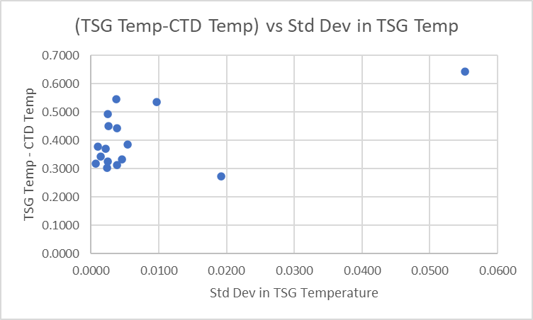
When all casts were included the TSG temperature was higher than the CTD temperature by a median of 0.374Cº (std dev 0.106Cº). When the data set was reduced by excluding 2 outliers with high standard deviations in the TSG temperature, the median remained the same while the standard deviation was lower at 0.084Cº. This result is similar to that from 2022-070 a week earlier in the same region. The difference is mostly due to heating in the loop.
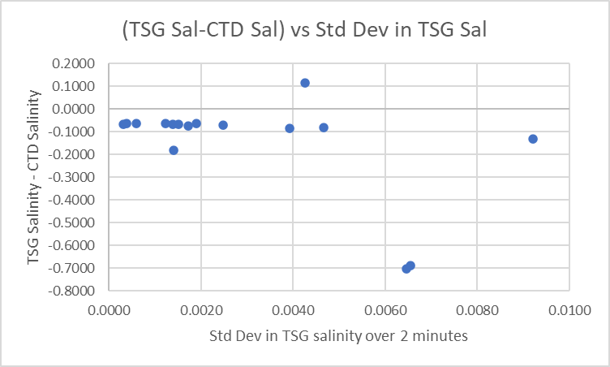
The TSG salinity was lower than CTD salinity by a median of 0.069psu (std dev 0.222psu). A plot of differences against TSG Salinity standard deviation shows consistent results when standard deviation is <0.002psu, with 1 exception. Unfortunately, that limits the comparison to only 8 casts. When those 8 outliers were excluded the TSG salinity was found to be low by a median of 0.066psu (std dev 0.003psu). This is slightly higher than found during 2022-070. The difference is likely due to a combination of calibration drift and bubbles in the loop water.

See 2022-019-tsg-ctd-comp.xls for details.

Calibration History
This TSG has been used on 5 previous Vector cruises. For the first 4 a proxy for intake temperature was created by subtracting 0.2C from the lab temperature and salinity was recalibrated by adding 0.02psu.
For cruise 2022-070 which visited the same area as this cruise just a week earlier, a proxy for TSG intake temperature was created by subtracting by 0.4Cº from the lab temperature. Salinity was recalibrated by adding by 0.055psu.

Conclusions
1. The TSG clock worked well.
2. The TSG lab temperature was higher than the CTD temperature by roughly 0.37Cº which is close to the observations of 2022-070. These 2 results are higher than noted in the past, but there could be differences in flow rate in the loop.
3. The TSG Salinity is low by ~0.066psu, which is a little higher than during 2022-070 when it was 0.055psu. There could be some differences in the effect of bubbles in the loop water or some calibration drift.
3. There were few casts available for this comparison, especially after rejecting outliers. Cruise 2022-070 had more points of comparison and occurred only a week before this cruise. The results for 2022-017 are reasonably close to 2022-070, so recalibration will be based on the earlier comparison as it looks more reliable.

f.) Editing
No editing was needed.

g.) Recalibration
Add Channels was used to add Channel Temperature:Lab with values set equal to Temperature:Primary.
Calibrate was run using file 2022-070-tsg-recal1.ccf to subtract 0.40 from Temperature:Primary and to add 0.055psu to Salinity.
REMOVE was used to remove the following channels: Scan Number and Flag channels.

h.) Preparing Final Files
HEADER EDIT was used to change the DATA DESCRIPTION to THERMOSALINOGRAPH and add the depth of sampling to the header and to change channel names to standard names and formats.
The TSG sensor history was updated.
As a final check plots were made of the cruise track and time-series and all look fine.
The cruise plot was added to the end of this report.

The cross-reference list for the TSG files is below.
Filename Event Station Latitude Longitude Date Time
---------------- ----- ------- ---------- ----------- -------------- -----
2022-019-0001.tob 0001 o 48 15.86 N 124 21.78 W UTC 2022/10/13 03:56
2022-019-0002.tob 0002 o 48 15.58 N 125 3.25 W UTC 2022/10/16 03:41

Particulars - Notes from digital Daily Science Log
2. Archived as event 1
5. Time stamp late
55. Ship drifted into deeper water during cast.

CRUISE SUMMARY – CTD
CTD# | Make | Model | Serial# | Used with Rosette? | CTD Calibration Sheet Competed?
1 | SEABIRD | 911+ | 1453 | No | Yes
Calibration Information - 1453
Sensor |  |  | Pre-Cruise |  | Post Cruise
Name |  | S/N | Date | Location | Date | Location
Temperature |  | 2023 | 15Jul2022 | Factory
Conductivity |  | 3500 | 19Jul2022 | Factory
Secondary Temp. |  | 6565 | 15Jul2022 | Factory
Secondary Cond. |  | 5043 | 15Jul2022 | Factory
SBE 43 DO sensor |  | 3038 | 26Febl2022 | Factory
Altimeter |  | 73171 | 20Jan2021
Pressure Sensor |  | 1453 | 21Jul2022 | Factory

Calibration Information – TSG 3411
Sensor |  | Pre-Cruise |  | Post Cruise
Name | S/N | Date | Location | Date | Location
Temperature | 3411 | 31Dec2019 | Factory
Conductivity | 3411 | 31Dec2019 | Factory

