## REVISION NOTICE TABLE

|  |  |
| --- | --- |
| DATE | DESCRIPTION OF REVISION |
| 17 March 2025 | Updated channel names & formats in TOB files. G.G. |
| 11April 2023 | Removed Channel Fluorescence:URU:SeaPoint from CHE and CTD files. Values very low in comparison to CHL. Data available upon request. |

## PROCESSING NOTES

Cruise: 2022-015

Agency: OSD

Location: West Coast Vancouver Island

Project: La Perouse

Chief Scientist: Nelson J.

Platform: Sir John Franklin

Date: 2 May 2022 – 12 May 2022

Processed by: Germaine Gatien

Date of Processing: 7 November 2022 – 16 December 2022

Number of HEX files: 60 (including 1 on-deck test) Number of CTD files processed: 59

Number of rosette files: 31 (including 2 tests) Number of bottle casts processed: 29

Number of TSG files: 2 Number of TSG files processed: 1

# INSTRUMENT SUMMARY

CTD #0585 was mounted in a rosette and attached were a Wetlabs CSTAR transmissometers (1201DR), a SBE 43 DO sensor on the primary pump (#1176), SeaPoint Fluorometer on the secondary pump (#2225) and an altimeter (#75321).

Seasave version 7.26.7.121was used for acquisition.

The deck unit was a Seabird model 11+ #1043.

A Guildline model 8400B Autosal serial # 73274 was used to analyze salinity samples.

An IOS rosette with 24 10L bottles was used.

A thermosalinograph (SeaBird 21 S/N 2488) was mounted with a Wetlabs WETStar fluorometer (#1656) and flow meter; sampling interval was 30s.

# SUMMARY OF QUALITY AND CONCERNS

The Daily Science Log Book and rosette log sheets were in excellent order with comments about problems encountered.

Deck Pressure readings were approximately -0.2db. No adjustments were made to pressure as there are some doubts about the reliability of the readings; any error is likely small.

The descent rate of the CTD was often extremely noisy and maximum speeds are higher than recommended reaching values >2m/s for a quarter of the casts. Rapid acceleration/deceleration affects data quality and led to some data removal even when speeds did not go below the minimum recommended speeds.

CTD fluorescence values were extremely low compared to extracted chlorophyll samples. This may be due to an equipment set-up error. A gain of 10X was recorded in the log and entered in the configuration file, but if it was really 1X, that would bring the fluorescence values into line with the normal patterns when compared with extracted chlorophyll. Many of the chlorophyll samples from this cruise were lost before analysis, so providing CTD fluorescence is especially valuable. All fluorescence values were multiplied by 10. The CTD fluorescence data are always considered nominal, and in this case it is especially important to rely on extracted chlorophyll where available.

An initial fit of SBE dissolved oxygen versus titrated samples turned up most unusual results with two groups showing near-linear fits, but with very different slopes. The two fits were close in deep water, so a change in sensor hysteresis does not appear to be the cause. Calibration drift or sensor malfunction could be factors, but natural conditions varied greatly between the 2 groups. There were intrusive features between 180m and 450m in both groups, but they looked more developed in the 2nd. Vertical gradient variability may have changed how well the sensor responded to changes in dissolved oxygen.

The SBE DO sensor has a fairly long response time so data accuracy is not as high when it

is in motion as it is during stops for bottles. This will be especially true when vertical

DO gradients are large. To get an estimate of the accuracy of the SBE DO data during

downcasts (after recalibration) a rough comparison was made between downcast SBE DO and upcast

titrated samples. Some of the difference will be due to problems with flushing of Niskin

bottles and/or analysis errors and small mismatches in depth in the presence of large DO

gradients, so the following statement likely underestimates SBE DO accuracy.

Downcast (CTD files) Oxygen:Dissolved:SBE data for this cruise are considered, very roughly, to be:

±0.30 mL/L from 0-100db except in areas of very large DO gradients

±0.10 mL/L from 100db-300db

±0.03 mL/L below 300db

Water to the TSG was not turned on until May 11th at 12:19 UTC and recorded data for only 28.25 hours, the last 100 minutes of which was while the ship was docked. There was only one CTD cast run during the short TSG record. There was no intake thermistor, no flow meter and no history of TSG use on this vessel. Estimates based on the 1 CTD cast that overlapped with the TSG record were used to recalibrate the TSG salinity and to create a proxy for intake temperature. The TSG salinity contained many small spikes that are likely due to bubbles. This may have been due to local sea conditions or could have been created within the loop. More data will be required to assess this.

# PROCESSING SUMMARY

##### Seasave

This step was completed at sea; the raw data files have extension HEX.

##### Preliminary Steps

* The configuration files used at sea was checked and errors in the transmissivity parameters were corrected. The corrected file was saved as 2022-015-ctd.xmlcon.
* The Log Book and rosette log sheets were obtained.
* Nutrients, extracted chlorophyll, dissolved oxygen and salinity data were obtained in QF spreadsheet format from the analysts.
* The cruise summary sheet was completed.
* The history of the sensors was checked and all were used during 2022-002.
* During cruise 2022-002 when this equipment was also used on the Franklin, the deck pressure readings varied from -0.3 to -0.6db and pressure was recalibrated by adding 0.6db. Some initial investigation was done to see if the offset for pressure in the configuration file should be adjusted for this cruise. A test was run recording pressure when the CTD was on deck; readings ranged from -0.09 to -0.307db, with most between -0.17 and -0.24db. There was a fairly steady increase in the readings during the 75s of the record.
* There are some concerns about deck pressure readings from the Franklin since there have been contradictory results for another CTD that was used on 2 different ships with different results. There may be an issue concerning the CTD being sheltered on the Franklin so that temperature equilibration is slower. 2022-002 was run offshore in February, so conditions would have been very different from the test run in Alberni Inlet in May.
* The configuration file was not changed since an error of +0.2db is within the specifications, and may be due to the sensor not being equilibrated. This was reviewed after initial conversion to see if the CTD files offer any further evidence, but none was found. There were no cases of negative pressures at the end of casts with the lowest pressure measured being 0.4db and that was very brief.
* Some files had non-standard names – missing a 0. Those names were corrected before conversion.

##### BOTTLE FILE PREPARATION

The ROS files were created using files 2022-015-ctd.xmlcon.

They were converted to IOS Header format with extension *.IOS.

The IOS files were put through CLEAN to create BOT files.

Temperature and salinity were plotted for all BOT files to check for outliers. Noisy patches are seen in many casts but these are not simple outliers. No editing was applied.

A preliminary header check was run and no problems were found.

The BOT files were bin-averaged on bottle number.

The output was used to create file ADDSAMP.csv. First, the file was sorted on event number and Bottle Position order. Then sample numbers were added based on the rosette logs.

Cast #41 was removed from the file since there was no sampling.

The file was sorted on sample number.

The ADDSAMP file was used to add sample numbers to the BOT files – output *.SAM.

The SAM files were bin-averaged on bottle # and called SAMAVG.

The addsamp.csv file was converted to CST files, which will form the framework for the bottle files.

Next, each of the analysis spreadsheets were examined to see what comments the analysts wanted included in the header file. These were used to create file 2022-015-bot-hdr.txt which will be updated as needed during processing.

DISSOLVED OXGYEN

Dissolved oxygen data were provided in spreadsheet QF2022-015_OXY*.xlsx which includes flags, comments and a precision study. Draw temperatures are available. The spreadsheet page with the final data was simplified and saved as 2022-015oxy.csv. That file was converted into individual *.OXY files.

There were 4 samples in the DO file that had comments starting with “ALL:” (17, 80, 125, 236).

EXTRACTED CHLOROPHYLL

Extracted chlorophyll and phaeo-pigment data were obtained in file QF2022-015_CHL*.xlsx. The file included comments and flags and a precision study. A simplified version of the spreadsheet was prepared and saved as 2022-015chl.csv. The csv file was then converted to individual CHL files.

SALINITY

Salinity analysis was obtained in file QF2022-015_SAL.xlsx which included a precision study. The analyses were carried out in a temperature-controlled lab within 35-43 days of collection. The files were simplified and saved as 2022-015sal.csv. That file was then converted to individual SAL files.

NUTRIENTS

The nutrient data were obtained in spreadsheet QF_NUTS_2022-015*.xlsx. This includes a precision study. The file was simplified, saved as 2022-015nuts.csv and converted to individual NUT files.

The file was then converted to individual files.

Flag 3 was added to all bottles affected by DO comments preceded by “ALL:” due to leaks.

The SAL, CHL, OXY and NUT files were merged with CST files in 4 steps.

The files were then put through CLEAN to reduce the headers to File and Comment sections only.

These files are ordered on sample number, but the SAMAVG files are ordered on bottle number, so the MRGCLN1 files were reordered on Bottle_Number and saved as *. MRGCLN1s.

The MRGCLN1s files were then merged with SAMAVG files using merge channel Bottle_Number.

The output of the MRG files were exported to a spreadsheet and compared to the rosette log sheets to look for omissions. A few problems were noted:

1. There was no sampling during event 1 so that bottle file will not be processed further.

2. A lot of CHL data were missing - samples 153 onward. They were collected but a box of samples was lost before analysis.

The minimum CTD Salinity in the spreadsheet was 29psu so there was no need to apply a correction to silicate samples.

A header check and cross-reference listing were produced and no problems were found.

##### Compare

Salinity

Compare was run with pressure as reference channel.

There were 16 bottles, including 6 from ~5m. When 5 of the surface bottles were excluded the fit of differences versus pressure was fairly flat, with the primary salinity low by an average of 0.0072psu (std dev. 0.0015psu) and the secondary was low by 0.0024psu (std. dev. 0.0015psu). the difference between the 2 fits is close to the difference found between the two salinity channels during downcast as reported in section 9

When the T & C sensors were used during 2022-002 the primary and secondary were found to be low by 0.0052psu and 0.0019psu, respectively. Neither cruise had a lot of salinity sampling and there was a lot of scatter in both fits. Quite a few bottles were rejected from 2022-002.

There was weak evidence from 2022-002 that CTD salinity might be drifting downwards, with the primary showing more drift than the secondary. These results support that conclusion, though once again the evidence is very weak.

Errors due to incomplete flushing and evaporation/desorption of samples are likely small given fairly quick salinity analysis and generally rough conditions. But the errors would not be 0 and bottle contents are likely high by 0.001 to 0.002psu. Thus the CTD salinity is probably closer to bottles than it appears. If the primary is selected for archiving it should be recalibrated by adding 0.005psu, thus bringing it into line with the secondary. With that adjustment both channels would likely be within ±0.002psu. There were only 2 duplicates so precision was not assessed, but the differences were 0.0010 and 0.0001psu which is within normal expectations.

For full details for the COMPARE run see file 2022-015-sal-comp1.xls.

Dissolved Oxygen

COMPARE was run with pressure as the reference channel.

An initial fit turned up most unusual results with two groups showing different near-linear fits. An explanation was sought:

* There had not been a change of sensor according the serial #s in the header files and the configuration files.
* Another recent cruise on a different ship with a different DO sensor had a few casts that didn’t seem to fit others, having a very flat fit. There appeared to be active mixing leading to noisy temperature, which could affect the dissolved oxygen sensor performance due to its slow response. The differences between the fits were smaller than for this cruise.
* There was a problem during cast #41 with bad upcast data after an error message. During cast #42 there were spikes and large differences between T and C pairs. Cables and connectors checked, pumps flushed, sensors checked. The next cast looked ok.
* Casts #51 to 94 all fit in one group with just a couple of minor outliers. These are all from the most southerly part of the cruise, including LD10, the LC line and JF2. Others on the LD line don’t fit in that group but they were more northerly and were sampled earlier in the cruise.
* A number of other casts might fit in that southern group as well but had no DO sampling so we can’t judge.
* The change in fits could be due to either time or geography or a combination of those. 5 casts were found that have similar depths and range from north to south, but not in increasing cast # order. They were cast #16 in the north, then 50, 26, 28 ending with 80 in the south. Unfortunately, there were no DO samples for 3 of them. So we only know that cast #26 belongs to the first group and #80 to the second group. Plots were made of DO and Temperature vs depth and no pattern emerged.
* There were many casts with bottle sampling at 75db and arranging the differences between bottles and SBE DO shows that differences increased between casts 39 and 51 and stayed high after that change. The DO values at 75m are similar among all casts in the first group, while they vary greatly among the 2nd group.
* The first group has more reversals in DO at the surface and in the top 100m; there are also fewer deep casts in that group. The differences at low DO are close in the 2 groups.

There are differences in DO profiles from north to south, but there are too many variables to find a clear pattern to explain the 2 groups. While tempting to blame the sensor, similar odd patterns noted in August at P8 suggest there is some geographical influence.

The fit for the Group 1 looks poor when the offset is set as 0 even though the R2 value is high. If the offset is left free, the R2 value is low. While the average distance from the trendline is likely low with offset=0, almost all points are mostly above the line when DO is high and below it when DO is low. Leaving the offset free is better, but not terribly reliable since there are few deep casts in this group. There are usually more outliers near the surface because of high gradients, with the CTD tending to read higher than the bottles. But for Group 1 the outliers tend to be in the opposite direction, likely due to near-surface gradient reversals.

The fit for Group 2 looks good using any offset method, probably due to many deep casts. So the offset for Group 2 was used for Group 1 as well and the results look good.

Fits of differences versus CTD DO were analyzed in the 2 groups and outliers were removed based on residuals standard deviation in the SBE DO >0.1.

The 2 fits found using a free offset for Group 2 and using that offset for Group 1 are:

Casts #4-39

CTD DO Corrected = CTD DO * 1.0158 + 0.0449 R2 =0.60 (1)

Casts #41-94

CTD DO Corrected = CTD DO * 1.0726 + 0.0449 R2 = 098 (2)

Both fits have slopes higher than in the previous use of this sensor, so there does appear to be some calibration drift.

There were few deep casts in the early part of the cruise, so to check if the groups are more defined by water depth than time or latitude, a check was made of the deepest cast of group 1, #17, at LG06 and it falls well within Group 1. The same station was occupied almost 3 days later during cast #43, but there was no DO sampling then. However, T-S plots offer a suggestion as they look very different between 180m and 450m but similar above and below that. (See the end of the report for plots.)

Cast #17 has a couple of high-gradient intrusive features, whereas later the intrusion looks broader with lower gradients. So this cruise may have witness the development of large-scale intrusion. This suggests that the casts between #39 and #51 should be included in Group 2 though we have no DO sampling to prove this is appropriate.

During cruise 2022-022 a similar problem was noted in having the fits change mid-cruise, but in that case the differences were most significant when DO was low and it was found changing hysteresis parameter E for the late casts produced similar fits for the 2 sections. For this cruise the low values are similar in both groups, so the problem does not appear to one of hysteresis.

For full details for the COMPARE run see file 2022-015-dox-comp1.xls.

Plots of Titrated DO and CTD DO against CTD salinity were examined. No further outliers were found.

No outliers were identified that require further flagging of DO samples.

Fluorescence

COMPARE was run with extracted chlorophyll and CTD Fluorescence using pressure as the reference variable.

Plots of Fluorescence versus CHL and FL/CHL vs CHL have the normal shape but the CTD FL is extremely low.

The configuration file agrees with the log entry for gain. If, in fact, the gain were 1 rather than 10, then the fluorescence values look reasonable, though perhaps just a little higher than expected. The last time this equipment was used there was a 10X cable and the fluorescence values were not as low as this. A quick check of a test cast from a cruise run after this one shows similar low values but no chlorophyll was available for that cruise. There was much confusion during this cruise due to a sudden change of cruise plans and some equipment problems. So confusion over the gain is not terribly surprising. Since fluorescence data are considered nominal, it is reasonable to multiple the values by 10 in order to get data that resembles the values found in the extracted chlorophyll data.

For full details for the COMPARE run see file 2022-015-fl-chl-comp1.xls.

##### Conversion of Full Files from Raw Data

All files were converted using 2022-015-ctd.xmlcon.

The Tau function was selected and the hysteresis function since there was some deep sampling. Depth was included in the conversion.

A few casts were examined. The descent rate is noisy with some complete reversals in direction and much evidence of shed wake corruption in the profiles of temperature.

The transmissivity, DO, altimetry and fluorescence traces look normal.

The dark value for fluorescence was ~0.055ug/L.

The upcast data are very noisy with many bottle stops and noisy upcast speeds.

The upcast for event #41 is extremely noisy; the log notes an error message during the upcast. There was no bottle sampling and the downcast is likely ok.

The T and C pairs were generally close during downcasts thought there was some noise in the secondary not seen in the primary. During upcasts both channels were extremely noisy.

##### WILDEDIT

Program WILDEDIT was run to remove spikes from the pressure, depth, conductivity & temperature only in the full cast files (*.CNV).

Parameters used were: Pass 1 Std Dev = 2 Pass 2 Std Dev = 5 Points per block = 50

The parameter “Keep data within this distance of the mean” was set to 0 so all spikes would be removed.

There is no obvious difference in profiles after this step, but the only spikes noted before this step contained many records.

##### ALIGN DO

A few casts were examined; both temperature channels were noisy during upcasts so the tests were not easy to interpret, but using +2.5s certainly improves the alignment and overall looks like a good choice for both sensors. That setting has worked well for many SBE DO sensors in recent years.

ALIGNCTD was run on all casts using +2.5s.

##### CELLTM

The noise in the upcast data makes tests for the best parameters for this routine very difficult to interpret. In the past when upcast data were not so noisy, the default setting of (α = 0.0245, β=9.5) was generally found to be the best choice. A few casts were checked for this cruise and the default setting does improve the data. CELLTM was run using (α = 0.0245, β=9.5) for both the primary and secondary conductivity.

##### DERIVE and Channel Comparisons

Program DERIVE was run on all casts to calculate primary and secondary salinity and dissolved oxygen concentration.

DERIVE was run a second time on 4 casts to find the differences between the pairs of temperature, conductivity and salinity channels. Only 2 were deeper than 1200db.

Data are included from the 1 previous cruise since the last factory calibration.

|  |  |  |  |  |  |
| --- | --- | --- | --- | --- | --- |
| Cast # | Press | T1-T0 | C1-C0 | S1-S0 | Descent Rate |
| 2022-002-0058 | 1000 | +0.0002 | +0.00031 | +0.0035 | High, XNoisy |
|  | 1900 | +0.0001 | +0.00025 | +0.0030 | “ |
| 2022-0002-0065 | 1000 | +0.0002 | +0.00030 | +0.0037 | High, XNoisy |
|  | 1900 | +0.0002 | +0.00027 | +0.0032 | “ |
| 2022-002-0142 | 1000 | +0.0001 | +0.00033 | +0.0040 | High, XNoisy |
|  | 1900 | +0.0002 | +0.00029 | +0.0033 | “ |
| 2022-015-0046 | 1000 | +0.0002 | +0.00040 | +0.0047 | High, Very Noisy |
|  | 1900 | +0.0002 | +0.00035 | +0.0041 | “ |
| 2022-015-0048 | 1000 | +0.0001 | +0.00040 | +0.0048 | High XNoisy |
|  | 1900 | +0.0000 | +0.00036 | +0.0043 | “ |
| 2022-015-0057 | 1000 | +0.0001 | +0.00043 | +0.0051 | High, VNoisy |
| 2022-015-0077 | 1000 | +0.0002 | +0.00045 | +0.0052 | High, Moderate |

There appears to be a steady, but small increase in the conductivity and salinity differences over time, but none in the temperature.

##### Conversion to IOS Header Format

The IOSSHELL routine was used to convert Sea-Bird 911+ CNV files to IOS Headers.

CLEAN was run to add event numbers and to replace pad values in the pressure channel with interpolated values based on record number.

##### Checking Headers

* The cross-reference check was run. No problems were found.
* The header check was run and showed pressures got as low as 0.4db with pumps on and temperature, salinity and DO values look reasonable for shallow water offshore.
* Surface check was run and found an average of 2.9db with values ranging from 1db to 4.9db. The deeper starts are likely due to rough conditions.
* Cruise tracks were plotted and look fine, though due to the nature of this cruise they are much more irregular than normal. The usual La Perouse cruise was cancelled and this mini-version had to fit around a shrimp sampling program. The track plots were added to the end of this report.

Water depth entries were checked since there are often sounder problems, or ship movement between the entry in the header and the time of the CTD cast. Header values for altimetry and water depth were exported to file 2022-015-altimeter-ctd.xlsx. A “check value” was calculated as follows:

Check Value = Water depth + (Altimetry header-1) – Max. depth sampled.

This value is expected to be close to 0. For casts the difference was >5m, checks were made:

* In some cases the log entry for depth was different from the header. Using the log entry improved the results for some casts, though generally only by an insignificant amount. In 5 cases there is a significant improvement using the log entries.
* The altimetry signal at the bottom was checked for the casts with large check values even with log entries, and only event #17 at Station LG6 looked likely to have an unreliable header entry with both spikes and some drift while at the bottom. While the error is unlikely large enough to fully account for the check value, it does suggest that there was shoaling in this area.
* Calculated depths (Max depth sampled + Altimetry -1) were found for the 9 casts. Depths and positions for the same sites were found for the August 2022 La Perouse cruise. For 3 casts with the largest check values the calculated value was very close to the August depth entry and for 1 it differed by just 10m.
* Site LD07 was occupied twice (41 and 50). For event #41 the site was some distance from the #50 and from the August site. So the log entry may well be correct and was selected.
* For station A02 the site is close to the August site and the log entry is closer to the August site than the calculated value. The altimetry was noisy and seemed to drift somewhat, so this is likely an area of shoaling. Using the log entry is the best available information

For 5 casts (17, 30, 41, 51, 57) the log entry was used and for 4 casts (43, 45, 46, 50) a calculated value was used. It is notable that the deepest casts tend to be the ones with the most suspicious water depth entries. This may be due to calibration error in the sounder, or there may be more drift offshore and steeper bottom topography at some sites. Using the calculated value is most likely to produce a reasonable water depth at the point when bottom sampling was done, but water depth data should be considered nominal.

The bottle files were also adjusted for events #17, 30 and 41.

##### Shift

Fluorescence

SHIFT was run on the SeaPoint fluorescence channel in all casts using the usual advance of +24 records. Plots show that the fluorescence offset is reasonably close to the temperature offset after this step, though the very low values make the plots so noisy it is hard to judge.

Dissolved Oxygen

The Dissolved Oxygen voltage channel was aligned earlier. The upcast temperature is so noisy that it is impossible to fine-tune the alignment, but there is no evidence that the setting applied earlier was inappropriate. No further alignment will be applied.

Conductivity

Tests were run on 3 casts to assess what settings are best to align conductivity with temperature (as judged by the effect on salinity as seen in T-S space). The data are noisy with all choices. The best settings were -0.3 records for the primary and -0.1 records for the secondary conductivity. SHIFT was run twice on all SBE911 casts using those settings. Salinity was recalculated for both channels.

##### DELETE

The following DELETE parameters were used:

Surface Record Removal: Last Press Min

Maximum Surface Pressure (relative): 10.00

Surface Pressure Tolerance: 1.0 Pressure filtered over 15 points

Swells deleted. Warning message if pressure difference of 2.00

Drop rates < 0.30m/s (calculated over 11 points) will be deleted.

Drop rate applies in the range: 10db to 10db less than the maximum pressure

Sample interval = 0.042 seconds. (taken from header)

COMMENTS ON WARNINGS: There were no warnings.

##### Other Comparisons

Experience with these sensors since last factory service –

* The CTD was used during 2022-002. Pressure was thought to be reading low by 0.6db.The primary salinity was lower than bottles by 0.0052 & secondary salinity lower by 0.0019psu; primary was recalibrated by adding 0.0033psu and was selected for archiving. Dissolved oxygen was recalibrated using slope/offset=1.0076/0.0507.

Historic ranges – Profile plots were made with 3-standard deviation climatology ranges of T and S superimposed. All temperature data fell within the climatology. There were some near-surface salinity values below the minimum, and salinity near the bottom of LC04 was low. These do not suggest any problems with calibration as there were no systematic excursions.

Post-Cruise Calibration – There were no post-cruise calibrations available.

##### DETAILED EDITING

The decision on which channel pair to use is not obvious. The secondary salinity is closer to bottles but looks a bit noisier. However, the points that are noisier in the secondary are ones that likely need removal in either case, and the primary calibration is clearly drifting, so the secondary data were selected for editing and eventual archiving.

CTDEDIT was used to remove records that appear to be corrupted by shed wakes and to clean salinity where small spikes appear to be due to small misalignment or instrumental noise. Many casts had very noisy descent rates with some complete reversals of direction, resulting in corrupted data as shed wakes catch up to the CTD. Some casts had extremely high descent rates which are often associated with poor salinity values. Some salinity points were removed.

All casts required editing.

Notes about editing applied were added to the files.

The edited files were copied to *.EDT.

After editing T-S plots were examined for all casts. A few small unstable features found were from areas where they could be real.

##### Corrections to Pressure, Salinity and Dissolved Oxygen Concentration

The change in dissolved oxygen correction came between casts 39 and 51.

File 2022-015-recal1.ccf was prepared to multiply fluorescence values by 10 and to apply the following correction to channel Oxygen:Dissolved:

Casts #4-39

CTD DO Corrected = CTD DO * 1.0158 + 0.0449

Casts #41-94

CTD DO Corrected = CTD DO * 1.0726 + 0.0449

This correction was first applied to the SAM and MRGCLN2 files.

Silicate does not require recalibration since the minimum salinity during bottle stops was 29psu.

COMPARE was rerun and shows that the corrections were applied properly.

There are approximately the same number of bottles for each section.

When outliers were removed based on standard deviation in the CTD DO data being >0.1mL/L and a few others based on residuals, the CTD DO was found to be low by about 0.002mL/L (std dev 0.026mL/L). Dividing the data into groups #4-39 and #51-94 produced similar results (-0.0031mL/L and ‑0.0018mL/L). The first group has more outliers, mostly near the surface.

Calibrate was then run the EDT files.

##### Final Calibration of DO

The initial recalibration of dissolved oxygen corrects for sensor calibration drift. Alignctd corrects for transit time errors. Those 2 steps may partly correct for response time errors, but to see if a further correction is needed, a comparison is made of downcast CTD data to bottle data from the same pressure. Small differences are expected due to ship drift, temporal changes, incomplete flushing of Niskin bottles and delayed response and noise in CTD data and imperfect matching of levels.

Downcast files were bin-averaged to 0.5m bins for the casts with DO bottle samples. Those files were then thinned and compared to the bottle values in the MRG files. COMPARE was run to study the differences between the recalibrated downcast CTD DO data and the titrated samples from upcast bottles.

When a few outliers were removed based on standard deviations in the CTD DO data, the CTD DO was higher than the titrated samples by an average of ~0.0035mL/L and the standard deviation was 0.093mL/L using all hydro casts. Since the downcast SBE DO may be reading slightly high due to slow response time and the bottle DO may be a little low due to incomplete flushing of bottles, a small positive difference is expected above the oxygen minimum; the opposite is expected below the minimum and sometimes close to the surface.

The downcast CTD dissolved oxygen values are likely reading slightly higher than bottles, as expected, but the differences are very small. No further calibration will be applied.

A plot of differences versus pressure was then done, excluding outliers as determined in a fit against bottle DO. Based on this an estimate is made of errors in DO in different pressure ranges. This is likely too severe a method given time differences and inexact matches in depths.

Downcast (CTD files) Oxygen:Dissolved:SBE data for this cruise are considered, very roughly, to be:

±0.30 mL/L from 0-100db except in areas of very large DO gradients

±0.10 mL/L from 100db-300db

±0.03 mL/L below 300db

For more detail see file 2022-022-dox-comp3.xls.

##### Fluorescence Processing

A median filter, size 11, was applied to the fluorescence channel in the COR1 files. Plots of a few casts showed that the filter was effective. (Output:*.FIL)

##### BIN AVERAGE of CTD files

The following Bin Average values were applied to the FIL files (output AVG):

Bin channel = pressure Averaging interval = 1.000 Minimum bin value = .000

Average value will be used. Interpolated values are NOT used for empty bins.

On-screen T-S plots were examined. There are some small unstable features but from this region of active mixing they may well be real.

Profile plots were examined to see if there any problems. No problems were noted.

##### Final CTD File Steps (REMOVE and HEADEDIT)

REMOVE was run to remove the following channels:

Scan_Number, Temperature:Secondary, Conductivity:Secondary, Oxygen:Voltage:SBE, Descent_Rate, Status:Pump, Altimeter, Salinity:T1:C1 and Flag and Prediction_Flag.

A second SBE DO channel (with umol/kg units) was added.

REORDER was run to get the two DO channels together.

HEADER EDIT was used to fix formats and channel names and to add the comments about processing.

The Standards Check routine was run and no problems were found.

The Header Check was run; no problems were found.

Profile and T-S plots were examined. A few problems were found:

* A spike in fluorescence was found in cast #30 at ~440db. Four data points were replaced with pad values.
* There were spikes in the 2 dissolved oxygen channels around ~465db in cast #54 . Four data points were replaced with pad values. Transmissivity dropped to 0 nearby – this value was left in place and may explain what happened to the oxygen values.

No other problems were found.

The sensor history was updated.

##### Dissolved Oxygen Study

As a final check of dissolved oxygen data, % saturation was calculated and plotted. Values at 4m ranged between 95% at Port Alberni and 100-125%, with offshore values mostly between 100% ad 110%, values typical of the offshore. These values look reasonable for the area and season and do not indicate a problem with DO calibration.

##### Final Bottle Files

MRGSORT was run to get files in pressure order.

REMOVE was run to remove the following channels:

Scan_Number, Temperature:Primary, Conductivity:Primary, Oxygen:Voltage:SBE, Descent_Rate, Status:Pump, Altimeter, Salinity:T0:C0 and Flag.

A second SBE DO channel with mass units was added for both the CTD DO and titrated DO and REORDER was run to get the pairs of DO channels together.

HEAD EDIT was run to add comments to the headers.

Data were exported from the CHE files to file 2022-015-bottles-final.xlsx. The entries were compared with the rosette log sheets and no data were missing.

A Header Check and Standard Check were prepared and no problems were found.

The track plot looks ok.

A cross-reference listing and header check were produced for the CHE files.

##### Thermosalinograph Data

There were 2 thermosalinograph files, but the first contained no useful data since there was no flow to the TSG. There were no loop samples, flow meter or intake thermistor. The intake is believed to be at about 6.5m. The only method to check calibration is to compare with the CTD casts.

a.) Checking calibrations

The configuration file used at sea had the correct parameters.

b.) Conversion of Files

The CNV file was converted to IOS HEADER format and the name changed to remove the word RESTART.

The configuration file included fluorescence channel and one for the external temperature sensor, but no data were found, so the file was reconverted without those channels.

CLEAN was run to add End times and Longitude and Latitude minima and maxima to the headers.

ADD TIME CHANNEL was used to add Time and Date channels.

The record is short with only 28 hours of data and only 1 CTD cast that overlaps that time period.

Cast #94 was in Juan de Fuca Strait starting at 5:29:22 on May 12th

A time-series plot was produced. The salinity trace has a steady jitter with spikes of size 0.2psu, likely due to small bubbles. The temperature trace is smooth.

The track plot looks fine and was added to the end of this report.

c.) Checking Time Channel

There was only one CTD cast taken while the TSG was acquiring data. The NMEA position recorded at 5:26:41 UTC was 48° 18.03’ N 123° 59.99’ W.

The TSG position at 5:26:24 was 48.30054° -123.99970° (48° 18.03 N 123° 59.98 W). This is an excellent match so the clocks appear to have been synced.

d.) Comparison of T and S from TSG and CTD data

There is only 1 cast available for comparison and it is unfortunately one in an area of active mixing and strong vertical gradients. The exact depth of the intake to the loop was not available but believed to be at about 6m. Data were found from the TSG and CTD cast based on start and end times of the CTD cast. The CTD data were taken from the downcast at ~6m and the upcast during the bottle stop at ~5.7m.

|  |  |  |  |  |
| --- | --- | --- | --- | --- |
|  | Time | TSG Temp | CTD Temp | TSG-CTD |
| Start of cast | 5:26 | 10.5221 | 10.1795 | 0.3426 |
| End of cast | 5:50 | 10.5138 | 10.1518 | 0.3620 |
|  |  |  |  |  |
|  | Time | TSG Sal | CTD Sal | TSG-CTD |
| Start of cast | 5:26 | 30.1422 | 30.2296 | -0.0874 |
| End of cast | 5:50 | 30.1726 | 30.2603 | -0.0877 |

The TSG temperature is higher than that from the CTD by 0.34 C° and 0.36 C°. Water is expected to warm in the loop by an amount that varies according to the length of the loop and the difference between the intake temperature and the ambient temperature of the ship. We have no experience with TSG data from this vessel, but typical values found from other ships range of 0.2 C° to 0.5 C°, so the result is reasonable.

The TSG salinity is lower than that from the CTD by about 0.087psu in both cases. The difference between CTDs and TSG varies greatly from cruise to cruise, but the TSG always reads lower and this is likely due to bubbles. For this cruise the TSG salinity was full of small spikes that are also likely due to bubbles. Since we only have records from Juan de Fuca Strait we cannot determine if the bubbles were due to the local sea state or are caused by the loop itself.

There is no evidence of calibration problems with this CTD, but given the limited information and history, we cannot make a stronger statement.

Calibration History

This TSG has not been used since its latest factory calibration.

Conclusions

1. The TSG clock appears to have worked well.

2. The TSG lab temperature was higher than the CTD temperature by ~0.35C°. A proxy for intake temperature will be derived by subtracting 0.35C° from the lab temperature.

3. The TSG Salinity is lower than the CTD salinity by ~0.087psu.

f.) Editing

No editing was required.

g.) Recalibration

Add Channels was used to add Channel Temperature:Lab with values set equal to Temperature:Primary.

Calibrate was run using file 2022-015-tsg-recal1.ccf to subtract 0.35C° from Temperature:Primary and to add 0.087psu to Salinity:T0:C0.

h.) Preparing Final Files

REMOVE was used to remove the following channels: Scan Number, Record Number and Flag channels.

At the time of processing details about the TSG set-up on the Franklin were not available. (Details will be added when possible.) A brief entry was made in the file but if further description becomes available this should be updated.

HEADER EDIT was used to change the DATA DESCRIPTION to THERMOSALINOGRAPH and add the estimated depth of sampling to the header and to change channel names to standard names and formats.

The TSG sensor history was updated.

As a final check plots were made of the cruise track and time-series and all look fine.

The cruise plot was added to the end of this report.

**Particulars -**

TSG – Water to TSG was not turned on until May 11. A new file was started at that time.

General –Waits before firing bottles was 60s for 0-150db and 30s for pressure>150db except as noted below.

1. Test cast in Alberni Inlet

4. Came up to 40m then returned to 75m.

4. Waits for bottle firing – all 30s.

5. Waits for bottle firing – all 30s.

12. Error on sample log - Bottle 4 not sampled.

21. Originally saved as event 20.

26. Sal and DIC not sampled at 5m due to sample label print error.

31. Latitude error – not at LD01 – named LD01(a).

32. Repeated cast at actual LD01.

41. Error message during upcast at ~290db concerning carousel. Cleaned bulkhead and sensor connectors, sea cable connector, pylon connector. Checked all connectors. Tested pylon and trigger mechanism. All fine.

42. Test cast – all worked well. Restarted computer, ensured OS updates not possible.

43. Cast looked good going down but line colours on graph changed and spikes/differences between T and C sensor pairs. Cast looks ok. Back flushed both pumps with fresh water to ensure no blockage.

45. Cast ok.

51. Wait only 30s at 125 and 150db.

54. LD10 - Error message ~577db. Stopped cast, returned to surface.

55. Redid cast at LD10.

59. Before cast replaced pylons.

**2022-015**

**CRUISE SUMMARY – CTD**

|  |  |  |  |  |  |  |  |  |  |  |  |  |  |  |  |
| --- | --- | --- | --- | --- | --- | --- | --- | --- | --- | --- | --- | --- | --- | --- | --- |
| **CTD#** | **Make** | **Model** | | | **Serial#** | | | **Used with Rosette?** | | | **CTD Calibration Sheet Competed?** | | | | |
| **1** | **SEABIRD** | **911+** | | | **0585** | | | **Yes** | | | **Yes** | | | | |
| **Calibration Information - 0506** | | | | | | | | | | | | | | | | |
| **Sensor** | | | | | | **Pre-Cruise** | | | | | | | **Post Cruise** | | | |
| **Name** | | | **S/N** | | | **Date** | | | **Location** | | | | **Date** | | **Location** | |
| **Temperature** | | | **2449** | | | **28Jan2021** | | | **Factory** | | | |  | |  | |
| **Conductivity** | | | **1764** | | | **01Feb2021** | | | **Factory** | | | |  | |  | |
| **Secondary Temp.** | | | **4484** | | | **02Feb2021** | | | **Factory** | | | |  | |  | |
| **Secondary Cond.** | | | **2128** | | | **02Feb2021** | | | **Factory** | | | |  | |  | |
| **Transmissometer** | | | **1201DR** | | | **17Feb2022** | | | **Factory** | | | |  | |  | |
| **SBE 43 DO sensor** | | | **1176** | | | **04Feb2021** | | | **Factory** | | | |  | |  | |
| **SeaPoint Fluor.** | | | **2225** | | |  | | | **Factory** | | | |  | |  | |
| **Pressure Sensor** | | | **0585** | | | **17Feb2021** | | | **Factory** | | | |  | |  | |
| **Valeport Altimeter** | | | **75321** | | | **23Sept2020** | | | **Factory** | | | |  | |  | |
| **Calibration Information** | | | | | | | | | | | | | | | | |
| **Sensor** | | | | | | | | **Pre-Cruise** | | | | | **Post Cruise** | | | |
| **Name** | | | | | **S/N** | | | **Date** | | | **Location** | | **Date** | | **Location** | |
| **Temperature** | | | | | **2488** | | | **10 Sep 21** | | | **Factory** | |  | |  | |
| **Conductivity** | | | | | **2488** | | | **10 Sep 21** | | | **Factory** | |  | |  | |

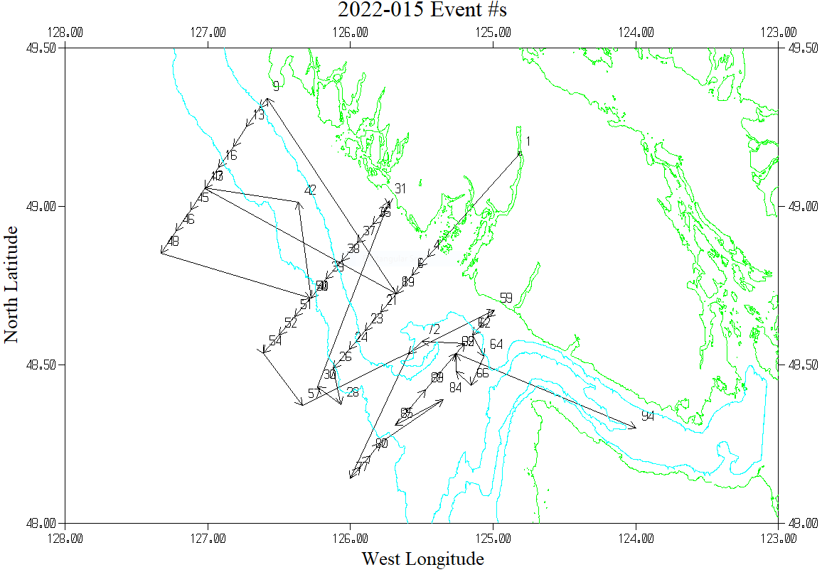

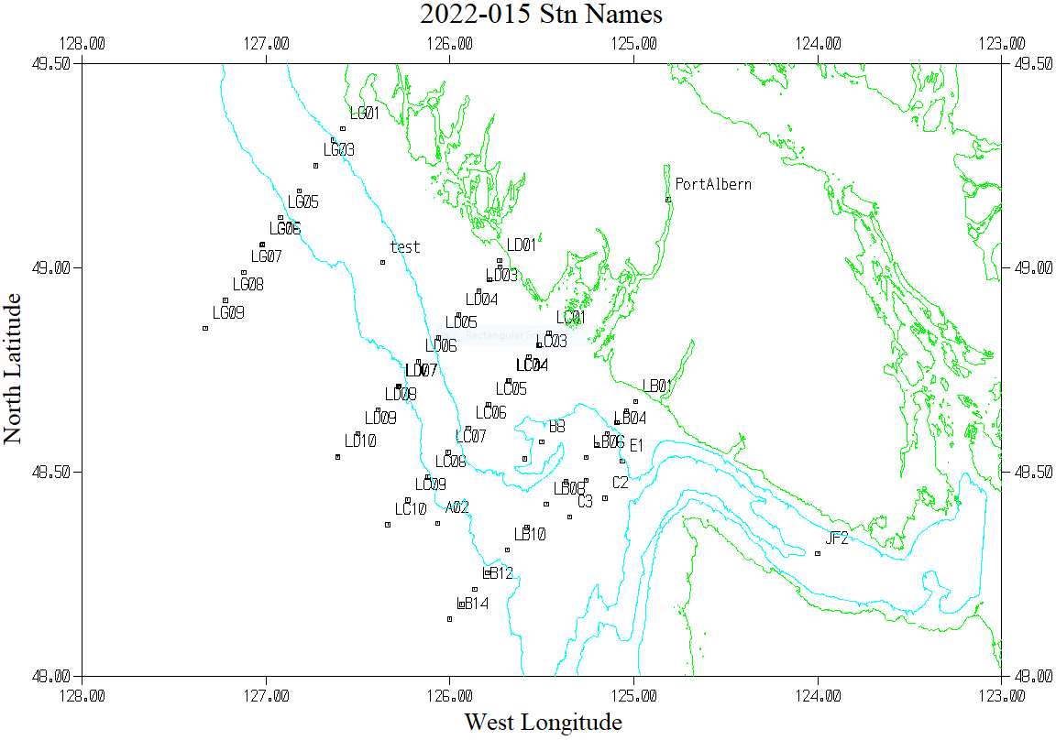

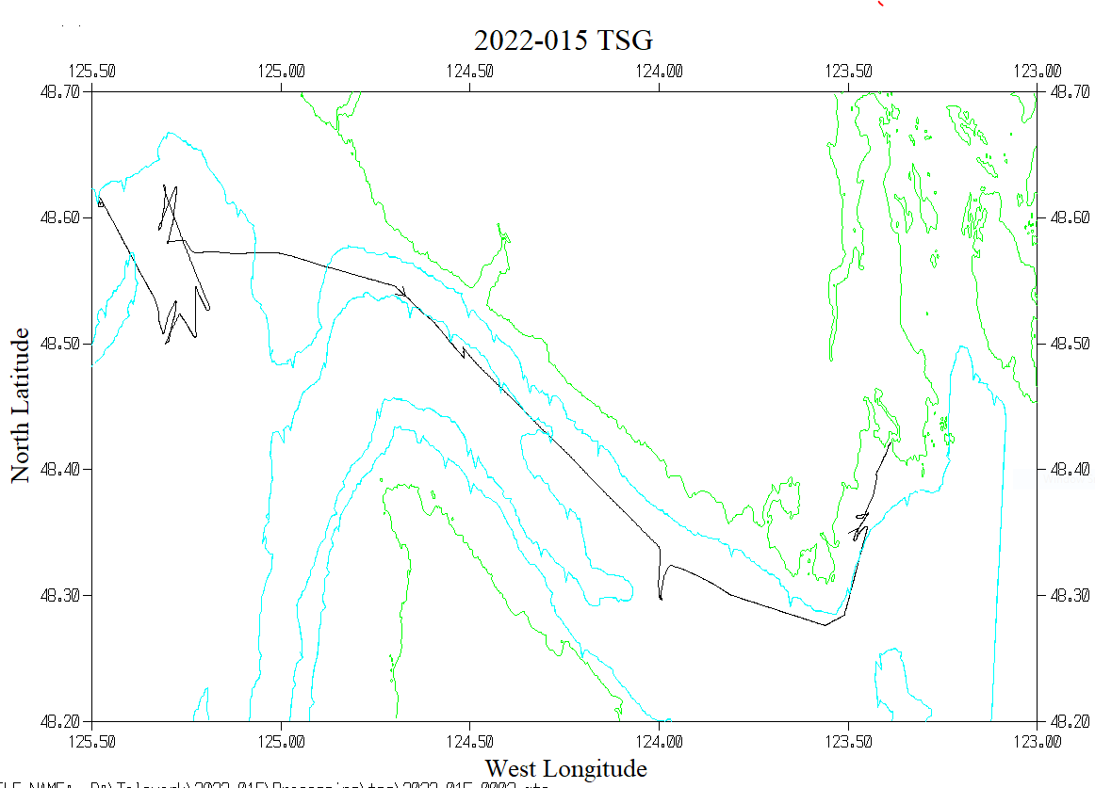

**CASTS at LG06 – May 4,2022 9:25 and May 7, 2022 1:18 – full data and expanded view**

