**Revision Notice Table**

|  |  |
| --- | --- |
| **Date** | **Description of Revision** |
| July 14, 2023 | DO Saturation converted to DO Concentration. SH. |

**RBR CTD DATA PROCESSING NOTES**

Cruise: 2022-012

Agency: OSD

Locations: Alison Sound, Strait of Georgia, Johnstone Strait, Inlets, NWCVI, Cape Scott, Hecate Strait

Project: Inlets

Party Chief: Spear D.

Platform: Vector

Date: April 6, 2022 – April 19, 2022

Processed by: Hana Hourston

Date of Processing: January 24, 2023 – February 1, 2023

Number of Raw files: 4 Number of Processed Files: 3

**Instrument Summary**

Equipment: RBR Maestro CTD (s/n 208765) with a Turner Cyclops Fluorometer (s/n 21101792) and a JFE Advantech Rinko III oxygen sensor (s/n 447). Sampling frequency was at 8Hz.

**Summary of Quality and Concerns**

The test cast was the only raw file not processed. The test cast was done during event 78 by strapping the RBR CTD to the main ship’s CTD/Rosette.

A cast list of times and locations was not provided, so cross-referencing dates and times in the RSK files was done with the cruise log. The dates and times in the RSK files match the dates and times in the cruise log.

The data overall look good.

**Processing Summary**

1. **Conversion to IOS Headers**

Each of the three .rsk files from Alison Sound contained only one profile. These profiles were extracted using the Python function READ_EXCELrsk().

A single file (2022-012_CTD_Data.csv) with all the data including event numbers and a single line of headers was prepared using the Python function MERGE_FILES().

A 6-line header was inserted using the Python function Add_6Lineheader_2().

File “2022-012_header-merge.csv” was created, based on the information provided by the chief scientist.

* Column “File_Name”: entries were derived from the event number.
* Column “LOC:LATITUDE”: latitude was provided and reformatted to “XX XX.XXXX N !(deg min)”.
* Column “LOC:LONGITUDE”: longitude was provided and reformatted to “XX XX.XXXX W !(deg min)”.
* Column “LOC: Event Number”: entries were event numbers.
* Column “LOC: STATION”: all stations were set to those provided in the cruise log.
* Column “LOC: Water Depth:” was set to the water depth provided in the cruise log.

The sampling site was mapped (Figure 1) from “2022-012_header-merge.csv” using the Python function Plot_Track_Location() to check the location of all casts.

Prior to conversion to IOS header format, the presence of zero-order holds was checked using the Python function Plot_Pressure_Diff() (Figure 2). It was unclear if there were zero-order holds from the output figure so a differential was calculated on pressure on the 2022-012_CSV_DATA-6Linedr.csv and holds occurred at regular intervals in the files. A correction was applied using the Python function CORRECT_HOLD() and the corrected data were plotted (Figure 3).

CONVERT Spreadsheet Files was run to produce files with IOS Header format. Header entries of “Administration”, “File” and “Instrument” were filled in this step.

Raw data were plotted and examined:

* Conductivity looks good.
* Salinity looks good.
* Oxygen looks good with some bad data at the top of cast 107 and at the bottom of cast 108.
* Fluorescence looks good with some bad data at the top of cast 109.
* Temperature looks good.

T-S plots were also made.

The routine “Merge:CSV Files to headers” was run to add location headers to the IOS files.

Next CLEAN was run to add a start time and event numbers to headers.

Then REORDER was run to reorder the channels in all files.

1. **Data processing**

* No correction to pressure was needed for this cruise.
* Data despiking: There were no significant spikes in temperature, conductivity and salinity. So there is no need to apply data despiking.
* CLIP: Pressure was steady for a few scans. Initial records were removed until the downcast began using file “2022-012_CLIP.csv”.
* Filter: a Gull-winged filter, size 5, was applied to temperature, conductivity, and pressure. Salinity will be recalculated after the shift steps.
* SHIFT: Based on suggested values in document “Guidelines for processing RBR CTD profiles”, the alignment of temperature and conductivity was corrected by applying a shift of -2 scans in conductivity. Salinity was recalculated after this step.
* SHIFT: Better alignment with Oxygen profiles was found by advancing it by 11 scans. The advice given in document “Guidelines for processing RBR CTD Profiles” was that an advance between 2 and 3 seconds is appropriate. T-O plots before and after alignment were compared.
* Delete was run to remove records with a descent rate lower than 0.3m/s over 8 points. This was not applied in the top 10m to avoid loss of surface records as the CTD began its descent, nor in the bottom 10m.
* Profile plots were examined after DELETE and confirm that plots show reasonable values for salinity, conductivity and fluorescence. DO saturation levels at the surface ranged from 105% to 110%. There was no calibration sampling and no climatology to enable a judgement about the data reliability.
* Post-processing T-S plots were also made at this stage.

1. **Final checks and header editing**

* REMOVE was run to remove the following channels from all casts: Date, Time:UTC and Event.
* BIN AVERAGE was used to average the data by pressure into 1 dbar bins.
* CALIBRATE was run to convert conductivity units to S/m using file 2022-012-recal2.ccf.
* CLEAN was run to reset the Maximum and Minimum values in the Header.
* Header Edit was used to fix channel names and format as listed below:
* Depth: meters ==> metres
* Temperature: deg C(ITS90) ==> deg C (ITS90)
* Salinity:CTD ==> Salinity
* Fluorescence ==> Fluorescence:URU
* Conductivity: F10.5 ==> F10.6
* Oxygen:Dissolved ==> Oxygen:Dissolved:Saturation:RBR, format F11.4 ==> F8.2
* Header Check was run and no problems were found. Standards check was run and no problems were found.
* Final profile and T-S plots were made. A track plot was also made using IOS Shell to show the sampling locations more closely.

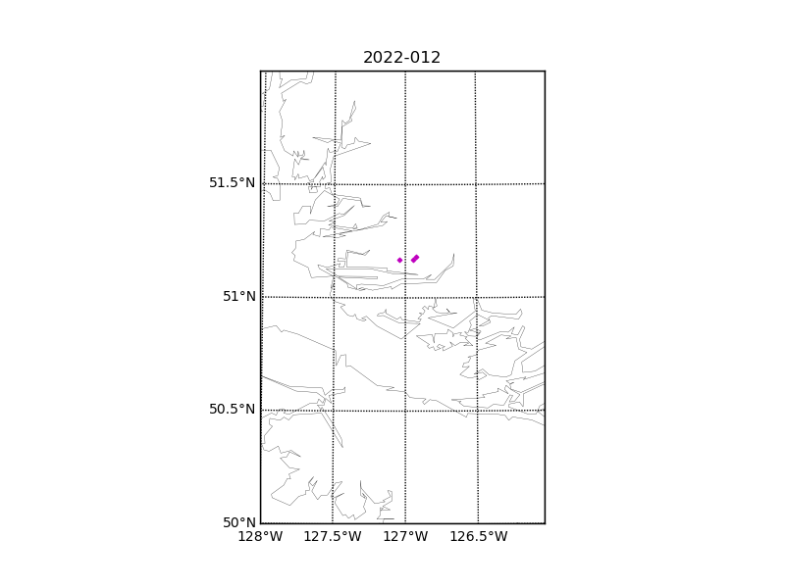

Figure 1 – location of casts (three in total) in Alison Sound. The coastline resolution is not high enough to show Alison Sound.

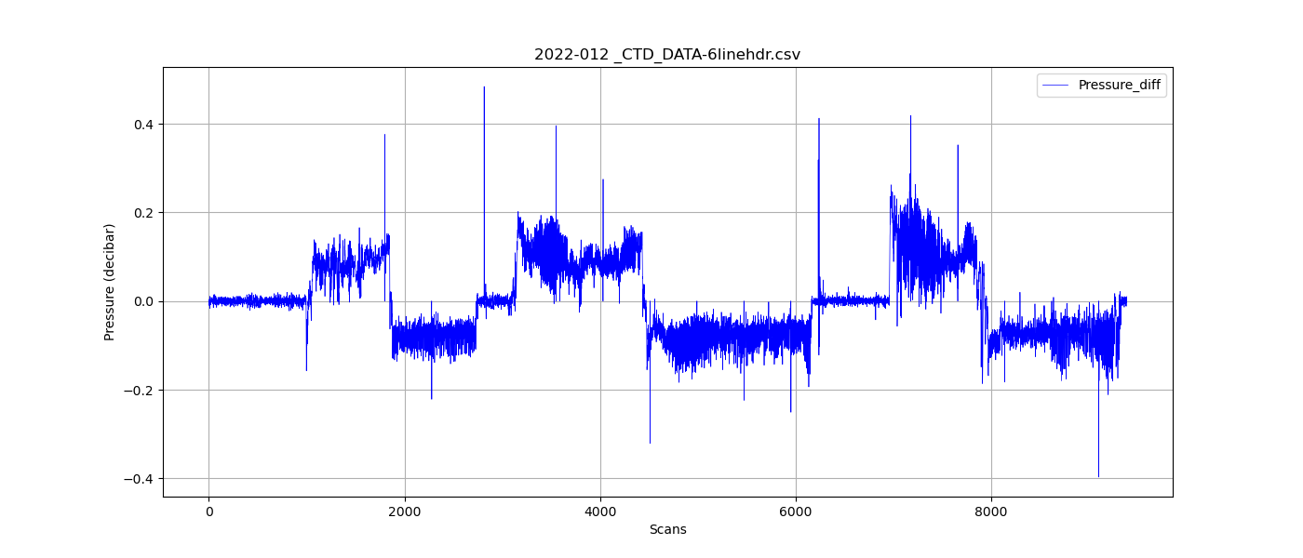

Figure 2 – Zero-order holds prior to correction.

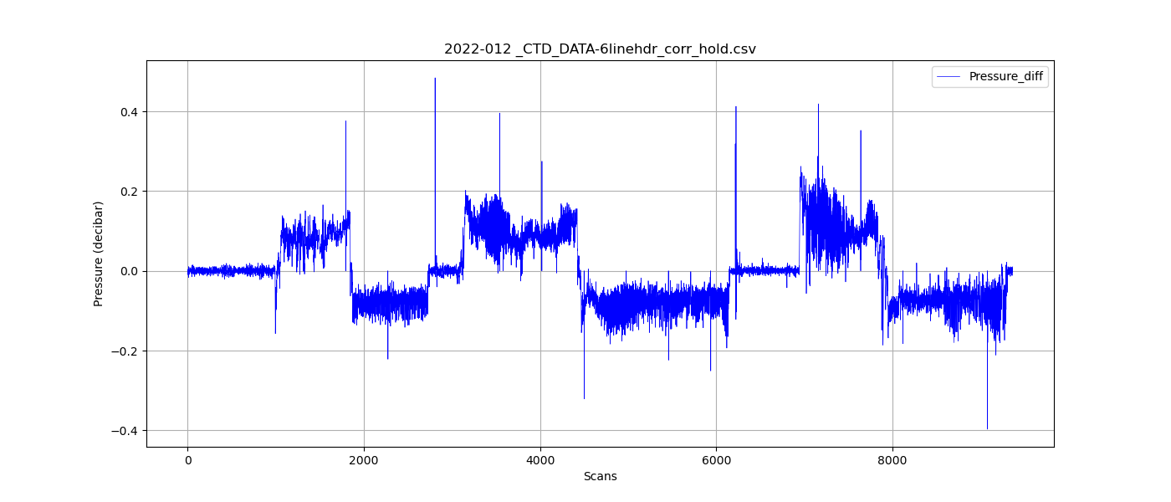

Figure 3 – Pressure differentials after the zero-holds correction.