REVISION NOTICE TABLE
DATE | DESCRIPTION OF REVISION

PROCESSING NOTES
Cruise: 2022-011
Agency: IOS, Ocean Sciences Division, Nanaimo BC
Chief Scientist: King J. Platform: Nordic Pearl
Location: WCVI Project: WCVI Juvenile Salmon Survey
Date: 8 October 2022 –23 October 2022

Processed by: Germaine Gatien
Date of Processing: 27 April 2023 – 8 May 2023
Number of original XML files: 65
Number of CTD files: 61 (4 had only surface data) Number of BOT files: 38

INSTRUMENT SUMMARY
A SeaBird Model SBE-25plus CTD (s/n 1091) was used with temperature sensor #6376, conductivity sensor #4799, ECO Fluorometer #2215, WET Labs transmissometer 896D, dissolved oxygen sensor #1483 and pressure sensor 1091. The sampling rate was 16Hz.

SUMMARY OF QUALITY AND CONCERNS
The log book was generally in good order with comments about problems encountered, but there were errors in the equipment list. The serials numbers for the fluorometer and transmissometer differ from those in the configuration file and do not correspond to any sensors on file. This likely occurred due to difficulty reading the serial numbers on the sensors.

The configuration file in use at sea had out-of-date parameters for all sensors except the fluorometer and the transmissometer.

Header information (station names, positions and sounder readings) was entered in the raw files which is very helpful. Three positions were wrong – all were cases where times differed very slightly between files and the log; the entry for degrees was wrong when positions were close to 60’. Fortunately, checks of speed between casts and track plots make such errors easy to find.

Samples were collected at 5m using a Niskin bottle deployed at the same time as the CTD was in water and the same event numbers are used for both. BOT files were prepared that include salinity, extracted chlorophyll, dissolved oxygen and nutrient samples plus CTD data extracted from downcast CTD files averaged over 0.5m at the nominal sampling depth (5m). For events #79 and 114 there were no CTD data available, so BOT files contain only estimated pressure plus analysis results.

The comparison of CTD salinity with bottle samples was limited to 5m and had a lot of scatter. Normally such shallow samples would not be included in comparisons with CTD data since vertical gradients are often high and there is likely to be some surface water drawn down to 5m by the CTD as it accelerates. Salinity appeared to be low by about 0.012psu. Salinity was found to be low by about 0.006psu during a July cruise which also had only 5m sampling. The sensors were recalibrated in early 2022, so this large a drift seems unlikely. No recalibration was applied.

The sampling of dissolved oxygen was insufficient to assess calibration because all samples were from a level where DO values were very high and vertical gradients were frequently large. A good range of DO values and many samples are needed to do a reliable comparison. This was the second use for the oxygen sensor since it was last serviced at the factory; during the earlier cruise the CTD also had only near-surface sampling and appeared to be reading very low. While a little calibration drift is expected, dissolved oxygen is generally found to read low by no more than 2% soon after servicing.

Fluorescence values also appear to be relatively low but with only 5m chlorophyll samples and the poor resolution of the fluorometer, it is impossible to evaluate the reliability of the data.

A longer wait (at least 30s) is recommend at the end of the 10m soak to allow wakes to dissipate before beginning the full cast.

PROCESSING SUMMARY
1. Seasave - This step was completed at sea.

2. Preliminary Steps
The Daily Log and a spreadsheet of sampling done were obtained.
There was a discrepancy between the serial numbers in the configuration files and in the log equipment list; this was likely due to difficulty reading the serial numbers.
The cruise summary sheet was completed.
The SBE25 CTD had a 16Hz sampling rate.

3. Conversion of Raw Data
The configuration file had out-of-date parameters entered for pressure, temperature, conductivity and dissolved oxygen sensors. Correct parameters were imported to a file which was saved as 2022-011-ctd.xmlcon. All files were converted to CNV format.

Acquisition began as the CTD entered water. Pressure was very close to 0 at the beginning and end of casts (0 to 0.02db). There was a 10m soak that lasted about 1 minute. The wait at the top before beginning the full cast was very brief. A longer wait (at least 30s) is recommended to allow wakes to settle before starting the full cast.

All expected variables are present and the profiles look reasonable, but there are more negative fluorescence values than usually seen. Tests were run by reducing the dark value in the configuration until there were very few negative values. A choice 0.012 instead of 0.023 produced good results with a few negative values that will disappear with bin-averaging.

4. WILDEDIT
A few casts were checked for spikes and a few were found in conductivity.
WILDEDIT was run to remove spikes from the pressure, depth, conductivity & temperature only in the full cast files (*.CNV).
Parameters used were: Pass 1 Std Dev = 2 Pass 2 Std Dev = 5 Points per block = 32
The parameter “Keep data within this distance of the mean” was set to 0 so all spikes would be removed.
The routine removed spikes in pressure effectively and reduced the few spikes in temperature and conductivity.

5. FILTER
The last time this CTD was used, tests were run to see if the usual approach of applying a cosine filter to temperature and conductivity using routine WFILTER did a good job of removing small reversals. Filter size 13 to 21 were tested and size 19 removed most problems.
WFILTER was run on all casts from this cruise using cosine filter, size 19.

6. ALIGNCTD
Based on tests run for other cruises in this project using the same DO sensor, ALIGNCTD was run on all casts to advance the DO channel by 2.5s. Plots were examined after this step and the results look good.

7. CELLTM
CELLTM was run on all casts using the SeaBird recommended parameters, (α, 1/β) = (0.04, 8).

8. DERIVE
Program DERIVE was run to calculate salinity and dissolved oxygen concentration (tau correction included). Plots were examined and confirmed that steps 5, 6 and 7 had improved the data.
The DO alignment looks good.

9. Conversion to IOS Headers
The IOSSHELL routine was used to convert the CNV files to IOS Headers.
There are 4 casts with no data below 1db: 79, 110, 114, 117. They will not be processed further.
CLEAN was run to add event numbers and replace pad values in the pressure channel with interpolated values.

A track plot was produced and turned up an error:
Event #132 –Latitude 49° 59.013’ should be 48° 59.013’.
A header check was run and the speed check turned up two other position errors.
Cast #57 : Longitude 127° 00.803 should be 128° 0.803
Cast #100: Longitude 127° 27.896 should be 126° 27.896
Corrections were made to the 3 casts in the CLN files.
Track plots for casts around those 3 were made to ensure the corrections were appropriate and they were. Header check was rerun and the speed check results look excellent.
Corrections for those positions were made in the paper log and in the scanned version of the log.

10. Checking Headers
Track plots looked ok so were added to the end of this report.
The surface check was run. The average was +0.09db with a range of -0.09db to +0.32db. This is well within the specifications.
The CLN files were put through REVERSE and surface check was rerun. The average was +0.07db, so there is no sign of pressure hysteresis. No casts were deeper than 260db so little hysteresis is expected.

11. SHIFT
Conductivity
SHIFT was run using a variety of settings to align conductivity and recalculate salinity, followed by a pass through DELETE to see which made the most improvement to stability in T-S space. When last used the best choice was found to be +1.5 records. Once again +1.5 records looks best overall though a slightly higher setting was also good. Shift was run on all casts using +1.5 records.
Fluorescence
The fluorometer used for this cruise is a type not usually pumped. Values were very low so alignment is difficult to judge. No shift was applied to the sensor.
Dissolved Oxygen
This channel was aligned earlier, but checks were made by examining plots of temperature and dissolved oxygen. No further adjustment was made.

12. DELETE
DELETE was run on all casts using the following parameters:
Surface Record Removal: Last Press Min. Surface Swell Pressure Tolerance: 1.0
Pressure filtered over width: 9
Swells deleted. Warning message if pressure difference of 2.00
Drop rates < 0.3m/s (calculated over 9 points) was deleted from 10db to 10db above the maximum pressure.
COMMENTS ON WARNINGS: The only warnings were from upcast #92, so of no concern.

13. DETAILED EDITING
All DEL files were copied to *.EDT so there will be a complete set of files even if some need no editing.

CTDEDIT was used to remove records corrupted by shed wakes and to clean salinity where unstable features looked likely to be caused by misalignment of T and C.
Some casts had extremely noisy descent rates with some complete reversals of direction. Editing was applied where the effects of resulting shed wakes were clear. In some shallow casts the salinity is noisy with 2-sided excursions associated with large temperature gradients rather than shed wakes; that will likely be resolved somewhat by bin-averaging.

Notes of editing details were made in the headers.
All EDU files were copied to *.EDT.

T-S plots were examined after this step. A few unstable features were found that could be real – no further editing was applied..

A median filter, size 7, was run on the files with the SeaPoint fluorometer.
The data were then averaged over 0.5db and thinned to data closest to 5db.
Data were then exported to a spreadsheet and saved as 2022-011-CTD-Samples-comp.xlsx.

14. Initial Bottle Data Steps
Bottle samples were taken during a separate cast to 5m while the CTD cast was underway.
The analysis results were added to the file with 5m CTD data to enable comparison and possible recalibration of CTD data. This was compared to the sample summary in document “2022-011 Bottle Summary.xlsx” and it was found that salinity sample labelled #11 should be #12. That choice compares much better with CTD salinity. The salinity analyst was informed and the QF file was updated.
Later, final data, including more channels, will be used to replace the CTD data in this file and it will then be converted to BOT files.

There were 2 cases of sampling done when the CTD failed to record data. CTD values were padded in the spreadsheet. Header details were obtained from the log.
The CHL and nutrient QF files had the wrong event number for the CTD cast at BB03. It should be 54, not 55.
Event 89 was missing from the event log, but is in daily log and there is a CTD file and samples
There are no CTD files for events 79 and 114 – date/time were taken from log

Each of the analysis spreadsheets were examined to see what comments the analysts wanted included in the header file. These were used to create file 2022-011-bot-hdr.txt which will be updated as needed during processing.

A 6-line header was added to the main worksheet and saved as 2022-011-CTD-bottles-6linehdr.csv. This will be used later to created individual BOT files later.

15. Comparisons
- Florescence vs Extracted CHL
All CHL samples came from 5m. The ratio of Fluorescence:URU:WetLabs / Extracted CHL had a median value of 0.3. This is lower than usual.
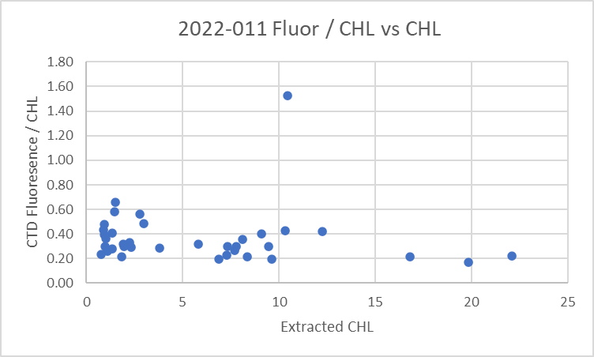
Upcast fluorescence values were compared with those from the downcast and were generally a little lower. There was one outlier with fluorescence higher than chlorophyll; there was a sharp gradient in the fluorescence so this might be due to a slight mismatch in depth between CTD value and sample. The last time this fluorometer was used was in during 2022-028 in May 2022 when fluorescence was relatively higher at about 60% of CHL. The dark values look reasonable for deeper casts.

The major outlier was examine. It had a spike to 18ug/L that dropped to 1.8 at 5db. When that outlier was removed the shape the plot looks much as expected, though the ratio is lower than expected.
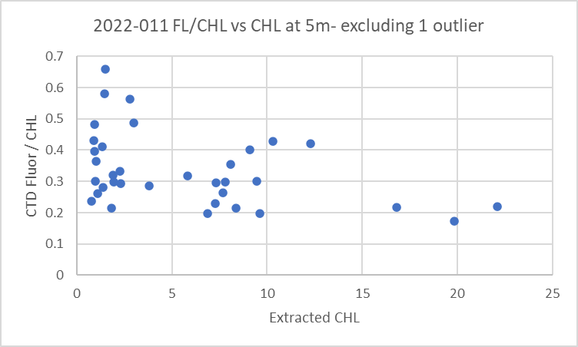
There is no reason to believe the gain had changed. The resolution of the sensor is low so some spikes might well be missed. With only 5m data available, it is impossible to say if the profiles are reasonable or not. There are no very low CHL values which is where we usually see high FL/CHL ratios and ratios of 0.4 are often found where CHL>5ug/L. There is insufficient sampling to say whether there was a problem with the sensor or not.

- Bottle Salinity vs CTD Salinity
There were 10 salinity samples available from 5db. The CTD Salinity was lower by a median of 0.0141psu (std dev 0.0287psu) and a range from being low by 0.081psu to high by 0.004psu. Samples #12 from event #43 and #35 from event #150 were outliers.
When those 2 outliers were removed the median difference was 0.011psu (standard deviation 0.016psu).

Because all samples came from 5m there are problems of shed wakes bringing low salinity water downwards. So having the CTD read lower than samples is not unexpected.
Bottle values may be slightly high due to evaporation/desorption though analysis was fairly quick, so such errors are likely no more than 0.003psu.
The sensors were recalibrated in early 2022 and have not been used a lot, so there is no expectation that calibration drift should lead to salinity errors as large as 0.01psu.
During the previous use it appeared to be low by 0.006. The evidence was weak then as well with only near-surface sampling.

There is insufficient information to justify recalibration.

- CTD Dissolved Oxygen vs Titrated DO samples
The titrated samples ranged from 3.9mL/L to 9.7mL/L
The CTD DO is less than the titrated samples by about 9%, but with only surface samples this is not a reliable estimate. There was little difference between upcast and downcast values at 5m.
A fit of differences versus CTD DO suggests a correction closer to 8%, slightly more if downcast CTD DO data are used and slightly less if upcast CTD data are used.
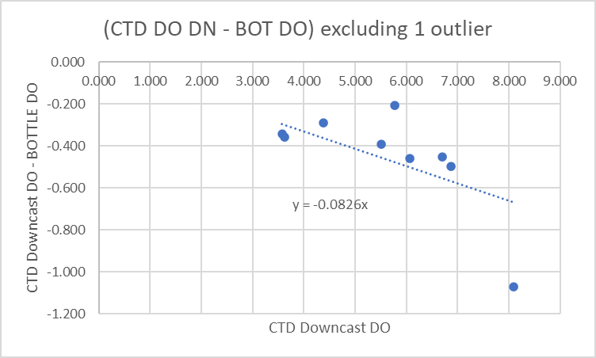
The result is similar to that of 2022-010, but that was another cruise with only 5m sampling. Near-surface comparisons are usually poor and the correction seems unreasonably high for a sensor that was serviced in early 2022. Generally these sensors are low by 1% to 2% soon after service, so CTD DO values will likely be slightly low.

16. Other calibration checks
Sensor History –
2022-010 – Pressure, conductivity and temperature sensors were serviced in early 2022. Pressure was high by ~0.1db. Salinity low by about 0.006psu. DO low by about 8%. All sampling at 5db so comparisons not considered reliable enough to justify recalibration. The ECO fluorometer read somewhat low compared to extracted CHL, at about 60% of CHL.
Historic Ranges – The only excursions from the local climatology were from 2 casts in Queen Charlotte Strait and at station CS03; the 3 had temperatures above the maximum and salinity below the minimum near the bottom. The casts were all near shore and likely not well represented in the climatology.
Post-cruise calibrations – None were available.

17. CALIBRATE
Pressure at the end of upcasts was found to be very accurate with an average of 0.08db. No recalibration is needed.
Comparisons of salinity and dissolved oxygen with samples did not provide sufficient evidence upon which to base recalibration of CTD data.
Salinity was never <25psu at 5m so silicate does not need correction.
No recalibration was applied.

18. Fluorescence Filter
Filter was run on channel Fluorescence:URU:Seapoint using a median filter size 7 to reduce spikes.

19. Bin Average, Remove, Derive DO in mass units, Reorder
The files were bin averaged using 1db bins.
REMOVE was run to remove Scan_Number, Oxygen:Voltage, Descent Rate and Flag channels.

Dissolved Oxygen was derived in mass units and that was used to calculate DO saturation. Plots of near-surface saturation show a range of 50% to 130% with one off-scale value. Values were generally in the70-130% range off the west coast of Vancouver Island and low in the Juan de Fuca Strait. This offers no evidence as to DO calibration.

REORDER was used to get the 2 dissolved oxygen channels together.

20. HEADER EDIT and final checks of CTD files.
Header Edit was used to fix headers, fix formats and to add comments about processing.
The final files were thinned to 5m and those data were exported to a spreadsheet and added to file 2022-011-CTD-Bottles-6linehdr.csv.

A cross-reference listing was produced and no problems were found.
A header check and a standards check were run on the CTD files and no errors were found.
The sensor history was updated.
Plots of CTD casts were examined and no problems were found.

20. Final BOT file preparation
File 2022-011_CTD_bottle_6linehdr.csv was converted into individual IOS files.
CLEAN was run to remove empty data channels and to enter 0 flags where the flag channels are empty.
Change Units was used to add CTD dissolved oxygen in mass units.
Reorder was used to get the 2 CTD DO channels together.
REMOVE was used to remove Date and Time channels.
HEADER EDIT was used to add comments, remove End Time and Time Zero and correct channel names and formats.
The final files have extensions BOT.

The data were exported to a spreadsheet and compared to data from analysts. A number of errors were found that were corrected in the 6-line header. The steps from Convert to Header Edit were repeated until no further errors were found.

Header check and cross-reference lists were run and no further errors were found
The standards check was run and no errors were found.
The track plot looks fine.

PARTICULARS –
79. No data below 0.2db
89. After this cast it was noticed that the T-C duct was disconnected. Repaired it.
92. T-C duct disconnected – tubing replaced.
110. Short file. No data below 0.05db.
114 & 117. No data. Shut down after deployment. Battery looks ok. Next cast ok.

CRUISE SUMMARY
Cruise ID#: 2022-011
Dates: Start: 8 October 2022 End: 23 October 2022
Location: WCVI
Chief Scientist: King J.
CTD# | Make | Model | Serial# | Used with Rosette? | CTD Calibration Sheet Competed?
1 | SEABIRD | 25 | 1091 | No | Yes

CTD CALIBRATION INFORMATION
Make/Model/Serial#: SEABIRD/SBE25/1091 Cruise ID#: 2022-011
Calibration Information
Sensor |  | Pre-Cruise |  | Post Cruise
Name | S/N | Date | Location | Date | Location
Temperature | 6376 | 11Jan2022 | Factory
Conductivity | 4799 | 14Jan2022 | Factory
ECO Fluorometer | 2215 | 27Nov2018 | Factory
Transmissometer | 1396DR | 23Jan2020 | Factory
SBE43 Oxygen | 1483 | 5Mar2022 | Factory
Pressure | 1091 | 26Jan022 | Factory | Make/Model/Serial#: SEABIRD/SBE25/1091 Cruise ID#: 2022-011
  Calibration Information
  Sensor |  | Pre-Cruise |  | Post Cruise
  Name | S/N | Date | Location | Date | Location
  Temperature | 6376 | 1Mar2021 | Factory
  Conductivity | 4799 | 5Mar2021 | Factory
  ECO Fluorometer | 2216 | 8Mar2017 | Factory
  SBE43 Oxygen | 1483 | 5Mar2021 | Factory
  Pressure | 1091 | 10Mar2021 | Factory

