## REVISION NOTICE TABLE

|  |  |
| --- | --- |
| DATE | DESCRIPTION OF REVISION |
| 18 March 2025 | TSG and Loop file channel names & Formats updated. GG & SH |
| 18April2023 | Updates to CHL QF file & CHL flags and comments in 2022-008-0013.che. |

## PROCESSING NOTES

Cruise: 2022-008 Agency: OSD

Location: North-East Pacific Project: Line P

Chief Scientist: Robert M. Platform: John P. Tully

Date: 9 August 2022 – 25 August 2022

Processed by: Germaine Gatien

Date of Processing: 28 September 2022 – 1 December 2022

Number of original HEX files: 46 Number of processed CTD files: 46

Number of rosette casts: 43 (includes test cast) Number of processed CHE files: 42

Number of original TSG csv files: 13 Number of processed TOB files: 12

# INSTRUMENT SUMMARY

CTD #443 was mounted in a rosette and attached were 2 Wetlabs CSTAR transmissometer (1185DR & #1883DG), a SBE 43 DO sensor on the primary pump (#3791), SeaPoint Fluorometer on the secondary pump (#3982 for casts 1-27 and #3641 for casts #28-102), a Biospherical QSP-400 PAR sensor (#70613) and an altimeter (#76341).

A thermosalinograph (SeaBird 45 S/N 0620) was mounted with a Wetlabs WETStar fluorometer (#1656) and flow meter; sampling interval was 5s.

Seasave version 7.26.7.121 was used for acquisition.

The data logging computer WP #102.

The deck unit was a Seabird model 11+ #425.

An IOS rosette with 24 10L bottles was used.

# SUMMARY OF QUALITY AND CONCERNS

The Daily Science Log Book was in excellent order with comments about problems encountered and a detailed list of equipment. The sampling log for the first bottle cast was very confused, but the rest of the log sheets were in good order. Sampling notes provided by the Chief Scientist were a big help in processing data.

The standard deployment procedure for this cruise as follows:

The rosette was brought to the surface. Pumps were turned ON. The rosette was brought down to 10m and kept there for 30 seconds. Once back at the surface, the data started to be archived, with the rosette at the surface for 30 seconds longer. Then the cast would start.

For all rosette casts:

Niskin bottles closed from 0 to 400 db (both included) had a wait time of 60 seconds.

All Niskin bottles deeper than 400 db had a wait time of 30 seconds.

The water depths in the headers of files for stations P4 to P26 were out of line with depths from previous cruises and with a calculated value (=maximum depth sampled by the CTD + altimetry reading at the bottom). Water depth entries were changed to match a standard list provided by the chief scientist except for P24 and PA-016 for which calculated values were used.

There were 2 WetLabs CStar transmissometers in use during this cruise:

Channel Transmissometer refers to sensor #1185DR (650nm - red)

Channel Transmissometer:Green refers to sensor #1883DG (530nm - green)

For comparison with other Institute of Ocean Sciences cruises, note that the transmissometer wavelength is 650nm unless otherwise stated.

The fluorometry from P3 to P5 was bad near the bottom and questionable at other depths, so that channel was removed from those files (events #16-#27). The sensor was replaced after cast #27. Given the different environments sampled it was impossible to assess how well the two fluorometers compared.

Fluorescence was unusually high at about 30m at station P8 with a narrow peak reaching a maximum of ~20ug/L at cast #30 (in both up and downcast) and 46ug/L 4 hours later at cast #33 (~11ug/L during upcast). Smaller peaks at about 30m were seen from P6 to P10. The peak values are considerably lower in the bin-averaged files due to the very narrow peaks.

The comparison of CTD salinity with bottles showed an interesting pattern, with results between 200m and 500m resembling those below 2000db, with much larger scatter in results between 500db and 2000db. There were also a few near-surface samples from well-mixed waters that give similar results to deep bottles. This may be due to the longer waits before firing Niskin bottles above 400m and low vertical gradients below 2000db. This may suggest longer waits might be a good idea to 2000m, but the evidence is weak, since most of the bottles above 400m came from a single cast. Even with the scatter the differences are not large, but this does suggest that the longer waits are useful in high gradient zones.

The comparison of SBE DO data with bottles from casts #18, 33 and 38 were out of line with other casts and with the expected performance of the sensor. There was no evidence of a problem with the sensor, sampling or analysis. There was evidence of intrusions of cool, fresh water leading to marginal stability from about P5 to P17, but only from P4 to P12 is the dissolved oxygen variability noteworthy. From P15 to P17 both temperature and salinity were below the climatology from about 200m to 300m, but temperature gradients are fairly smooth. At P8 salinity, temperature and dissolved oxygen traces all display unusually high variability between 200m and 300m and there are odd reversals near the surface. These unusual conditions likely explain why the comparison of SBE dissolved oxygen with titrated samples varies so much through the cruise.

Checks for hysteresis in the SBE DO sensor turned up problems in cast #38 only. Later deep casts looked normal. This could be related to unusual conditions at P12 or it may be an intermittent problem with the sensor. Preliminary results from the next cruise that used this sensor indicate a sudden shift in hysteresis settings partway through the cruise.

The SBE DO sensor has a fairly long response time so data accuracy is not as high when it is in motion as it is during stops for bottles. This will be especially true when vertical DO gradients are large. To get an estimate of the accuracy of the SBE DO data during downcasts (after recalibration) a rough comparison was made between downcast SBE DO and upcast titrated samples. Some of the difference will be due to problems with flushing of Niskin bottles and/or analysis errors and small mismatches in depth in the presence of large DO gradients, so the following statement likely underestimates SBE DO accuracy.

Downcast (CTD files) Oxygen:Dissolved:SBE data for this cruise are considered, very roughly, to be:

±0.40 mL/L from 0-125db except in areas of very large DO gradients

±0.20 mL/L from 125db-400db

±0.06 mL/L from 400db-600db

±0.01 mL/L from 600db-1500db

±0.02 mL/L below 1500db (except for cast #38)

For cast #38 all values below 1500db high by up to 0.08mL/L.

After the flow started to the Thermosalinograph the intake temperature values were unbelievably high for about 7.5 hours, at which point they dropped abruptly. Intake temperature data were removed for the first 7.75 hours until values looked stable. There is a gap of about 2.5 days in the thermosalinograph data caused by a problem at sea with starting new files. At other times the TSG worked well with good detail in temperature, salinity and fluorescence traces and few spikes in salinity. TSG intake temperatures were higher than CTD temperature at 4m by about 0.006C°at times when the standard deviation in the intake temperature was low. TSG fluorescence values were about 60% of those from the second fluorometer used on the CTD. Loop chlorophyll and salinity samples compared well with 5m rosette samples.

TSG salinity was recalibrated by adding 0.02psu based on comparisons with CTD salinity and loop samples; the difference is likely due to bubbles in the loop water.

# PROCESSING SUMMARY

##### Seasave

This step was completed at sea; the raw data files have extension HEX.

The chief scientist provided a summary of sampling protocols and problems.

The standard deployment procedure for this cruise as follows:

The rosette was brought to the surface. Pumps were turned ON. The rosette was brought down to 10m and kept there for 30 seconds. Once back at the surface, the data started to be archived, with the rosette at the surface for 30 seconds longer. Then the cast would start.

For all rosette casts:

Niskin bottles closed from 0 to 400 db (both included) had a wait time of 60 seconds.

All Niskin bottles deeper than 400 db had a wait time of 30 seconds.

##### Preliminary Steps

The Log Book and rosette log sheets were obtained as well as sampling notes from the Chief Scientist.

* Corrections were made to station names & depths in hex & hdr files based on the sampling notes.
* Nutrients, extracted chlorophyll, dissolved oxygen, salinity and DMS/DMSP data were obtained in QF spreadsheet format from the analysts.
* The cruise summary sheet was completed.
* The history of use of the pressure sensor, conductivity and dissolved oxygen sensors was found.

The configuration files were checked. There was an error in the entry for the fluorometer serial number early in the cruise. File 2022-008-ctd1 was prepared with that correction and is for casts 1-27. The file used at sea was saved as 2022-008-ctd2.xmlcon and is for casts #28-107.

##### BOTTLE FILE PREPARATION

The ROS files were created using files 2022-008-ctd1.xmlcon and 2022-008-ctd2.xmlcon.

The ROS files were converted to IOS format. File #1 was not included as it included no sampling.

The IOS files were put through CLEAN to create BOT files.

Temperature and salinity were plotted for all BOT files to check for significant outliers. None were found.

A preliminary header check was run; no problems were found.

The BOT files were bin-averaged on bottle number.

The output was used to create file ADDSAMP.csv. First, the file was sorted on event number and Bottle Position order. Then sample numbers were added based on the rosette logs.

The ADDSAMP file was then reordered on event # & sample #.

The ADDSAMP file was used to add sample numbers to the BOT files – output *.SAM.

Run MERGE on SAM files to get the water depths right.

The SAM files were bin-averaged on bottle # and called SAMAVG.

The addsamp.csv file was converted to CST files, which will form the framework for the bottle files.

Next, each of the analysis spreadsheets were examined to see what comments the analysts wanted included in the header file. These were used to create file 2022-008-bot-hdr.txt which will be updated as needed during processing.

Loops samples were moved from the salinity, chlorophyll and nutrient CSV files to a combined loop data file for later use.

DISSOLVED OXGYEN

Dissolved oxygen data were provided in spreadsheet QF2022-008_OXY*.xlsx which includes flags, comments and a precision study. Draw temperatures are available. The spreadsheet page with the final data was simplified and saved as 2022-008oxy.csv. That file was converted into individual *.OXY files.

EXTRACTED CHLOROPHYLL

Extracted chlorophyll and phaeo-pigment data were obtained in file QF2022-008_CHL QF*.xlsx. The file included comments and flags and a precision study. A simplified version of the spreadsheet was prepared and saved as 2022-008chl.csv. The csv file was then converted to individual CHL files.

SALINITY

Salinity analysis was obtained in file QF2022-008_SAL.xlsx which included a precision study. The analyses were carried out in a temperature-controlled lab 8 to 21 days after collection. The files were simplified and saved as 2022-008sal.csv. That file was then converted to individual SAL files.

NUTRIENTS

The nutrient data were obtained in spreadsheet QF2022-008_NUTS*.xlsx. This includes a precision study. The file was simplified, saved as 2022-008nuts.csv. The file was converted to individual NUT files.

DMS

DMS data were obtained in spreadsheet DMS Summary (2022-008).xls which includes duplicate analysis. Details on analysis are in file 2022-008 DMS report*.doc. Only 2 figures are considered significant. Event #s were added to the file.

DMSP

DMSP-D and DMSP-T data were obtained in file DMSP 2022-008 Summary*.xls. Details on analysis are in file 2022-008 DMS report*.doc. The data were converted into DMSP files. Only 2 figures are considered significant. Event #s were added to the file.

The SAL, CHL, OXY, NUT, DMS and DMSP files were merged with CST files in 6 steps.

After the 6th step the files were put through CLEAN to reduce the headers to File and Comment sections only.

The files were then put through CLEAN to reduce the headers to File and Comment sections only.

These files are ordered on sample number, but the SAMAVG files are ordered on bottle number, so one or the other set needs to be reordered in order to merge them. The MRGCLN1 files were reordered on Bottle_Number and saved as *. MRGCLN1s.

The MRGCLN1s files were then merged with SAMAVG files using merge channel Bottle_Number.

The output of the MRG files were exported to a spreadsheet and compared to the rosette log sheets to look for omissions. CTD salinity was checked and there are no values <25psu, so no silicate correction is needed.

Some issues investigated including items from the Sampling Notes:

* The MRG files for casts #48 and #93 each had 1 bottle with no sample # and no sampling so those records were removed from the SAMAVG file and MERGE was rerun.
* Event #2 has a very confused rosette sheet; check later in processing.
* Event 64 – Only bulk sampling from 2005db bottle, but sample # assigned so kept in file.
* Event 82 – Only 1 bottle fired and SAM file is correct.

##### Compare

Salinity

Compare was run with pressure as reference channel. A fit was done excluding cases where the standard deviation in the CTD salinity during the 10s window was >0.0008psu plus one outlier flagged 46 by the analyst. The primary salinity was lower than bottles by an average of ~0.0015psu (std dev 0.0015psu) and the secondary salinity was low by an average of 0.0013psu (std dev 0.0017psu). The differences between the 2 fits correspond well with the differences between downcast salinity channels reported in section 9.

There is a suggestion of pressure dependence in both channels but it is not large and likely reflects the local gradient so that any flushing errors decrease with depth. Close to the bottom both salinity channels are very close to bottles. For 4 casts the surface salinity was very well mixed and surface salinity samples were available. The primary salinity was lower than the bottles by an average of 0.0002psu and the secondary by 0.0004psu. The differences between these is similar to that found in the fit of all bottles, but the difference from the CTD is much smaller. There was a lot of noise in the fit of all bottles; the shallow result is closer to the deeper bottles. What accounts for the scatter?

SeaBird advise removing outliers until a flat fit against pressure is achieved. Assuming that the deep and surface samples are most reliable, outliers were removed with differences outside -0.0012 to +0.0008. This produced a flat fit with an average difference -0.0005. Most of the outliers are on the negative side and between 600db and 2500db. Examining CTD profiles shows a lot of noise at the beginning of bottle stops though that generally settled down before the bottles were fired. That could create scatter but not one-sided outliers. More likely is the fact that the longer wait before firing Niskin bottles above 400db has improved that comparison. Below 2000db the vertical salinity gradient decreases, so any flushing error would be small. Even the errors between 1000db and 2000db are small, just a little out of line. But they do suggest that the longer waits before firing bottles is useful.

There were 2 bottles from event 49 (samples 241 and 242) that were not included in the fit; they were flagged by the analyst due to missing inserts. They are outliers in the comparison, each out of line by ~0.02psu.The analyst padded those values (and one loop sample with a similar comment) with flag 5.

One other value was flagged due to poor replicates – cast #33 sample 117. Rep A is lower than CTD Sal by 0.0022psu and Rep B is lower by 0.0088psu. The analyst decided to use only Rep A with a 2 flag.

Analysis was done very quickly so we do not expect significant evaporation and longer waits before firing bottles should minimize errors due to incomplete flushing.

The fits against time show no obvious time dependence in calibration.

For full details for the COMPARE run see file 2022-008-sal-comp1.xls.

Dissolved Oxygen

COMPARE was run with pressure as the reference channel. Plots of differences against DO concentration looks very odd with a lot more scatter than usual and many cases of the DO sensor reading higher than bottle samples. The calibration drift in these sensors almost always leads to values reading low due to changes in the membrane, though there are always a few outliers due to imperfect matches between the source water for each measurement. The plots against time show that most of those odd values come from casts between #18 and 38.

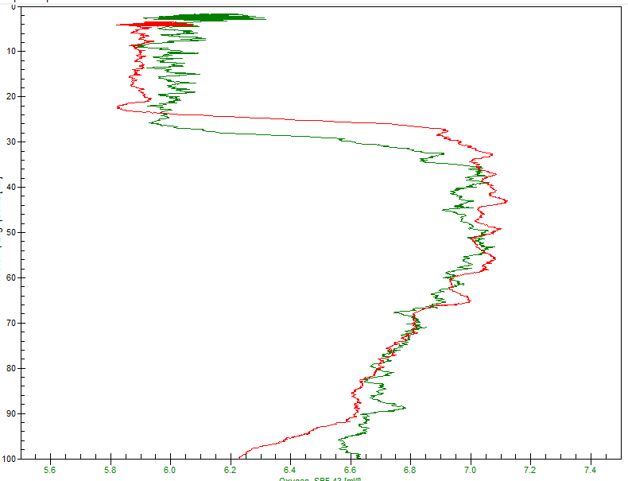

Plots of DO and pressure versus scan # look odd for some casts; there are large spikes in SBE DO at the end of bottle stops and during stops the DO signal often overshoots at first when a shed wake would have the opposite effect; sometimes DO never seems to completely equilibrate despite long waits. These are mostly related to very high temperature gradients. For some of cast #57 and from cast #67 to the end of the cruise, the pattern is quite different with less noise in the SBE DO and values equilibrating as expected. Comparing casts #57 (green) and #67 (red) in the top 100db, there are similar gradients but the noise level is much lower for event #67.

There is no mention in the logs of any change in the rosette mounting or CTD cables. The descent rate is, if anything, noisier for the later casts, though not particularly different near the surface. The temperature gradients are frequently very high around 25-30db in the casts with the SBE spiking to higher values, but this does not explain the deeper outliers. There were unusually high fluorescence values from P6 to P10.

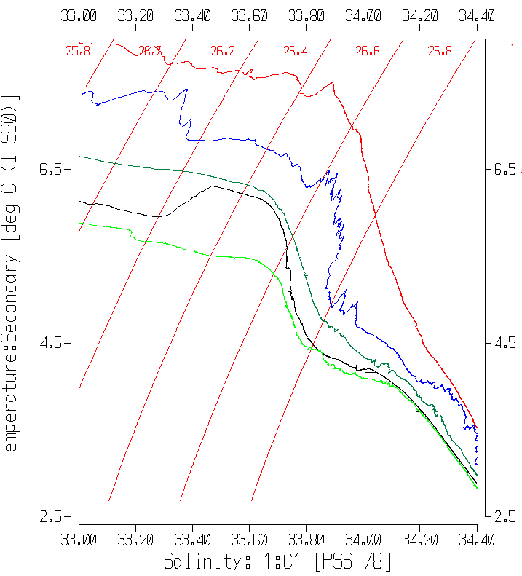

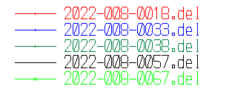

These results could be due to intrusions leading to high gradients. Such features are seen in all casts in the T-S plot above (P4, P8, P12,P16,P20), but the very high variability in cast #33 (P8 in dark blue) suggests a more active intrusion there, and possibly at P4 and P12.

Examination of the full downcast files with historic ranges included shows temperatures and salinity gradually drifting down relative to the historic range from P4 to P14 and falling below the minimum from P15 to P17 around 200-300m. To have cooler and fresher water intruding implies reduced stability for those depths for casts east of P14.

Fits found using a variety of cast choices excluding standard deviations in the SBE DO > 0.03mL/L and outliers based on residuals and setting the offset to 0 were:

* Using all casts

CTD DO Corrected = CTD DO * 1.0136 R2 = 0.74 (1)

* All casts except #18, 22 and 38

CTD DO Corrected = CTD DO * 1.0163 R2 = 0.91 (2)

* Casts #18, 33, 38

CTD DO Corrected = CTD DO * 1.0008 R2 = 0.10 (3)

* Casts 67, 92, 93, 102

CTD DO Corrected = CTD DO * 1.0172 R2 = 0.96 (4)

The decision to set the offset to 0 was done to reduce the effect of near-surface bottles where the DO gradient often reverses in sign, so those fits are out of step with most of the profile if the offset is free.

Preliminary data were available from the cruise that followed and used the same sensor but in a different region. There were problems with the sensor late in the cruise that do not look like what was seen during this cruise. The fit found for casts before that problem arose was:

CTD DO Corrected = CTD DO * 1.0164 -0.0063 R2 = 0.83

Or if the offset was forced to 0:

CTD DO Corrected = CTD DO * 1.0150 R2 = 0.92

Fit (4) has the tightest fit while (2) contains the greater variety of sites and looks closest to the cruise that followed. One comparison is intended to measure calibration drift but slow response renders that judgment much more difficult when dissolved oxygen is varying rapidly. During stops the response errors may cancel each other to some extent but the mismatch with temperature response likely complicates that picture. Fit (2) will be applied.

The hysteresis check was done by highlighting points from below 1000db except those from cast #38 and a few outliers from cast #57. There are too few data to provide a reliable fit but it looks reasonably close to the general fit.

CTD DO Corrected = CTD DO * 1.0138 + 0.0016 R2 = 0.77

This suggests that the default settings for Tau are appropriate. But it does raise the question of why there seems to be hysteresis in cast #38 only. No obvious reason could be found for that.

During the cruise that followed the hysteresis parameter changed between 2 DO sampling casts. This is not believed to have anything to do with the general observations from casts #18, 33 and 38, but might be a factor in why the hysteresis looks odd at cast #38 but not at other deep casts later in the cruise.

There were 4 significant outliers:

Cast #6, sample #22, 60db – site of a local reversal in DO. No flag change needed.

Cast #6, sample #26, 20db – CTD values changed rapidly during stop – high local gradient so slight flushing error can account for difference. No flag change needed.

Cast #15, sample #56, 10db – site of a local reversal in DO. No flag change needed.

Cast ##38, sample #179, 3275db – way out of line with historical data – analyst changed flag to 3.

For full details for the COMPARE run see file 2022-008-dox-comp1.xls.

The odd comparison is assumed to be due to unusually variable temperature gradients between P4 and P12, with especially high variability at P8 (in temperature, salinity and dissolved oxygen). It is most notable from 125 to 350m. From P12 to P17 there are lower temperature values than usual at those depths but there is no sign of the small-scale variability in either year. A few plots are included at the end of the report to show comparison between 2021 and 2022 at P8 and P15.

Fluorescence

COMPARE was run with extracted chlorophyll and CTD Fluorescence using pressure as the reference variable. The data from casts #16 to #27 look bad near the bottom and odd near the surface, with many sections of near-zero readings. The fluorescence channel will be removed from those casts. The fluorometer was replaced after cast #27.

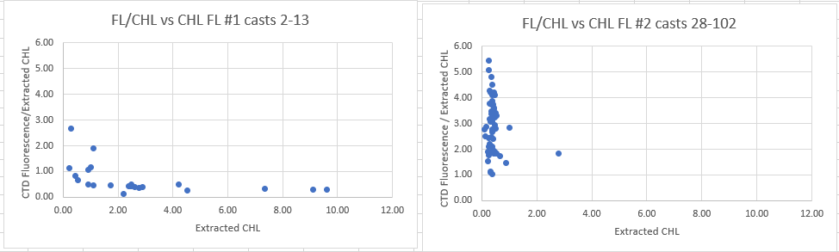

The fits of Fluorescence against Extracted CHL do look different but there is often a distinct difference between such fits between casts near shore and those well offshore.

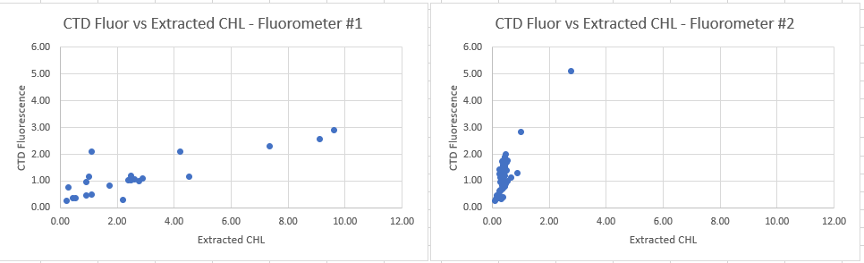

For casts #2 to #13 the fluorometer read much lower than CHL overall but there was a lot of variability with the ratio FL/CHL varying from 0.3 to 1.9. Given the presence of some sharp peaks in the CTD fluorometry the variability is likely due to a poor vertical match between samples and CTD. For casts #28 onwards the second fluorometer was in use. There were some episodes of very high fluorescence for that group of casts as well, but the ratio FL/CHL was much higher. However, when plotted on the same scale it becomes obvious that the difference is primarily due to the lower CHL values from the offshore region.

Fluorescence values were unusually high at about 20-30m from P8 to P11. These were in discrete spikes. As usual upcast fluorescence values were considerably lower than downcasts but were 2 to 3 times higher than extracted chlorophyll samples. That may be due to high gradients with the bottles containing deeper water than seen by the fluorometer.

The usual patterns were seen. CTD Fluorescence is higher than CHL when CHL is very low, then drops sharply to a ratio FL/CHL ~ 1 as CHL approaches 1ug/L. For CHL>1 fluorescence gradually drops from~50% of CHL to ~30% when CHL~10ug/L.

It is impossible to compare the 2 fluorometers since they sampled very different sites that likely have very different phytoplankton and there were some very sharp peaks, especially for fluorometer #2.

The only significant outliers were single samples associated with very large vertical gradients in CTD Fluorescence. The CHL samples likely came from lower in the water column. There is no reason to doubt the chlorophyll values, so no flag changes are warranted.

For full details for the COMPARE run see file 2022-008-fl-chl-comp1.xls.

##### Conversion of Full Files from Raw Data

File 2022-008-ctd1.xmlcon was used to convert files 1-27 and 2022-008-ctd2.xmlcon was used to convert files 28-107. The Tau function and the hysteresis function were selected since there was deep sampling. Depth was included in the conversion.

A few casts were examined and all expected channels are present, but there are problems in the fluorescence data in casts #16 to 27. There were a few small spikes. The 2 transmissivity channels had similar shapes. The altimetry had a few spikes near the bottom but there is a clear signal.

It was noted in the log that fluorescence spiked very high at about 30m at P8. The upcast shows a much smaller spike but upcast fluorescence does generally look lower than upcasts. The spikes are narrow but look real and transmissivity spikes low at the same level and dissolved oxygen has a small reversal, so these appear to be real. The CTD technician checked to be sure the cable was operating correctly and entered correctly in the configuration file, and could find no problem.

##### WILDEDIT

Program WILDEDIT was run to remove spikes from the pressure, depth, conductivity & temperature only in the full cast files (*.CNV).

Parameters used were: Pass 1 Std Dev = 2 Pass 2 Std Dev = 5 Points per block = 50

The parameter “Keep data within this distance of the mean” was set to 0 so all spikes would be removed.

##### ALIGN DO

A few casts were examined; both temperature channels were noisy during upcasts so the tests were not easy to interpret, but using +2.5s improved the alignment and overall looks like a good choice. That value is the one most often chosen for the SBE911s.

ALIGNCTD was run on all casts using +2.5s.

##### CELLTM

The noise in the upcast data makes tests for the best parameters for this routine very difficult to interpret. In the past when upcast data were not so noisy, the default setting of (α = 0.0245, β=9.5) was generally found to be the best choice. A few casts were checked for this cruise and the default setting does improve the data. CELLTM was run using (α = 0.0245, β=9.5) for both the primary and secondary conductivity.

##### DERIVE and Channel Comparisons

Program DERIVE was run on all casts to calculate primary and secondary salinity and dissolved oxygen concentration.

DERIVE was run a second time on 4 of the deeper casts to find the differences between the pairs of temperature, conductivity and salinity channels.

All differences were all small. There is a slight increase in the temperature and conductivity differences with time but the very noisy descent rates may account for some of that as it is hard to pick off representative values. The sensors were fresh from the factory, so small differences are expected. The salinity differences are negligible.

|  |  |  |  |  |  |
| --- | --- | --- | --- | --- | --- |
| Cast # | Press | T1-T0 | C1-C0 | S1-S0 | Descent Rate |
| 2022-008-0027 | 1000 | 0 | 0 | -0.0001 | High, Mod |
|  | 2000 | -0.0004 | 0.00002 | 0.0004 | “ |
| 2022-008-0048 | 1000 | -0.0001 | -0.00002 | -0.0003 | High,VNoisy |
|  | 2000 | -0.0004 | -0.00002 | 0.0001 | “ |
| 2022-008-0067 | 1000 | -0.0002 | -0.00004 | -0.0003 | High, XNoisy |
|  | 2000 | -0.0006 | -0.00002 | 0.0002 | “ |
|  | 3000 | -0.0006 | -0.00003 | 0.0003 | “ |
|  | 4000 | -0.0007 | -0.00003 | 0.0004 | “ |
| 2022-008-0093 | 1000 | -0.0007 | -0.00007 | -0.0003 | High, VNoisy |
|  | 2000 | -0.0007 | -0.00005 | 0 | “ |
|  | 3000 | -0.0007 | -0.00006 | 0 | “ |
|  | 4000 | -0.0007 | -0.00005 | 0.0001 | “ |

##### Conversion to IOS Header Format

The IOSSHELL routine was used to convert Sea-Bird 911+ CNV files to IOS Headers.

CLEAN was run to add event numbers and to replace pad values in the pressure channel with interpolated values based on record number.

##### Checking Headers –

* The cross-reference check and header check were run. No problems were found.
* Surface check was run and the average surface value was 2.5db. This is reasonable for a Tully cruise in the offshore area. There are a few casts that are well-mixed so that near-surface samples may be more useful for calibration than usual: 37-48, 61, 64-66, 80-81.
* During cast #25 the pressure has a minimum of -0.026db at the end of the cast. At about +0.1db the transmissivity drops precipitously, likely indicating a surface slick or bubbles and then climbs to what look like clear-air values. During cast #64, based on near-zero transmissivity, the CTD appears to be right at the surface when pressure is -0.05db. The CTD ran for a long time after that, presumably on deck. The minimum value recorded was -0.6db but that was in a spike. So the pressure appears to be within ±0.1db, well within specifications for this sensor.
* Cruise tracks were plotted and added to the end of this report.

The altimeter and water depth readings from the headers of the CLN files were exported to a spreadsheet. A check value was calculated by subtracting water depth from maximum depth sampled plus altimetry header. The value was reduced by 1 to allow for the fact that altimetry is averaged over the bottom 2m so are likely too high by an average of 1m Where that number was > 5m checks were made to see if the log entry differed from the header entry and whether the altimetry signal at the bottom provided a good header value. No problems were found in the altimetry headers. One water depth entry did not match the log entry.

The water depths in the headers of 2022-008 look poor in the offshore.

What I have to judge by is only available for sites where the CTD got close enough to the bottom to have good altimetry available. I calculate a “Check Value” as follows:

Check value = maximum depth sampled by the CTD + (altimetry header -1) – water depth from the header.

Altimetry is averaged over the bottom 2m, so 1m is subtracted.

The Check Value should be reasonably close to 0.

For this cruise all the casts from P4 to P26 were out of line.

Checking the log entry turned up only 1 case where the header entry was significantly different from the log. In that case the Check Value was large either way, but using the log entry did bring that value into line with the other casts.

The depths from 2022-001 data files compare well with the estimate based on Check Values. They also compare well with a list of standard depths provided by the Chief Scientist except for P24. The standard depths were entered into spreadsheet “2022-008-merge.csv” except that estimated depths were used for P24 and PA-016.

CLN files were copied to *.MRH.

“Merge csv files to headers” was used to replace the water depths for casts 36-93.

The header data was downloaded again and the check value recalculated until all values looked reasonable.

Bottle file header depths were fixed just before the final step “Edit Headers” was run.

##### Shift

Fluorescence

SHIFT was run on the SeaPoint fluorescence channel in all casts using the usual advance of +24 records. Plots show that the fluorescence offset is reasonably close to the temperature offset after this step.

Dissolved Oxygen

The Dissolved Oxygen voltage channel was aligned earlier. A few casts were checked to see if the alignment looked ok, and it did. No further alignment is needed for the DO concentration channel.

Conductivity

Tests were run on a selection of casts to find the alignment shift best for the 2 conductivity sensors as judged by noise in T-S space. The best choice was -0.55 records for the primary and -0.85 records for the secondary channels.

SHIFT was run twice on all SBE911 casts using -0.55 records for the primary and -0.85 for the secondary. Salinity was recalculated for both channels.

##### DELETE

The following DELETE parameters were used:

Surface Record Removal: Last Press Min

Maximum Surface Pressure (relative): 10.00

Surface Pressure Tolerance: 1.0 Pressure filtered over 15 points

Swells deleted. Warning message if pressure difference of 2.00

Drop rates < 0.30m/s (calculated over 11 points) will be deleted.

Drop rate applies in the range: 10db to 10db less than the maximum pressure

Sample interval = 0.042 seconds. (taken from header)

COMMENTS ON WARNINGS: The only warning came from the upcast of cast #17, so is of no significance.

##### Other Comparisons

Experience with these sensors since last factory service –

The pressure, temperature, conductivity and dissolved oxygen sensors have not been used between the last factory service and this cruise.

Historic ranges – Profile plots were made with 3-standard deviation climatology ranges of T and S superimposed. Temperature was slightly high at P3 around 700-800db, and low between 200 and 300db from P15 to P17. Salinity was low from P9 to P17 around 250db. These results are in agreement with anomalies reported based on recent Argo data from the same area. So they likely reflect real conditions rather than a problem with calibration. It is noted that the Argo anomaly plots show low salinity at the surface. For the plots with historic ranges, the surface salinity does not appear to be low, which is likely a reflection of either a climatology covering too large an area or different approaches in climatology method.

Post-Cruise Calibration – None available.

Repeat Casts –Two casts at P26 taken about 20 hours apart were compared around 950db and differences in temperature were ~0.007C° and in salinity ~0.001psu along lines of constant density with no systematic differences and frequent sections with virtually no difference. This is good repeatability given the long time between the casts.

##### DETAILED EDITING

There is little difference between the channel pairs though perhaps slightly less noise in the secondary. There are some concerns about the dissolved oxygen sensor performance for a few casts and it was mounted on the primary pump. While the problem is not likely due to a problem with the primary system, it gives a second reason to choose the secondary channels for editing.

All DEL files were copied to *.EDT.

The data were edited using files prepared as part of a test of an AI predictive model that indicates where records may need deletion.

CTDEDIT was used to remove records that appear to be corrupted by shed wakes. Salinity was cleaned to remove spikes that appear to be due to small misalignment or instrumental noise. All files required some editing.

Notes about editing applied were added to the files.

After editing, T-S plots were examined for all casts and no further editing was found necessary.

##### Corrections to Pressure, Salinity and Dissolved Oxygen Concentration

There was no salinity <25psu in CTD salinity in the bottle files (MRG) so silicate does not need correction.

The secondary salinity was found to be lower than bottles by about 0.0012psu with a standard deviation of ~0.0015psu and differences were even smaller when deep samples and shallow samples from well-mixed areas were used. There is some evidence that there may be some small errors due to incomplete flushing of Niskin bottles, so it is likely that CTD salinity is actually reading somewhat higher than it appears, but should still be within ±0.002psu. Recalibration will not be applied.

The pressure looks accurate so no recalibration is required.

File 2022-008-recal1.ccf was prepared to apply the following correction to the SBE dissolved oxygen channel:

CTD DO Corrected = CTD DO * 1.0163

This correction was first applied to the SAM and MRGCLN2 files.

COMPARE was rerun for dissolved oxygen and shows that the correction was applied properly. When data are excluded based on using the same points as in the original fit, the average is -0.0006mL/L with a standard deviation of 0.0186mL/L. See file 2022-008-DO-comp2.xls for details.

CALIBRATE was then run on the EDT files using the same recalibration file.

##### Final Calibration of DO

The initial recalibration of dissolved oxygen corrects for sensor calibration drift. Alignctd corrects for transit time errors. Those 2 steps may partly correct for response time errors, but to see if a further correction is needed, a comparison is made of downcast CTD data to bottle data from the same pressure. Small differences are expected due to ship drift, temporal changes, incomplete flushing of Niskin bottles and delayed response and noise in CTD data.

Downcast files were bin-averaged to 0.5m bins for the casts with DO bottle samples. Those files were then thinned and compared to the bottle values in the MRG files. COMPARE was run to study the differences between the downcast CTD DO data and the titrated samples from upcast bottles.

When casts #18, 33 and 38 were excluded as well as standard deviation in the CTD DO being >0.3mL/L, the CTD DO was lower than titrated samples by -0.0077mL/L with a standard deviation of 0.122mL/L.

For casts #18, 33 and 38 the CTD DO was higher by an average of 0.039mL/L and a standard deviation of 0.132mL/L. The recalibration worked as well as can be expected for this complex cruise.

Downcast (CTD files) Oxygen:Dissolved:SBE data for this cruise are considered, very roughly, to be:

±0.40 mL/L from 0-125db except in areas of very large DO gradients

±0.20 mL/L from 125db-400db

±0.06 mL/L from 400db-600db

±0.01 mL/L from 600db-1500db

±0.02 mL/L below 1500db (except for cast #38)

All values below 1500db high by up to 0.8mL/L.

For more detail see file 2022-008-dox-comp3.xls.

##### Fluorescence Processing

There were no off-scale fluorescence values but cast #33 (P8) has unusually high values around 32db on the downcast, peaking at ~47ug/L. On the upcast there is a small but noticeably distinct peak between 25db and 31db, starting as the CTD stopped but rising higher as the CTD started moving upwards again. The maximum value is ~12ug/L. Both of the features are seen at the base of a well-mixed layer with temperature dropping by ~4C° in 5m. Similar features are seen from P6 to P10, though are not as dramatic as at P8.

A median filter, size 11, was applied to the fluorescence channel in the COR1 files. Plots of a few casts showed that the filter was effective. (Output:*.FIL)

##### BIN AVERAGE of CTD files

The following Bin Average values were applied to the FIL files (output AVG):

Bin channel = pressure Averaging interval = 1.000 Minimum bin value = .000

Average value will be used. Interpolated values are NOT used for empty bins.

On-screen T-S plots were examined.

Profile plots were examined. No problems were noted.

##### Final CTD File Steps (REMOVE and HEADEDIT)

For all casts REMOVE was run to remove the following channels:

Scan_Number, Temperature:Secondary, Conductivity:Secondary, Oxygen:Voltage:SBE, Descent_Rate, Status:Pump, Altimeter, Salinity:T1:C1 and Flag.

PAR was removed for casts # 38,39,43,50,51,55,61,62,65,68,78,82.

Channel Fluorescence was removed from events 16-27.

A second SBE DO channel (with umol/kg units) was added.

REORDER was run to get the two DO channels together.

HEADER EDIT was used to fix formats and channel names and to add comments about processing. Separate versions were used for 1-27 and 28-107 to fix the serial # of the fluorometer in the first group.

The Standards Check routine was run and no problems were found.

The Header Check was run; no problems were found.

Profile and T-S plots were examined. No problems were found.

The 2 transmissivity values at 4000db were 59.1 %/m and 95.6%/m at one cast and 59.8%/m and 97.0%/m at another (compared to 59.7%/m and 94.3%/m in August 2021 and 60.2%/m and 93.5%/m in February 2021.) These are in the normal range for station Papa.

##### Dissolved Oxygen Study

As a final check of dissolved oxygen data, % saturation was calculated and plotted. Values at 2 to 3m ranged between ~68% in Juan de Fuca Strait to 130% in Saanich Inlet. Along Line P values ranged from about 103% at P1 to 106% at P26.

These values are in a typical range for the offshore.

##### Final Bottle Files

SORT was run to arrange casts in pressure order.

For all casts REMOVE was run to remove the following channels:

Scan_Number, Temperature:Primary, Conductivity:Primary, Oxygen:Voltage:SBE, Descent_Rate, Status:Pump, Altimeter, Salinity:T0:C0 and Flag.

Fluorescence:URU:SBE was removed from casts #16 - 27

PAR was also removed for casts # 38,49,57,67,77,80,92,93.

Channel Fluorescence was removed from events 16-27.

A second SBE DO channel with mass units was added for both the CTD DO and titrated DO and REORDER was run to get the pairs of DO channels together.

EDIT HEADERS was run to fix formats and channel names and to add comments about analyses and CTD processing. Separate header files were used. For casts #1-27 the instrument table was also replaced because there was an error in the fluorometer serial number. For casts 28-102 the table was correct.

Data were exported from the CHE files to file 2022-008-bottles-final.xlsx. The entries were compared with the rosette log sheets and no problems were found.

Standards check and a header check were run. No problems were found.

The track plot looks ok.

Plots of each file were examined and no problems were found.

A cross-reference listing and header check were produced for the CHE files.

##### Thermosalinograph Data

An IOS TSG45 was used for this cruise and data were saved in 1 file, CR6Series_Data.dat.

The files were also delivered in separate files for each day, but since each needed changes to formatting, it was easier to do that in the full file and then divide that.

Formatting problems include having the Date and Time columns combined and having quotation marks and NAN entries. Ultraedit was used to separate the date and time. Headers were reduced to 2 lines with variable names and units entered.

The file was opened in EXCEL.

In opening DELIMITED was selected, TAB deselected, COMMA and Space selected.

(Usually It is necessary to choose TEXT for the time on the 2nd page of the text import wizard, but the format used this time made that step inappropriate.)

Data from before the ship moved were removed.

The flow was off to the TSG from the beginning of the file until 9:33 on August 11 and for the last 3 minutes of the file on August 25th. Temperature, conductivity and fluorescence data were padded until the flow started and after it stopped.

There were also 2 short periods on August 23 (255-300 and 304-307) when flow was off to the fluorometer or was very low, affected fluorescence data were padded.

A column with pressure was added with all values set to 4.5 (to enable derivation of salinity).

There was a 3.5 day gap in data from midnight 023:34 on August 13th to 15:16 on the August 17.

The fluorescence channel is in volts. It was moved to column M. Then a concentration value was calculated in column F using scale 14.6 as determined in the most recent factory recalibration of the fluorometer. The clean water offset value was 0.081. For previous uses of this equipment it was sometimes found necessary to adjust the offset to obtain reasonable values, but during 2022-001 no change was needed. No negative fluorescence values were found other than when the flow was off, so no further change was made to the offset.

A quick comparison was made between the fluorescence values in the TSG file and CTD values around 4.5m using a few casts for each sensor. There was a 3.5 day gap in TSG data. The TSG values were close to the CTD values for the fluorometer used on CTD casts up to event #27, but it was about 60% of the CTD values when the 2nd CTD fluorometer was in use.

|  |  |  |  |  |
| --- | --- | --- | --- | --- |
| Event # | FL # | CTD FL | TSG FL | TSG/CTDFL |
| 2 | 3982 | 2.8 | 2.8 | 1.0 |
| 6 | " | 2.8 | 3.0 | 1.1 |
| 9 | " | 1.4 | 0.6 | 0.4 |
| 15 | " | 1.2 | 1.1 | 0.9 |
| 28 | 3641 | 0.8 | 0.5 | 0.6 |
| 92 | " | 1.2 | 0.6 | 0.5 |
| 93 | " | 1.5 | 0.9 | 0.6 |
| 102 | " | 1.6 | 0.9 | 0.6 |
| 106 | " | 1.1 | 0.7 | 0.6 |
| 107 | " | 1.0 | 0.6 | 0.6 |

The differences between the 2 CTD fluorometers were discussed in section 4.

This quick comparison might suggest that the 2nd CTD fluorometer was reading higher than the first, leading to a smaller TSG/FL ratio. However, at cast #9 there was a ratio even lower than for the offshore casts.

The files were then converted to IOS Header format with header info added. There are 15 IOS files, each covering all or part of 1 day.

CLEAN was run to reset the number of records, min and max values, set the start and end times, and latitude and longitude limits.

ADD TIME CHANNEL was used to add Julian dates – i.e. Day of Year. A record number was also added to enable averaging (for use in comparison to CTD files). Time zero was set to 31 December 2021 0:00:00. (Note that this step leads to problems plotting until REORDER is run.)

DERIVED QUANTITIES was run twice, first to derive salinity using the lab temperature and again to derive sigma-T.

REORDER was run to move the Julian date to after the Time/Date channels and to put salinity and fluorescence after the lab temperature. Also the record # was moved to the end.

The first file contains no useful data since the flow was off and the ship only moved a short distance in Saanich Inlet, so will not be processed further.

a.) Plots

A track plot was produced and added to the end of this report.

Time-series plots were produced and turned up some problems at the beginning of the cruise.

* The flow was not turned on until ~9:30 on August 11th when the ship was in Haro Strait, well south of station Haro59.
* The intake temperature was higher than the lab temperature by >5 C° and unbelievably smooth at first. Between JF2 and P1 at ~17:07 on August 11 it dropped by 4C° in 1 minute. There is some variability in the flow rate at the time of that change and a spike about 6 minutes later, but the flow rate is ~1 before and after the spike.
* The lab temperature dropped significantly when the flow started but is fairly smooth until the intake temperature suddenly dropped, after which there is more detail.
* The lab temperature, salinity and fluorescence do not look obviously bad between flow turning on and the intake temperature dropping suddenly. There was one CTD cast (at JF2) that occurred during the period. The lab temperature is higher than the CTD by about 0.7C°; we expect it to be high due to heating in the loop and the difference is just a little higher than seen in August 2021. Salinity is lower by ~0.08psu; we expect it to be low due to bubbles and this is not as low as often seen. Fluorescence variability looks a little low though the values seem reasonable.
* There were loop samples taken during the relevant period and the TSG salinity was lower than the loop by 0.064psu. Two other loops taken at JF3 and JF4, after the intake temperature began to look normal, had the TSG reading low by 0.025psu and 0.040psu. Those sort of variations are not unusual, so the TSG was likely operating well. The flow rates were normal, but the salinity trace is rather smooth.

b.) Checking Time Channel

The CTD files were thinned to reduce the files to a single point from the downcast at or within 0.5db of 4.5db. These were exported to a spreadsheet which was saved as 2022-008-tsg-ctd-loop-rosette-comp.xlsx. data were removed from the list for times when the TSG was not recording or the flow in the loop was off. This left 29 points of comparison, at least one of which is before the intake temperature is reliable.

The TSG files were averaged over 12 records (1 minute) on record number to reduce the noise and file size. Standard deviations were included. Then required records (times, positions, temperatures with standard dev, salinity with standard dev, fluorescence with standard dev, flow rate) were exported to a spreadsheet and that file was thinned to the closest times of CTDs and added to file 2022-008-tsg-ctd-loop-rosette-comp.xlsx..

The same file was thinned to the closest times to loop files (after removing loops that were taken when TSG was not recording) and added to the TSG-Loop comparison. There were 15 loop samples that overlapped with TSG records, but only 13 salinity values available, one of which was flagged 4.

A comparison was made of positions for the CTD and TSG data to check for good matches. The differences in positions are expected to be small despite the averaging because the ship was stopped at these times. The median differences were 0.0000º for latitude and 0.0002º for longitude. The largest differences were at P5 and that site also had the largest differences between CTD and TSG intake temperature. The loop sample for P5 was taken a few minutes before the beginning of the CTD cast so it is possible the ship was still in motion. That cast was removed from the loop-TSG comparison.

c.) Comparisons

* Comparison of T, S and Fluorescence from TSG and CTD data

The initial comparison between TSG and CTD data using all casts was had some very large differences in Temperature at JF2, P1 and P6, and salinity was also out of line at JF2 and P2. Fluorescence is always harder to assess but seems ok. There was a deep dip in temperature at P6 that lasted less than 10 minutes. The variability in TSG intake temperature at the time of the P6 observations was extremely high. So comparisons between TSG and CTD excluded data from casts #6, #9, #13 and #28, except for latitude and longitude differences.

|  |  |  |  |  |  |
| --- | --- | --- | --- | --- | --- |
| **Excluding casts 6, 9, 13, 28** | | |  |  |  |
|  | **Tintake-Tctd** | **Tlab-Tctd** | **SALtsg-SALctd** | **FLtsg/FLctd** |  |
| **min** | -0.0142 | -0.3571 | -0.0314 | 0.459 |  |
| **max** | 0.3121 | 0.7371 | 0.0049 | 1.005 |  |
| **average** | 0.1003 | 0.4254 | -0.0183 | 0.627 |  |
| **median** | 0.0898 | 0.4717 | -0.0188 | 0.600 |  |
| **stdev** | 0.1092 | 0.2133 | 0.0066 | 0.162 |  |
| **Using 10 casts with lowest std dev in TSG over 1 minute for each variable** | | | | | |
|  | **Tintake-Tctd** | **Tlab-Tctd** | **SALtsg-SALctd** | **FLtsg/FLctd** |  |
| **min** | -0.0142 | 0.2467 | -0.0314 | 0.459 |  |
| **max** | 0.3121 | 0.7371 | -0.0143 | 0.852 |  |
| **average** | 0.0835 | 0.4574 | -0.0202 | 0.587 |  |
| **median** | 0.0058 | 0.4882 | -0.0187 | 0.534 |  |
| **stdev** | 0.1223 | 0.1527 | 0.0054 | 0.137 |  |

* TSG Salinity was lower than CTD salinity by a median of 0.0188psu (std dev 0.0066) excluding 4 casts; there is little difference when using the 10 with lowest standard deviation or only P7 to P26.
* TSG intake temperature is higher than CTD temperature by a median of 0.0898C° (std dev 0.1092C°). Using only the 10 casts with lowest standard deviation the TSG is much closer to the CTD being high by 0.0058C°, but the standard deviation is larger at 0.1223C°. Using P7 to P26 the median is exactly the same as using all data, but the standard deviation is much lower at 0.06940 C°.
* The lab temperature is higher than the intake temperature by 0.4717 C° or 0.4882 C° using any of the methods, so 0.48C° looks appropriate
* TSG Fluorescence is about 60% of CTD fluorescence using all data or 53% using either the 10 lowest standard deviations or P7-P26. The CTD fluorometer malfunctioned and was replaced before cast #28. The TSG looks closer to the CTD fluorometer early in the cruise and lower later, but chlorophyll levels were different for the 2 groups.

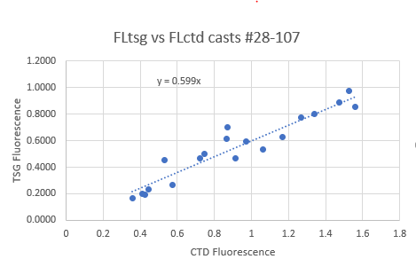

* Comparisons of Loop samples and TSG data

There were 15 loop Salinity and Chlorophyll samples of which 6 were taken while stopped and the rest while underway. Two of the salinity samples taken underway were rejected due to improper seals/inserts. The loops were compared with TSG data. As is usually the case, TSG fluorescence was higher than Extracted CHL by up to a factor of 2.5 for the samples with CHL < 0.4ug/L. It dropped sharply as CHL increased. It was close to CHL for CHL=0.7ug/L and about 20% of CHL for CHL=11.6ug/L. This pattern is typical for this type of instrument though the ratio is lower than usual at the high end. However, there were only 3 CHL samples >0.74ug/L, so the evidence is weak. The median ratio was 1 for casts when the CTD was stopped, which only reflects the fact that the highest CHL values came from underway samples.

The TSG salinity was lower than the loop samples by a median of 0.021psu (std dev 0.024psu). There was little difference between stopped and underway median values. Using only sampling from west of P6 also made little difference.

* Comparison of 5m Rosette samples and Loop samples

There were loop nutrient samples but none were taken during bottle casts so no comparison is possible.

There were 5 salinity and extracted chlorophyll loop samples taken during rosette casts. There was good agreement between the two with the ratio of Loop to Rosette CHL being 01.15ug/L (std dev 0.17) and Loop Salinity being higher than rosette salinity by an average of 0.0014psu (std dev 0.0039psu.) The samples came from between P5, P7, P9, P25 and Hal. This confirms that loops are useful for assessing TSG data.

d.) Calibration History

The TSG was serviced and recalibrated shortly before cruise 2022-001.

* During 2022-0001 – Salinity close to CTD in open ocean; larger differences in inlets. No recal applied. Problem with intake thermistor that cleared up suddenly with temperature dropping by 1C° in 5s and 1.9C° in 25s. . TSG fluorescence was higher than Extracted CHL by up to a factor of 3 for the samples with CHL < 1ug/L and dropped sharply for CHL>0.5ug/L. There were only 2 samples with CHL>5ug/L and TSG fluorescence was about 30% of CHL for those.

e.) Conclusions re TSG

1. The TSG clock worked well and position information was available.

2. Both flow rates were mostly in a good range.

3. Loop samples agreed well with rosette samples.

3. The TSG salinity is lower than that from the CTD by about 0.0188psu and compared to loops it is low by about 0.021psu. There is little difference between samples taken underway or stopped and between using all data or only P7-P26. This difference from CTD salinity is likely due to the presence of small bubbles in the water. Recalibration will be applied by adding 0.020psu.

4. The intake temperature looks very bad up to about 17:10 on August 11th between JF3 and JF4. Even beyond that it is suspicious, so values were padded up to 17:21 on August 11th. Beyond that time the differences were often very noisy. The differences between 2 noisy signals is exaggerated by the time difference between when water enters and leaves the loop. So those data are likely ok.

5. The lab temperature, salinity and fluorescence data were padded up to 9:30 on August 11th (about 6 minutes after the flow started) when the trace looks like the flow had been fully established.

6. The intake temperature is higher than CTD temperature by a median of 0.090C° (std dev 0.109C°) when all casts are included except for 4 major outliers. It is high by only 0.006C° when only the 10 casts with the lowest variability over 1 minute are used, but the standard deviation is high at 0.122C°. Using the five casts with very low std dev over 1 minute indicates the intake temperature is high by 0.0045C° (std dev 0.049C°). All these comparisons indicate that the intake temperature is higher than the CTD which may be due to the loop drawing water from a little higher than the CTD or there may be some heating of water near the intake thermistor.

7. The TSG lab temperature read higher than the TSG intake temperature by a median of 0.4714C° (std dev 0.2133C°) using all but 4 outliers and by 0.4882C° (0.1527C°) using the 10 casts with the lowest standard deviation in the lab temperature over 1 minute. Warming by 0.48C° looks fairly typical for this vessel at this time of year.

8. The change in intake temperature was very sudden. A similar problem arose when it was last used and at that time the other TSG variables looked reasonable. It is likely that as soon as the flow was steady, lab temperature, salinity and fluorescence values are good.

9. TSG Fluorescence was higher than loop chlorophyll when CHL<0.5ug/L and lower when CHL>0.5ug/L. This pattern is typical of this type of fluorometer. The TSG fluorescence was ~60% of that from the CTD fluorometer that was used from casts #28 to the end of the cruise, all data coming from regions of low CHL.

f.) Editing

Some editing was done earlier using a text editor.

CTDEDIT was used to apply further editing to 2 files:.

20220820 – Cleaned a few deep single-point spikes by interpolation.

20220823 – Starting at 2:26 UTC data were padded from the Temperature:Lab, Salinity and Fluorescence channels for a period when flow rate became unstable with very high rate followed by 0 or very low flow. The interruption to fluorescence was erratic lasting longer than for the TSG but with a short period in the middle when flow was ok.

g.) Calibrate

CALIBRATE was run using file 2022-008-tsg-recal.ccf to add 0.02 to channel Salinity.

h) Preparing Final Files

HEADER EDIT was used to change the DATA DESCRIPTION to THERMOSALINOGRAPH and add the depth of sampling to the header and to change channel names to standard names and formats and to add comments.

The TSG sensor history was updated.

As a final check plots were made of the cruise track and time-series and all looks fine.

A cross-reference list was prepared – see below*.

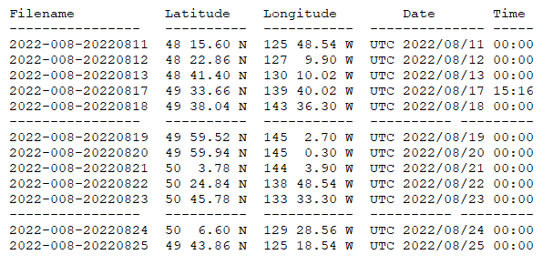

##### Loop File

The Chief Scientist provided file 2022-008-che-surface-loop.csv which included data from surface rosettes and loop samples including almost all necessary information (including times appropriate for surface rosette data) for creation of the loop file.

Loop sample data were added.

The sampling method column was added and filled with ROS or USW.

A few alterations were made in the order of columns and then a 6-line header was inserted.

The dates were fixed.

That file was saved as 2022-008-surface-6linehdr.csv.

The file break column was filled with value 1 so all data will be in a single file when converted.

CONVERT was run to produce an IOS Header file.

CLEAN was run to get start and stop times and to add flag 0 to empty flag cells.

A comment file was prepared which was essentially the same as the one used in preparing CHE files but including a description of the loop system and comments on the CTD data processing.

Header Edit was used to correct channel names and formats and to add comments. The final file was renamed as 2022-008-surface.loop. The track plots look reasonable and plots of temperature and salinity versus event numbers, latitude and longitude look reasonable.

P**articulars - Notes from Daily Science Log and Sampling Notes**

PAR off: 38, 49, 57, 67, 77, 80, 92, 93

Casts with bottle fired out of order: 38, 39, 49, 51, 57, 61, 62, 67, 68, 77, 78, 80, 92, 93.

Casts with no Niskin closed: 12, 106, 107

Casts run out of order: 6, 17, 39, 48 (1 bottle not needed), 53, 64, 68, 84.

Casts with bottles fired but not sampled: 1 – Saanich Inlet – no bottle file needed

No split casts.

Deployment schemes:

The rosette was brought to the surface. Pumps were turned ON. The rosette was brought down to 10m and kept there for 30 seconds. Once back at the surface, the data started to be archived, with the rosette at the surface for 30 seconds longer. Then the cast would start.

For ALL rosette casts:

Niskin bottles closed from 0 to 400 db (both included) had a wait time of 60 seconds.

All Niskin bottles deeper than 400 db had a wait time of 30 seconds.

TSG notes

Files in new format – one long file later divided into 24-hour data.

CTD notes

1-27. Fluorometer ID entered wrong in configuration files. Corrected in processing.

l. All bottles closed for testing. No CHE file needed.

2 – Haro59: this cast should have been out-of-order, but all Niskins were closed in order. The bottle number on the labels were corrected to the correct numbers but the sample numbers did not get corrected. Sample numbers should match bottle numbers.

6 – JF2: sample 32, Niskin 17 not needed, not closed.

16. Glitch at beginning of file causes difficulty in conversion. Corrupted header lines replaced with a copy from another file.

16. Fluorometer trace bad below 550m.

17-27. Fluorescence trace bad.

18. Fluorescence not responding.

30 & 33. Spikes in fluorescence at P8. Also spikes in Trans and small DO reversal. Technician tested cable and checked configuration file and found no problems. These features look real.

48 – P13: two bottles closed, bottle 4 at 2005 m NOT needed, it doesn’t need to be in the CHE file.

64 – P19: two bottles closed, put the 2005 bottle in the CHE file since it has a sample number.

82 – P35: the .bl file contains 1 entry but the .btl file has 2 bottles. Only 1 on rosette sheet.

93 – PA-016: bottle 3 closed out of the water so samples came from bottle 4; bottle 3 not needed in CHE.

Casts with errors in file headers or logs – headers corrected in HEX files before conversion

Cast 0001: wrong station name, should be SI, not SI-01 (we were not at a specific station).

Cast 0016: wrong station name, should be P3 not P4.

Cast 0017 – P4: wrong depth, should be 1324 not 809.

Cast 0028 – P6: wrong depth, should be 2537 not 2087.

Cast 0037: wrong station name, should be P12 not P11. Wrong depth, should be 3218 not 3010.

Casts 0038 and 0039: wrong station name, should be P12 not P11.

Cast 0040 – P13: wrong file name, should be 0048 not 0040.

Cast 0061: wrong station name, should be P17 not P18. Wrong depth, should be ~3640 not the 4136.

Casts 0064 and 0066: correct depth in the header, wrong on sampling log.

Cast 0092: wrong station name, should be P26, not P26 –Deep cast.

**2022-008**

|  |  |  |  |  |  |  |  |  |  |  |
| --- | --- | --- | --- | --- | --- | --- | --- | --- | --- | --- |
| **CTD#** | **Make** | **Model** | | **Serial#** | | **Used with Rosette?** | | **CTD Calibration Sheet Competed?** | | |
| **1** | **SEABIRD** | **911+** | | **0443** | | **Yes** | | **Yes** | | |
| **Calibration Information - 0506** | | | | | | | | | | | |
| **Sensor** | | | | | **Pre-Cruise** | | | | **Post Cruise** | | |
| **Name** | | | **S/N** | | **Date** | | **Location** | | **Date** | **Location** | |
| **Temperature** | | | **4700** | | **5Jan2022** | | **Factory** | |  |  | |
| **Conductivity** | | | **3531** | | **8 Feb2022** | | **Factory** | |  |  | |
| **Secondary Temp.** | | | **4888** | | **14Jan2022** | | **Factory** | |  |  | |
| **Secondary Cond.** | | | **4513** | | **8 Feb2022** | | **Factory** | |  |  | |
| **Transmissometer** | | | **1185DR** | | **28Apr2021** | | **Factory** | |  |  | |
| **Transmissometer** | | | **1883DG** | | **28Apr2021** | | **Factory** | |  |  | |
| **SBE 43 DO sensor** | | | **3791** | | **18Mar2022** | | **Factory** | |  |  | |
| **PAR sensor** | | | **70613** | | **24Feb2021** | | **Factory** | |  |  | |
| **SeaPoint Fluor.** | | | **3982** | |  | |  | |  |  | |
| **SeaPoint Fluor.** | | | **3641** | |  | |  | |  |  | |
| **Pressure Sensor** | | | **0443** | | **23Mar2022** | | **Factory** | |  |  | |
| **Valeport Altimeter** | | | **76341** | | **10Feb2021** | | **Factory** | |  |  | |

**CRUISE SUMMARY – CTD**

# TSG Make/Model/Serial#: SEABIRD/45/0620

|  |  |  |  |  |  |
| --- | --- | --- | --- | --- | --- |
| **Calibration Information** | | | | | |
| **Sensor** | | **Pre-Cruise** | | **Post Cruise** | |
| **Name** | **S/N** | **Date** | **Location** | **Date** | **Location** |
| **Temperature** | **0620** | **12Jan22** | **Factory** |  |  |
| **Conductivity** | **0620** | **12Jan22** | **Factory** |  |  |
| **Wetlabs WETStar Fluor.**  For depths deeper than, and including, 125 dbar, we would wait 30 seconds before closing a bottle. For depths shallower than, and including, 100 dbar, we would wait 60 seconds before closing a bottle. | **1656** | **12Mar2021** | **Factory** |  |  |

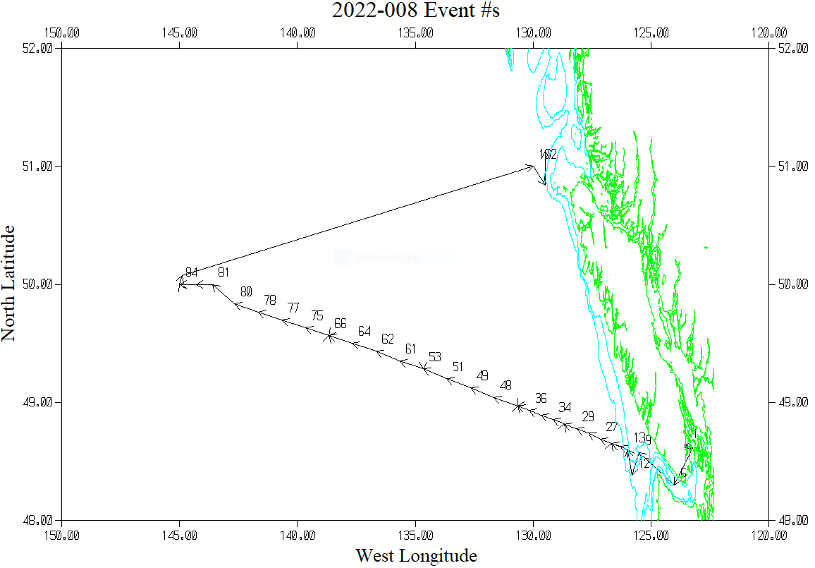

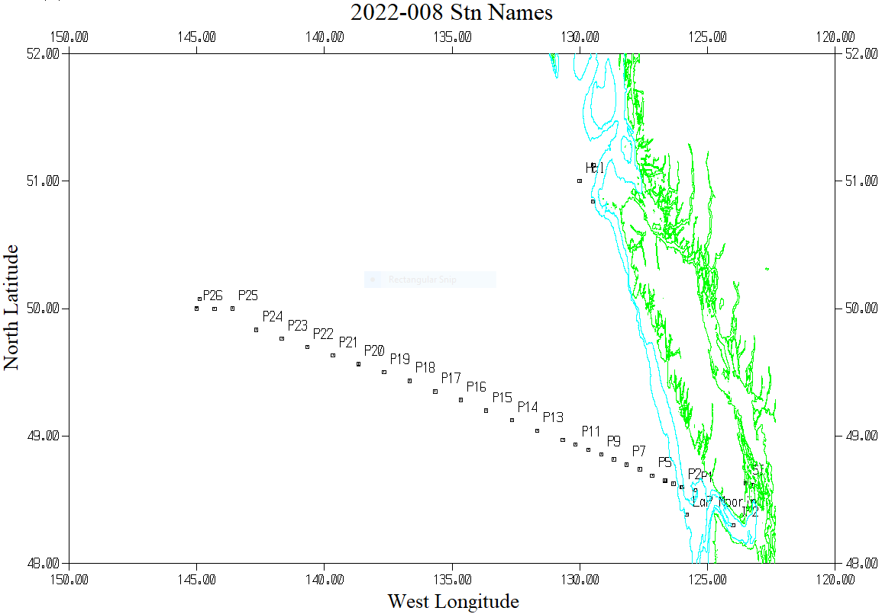

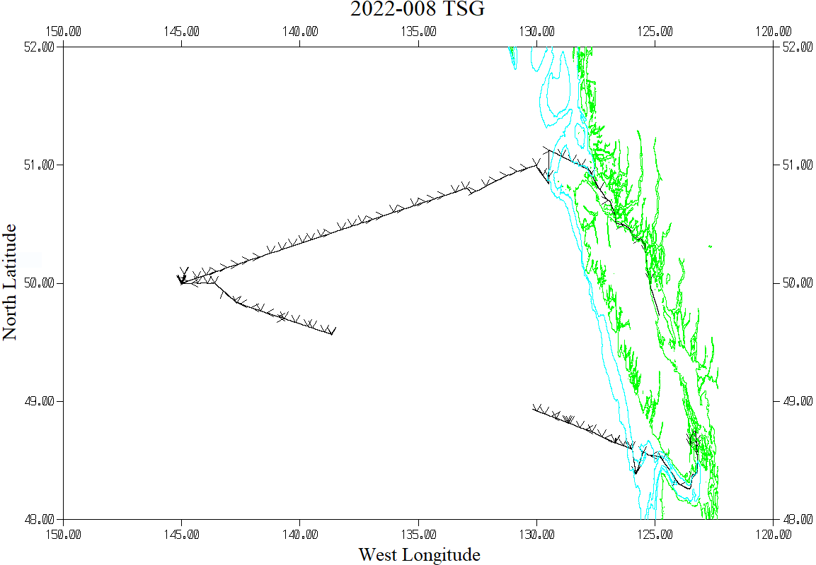

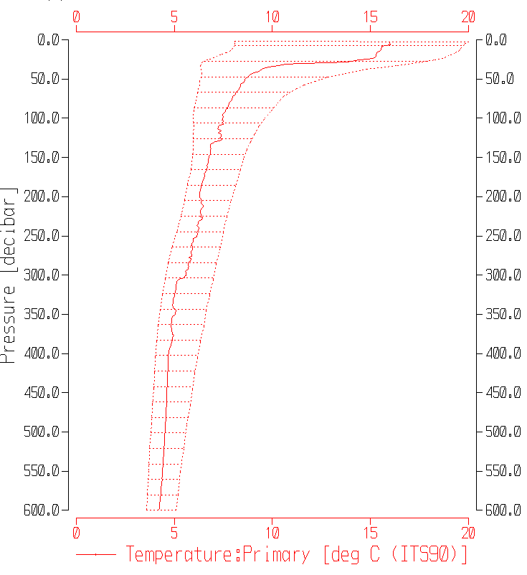2022 August Stn P8

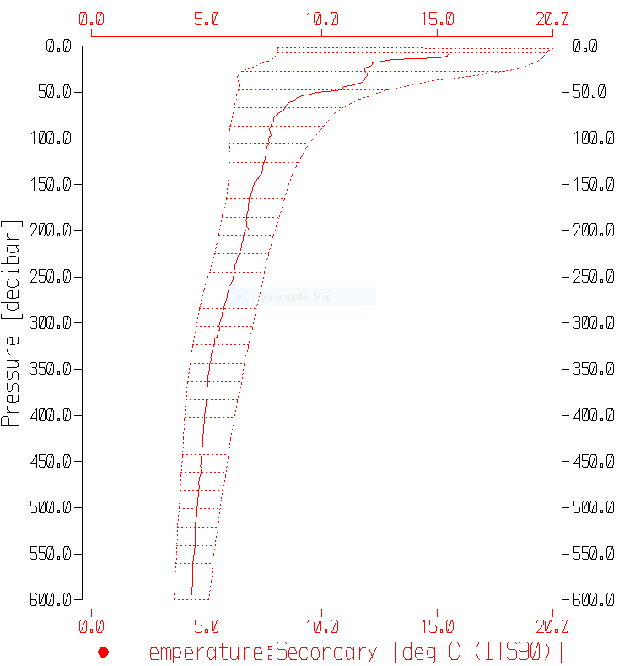

2021 August Stn P8

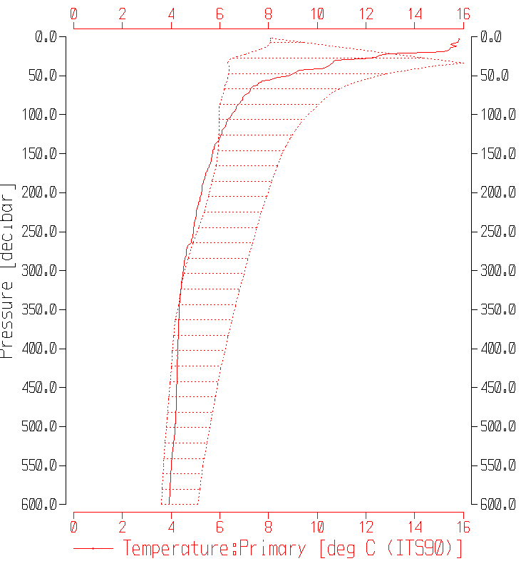2022 August Stn P15

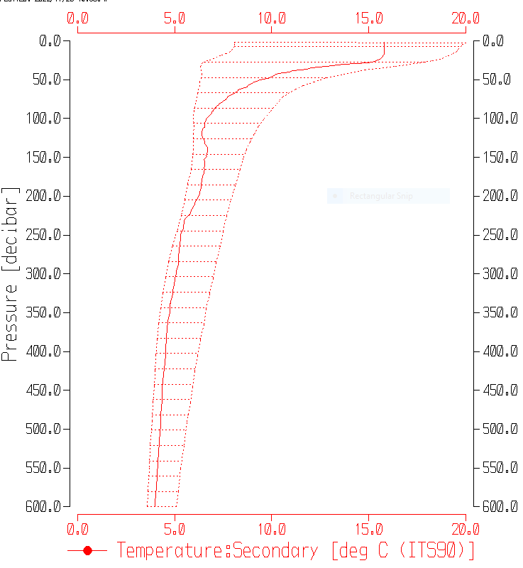

2021 August Stn P15