REVISION NOTICE TABLE
DATE | DESCRIPTION OF REVISION

PROCESSING NOTES
Cruise: 2021-003
Agency: IOS, Ocean Sciences Division, Sidney BC
Chief Scientist: Young K. Platform: Neocaligus
Location: Strait of Georgia Project: Strait of Georgia Zooplankton
Date: 10 February 2022 –13 February 2022

Processed by: Germaine Gatien
Date of Processing: 6 June 2022 –
Number of original HEX files:
Number of CTD files: Number of BOT files:

INSTRUMENT SUMMARY
A SeaBird Model SBE-25 CTD (s/n 0404) was used with temperature sensor #5724, conductivity sensor #1763, Wetlabs ECO Fluorometer #2215, dissolved oxygen sensor #47 and pressure sensor #0464.

SUMMARY OF QUALITY AND CONCERNS
There was a digital log book with positions and notes about sampling. It was missing start times.
Header information was entered in the raw files in a format that enabled easy conversion into IOS Header format.

There were surface bottles fired at 15 sites; they were given separate event numbers from the CTD casts. At 5 of those sites there was also a Niskin mounted 2m or 1m above the CTD to collect near-bottom samples. In the BOT files all sample data are identified by the event number of the corresponding CTD cast.

Calibration samples were available for comparison with CTD salinity and fluorescence. The CTD salinity was reading a little higher than samples, but incomplete flushing of Niskin bottles might explain the differences seen. All extracted chlorophyll samples came from the surface, so there is insufficient evidence to judge how well the CTD fluorometer performed. DO values are likely a little low. Pressure was recalibrated by adding 0.4db.

PROCESSING SUMMARY

1. Seasave
This step was completed at sea. The file names were in non-standard format.
The names were corrected after conversion to CNV format.

2. Preliminary Steps
A digital daily log was obtained but it was missing start times.
The cruise summary sheet was completed.

CTD Deployment method: Timer set to 2 minutes. CTD down to 10m for soak until 1m 30s mark, bought back to surface to sit until 2 minutes are up. Then full cast begins.
BOTTLES: Samples were drawn right after the cast, no more than 15minutes after the CTD was brought on deck. Bottles were deployed as follows:
1. For casts with bottom sampling a 1.7L Niskin bottle was mounted ~1.5m above the CTD except for casts 40 and 55 when it was ~1m above.
2. Surface sampling was done for each cast after the CTD was taken out of the water and turned off. A 5L Niskin bottle was attached to the wire, sent to the surface and triggered. A separate event number is given for the surface samples.

3. Conversion of Raw Data
The configuration file used at sea was correct. It was saved as 2021-003-ctd.xmlcon and used to convert all HEX files.
All expected variables are present.
Plots show that the channels all produced reasonable values, although oxygen looked odd for cast #26; that is likely because it was a very shallow cast with little variability.
Fluorescence dark value is ~0.5ug/L; while a little high for deep water, this is not unusual in the Strait of Georgia.
There is the usual steppy pressure which leads to unusual profiles.

4. WILDEDIT
The only spikes noted in the data occurred at the beginning or end of the casts or included many points, and will be removed in the normal course of editing. So WILDEDIT was not run.

5. FILTER
Normally pressure is filtered later in processing when running DELETE, but the poor resolution of this instrument means it is necessary to do this early to make sense of the other data which update more often than pressure. So program FILTER was used to apply a low-pass filter with a time constant of 0.5 seconds to pressure. The results were excellent.
Next the temperature and conductivity were examined and the usual approach of applying a cosine filter size 8 in routine WFILTER did a good job of removing small reversals.

6. ALIGNCTD
Based on tests run for other cruises in this project using the same DO sensor, ALIGNCTD was run on all casts to advance the DO channel by 2.5s. Plots were examined after this step and the results look excellent.

7. CELLTM
CELLTM was run on all casts using the SeaBird recommended parameters, (α, 1/β) = (0.04, 8).

8. DERIVE
Program DERIVE was run to calculate salinity and dissolved oxygen concentration (tau correction included). Plots were examined and confirmed that steps 5, 6 and 7 had improved the data.
There were no fluorescence values <0

9. Conversion to IOS Headers
The IOSSHELL routine was used to convert the CNV files to IOS Headers.
CLEAN was run to add event numbers and replace pad values in the pressure channel with interpolated values. The setting was ticked to replace fluorescence values <0 with pad values, but there were none.

10. Checking Headers
A cross-reference list was produced and file #19 had no latitude due to a missing hemisphere entry in the CNV file. That was fixed and no further problems were found.
Track plots looked ok so were added to the end of this report.

Surface Check was run and the average was -0.3db with a range from 0 to -0.8db. All files were put through REVERSE and another run of Surface Check gives an average of -0.7db with a range of -0.2 to -1.2db. The CTD was clearly out of water in both cases so these checks give an approximate deck pressure. After the 10m soak a few of the CTDs recorded slightly negative pressures with “in water” salinity; for cast #28 the CTD was at about -0.2db for long enough that this was not a case of the CTD leaving water only briefly.

During 2021-078 when this sensor was last used it was thought to be reading slightly low, between -0.2 and -0.5db. The pressure sensor has a resolution of ~1db, so variable surface readings are expected. Adding 0.4db looks like a reasonable step to ensure good data are not lost.

HEADER CHECK was run. No problems were found.

11. CLIP and CALIBRATE
The next step is to remove the data collected during soaks at 10m. CLIP was run removing the initial 1000 scans from all casts. Then plots were made to identify casts that needed a different choice and CLIP was run on those individually, until plots showed an appropriate number of scans had been removed. made.
CALIBRATE was run using file 2022-003-recal1.ccf to add 0.4db to the Pressure channel. (Depth should have been recalibrated at this point as well, but was forgotten. See section18 CALIBRATE

12. SHIFT
Conductivity
Tests were run to see what shift to conductivity made the best improvement to stability in T-S space. There was not a lot of difference, but a shift of +0.2 records made a slight improvement. That setting was applied to all casts.
Fluorescence
The fluorometer was not pumped, so a shift in alignment is expected to be small or unnecessary. Profile plots of temperature and fluorescence were examined and confirm that the alignment is ok.
Dissolved Oxygen
This channel was aligned earlier, but checks were made by examining plots of temperature and dissolved oxygen. No further adjustment was made.

13. DELETE
DELETE was run on all casts using the following parameters:
Surface Record Removal: Last Press Min. Surface Swell Pressure Tolerance: 1.0
Swells deleted. Warning message if pressure difference of 2.00
Drop rates < 0.3m/s (calculated over 5 points) was deleted from 10db to 10db above the maximum pressure.
COMMENTS ON WARNINGS: There were no warnings.

14. DETAILED EDITING
All DEL files were copied to *.EDT so there will be a complete set of files even if some need no editing.

CTDEDIT was used to do some light editing of 21 files, mostly removal of a few records near the top and/or bottom. One file needed light editing of salinity.
Notes of editing details were made in the headers.
T-S plots were examined after this step. Small unstable features remain but that is common in this region and may well be real.

15. Initial Bottle Data Steps
There was no rosette available for this cruise. There were surface bottles fired at 16 sites; they were given separate event numbers from the CTD casts. At 5 of those sites there was also a Niskin mounted above the CTD to collect near-bottom samples.
BOT files were prepared with the sample data plus CTD gathered at the same site.
The event numbers will be those of the CTD cast at the site.

Each of the analysis spreadsheets were examined to see what comments the analysts wanted included in the header file. These were used to create file 2021-003-bot-hdr.txt which will be updated as needed during processing.
- Chlorophyll analysis was obtained in spreadsheet QF 2021-003_CHL*.xlsx.
- Salinity analysis was obtained in spreadsheet QF 2021-003_SAL*.xlsx.
- Nutrient analysis was obtained in spreadsheet QF2021-003_NUTS..xlsx.
Note that only HPLC sampling was done at a few sites. At the time of processing HPLC data were not available, but BOT files were prepared so that those data can be added later.

Workbook 2021-003-bottles_plus_CTD_6linehdr. csv was created. Data from the QF worksheets were added to one sheet of the workbook. A 6-line header was prepared using entries from the event log relevant to Niskin sampling plus bottle data. Space was included for the addition of CTD data.

There are no CTD data right at the surface, so data from as close to the surface as possible were obtained. For the bottom samples data were found from the maximum depth. Although the bottle was above the CTD some data were removed from the bottom in editing and incomplete flushing of Niskin bottles likely means the water in the bottles is from a little above the level at which they closed. To obtain those data the EDT files were binned to 0.5db and then thinned to 0.5, 1db, 2db and the maximum level sampled. They were extracted to a spreadsheet and reduced to the shallowest values for each cast and the appropriate pressure for the casts with deep sampling. Those data were added to the 6-line header file.

File 2012-003-bottles_CTD-comparison.xlsx was prepared to do a comparison of CTD and bottle data for salinity and fluorescence.

16. Compare
Salinity Comparison
The CTD salinity was found to be higher than bottle salinity by a median of 0.002 including surface samples. Using only the 4 bottles closed below 300db the CTD read higher by an average of 0.021psu with a median difference of 0.008psu. The surface samples are higher than bottles by 0.954, 0.03, 0.0009psu. Upcast near-surface salinity values were generally higher than downcast values, presumably due to shed wake effects. The CTD reading higher is to be expected at the bottom of casts since Niskin bottles don’t flush perfectly, especially in areas with fairly calm seas.

The near-bottom CTD files were examined to see at what pressure the CTD salinity matched the bottle salinity. Matches were found between 9db and 21db above the CTD salinity selected in the comparison. Poor flushing can account for that sort of difference in quiet waters, and descent rates suggest conditions were calm during these casts.

The salinity comparison from this program is never good enough to justify recalibration but it does not indicate any serious problems with the sensor.

There were 2 cases of salinity <25psu for surface samples; the nutrient analyst was informed and corrections were made.
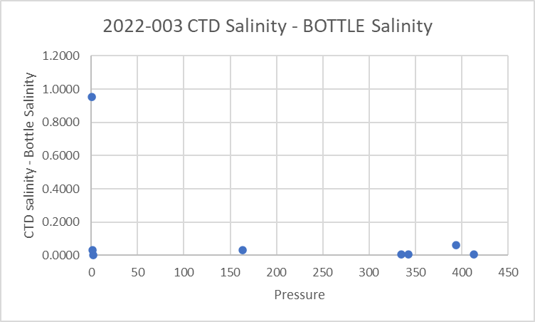

Fluorescence
The only chlorophyll sampling was at the surface. As usual the fluorescence is higher than CHL when CHL is low. However, when the CHL was very high, the fluorescence was even higher. This is unusual, but the vertical gradient was extreme, so the match in time and depth for 2 measurements is not likely to be good.
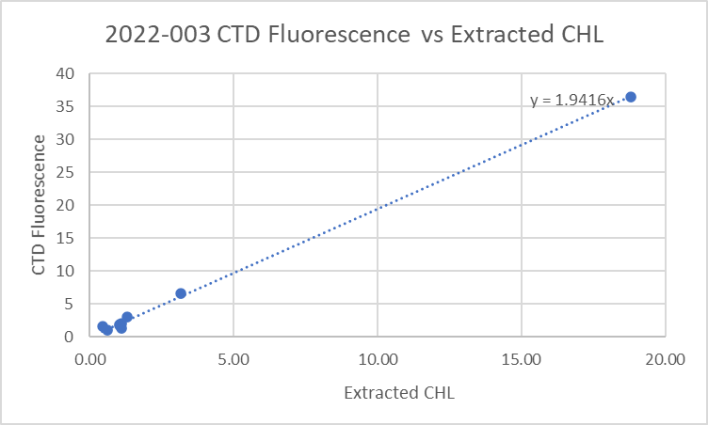
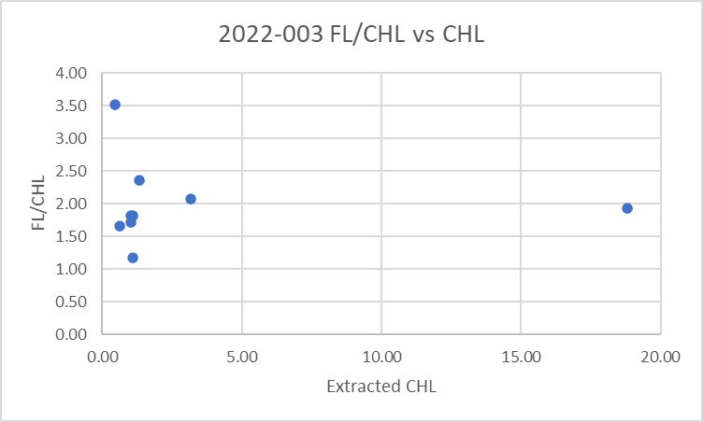

17. Other calibration checks
Sensor History – The pressure, conductivity and dissolved oxygen sensors were used on 1 other cruise since last being serviced but there was no calibration sampling. The pressure sensor appeared to be reading a little high, perhaps by 0.4db.
Historic Ranges – Temperature data were within the historic ranges in the northern and central parts of the cruise. There was a small section of cast #43 around 170db where values were a little lower than the minimum. To the south the casts were extremely well mixed and there were some excursions to low temperature near the top and bottom of some casts. Salinity was within the climatology in the central and southern sections except for one slight excursion above the maximum. To the north there were excursions towards lower salinity around 100-150db; most casts between events #6 and #28 were affected. This looked like a case of deeper mixing than usual. The climatology is not well suited to sampling so close to shore.
Post-cruise calibrations – None were available.

18 CALIBRATE
The pressure has been recalibrated but depth was not, so CALIBRATE was run using file 2022-003-recal2.ccf to add 0.4m to depth.
There is insufficient information to recalibrate salinity.
For dissolved oxygen there is insufficient evidence upon which to base any recalibration. There was no calibration sampling; the surface saturation values are a little low but given fairly well-mixed surface waters that may reflect real conditions. See section21. HEADER EDIT and final checks of CTD files. for details.

19. Fluorescence Filter
The fluorescence data was not filtered as it had little effect on the data.

20. Bin Average, Remove, Derive DO in mass units, Reorder
The files were bin averaged using 1db bins.
REMOVE was run to remove Scan_Number, Oxygen:Voltage, Descent Rate and Flag channels.

Dissolved Oxygen was derived in mass units and that was used to calculate DO saturation. Plots of near-surface saturation show a range of 78% to 125%, with values in the central Strait being mostly between 98% and 102% and the lowest values in the Gulf Islands area where there is likely strong vertical mixing.
The highest value is from station 22 which had a very high surface DO and fluorescence values, ~8.8mL/L and ~37ug/L, respectively.
REORDER was used to get the 2 dissolved oxygen channels together.

21. HEADER EDIT and final checks of CTD files.
Header Edit was used to fix headers, fix formats and to add comments about processing.
A cross-reference listing was produced.
A header check and standards check were run on the CTD files and no errors were found.
The sensor history was updated.
Plots of CTD casts were examined and no problems were found.

2. Final BOT file preparation
To enable searching of bottle data, BOT casts were created that contain sample data and CTD data from the downcast at the same site. The event number will match the CTD cast. CTD data were extracted from metre-averaged files and added to spreadsheet 2021-003-bottles_plus_CTD_6linehdr.csv. That file was converted to IOS Header files for each cast.

The time and date are present as channels as these cannot be converted directly into header entries.
CLEAN was run to add START and END time. The END TIME is identical so the START time so it will be removed later. CLEAN was also used to enter 0 flags where the flag channels are empty.
The CTD data do not include DO in mass units, so Change Units was run to add that channel.
There was no DO sampling so there is no need to derive mass units for the sample data.
REMOVE was run to remove the DATE and TIME channels
REORDER was run to get the 2 DO channels together..
SORT was run to get entries in pressure order.

Header Edit was run to add comments and to remove the END time since it is the same as START TIME.
A header check turned up a problem – depth had not been recalibrated. Calibrate was run on the SORT files and Header Edit was rerun. No further problems were found.

The final files have extensions BOT.
The standards check was run until all errors had been corrected.
A cross-reference list and header check were run on the BOT files and no problems were found.
Plots were made of all BOT casts. With just 1 or 2 levels these were not very useful.
Finally all data from BOT files were extracted to a spreadsheet and compared to the event log; no problems were found.
Low salinity corrections were made provided by the analyst and entered in the final files for silicate samples #5 and 17.

CRUISE SUMMARY

Cruise ID#: 2022-003
Dates: Start: 10 February 2022 End: 13 February 2022
Location: Strait of Georgia Zooplankton
Chief Scientist: Young K.
CTD# | Make | Model | Serial# | Used with Rosette? | CTD Calibration Sheet Competed?
1 | SEABIRD | 25 | 404 | No | Yes

CTD CALIBRATION INFORMATION
Make/Model/Serial#: SEABIRD/SBE25/0404 Cruise ID#: 2022-003
Calibration Information
Sensor |  | Pre-Cruise |  | Post Cruise
Name | S/N | Date | Location | Date | Location
Temperature | 5130 | 12Dec2019 | Factory
Conductivity | 3500 | 17Dec2019 | Factory
ECO Fluorometer | 4185 | 11Dec2019 | Factory
SBE43 Oxygen | 3234 | 6Dec2019 | Factory
Press | 0573 | 1Feb2019 | Factory

