## REVISION NOTICE TABLE

|  |  |
| --- | --- |
| DATE | DESCRIPTION OF REVISION |

## PROCESSING NOTES

Cruise: 2022-002

Agency: ESD

Location: North-East Pacific

Project: International Year of the Salmon

Chief Scientist: King J.

Platform: Sir John Franklin

Date: 19 February 202 – 24 March 2022

Processed by: Germaine Gatien

Date of Processing: 5 May 2022 – 4 August 2022

Number of HEX files: 37 (2 split casts) Number of CTD files processed: 35

Number of rosette files: 37 (2 split casts) Number of bottle casts processed: 35

# INSTRUMENT SUMMARY

CTD #0585 was mounted in a rosette and attached were a Wetlabs CSTAR transmissometers (1201DR), a SBE 43 DO sensor on the primary pump (#1176), SeaPoint Fluorometer on the secondary pump (#2225), a pH sensor (0691), an altimeter (#75321).

Seasave version 7.26.7.121was used for acquisition.

The data logging computer was WP Mini #103.

The deck unit was a Seabird model 11+ #1043.

A Guildline model 8400B Autosal serial # 73274 was used to analyze salinity samples.

An IOS rosette with 24 10L bottles was used.

# SUMMARY OF QUALITY AND CONCERNS

The Daily Science Log Book and rosette log sheets were in good order with helpful comments about problems encountered.

There were problems with the sounder so readings are considered ±10%. The casts did not get close enough to the bottom for altimetry to be useful in establishing water depths.

Deck Pressure readings varied from -0.3 to -0.6db, so CTD pressure was recalibrated by adding 0.6db.

The SBE DO sensor has a fairly long response time so data accuracy is not as high when it

is in motion as it is during stops for bottles. This will be especially true when vertical

DO gradients are large. To get an estimate of the accuracy of the SBE DO data during

downcasts (after recalibration) a rough comparison was made between downcast SBE DO and upcast

titrated samples. Some of the difference will be due to problems with flushing of Niskin

bottles and/or analysis errors and small mismatches in depth in the presence of large DO

gradients, so the following statement likely underestimates SBE DO accuracy.

Downcast (CTD files) Oxygen:Dissolved:SBE data for this cruise are considered, very roughly, to be:

±0.20 mL/L from 0-200db

±0.10 mL/L from 200-400db

±0.03 mL/L below 400db

The pH:SBE:Nominal data should be used with caution; no field calibration data were gathered. Calibration is required for each cast to get absolute values, although general trends within a cast are likely real.

# PROCESSING SUMMARY

##### Seasave

This step was completed at sea; the raw data files have extension HEX.

##### Preliminary Steps

* The configuration files used at sea were changed twice to update the pH sensor parameters based on tests done at sea. The last calibration on record was from February 2021. All other calibrations were correct. One file with corrected pH parameters was saved as 2022-002-ctd.xmlcon.
* The Log Book and rosette log sheets were obtained.
* Nutrients, extracted chlorophyll, dissolved oxygen and salinity data were obtained in QF spreadsheet format from the analysts.
* The cruise summary sheet was completed.
* This CTD had no history of use since the last factory calibration.
* Two casts (#58 & #133) were interrupted and have 2 files per cast. The first parts contains all the downcast data, but the pairs will need to be joined for bottle files.

##### BOTTLE FILE PREPARATION

The ROS files were created using files 2022-002-ctd.xmlcon.

They were converted to IOS Header format with extension *.IOS.

JOIN was used to combine the split casts #58 and 133.

The IOS files were put through CLEAN to create BOT files.

Temperature and salinity were plotted for all BOT files to check for outliers. A few outliers were found in casts #24 and142. CTDEDIT was used to edit those files and the output was copied to *.BOT.

Noisy patches are seen in many casts but these are not simple outliers.

CALIBRATE was run using file 2022-002-recal1.ccf to add 0.6db to pressure. See section 11 for evidence. Running this early will ensure no useful near-surface data are lost. Output:COR1

A preliminary header check was run and no problems were found.

The COR1 files were bin-averaged on bottle number.

The output was used to create file ADDSAMP.csv. First, the file was sorted on event number and Bottle Position order. Then sample numbers were added based on the rosette logs.

The file was sorted on sample number.

The ADDSAMP file was used to add sample numbers to the BOT files – output *.SAM.

The SAM files were bin-averaged on bottle # and called SAMAVG.

The addsamp.csv file was converted to CST files, which will form the framework for the bottle files.

Next, each of the analysis spreadsheets were examined to see what comments the analysts wanted included in the header file. These were used to create file 2022-002-bot-hdr.txt which will be updated as needed during processing.

DISSOLVED OXGYEN

Dissolved oxygen data were provided in spreadsheet QF2022-002_OXY*.xlsx which includes flags, comments and a precision study. Draw temperatures are available. The spreadsheet page with the final data was simplified and saved as 2022-002oxy.csv. That file was converted into individual *.OXY files.

There were no samples in the DO file that had comments starting with “ALL:”.

EXTRACTED CHLOROPHYLL

Extracted chlorophyll and phaeo-pigment data were obtained in file QF2022-002_CHL*.xlsx. The file included comments and flags and a precision study. A simplified version of the spreadsheet was prepared and saved as 2022-002chl.csv. The csv file was then converted to individual CHL files.

SALINITY

Salinity analysis was obtained in file QF2022-002_SAL.xlsx which included a precision study. The analyses were carried out in a temperature-controlled lab within 19-36 days of collection. The files were simplified and saved as 2022-002sal.csv. That file was then converted to individual SAL files.

NUTRIENTS

The nutrient data were obtained in spreadsheet QF_NUTS_2022-002*.xlsx. This includes a precision study. The file was simplified, saved as 2022-002nuts.csv and converted to individual NUT files.

The file was then converted to individual files.

The SAL, CHL, OXY and NUT files were merged with CST files in 4 steps.

The files were then put through CLEAN to reduce the headers to File and Comment sections only.

These files are ordered on sample number, but the SAMAVG files are ordered on bottle number, so the MRGCLN1 files were reordered on Bottle_Number and saved as *. MRGCLN1s.

The MRGCLN1s files were then merged with SAMAVG files using merge channel Bottle_Number.

Niskin 5, cast #84 was fired accidentally; that line was removed from the SAMAVG file and MRG files.

The output of the MRG files were exported to a spreadsheet and compared to the rosette log sheets to look for omissions. A few problems were noted:

1. There was no sampling log for event 142 – either digital or original paper version.

2. The rosette sheet for event #113 was labelled as 111 so the nutrient and chlorophyll samples were also given the wrong names. They were missed in the first version of bottle files.

3. A few chlorophyll samples that were lost had labels on the back of the rosette sheets, but the analyst had no access to those at the time of analysis, so entries were missed.

The minimum CTD Salinity in the spreadsheet was 32psu so there was no need to apply a correction to silicate samples.

A header check was run and the project name and area were reversed in the headers. This will be fixed later when Header Edit is run.

##### Compare

Salinity

Compare was run with pressure as reference channel.

There were a number of bottles flagged 3 or 4 by the analyst due to the presence of salt crystals or poor seals on bottles. Those bottles were excluded from the fit to check whether they were outliers and most of them were. The only one that did not seem out of line was sample #303 from 5m.

When those bottles plus ones with noisy CTD salinity (Std Dev >0.0008psu) are excluded, the fits are quite flat, though there is considerable scatter. One value that was removed due to CTD variability for the primary but not the secondary, was included so that the same bottles are included in both fits; it was not out of line in the fit. The primary salinity was low by an average of 0.0052psu (std dev 0.0012psu) and the secondary is low by an average of 0.0019 (std dev 0.0011psu).

Variations in how bottles were excluded had little effect on the differences but did affect the slope of the fit. Achieving a fairly flat fit is recommended by the manufacturer and the fits in this comparison are relatively flat.

Plots of differences versus file pair number (proxy for time) suggests that both salinity channels drifted downwards through the cruise, with the primary changing by ~0.005 and the secondary by ~0.002psu. However, the first cast, #58, is out of line with the others. If that cast is left out of the plot the drift with time is ~0.001psu for both sensors. Examination of the differences between the 2 salinity channels for casts #58 and #65 at about 1800db shows no change, so there was likely no significant shift. There are too few casts with salinity sampling to establish such a drift or shift.

The differences between channels at 300db were checked for 10 casts through the cruise. There were large variations through the casts with rough estimates of 0.35psu to 0.47psu. They do not show any temporal trend. The smallest differences came from casts early in the cruise (casts #8 and #12) and near the end (casts #130 and #141). Higher and noisier descent rates likely lead to minor variations in T/C alignment and the differences did vary a lot at 300db.

There are too few data to enable a time-dependent recalibration and it seems most likely that there was no significant temporal variation.

The secondary salinity is closer to bottles, being lower by an average of 0.0019psu. Errors due to incomplete flushing and evaporation/desorption of samples are likely small given quick salinity analysis and deep sampling under rough conditions. But the errors would not be 0 and bottle contents are likely high by 0.001 to 0.002psu. Thus the CTD salinity is probably closer to bottles than it appears. No recalibration is justified for the secondary. The primary is lower than the secondary by an average of 0.0033psu (based on the COMPARE results). If the primary is selected for archiving it should be recalibrated by adding 0.003psu, thus bringing it into line with the secondary. With that adjustment both channels would likely be within ±0.002psu. There were no duplicates but the salinometer had been performing well.

For full details for the COMPARE run see file 2022-002-sal-comp1.xls.

Dissolved Oxygen

COMPARE was run with pressure as the reference channel.

An initial fit was based on plots of (SBE DO – Bottle DO) versus SBE DO. After removing cases where the standard deviation in the SBE DO is >0.03mL/L and then gradually removing outliers based on residuals was:

CTD DO Corrected = CTD DO * 1.0076 + 0.0507 R2 = 0.82 (1)

A plot of differences versus time shows cast #24 standing out from the others. The vertical gradients at their peak were somewhat lower for the first 3 casts with DO sampling (24, 53, 58), so they were plotted separately from the higher gradient casts (65, 76, 88, 100, 124, 133, 142). Bottles from the highest gradient zone were removed from each group – generally between 75 and 175db, but there were deeper mixed layers for a few casts. If poor flushing of bottles in high gradients is a factor in the fits, we would expect the bottles excluded to have differences above the trendline, and they do not; the differences look random except right at the surface where the gradient may reverse. The descent rate of the CTD shows conditions were fairly rough, so it is likely that most bottles were quite well flushed.

The fits using the 2 groups, excluding the high-gradient zone and a few obvious outliers in each, are reasonably close to each other. The 2nd group is very close to the general fit, which is not surprising given they represent the bulk of the sampling. The first 3 casts have a somewhat different fit, but when 1 obvious outlier was removed it was similar.

CTD DO Corrected = CTD DO * 1.0086 + 0.0518 R2 = 0.64 (2) Casts 24-58

CTD DO Corrected = CTD DO * 1.0072 + 0.0509 R2 = 0.64 (3) Casts 65-142.

Plots of Titrated DO and CTD DO against CTD salinity were examined. No further outliers were found.

No outliers were identified that require further flagging of DO samples.

One sample was padded in the data used in the comparison – sample #470 was changed by the analyst to 2.670 and flagged 26 with a comment.

Fluorescence

COMPARE was run with extracted chlorophyll and CTD Fluorescence using pressure as the reference variable. Values flagged as <MLD were not included in the comparison

As usual, CTD fluorescence is higher extracted CHL for very low CHL, with a FL/CHL ratio of up to 3. The ratio drops rapidly to 0.5 in the range 0.2<CHL<0.4ug/L. As CHL increases the fluorescence data spit into 2 groups.

The fit of CTD fluorescence versus extracted CHL samples indicates that the data fall into a fairly tight group for low CHL but divide into 2 distinct groups for high CHL.

To study the source of the 2 lines, a plot of CHL and CTD Fluorescence versus event number was prepared and shows a geographic division. In the north-eastern section of the cruise CHL is relatively high and fluorescence low. In the south-western section CTD fluorescence is closer to CHL even when CHL levels are similar. Temperature and dissolved oxygen vary greatly through this region, so this split is more likely due to variations in types of phytoplankton than a problem with the fluorometer.

##### Conversion of Full Files from Raw Data

All files were converted using 2022-002-ctd.xmlcon.

The Tau function was selected and the hysteresis function since there was some deep sampling. Depth was included in the conversion.

A few casts were examined. The descent rate is extremely noisy with many complete reversals in direction and much evidence of shed wake corruption in the profiles of temperature.

The transmissivity, pH, DO and fluorescence traces look normal. No useful altimetry was found because the CTD was never close enough to the bottom for it to register values <100.

The dark value for fluorescence was 0.055ug/L.

There are some spikes that do not appear to be related to shed wake corruption.

The T and C pairs were reasonably close during downcasts with upcasts extremely noisy.

##### WILDEDIT

Program WILDEDIT was run to remove spikes from the pressure, depth, conductivity & temperature only in the full cast files (*.CNV).

Parameters used were: Pass 1 Std Dev = 2 Pass 2 Std Dev = 5 Points per block = 50

The parameter “Keep data within this distance of the mean” was set to 0 so all spikes would be removed.

The spikes noted in cast #1 were resolved by this step.

The small spikes in conductivity were reduced, though not completely removed.

##### ALIGN DO

A few casts were examined; both temperature channels were noisy during upcasts so the tests were not easy to interpret, but using +2.5s certainly improves the alignment and overall looks like a good choice for both sensors. That setting has worked well for many SBE DO sensors in recent years.

ALIGNCTD was run on all casts using +2.5s.

##### CELLTM

The noise in the upcast data makes tests for the best parameters for this routine very difficult to interpret. In the past when upcast data were not so noisy, the default setting of (α = 0.0245, β=9.5) was generally found to be the best choice. A few casts were checked for this cruise and the default setting does improve the data. CELLTM was run using (α = 0.0245, β=9.5) for both the primary and secondary conductivity.

##### DERIVE and Channel Comparisons

Program DERIVE was run on all casts to calculate primary and secondary salinity and dissolved oxygen concentration.

DERIVE was run a second time on 3 casts to find the differences between the pairs of temperature, conductivity and salinity channels.

|  |  |  |  |  |  |
| --- | --- | --- | --- | --- | --- |
| Cast # | Press | T1-T0 | C1-C0 | S1-S0 | Descent Rate |
| 2022-02-0058 | 1000 | +0.0002 | +0.00031 | +0.0035 | High, XNoisy |
|  | 1900 | +0.0001 | +0.00025 | +0.0030 | “ |
| 2022-002-0065 | 1000 | +0.0002 | +0.00030 | +0.0037 | High, XNoisy |
|  | 1900 | +0.0002 | +0.00027 | +0.0032 | “ |
| 2022-002-0142 | 1000 | +0.0001 | +0.00033 | +0.0040 | High, XNoisy |
|  | 1900 | +0.0002 | +0.00029 | +0.0033 | “ |

There were no known previous uses since the last factory calibration. The differences are consistent and show no sign of drift through the cruise. Casts before #58 were quite shallow, but at 300m salinity differences are on the order of +0.0036psu.

##### Conversion to IOS Header Format

The IOSSHELL routine was used to convert Sea-Bird 911+ CNV files to IOS Headers.

CLEAN was run to add event numbers and to replace pad values in the pressure channel with interpolated values based on record number.

##### Checking Headers

* The cross-reference check was run. The format for the station names made it easiest to check for accuracy by looking at a track plot with station names. All appear to be correct. A few positions and times were checked against the log and no problems were found.
* The header check was run and showed pressures got as low as -0.6db with pumps on and salinity that is low but in water. Three casts show transmissivity dropping to 0 at -0.5db and -0.6db. Deck pressures were found between -0.3db and -0.6db. Pressure is likely low by 0.6db.
* Surface check was run and found an average of 3.3db which is fairly deep if we add another 0.6db. However, conditions were very rough so a deeper start is reasonable. The range of values was large from 0.8db to 4.8db.
* Cruise tracks were plotted and look fine; they were added to the end of this report.
* The CTD never got close enough to the bottom to produce header altimetry readings, so there is no way to check the accuracy of the water depth records.

CALIBRATE was run using file 2022-002-recal1.ccf to add 0.6db to the pressure readings so no useful data would be lost.

##### Shift

Fluorescence

SHIFT was run on the SeaPoint fluorescence channel in all casts using the usual advance of +24 records. Plots show that the fluorescence offset is reasonably close to the temperature offset after this step, though the very low values make the plots so noisy it is hard to judge.

Dissolved Oxygen

The Dissolved Oxygen voltage channel was aligned earlier. The upcast temperature is so noisy that it is impossible to fine-tune the alignment, but there is no evidence that the setting applied earlier was inappropriate. No further alignment will be applied.

Conductivity

Tests were run on 3 casts to assess what settings are best to align conductivity with temperature (as judged by the effect on salinity as seen in T-S space). The data are extremely noisy with all choices. The best settings were -0.3 records for both the primary and the secondary conductivity. SHIFT was run twice on all SBE911 casts using those settings. Salinity was recalculated for both channels.

pH:SBE

Tests run on 3 casts indicate that a shift of +25 records looks best at aligning up/down profile offsets with those of the temperature traces. SHIFT was run on channel pH:SBE to advance the records by 25 records.

##### DELETE

The following DELETE parameters were used:

Surface Record Removal: Last Press Min

Maximum Surface Pressure (relative): 10.00

Surface Pressure Tolerance: 1.0 Pressure filtered over 15 points

Swells deleted. Warning message if pressure difference of 2.00

Drop rates < 0.30m/s (calculated over 11 points) will be deleted.

Drop rate applies in the range: 10db to 10db less than the maximum pressure

Sample interval = 0.042 seconds. (taken from header)

COMMENTS ON WARNINGS: There were no warnings.

##### Other Comparisons

Experience with these sensors since last factory service – None

Historic ranges – Profile plots were made with 3-standard deviation climatology ranges of T and S superimposed. All temperature data fell within the climatology and there were just 2 small excursions in salinity. These do not suggest any problems with calibration as there were no systematic excursions.

Post-Cruise Calibration – There were no post-cruise calibrations available.

##### DETAILED EDITING

The decision on which channel pair to use is not obvious. The secondary salinity is closer to bottles but was more heavily corrupted by shed wakes. Since more data would have to be deleted from the secondary than from the primary, the primary salinity was chosen to be edited.

CTDEDIT was used to remove records that appear to be corrupted by shed wakes and to clean salinity where small spikes appear to be due to small misalignment or instrumental noise. Many casts had very noisy descent rates with some complete reversals of direction, resulting in corrupted data as shed wakes catch up to the CTD.

All casts required editing.

Notes about editing applied were added to the files.

The edited files were copied to *.EDT.

After editing T-S plots were examined for all casts. A little touch-up editing was applied to one cast. A few other unstable features found were from areas where they could be real and are likely to disappear when the files are bin-averaged.

##### pH correction – all casts except 121-138

When DELETE was run the wrong input files were chosen for most casts so that the pH alignment step was missing. So all files were put through DELETE separately to create DELpH files that included the pH SHIFT step. The pH channel was removed from the EDT files to create EDTrem and then MERGE was run to add the pH channel from the DELpH files to EDTrem to create EDTpH files.

##### Corrections to Pressure, Salinity and Dissolved Oxygen Concentration

The pressure channel was recalibrated earlier for both bottle and CTD files.

File 2022-002-recal2.ccf was prepared to add 0.033psu to channel Salinity:T0:C0 and to apply the following correction to channel Oxygen:Dissolved:

CTD DO Corrected = CTD DO * 1.0076 + 0.0507

This correction was first applied to the SAM and MRGCLN2 files.

COMPARE was rerun for salinity and dissolved oxygen and show that the correction was applied properly. When data are excluded based on using the same points as in the original fits:

* Salinity:T0:C) was lower than bottles by an average of 0.0019psu. See file 2022-002-sal-comp2.xls for details.
* SBE Dissolved oxygen was lower than titrated samples by an average is 0.0001mL/L, with a standard deviation of 0.010mL/L. See file 2022-002-DO-comp2.xls for details.

CALIBRATE was then run on the EDTpH files using the same recalibration file.

##### Final Calibration of DO

The initial recalibration of dissolved oxygen corrects for sensor calibration drift. Alignctd corrects for transit time errors. Those 2 steps may partly correct for response time errors, but to see if a further correction is needed, a comparison is made of downcast CTD data to bottle data from the same pressure. Small differences are expected due to ship drift, temporal changes, incomplete flushing of Niskin bottles and delayed response and noise in CTD data and imperfect matching of levels.

Downcast files were bin-averaged to 0.5m bins for the casts with DO bottle samples. Those files were then thinned and compared to the bottle values in the MRG files. COMPARE was run to study the differences between the recalibrated downcast CTD DO data and the titrated samples from upcast bottles.

When a few outliers were removed based on standard deviations in the CTD DO data, the CTD DO was lower than the titrated samples by an average of ~0.017mL/L and the standard deviation was 0.086mL/L using all hydro casts. Since the downcast SBE DO may be reading slightly high due to slow response time and the bottle DO may be a little low due to incomplete flushing of bottles, a small positive difference is expected above the oxygen minimum; the opposite is expected below the minimum and sometimes close to the surface, though low gradients at those levels minimize those effects. When the differences are plotted against file pair number (proxy for time), the earlier casts have more negative differences, especially #24.

Looking back to the original comparisons done between bottles & CTD data gathered while stopped, the first few casts with DO sampling were somewhat out of line, particularly cast #24. When local gradients were compared in the top 300db of casts #24, 53 and 58, the gradients are quite different from the other casts, being more gradual and going deeper and being smaller overall. The lowest DO values at 300db for those casts was >2.9mL/L, whereas for all casts after that the lowest DO at 300db was <1.8mL/L. So both potential errors are likely to be smaller for some bottles, but perhaps larger below 200m. In the original comparison, cast #24 appeared more out of line than #53 and #58. This may be partly because the fit was chosen to suit the full range of DO values and these early casts had no low DO. So the fit for those casts could be better suited to the high gradient zone.

There are too few data with DO sampling to consider time-varying or pressure variating corrections.

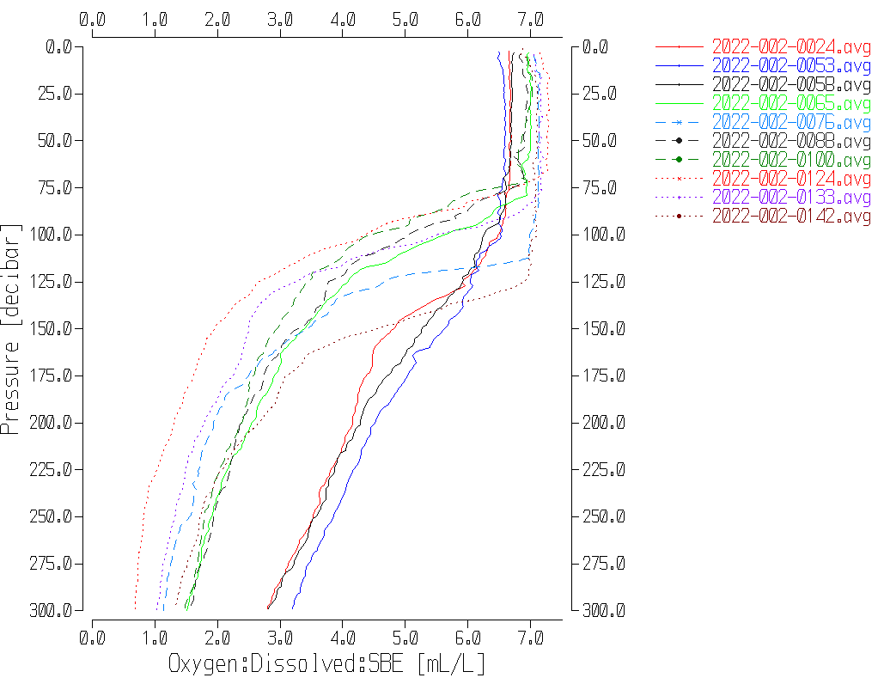

When the data were divided between high-gradient and low-gradient zones, the CTD read low by an average of 0.004mL/L (std dev 0.076mL/L) away from high gradients and by 0.108mL/L (std dev 0.107mL/L ) in high-gradient zones. Some error will be due to matching depths rather than density but it is hoped that this error is random in sign. The DO gradients are very low around the DO minimum; the extent and levels of this zone varied from cast to cast, but all fell within 600db to 1250db. The CTD was high by an average of 0.003mL/L in those areas.

Other explanations for the downcast CTD reading low in high gradient zones:

* The CTD DO calibration drifted, but it would be most unusual to have it drift towards a smaller correction rather than higher.
* The CTD DO sensor has improved response time over expectations and able to resolve small reversals in DO through the high-gradient zone may lead to errors of variable sign. This would reduce the differences somewhat, but does not explain them being negative on average.
* Related to this is the fact that the early casts had more sampling from the high gradient zone. While the gradients were not so large as in later casts, they cover a larger range of depths so have more influence. Since the early casts have little sampling in the oxygen minimum zone where gradients are very small, this effect would be even more significant.
* The data included in the original comparisons, and thus contributing to the correction, rejected cases with very noisy CTD data during stops. In the final comparison downcast CTD data from those levels were included. The noisy CTD data would mostly be in depths with active mixing so the downcast data from those levels are also likely to be less reliable than from other parts of the cast. The selection of data for the final comparison are too crude to measure noise level since the files are binned and thinned. The CTD data from the high-gradient zone are not as reliable.

The downcast CTD dissolved oxygen values are likely reading slightly higher than bottles, as expected, but the differences are very small. This may be due to improved function in the sensor which is also suggested by the smaller correction than usually seen. The original correction looks to be as good as we can achieve. No further calibration will be applied.

##### Fluorescence Processing

A median filter, size 11, was applied to the fluorescence channel in the COR1 files. Plots of a few casts showed that the filter was effective. (Output:*.FIL)

##### BIN AVERAGE of CTD files

The following Bin Average values were applied to the FIL files (output AVG):

Bin channel = pressure Averaging interval = 1.000 Minimum bin value = .000

Average value will be used. Interpolated values are NOT used for empty bins.

On-screen T-S plots were examined. There are some small unstable features but from this region of active mixing they may well be real.

Profile plots were examined to see if there any problems. No problems were noted.

##### Final CTD File Steps (REMOVE and HEADEDIT)

REMOVE was run to remove the following channels:

Scan_Number, Temperature:Secondary, Conductivity:Secondary, Oxygen:Voltage:SBE, Descent_Rate, Status:Pump, Altimeter, Salinity:T1:C1 and Flag.

A second SBE DO channel (with umol/kg units) was added.

REORDER was run to get the two DO channels together.

HEADER EDIT was used to fix formats and channel names and to add the comments about processing.

The Standards Check routine was run and no problems were found.

The Header Check was run; no problems were found.

Profile and T-S plots were examined. No problems were found.

The sensor history was updated.

##### Dissolved Oxygen Study

As a final check of dissolved oxygen data, % saturation was calculated and plotted. Values at 3m ranged between 97% and 103%, values typical of the offshore.

##### Final Bottle Files

MRGSORT was run to get files in pressure order.

REMOVE was run to remove the following channels:

Scan_Number, Temperature:Secondary, Conductivity:Secondary, Oxygen:Voltage:SBE, Descent_Rate, Status:Pump, Altimeter, Salinity:T1:C1 and Flag.

A second SBE DO channel with mass units was added for both the CTD DO and titrated DO and REORDER was run to get the pairs of DO channels together.

HEAD EDIT was run to add comments to the headers.

Data were exported from the CHE files to file 2022-002-bottles-final.xlsx. The entries were compared with the rosette log sheets and no data were missing.

A Header Check and Standard Check were prepared and no problems were found.

The track plot looks ok.

Plots of each file were examined and sample #613 nutrients are way out of line in profile. They had been flagged 4; the analyst changed the values to -99 and flags to 5.

A cross-reference listing and header check were produced for the CHE files.

**Particulars -**

General – Sounder somewhat erratic and not entirely accurate – seems to be ±10%.

Deck Pressure readings varied from -0.3 to -0.6db.

6. Acquisition did not start until 6db.

58. With one bottle left to fire, lost connection. Second file started for 1 bottle, called 58b. Later combined in file 58.

65. New pH calibration parameters. Used for conversion of all files.

84. Niskin 5 not fired – closed at wrong depth.

96. Started up from 150db and returned to that depth because enough bottles had not been tripped. So 2 separate stops at 150db.

113. Identified as event 111 on rosette log – corrected on paper and in digital log.

117. Niskin 3 not fired, no samples with sample #555.

124. Electrical blip on upcast ~400db affected display. Data file seems ok.

133. Upcast computer needed rebooting ~25db. 2nd cast run for rest of bottles called 133b. Later combined as 133.

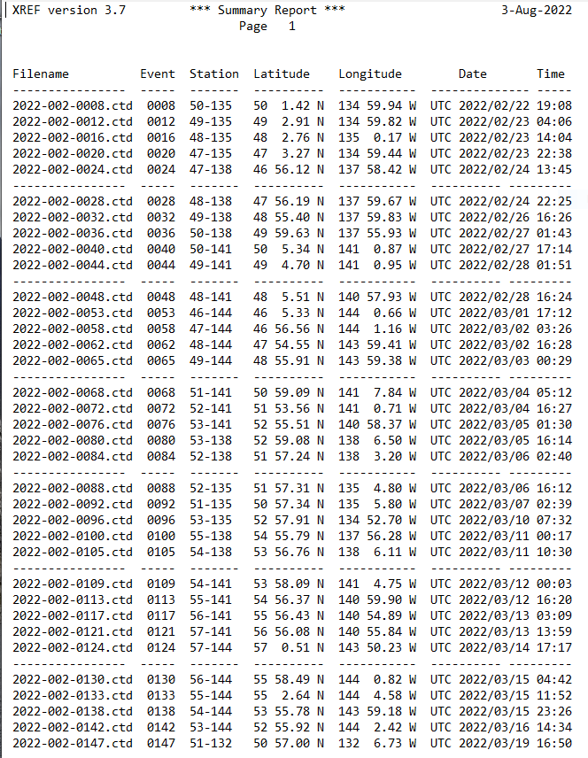

**2022-002**

**CRUISE SUMMARY – CTD**

|  |  |  |  |  |  |  |  |  |  |  |
| --- | --- | --- | --- | --- | --- | --- | --- | --- | --- | --- |
| **CTD#** | **Make** | **Model** | | **Serial#** | | **Used with Rosette?** | | **CTD Calibration Sheet Competed?** | | |
| **1** | **SEABIRD** | **911+** | | **0585** | | **Yes** | | **Yes** | | |
| **Calibration Information - 0506** | | | | | | | | | | | |
| **Sensor** | | | | | **Pre-Cruise** | | | | **Post Cruise** | | |
| **Name** | | | **S/N** | | **Date** | | **Location** | | **Date** | **Location** | |
| **Temperature** | | | **2449** | | **28Jan2021** | | **Factory** | |  |  | |
| **Conductivity** | | | **1764** | | **01Feb2021** | | **Factory** | |  |  | |
| **Secondary Temp.** | | | **4484** | | **02Feb2021** | | **Factory** | |  |  | |
| **Secondary Cond.** | | | **2128** | | **02Feb2021** | | **Factory** | |  |  | |
| **Transmissometer** | | | **1201DR** | | **17Feb2022** | | **Factory** | |  |  | |
| **SBE 43 DO sensor** | | | **1179** | | **04Feb2021** | | **Factory** | |  |  | |
| **SBE43 pH** | | | **691** | | **11Mar2022** | | **Factory** | |  |  | |
| **SeaPoint Fluor.** | | | **2225** | |  | | **Factory** | |  |  | |
| **Pressure Sensor** | | | **0585** | | **17Feb2021** | | **Factory** | |  |  | |
| **Valeport Altimeter** | | | **75321** | | **23Sept2020** | | **Factory** | |  |  | |

# 

