REVISION NOTICE TABLE
DATE | DESCRIPTION OF REVISION

PROCESSING NOTES
Cruises: CFMETR Nanoose
Agency: Canadian Forces
Project: Canadian Forces Maritime Experimental Test Range
Area: Nanoose
Date: 3 February 2021 – 4 December 2021
Platform: CFAV Stikine (and possibly others)

Processed by: Germaine Gatien
Date of Processing: 28 March 2022 – 30 March 2022
Number of original Hex files: 31 Number of casts processed: 31

INSTRUMENT SUMMARY
Four Sea Bird Model SBE 19 SEACAT CTDs (serial #1449, 1452, 1511, 4342) were used with an altimeter attached. The first 3 CTDs had a sampling interval of 0.5s. #4342 was used for only 1 cast (N21060902) and had a sampling interval of 0.25s.

SUMMARY OF QUALITY AND CONCERNS
These data form part of a long-standing time-series rather than a cruise. They cover sampling by the Canadian Forces Maritime Experimental and Test Ranges during 2021 in Nanoose Bay, BC.

Calibration information for the CTDs could not be confirmed; they had not been recalibrated since 2014 (#1449, #1452, #1511) and 2015 (#4342).

To assist in analysis, event numbers are helpful and the software in use will only allow 4 digits which suits most cruises. However, a 7-character system is used for this project based on the date. A 4-character format was derived from those IDs based on the month and day of each cast. This means the same event # will appear if there is more than 1 cast on 1 day, as frequently occurred.

The soak period at 0-1.5m varied greatly, from 15 seconds to 100 seconds. It is unknown what pump delay was set or if data logging was delayed. It is recommended that the SBE19+ be soaked for at least 2 minutes to improve salinity quality, but the conductivity appears to have generally equilibrated before pressure begins to change.

There was no salinity calibration sampling. SeaCat salinity is prone to error due to mismatch of conductivity and temperature response times, especially when the descent rate is non-uniform. SeaCat salinity errors are expected to be as high as 0.05units in areas of high gradients. Away from high gradients errors in salinity are expected to be on the order of 0.005. Other errors are expected due to calibration drift over 6 to 7 years.

The times given in the SeaBird headers do not include a time zone, but it is believed that local time was used. All times were converted to UTC by adding 7 or 8 hours depending on whether local time was PDT or PST. The file names were assigned before time was converted to UTC, so the date in the file name may not match the UTC time.

PROCESSING SUMMARY
1. Seasave - This step was completed at sea; the raw data files are *.hex.

2. Preliminary Steps
31 hex and 30 con files were delivered.
The file names were non-standard and contain the letter (U)N followed by the date in YYMMDD format and 2 digits to indicate the sequential casts on a single day. While names are non-standard they are in the usual format for this project except for the initial (U), so that part was removed.

- Conversion of Raw Data
A test conversion was done to see if the 2 voltage channels contained useful data. Voltage 0 corresponds to the altimeter channel and Voltage 1 contained only noise.

The raw data were converted by matching the configuration file to the input file name. One cast (21061002) did not have a con file, so 21061003.con was used to convert it at this stage, and later for DERIVE.
One cast (21060902) had a sampling rate of 4hz while others had 2hz, so it had to be put through SeaSoft processing steps separately.

A spreadsheet “NanooseCtdStationLocationss2021.xls” was provided with positions for all casts.
The spreadsheet provided was saved as 2021NanooseCtdStations-merge-hdr.csv. Some editing was required:
- The format of latitude and longitude in the spreadsheet needed to be changed to:
DD MM.MM N and DDD MM.MM W. Concatenate was used to do this.
- A column LOC:Station was added with every row having “Nanoose” entered.
- A column of event numbers was added to the CSV file using MMDD part of the file name as event number.

Data were acquired at the surface for between 15s to 100s. It is unknown what pump delay was set or if data logging was delayed. A 2-minute soak is generally advised for the best salinity data. For most casts the conductivity seems to have reached equilibrium before the cast began.
Temperature and conductivity generally look ok.

The altimetry generally looks fine though there are a few spikes at the bottom. The CTD did not get within 15m for some casts so the altimetry will not get entered into the IOS Headers.

- WILDEDIT
No spikes were noted in the data so WILDEDIT was not run.

- FILTER
Tests were run to determine the best setting for a low-pass filter applied to the conductivity to force it to have the same response as the temperature. A time constant of 0.5 seconds proved best as judged by the effect on T-S plots.
The pressure was not filtered since it is quite smooth already other than a couple of reversals that look like they might be real. In previous years, tests showed that filtering made things worse in sections where pressure was constant.

- ALIGNCTD
An initial run with no alignment applied to the temperature channel produced poor results with instabilities in T-S plots. Temperature was advanced by 0.73s relative to pressure since that has worked well for data from this project in previous years. A few casts were checked and the results were good. Alignment can be fine-tuned later using SHIFT if further adjustment is found useful.

- DERIVE
Program DERIVE was run to calculate salinity.

7. Conversion to IOS Headers
The IOSSHELL routine for Sea Bird ASCII files was used to convert the Sea-Bird data to IOS Headers.
The program MERGE CSV FILES TO HEADERS was then used to add positions, station name, event numbers and project name to the headers.

8. Checking Headers
- Track Plot was used to ensure positions look normal. There are no problematic outliers though, as usual, there is scatter in locations.
- Header Check was run. All variable ranges look reasonable.
- The altimetry header information from each file was exported to a spreadsheet. Most casts got within 15m of the bottom. No bottom depths were available, so no checks could be made on altimetry accuracy.
- A cross-reference list was produced. The times appear to be in local time which is the usual case for this project. The times of casts are not consistent enough to notice if clocks might have changed from standard to daylight time, but in the past the Nanoose project was thought to use local time with both PST and PDT in use.
- Surface check was run and values ranged from -0.8 to +1.4db, with an average of 0.24db.

ADD TIME CHANNEL was used to add 8 hours to casts up to March 14th and from November 6th to the end of the year. ADD TIME CHANNEL was used to add 7 hour to all other casts.

9. SHIFT
These data were aligned earlier in the process, but tests were run to see if a further shift might reduce unstable features. For a few casts a shift of -0.5records made slight improvements while making most casts worse; variable descent rates and gradients limit the ability to improve alignment. SHIFT was not run.

10. CLIP
CLIP was used to remove the first 50 scans for most files, but only 40 for the first 2 casts that started down before the 50 record point.

11. FILTER
A median filter, size 7, was applied to salinity which removed many of the unstable features.

12. DELETE
DELETE was run on the clipped files using the following parameters:
Surface Record Removal: Last Press Min Maximum Surface Pressure (relative): 10.00
Surface Swell Pressure Tolerance: 1.0 Pressure not filtered
Swells deleted. Warning message if pressure difference of 2.00
Minimum Drop Rate 0.2m/s over 5 records between 10db and 10db above maximum pressure
There were no warnings.

13. CTDEDIT
The DEL files were copied to EDT.
CTDEDIT was used to edit 25 casts.
Salinity was smoothed in cases where unstable features appeared to be due to misalignments of T and C in the presence of temperature gradients. A few records were removed from one cast due to shed wake corruption.
The edited files were copied to EDT.

14. BIN AVERAGE
The following Bin Average values were used:
Bin channel = pressure Averaging interval = 1.000
Minimum bin value = .000 Average value will be used.
Interpolated values are NOT used for empty bins
Profile plots were examined on-screen.
T-S plots were examined. Most look ok with only a few very slightly unstable features. There were 3 casts in April that have near-surface instable features. Salinity values were very low and temperatures high at the surface; no editing was applied as it is not clear whether these are real unstable features or not.

15. Intercomparisons
Historic ranges – Profile plots of temperature and salinity data were examined with the local seasonal climatology ranges superimposed. All casts fell within the climatology except for some slightly low salinity near the surface in December. Most of the climatology does not include the top 10 to 20m due to extreme variability.

16. CALIBRATION
No recalibration was applied.

17. REMOVE and HEADEDIT
The following channels were removed from all casts: Scan_Number, Descent_Rate Altimetry and Flag.

The HEADEDIT routine was used to fix formats and to add the following comment to the headers:
-----------------------------------------------------------------------------------------
SeaCat salinity is prone to error due to a mismatch of conductivity and
temperature response times, especially when the descent rate is non-uniform.
Such errors are likely to be larger than calibration errors. SeaCat salinity
errors are expected to be as high as 0.05 units in areas of high gradients,
but on the order of 0.005 where gradients are low and descent rate steady.

There were no salinity calibration data available for this cruise and no recent
factory calibrations, so significant drift in calibration is likely.
CTD sensors #1449, #1452 and #1511 have not been calibrated since 2014.
CTD sensor #4342 had not been calibrated since 2015.

For processing details see 2021-099_Processing_Report.doc.
-----------------------------------------------------------------------------------------
The standards check routine was run and no problems were found.
T-S plots were examined and no problems were found.

18. Producing final files
a.) The final files were renamed *.ctd.
b.) A cross-reference listing (see below) and header check were produced. No errors were found.

Institute of Ocean Sciences
CRUISE SUMMARY
Cruise ID#: Nanoose Test Range
Dates: Start: 12 January 2021 End: 3 February 2021
Location: Nanoose Test Range Vessel: Stikine (and possibly others – no record available)
CTDs
CTD# | Make | Model | Serial# | Altimeter | Calibration data – Pressure, Temperature, Conductivity
1 | SEABIRD | 19 | 1449 | 1094 | September / October 2014
2 | SEABIRD | 19 | 1452 | 1093 | July 2014
3 | SEABIRD | 19 | 1511 | 1095 | August/ September 2014
4 | SEABIRD | 19 | 4342 | 47578 | September 2015

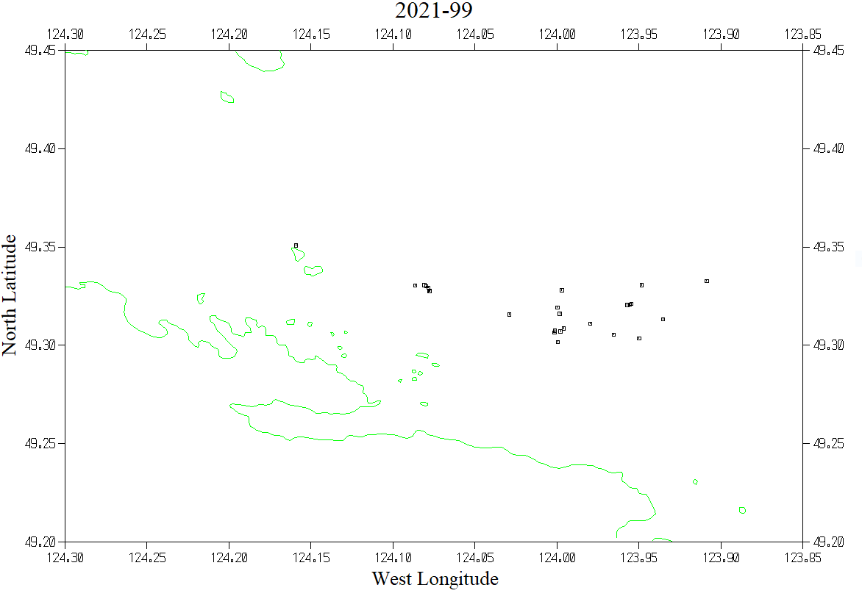
XREF version 3.7 *** Summary Report *** 29-Mar-2022

Filename Event Station Latitude Longitude Date Time
---------------- ----- ------- ---------- ----------- -------------- -----
N21020301.mrh 0301 Nanoose 49 18.97 N 123 59.90 W UTC 2021/02/03 08:37
N21031105.mrh 1105 Nanoose 49 19.96 N 123 54.52 W UTC 2021/03/11 09:41
N21031201.mrh 1201 Nanoose 49 18.22 N 123 57.00 W UTC 2021/03/12 08:44
N21041401.mrh 1401 Nanoose 49 18.33 N 123 57.93 W UTC 2021/04/14 08:37
N21041501.mrh 1501 Nanoose 49 19.76 N 124 4.70 W UTC 2021/04/15 08:19
---------------- ----- ------- ---------- ----------- ---------- ---------
N21041601.mrh 1601 Nanoose 49 19.76 N 124 4.70 W UTC 2021/04/16 10:15
N21041901.mrh 1901 Nanoose 49 19.76 N 124 4.70 W UTC 2021/04/19 08:17
N21060301.mrh 0301 Nanoose 49 19.84 N 124 4.85 W UTC 2021/06/03 09:33
N21060701.mrh 0701 Nanoose 49 18.94 N 124 1.74 W UTC 2021/06/07 08:36
N21060801.mrh 0801 Nanoose 49 18.11 N 123 59.97 W UTC 2021/06/08 08:17
---------------- ----- ------- ---------- ----------- ---------- ---------
N21060902.mrh 0902 Nanoose 49 19.84 N 124 4.85 W UTC 2021/06/09 15:24
N21060903.mrh 0903 Nanoose 49 18.52 N 123 59.76 W UTC 2021/06/09 15:39
N21061002.mrh 1002 Nanoose 49 19.84 N 124 4.85 W UTC 2021/06/10 15:45
N21061003.mrh 1003 Nanoose 49 19.24 N 123 57.43 W UTC 2021/06/11 00:08
N21061101.mrh 1101 Nanoose 49 18.43 N 123 59.87 W UTC 2021/06/11 13:05
---------------- ----- ------- ---------- ----------- ---------- ---------
N21061401.mrh 1401 Nanoose 49 19.16 N 123 59.99 W UTC 2021/06/14 15:20
N21061402.mrh 1402 Nanoose 49 19.25 N 123 57.33 W UTC 2021/06/15 01:14
N21061501.mrh 1501 Nanoose 49 19.84 N 123 56.90 W UTC 2021/06/15 15:27
N21061502.mrh 1502 Nanoose 49 19.27 N 123 57.27 W UTC 2021/06/16 00:16
N21061601.mrh 1601 Nanoose 49 18.45 N 124 0.07 W UTC 2021/06/16 15:15
---------------- ----- ------- ---------- ----------- ---------- ---------
N21061602.mrh 1602 Nanoose 49 18.67 N 123 58.78 W UTC 2021/06/16 23:36
N21061701.mrh 1701 Nanoose 49 18.40 N 124 0.09 W UTC 2021/06/17 15:59
N21070801.mrh 0801 Nanoose 49 21.05 N 124 9.55 W UTC 2021/07/08 16:29
N21072201.mrh 2201 Nanoose 49 18.80 N 123 56.12 W UTC 2021/07/22 16:00
N21083101.mrh 3101 Nanoose 49 19.76 N 124 4.70 W UTC 2021/08/31 15:35
---------------- ----- ------- ---------- ----------- ---------- ---------
N21092301.mrh 2301 Nanoose 49 19.69 N 123 59.83 W UTC 2021/09/23 16:29
N21110201.mrh 0201 Nanoose 49 19.80 N 124 4.78 W UTC 2021/11/02 15:19
N21110301.mrh 0301 Nanoose 49 19.76 N 124 4.70 W UTC 2021/11/03 15:26
N21110401.mrh 0401 Nanoose 49 19.83 N 124 5.19 W UTC 2021/11/04 19:02
N21120202.mrh 0202 Nanoose 49 19.66 N 124 4.67 W UTC 2021/12/02 19:17
---------------- ----- ------- ---------- ----------- ---------- ---------
N21120301.mrh 0301 Nanoose 49 19.65 N 124 4.65 W UTC 2021/12/03 16:58

