**REVISION NOTICE TABLE**

|  |  |
| --- | --- |
| **Date** | **Description of Revision** |
| 19 July 2023 | Name format corrected. Gain change FL spikes removed in casts 5 & 6. DO Saturation converted to DO Concentration. SH. |

**RBR CTD DATA PROCESSING NOTES**

Cruise: 2021-080

Agency: OSD

Locations: Quatsino Sound, Holberg Inlet and Neroutsos Inlet

Project: Meteorological Network

Party Chief: Cooper, G.

Platform: Small Launch

Date: December 13, 2021 – December 17, 2021

Processed by: Samantha Huntington

Date of Processing: April 27, 2022 – April 29, 2022

Number of Raw files: 28 Number of Processed Files: 27

**Instrument Summary**

Equipment: RBR Concerto CTD (s/n 204694) with a Turner Cyclops Fluorometer (s/n 21101282) and a JFE Advantech Rinko III oxygen sensor (s/n 411).

Sampling frequency was at 8Hz.

**Summary of Quality and Concerns**

A cast list of times and locations was provided, “2021-080CTDLogFileFinal.xlxs”. The log indicates that Cast 1 was a misfire and should be disregarded.

The data overall look good. There is a small spike in Conductivity and Salinity in Cast 2.

**Processing Summary**

1. **Conversion to IOS Headers**

28 profiles were found in the file ‘204694_20211216_1628.rsk’ and were extracted using python function READ_EXCELrsk(). The first profile will be disregarded after the spreadsheet is converted to IOS format.

A single file (2021-080_CTD_Data.csv) with all the data including event numbers and a single line of headers was prepared using python function MERGE_FILES().

A 6-line header was inserted using python function Add_6Lineheader_2().

File “2021-080_header-merge.csv” was created, based on the information provided by the chief scientist.

* Column “File_Name”: entries were derived from the event number.
* Column “LOC:LATITUDE”: latitude was provided and reformatted to “XX XX.XXXX N !(deg min)”.
* Column “LOC:LONGITUDE”: longitude was provided and reformatted to “XX XX.XXXX W !(deg min)”.
* Column “LOC: Event Number”: entries were event numbers.
* Colmun “LOC: STATION”: all stations were set according to the log file.

The sampling site was mapped (Figure 1) using from “2021-080_header-merge.csv” using python function Plot_Track_Location() to check the location of all casts.

Prior to conversion to IOS header format, the presence of zero-order holds were checked using Python function Plot_Pressure_Diff(). Zero-order holds were found (Figure 2.) and these values were replaced with Nan using the python function Correct_Hold().

A new csv file was created “2021-080_CSV_DATA-6Linedr_corr_hold.csv” and the corrected values were checked in python function Plot_Pressure_Diff(). Zero-order holds were found to be removed (Figure 3.).

CONVERT Spreadsheet Files was run to produce files with IOS Header format. Header entries of “Administration”, “File” and “Instrument” were filled in this step. At this step Cast 1 was deleted and not processed.

The routine “Merge:CSV Files to headers” was run to add location headers to the IOS files.

Raw data were plotted and examined:

* Conductivity looks OK with a small spike in cast 2 and some bad data at the bottom of casts 4, 11 and 12.
* Salinity looks OK with a small spike in cast 2 and some bad data at the bottom of casts 4, 13 and 14.
* Temperature looks OK.
* Dissolved Oxygen looks OK.
* Fluorescence looks OK with some bad data at the bottom of cast 4.

Next CLEAN was run to add a start time and event numbers to headers.

1. **Data processing**

* Correction to Pressure: negative pressures were found towards the bottom of most casts with a corresponding Conductivity over 14 mS/cm. Pressure was calibrated with file 2021-080_recal1.ccf to add 0.1 to the pressure and depth channels. While this is not a significant error, it removes most negative pressures.
* CLIP: Pressure is steady for a variable number of scans. Initial records were removed until the downcast began using file “2021-080_CLIP.csv”.
* Data despiking: Cast 2 had a few spikes in Conductivity and Salinity, these were manually removed using a text editor.
* Filter: a Gull-winged filter, size 7, was applied to temperature, conductivity, and pressure. Salinity will be calculated in the next step.
* SHIFT: Based on suggested values in document “Guidelines for processing RBR CTD profiles”, the alignment of temperature and conductivity was corrected by applying a shift of -2 scans in conductivity.
* SHIFT: Better alignment with Oxygen profiles was found by advancing it by 11 scans. The advice given in document “Guidelines for processing RBR CTD Profiles” was that an advance between 2 and 3 seconds is appropriate. T-O plots before and after alignment were compared. Salinity was recalculated and the results are shown in Figure 4.
* Delete was run to remove records with a descent rate lower than 0.4m/s over 8 points. This was not applied in the top 10m to avoid loss of surface records as the CTD began its descent.
* Profile plots were examined after DELETE and confirm that plots show reasonable values for salinity and conductivity and fluorescence. DO saturation levels at the surface ranged from 0% to 99%. However there was no calibration sampling and no climatology to enable a judgement about the data reliability.

1. **Final checks and header editing**

* REMOVE was run to remove the following channels from all casts: Date, Time:UTC and Event.
* BIN AVERAGE was used to metre-average data.
* CALIBRATE was run to convert conductivity units to S/m using file 2021-080-recal2.ccf.
* Header Edit was used to fix channel names and format as listed below:
* Pressure: format F11.2 ==> F7.1
* Salinity:CTD ==> Salinity
* Oxygen==> Fluorescence:URU
* mL/L==> %
* F11.4==>F8.2
* Conductivity: F10.5 ==> F10.6
* CLEAN was run to reset the Maximum and Minimum values in the Header.
* Header Check was run and no problems were found.

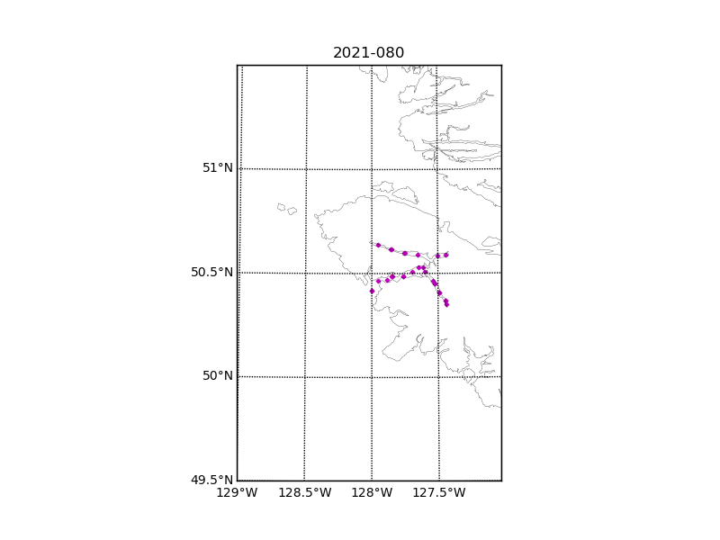

Figure 1 – location of casts.

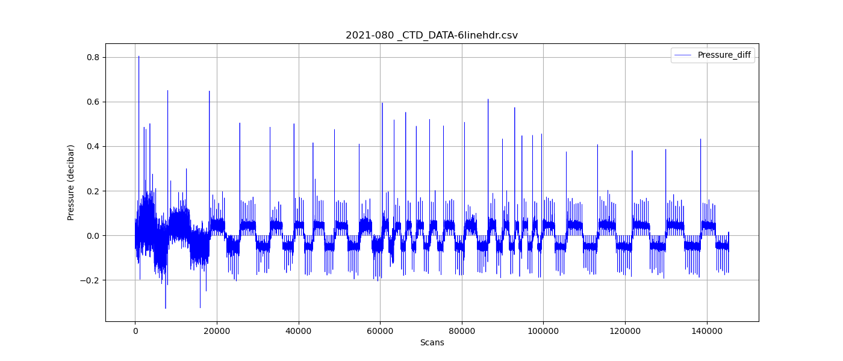

Figure 2 – zero-order holds

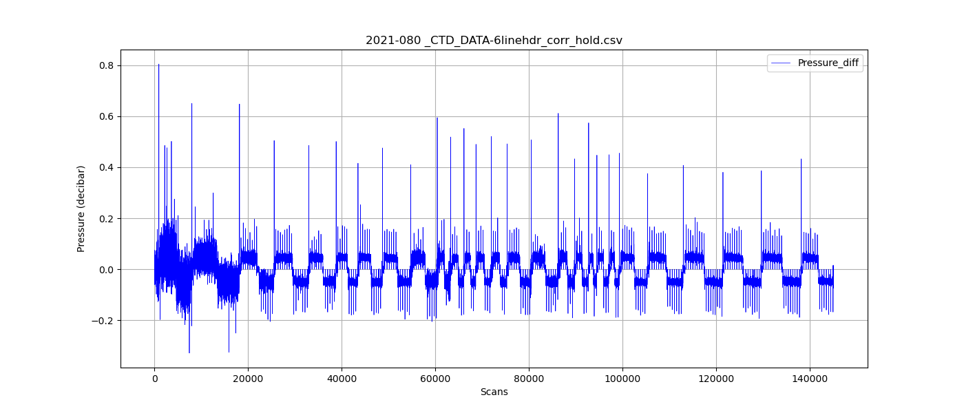

Figure 3 – zero order holds removed

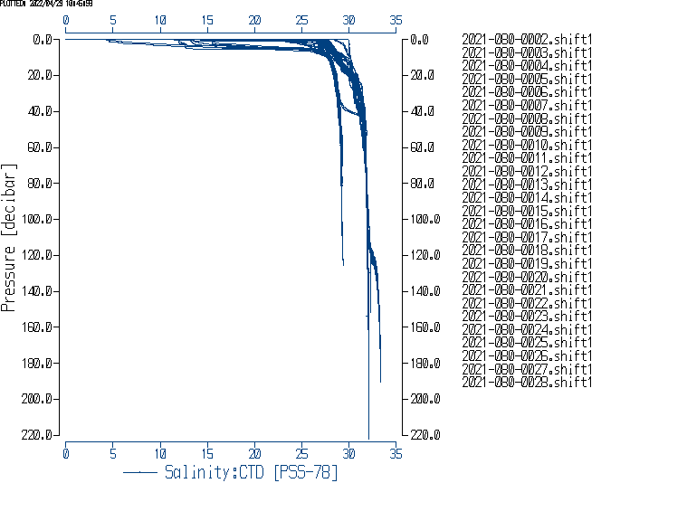

Figure 4 – Salinity after Shift.