REVISION NOTICE TABLE
DATE | DESCRIPTION OF REVISION
19 March 2025 | Updated channel names & formats in TOB files. G.G.

PROCESSING NOTES
Cruise: 2021-078
Agency: Ocean Sciences Division (OSD)
Location: Strait of Georgia / Vancouver Harbour / Indian Arm
Project: Winter Inlets
Party Chief: Page S.
Platform: Vector
Date: 17 December 2021 – 23 December 2021

Processed by: Germaine Gatien
Date of Processing: 2 February 2022 – 8 April 2022
Number of original HEX files: 57 (38 from SBE911 and 19 from SBE25)
Number of CTD files: 56 (37 SBE911, 19 SBE25)
Number of bottle files: 6 Number of bottle casts processed: 5 (1 was a test – no sampling)
Number of TSG files: 1 Number of TSG files processed: 1

INSTRUMENT SUMMARY
1, SBE911+ CTD #0506 was mounted in a rosette and attached were a Wetlabs CSTAR transmissometer (#983DR), a SBE 43 DO sensor (#1119), a Wet Labs ECO-AFL Fluorometer (#3982), a Biospherical/Licor PAR sensor (#4565) and an altimeter (#73171).
Seasave version 7.26.7.121 was used for acquisition.
The salinometer used at IOS was a Guildline model 8400B Portasal, serial # 68572.
An IOS rosette with 24 10L bottles was used.

2. SBE25+ #404 was mounted with an SBE 43 DO sensor (#1483) and Wet Labs ECO-AFL Fluorometer (#2215).

3. A SeaBird SBE21 Thermosalinograph (#3353) was used.

SUMMARY OF QUALITY AND CONCERNS
The SBE911+ malfunctioned during the first cast. A backup SBE25+ CTD was used for casts #2- 27 while repairs were made to the SBE911. The 911 was used for casts #1 and #28 – 79. The CTDs were lowered to between 10 and 12m for a pre-cast soak then raised to near the surface; data were acquired during the full cast including the soak period.

The Science Log was in digital format and there was no paper log. The digital log was missing information normally found in a paper log: which CTDs were in use and what sensors were mounted on each of them. There were useful comments entered about problems encountered.

The science crew included locations in the headers of the SBE25 files which is very helpful. However, the information was not captured into the IOS Headers because there was a degree symbol included and because “Longitude” was misspelled. These errors have occurred on other cruises so are likely “cut and paste” errors. The correct format is:
* NMEA Latitude = 49 00.90 N
* NMEA Longitude = 123 25.46 W

The only calibration sampling was for salinity with duplicates taken at a single depth, ~200db for 4 casts and ~650db for one cast. The salinity from the SBE911 compared well with samples. There was no dissolved oxygen sampling.

When the pressure sensor on the SBE911 CTD was used on 2 summer cruises on the Franklin, there was some evidence that pressure might be reading high by about 1.5db and a lab test at IOS gave a similar result. However, there is a good deal of evidence that pressure was accurate during this cruise based on observations when the CTD was in water and when it moved through the sea surface at the beginning and end of casts. A possible explanation may be that the high values were found when the CTD had been stored in a very warm lab, whereas it would have been outside on the Vector.

The primary salinity from the SBE911 was within 0.002psu of bottles. No recalibration was applied. For the SBE25 there was no calibration sampling and none during other cruises that used it since it was last calibrated at the factory, but values were reasonably close when a cast at station IND07 was compared with one at the same site using the SBE911. Dissolved oxygen values from the 2 CTDs were reasonably close at IND07. Dissolved oxygen values are likely low but it is impossible to estimate by how much.

The thermosalinograph performed well with only a few spikes in salinity that were easily removed. Salinity values compared well with CTD data at 2m. The comparison of temperatures from CTD casts and TSG was used to estimate heating in the loop, in order to create a proxy for intake temperature, called Temperature:Primary.

PROCESSING SUMMARY
GENERAL

Seasave
This step was completed at sea; the raw data files have extension HEX.

Preliminary Steps
- The digital log and rosette logs were obtained.
- Salinity data were obtained in QF spreadsheet format from the analyst.
- The cruise summary sheet was completed.
- The history of the pressure sensor, conductivity and dissolved oxygen sensors were checked.
- The calibration control files were obtained and checked. Errors were found in both:
  - The PAR sensor offset had a small error in the SBE911 con file. After fixing that it was saved as 2021-078-sbe911.xmlcon.
  - An error was found in the settings for the ECO fluorometer #2215 used on the SBE25. The gain setting was found to have been “2” several months after the cruise but the scale/offset settings entered were those for gain “4”. The calibration control file was adjusted and saved as 2021-078-sbe25.xmlcon.

PART I – SBE911 (SBE25 processing is described in PART II)

BOTTLE FILE PREPARATION
The ROS files were created using file 2021-078-ctd911.xmlcon. Depth was included.
There was also DIC sampling during 4 casts at multiple depths, but those data were not available at the time of initial data processing. One file was run as a test with no sampling.
The ROS files were converted to IOS format.
They were put through CLEAN to create BOT files.
Temperature and salinity were plotted for all BOT files to check for outliers. None were found.

A preliminary header check was run and no problems were found.

The BOT files were bin-averaged on bottle number and the output was used to create file ADDSAMP.csv. First, the file was sorted on event number and Bottle Position order. Then sample numbers were added based on the rosette logs.
The ADDSAMP file was then sorted on event number & then sample number.
It was used to add sample numbers to the BOT files – output *.SAM.
The SAM files were bin-averaged on bottle # and called SAMAVG.
The addsamp.csv file was converted to CST files, which will form the framework for the bottle files.

Next, the salinity analysis spreadsheet was examined to see what comments the analysts wanted included in the header file. These were saved in file 2021-078-bot-hdr.txt.

SALINITY
Salinity analysis was obtained in file 2021-078SAL.xlsx which included a precision study. The analyses were carried out in a temperature-controlled lab 21-42 days after collection. The files were simplified and saved as 2021-078sal.csv. That file was then converted to individual SAL files.
The SAL files were merged with CST files.
The files were put through CLEAN to reduce the headers to File and Comment sections only.

The merged files are ordered on sample number, but the SAMAVG files are ordered on bottle number, so one or the other set needs to be reordered in order to merge them. The MRGCLN1 files were reordered on Bottle_Number. The output files were named MRGCLN1s. Those files were then merged with SAMAVG files choosing the Bottle_Number from the SAMAVG files.

The output of the MRG files were examined and no data were missing.

Compare
Salinity
There were 4 salinity samples at 200db and 1 at 650db.
- The primary salinity was found to be low by a median of 0.0002psu, standard deviation of 0.0011psu.. The secondary salinity was found to be low by a median of 0.0065psu, standard deviation of 0.0010psu..
- Descent rates were very steady which often leads to incomplete flushing of Niskin bottles. Usually this leads to samples having higher salinity than ambient waters, but there are some cases of local reversals in salinity gradient and steps in salinity that could be short-lived, so this effect may be less significant than usual.
- The salinity gradient was very low around 650db during event 76, so even if flushing was poor the comparison should be the reliable. For that sample, the primary salinity was low by 0.0015psu and for the secondary it was low by 0.0076psu.
- For event 57 the CTD rose above the target depth and then came down which might help with flushing. The local salinity gradient was fairly low as well. For that sample the primary was low by 0.0015psu and the secondary by 0.0077psu.
The samples from events 57 and 76 lead to very similar comparisons.

Allowing for some slight evaporation of samples and desorption of glass into samples which would raise bottle values, no recalibration of the primary salinity is justified. The secondary salinty appears to be reading significantly low. See 2021-078-sal-comp1.xls for details.

Conversion of Full Files from Raw Data
All files were converted using 2021-078-sbe911.xmlcon.
The Tau function was selected but not the hysteresis function as there was no deep sampling.
A few casts were examined and all expected channels are present.
- There was a lot of noise in the temperature and conductivity, mostly in the upcast.
- The Dissolved Oxygen. and transmissivity traces looked reasonable.
- Fluorescence had a dark value of ~0.07ug/L which is good.
- The altimetry looks good near the bottom.

WILDEDIT
Program WILDEDIT was run to remove spikes from the pressure, conductivity & temperature only in the
full cast files (*.CNV).
Parameters used were: Pass 1 Std Dev = 2 Pass 2 Std Dev = 5 Points per block = 50
The parameter “Keep data within this distance of the mean” was set to 0 so all spikes would be removed.

ALIGN DO
A few casts were examined; both temperature channels were noisy during upcasts so the tests were not easy to interpret, but using +2.5s certainly improves the alignment and overall looks like a good choice for both DO sensors. ALIGNCTD was run on all casts using +2.5s.

CELLTM
CELLTM was run using the default settings (α = 0.0245, β=9.5) for both the primary and secondary conductivity. A few casts were checked and those parameters appear to have worked well.

DERIVE and Channel Comparisons
Program DERIVE was run on all casts to calculate primary and secondary salinity and dissolved oxygen concentration.
The differences between the channel pairs was examined:
Cast # | Press | T1-T0 | C1-C0 | S1-S0 | Descent Rate
2021-078-0038 | 300 | -0.0005 | -0.00068 | -0.0063 | High, Steady
2021-078-0049 | 300 | -0.0005 | -0.00068 | -0.0063 | High, Steady
2021-078-0071 | 350 | -0.0005 | -0.00064 | -0.0061 | High, Steady
2021-078-0076 | 350 | -0.0005 | -0.00064 | -0.0061 | High, Steady
“ | 650 | -0.0005 | -0.00062 | -0.0059 | High, Steady
The temperature differences are small. Salinity and conductivity differences are a little high; the salinity differences are consistent with those noted in the comparison with bottles.

Conversion to IOS Header Format
The IOSSHELL routine was used to convert SEA-Bird 911+ CNV files to IOS Headers.
CLEAN was run to add event numbers and to replace pad values in the pressure channel with interpolated values based on record number.
There was an initial soak at about 10m and those data were included in the data files. Plots were used to determine how many records needed to be removed; those values were saved in file clip.csv.
CLIP was run to remove records from each file as noted in clip.csv. Plots were made to see if too few or too many records were removed. One cast was rerun.

Checking Headers
The header check was run and no problems were found.

A cross-reference list was checked against the log book. The only problem found was a missing station name for event #38. That was added. A cruise track plot looks good.

The altimetry almost always had a spike at the bottom, but the algorithm used for the header entry worked well. The usual check made to see if altimetry header values are reasonable is to add the maximum depth sampled + altimetry header value and subtract the water depth from the sounder and subtract 1m since the algorithm checks altimetry over a 2m range. Ideally the result should be ~0m, but variations in depth through the cast and errors in sounder readings lead to variations, and this is particularly true near-shore and in narrow inlets. For this cruise, the “check” values were mostly <5m, but for a few casts it was >5m. There was no sounder in the lab, so crew were dependent on calling the bridge for a reading. We normally see variable depths through a cast, but the log entries do not usually change for this cruise, as expected given the absence of a sounder in the lab. So the check values are not considered as reliable as usual. A few casts were examined in detail and changes made to *.CLIP files as appropriate:
- Event 64 – The water depth entry in the file did not match the one in the log, but changing it led to a similar size error, just opposite sign, so no change was made.
- Event 65- This was one cast which did have different entries through the cast, both of which disagree with the log entry so there was likely shoaling through the cast. When the depth recorded at the bottom is used, the “check” value is reduced from 21m to 3m. The bottom depth in the header was changed from 500 to 475.
- Event 68 – There was no bottom depth entered in the log. The value in the header makes no sense. The entry was changed to Maximum Depth Sampled plus Altimeter Header -1. (482m)
- Event 72 – There was a small difference between the log entry and the header depth entry. Adjusting the header entry lowered the “check” value so that was entered in the headers.

The pressure sensor used for this cruise was reported to read high on 2 previous cruises on the Franklin.
The CTD on the Franklin was stored in a very warm room which could possibly have affected the pressure sensor until it had time to equilibrate. This cruise was on the Vector with the CTD stored on deck. Acquisition began early, included the 10m soak and sometimes included out-of-water values, so we can judge pressure at the beginning and end of the casts and pressure looked very good for both. Pumps were turned on and off at about 0.1 to 0.5db and the data look appropriate for being in water; it would be most unusual to turn pumps on and off out of water. If anything these data might indicate pressure was reading low, not high.
- For example, during cast #28 the transmissivity indicates that the CTD was likely out of water when pressure read 0.06db and dropped suddenly at about 0.10db.Temperature rose sharply and DO fell sharply at the same level, though pumps were not on, so the DO values are not reliable but do indicate a change of environment. After the 10m soak the CTD was raised to 0.4db and all values indicate it was in water, but close to the surface. The CTD did the full cast and then returned to the surface where pumps were turned off at 0.5db. All values show it was near the surface but in water. The CTD was then raised again and when pressure was about 0.1db the transmissivity shows it was in air. So, pressure looks very accurate at both the beginning and end of the cast.
- For several other casts the upcast data suggests the surface was at about 0.3db or 0.4db. It is common to see noisy and sometimes low transmissivity near the surface of casts which is thought to be due to surface slicks; for this cruise that is seen in many of the casts at about 0.4db. So there is some variability but no suggestion of an error >0.5db.
The surface check had an average of 1.1db with a range from -0.1db to 2.8db.

Shift
Fluorescence
SHIFT was run on the fluorescence channel with an advance of 24 records. Plots showed this setting was appropriate.
Dissolved Oxygen
The Dissolved Oxygen voltage channel was aligned earlier. No further alignment is needed for the DO concentration channel.
Conductivity
Tests were run on the 3 casts to determine the best setting to align conductivity and temperature by judging the effect on salinity as seen in T-S space.
SHIFT was run twice on all SBE911 casts using -0.7 records for the primary conductivity and -0.5 records the secondary. Salinity was recalculated for both channels.

DELETE
The following DELETE parameters were used:
Surface Record Removal: Last Press Min
Maximum Surface Pressure (relative): 10.00
Surface Pressure Tolerance: 1.0 Pressure filtered over 15 points
Swells deleted. Warning message if pressure difference of 2.00
Drop rates < 0.30m/s (calculated over 11 points) will be deleted.
Drop rate applies in the range: 10db to 10db less than the maximum pressure
Sample interval = 0.042 seconds. (taken from header)
COMMENTS ON WARNINGS: The only warning pertained to upcast data.

Other Comparisons
Previous experience with these sensors –
SBE911+ sensors – The pressure sensor had been used on 4 other cruises since they were last recalibrated. Problems were noted during 2 of the cruises suggesting pressure was too high by 1.5db or more. There were only 2 casts on the 2nd of those cruises. A lab test had a pressure of 1.25db.
The conductivity sensors were also used on 4 previous cruises with no salinity sampling on any of them.
The dissolved oxygen sensor was recalibrated in February 2021 and used for 3 other cruises (only 2 casts on one of them). There was no calibration sampling on any of those cruises.
Historic ranges – There is no suitable climatology available for the inlets. Even in the open Strait of Georgia there are few observations available at this time of year. Temperatures in the Strait of Georgia fell within the historic ranges, but in the northern part of the Strait, salinity was low in the upper 50m. This does not appear to be due to a calibration problem.
Repeat Casts – The only repeat cast involved 2 different CTDs.
Post-Cruise Calibration – There were no post-cruise calibrations available.

DETAILED EDITING
The primary T-S pair were chosen for editing and eventual archiving because they were slightly noisier and closer to bottle salinity values.
All DEL files were copied to *.EDT.

CTDEDIT was used to remove records near the top and bottom of casts that appear to be corrupted by shed wakes or ship effects. Salinity was cleaned to remove spikes that appear to be due to small misalignment or instrumental noise. All files required light editing.
The edited files were copied to *.EDT.
After editing T-S plots were examined for all casts and while there remain some small unstable features, these are expected in areas with active mixing. No further editing was applied.

Fluorescence Processing
A median filter, size 11, was applied to the fluorescence channel. It worked well to reduce noise.

Recalibration
There was no dissolved oxygen sampling. Surface oxygen saturation values were derived and found to range from 75% to 93%. While some calibration drift is likely, it would be expected to be on the order of 2 to 3%, not enough to explain such low values. Many of the casts were in areas of active mixing where low DO values are to be expected and winter winds may be a factor in mixing surface waters. There is insufficient information to justify recalibration.

Salinity will not be recalibrated since the primary salinity was found to be close to bottles and analysis was done promptly so errors due to evaporation and desorption of glass particles are likely small.

BIN AVERAGE of CTD files
The following Bin Average values were applied to the FIL files (output AVG):
Bin channel = pressure Averaging interval = 1.000 Minimum bin value = .000
Average value will be used. Interpolated values are NOT used for empty bins.
On-screen T-S plots were examined.
Profile plots were examined to see if there any problems. No problems were noted.

Final CTD File Steps (REMOVE and HEADEDIT)
- For all casts REMOVE was run to remove the following channels:
Scan_Number, Temperature:Secondary, Conductivity:Secondary, Oxygen:Voltage:SBE, Descent_Rate, Status:Pump, Altimeter, Salinity:T1:C1 and Flag.
- A second SBE DO channel (with umol/kg units) was added.
- HEADER EDIT was used to fix formats and channel names and to add comments to the headers.
- The Standards Check routine was run and no problems were found.
- The Header Check was run; no problems were found.
- Profile and T-S plots were examined and no problems were found.
- The sensor history was updated.

Final Bottle Files
- The MRGCOR1 files were put through SORT to order on increasing pressure.
- For all casts REMOVE was run to remove the following channels:
Scan_Number, Temperature:Secondary, Salinity:T1:C1, Conductivity:Secondary, Oxygen:Voltage:SBE, Transmissivity, Altimeter, Status:Pump, Descent_Rate and Flag.
- A second SBE DO channel with mass units was added for both the CTD DO and REORDER was run to get the pair of DO channels together.
- HEADER EDIT was run to ensure formats and units are correct, correct the vessel name, change the channel name Bottle_Number to Bottle:Firing_Sequence and the name Bottle:Position to Bottle_Number and to add a comment about quality flags and analysis methods and a few notes about the CTD data processing.
- Standards check was run. 1 format error was found and corrected.
- A header check were run. No problems were found.
- Plots of each file were examined and no problems were found.
- A cross-reference listing was produced for the CHE files.

PART II – SBE25

Conversion of Raw Data
All files were converted using configuration file 2021-078-ctd25.xmlcon.
To ensure that the fluorometer scale/offset are correct a comparison was made between a cast using the setting used at sea with one using the corrected configuration. The results show a more reasonable dark value (0.12ug/L compared to 0.60ug/L at 280db) and maximum values look more reasonable for December.

Plots were examined and all expected channels were present and values look reasonable except for fluorescence spikes as the CTD leaves the water. Pressure appears accurate to within ±0.2db on entering water and looks low by about 0.5db leaving water, though pumps are likely off at that point so there is likely some delay in getting “out of water” values. The accuracy quoted by SeaBird for this type of pressure sensor is ±01db and the pressure appears to be well within that range.

WILDEDIT
Since there are no obvious spikes in the data below the surface, this step was skipped. The near-surface spikes will be removed in the DELETE step or using CTDEDIT.

FILTER
There are frequent small steps in the pressure but no reversals were noted.
A low pass filter size 0.5s was run on pressure and depth. This smoothed the pressure well.
WFILTER was run on temperature and conductivity with a cosine filter, width 5. When salinity is derived the results look good, though a few suspicious unstable features remain, but those can be addressed with either the SHIFT stage or in graphical editing.

ALIGNCTD
ALIGNCTD was run to apply a 3s advance to the oxygen voltage. After derivation of DO concentration, the vertical offset between up and down traces was in good correspondence with those in temperature.

CELLTM
CELLTM was run on all casts using the default setting: (α, 1/β) = (0.04, 8).

DERIVE
Program DERIVE was run to calculate salinity and dissolved oxygen concentration with tau correction.

Conversion to IOS Headers
The IOSSHELL routine was used to convert the CNV files to IOS Headers.
Locations did not convert properly because there was a degrees symbol included and because “Longitude” was misspelled. The files from the DERIVE step were edited to remove those symbols and then conversion worked properly.

CLIP was run to remove data from the initial soak period. File “clip.csv” was created with a list of files and how many records needed to be removed from each. Plots were made to ensure too few or too many scans had been removed and adjustments made to the clip file as needed.

CLEAN was run to add event numbers in case any were missed and to interpolate any pad values in pressure. The only negative fluorescence values were at the end of casts and will be removed at the DELETE step.

Checking Headers
Preliminary Track Plot and Header Checks were run together and look fine.

Plots were made to determine the pressure at which conductivity began to show signs of being in water; the pumps were off but some effect is seen. The initial pressures for “in water” records ranged from +0.1db to -0.5db.
This is in agreement with the surface check which shows an average of -0.23db before CLIP was applied, with values ranging from +0.1 to -0.4db. The SBE25 pressure appears to be accurate.

SHIFT
Fluorescence
The fluorometer on the SBE25 was not pumped so alignment was not needed.
Conductivity
Applying a shift of +0.2records to the conductivity improved the salinity as judged by stability in T-S space after running DELETE.
SHIFT was applied to all casts using +0.2 records.
Dissolved Oxygen
This channel was aligned earlier, but checks were made by examining plots of temperature and dissolved oxygen; the alignment looks reasonable. SHIFT was not run on DO.

DELETE
DELETE was run on all casts using the following parameters:
Surface Record Removal: Last Press Min. Surface Swell Pressure Tolerance: 1.0
Swells deleted. Warning message if pressure difference of 2.00
Drop rates < 0.3m/s (calculated over 5 points) was deleted from 10db to 10db above the maximum pressure. Pressure was not filtered as it had been filtered earlier.
COMMENTS ON WARNINGS: There were no warnings.

DETAILED EDITING
All DEL files were copied to *.EDT.
Examination of T-S plots shows a need to edit some surface and/or near-bottom data for most casts and some light editing of salinity for a few.
CTDEDIT was used to remove near-surface records and some data corrupted by shed wakes near the bottom of many casts; salinity was cleaned lightly in a few casts. Notes of editing details were made in the headers.
All casts except #14, 16 and 21 required some editing.
The edited files were copied to *.EDT.
T-S plots were examined and no problems were found.

Other calibration checks
Sensor History – There has been no other use of these sensors since the latest factory calibration.
Comparison of repeat casts – Cast #28 was at the same site as #27 – they used different CTDs.
Historic Ranges – These data were collected close to shore where the climatology is not very reliable. Nonetheless, most temperature data fell within the climatology. Salinity data did not, with only the casts nearest the Strait of Georgia falling within the climatology except near the bottom where salinity was below the minimum. Salinity was well below the minimum for most levels in Vancouver Harbour and Indian Arm. This is not considered evidence of a calibration problem, but reflects the fact that the area is not well represented in the climatology.
Post-cruise calibrations – None were available.
Inter-comparison of the 2 CTDs – See section 34.

Bin Average and REMOVE and DO saturation study
The files were bin averaged using 1db bins.
REMOVE was run to remove Scan_Number, Oxygen:Voltage, Descent Rate and Flag channels.
Dissolved Oxygen was derived in mass units.
REORDER was used to get the 2 DO values together..

Calibration Checks
Checks on calibration quality in the SBE25 casts:
- Saturation rates were calculated and plots show near-surface saturation ranges from 72% to 85%. Those are similar to results from several inlet sections for the SBE911.
- Casts #27 and 28 were compared as they were at the same location with the 2 different CTDs. The dissolved oxygen saturation was lower for the SBE25 overall, except near the surface where they are close. The traces are offset vertically; when aligned the SBE25 is lower by ~0.05mL/L below 10m and the SBE25 is slightly higher above that, possibly due to slower sampling rate reducing its ability to resolve the rapid decrease in DO. The difference does not look like it is due to calibration drift since it is not DO-dependent as usually seen in drift of these DO sensors.
- Comparison of casts #27 and 28 on a T-S plot shows a large difference in the top few metres but good correspondence below that. The SBE25 does not resolve individual features as well, but overall values are close, with differences along lines of constant sigma-T being within 0.005C° and salinity within 0.002psu at about 60m.
Plots may be seen at the end of this report.

CALIBRATE
No recalibration was applied.

HEADER EDIT and final checks of CTD files from both CTDs
Header Edit was used to fix headers, fix formats and channel names and to add some notes concerning processing to the headers:
The standards check was run and no problems were found.

A cross-reference listing was produced for the whole cruise. No problems were found.
A header check was run including files from both CTDs. No problems were found.
The sensor history was updated.
Plots of CTD casts were examined and no problems were found.

PART III – TSG

Thermosalinograph processing
There was 1 thermosalinograph file.
There were no loop samples, flow meter or intake thermistor. The intake is at about 2m. The only method to check calibration is to compare with the CTD casts.

a.) Checking calibrations
The configuration file used at sea was checked and no errors were found.

b.) Conversion of Files
The cnv file was converted to IOS HEADER format.
CLEAN was run to add End times and Longitude and Latitude minima and maxima to the headers.
ADD TIME CHANNEL was used to add Time and Date channels.
A time-series plot was produced. There are a few spikes in salinity early in the record.
The track plot looks fine and was added to the end of this report.

c.) Checking Time Channel
- The CTD files were thinned to reduce the files to a single point from the downcast within 0.5db of 2db. These were exported to a spreadsheet which was saved as 2021-078-ctd-tsg-comp.xls. There were 53 CTD casts with data available from 2m; only 40 overlapped with TSG data.
- The TSG ATC file was bin-averaged over 9 records (~30s) with standard deviations included and was then opened in EXCEL. The file was reduced to the times of CTD casts. Those data were added to 2021-078-ctd-tsg-comp.xls.
- To check for problems in the TSG clock or bad matches of TSG and CTD data, the differences between latitudes and longitudes were found. The median and average differences were both <0.0000º with a maximum difference of 0.0011º. The TSG clock worked well.

d.) Comparison of Temperature and Salinity from TSG and CTD data
Using all casts
 |  | Ttsg-Tctd | Stsg-Sctd
 | average | -0.2151 | -0.6222
 | median | 0.0926 | -0.0374
 | stdev | 0.7062 | 1.4079
15 casts with lowest std dev over 30s for T and S
 |  | Ttsg-Tctd | Stsg-Sctd
 | average | 0.0909 | -0.0113
 | median | 0.1153 | -0.0018
 | stdev | 0.0952 | 0.0231
When all casts are included the TSG temperature is lower than the CTD temperature by a median of 0.0926C° with standard deviation of 0.0.7062C°. When only 15 casts with the lowest standard deviation in temperature are used, the TSG is higher than the CTD by a median of 0.1153 C° with standard deviation 0.0952C°; the cases with the TSG looking much lower than the CTD were all associated with noisy TSG temperature data, which was mostly early in the cruise. We expect the lab temperature to be higher than the CTD temperature due to heating in the loop. That amount of heating is dependent on intake temperatures, flow rate and ambient temperatures along the loop. During previous cruises on the Vector heating in the loop was on the order of 0.1 to 0.2C°. While intake temperatures were fairly low, the ambient temperature of the ship was probably also low in December so the result is reasonable.

When all casts are included salinity is lower by a median of 0.0374psu and standard deviation of 1.4079psu. When only 15 casts with the lowest standard deviations in salinity were selected, TSG salinity is lower by a median of 0.0018psu and standard deviation of 0.0231psu. This is an excellent correspondence and suggests that both the TSG and the CTD were well calibrated.
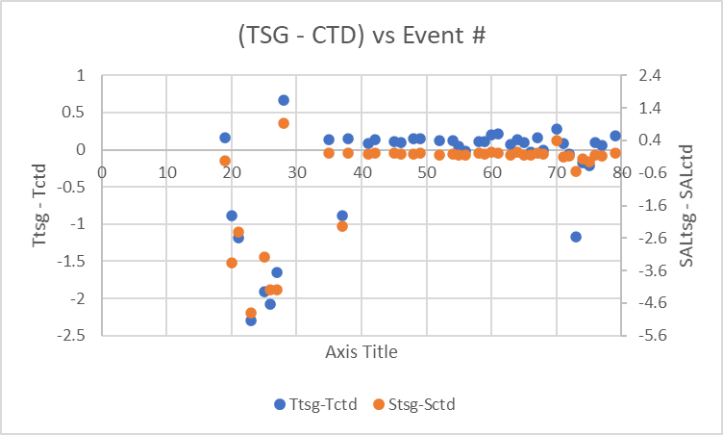
See 2020-078-ctd-tsg-comp.xls for details.

Calibration History
The TSG temperature and conductivity were recalibrated in September 2021 and this is the 1st known use of it since then.

Conclusions
1. The TSG clock worked well.
2. The TSG lab temperature was higher than the CTD temperature by about 0.11Cº which is about what is expected due to heating in the loop. Unknown factors are the flow rate in the loop and the ambient temperature of the loop environment.
3. The TSG Salinity is low by about 0.002psu which is an excellent correspondence.

f.) Editing
Light editing was applied to remove large single-point spikes in salinity.
REMOVE was used to remove the following channels: Scan Number and Flag channels.

g.) Recalibration
Add Channels was used to add Channel Temperature:Lab with values set equal to Temperature:Primary.
Calibrate was run using file 2019-050-tsg-recal1.ccf to subtract 0.115 from Temperature:Primary.

h.) Preparing Final Files
HEADER EDIT was used to change the DATA DESCRIPTION to THERMOSALINOGRAPH and add the depth of sampling to the header and to change channel names to standard names and formats.
The TSG sensor history was updated.
As a final check plots were made of the cruise track and time-series and all look fine.
The cruise plot was added to the end of this report.

Particulars
- Test cast with the 9/11 in Saanich Inlet failed at 35m. CTD cable was re-terminated enroute to Vancouver Harbour and 9/11 was ready for deployment at IND8.
- There was no sounder on the ship.
1. Test cast - lost connectivity with CTD at ~ 35m going down. Appeared to potentially be a problem with the slip ring on the winch. Tried to replace - still no connectivity and blew fuse again. File not processed.
2 – 27. Used backup SBE25 CTD.
28. Test rosette cast with SBE911 after re-termination – closed all bottles ~10m, good cast. No sampling.
35. Computer crash. Excel would not open “No license for this product found”. Restarted computer. Excel opened fine.
59. Propulsion problem – upcast sped up
72. Ice on surface between stations.
79. Aborted cast at 35m above bottom with 320m of wire out and crazy wire angles.
CRUISE SUMMARY – CTD & TSG
CTD# | Make | Model |  | Serial# |  | Used with Rosette? |  |  | CTD Calibration Sheet Competed?
1 | SEABIRD | 911+ |  | 0506 |  | Yes |  |  | Yes
2 | SEABIRD | 25 |  | 404 |  | No |  |  | Yes
3 | SEABIRD | 21 |  | 3353 |  | n/a |  |  | Yes
Calibration Information - 0506
Sensor |  |  |  |  | Pre-Cruise |  |  |  |  | Post Cruise
Name |  |  | S/N |  | Date |  | Location |  |  | Date |  | Location
Temperature |  |  | 2374 |  | 3Feb2021 |  | Factory
Conductivity |  |  | 3184 |  | 3Mar2021 |  | Factory
Secondary Temp. |  |  | 4883 |  | 4Feb2021 |  | Factory
Secondary Cond. |  |  | 4395 |  | 3Mar2021 |  | Factory
Transmissometer |  |  | 983 |  | Oct 2020 |  | IOS
SBE 43 DO sensor |  |  | 1119 |  | 5Feb2021 |  | Factory
SeaPoint Fluor. |  |  | 3982 |  |  |  | Factory
PAR |  |  | 4565 |  | 24Feb2021 |  | Factory
Pressure Sensor |  |  | 0506 |  | 29Jan2021 |  | Factory
Altimeter |  |  | 73171 |  | 20Jan2021 |  | Factory
Calibration Information - 0404
Sensor |  |  |  |  | Pre-Cruise |  |  |  |  |  | Post Cruise
Name |  | S/N |  |  | Date |  |  | Location |  |  | Date |  | Location
Temperature |  | 5724 |  |  | 5Dec2019 |  |  | Factory
Conductivity |  | 1763 |  |  | 12Dec2019 |  |  | Factory
ECO Fluorometer |  | 2215 |  |  | 27Nov2018 |  |  | Factory
SBE 43 DO sensor |  | 0047 |  |  | 3Feb2021 |  |  | Factory
Pressure |  | 464 |  |  | 26Nov2018 |  |  | Factory

Calibration Information – TSG 3363
Sensor |  | Pre-Cruise |  | Post Cruise
Name | S/N | Date | Location | Date | Location
Temperature | 3353 | 1Sept2021 | Factory
Conductivity | 3353 | 1Sept2021 | Factory

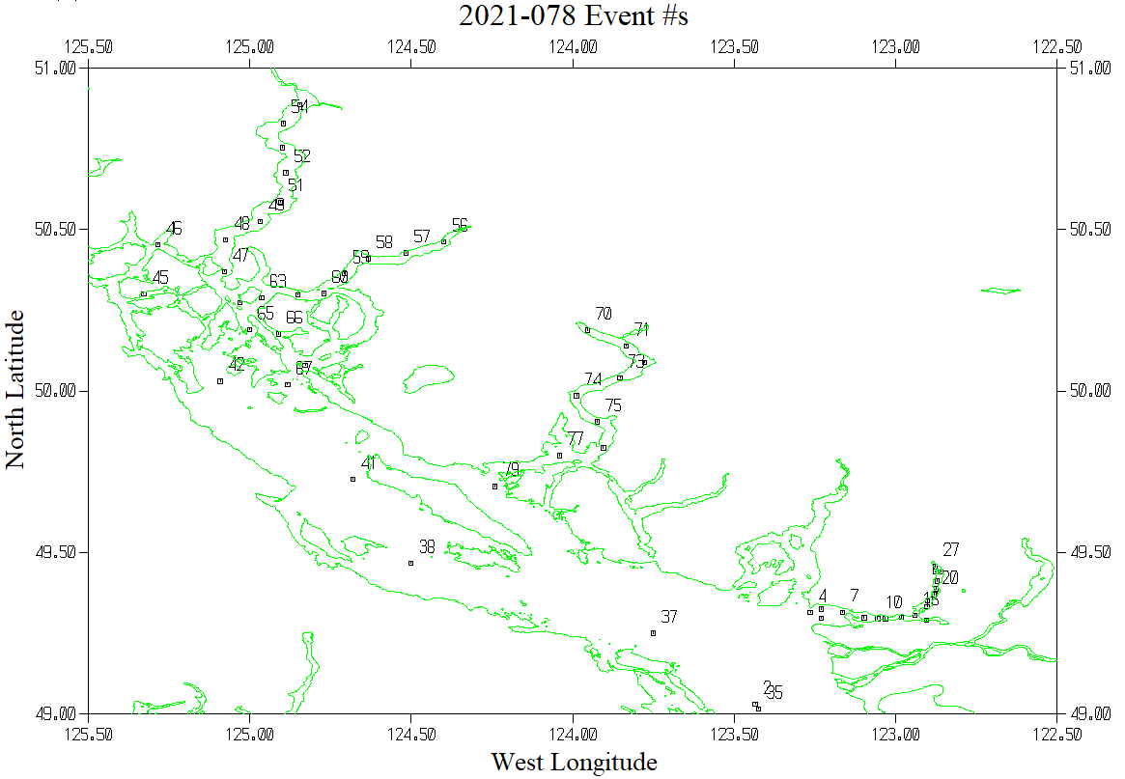
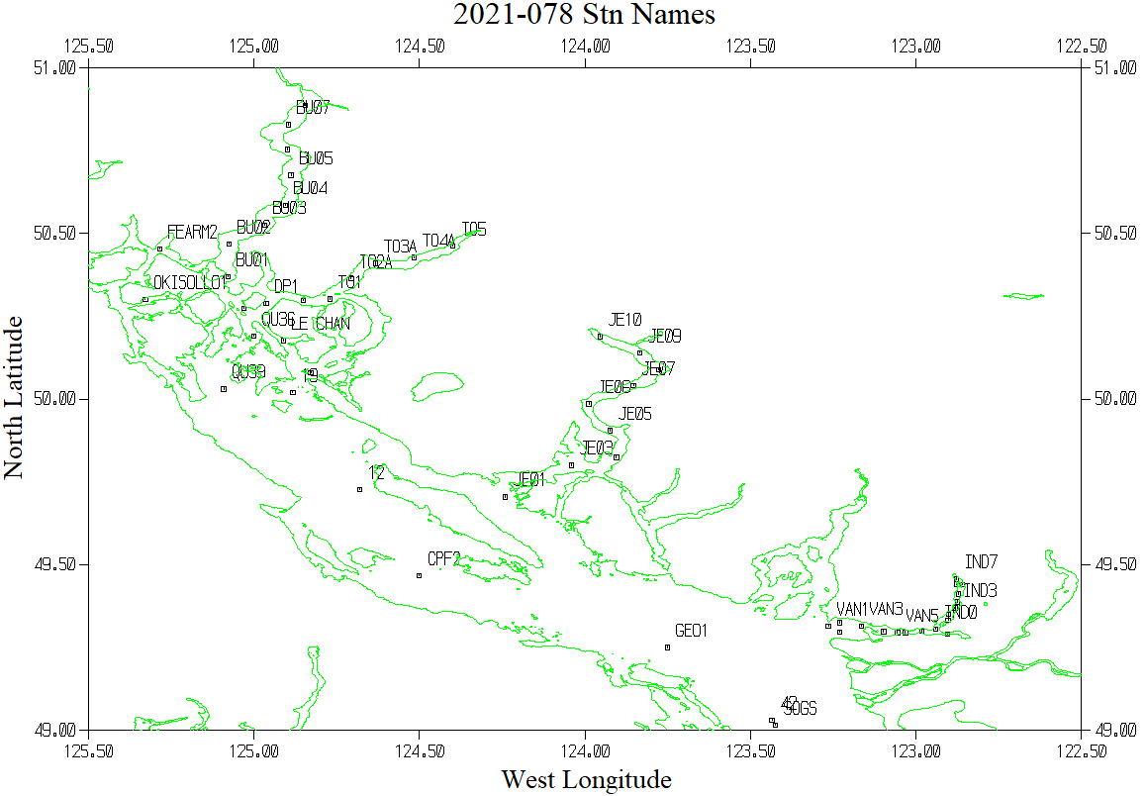

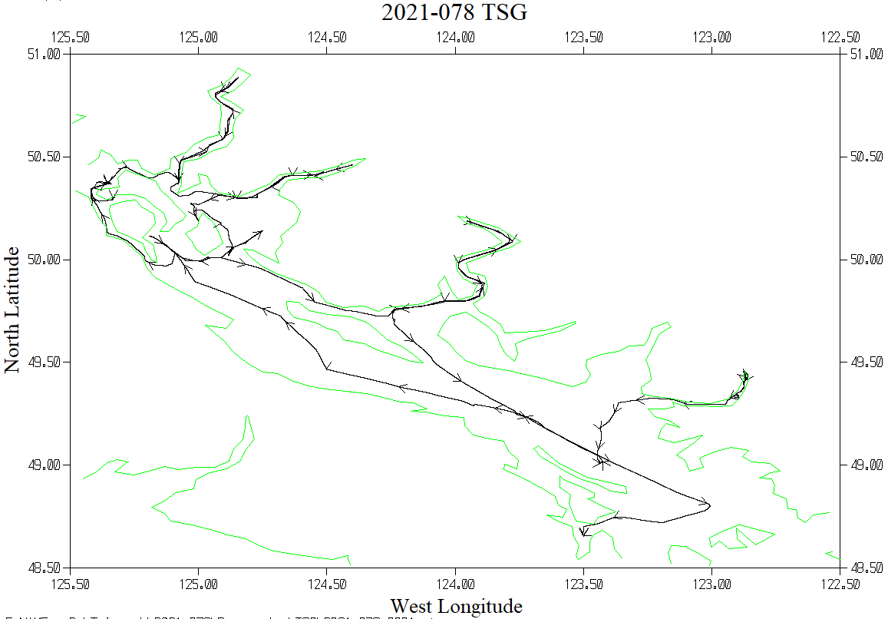

Intercomparison of SBE25 (#27) and SBE 911+ (#28) at station IND07

