**REVISION NOTICE TABLE**

|  |  |
| --- | --- |
| **Date** | **Description of Revision** |
| 19 July 2023 | Fixed Name. Removed generic vessel and left blank. Gain change related spike in FL removed from cast 21. DO Saturation converted to DO Concentration. S.H. |

**RBR CTD DATA PROCESSING NOTES**

Cruise: 2021-077

Agency: OSD

Locations: Quatsino Sound, Holberg Inlet and Neroutsos Inlet

Project: Meteorological Network

Party Chief: Cooper, G.

Platform: Blackie (MOWI Vessel)

Date: November 2, 2021 – November 4, 2021

Processed by: Samantha Huntington

Date of Processing: April 26, 2022 – April 28, 2022

Number of Raw files: 26 Number of Processed Files: 25

**Instrument Summary**

Equipment: RBR Concerto CTD (s/n 204694) with a Turner Cyclops Fluorometer (s/n 21101282) and a JFE Advantech Rinko III oxygen sensor (s/n 411).

Sampling frequency was at 8Hz.

**Summary of Quality and Concerns**

A cast list of times and locations was provided, “2021-077CTDLogFileFinal.xlxs”. Cast 4 was stopped at 60m during the ascent and returned to 102m due to an issue with the winch wire. It was then brought back to the surface and this resulted in a second unique profile being created for this cast. The upast is eventually removed in processing so this extra profile was removed from the output csv file and explains the large difference in pressure seen in the plot for zero-order holds.

The data overall look good.

* Conductivity looks OK with some bad data at the bottom of casts 13 and 20, and at the top of cast 22.
* Temperature looks OK with some bad data at the bottom of casts 4, 5, 7, 16 and 20.
* Fluorescence looks OK with some bad data at the bottom of casts 16 and 20.
* Dissolved Oxygen looks OK with some bad data at the bottom of casts 5, 7 and 20.
* Salinity looks OK with some bad data at the bottom of casts 13 and 20.

**Processing Summary**

1. **Conversion to IOS Headers**

26 profiles were found in 204694_20211102_1830_2021_077.rsk file and were extracted using python function READ_EXCELrsk(). One profile was excluded since it was created while the winch was adjusted during the ascent for cast 4.

A single file (2021-0077_CTD_Data.csv) with all the data including event numbers and a single line of headers was prepared using python function MERGE_FILES().

A 6-line header was inserted using python function Add_6Lineheader_2().

File “2021-077_header-merge.csv” was created, based on the information provided by the chief scientist.

* Column “File_Name”: entries were derived from the event number.
* Column “LOC:LATITUDE”: latitude was provided and reformatted to “XX XX.XXXX N !(deg min)”.
* Column “LOC:LONGITUDE”: longitude was provided and reformatted to “XX XX.XXXX W !(deg min)”.
* Column “LOC: Event Number”: entries were event numbers.
* Colmun “LOC: STATION”: stations were set according to the cast log.

The sampling site was mapped (Figure 1) using from “2021-077_header-merge.csv” using python function Plot_Track_Location() to check the location of all casts.

Prior to conversion to IOS header format, the presence of zero-order holds were checked using Python function Plot_Pressure_Diff(). Zero-order holds were found (Figure 2.) and this was corrected using the python function Correct_Hold().

A new csv file was created “2021-077_CSV_DATA-6Linedr_corr_hold.csv” and the corrected values were checked in python function Plot_Pressure_Diff(). Zero-order holds were found to be removed (Figure 3.).

CONVERT Spreadsheet Files was run to produce files with IOS Header format. Header entries of “Administration”, “File” and “Instrument” were filled in this step.

The routine “Merge:CSV Files to headers” was run to add location headers to the IOS files.

Raw data were plotted and examined:

* Conductivity looks OK with some bad data at the bottom of casts 13 and 20, and at the top of cast 22.
* Temperature looks OK with some bad data at the bottom of casts 4, 5, 7, 16 and 20.
* Fluorescence looks OK with some bad data at the bottom of casts 16 and 20.
* Dissolved Oxygen looks OK with some bad data at the bottom of casts 5, 7 and 20.
* Salinity looks OK with some bad data at the bottom of casts 13 and 20

Next CLEAN was run to add a start time and event numbers to headers.

1. **Data processing**

* Correction to Pressure: Several casts had negative pressures with corresponding Conductivity measurements over 28 mS/cm. Pressure was calibrated with file 2021-077_recal1.ccf to add 0.1 to the pressure and depth channels. While this is not a significant error, it removes most negative pressures.
* Data despiking: There are no significant spikes in temperature, conductivity and salinity. So there is no need to apply data despiking. There was some bad data at the bottom of casts 13 and 20 for Salinity and Conductivity but this was removed in the next step.
* CLIP: Pressure is steady for a variable number of scans. Initial records were removed until the downcast began and when the upcast slowed using file “2021-077_CLIP.csv”. For casts 13 and 20 the bad data at the bottom was removed at this step.
* Filter: a Gull-winged filter, size 7, was applied to temperature, conductivity, fluorescence and pressure. Salinity will be calculated in the next step.
* SHIFT: Based on suggested values in document “Guidelines for processing RBR CTD profiles”, the alignment of temperature and conductivity was corrected by applying a shift of -2 scans in conductivity.
* SHIFT: Better alignment with Oxygen profiles was found by advancing it by 11 scans. The advice given in document “Guidelines for processing RBR CTD Profiles” was that an advance between 2 and 3 seconds is appropriate. T-O plots before and after alignment were compared. Salinity was recalculated and the results shown in Figure 4.
* Delete was run to remove records with a descent rate lower than 0.4m/s over 8 points. This was not applied in the top 10m to avoid loss of surface records as the CTD began its descent.
* Profile plots were examined after DELETE and confirm that plots show reasonable values for salinity and conductivity and fluorescence. DO saturation levels at the surface ranged from 1% to 103%. However there was no calibration sampling and no climatology to enable a judgement about the data reliability.

1. **Final checks and header editing**

* REMOVE was run to remove the following channels from all casts: Date, Time:UTC and Event.
* BIN AVERAGE was used to metre-average data.
* CALIBRATE was run to convert conductivity units to S/m using file 2021-077-recal2.ccf.
* Header Edit was used to fix channel names and format as listed below:
* Pressure: format F11.2 ==> F7.1
* Salinity:CTD ==> Salinity
* Oxygen==> Fluorescence:URU
* mL/L==> %
* F11.4==>F8.2
* Conductivity: F10.5 ==> F10.6
* CLEAN was run to reset the Maximum and Minimum values in the Header.
* Header Check was run and no problems were found.

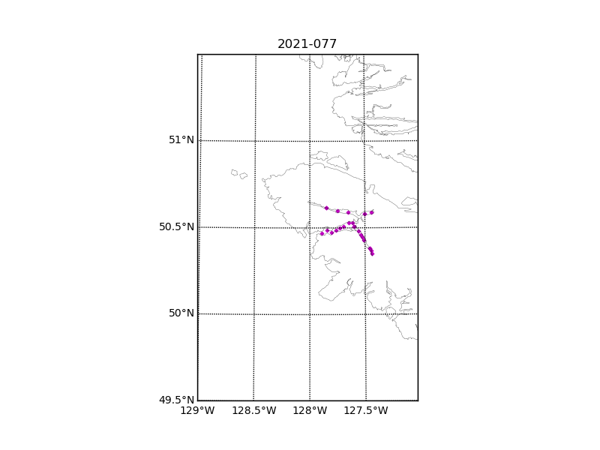

Figure 1 – location of casts.

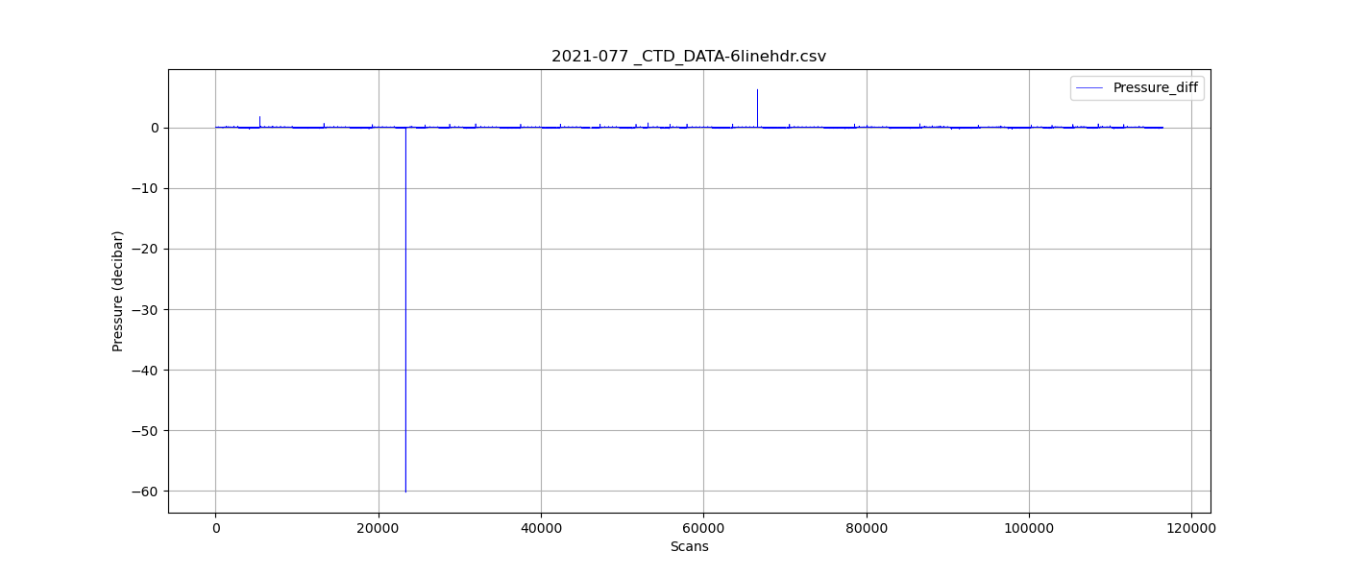

Figure 2 – zero-order holds

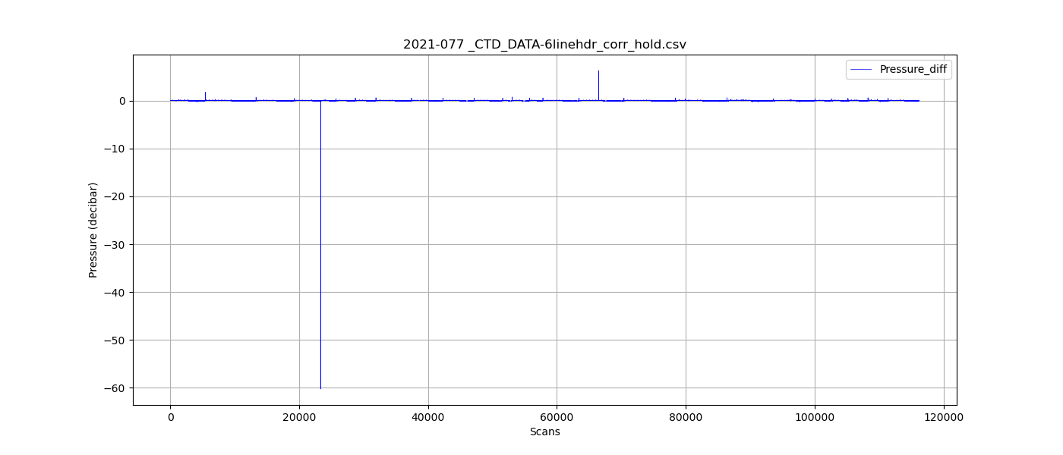

Figure 3 – zero order holds corrected

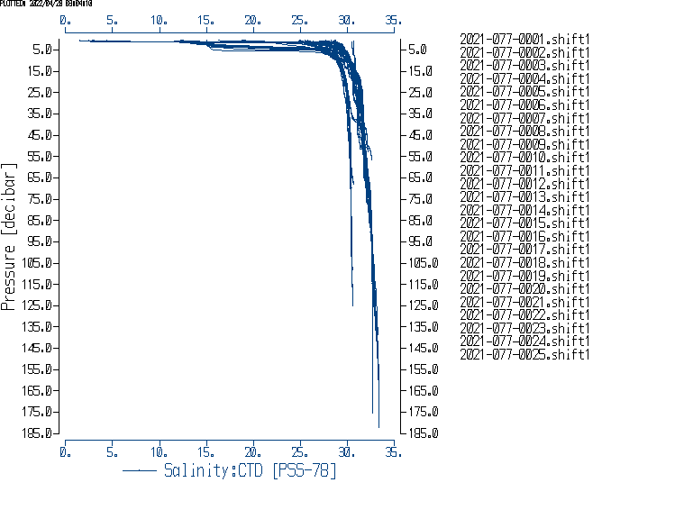

Figure 4. Salinity after Shift.