**REVISION NOTICE TABLE**

|  |  |
| --- | --- |
| **Date** | **Description of Revision** |
| 24 July 2023 | Corrected Salinity – re-ran from Shift to recalculate Salinity. Re-did the oxygen conversion afterwards. SH |
| 18 July 2023 | All casts re-detected. File names changed to ‘upgraded_new_cast.rsk’  DO Saturation converted to DO Concentration. SH. |

**RBR CTD DATA PROCESSING NOTES**

Cruise: 2021-070

Agency: OSD

Locations: Fraser River

Project: OPP Fraser River Survey

Party Chief: Hourston, R.

Platform: RV Doug Anderson

Date: October 18, 2021 – October 22, 2021

Processed by: Samantha Huntington

Date of Processing: March 7, 2022 – April 21, 2022

Number of Raw files: 66 Number of Processed Files: 66

**Instrument Summary**

Equipment: RBR Concerto CTD (s/n 204694) with a Turner Cyclops Fluorometer (s/n 21101282) and a JFE Advantech Rinko III oxygen sensor (s/n 411).

Sampling was at 8Hz.

**Summary of Quality and Concerns**

A CTD Log sheet was provided with times and positions of all casts. A note was also provided about recalibration of the Oxygen sensor. The Dissolved Oxygen Saturation was recalibrated in all the files using the new coefficients provided by Glenn Cooper.

Many of the casts are shallow and therefore appear noisy due to their short descent and ascent. Cast 44 and 53 each have an oddly negative pressure but this looks like an anomaly among readings of 0db. Cast 54 was not clipped, it starts at 2.1db and only decreases in pressure. The remainder of the casts had a lot clipped from the start of the downcast, it appears that the RBR stayed on the surface for a while before each descent.

**Processing Summary**

1. **Conversion to IOS Headers**

Multiple profiles were found in the following recalibrated files:

* 204694_20211018_1808_upgraded.rsk
* 204694_20211019_1802_upgraded.rsk
* 204694_20211020_2136_upgraded.rsk
* 204694_20211021_1751_upgraded.rsk
* 204694_20211022_1742_upgraded.rsk

Reading the log book and matching times and depths to the CTD Log sheet ‘2021-070_CTD_Times_Locations.xlxs’, a single csv file for all profiles from each file was extracted using python function READ_EXCELrsk().

A single file (2021-070_CTD_Data.csv) with all the data including event numbers and a single line of headers was prepared using python function MERGE_FILES().

A 6-line header was inserted using python function Add_6Lineheader_2().

File “2021-070_header-merge.csv” was created, based on the information in the file 2021-070_CTD_Times_Locations.xlxs.

* Column “File_Name”: entries were derived from the event number.
* Column “LOC:LATITUDE”: latitude data were taken from the 2021-070_CTD_Times_Locations.xlxs and reformatted to “XX XX.XXXX N !(deg min)”.
* Column “LOC:LONGITUDE”: longitude data were taken from the 2021-070_CTD_Times_Locations.xlxs and reformatted to “XX XX.XXXX W !(deg min)”.
* Column “LOC: Event Number”: entries were event numbers.
* Colmun “LOC: STATION”: station data were taken from 2021-070_CTD_Times_Locations.xlxs.

Sampling sites were mapped (Figure 1) using from “2021-070_header-merge.csv” using python function Plot_Track_Location() to check the location of all casts.

Prior to conversion to IOS header format, the presence of zero-order holds were checked using Python function Plot_Pressure_Diff(). There were zero-order holds found in each cast (fig 2) Python function correct_hold() was used to correct this.

CONVERT Spreadsheet Files was run to produce files with IOS Header format. Header entries of “Administration”, “File” and “Instrument” were filled in this step.

The routine “Merge:CSV Files to headers” was run to add location headers to the IOS files.

Raw data were plotted and examined:

* Salinity looks ok, casts 1 and 44 are unsteady. There is bad data at the top of the upcast for numerous casts.
* Conductivity looks ok, casts 1 and 44 are unsteady. There is bad data at the top of the upcast for numerous casts.
* Temperature looks ok with some bad data at the top of the upcast for numerous casts. Temperature is unsteady for casts 1, 8, 34, 35, 36, 37, 44, 47, 48, 55 and 61.
* Oxygen looks ok with some bad data at the top of the upcast for numerous casts.
* Fluorescence looks ok.

Next CLEAN was run to add a start time and event numbers to headers.

1. **Data processing**

* Correction to Pressure: Negative pressures were seen at the end of each upcast, and on some casts (28, 33 39,44, 45, 46, 51, 55, 63, 64 example) prior to the CTD starting it’s descent and the corresponding Conductivity was found to be less than 0.01 mS/cm (except for cast 40), so pressure was not calibrated.
* Data despiking: There are no significant spikes in temperature, conductivity and salinity. So there is no need to apply data despiking.
* CLIP: Pressure is steady for a variable number of scans. Initial records were removed until the downcast began its descent and final records after the ascent were removed using file “2021-070_CLIP.csv”.
* Filter: a Gull-winged filter, size 3 was applied to temperature, conductivity, and pressure. Salinity will be calculated in the next step.
* SHIFT: Based on suggested values in document “Guidelines for processing RBR CTD profiles”, the alignment of temperature and conductivity was corrected by applying a shift of -2 scans in conductivity. Oxygen was corrected by applying a shift of 11 scans. Salinity was recalculated and the results are shown in Figure 3.
* Delete was run to remove records with a descent rate lower than 0.3m/s over 8 points. This was not applied in the top 10m to avoid loss of surface records as the CTD began its descent.
* Profile plots were examined after DELETE and confirm that plots show reasonable values for temperature and salinity.

1. **Final checks and header editing**

* REMOVE was run to remove the following channels from all casts: Date, Time:UTC and Event.
* BIN AVERAGE was used to metre-average data.
* CALIBRATE was run to convert conductivity units to S/m using file 2021-070-recal2.ccf.
* REORDER was run to reorder the channels in all files.
* Header Edit was used to fix channel names and format as listed below:
* Pressure: format F11.2 ==> F7.1
* Salinity:CTD ==> Salinity
* Conductivity: F10.5 ==> F10.6
* Fluorescence ==> Fluorescence:URU
* Oxygen ==> Oxygen:Dissolved:Saturation:RBR

mL/L ==> %

F11.4 ==> F8.2

* CLEAN was run to reset the Maximum and Minimum values in the Header.
* Header Check was run and no problems were found.

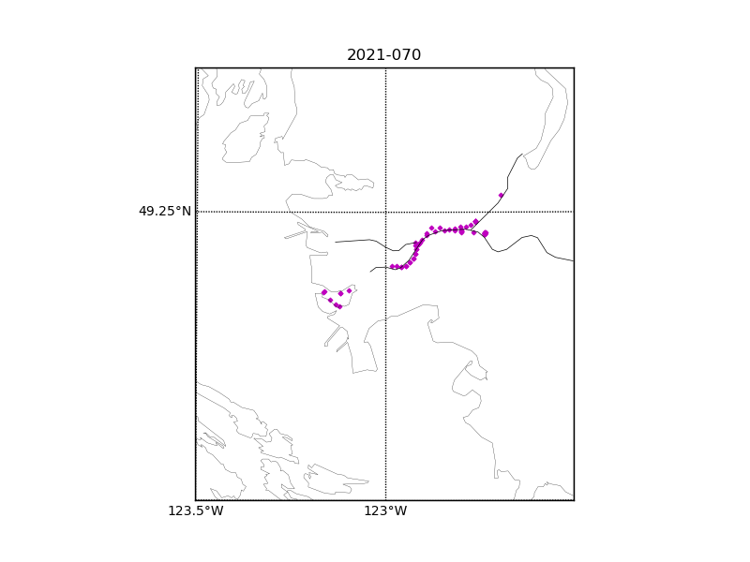

Figure 1 – location of casts.

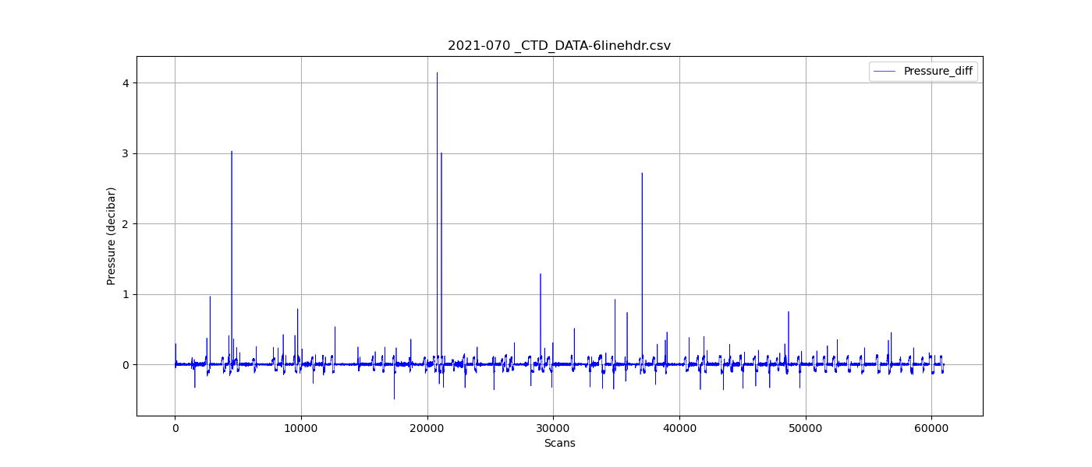

Figure 2 – zero-order holds

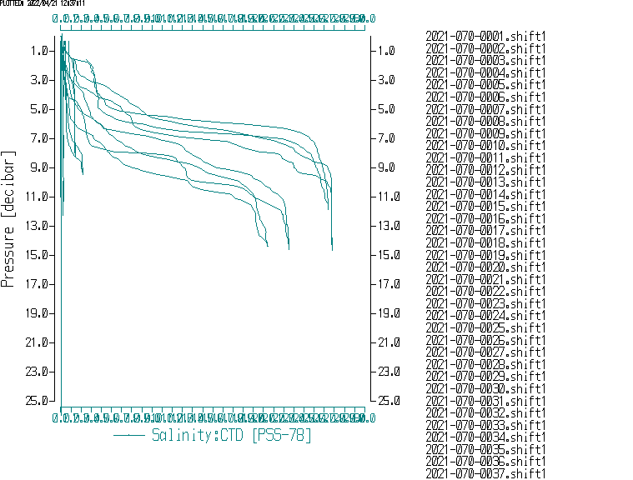

Figure 3. Salinity after Shift