## REVISION NOTICE TABLE

|  |  |
| --- | --- |
| DATE | DESCRIPTION OF REVISION |
| 18 March 2025 | Updated file names, channel names & formats in TOB files. G.G. |

## PROCESSING NOTES

Cruise: 2021-069

Agency: OSD

Location: Juan de Fuca Strait to Hecate Sound

Project: IOS Mooring Cruise

Chief Scientist: Spear D.

Platform: John P. Tully

Date: 1 June 2021 – 12 June 2021

Processed by: Germaine Gatien

Date of Processing: 18 October 2021 – 9 November 2021

Number of original HEX files: 111 Number of processed CTD files: 109

Number of rosette files: 47 Number of processed CHE files: 47

Number of original TSG files: 11 Number of processed TOB files: 12

# INSTRUMENT SUMMARY

CTD #0443 was mounted in a rosette and attached were 2 Wetlabs CSTAR transmissometer (1185DR & #1883DG), a SBE 43 DO sensor on the primary pump (#3791), SeaPoint Fluorometer on the secondary pump (#3950), a Biospherical QSP-400 PAR sensor (#70613) and an altimeter (#75321).

A thermosalinograph (SeaBird 45 S/N 0620) was mounted with a Wetlabs WETStar fluorometer (#1656) and flow meter.

Seasave version 7.26.7.121 was used for acquisition.

The data logging computer WP #102.

The deck unit was a Seabird model 11+ #425.

A Guildline model 8400B Autosal serial # 68572 was used to analyze salinity samples.

An IOS rosette with 24 10L bottles was used.

# SUMMARY OF QUALITY AND CONCERNS

The Daily Science Log Book and rosette log sheets were generally in good order with comments about problems encountered, but the equipment list was not completed. There was a note that the equipment was the same as on the previous Tully cruise, but the cruise number for that previous trip was not included. The log should have as complete a record as possible both for the convenience of future users who may not have easy access to information from a previous cruise and to check for any errors in the record of the previous cruise. There were notes about variations in the deployment method for some casts but they were incomplete.

There were some errors in event numbers in the rosette sampling log, presumably due to last minute changes in order of events.

For most casts acquisition started as the CTD was lowered into the water; the CTD was kept at the surface for 30s-60s. The intention was to wait until the two sets of sensors stabilized, but the conductivity (and hence salinity) channels were often far apart when the full cast began. Perhaps the scale at which the differences were displayed at sea was too crude to be a useful guide.

For casts #71, 72, 86, 87, 88 and 89 the CTD soaked for 30s at the surface, lowered to 10m for a 60s soak and then raised to 1.5-2m for another 30s soak; the full cast then followed. There were clear notes in the log about the alternate scheme for most of these casts, but it was only late in the processing process that it was discovered that cast #89 had been run using the alternate deployment scheme. Such casts need special handling to remove data from the soak period.

During the casts with only a soak at 2 to 3m the two salinity channels often differed greatly until the CTD reached 15db to 20db. The few casts with a 10m soak show the secondary salinity beginning to equilibrate during the initial drop and soak and the 2 channels are close for the full cast that followed. So while the 10m soak has been recommended to allow release of bubbles to improve dissolved oxygen data, it also appears to be useful for conductivity. Whatever the cause of the initial poor secondary conductivity data, a deeper soak looks like a good safety measure to ensure we can take full advantage of the dual sensor pairs. (A report on the study of 10m-soak effects is in section 25.)

Waits before firing bottles were usually at least 30s, but on a few occasions were a little shorter. Incomplete flushing of Niskin bottles can lead to significant differences between bottle contents and in situ values, The differences will be largest in areas of large vertical gradients and in areas of calm seas where the Niskin contents don’t get stirred up.

The choice of levels for salinity sampling was not very useful for calibration purposes. Many were from the bottom of casts. The casts were generally about 5m above bottom, but for salinity calibration being 10m above the bottom of the cast is best. Other samples came from between 0m and 50m where vertical gradients tend to be large so flushing errors are large. There were stops for sampling between 200m and 1500m during the deepest cast; salinity samples from those depths are recommended in future.

PAR sensor #70613 is rated for 2000db so removal of the sensor was unnecessary for any casts.

There were 2 WetLabs CStar transmissometers in use during this cruise:

Channel Transmissometer refers to sensor #1185DR (650nm - red)

Channel Transmissometer:Green refers to sensor #1883DG (530nm - green)

For comparison with other Institute of Ocean Sciences cruises, note that the transmissometer wavelength is 650nm unless otherwise stated.

The salinity analyst noted that many of the outer lids on sample bottles were not on tight.

Two casts had problems with some pumped channels.

* For event #121 there were problems in both conductivity channels below 200db. The primary was least affected. Points were removed from channels Salinity:T0:C0 and Oxygen:Dissolved in the affected depth ranges. Temperature data looked fine; fluorescence was near-zero at those depths.
* For event #150 the problems affected all pumped channels at most depths below 16db and the data were very noisy above that. Cast #150 will not be archived. The problem was noted at sea and an attempt was made to run another cast at the same site but the pumps were not turned on.

The SBE DO sensor has a fairly long response time so data accuracy is not as high when it is in motion as it is during stops for bottles. This will be especially true when vertical DO gradients are large. To get an estimate of the accuracy of the SBE DO data during downcasts (after recalibration) a rough comparison was made between downcast SBE DO and upcast titrated samples. Some of the difference will be due to problems with flushing of Niskin bottles and/or analysis errors and small mismatches in depth in the presence of large DO gradients, so the following statement likely underestimates SBE DO accuracy.

Downcast (CTD files) Oxygen:Dissolved:SBE data for this cruise are considered, very roughly, to be:

±0.30 mL/L from 0-100db

±0.20 mL/L from 100-200db

±0.04 mL/L from 200-500db

±0.02 mL/L below 500db

The Thermosalinograph system functioned well with lots of detail in the traces and no suspicious spikes. The comparisons of TSG data with co-incident CTD data were complex with 3 sections having quite different results. Before and after the inlet section near-surface waters were quite well mixed while in the inlets there were large vertical gradients. The TSG data in the first section had salinity lower than co-incident CTD data by about 0.026psu. In the inlets the TSG salinity was much lower than CTD salinity and the differences were highly variable. In the final section after the ship left the inlets the surface waters were very well-mixed and the TSG salinity was lower than CTD salinity by about 0.0033psu It is likely that there were more bubbles in the loop in the final section than in the first. There were only a few underway loop samples. In the absence of more information the salinity was recalibrated by adding 0.30psu, the average from the 2 well-mixed regions. The TSG salinity values are given with 4 decimal places to enable resolution of relative changes but there is insufficient evidence to establish accuracy.

TSG Temperature may be high by ~0.02C°but the evidence is too weak to justify recalibration.

TSG Fluorescence values looked normal with values reasonably close to CTD fluorescence and showing the usual pattern of reading higher than extracted chlorophyll rosette samples when CHL was low and gradually dropping relative to CHL as CHL decreased. For CHL > 4ug/L fluorescence was about 50% of CHL.

The TSG data have been organized into individual files for each day.

# PROCESSING SUMMARY

##### Seasave

This step was completed at sea; the raw data files have extension HEX.

The deployment protocol was:

* For most casts: No 10m dip – acquisition started at the beginning of casts with a 1 to 2 minute wait at about 2db.
* For casts 71-72 & 86-89: The CTD was lowered to 1.5-2m and kept there for 30s. Pumps were turned on. The rosette was brought down to 10m and kept there for 60 seconds. It was returned to 1.5-2m where it was soaked for 30 seconds longer. Then the cast would start.
* During bottle stops there was a wait of about 30s before bottles were closed.

##### Preliminary Steps

The Log Book and rosette log sheets were obtained.

* Nutrients, extracted chlorophyll, dissolved oxygen, salinity data were obtained in QF spreadsheet format from the analysts.
* The cruise summary sheet was completed.
* The histories of the pressure sensor, conductivity and dissolved oxygen sensors were checked. The temperature, conductivity and dissolved oxygen sensors had been used on 3 other cruises since the last factory recalibrations. See section 14 for details.

Based on log notes the station names were changed for 2 casts.

The configuration file was checked. All parameters were correct except for one of the transmissometers; an error was found in the derivation of SeaBird parameters for the last calibration and the new slope and offset entered in file 2021-069-ctd.xmlcon.

##### BOTTLE FILE PREPARATION

The ROS files were created using files 2021-069-ctd.xmlcon.

The ROS files were converted to IOS format.

The IOS files were put through CLEAN to create BOT files.

Temperature and salinity were plotted for all BOT files to check for outliers.

The file for event 14 was opened in CTDEDIT and channel Salinity:T0:C0 was edited very lightly.

The file for event 108 was opened in CTDEDIT and channel Salinity:T1:C1 was edited very lightly.

The output files were copied to *.BOT.

A preliminary header check was run and no problems were found.

The BOT files were bin-averaged on bottle number.

The output was used to create file ADDSAMP.csv. First, the file was sorted on event number and Bottle Position order. Then sample numbers were added based on the rosette logs.

Event #43 was called #42 and #126 was called #124 on the Sampling Log. Those were corrected in the QF files for CHL and Dissolved Oxygen.

The Salinity QF file had the right event numbers but the number of days between collection and analysis was wrong, so that was corrected.

The ADDSAMP file was then reordered on event # & sample #.

The ADDSAMP file was used to add sample numbers to the BOT files – output *.SAM.

The SAM files were bin-averaged on bottle # and called SAMAVG.

The addsamp.csv file was converted to CST files, which will form the framework for the bottle files.

Next, each of the analysis spreadsheets were examined to see what comments the analysts wanted included in the header file. These were used to create file 2021-069-bot-hdr.txt which will be updated as needed during processing.

Loops samples were moved from the salinity and chlorophyll files to a combined loop data file.

DISSOLVED OXGYEN

Dissolved oxygen data were provided in spreadsheet QF2021-069_OXY*.xlsx which includes flags, comments and a precision study. Draw temperatures are available. The spreadsheet page with the final data was simplified and saved as 2021-069oxy.csv. That file was converted into individual *.OXY files.

There were 2 samples in the DO file that had comments starting with “ALL:” One only referred to bottles being closed out of order and no flag was attached, so this was removed. The other concerns possible problems with the integrity of the Niskin bottle, so the flag 3 was added to other samples.

EXTRACTED CHLOROPHYLL

Extracted chlorophyll and phaeo-pigment data were obtained in file QF2021-069_CHL QF*.xlsx. The file included comments and flags and a precision study. A simplified version of the spreadsheet was prepared and saved as 2021-069chl.csv. The csv file was then converted to individual CHL files.

SALINITY

Salinity analysis was obtained in file QF2021-069_SAL.xlsx which included a precision study. The analyses were carried out in a temperature-controlled lab 50 to 61 days after collection. The files were simplified and saved as 2021-069sal.csv. That file was then converted to individual SAL files.

NUTRIENTS

The nutrient data were obtained in spreadsheet QF2021-069_NUTS*.xlsx. This includes a precision study. The file was simplified, saved as 2021-069nuts.csv. The file was converted to individual NUT files.

The SAL, CHL, OXY and NUT files were merged with CST files in 4 steps.

After the 4th step the files were put through CLEAN to reduce the headers to File and Comment sections only.

The files were then put through CLEAN to reduce the headers to File and Comment sections only.

These files are ordered on sample number, but the SAMAVG files are ordered on bottle number, so one or the other set needs to be reordered in order to merge them. The MRGCLN1 files were reordered on Bottle_Number and saved as *. MRGCLN1s.

The MRGCLN1s files were then merged with SAMAVG files using merge channel Bottle_Number.

The output of the MRG files were exported to a spreadsheet and compared to the rosette log sheets to look for omissions. A few problems emerged:

* Sample data were missing from Event #1 because the file should have been #2. After renaming the CTD files, the merge process was repeated for event #2.
* For event #32 the sample files were misnamed as #31, no doubt due to the very unclear record in the Daily log. The Sampling Log appears to be correct and the start time of the CTD file confirms this match.
* Event #34 has CHL samples in the QF file but not on the rosette sheet; no CHL values are missing from other files so it is assumed they really did come from event #34.
* Event #56 – one salinity sample had event number mislabelled.
* Event #114 – 3 nutrient sample missing but this is assumed to be intentional since the water was much shallower than expected and 3 depths were crossed out.

##### Compare

Salinity

Compare was run with pressure as reference channel.

All of the bottles were fired either in the top 50m or close to the bottom. Many were also in protected waters where flushing of Niskin bottles is liable to be incomplete; above 50m the vertical salinity gradients tend to be large so if they don’t flush well the Niskin bottles may have salinity significantly higher than ambient waters. For some of the casts the top 10 to 20m were well-mixed so flushing is not so critical for some of the shallowest samples. And for some the Niskin being above the CTD might offset the flushing error. The standard deviation in the CTD salinity during the 10s window offers some guidance as to the size of the local vertical gradients.

The deeper bottles were mostly closed at the bottom of casts, about 5m above the bottom of the water column. If flushing is poor that means they are likely to contain water from higher in the water column. Being within 5m of the bottom also means there many be shed wakes bouncing around the Niskins complicating analysis. It is best to take calibration samples further from the bottom and preferably about 10m above the maximum depth sampled. However, vertical salinity gradients near the bottom of deep casts tend to be low which should limit errors associated with shed wakes and poor flushing.

Using all the data the average difference between the 2 CTD salinity channels was about 0.0063psu which is close to the results from 2 previous cruises with lots of deep sampling.

When outliers were removed based on standard deviation in the CTD salinity >0.001psu and differences in (Sal-Bot) differing from the average by more than 0.005psu, the primary salinity was found to be low by 0.0060 (standard deviation 0.0022psu) and the secondary was found to be low by 0.0014psu (standard deviation 0.0024psu). That suggests a difference of ~0.005psu but each of the results are lower compared to bottles than during 2021-006 and 2021-005. Possible reasons for that include flushing errors and errors due to the 5-7 week delay in analysis. Based on Alexander and Hinrichsen (1986) the effect of desorption of glass particles into the samples would raise salinity values by ~0.0025psu over that time and there is likely a small and random error due to evaporation. This plus a small flushing error would bring the primary salinity close to bottle values. The secondary would be higher than the primary by ~0.005psu based on the bottle comparison or by ~0.006psu based on the average difference between the 2 CTD channels using all data available. This is similar to results from the 2 previous cruises.

The only outliers were right at the surface. Most were easily explained as being due to either very noisy CTD data or flushing errors. A few did not:

* Sample #384 from event #106 at 5m had salinity value that is close to that from the 2m sample. The pressure was very steady during the stop. The primary CTD detected no salinity <25psu during the stop and most was considerably higher than that. Even allowing for the rosette being above the CTD there was no salinity that low. This sample was flagged 3 because the lid was not on tight but that would not explain lower salinity. A flag 4 looks appropriate since it may well have come from the wrong Niskin bottle. The analyst agreed and changed the flag to 4.
* Sample #431 from event #110 also looks too fresh. It doesn’t look like a miss-sample and for this one the Niskin being above the CTD might have been enough to explain the value due to a large vertical gradient.
* Sample #493 from event #116 also looks like the distance between Niskin and CTD can explain the large difference since the vertical gradient was large.

For full details for the COMPARE run see file 2021-069-sal-comp1.xls.

Dissolved Oxygen

COMPARE was run with pressure as the reference channel.

The fit was remarkably tight:

CTD DO Corrected = CTD DO * 1.0486 - 0.0023 R2 = 0.96

The results from the 2 previous cruises 2021-006 (Line P section only) and La Perouse 2021-005 were:

CTD DO Corrected = CTD DO * 1.0515 - 0.0131 R2 = 0.98 (Line P)

CTD DO Corrected = CTD DO * 1.0536 - 0.0018 R2 = 0.95 (La Perouse)

There are likely flushing errors in the current cruise data, which would lead to decreases in the correction to dissolved oxygen. The 2021-006 results were from samples collected offshore where flushing is usually better and for 2021-005 there were longer waits before firing bottles at levels with high DO vertical gradient zones which likely helped flushing. Normally the 2021-006 fit would be considered most appropriate for recalibration of the data from this cruise since it has the most offshore data available. But the 2021-005 fit was closest in time and had a tight fit, possibly due to the longer waits where DO gradients were largest. The correction is higher than for 2021-006; normally we expect a smaller correction where flushing is poorer, so either there was significant calibration drift or the sampling method did lead to better flushing.

Major outliers were examined:

* Event 32, Sample 119 – This looks like a possible flushing error as the DO sample is lower than the CTD value and there are values below the firing level that would match it. No flag is recommended.
* Event 110, Sample 431 - This sample is already flagged, because of sediment, the CTD data are noisy and the value could be explained by the Niskin being higher than the CTD as the vertical gradient is high. No change to the flag is recommended.
* Event 116, Sample 338 – This looks like a possible flushing error as the DO sample is lower than the CTD value and there are values below the firing level that would match it. No flag is recommended as the analysis is likely fine.

For full details for the COMPARE run see file 2021-069-dox-comp1.xls.

Fluorescence

COMPARE was run with extracted chlorophyll and CTD Fluorescence using pressure as the reference variable.

The CTD fluorescence is ~56% of the extracted CHL but this varies widely, as expected given the different regions sampled. Fluorescence is much higher than CHL for very low CHL values. When CHL is between 0.5ug/L and 3ug/L they are close and for CHL>3ug/L the fluorescence is about 50% of the CHL.

This is very similar to the results of 2021-005 in late May/early June.

For full details for the COMPARE run see file 2021-069-fl-chl-comp1.xls.

##### Conversion of Full Files from Raw Data

File 2021-069-ctd.xmlcon was used to convert all files.

The Tau function and the hysteresis function were selected since there was deep sampling. Depth was included in the conversion.

A few casts were examined and all expected channels are present. The descent rate was often extremely noisy offshore but steady inshore. The T and C pairs were reasonably close during downcasts except at the surface. The altimetry looked ok even though the signal was sometimes noisy at the bottom of casts.

##### WILDEDIT

Program WILDEDIT was run to remove spikes from the pressure, depth, conductivity & temperature only in the full cast files (*.CNV).

Parameters used were: Pass 1 Std Dev = 2 Pass 2 Std Dev = 5 Points per block = 50

The parameter “Keep data within this distance of the mean” was set to 0 so all spikes would be removed.

##### ALIGN DO

A few casts were examined; both temperature channels were noisy during upcasts so the tests were not easy to interpret, but using +2.5s certainly improves the alignment and overall looks like a good choice for both sensors. That setting has worked well for many SBE DO sensors in recent years.

ALIGNCTD was run on all casts using +2.5s.

##### CELLTM

The noise in the upcast data makes tests for the best parameters for this routine very difficult to interpret. In the past when upcast data were not so noisy, the default setting of (α = 0.0245, β=9.5) was generally found to be the best choice. A few casts were checked for this cruise and the default setting does improve the data. CELLTM was run using (α = 0.0245, β=9.5) for both the primary and secondary conductivity.

##### DERIVE and Channel Comparisons

Program DERIVE was run on all casts to calculate primary and secondary salinity and dissolved oxygen concentration.

DERIVE was run a second time on 3 of the deeper casts to find the differences between the pairs of temperature, conductivity and salinity channels.

|  |  |  |  |  |  |
| --- | --- | --- | --- | --- | --- |
| Cast # | Press | T1-T0 | C1-C0 | S1-S0 | Descent Rate |
| 2021-020-0037 | 320 | -0.0002 | ~ | +0.0002 | High, F.Steady |
| 2021-020-0082 | 350 | +0.0001 | +0.00017 | +0.0015 |  |
| 2021-020-0117 | 375 | +0.0004 | +0.00022 | +0.0021 | High, Noisy |
| 2021-006-0020 | 375 | +0.0004 | +0.00044 | +0.0043 | High, Noisy |
|  | 1200 | +0.0002 | +0.00042 | +0.0050 | “ |
| 2021-006-0039 | 1200 | 0 | +0.00042 | +0.0049 | High, XNoisy |
| “ | 2000 | -0.0002 | +0.00044 | +0.0055 | “ |
| “ | 3000 | -0.0003 | +0.00044 | +0.0057 | “ |
| 2021-006-0052 | 1200 | 0 | +0.00043 | +0.0057 | High, XNoisy |
| “ | 2000 | -0.0005 | +0.00042 | +0.0056 | “ |
| “ | 3000 | -0.0005 | +0.00044 | +0.0060 | “ |
| 2021-006-0077 | 1200 | -0.0005 | +0.00042 | +0.0059 | High XNoisy |
|  | 2000 | -0.0007 | +0.00044 | +0.0063 | “ |
|  | 3000 | -0.0006 | +0.00045 | +0.0062 | “ |
| 2021-005-0099 | 1000 | -0.0002 | +0.00050 | +0.0058 | High, Noisy |
|  | 1900 | -0.0004 | +0.00050 | +0.0064 | High, V. Noisy |
| 2021-005-0140 | 1000 | -0.0002 | +0.00055 | +0.0065 | High, Noisy |
|  | 1900 | -0.0005 | +0.00055 | +0.0072 | F. High, NOisy |
| 2021-069-0009 | 500 | +0.0002 | +0.00040 | +0.0044 | High, Noisy |
|  | 900 | -0.0001 | +0.00040 | +0.0048 | “ |
|  | 1850 | -0.0004 | +0.00041 | +0.0054 | “ |
| 2021-069-0014 | 500 | ~0 XN | +0.00038 | +0.0046 | High, Noisy |
|  | 900 | -0.0001 | +0.00039 | +0.0047 | “ |
|  | 1850 | -0.0005 | +0.00041 | +0.0054 VN | “ |
| 2021-069-0120 | 500 | -0.0001 | +0.00030 | +0.0044 | High, Mod |
| 2021-069-0148 | 500 | ~0 XN | +0.00033 | +0.0038 | High, V Noisy |
|  | 900 | -0.0002 | +0.00030 | +0.0040 | “ |

The salinity and conductivity differences are slightly lower than during the 2 previous cruises. As usual there is a little pressure dependence in the salinity differences. Temperature differences are close to the ones late in 2021-006.

##### Conversion to IOS Header Format

The IOSSHELL routine was used to convert SEA-Bird 911+ CNV files to IOS Headers.

CLEAN was run to add event numbers and to replace pad values in the pressure channel with interpolated values based on record number.

##### Checking Headers

An initial header check showed evidence of some spikes but all appear to be from before pumps were turned on.

The cross-reference check and header check were run. Some files were found to be missing. More raw data were found and processed. A few errors were found and corrected:

* Station names or formats corrected (also in bottle files where they exist): Casts #4, 34, 60, 90, 94 (error noted in log), 112 and 114.

For most casts acquisition began on deck. The CTD was then lowered until the CTD pressure read about 1.5m (when the bottom of the bottles were in water) or occasionally 0.5m (when there were no waves) when the water level was between the bottom of the bottles and the top of the top ring.

* The Surface Check gave an average surface value of 1.3db with a range of 0.8db to 4.9db. There were many readings of +0.8 to +1.2db. So the pressure appears to be high by at least 0.8db.
* During one cast the CTD was left running for 20 minutes after the cast and pressures are about +0.8db where we would expect something close to 0. So this also suggests pressures are too high.
* Many casts end with pressures at ~0.8db but pumps were off so whether the CTD was in or out of water is not clear, but it is believed that acquisition stopped soon after the pumps were turned off and the CTD was in water, but may have been very close to the surface.
* During cast #109 the Niskin bottles came out of the water briefly during the final bottle stop. The CTD pressure got as low as 1.09db at the beginning of that final bottle stop. If the Niskins came fully out of the water, then the CTD pressure should have been 0db but it may not have been fully out of water.
* The accuracy given for this sensor is ±1db. And stability is said to be 1.4db per year and it was last calibrated about 5 months before this cruise, but has been used for 3 other cruises, so some drift may be expected. Previous uses did not provide evidence of calibration drift but there was also little evidence one way or the other.
* For most casts there was an initial soak at about 1.5db. If pressure is too high by 0.8db, then the CTD would actually have been at 0.7db and half of the rosette would have been out of the water. This fits the description of how many of the deployments were done.
* Recalibrating by subtracting 0.8db looks appropriate.

Cruise tracks were plotted and added to the end of this report.

The altimeter and water depth readings from the headers of the CLN files were exported to a spreadsheet. A check value was calculated by subtracting water depth from maximum depth sampled plus altimetry header). Where that number was > 5 or <-5 plots of the altimetry were checked. In all cases the altimetry header entry looks reliable. In some cases the water depth entry in the file headers was clearly incorrect so either the entry from the log or a calculated value based on altimetry plus maximum depth sampled were used to replace the water depth entry in the headers. These changes were made after the SHIFT steps – they were applied to the DEL files. The same changes were made to bottle files, as appropriate. For details see document “2021-069-altimeter-ctd.xlsx”.

##### Shift

Fluorescence

SHIFT was run on the SeaPoint fluorescence channel in all casts using the usual advance of +24 records. Plots show that the fluorescence offset is reasonably close to the temperature offset after this step.

Dissolved Oxygen

The Dissolved Oxygen voltage channel was aligned earlier. A few casts were checked to see if the alignment looked ok, and it did. No further alignment is needed for the DO concentration channel,

Conductivity

Tests were run on a few casts to assess what settings are best to align conductivity with temperature (as judged by the effect on salinity as seen in T-S space). The last time these sensors were used the best settings were -0.8db for both sensors. The best settings for this cruise was -0.8 records for the primary channels, with but for the secondary a setting of -1.4 records was best overall, though as usual this varied from feature to feature.

SHIFT was run twice on all SBE911 casts using -0.8 records for the primary conductivity channel and ‑1.4 records for the secondary channel. Salinity was recalculated for both channels.

##### CLIP

CLIP was run to remove data with pumps off.

Surface Check was rerun to ensure too much data were not removed as occasional glitches in pump status could occur mid-cast. The maximum pressure in the files were the same as in the surface check of CLN files..

##### DELETE

The following DELETE parameters were used:

Surface Record Removal: Last Press Min

Maximum Surface Pressure (relative): 10.00

Surface Pressure Tolerance: 1.0 Pressure filtered over 15 points

Swells deleted. Warning message if pressure difference of 2.00

Drop rates < 0.30m/s (calculated over 11 points) will be deleted.

Drop rate applies in the range: 10db to 10db less than the maximum pressure

Sample interval = 0.042 seconds. (taken from header)

COMMENTS ON WARNINGS: The only warning concerned cast #51 for which the pumps never came on so most data had been removed. This cast will not be processed further.

Special files were prepared for casts #86, 87 and 88 containing a set of files with data from the initial drop to 10m and a second set of files with data from the main drop from the surface to 10m. A study was done comparing the 2 sets to consider the effect of a 10m soak on surface salinity data. Details of this study are in section 25 of this report. The conclusion of that study was that the 10m soak did not appear to degrade near-surface salinity data, and in fact, allowed the equilibration of the secondary salinity so that the 2 channels had good correspondence before the cast began.

A second part to the study above investigated the deployment scheme without a 10m soak. The intention was to disturb surface waters as little as possible. The CTD was held at approximately 3m until the sensor pairs were in good agreement. It is likely that the scale of the display was too crude to see that the equilibration of the secondary conductivity had not been achieved. See section 25 Part 2 for plot.

##### Other Comparisons

Experience with these sensors since last factory service –

The pressure, temperature, and conductivity sensors were used during only 1 cruise since the last factory visit:

* 2021-020 – The salinity channels started out close and gradually drifted apart. Based on information from the Line P section of cruise 2021-006 it appeared that the primary salinity did not drift much during this cruise. The drift in secondary salinity appears to have been fairly sudden and then settled down. Dissolved oxygen was recalibrated using slope/offset =1.0515/-0.0131 based on cruise 2021-006. This correction seemed high since it was first use since previous factory calibration. Pressure looked ok. No TSG.
* 2021-006 Dissolved oxygen recal slope/offset = O 1.0515/-0.0131; Primary very close to bottles selected for archive; secondary high by 0.006psu. TSG salinity low by 0.183.
* 2021-005 Dissolved oxygen recal slope/offset = 1.0536/-0.0018; Primary high by about 0 to 0.001psu, selected for archive; secondary high by 0.005 to 0.006psu. TSG salinity low by 0.191; intake temp high by 0.02C degrees – no recal applied.

Historic ranges – Profile plots were made with 3-standard deviation climatology ranges of T and S superimposed. The only climatology available for many of the sites was based on large-scale blocks that include offshore values, so not useful for inlets. For non-inlet casts temperatures fell within local climatology. Similarly, salinity fell within the climatology in the offshore but in inlets and near land near-surface salinity was usually below the climatological value and deeper values were near the minimum and occasionally lower than the minimum.

None of these excursions suggest calibration drift.

Post-Cruise Calibration – None available.

Repeat Casts – There were no repeat casts deep enough to expect a good comparison.

##### DETAILED EDITING

The primary channels were chosen for editing because the salinity is believed to be more accurate and there were problems with near-surface secondary salinity.

All DEL files were copied to *.EDT.

CTDEDIT was used to remove records that appear to be corrupted by shed wakes. Salinity was cleaned to remove spikes that appear to be due to small misalignment or instrumental noise. All files required some editing except for files #64, 93 and 97. File #150 was rejected in editing – see note below*.

Notes about editing applied were added to the files.

The edited files were copied to *.EDT.

After editing, T-S plots were examined for all casts. Some small unstable features remain in some casts but come from areas where such features may well be real. No further editing was done.

A problem was found in cast #121 that affected both salinity channels but not temperature, so it was probably something getting stuck in the tubing. The primary appears to have been affected between 200 and 202db and 240 – 260db, whereas the secondary conductivity is bad from 200db (downcast) and stays bad until the end of the cast. The affected downcast primary salinity points were removed in editing.

*Another problem was in cast #150. It was noticed at sea that he 2 salinity channels were very different. In fact, there are many problems in the cast. Trouble starts at about 16db. There was a very noisy descent rate with complete reversals of direction. This can explain some of the noise in the data, but not the sudden switches from high to low values at several points in the profile in all pumped channels. The transmissivity suddenly moves to low values at the beginning of the bad section and at several other points with associated swings in values. This suggests that the problem is biological material in the tubing or over the sensors. Both primary and salinity temperature and salinity are affected. The upper 16db may be ok, but the shed wake corruption caused by the CTD reversing direction renders the near-surface data poor as well, so the cast will not be processed further. Cast #151 was a repeat cast at this site but the pumps were not turned on for that cast.

##### Corrections to Pressure, Salinity and Dissolved Oxygen Concentration

Salinity data will not be recalibrated. Pressure will be recalibrated by subtracting 0.8db. The Dissolved Oxygen correction will be based on the fit for La Perouse cruise 2021-005 which immediately preceded this cruise.

File 2021-069-recal.ccf was prepared to subtract 0.8db from the pressure and to apply the following correction to channel Oxygen:Dissolved:

CTD DO Corrected = CTD DO * 1.0536 - 0.0018

This correction was first applied to the SAM and MRGCLN2 files.

COMPARE was rerun for dissolved oxygen and shows that the correction was applied properly. When data are excluded based on using the same points as in the original fit the average is 0.018mL/L, with a standard deviation of 0.022mL/L. This is a larger difference than usual because the results of another cruise were used for the recalibration. Most likely 2021-069 had poorer flushing of Niskin bottles than 2021-005 making the CTD DO look as though it is reading a little too high. The differences increase as CTD DO increases and DO vertical gradients are generally highest where DO values are highest.

See file 2021-069-DO-comp2.xls for details.

CALIBRATE was then run on the EDT files using the same recalibration file.

##### Final Calibration of DO

The initial recalibration of dissolved oxygen corrects for sensor calibration drift. Alignctd corrects for transit time errors. Those 2 steps may partly correct for response time errors, but to see if a further correction is needed, a comparison is made of downcast CTD data to bottle data from the same pressure. Small differences are expected due to ship drift, temporal changes, incomplete flushing of Niskin bottles and delayed response and noise in CTD data.

Downcast files were bin-averaged to 0.5m bins for the casts with DO bottle samples. Those files were then thinned and compared to the bottle values in the MRG files. COMPARE was run to study the differences between the downcast CTD DO data and the titrated samples from upcast bottles.

When outliers are excluded based on residuals, the downcast CTD DO was higher than the titrated samples by an average of ~0.028mL/L (standard deviation 0.045mL/L). This is a reasonable result given that the bottle samples may come from slightly lower in the water column and the CTD DO may read slightly high due to slow response of the sensor. Near the surface where DO values are high, CTD DO is generally within 1% of titrated DO; % differences are larger in deeper water because the DO values are lower so small errors look more significant.

Based on the differences plotted against pressure a rough estimate of the downcast DO is:

±0.30 mL/L from 0-100db

±0.20 mL/L from 100-200db

±0.04 mL/L from 200-500db

±0.02 mL/L below 500db

For more detail see file 2021-069-dox-comp3.xls.

##### Fluorescence Processing

A median filter, size 11, was applied to the fluorescence channel in the COR1 files. Plots of a few casts showed that the filter was effective. (Output:*.FIL)

##### BIN AVERAGE of CTD files

The following Bin Average values were applied to the FIL files (output AVG):

Bin channel = pressure Averaging interval = 1.000 Minimum bin value = .000

Average value will be used. Interpolated values are NOT used for empty bins.

On-screen T-S plots were examined. No problems were noted.

##### Final CTD File Steps (REMOVE and HEADEDIT)

For all casts REMOVE was run to remove the following channels:

Scan_Number, Temperature:Secondary, Conductivity:Secondary, Oxygen:Voltage:SBE, Descent_Rate, Status:Pump, Altimeter, Salinity:T1:C1 and Flag.

PAR was removed for casts #9-40, 64-72 and 148.

A second SBE DO channel (with umol/kg units) was added.

REORDER was run to get the two DO channels together.

HEADER EDIT was used to fix formats and channel names and to add the comments about processing.

The Standards Check routine was run and no problems were found.

The Header Check was run; no problems were found.

Profile and T-S plots were examined. No problems were found.

The sensor history was updated.

##### Dissolved Oxygen Study

As a final check of dissolved oxygen data, % saturation was calculated and plotted. As expected in such a wide-ranging area sampled, there is a lot of variability. Values at 2 to 3m ranged between ~70% to 140%, but most were between 92% and 122%. The highest value was at station E01 where fluorescence and dissolved oxygen were both high. The lowest was at SC01 where there was a reversal in DO at the surface.

##### Final Bottle Files

SORT was run to arrange casts in pressure order.

For all casts REMOVE was run to remove the following channels:

Scan_Number, Temperature:Secondary, Conductivity:Secondary, Oxygen:Voltage:SBE, Descent_Rate, Status:Pump, Altimeter, Salinity:T1:C1 and Flag.

PAR was removed for casts #9-40, 64-77, 148.

A second SBE DO channel with mass units was added for both the CTD DO and titrated DO and REORDER was run to get the pairs of DO channels together.

EDIT HEADERS was run to fix formats and channel names and to add comments about analyses and CTD processing.

Data were exported from the CHE files to file 2021-069-bottles-final.xlsx. The entries were compared with the rosette log sheets and no problems were found except a 2 flag and comment was noted in the DO data (Event 102) that looks of no significance, so they were removed by the analyst.

Standards check and a header check were run. No problems were found.

The track plot looks ok.

Plots of each file were examined and no problems were found.

A cross-reference listing and header check were produced for the CHE files.

##### Thermosalinograph Data

An IOS TSG45 was used for this cruise and data were saved in 11 files. The time range in files varied from 5 minutes to 5 days. The very short file contained data that looked ok and the interval between successive files was very short, so they can be combined.

The IOS SBE TSG45 files were opened in EXCEL.

The files have extensions RAW but are in csv format, so the files were opened in EXCEL and combined in a single CSV file. (In opening use DELIMITED, deselect TAB, select COMMA and OTHER (*).

It is necessary to choose TEXT for the time on the 2nd page of the text import wizard.)

The 11 files were combined in file 2021-069-tsg.csv..

The spreadsheets were adjusted as follows:

* 2 lines of headers were added – channel names and units.
* A column with pressure was added with all values set to 4.5 (to enable derivation of salinity).
* A temperature difference column was added (Lab-Intake).
* The fluorescence channel is in volts. It was moved to column M. Then a concentration value was calculated in column F using scale 14.6 as determined in the most recent recalibration of the fluorometer. The clean water offset was originally set to 0.081ug/L but this led to some negative values during 2021-006. A study made during that cruise led to the choice 0f 0.065ug/L for the offset. The same value was entered for this cruise and a few cases were examined to see if the choice looks appropriate. There were no negative values. Comparisons with rosette files suggests the choice is better than using 0.81ug/L and gives reasonable values. The TSG fluorescence was usually close to or a little higher than CTD fluorescence and differed from CHL values in the expected way. Given the 2021-006 cruise sampled a wide range of fluorescence values including near-zero values, the offset of 0.065 was selected for use for 2021-069 as well..
* A file break column was filled with the cruise #-data/time info from the original file name.
* There is a note in the log that the PAR sensor on the TSG was cleaned at 20:30 on June 10th. This must refer to the fluorometer. The flow to the fluorometer was 0 from 20:25 to 20:32 and there are a few spikes to extremely high fluorescence values. Fluorescence values for the period when the flow was zero were padded.
* The minimum fluorescence value found was 0.5402 on June 12 at 5:47
* Time and Date formats are a problem – when converting from RAW choose TEXT but once opened in EXCEL set Time Format to HH:MM:SS and save the file again.
* The file break column was completed so that new files would be created at the beginning of each day by assigned file names like 20210610-000000 except for the first file which has a time later than 000000.

There were a few breaks when the flow was off to both the TSG and the fluorometer.

* The TSG was running for about 1 minute before the flow was started in the first file and it took a few minutes before lab temperatures looked reasonable, so the records from the first 3 minutes were removed.
* On June 3 the flow stopped from 22:24 to 22:57. Temperature:Intake, Temperature:Lab, Fluorescence and Conductivity data were padded during that period since all were clearly affected. The intake temperature recovered very quickly after flow started again but the other 3 channels took 10 minutes to return to believable values, so values for those 3 channels were padded until 23:07.
* On June 10 there was another section with the flow to the fluorometer off for about 7 minutes; the fluorescence values were padded while the flow was off and for a few records after it started again. Values looked reasonable after that.

The file was then converted to IOS Header format with header info added. There are 12 IOS files, one for each day.

CLEAN was run to reset the number of records, min and max values, set the start and end times, and latitude and longitude limits.

ADD TIME CHANNEL was used to add Julian dates – i.e. Decimal Year. A record number was also added to enable averaging (for use in comparison to CTD files). Time zero was set to 31 December 2020 0:00:00. (Note that this step leads to problems plotting until REORDER is run.)

DERIVED QUANTITIES was run twice, first to derive salinity using the lab temperature and again to derive sigma-T.

REORDER was run to move the Julian date to after the Time/Date channels and to put salinity and fluorescence after the lab temperature. Also the record # was moved to the end.

a.) Plots

A track plot was produced and added to the end of this report.

Time-series plots were produced.

* All traces looked good; salinity had no notable spikes.
* The loop flow rate was generally high and steady for hours at a time but the rate varied from 0.8 to 1.6 with most values between 1 and 1.4L/min. Flow to the fluorometer had similar values though occasionally reached 1.8L/minute.

b.) Checking Time Channel

The CTD files were thinned to reduce the files to a single point from the downcast at or within 0.5db of 4.5db. These were exported to a spreadsheet which was saved as 2021-069-tsg-ctd-loop-rosette-comp.xlsx. All CTD casts overlapped with TSG records.

The TSG files were averaged over 24 records (2 minutes) on record number to reduce the noise and file size. Standard deviations were included. Then required channels (times, positions, temperatures with standard dev, salinity with standard dev, fluorescence with standard dev, flow rate) were exported to a spreadsheet and that file was thinned to the closest times of CTDs and added to file 2021-069-ctd-tsg-loop-rosette-comp.xlsx.. The same file was thinned to the closest times to loop samples and added to the TSG-Loop comparison.

Comparisons were made of positions to check for good matches. The differences in positions are expected to be small despite the averaging because the ship was stopped at these times. The average differences were 0.0000º for latitude and 0.0000º longitude. The largest differences were 0.0005º for both latitude and longitude. This is an excellent agreement.

c.) Comparisons

* Comparison of T, S and Fluorescence from TSG and CTD data

The initial comparisons using all casts show a lot of variability especially in salinity.

|  |  |  |  |  |
| --- | --- | --- | --- | --- |
|  | Tint-Tctd | Tlab-Tctd | Stsg-Sctd | FLtsg/FLctd |
| Minimum | -0.5265 | -0.3450 | -10.4243 | 0.32 |
| Maximum | 1.3679 | 1.6640 | 0.9584 | 3.94 |
| Average | 0.1280 | 0.5895 | -1.7511 | 1.42 |
| Median | 0.0538 | 0.5249 | -0.3478 | 1.13 |
| Std. Dev. | 0.2903 | 0.3686 | 2.4261 | 0.77 |

One way to assess this is to look at the standard deviation over the 2minutes of data that went into the TSG averaged data. For salinity the TSG values were lower than the CTD by an average of -1.75psu and a median value of -0.348psu. But when the data used were restricted to those with a standard deviation in the TSG Salinity was <0.0007psu the average showed the TSG being lower by an average of 0.2932psu and a median of 0.2911psu. Similarly the median temperature difference went from 0.0538 to 0.0151C°.

The only notable change in fluorescence was in the minimum ratio but this method is not appropriate for fluorescence because restricting the values used to ones with lower standard deviations tends to exclude high fluorescence values. The cases with low standard deviations came from before and after the inlet section.

|  |  |  |  |
| --- | --- | --- | --- |
|  | Tint-Tctd | Stsg-Sctd | FLtsg/FLctd |
| Minimum | -0.0561 | -0.3408 | 0.96 |
| Maximum | 0.0039 | -0.2439 | 3.82 |
| Average | 0.0170 | -0.2932 | 1.67 |
| Median | 0.0151 | -0.2911 | 1.12 |
| Std. Dev. | 0.0144 | 0.0398 | 0.90 |

A plot of salinity differences versus event numbers makes it very clear that there are 3 distinct regimes. For events 2 to 64 the differences are ~0.26psu with some outliers.

For events 67 to 126 the differences vary widely and almost all have the TSG salinity much lower than that from the CTD.

For event 127 to 110 the differences are ~0.033psu with no significant outliers.

Temperature differences appear to have a different pattern but this is largely because of the large salinity differences in the inlets, forcing a large scale for the salinity plot . The temperature differences in the inlets are less significant and variable in sign because the near-surface gradients are smaller and there are frequent temperature reversals. The variability in the 1st section is clearer in temperature than in salinity. But if the salinity plot is limited to the 1st section so more variability is seen, the variability in salinity is similar to temperature, but the median difference stands out as most frequent.

The plot shows that all cases of TSG salinity being much lower than the CTD come between events #67 and #126, in the Chatham Sound and Douglas Channel region where near-surface salinity gradients are often very high. There are a number of factors that could explain this:

* There was no 10m soak for most of these casts so the CTD salinity may be less reliable near the surface than usual. However, the primary salinity does appear to have equilibrated during the shallow soak.
* In general we find TSG salinity to read low and suspect the reason is small bubbles in the loop water. This may be at least partly due to ship effects. Perhaps there are more bubbles in the inlets due to fast-moving waters near rivers. There is no evidence of large bubbles in the TSG traces, but the presence of more small bubbles would not be obvious.
* It is possible that the TSG draws water from higher than 4.5m. To investigate that possibility a few casts were examined. To look for a match to CTD salinity it is assumed all TSG values are low by about 0.3psu and temperature may be high by ~.02C°.

For cast #75 (Doug36) the CTD reading at 4.5, was 19.68psu and from the TSG 9.256psu. A CTD salinity reading as low as 9.6 is seen between 3 and 3.5m. The TSG intake temperature does look reasonable for 4.5m but the near-surface temperature gradient was very low so this is not significant.

Cast #87 (Doug11) was a cast that had a 10m soak. The TSG salinity is 2.813psu and the CTD at 4.5m is 9.820psu. To find a salinity near 3.1psu it is again necessary to look between 2.5 and 3m. To find a match for the TSG intake temperature one would look at 3.5m and it is only slightly higher than the 4.5m reading so not significant.

Cast #88 (Doug16) was a cast that had a 10m soak. The TSG salinity is 7.170psu and the CTD at 4.5m is 11.104psu. To find a salinity near 7.5psu it is again necessary to look between 3 and 3.5m. To find a match for the TSG intake temperature one would look between 3.5 and 4m. The TSG intake temperature is often a little higher than the CTD reading which may be because there is some slight heating right at the intake. So the temperature may be a reasonable match for 4.5m or could be from 3.5m.

Cast #102 (Chat2) had no 10m soak. The TSG salinity is 20.497psu and the CTD at 4.5m is 28.176psu. To find a salinity near 20.8psu it is necessary to look above 2m. To find a match for the TSG intake temperature one would look around 2.5m and it is only slightly higher than the 4.5m reading. The temperature gradient is sufficiently high to suggest that the TSG might be drawing from higher in the water column.

Cast #114 (CH05) had no 10m soak. The TSG salinity is 18.202psu and the CTD at 4.5m is 23.485psu. To find a salinity near 18.5psu it is necessary to look around 2m. To find a match for the TSG intake temperature one would look around 2m.

Cast #14 (CI08) was an offshore cast and had no 10m soak. Both temperature and salinity were well mixed in the top 5m. All salinity values in the top 5m are about 0.25psu higher than the TSG value. so well within the expected error overall. There is no evidence one way or the other about whether the TSG drew water from higher in the water column.

So while the TSG may be drawing water from a little higher in the water column, it is likely that an increase in bubbles in the loop water accounts for most of the large differences found between TSG and CTD salinity in the inlets.

Casts 2 to 35 and 86 to 110 both have mostly well-mixed surface temperature and salinity. There is no obvious difference between those sections to explain the change in salinity difference. Both sections had casts in a variety of depths and distances from shore. More bubbles in the loop during the last section might explain this, with weather or wave direction changes as possible differences.

A plot of TSG and CTD fluorescence shows good correspondence with the TSG fluorescence generally reading higher than the CTD sensor when fluorescence is low and lower when fluorescence is high. A similar pattern was noted during 2021-006 though the TSG values were more consistently higher than the CTD because the fluorescence was generally lower during 2021-006.

Heating in the loop (Lab Temperature – Intake Temperature) was plotted against intake temperature. There is too much scatter to learn much from the plot. This is expected with data coming from a variety of environments and areas of rapid variation in intake temperatures and a fairly small temperature range.

* Comparisons of Loop samples and TSG data

There were only 4 CHL loop samples and 5 salinity loop samples.

The TSG salinity was lower than the loop samples by a median of 0.25psu (range -0.237 to -0.365psu). There were 3 samples taken before entering the inlets and they had TSG reading lower than loops by an average of 0.274psu, 1 sample taken during the inlet section shows the TSG to be low by 0.237psu and 1 sample taken in Queen Charlotte Strait had the TSG low by 0.365psu.

The TSG fluorescence was higher than CHL samples by a median factor of 1.1. The ratios of TSG Fluorescence / Extracted CHL ranged from 0.88 to 2.19. CHL values ranged from 1.12 to 1.60, a range for which we expect the fluorescence to have similar values to CHL. So the performance of the fluorometer looks as good as we can expect from such a limited comparison.

* Comparison of Rosette samples and TSG data

TSG data were compared with rosette samples but the times differ because the TSG data were extracted to match the beginning of casts, while rosette samples came from the end. Also, the depths from which the samples came may vary. So this comparison is rough. Flagged rosette samples were not included and 1 extreme outlier was excluded in the fluorescence comparison.

The salinity was lower than the rosette samples by an average of 0.81psu but there were only 3 samples and the range of differences was -0.09 to -2psu,. This comparison is not useful.

For fluorescence there were 25 samples available (excluding 2 samples flagged 3 and 1 with extremely low CHL value). The average ratio of TSG FL / Rosette CHL was 1.4 with a range of 0.3 to 3.6. A plot of this ratio versus extracted CHL values shows the usual pattern of high values for low CHL gradually reducing until it settles to about 50% of CHL for CHL>4ug/L. This is normal performance.

d.) Calibration History

* The TSG and fluorometer were recalibrated shortly before cruise 2021-001.
* During 2021-001 the TSG salinity was found to be lower than CTD salinity by a median of 0.178psu, and lower than loops by 0.181psu with no significant difference between underway and stopped samples. There was no evidence of drift through the cast. The TSG intake temperature was higher than the CTD temperature by ~0.02C° offshore but if only casts with a low standard deviation in the intake temperature are included it is high by a median of 0.009C°. No recalibration was applied as the differences were reasonably small given some differences in depth and time between the 2 data sets. The TSG fluorescence values were about 32% of fluorescence from the CTD and 74% of the loop CHL samples. Loop and rosette salinity samples compared very well, while the loop chlorophyll was about 75% of that from the rosette.
* During 2021-006 the TSG salinity was recalibrated by adding 0.183psu. TSG temperature were higher than those from co-incident CTDs by about 0.01 C°. The TSG fluorescence values were about 50% higher than those from the CTD and higher than loop CHL samples by 50 to 300%. For the cases where the CHL was in the range 0.49 to 5.0ug/L, the TSG fluorescence was higher than loop samples by 8%, but the loop chlorophyll values were lower than rosette samples.
* During 2021-005 the TSG salinity was recalibrated by adding 0.191psu. TSG temperature were higher than those from co-incident CTDs by about 0.02 C°. The TSG fluorescence values were close to those from the CTD and higher than rosette CHL samples for low CHL and about 50% of CHL when CHL>4ug/L. There were too few loop samples to conclude much but the comparisons do not suggest a problem.

e.) Conclusions re TSG

1. The TSG clock worked well and position information was available and reliable.

2. The flow rate as recorded by the meter was generally high and steady for hours at a time with most values between 1.2 and 1.4 L/min, though there are a few 2-sided spikes with a range of 0.8 to 1.6 L/min.

3. The cruise was divided into 3 sections, with the first having a mix of deep and shallow casts most with well-mixed surface water, the second being in inlets with higher near-surface vertical gradients and the third being fairly close to shore but covering much of the same area as the first section and well-mixed near the surface.

4.The TSG salinity was found to be lower than CTD salinity by a median of 0.348psu using all data or by 0..256psu and 0.332 for the 1st and 3rd sections but much higher, 1.41psu, for the 2nd section. When the comparison is limited to the 20 casts with the lowest standard deviation in the TSG salinity over 2 minutes, the TSG salinity is found to be low by a median value of 0.291psu. Minor differences in the depth of sampling for CTD and TSG are not significant if the vertical gradient is low. The difference between the 2 well-mixed sections is likely due to a difference in bubble density which could be caused by changes in weather, sea state or the ship’s heading. It could also be that the level from which the TSG draws water could also vary with ship speed or waves. No attempt was made to create a variable recalibration scheme because there is little information from underway performance and it is impossible to come up with an estimate for the 2nd section as it varies greatly from one cast to another. The result from the 1st section is closest to other recent cruises. It is also closest to the comparison with loop samples but 3 of the 5 loops came from the 1st section so that is not very convincing. The final section has the lowest standard deviation in differences and the difference is close to the median for the whole cruise (‑0.348psu), but that median includes the very large differences in the inlets. The comparison of casts with very low standard deviation came from the 1st and 3rd sections and shows a difference of 0.291psu. The median of all casts from sections 1 and 3 is -0.296psu. Adding 0.30psu looks like a reasonable choice and is roughly the average of the 1st and 3rd section results. But it must be noted that salinity values may be significantly low for the inlets and may be a little high early in the cruise and a little low late in the cruise.

5. The TSG intake temperature was higher than the CTD temperature by a median of 0.054C° but in the 3rd section it is 0.012C°. The latter is similar to other recent cruises and given that temperatures may rise slightly near the TSG inlet and the TSG may draw water from slightly higher in the water column, the difference is not considered significant enough to justify recalibration.

6. The TSG fluorescence values are reasonably close to those from the CTD fluorometer. The plot of the ratio of TSG Fluorescence / Rosette CHL vs CHL has the usual pattern of the fluorometer reading high for low CHL and about 50% of CHL for CHL>4ug/L.

g.) Editing

Time-series plots were examined. The only editing required was to pad 2 large outliers in fluorescence at the beginning of the cruise as flow was established. The editing was done using a text editor.

h.) Preparing Final Files

REMOVE was used to remove channel Pressure, Temperature:Difference , and record #.

i.) Calibrate

CALIBRATE was used to add 0.30psu to channel Salinity

HEADER EDIT was used to change the DATA DESCRIPTION to THERMOSALINOGRAPH and add the depth of sampling to the header and to change channel names to standard names and formats and to add comments.

A cross-reference list was prepared.

The TSG sensor history was updated.

As a final check plots were made of the cruise track and time-series and all looks fine.

##### STUDY OF EFFECT OF 10m SOAK ON NEAR-SURFACE SALINITY

During 2021-069 most casts were run without a 10m soak. There was a soak at 2-3m.

**Part 1 – Casts with a 10m soak**

For events #86, 87 and 88 a test was done using a 10m soak but with acquisition turned on from the time the CTD was lowered from the ship. Comparisons were done to study what effect the 10m soak might have. (A few other casts with a 10m soak were discovered later, but they have not been examined in detail.)

The deployment protocol was:

* For most casts: No 10m dip – acquisition started at beginning of cast with a 30s to 60s wait at about 0.7db (after correction of pressure which was reading high by about 0.8db at sea).
* For casts 86-88: The CTD was lowered to 1.5-2m and kept there for 30s. Pumps were turned on. The rosette was brought down to 10m and kept there for 60 seconds. They were returned to 1.5-2m where they were soaked for 30 seconds longer. Then the cast would start.

In the following plots cast #s starting with 1 (1086 – 1087 – 1088) were from the initial drop to 10m

Cast #s starting with 3 (3086 – 3087 – 3088) were from after the soak and return to the surface and are the data that will be archived.

All data have been put through most of the usual processing steps except they have not been bin-averaged or recalibrated.

The first set of plots show how the primary salinity performed.

* Event #86 - both casts show a well-mixed surface layer.
* Event #87 - the first drop does not show a well-mixed surface and the 2nd drop does. It is likely the 2nd drop is a better reflection of the actual gradient as nothing in the water stirred up by the return from the 10m soak could explain lower salinity seen in the 2nd drop.
* Event #88 – the 2 drops look similar at the surface.

Temperature profiles were also examined and neither drop looked notably better than the other but they did show there is considerable temporal and vertical variability at these sites.

The second set of 2 plots shows how the primary and secondary salinity channels compare during the first and second drops from the surface for event #87. During the initial drop the secondary salinity looks out of line but during the 2nd drop the 2 channels are reasonably close and similar to the primary trace from the 1st drop.   
  
Finally, a look at some offshore data where there was no initial soak but where surface waters have lower gradients shows a similar problem with the secondary salinity until the CTD is at about 15m.

Conclusions –

* The 10m soak does not appear to have degraded the surface mixed layer and the post-soak data does at least as good a job of measuring salinity in the top 10m as does the initial drop.
* The 10m soak gave the secondary sensor time to equilibrate.

Event #86 – Initial drop to 10m and drop to 10m after soak

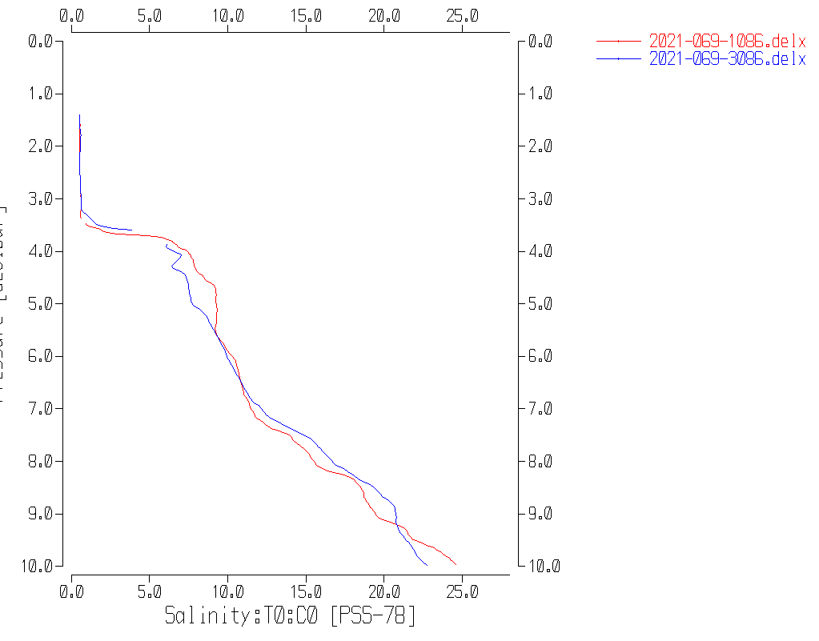

Event #87 – Initial drop to 10m and drop to 10m after soak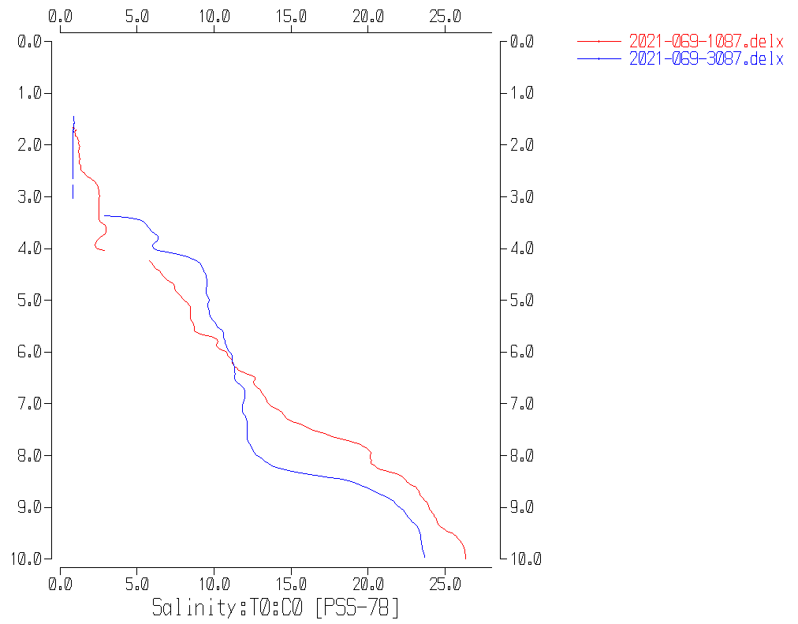

Event #88 – Initial drop to 10m and drop to 10m after soak

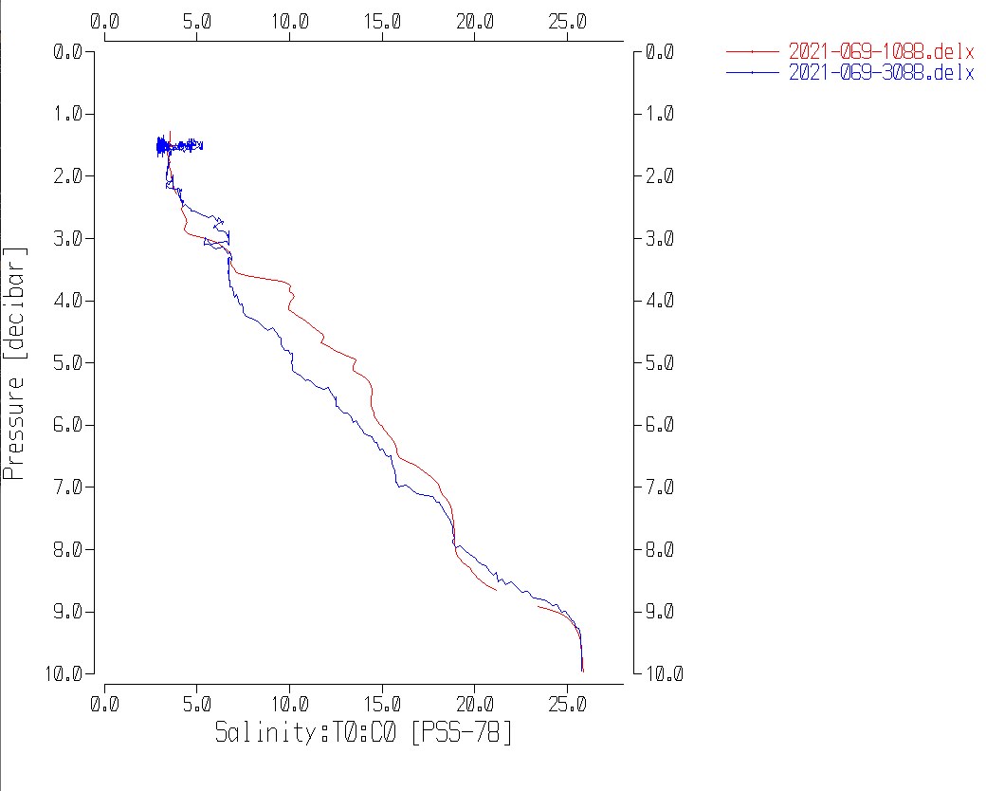

Event #87 Primary and Secondary Salinity during initial drop and during final drop after soak

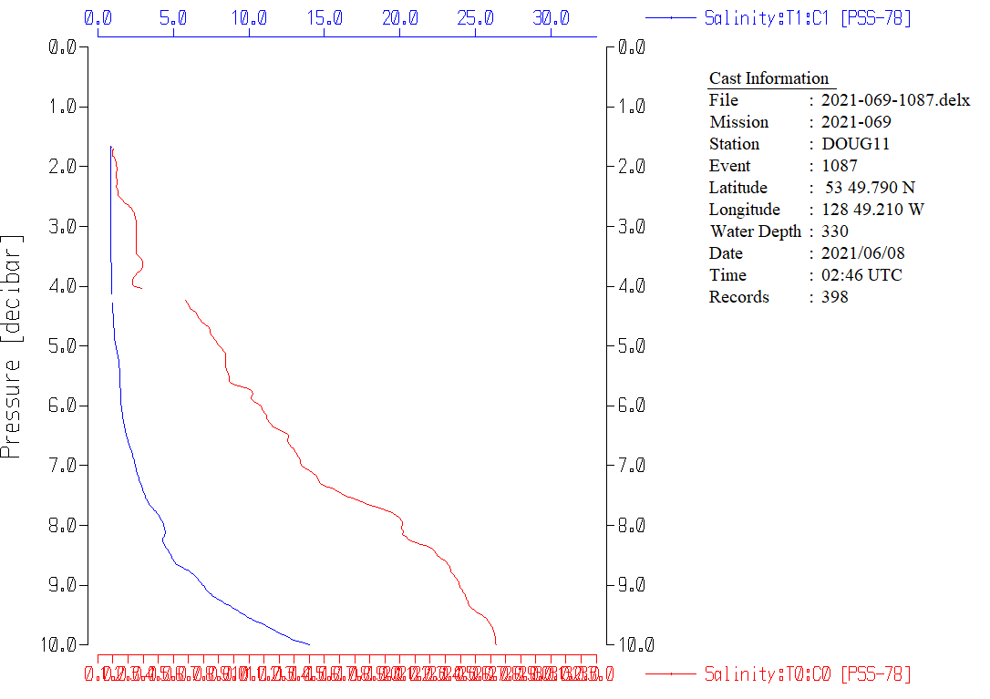

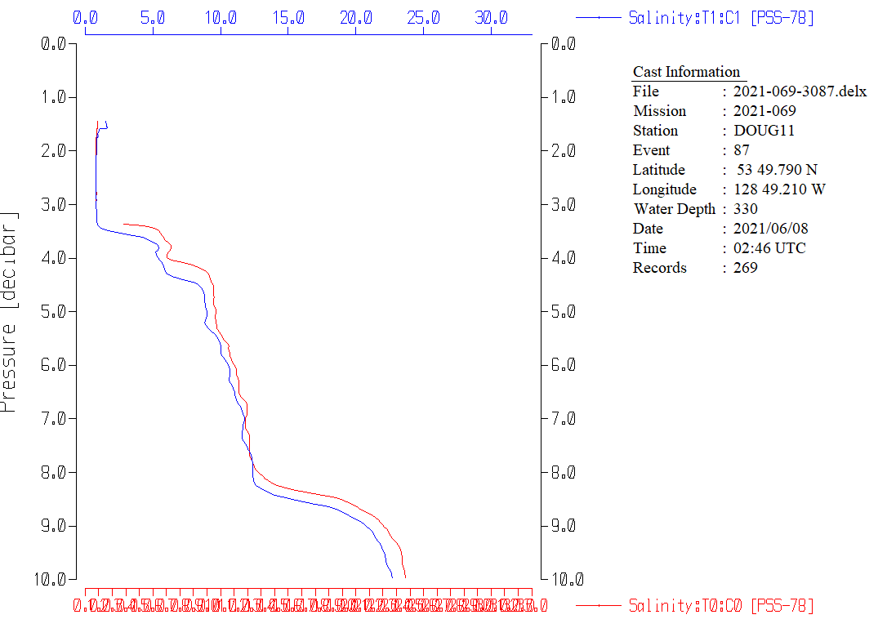

Event #14 – No 10m soak - Downcast

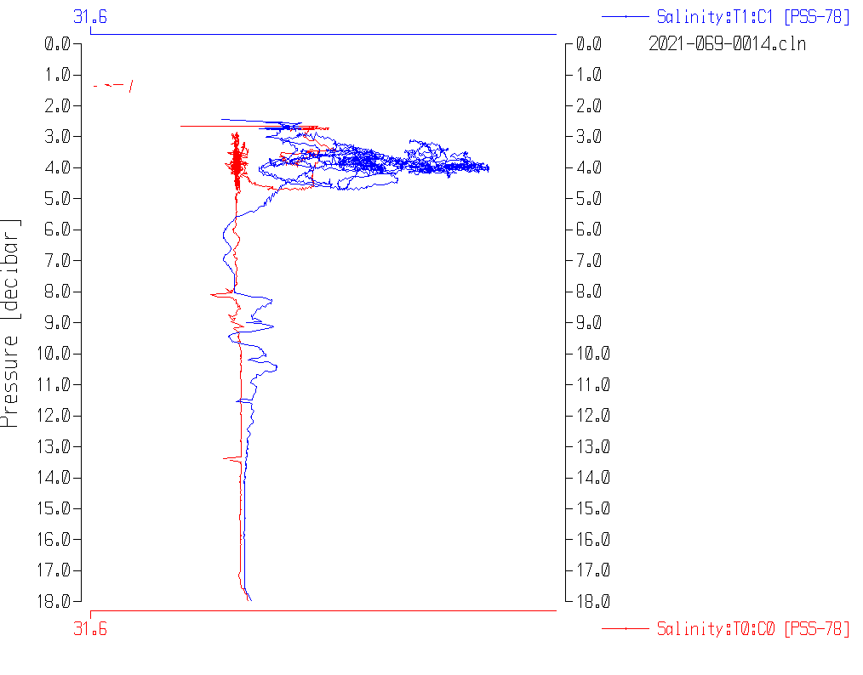

**Part 2 Study of Near-Surface Salinity from Cast with no 10m soak**

The last plot from Part 1 makes it clear that the 2 salinity channels were not in good agreement when the CTD started downwards from the initial soak. The intention was to wait until there was good agreement between sensor pairs before running the full cast, but it is likely that the scale of plots examined aboard ship was too crude to take note of significant differences between conductivity and salinity values.

The following plot shows salinity and pressure versus scan # for cast #36.

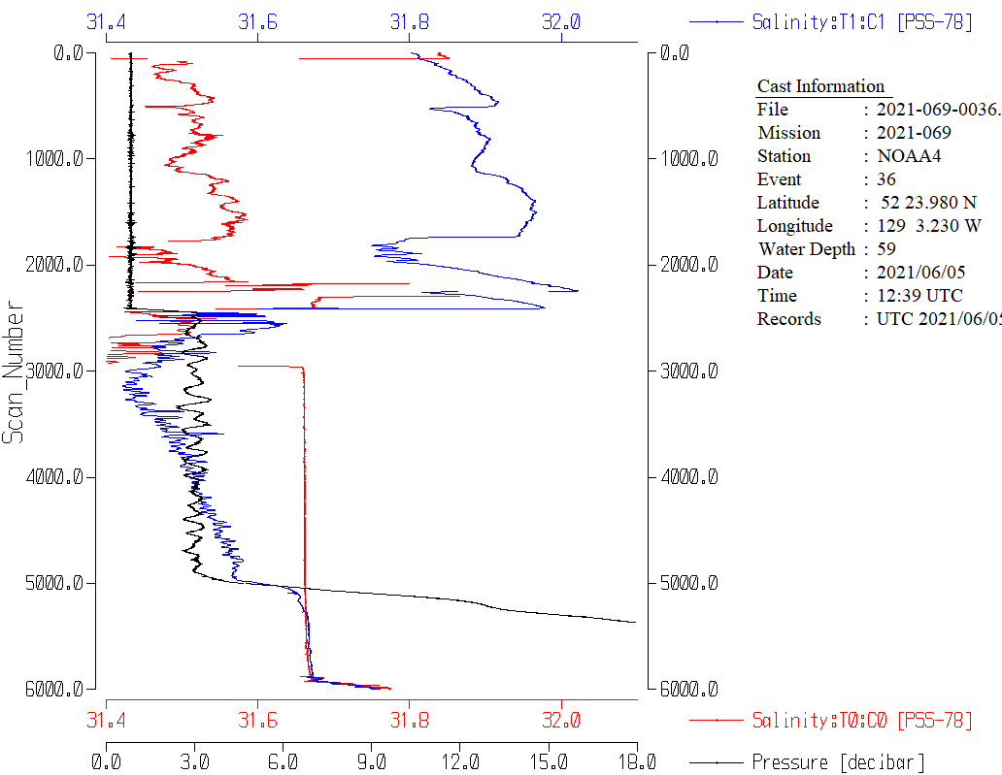

There was a soak at about 3m from scans 2450 to 4900 (~1.7 minutes).

During the 3m stop the secondary salinity is steadily getting closer to the primary. But when the downcast begins after the soak the salinity difference is still large.

The differences between channels at the end of the 3m soak and when the CTD reached 10m, 15m and 18m are shown in the following table. Also displayed are differences from when the CTD was at 500m during this cruise. Differences tend to be very noisy especially near the surface where there is a lot of variability. Also salinity differences tend to increase slightly with depth, so small variations are not surprising, but the very large differences in conductivity and salinity at 3m are definitely out of line

|  |  |  |  |
| --- | --- | --- | --- |
| Depth of CTD | Sec. Temp – Pri. Temp | Sec. Cond. – Cond. Sal. | Sec. Sal. – Pri. Sal. |
| 3m (soak level) | -0.004 | -0.01000 | -0.090 |
| 10m | -0.001 | +0.0002 | -0.008 |
| 15m | -0.0009 | +0.0001 | +0.001 |
| 18m | -0.0007 | 0.00003 | +0.003 |
| Typical diff at 500m | ~0 | +0.0004 | +0.005 |

P**articulars - Notes from Daily Science Log**

PAR off: 9 - 40, 64-72, 148

Loop Samples: #114 (Event 27), #163 (Event 38), #242 (Event 58), #533 (Event 123), #612 (Event 157).

Deployment schemes: For most casts there was no 10m soak. Acquisition was started at the surface and includes the surface soak data. For casts #71-72 & 86-89 there was a 10m soak; acquisition includes the soak period.

2. Data files saved as Event #1 – changed to #2 in processing.

9-40. PAR off.

17. Short stop at 68m to deal with aft lead.

25. Stops to correct wire angle: downcast 70, 110 & 205db and upcast 138, 109, 75 and 29db.

26. Stop downcast 70db to correct wire angle.

56. Stopped at 73db down for wire angle correction.

64. Station name entered wrong at sea – corrected in processing.

64-77. PAR sensor off.

68. Small DO decline just above 300m corresponds to a scattering layer on the sounder – plankton respiration.

69. Very fresh at surface ~15-16psu. It had been raining on North Coast.

72. Salinity ~12-24psu in upper 10m.

78. Note in log says Primary Salinity reading too high (~20psu) for surface waters where should be ~6psu. In processing both salinity channels found to read very low at 3m.

86-89. These casts had a 10m soak before the full cast.

87. DO profile a mix of Kitimat Arm and Devastation Channel; complicated upper 50m. Acquisition ran for 20m after cast.

94. Station name entered wrong at sea – corrected in processing.

109. Surface bottle broached surface.

118. All stop at 30db to correct ship’s heading. Restarted cast due to long wait.

148. PAR removed

149. PAR back on.

150. Big diff between S0 and S1. Bad data from about 16db down in all pumped channels. Cast not prepared for archive.

151. Repeat cast at GI02 –Pumps off, so do not process.

10 June 10:30 – TSG fluorometer cleaned.

**2021-069**

|  |  |  |  |  |  |  |  |  |  |  |
| --- | --- | --- | --- | --- | --- | --- | --- | --- | --- | --- |
| **CTD#** | **Make** | **Model** | | **Serial#** | | **Used with Rosette?** | | **CTD Calibration Sheet Competed?** | | |
| **1** | **SEABIRD** | **911+** | | **0443** | | **Yes** | | **Yes** | | |
| **Calibration Information - 0506** | | | | | | | | | | | |
| **Sensor** | | | | | **Pre-Cruise** | | | | **Post Cruise** | | |
| **Name** | | | **S/N** | | **Date** | | **Location** | | **Date** | **Location** | |
| **Temperature** | | | **4700** | | **12Dec2020** | | **Factory** | |  |  | |
| **Conductivity** | | | **3531** | | **06Jan2021** | | **Factory** | |  |  | |
| **Secondary Temp.** | | | **4888** | | **12Dec2020** | | **Factory** | |  |  | |
| **Secondary Cond.** | | | **4513** | | **18Dec2020** | | **Factory** | |  |  | |
| **Transmissometer** | | | **1185DR** | | **28Apr2021** | | **Factory** | |  |  | |
| **Transmissometer** | | | **1883DG** | | **28Apr2021** | | **Factory** | |  |  | |
| **SBE 43 DO sensor** | | | **3791** | | **22Dec2020** | | **Factory** | |  |  | |
| **PAR sensor** | | | **70613** | | **24Feb2021** | | **Factory** | |  |  | |
| **SeaPoint Fluor.** | | | **3950** | |  | |  | |  |  | |
| **Pressure Sensor** | | | **0443** | | **07Jan2021** | | **Factory** | |  |  | |
| **Altimeter** | | | **75321** | |  | | **Factory** | |  |  | |

**CRUISE SUMMARY – CTD**

# TSG Make/Model/Serial#: SEABIRD/45/0620

|  |  |  |  |  |  |
| --- | --- | --- | --- | --- | --- |
| **Calibration Information** | | | | | |
| **Sensor** | | **Pre-Cruise** | | **Post Cruise** | |
| **Name** | **S/N** | **Date** | **Location** | **Date** | **Location** |
| **Temperature** | **0620** | **21Jan20** | **Factory** |  |  |
| **Conductivity** | **0620** | **21Jan20** | **Factory** |  |  |
| **Wetlabs WETStar Fluor.**  For depths deeper than, and including, 125 dbar, we would wait 30 seconds before closing a bottle. For depths shallower than, and including, 100 dbar, we would wait 60 seconds before closing a bottle. | **1656** | **12Mar2021** | **Factory** |  |  |

