##### STUDY OF EFFECT OF 10m SOAK ON NEAR-SURFACE SALINITY

During 2021-069 most casts were run without a 10m soak. There was a soak at 2-3m.

**Part 1 – Casts with a 10m soak**

For events #86, 87 and 88 a test was done using a 10m soak but with acquisition turned on from the time the CTD was lowered from the ship. Comparisons were done to study what effect the 10m soak might have. (A few other casts with a 10m soak were discovered later, but they have not been examined in detail.)

The deployment protocol was:

* For most casts: No 10m dip – acquisition started at beginning of cast with a 30s to 60s wait at about 0.7db (after correction of pressure which was reading high by about 0.8db at sea).
* For casts 86-88: The CTD was lowered to 1.5-2m and kept there for 30s. Pumps were turned on. The rosette was brought down to 10m and kept there for 60 seconds. They were returned to 1.5-2m where they were soaked for 30 seconds longer. Then the cast would start.

In the following plots cast #s starting with 1 (1086 – 1087 – 1088) were from the initial drop to 10m

Cast #s starting with 3 (3086 – 3087 – 3088) were from after the soak and return to the surface and are the data that will be archived.

All data have been put through most of the usual processing steps except they have not been bin-averaged or recalibrated.

The first set of plots show how the primary salinity performed.

* Event #86 - both casts show a well-mixed surface layer.
* Event #87 - the first drop does not show a well-mixed surface and the 2nd drop does. It is likely the 2nd drop is a better reflection of the actual gradient as nothing in the water stirred up by the return from the 10m soak could explain lower salinity seen in the 2nd drop.
* Event #88 – the 2 drops look similar at the surface.

Temperature profiles were also examined and neither drop looked notably better than the other but they did show there is considerable temporal and vertical variability at these sites.

The second set of 2 plots shows how the primary and secondary salinity channels compare during the first and second drops from the surface for event #87. During the initial drop the secondary salinity looks out of line but during the 2nd drop the 2 channels are reasonably close and similar to the primary trace from the 1st drop.   
  
Finally, a look at some offshore data where there was no initial soak but where surface waters have lower gradients shows a similar problem with the secondary salinity until the CTD is at about 15m.

Conclusions –

* The 10m soak does not appear to have degraded the surface mixed layer and the post-soak data does at least as good a job of measuring salinity in the top 10m as does the initial drop.
* The 10m soak gave the secondary sensor time to equilibrate.

Event #86 – Initial drop to 10m and drop to 10m after soak

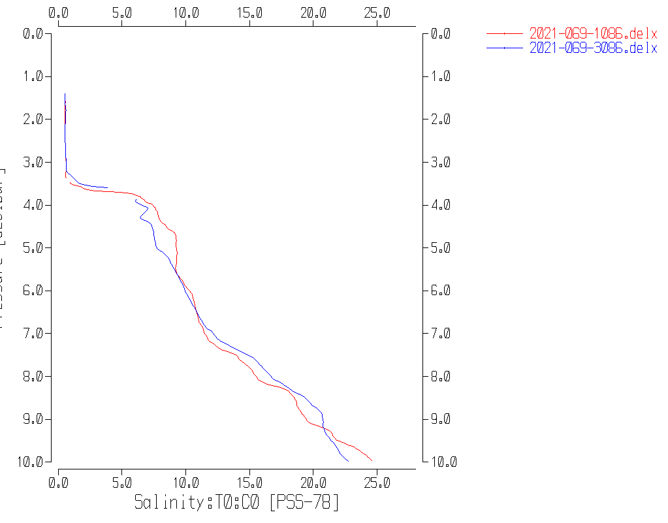

Event #87 – Initial drop to 10m and drop to 10m after soak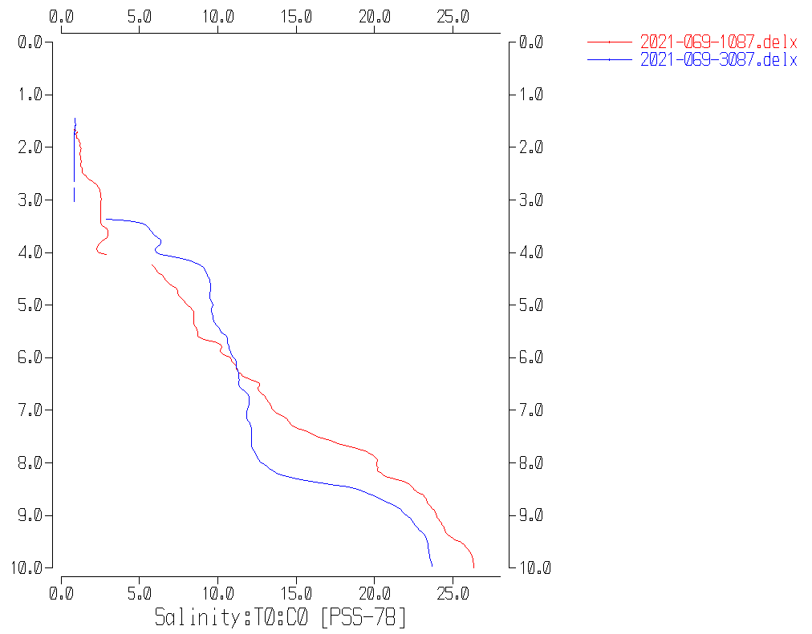

Event #88 – Initial drop to 10m and drop to 10m after soak

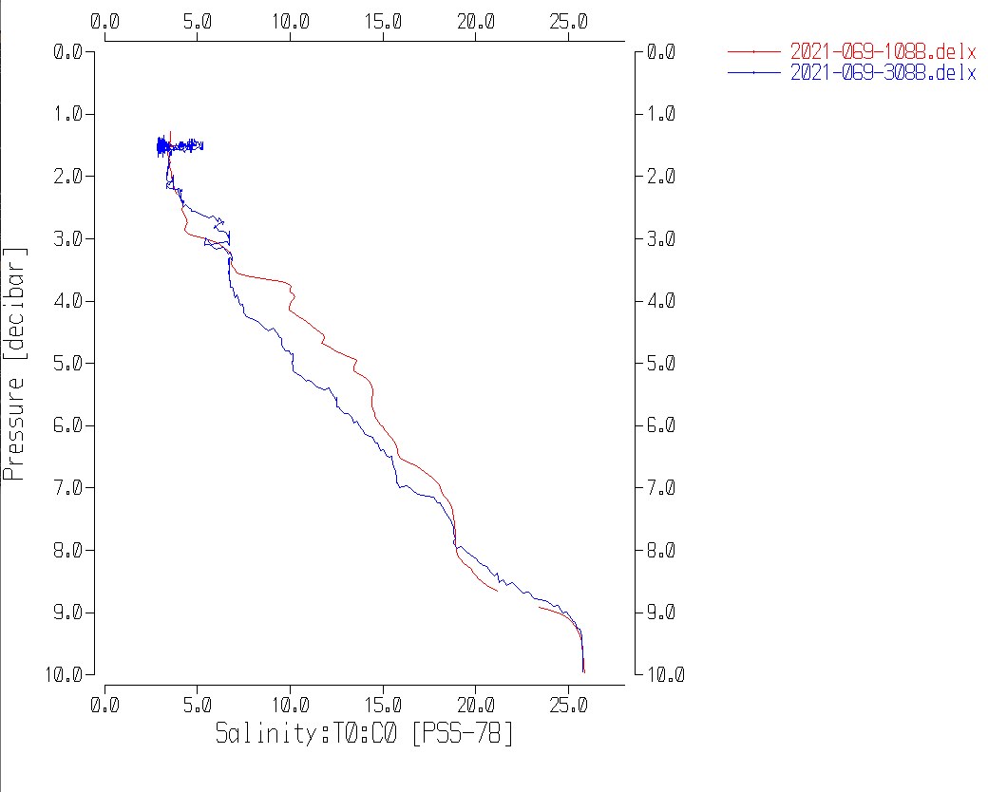

Event #87 Primary and Secondary Salinity during initial drop and during final drop after soak

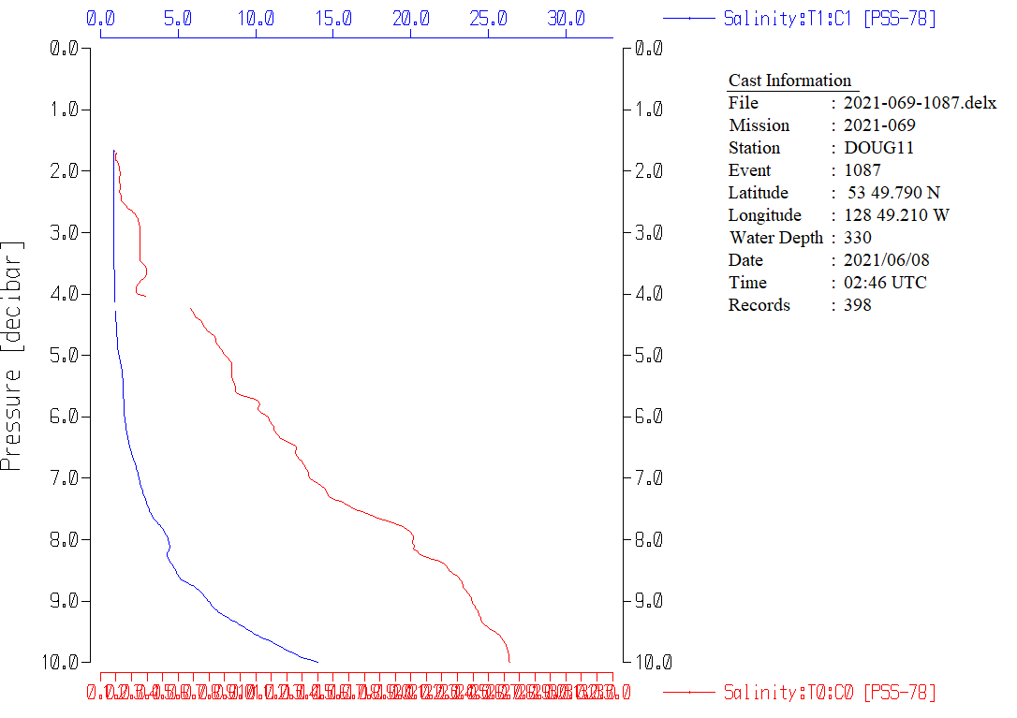

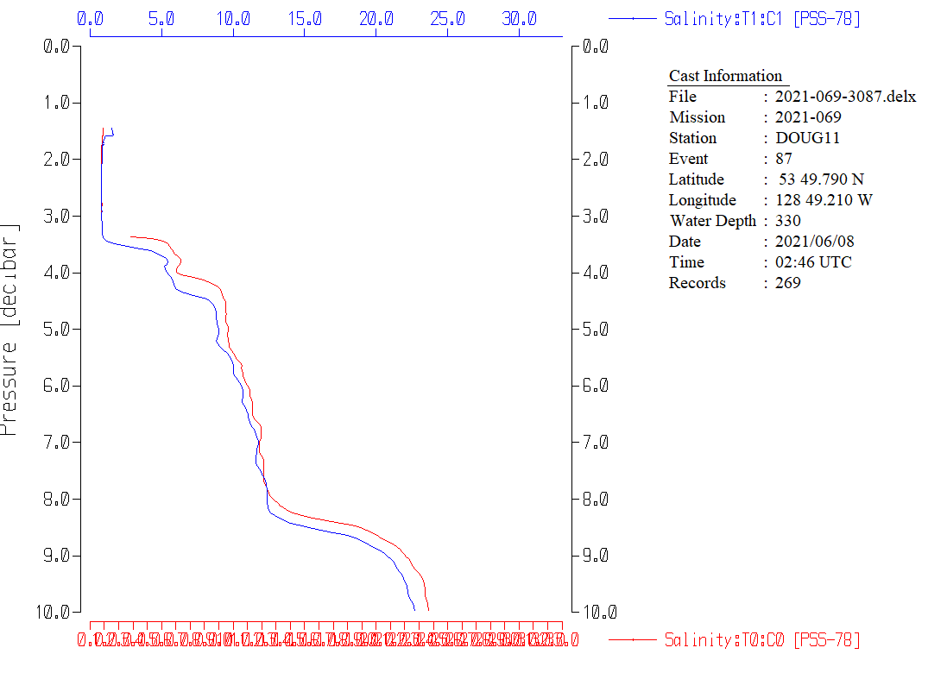

Event #14 – No 10m soak - Downcast

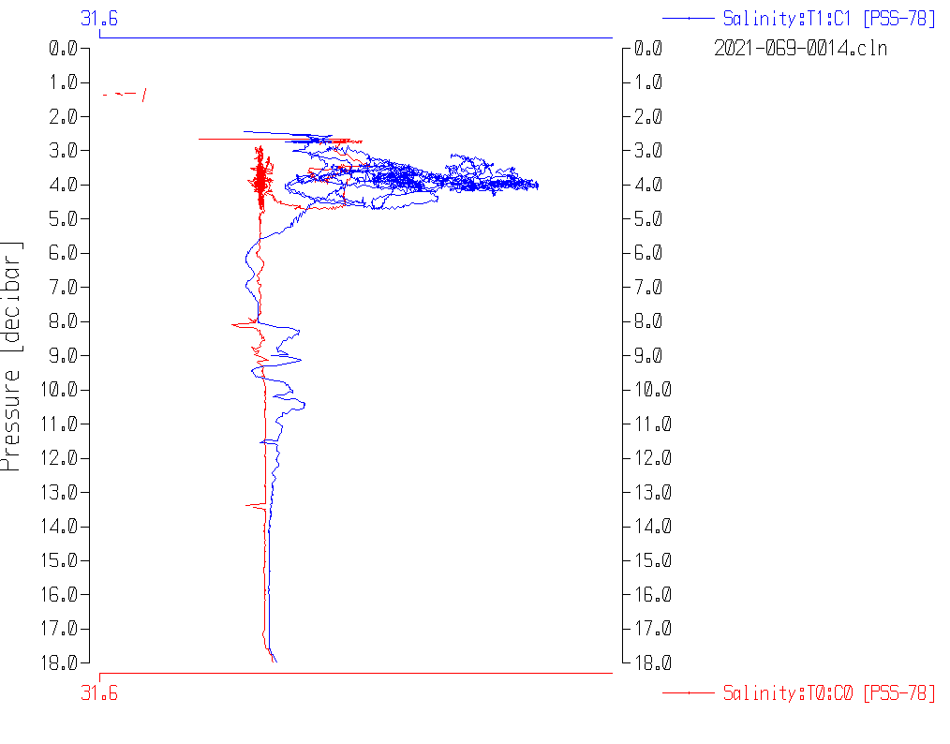

**Part 2 Study of Near-Surface Salinity from Cast with no 10m soak**

The last plot from Part 1 makes it clear that the 2 salinity channels were not in good agreement when the CTD started downwards from the initial soak. The intention was to wait until there was good agreement between sensor pairs before running the full cast, but it is likely that the scale of plots examined aboard ship was too crude to take note of significant differences between conductivity and salinity values.

The following plot shows salinity and pressure versus scan # for cast #36.

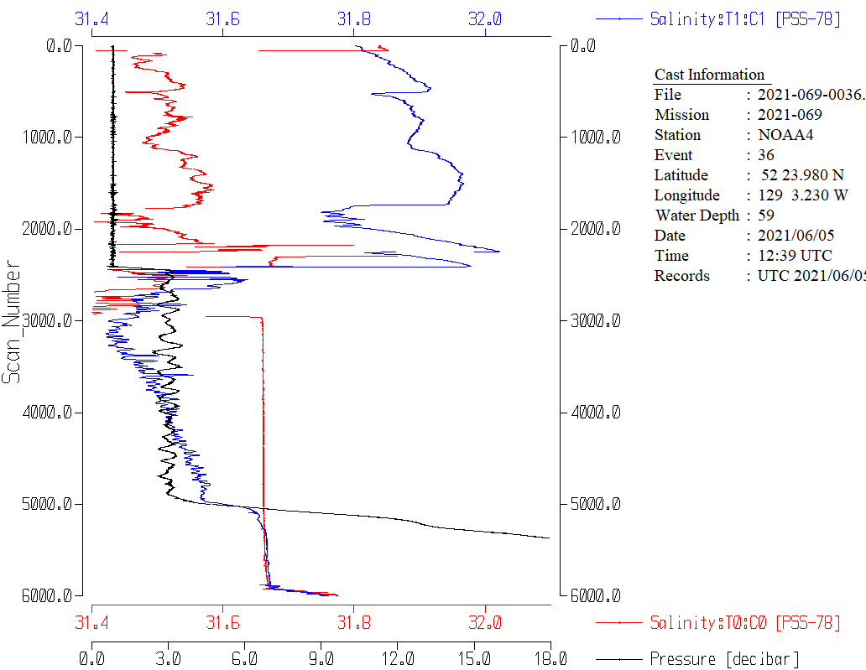

There was a soak at about 3m from scans 2450 to 4900 (~1.7 minutes).

During the 3m stop the secondary salinity is steadily getting closer to the primary. But when the downcast begins after the soak the salinity difference is still large.

The differences between channels at the end of the 3m soak and when the CTD reached 10m, 15m and 18m are shown in the following table. Also displayed are differences from when the CTD was at 500m during this cruise. Differences tend to be very noisy especially near the surface where there is a lot of variability. Also salinity differences tend to increase slightly with depth, so small variations are not surprising, but the very large differences in conductivity and salinity at 3m are definitely out of line

|  |  |  |  |
| --- | --- | --- | --- |
| Depth of CTD | Sec. Temp – Pri. Temp | Sec. Cond. – Cond. Sal. | Sec. Sal. – Pri. Sal. |
| 3m (soak level) | -0.004 | -0.01000 | -0.090 |
| 10m | -0.001 | +0.0002 | -0.008 |
| 15m | -0.0009 | +0.0001 | +0.001 |
| 18m | -0.0007 | 0.00003 | +0.003 |
| Typical diff at 500m | ~0 | +0.0004 | +0.005 |