**Revision Notice Table**

|  |  |
| --- | --- |
| **Date** | **Description of Revision** |
| July 13, 2023 | DO Saturation converted to DO Concentration. Bad data removed from the bottom of cast 2. SH |

**RBR CTD DATA PROCESSING NOTES**

Cruise: 2021-066

Agency: OSD

Locations: Johnstone Strait, Inlets

Project: PARR weather station network

Party Chief: Cooper, G

Platform: Charter

Date: 27 July 2021 to 29 July 2021

Processed by: Samantha Huntington

Date of Processing: 21 April 2022 to 22 April 2022

Number of Raw files: 3 Number of Processed Files: 3

**Instrument Summary**

Equipment: RBR Concerto CTD (s/n 204694) with a Turner Cyclops Fluorometer (s/n 21101282) and a JFE Advantech Rinko III oxygen sensor (s/n 411).

Sampling frequency was at 8Hz.

**Summary of Quality and Concerns**

A cast list, 2021-066CTDLogfile.xlsx, was provided with the times and locations of all the casts.

The data overall look good. There is some bad data at the top and bottom of cast 2 for Salinity and Conductivity.

**Processing Summary**

1. **Conversion to IOS Headers**

Three profiles were found in the following two files:

* 204694_20210728_0737.rsk
* 204694_20210805_1337.rsk

The three profiles were extracted using python function READ_EXCELrsk().

A single file (2021-066_CTD_Data.csv) with all the data including event numbers and a single line of headers was prepared using python function MERGE_FILES().

A 6-line header was inserted using python function Add_6Lineheader_2().

File “2021-066_header-merge.csv” was created, based on the information provided by the chief scientist.

* Column “File_Name”: entries were derived from the event number.
* Column “LOC:LATITUDE”: latitude was provided and reformatted to “XX XX.XXXX N !(deg min)”.
* Column “LOC:LONGITUDE”: longitude was provided and reformatted to “XX XX.XXXX W !(deg min)”.
* Column “LOC: Event Number”: entries were event numbers.
* Colmun “LOC: STATION”: all stations were set to the stations indicated in the log file.

The sampling site was mapped (Figure 1) using from “2021-066_header-merge.csv” using python function Plot_Track_Location() to check the location of all casts.

Prior to conversion to IOS header format, the presence of zero-order holds were checked using Python function Plot_Pressure_Diff(). Zero-order holds were found in each cast and a correction was applied and a new csv file was created “2021-066_CSV_DATA-6Linedr_corr_hold.csv”.

CONVERT Spreadsheet Files was run to produce files with IOS Header format. Header entries of “Administration”, “File” and “Instrument”, “Location”, were filled in this step.

The routine “Merge:CSV Files to headers” was run to add location headers to the IOS files.

Raw data were plotted and examined:

* Salinity looks good with some bad data at the top and bottom of cast 2.
* Temperature looks good.
* Conductivity looks good with some bad data at the top and bottom of cast 2.
* Oxygen looks good.
* Fluorescence looks good.

Next CLEAN was run to add a start time and event numbers to headers.

1. **Data processing**

* Correction to Pressure: No negative pressures were seen in the casts so pressure was not calibrated.
* Data despiking: There are no significant spikes in temperature, conductivity and salinity. So there is no need to apply data despiking.
* CLIP: Pressure is steady at the top of scans. Initial records were removed until the downcast began using file “2021-066_CLIP.csv”.
* Filter: a Gull-winged filter, size 5, was applied to temperature, conductivity, and pressure. Salinity will be calculated in the next step.
* SHIFT: Based on suggested values in document “Guidelines for processing RBR CTD profiles”, the alignment of temperature and conductivity was corrected by applying a shift of -2 scans in conductivity.
* SHIFT: Better alignment with Oxygen profiles was found by advancing it by 11 scans. The advice given in document “Guidelines for processing RBR CTD Profiles” was that an advance between 2 and 3 seconds is appropriate. T-O plots before and after alignment were compared. Salinity was recalculated and the results are shown in Figure 4.
* Delete was run to remove records with a descent rate lower than 0.3m/s over 8 points. This was not applied in the top 10m to avoid loss of surface records as the CTD began its descent.
* Profile plots were examined after DELETE and confirm that plots show reasonable values for salinity and conductivity and fluorescence. DO saturation levels at the surface ranged from 68% to 106%. However there was no calibration sampling and no climatology to enable a judgement about the data reliability.

1. **Final checks and header editing**

* REMOVE was run to remove the following channels from all casts: Date, Time:UTC and Event.
* BIN AVERAGE was used to metre-average data.
* CALIBRATE was run to convert conductivity units to S/m using file 2021-066-recal2.ccf.
* REORDER was run to put the channels into the standard order.
* Header Edit was used to fix channel names and format as listed below:
* Pressure: format F11.2 ==> F7.1
* Salinity:CTD ==> Salinity
* Oxygen==> Fluorescence:URU
* mL/L==> %
* F11.4==>F8.2
* Conductivity: F10.5 ==> F10.6
* CLEAN was run to reset the Maximum and Minimum values in the Header.
* Header Check was run and no problems were found.

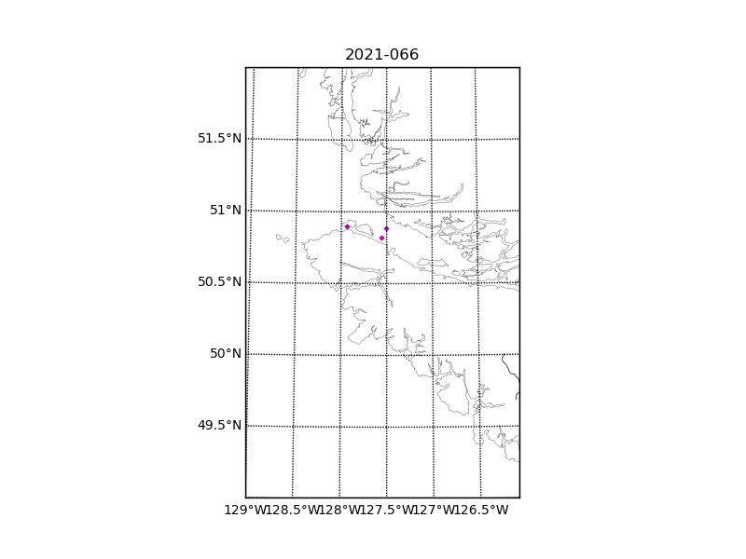Figure 1 – location of casts. 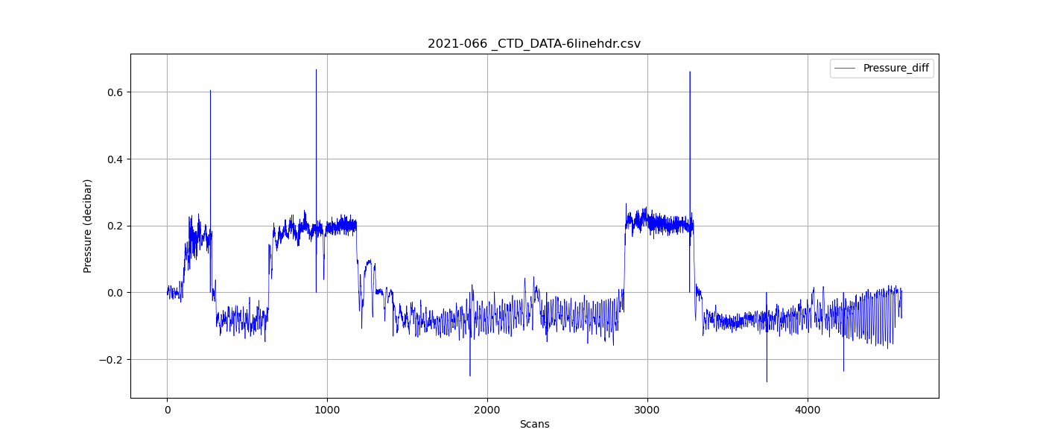

Figure 2 – zero-order holds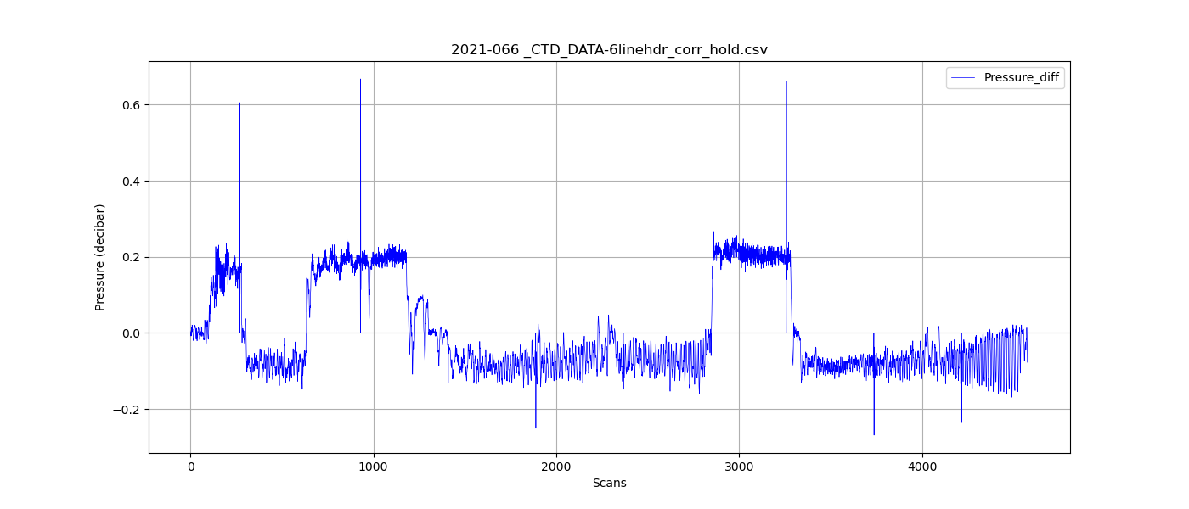

Figure 3 – zero order holds removed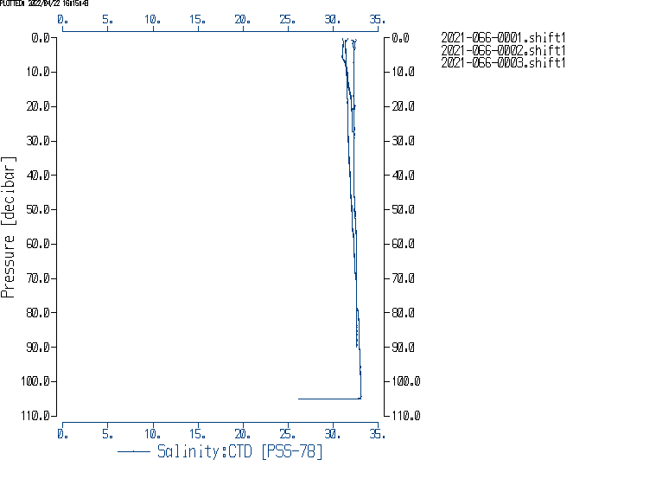

Figure 4. Salinity after Shift.