**Revision Notice Table**

|  |  |
| --- | --- |
| **Date** | **Description of Revision** |
| 24 July 2023 | Re-ran from Shift to re-calculate Salinity. Re-ran the oxygen conversion afterwards. SH |
| 12 July 2023 | DO Saturation converted to DO Concentration. Casts 4 and 5 reprocessed from scratch to capture upper 3m. Updated files in the DOC folder. Gain change related Fluorescence spikes removed from casts 2-5. |

**RBR CTD DATA PROCESSING NOTES**

Cruise: 2021-045

Agency: OSD

Locations: Bligh Island

Project: Bligh Island Shipwreck Oceanography

Party Chief: Page, S

Platform: Other Vessel

Date: January 1, 2021 – December 31, 2021

Processed by: Samantha Huntington

Date of Processing: September 9, 2021 – September 19, 2021

Number of Raw files: 26 Number of Processed Files: 5

**Instrument Summary**

Equipment: RBR Concerto CTD (s/n 204694) with a Turner Cyclops Fluorometer (s/n 21101282) and a JFE Advantech Rinko III oxygen sensor (s/n 411).

Sampling frequency was at 8Hz.

**Summary of Quality and Concerns**

All casts took place in the Zuciarte Channel, no cast list was provided but the dates of the cast were provided by the chief scientist.

The data overall look good. There were some negative pressures towards the end of the upcast for profiles 1 and 4. Casts 4 and 5 start from around 3m so there is no data above that.

**Processing Summary**

1. **Conversion to IOS Headers**

Multiple profiles were found in the following files:

* 2021-045-001-Zuciarte_14Mar21.rsk
* 2021-045-0002-Zuciarte.rsk
* 2021-045-0003-Zuciarte.rsk
* 2021-045-0004-Zuciarte.rsk

File 2021-045-0004-Zuciarte.rsk was found to contain the profiles contained in the previous files, as well as profiles from previous cruises. After discussion with the chief scientist the required profiles were identified by date and extracted using python function READ_EXCELrsk().

A single file (2021-0045_CTD_Data.csv) with all the data including event numbers and a single line of headers was prepared using python function MERGE_FILES().

A 6-line header was inserted using python function Add_6Lineheader_2().

File “2021-045_header-merge.csv” was created, based on the information provided by the chief scientist.

* Column “File_Name”: entries were derived from the event number.
* Column “LOC:LATITUDE”: latitude was provided and reformatted to “XX XX.XXXX N !(deg min)”.
* Column “LOC:LONGITUDE”: longitude was provided and reformatted to “XX XX.XXXX W !(deg min)”.
* Column “LOC: Event Number”: entries were event numbers.
* Colmun “LOC: STATION”: all stations were set to Zuciarte.

The sampling site was mapped (Figure 1) using from “2021-045_header-merge.csv” using python function Plot_Track_Location() to check the location of all casts.

Prior to conversion to IOS header format, the presence of zero-order holds were checked using Python function Plot_Pressure_Diff(). Zero-order holds were found (Figure 2.) and these values were replaced with Nan using the python function Correct_Hold().

A new csv file was created “2021-045_CSV_DATA-6Linedr_corr_hold.csv” and the corrected values were checked in python function Plot_Pressure_Diff(). Zero-order holds were found to be removed (Figure 3.).

CONVERT Spreadsheet Files was run to produce files with IOS Header format. Header entries of “Administration”, “File” and “Instrument” were filled in this step.

The routine “Merge:CSV Files to headers” was run to add location headers to the IOS files.

Raw data were plotted and examined:

* Salinity looks good.
* Temperature looks good with some bad data at the top of cast 4.
* Conductivity looks good with some bad data at the top of all casts.
* Oxygen looks good with some bad data at the top of all casts.

Next CLEAN was run to add a start time and event numbers to headers.

Then REORDER was run to reorder the channels in all files.

1. **Data processing**

* Correction to Pressure: although there were negative pressures seen in the raw data, they were at the end of the upcast for casts 1 and 4, and the corresponding Conductivity was found to be less than 0.01 mS/cm, so pressure was not calibrated.
* Data despiking: There are no significant spikes in temperature, conductivity and salinity. So there is no need to apply data despiking.
* CLIP: Pressure is steady for a variable number of scans. Initial records were removed until the downcast began using file “2021-045_CLIP.csv”.
* Filter: a Gull-winged filter, size 5, was applied to temperature, conductivity, and pressure. Salinity will be calculated in the next step.
* SHIFT: Based on suggested values in document “Guidelines for processing RBR CTD profiles”, the alignment of temperature and conductivity was corrected by applying a shift of -2 scans in conductivity.
* SHIFT: Better alignment with Oxygen profiles was found by advancing it by 11 scans. The advice given in document “Guidelines for processing RBR CTD Profiles” was that an advance between 2 and 3 seconds is appropriate. T-O plots before and after alignment were compared.
* Delete was run to remove records with a descent rate lower than 0.3m/s over 8 points. This was not applied in the top 10m to avoid loss of surface records as the CTD began its descent.
* Profile plots were examined after DELETE and confirm that plots show reasonable values for salinity and conductivity and fluorescence. DO saturation levels at the surface ranged from 18% to 141%. However there was no calibration sampling and no climatology to enable a judgement about the data reliability.

1. **Final checks and header editing**

* REMOVE was run to remove the following channels from all casts: Date, Time:UTC and Event.
* BIN AVERAGE was used to metre-average data.
* CALIBRATE was run to convert conductivity units to S/m using file 2021-045-recal2.ccf.
* Header Edit was used to fix channel names and format as listed below:
* Pressure: format F11.2 ==> F7.1
* Salinity:CTD ==> Salinity
* Oxygen==> Fluorescence:URU
* mL/L==> %
* F11.4==>F8.2
* Conductivity: F10.5 ==> F10.6
* CLEAN was run to reset the Maximum and Minimum values in the Header.
* Header Check was run and no problems were found.

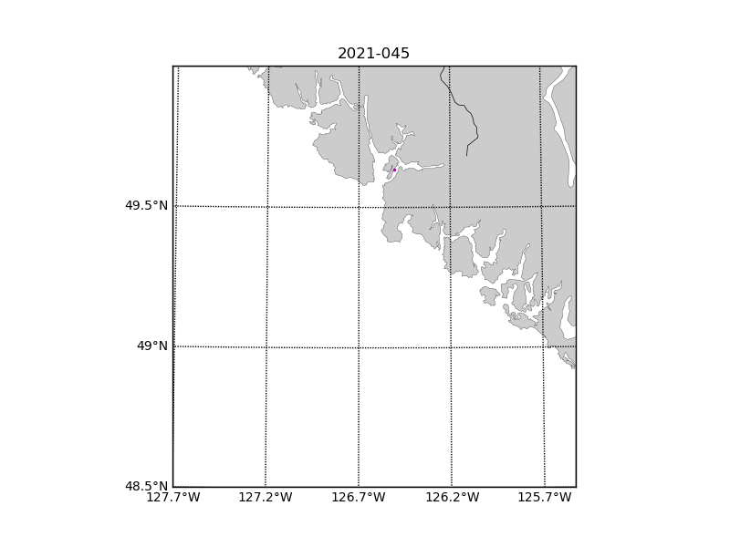

Figure 1 – location of casts.

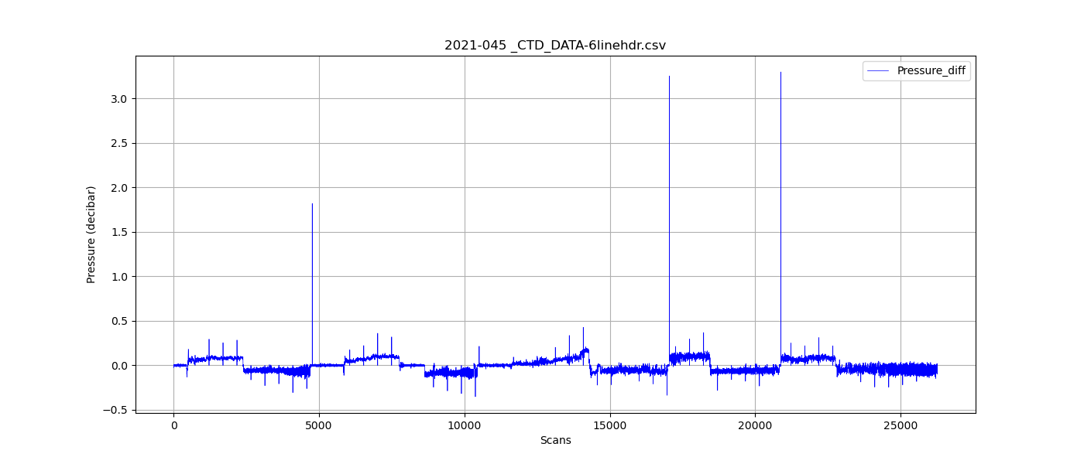

Figure 2 – zero-order holds

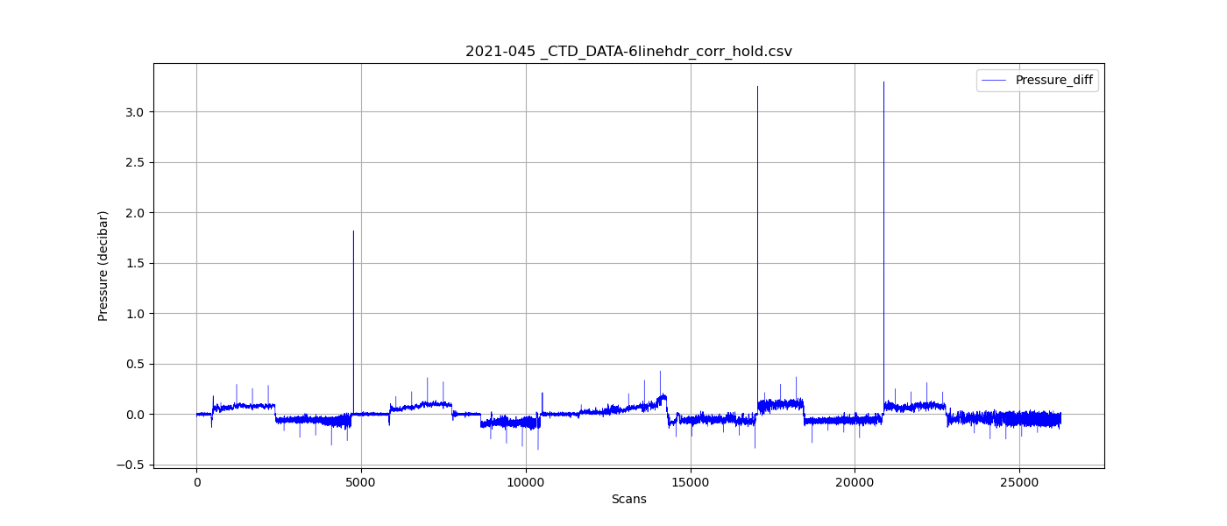

Figure 3 – zero order holds removed