|  |  |
| --- | --- |
| **Date** | **Description** |
| 1 April 2025 | Corrected temperature units format. G.G. |

**RBR CTD DATA PROCESSING NOTES**

Cruise: 2021-037

Agency: OSD

Locations: Strait of Georgia

Project: Passive Acoustics

Party Chief: O’Neill, C.

Platform: Charter

Date: February 1, 2021 – February 8, 2021

Processed by: Samantha Huntington

Date of Processing: July 25, 2021 – 8 September 2021

Number of Raw files: 18 Number of Processed Files: 8

**Instrument Summary**

Equipment: RBR Concerto CTD (s/n 204848).

Sampling was at 8Hz.

**Summary of Quality and Concerns**

A CTD Log sheet was provided with times and positions of all casts.

The data overall look good. Temperature is not steady for casts 2 and 3 which are the two deeper casts for this cruise.

**Processing Summary**

1. **Conversion to IOS Headers**

Multiple profiles were found in the following files:

* 204848_20210202_1718.rsk
* 204848_20210203_2358.rsk
* 204848_20210204_2154.rsk
* 204848_20210205_1905.rsk
* 204848_20210206_2306.rsk
* 204848_20210207_1935.rsk
* 204848_20210208_2010.rsk

Reading the log book and matching times and depths to the CTD Log sheet ‘2021-037_CTDcasts.xlxs’, a single csv file for the last profile from each file was extracted using python function EXPORT_MULTIFILES().

A single file (2021-037_CTD_Data.csv) with all the data including event numbers and a single line of headers was prepared using python function MERGE_FILES().

A 6-line header was inserted using python function Add_6Lineheader_2().

File “2021-037_header-merge.csv” was created, based on the information in the file 2021-037_CTDcasts.xlxs.

* Column “File_Name”: entries were derived from the event number.
* Column “LOC:LATITUDE”: latitude data were taken from the 2021-037_CTDcasts.xlxs and reformatted to “XX XX.XXXX N !(deg min)”.
* Column “LOC:LONGITUDE”: longitude data were taken from the 2021-037_CTDcasts.xlxs and reformatted to “XX XX.XXXX W !(deg min)”.
* Column “LOC: Event Number”: entries were event numbers.
* Colmun “LOC: STATION”: station data were taken from 2021-037_CTDcasts.xlxs.

Sampling sites were mapped (Figure 1) using from “2021-037_header-merge.csv” using python function Plot_Track_Location() to check the location of all casts.

Prior to conversion to IOS header format, the presence of zero-order holds were checked using Python function Plot_Pressure_Diff(). Zero-order holds were found (Figure 2.) and these values were replaced with Nan using the python function Correct_Hold().

A new csv file was created “2021-037_CSV_DATA-6Linedr_corr_hold.csv” and the corrected values were checked in python function Plot_Pressure_Diff(). Zero-order holds were found to be removed (Figure 3.).

CONVERT Spreadsheet Files was run to produce files with IOS Header format. Header entries of “Administration”, “File” and “Instrument” were filled in this step.

The routine “Merge:CSV Files to headers” was run to add location headers to the IOS files.

Raw data were plotted and examined:

* Salinity looks ok.
* Conductivity looks ok.
* Temperature looks ok with some bad data at the bottom in casts 1, 5, 6 and 7. Temperature is not steady for casts 2 and 3.

Next CLEAN was run to add a start time and event numbers to headers.

1. **Data processing**

* Correction to Pressure: there were no negative pressures seen in the raw data so a correction to pressure was not applied.
* Data despiking: There are no significant spikes in temperature, conductivity and salinity. So there is no need to apply data despiking.
* CLIP: Pressure is steady for a variable number of scans (22-270). Initial records were removed until the downcast began using file “2021-037_CLIP.csv”.
* Filter: a Gull-winged filter, size 3, was applied to temperature, conductivity, and pressure. Salinity will be calculated in the next step.
* SHIFT: Based on suggested values in document “Guidelines for processing RBR CTD profiles”, the alignment of temperature and conductivity was corrected by applying a shift of -2 scans in conductivity. Salinity was recalculated and the results are shown in Figure 4.
* Delete was run to remove records with a descent rate lower than 0.3m/s over 8 points. This was not applied in the top 10m to avoid loss of surface records as the CTD began its descent.
* Profile plots were examined after DELETE and confirm that plots show reasonable values for temperature and salinity. Salinity shows some missing data for cast 7.

1. **Final checks and header editing**

* REMOVE was run to remove the following channels from all casts: Date, Time:UTC and Event.
* BIN AVERAGE was used to metre-average data.
* CALIBRATE was run to convert conductivity units to S/m using file 2021-037-recal2.ccf.
* REORDER was run to reorder the channels in all files.
* Header Edit was used to fix channel names and format as listed below:
* Pressure: format F11.2 ==> F7.1
* Salinity:CTD ==> Salinity
* Conductivity: F10.5 ==> F10.6
* CLEAN was run to reset the Maximum and Minimum values in the Header.
* Header Check was run and no problems were found.

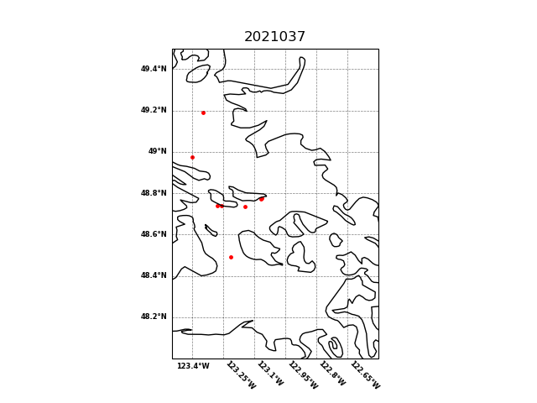

Figure 1 – location of casts.

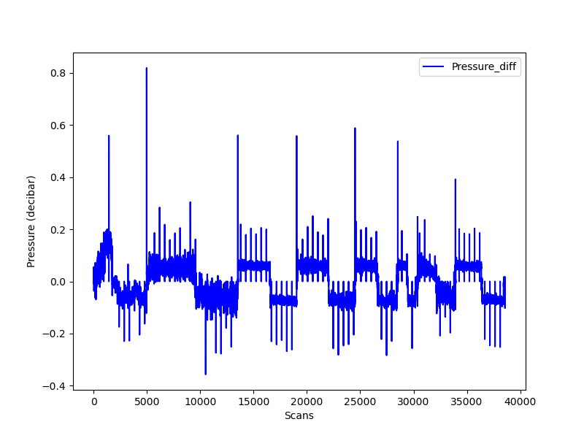

Figure 2 – zero-order holds

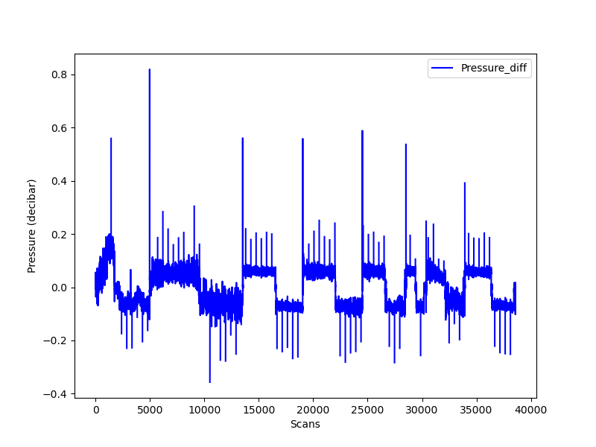

Figure 3 – zero order holds removed.