REVISION NOTICE TABLE
DATE | DESCRIPTION OF REVISION
4 April 2023 | Added HPLC data. J.R.

PROCESSING NOTES
Cruise: 2021-032
Agency: IOS, Ocean Sciences Division, Sidney BC
Project Scientist: Young K. Platform: Neocaligus
Location: Strait of Georgia Project: Strait of Georgia Zooplankton
Date: 8 March 2021 –12 March 2021

Processed by: Germaine Gatien
Date of Processing: 23 July 2021 – 29 July 2021
Number of original HEX files: 28
Number of CTD files: 28 Number of BOT files: 13

INSTRUMENT SUMMARY
A SeaBird Model SBE-25 CTD (s/n 0456) was used with temperature sensor #5130, conductivity sensor #3500, Wetlabs ECO Fluorometer #4185, dissolved oxygen sensor #3234 and pressure sensor 0573.

SUMMARY OF QUALITY AND CONCERNS
The cruise log and rosette sheets were in good order.
Header information was entered in the raw files in a format that enabled easy conversion into IOS Header format.

Samples were collected at 20 sites. At 5 of those sites there was a Niskin mounted 2m above the CTD to collect near-bottom salinity and nutrient samples. There was no extracted CHL sampling but HPLC:TChl-a data were available for assessment of the CTD fluorometer.

The 10m soak would be more useful if the stop were longer so that the pump is on and bubbles can be released. In many cases the pump did not come on until the CTD was almost back at the surface. There are frequent increases in DO near 10m that could be due to bubble release but upcast profiles suggest that some are due to real sub-surface increases in DO.

CTD salinity calibration appears to be within ±0.003psu. Larger errors will be present due to minor misalignment of temperature and conductivity when vertical salinity gradients are high.

Pressure did not require recalibration and there was no calibration sampling available for SBE dissolved oxygen.

PROCESSING SUMMARY
1. Seasave - This step was completed at sea.

2. Preliminary Steps
The Daily Log and a spreadsheet of sampling done were obtained.
The cruise summary sheet was completed.

CTD Deployment method: Timer set to 2 minutes. CTD down to 10m for soak, bought back to surface to sit until 2 minutes are up. Then full cast begins. The wait at 10m was very brief – a longer stop is recommended to enable pumps to come on and bubbles to clear.

For deep sampling a 1.7L Niskin bottle was mounted approximately 2m above the CTD.
Surface sampling was done for each cast after the CTD was taken out of the water and turned off. A 5L Niskin bottle was attached to the wire, sent to the surface and triggered. A separate event number was given for the surface samples, but in processing the event numbers were changed to match the CTD cast with which they are associated to enable creation of BOT files containing CTD data.

3. Conversion of Raw Data
The configuration file used at sea was correct except for the date of the fluorometer calibration . After that was fixed the file was saved as 2021-032-ctd.xmlcon and used to convert all HEX files.

An initial check indicates that surface pressure is good with conductivity falling to ~0 when pressure is between -0.1db and +0.2db. The deep fluorescence values are about 0.04ug/L with no spikes to negative values near the bottom. All expected variables are present.
Plots show that the channels all produced reasonable values.
There is the usual steppy pressure which leads to unusual profiles.

4. WILDEDIT
The only spikes noted in the data occurred at the beginning or end of the casts or included many points, and will be removed in the normal course of editing. So WILDEDIT was not run.

5. FILTER
Normally pressure is filtered later in processing when running DELETE, but the poor resolution of this instrument means it is necessary to do this early to make sense of the other data which update more often than pressure. So program FILTER was used to apply a low-pass filter with a time constant of 0.5 seconds to pressure. The results were excellent.

Next the temperature and conductivity were examined and the usual approach of applying a cosine filter size 5 in routine WFILTER did a good job of removing small reversals. Derive was run on a few casts to calculate salinity and plots showed great improvement in stability in T-S space after running WFILTER.

6. ALIGNCTD
Based on tests run for other cruises in this project using the same DO sensor, ALIGNCTD was run on all casts to advance the DO channel by 2.5s. Plots were examined after this step and the results look excellent.

7. CELLTM
CELLTM was run on all casts using the SeaBird recommended parameters, (α, 1/β) = (0.04, 8).

8. DERIVE
Program DERIVE was run to calculate salinity and dissolved oxygen concentration (tau correction included). Plots were examined and confirmed that steps 5, 6 and 7 had improved the data.

9. Conversion to IOS Headers
The IOSSHELL routine was used to convert the CNV files to IOS Headers.
CLEAN was run to add event numbers and replace pad values in the pressure channel with interpolated values.
A preliminary header check was run and turned up 2 casts with problems in latitude and longitude (missing hemispheres in the SeaBird headers.) Those were fixed and then CONVERT to IOS Header and CLEAN were rerun.
Plots were made to find the minimum pressure from the ends of casts and they varied from -0.1db to +0.2db, with most close to +0.05db.

The next step is to remove the data collected during soaks at 10m. CLIP was run to remove the first 960 records. Plots were examined to ensure the best choice was made and the setting was adjusted for 2 casts.

10. Checking Headers
A cross-reference list was produced and compared with the log book entries. No errors were found. There are small differences in positions but the times are slightly different as well so there was likely some movement between the 2 readings being recorded.
Track plots looked ok so were added to the end of this report. Due to a printer spooler security issue colour was not available.

HEADER CHECK was run. No problems were found.
The pressure sensor has a 2800db range so the resolution is only 0.5db and accuracy is ±2.6db so even with surface data it is difficult to assess.
The surface check shows an average of 0.7db before CLIP was run. The range was from +0.03 to +1.1db.
The pressure at the end of casts when conductivity drops to near-zero ranged from +0.05 to +0.20db; while the average was +0.05db there was a trend towards higher pressure towards the end of the cast so there may be a small drift in calibration but it is well within specifications.

Plots of temperature and salinity show reasonably good correspondence between upcast and downcast except very close to the surface where shed wakes are probably affecting the upcast significantly.

11. SHIFT
Conductivity
Tests were run to see what shift to conductivity made the best improvement to stability in T-S space. Shifts of +0.4 records and +0.5 records both worked quite well with variation from cast to cast as to which was best, so +0.45 was selected as the setting to be applied to all casts.
Fluorescence
The fluorometer was not pumped, so a shift in alignment is expected to be small or unnecessary. Profile plots of temperature and fluorescence were examined. The alignment is not as good as usual but the fluorescence is very steppy and the temperature is increasing with depth which complicates what is expected. Comparing downcast features does suggest that the downcast fluorescence does not need alignment. No shift was applied.
Dissolved Oxygen
This channel was aligned earlier, but checks were made by examining plots of temperature and dissolved oxygen. No further adjustment was made.

12. DELETE
DELETE was run on all casts using the following parameters:
Surface Record Removal: Last Press Min. Surface Swell Pressure Tolerance: 1.0
Swells deleted. Warning message if pressure difference of 2.00
Drop rates < 0.3m/s (calculated over 5 points) was deleted from 10db to 10db above the maximum pressure.
COMMENTS ON WARNINGS: There were no warnings.

13. DETAILED EDITING
All DEL files were copied to *.EDT so there will be a complete set of files even if some need no editing.

CTDEDIT was used to remove records corrupted by shed wakes and to clean salinity where unstable features looked likely to be caused by misalignment of T and C. 25 of 28 casts were edited, mostly near the surface and bottom.
Notes of editing details were made in the headers.
T-S plots were examined after this step. Small unstable features are common near the surface which may be real. There were some excursions from near-shore casts that are likely “unreal” but the choice of which data are good and which bad is not obvious so they were left unedited.

14. Initial Bottle Data Steps
There was no rosette in use for this cruise. There were surface bottles fired at 15 sites; they were given separate event numbers from the CTD casts. At 5 of those sites there was also a Niskin mounted above the CTD to collect near-bottom samples.
BOT files were prepared with the sample data plus CTD gathered at the same site.
The event numbers are those of the CTD cast at the site.

Each of the analysis spreadsheets were examined to see what comments the analysts wanted included in the header file. These were used to create file 2021-032-bot-hdr.txt which will be updated as needed during processing.
- The Tchl-a from HPLC analysis were included in the files since there was no extracted chlorophyll sampling, but full HPLC data were not yet available for inclusion.
- Salinity analysis was obtained in spreadsheet QF 2021-032 SAL*.xlsx.
- Nutrient analysis was obtained in spreadsheet QF2021-032 nuts*.xlsx.

Workbook 2021-032-bottles_plus_CTD_6linehdr.csv was created. Cast times, station names, sample numbers times and positions were copied from 2021-032-event log.xlsx. Data from the QF worksheets were added. Space was included for the addition of CTD data.

There are no CTD data right at the surface, so data from as close to the surface as possible were obtained. For the 5 bottom samples a record was made of the depth of sampling (=maximum pressure in file before editing– 2db).

The edited files were put through Change Units to obtain dissolved oxygen in mass units.

To prepare data to be added to the 6-line header file, the edited CTD files were binned to 0.5db and then thinned to 1db, 2db, 3db and the levels of the 5 bottom samples (in order of maximum depth). They were extracted to a spreadsheet and reduced to the shallowest values for each cast and the appropriate pressure for the casts with deep sampling. Those data were added to the 6-line header file.

Using the same CTD data file 2012-032-bottles_vs_CTD-comp.xlsx was prepared to do a comparison of CTD and bottle data for salinity and fluorescence.

15. Compare
Salinity Comparison
There were 3 surface salinity samples and 5 deep samples. Analysis was 3.5 months after the cruise so some increase in values is expected due to desorption of glass into samples. Using the estimates from Alexander and Hinrichsen (1986), bottle values might be high by about 0.0022psu after 3.5 months. There can also be some further increases due to evaporation if bottle seals are imperfect.

The CTD salinity was lower than the average of all bottles by 0.02psu but higher than the deep bottles by an average of 0.003psu. The surface results have a large scatter which is expected due to high variability near the surface and the fact that the CTD values came from the downcast and likely from a slightly different depth than the samples. The bottom bottles are likely to contain water from higher in the water column due to incomplete flushing making bottle values lower than ambient salinity, but offsetting this is that values may be a little high due to delayed analysis. The cast with the lowest gradient near the bottom was #17 and for that one the CTD appears to be high by 0.001psu. Examination of vertical salinity gradients near the bottom suggests that flushing errors are likely equal to or greater than the desorption error. So the CTD salinity values are probably not as high as they appear in the comparison. Salinity calibration is likely within ±0.003psu. These results are similar to other cruises from this program when the same sensors were used.
For more details see the “SAL COMP” worksheet in file 2021-032-bottles_vs_CTD_Comp.xlsx.

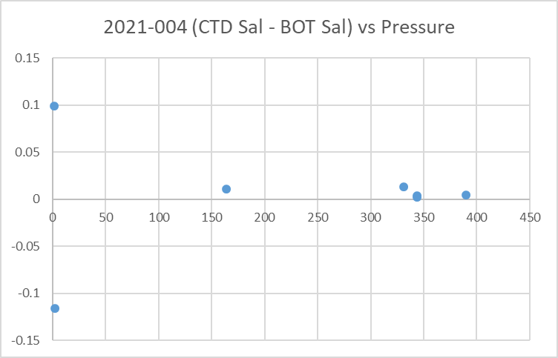

Fluorescence
The only HPLC sampling was at the surface. The median ratio of near-surface downcast CTD fluorescence to TChl-a was 0.41 with the highest ratios seen when TChl-a is lowest. There are several reasons to expect a poor match.
- The CTD data are from the downcast while the sampling was done after the upcast.
- The samples come from higher in the water column than the CTD data with which they are compared.
- The near-surface CTD data tend to be very noisy
Upcast near-surface data were extracted to see if they compared better with TChl-a. The result was CTD Fluorescence being a little closer to TChl-a with values quite close for TChl-a < 2ug/L.
For more details see the “FL vs TChla” worksheet in file 2021-032-bottles_vs_CTD_Comp.xlsx.

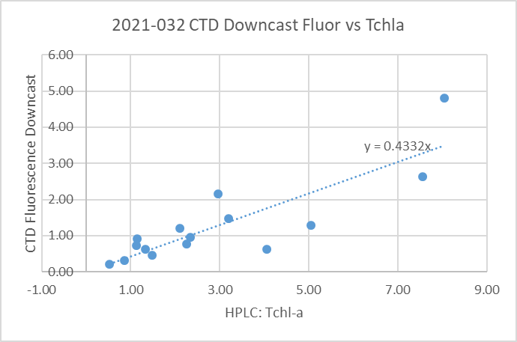
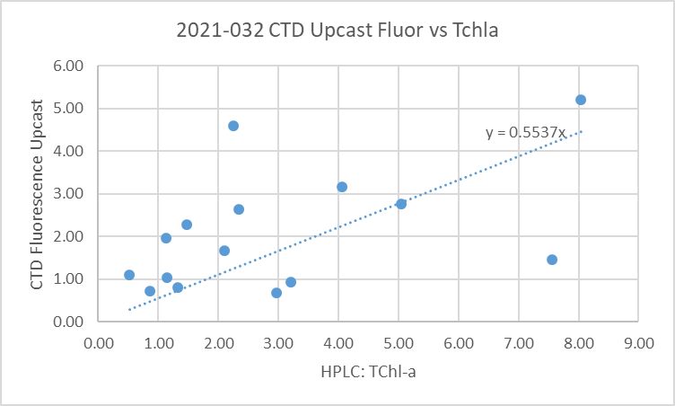

16. Other calibration checks
Sensor History – The conductivity sensor was used on 3 previous cruises since it was last serviced and salinity appeared to be slightly high but incomplete flushing could explain that. Salinity calibration was considered ±0.003psu for the first 2 of those cruises and it appeared to be high by ~0.004psu for the 3rd. Some of the difference was likely due to incomplete flushing of Niskin bottles. The pressure sensor had been used on for 6 other cruises with no problems noted.
Historic Ranges – Temperature at the northern end of Texada Island was slightly above the climatology maximum around 50m; this looks like the effect of mixing being deeper than any seen in the climatology. Temperatures were slightly low in deep waters at 2 stations, likely due to few data in the climatology from this time of year. Salinity was outside the climatology at 2 stations in deep water, in one case higher and another lower. The excursions do not appear to be indicative of calibration problems. They likely reflect the paucity of data for this season in the climatology..
Post-cruise calibrations – None were available.

17. CALIBRATE
The pressure does not need recalibration.
The salinity appears to be within expected accuracy.
For dissolved oxygen there is insufficient evidence upon which to base any recalibration. There was no calibration sampling; the surface saturation values are a little low on average, but given fairly well-mixed surface waters that may reflect real conditions. See section 19 for details.

18. Fluorescence Filter
The fluorescence data was not filtered as it had little effect on the data.

19. Bin Average, Remove, Derive DO in mass units, Reorder
The files were bin averaged using 1db bins.
REMOVE was run to remove Scan_Number, Oxygen:Voltage, Descent Rate and Flag channels.

Dissolved Oxygen was derived in mass units and that was used to calculate DO saturation. Plots of near-surface saturation show a range of 78% to 102%, with the highest values from the central Strait of Georgia. The temperature profiles indicate that near-surface waters were well mixed.
REORDER was used to get the 2 dissolved oxygen channels together.

20. HEADER EDIT and final checks of CTD files.
Header Edit was used to fix headers, fix formats and to add comments about processing.
A cross-reference listing was produced.
A header check and standards check were run on the CTD files and no errors were found.
The sensor history was updated.
Plots of CTD casts were examined and no problems were found.

20. Final BOT file preparation
To enable searching of bottle data, BOT casts were created that contain sample data and CTD data from the downcast at the same site. The event number will match the CTD cast. CTD data were extracted from metre-averaged files and added to spreadsheet 2021-032-bottles_plus_CTD_6linehdr.csv. That file was converted to IOS Header files for each cast.

The time and date are present as channels as these cannot be converted directly into header entries.
CLEAN was run to add START and END time. The END TIME is identical so the START time so it will be removed later. CLEAN was also used to enter 0 flags where the flag channels are empty.
REMOVE was run to remove the DATE and TIME channels.
There was no DO sampling so no need to derive different units.
SORT was run to get entries in pressure order.
HEADEDIT was used to add comments and to remove the END time since it is the same as START TIME. The final files have extensions BOT.

The standards check was run and no errors were found.
Plots were made of all BOT casts. Errors in longitude were found in a few casts. Those were corrected.
A cross-reference list was produced and turned up an error in date for the last cast.
A header check were run on the BOT files and no further problems were found.
Finally all data from BOT files were extracted to a spreadsheet and compared to the event log; no problems were found.

CRUISE SUMMARY

Cruise ID#: 2021-032
Dates: Start: 8 March 2021 End: 12 March 2021
Location: Strait of Georgia Zooplankton
Chief Scientist: Young K.
CTD# | Make | Model | Serial# | Used with Rosette? | CTD Calibration Sheet Competed?
1 | SEABIRD | 25 | 456 | No | Yes

CTD CALIBRATION INFORMATION
Make/Model/Serial#: SEABIRD/SBE25/0334 Cruise ID#: 2021-032

Calibration Information
Sensor |  | Pre-Cruise |  | Post Cruise
Name | S/N | Date | Location | Date | Location
Temperature | 5130 | 12Dec2019 | Factory
Conductivity | 3500 | 17Dec2019 | Factory
ECO Fluorometer | 4185 | 11Dec2019 | Factory
SBE43 Oxygen | 3234 | 6Dec2019 | Factory
Pressure | 0573 | 1Feb2019 | Factory

