REVISION NOTICE TABLE
DATE | DESCRIPTION OF REVISION
March 28 2023 | Added HPLC data. J.R.

PROCESSING NOTES
Cruise: 2021-024
Agency: IOS, Ocean Sciences Division, Sidney BC
Project Scientist: Young K. Platform: Neocaligus
Location: Strait of Georgia Project: Strait of Georgia Zooplankton
Date: 4 May 2021 –9 May 2021

Processed by: Germaine Gatien
Date of Processing: 4 October 2021 – 7 October 2021
Number of original HEX files: 29 (2 versions of first file)
Number of CTD files: 28 Number of BOT files: 15

INSTRUMENT SUMMARY
A SeaBird Model SBE-25 CTD (s/n 0456) was used with temperature sensor #5130, conductivity sensor #3500, Wetlabs ECO Fluorometer #4185, dissolved oxygen sensor #3234 and pressure sensor 0573.

SUMMARY OF QUALITY AND CONCERNS
The cruise log and rosette sheets were in good order. Header information was entered in the raw files in a format that enabled easy conversion into IOS Header format.

Samples were collected at 28 sites. At 4 of those sites there was a Niskin mounted 3m above the CTD to collect near-bottom salinity and nutrient samples.

The 10m soak lasted long enough for the pump to come on so bubbles could be released.

There was insufficient evidence to estimate CTD salinity accuracy but based on previous cruises using this equipment it is likely within ±0.005psu. Larger errors will be present due to minor misalignment of temperature and conductivity when vertical salinity gradients are high.

Pressure did not require recalibration and there was no calibration sampling available for SBE dissolved oxygen.

PROCESSING SUMMARY
1. Seasave - This step was completed at sea.

2. Preliminary Steps
The Daily Log, Sampling Log sheets and a spreadsheet of sampling done were obtained.
The cruise summary sheet was completed.

CTD Deployment method: CTD was lowered to 10m to soak, sat for at least 1 minute, was bought back to the surface to sit a short time until about 2 minutes were up. Then the full cast began. The wait at 10m was a minute or longer which should allow time for the pump to come on and bubbles to clear.

For deep sampling a 1.7L Niskin bottle was mounted approximately 3m above the CTD.
Surface sampling was done after the CTD was taken out of the water and turned off. A 5L Niskin bottle was attached to the wire, sent to the surface and triggered. A separate event number was given for the surface samples, but in processing the event numbers were changed to match the CTD cast with which they are associated to enable creation of BOT files containing CTD data.

3. Conversion of Raw Data
The configuration file used at sea was correct except for the date of the fluorometer calibration . After that was fixed the file was saved as 2021-024-ctd.xmlcon and used to convert all HEX files.

An initial check indicates that surface pressure is good with conductivity falling to ~0 when pressure is between -0.1db and +0.2db. The deep fluorescence values are about 0.035 to 0.085ug/L with no spikes to negative values near the bottom. All expected variables are present and values look reasonable.
Plots show that the channels all produced reasonable values.
There is the usual steppy pressure which leads to unusual profiles.

4. WILDEDIT
The only spikes noted in the data occurred at the beginning or end of the casts or included many points, and will be removed in the normal course of editing. So WILDEDIT was not run.

5. FILTER
Normally pressure is filtered later in processing when running DELETE, but the poor resolution of this instrument means it is necessary to do this early to make sense of the other data which update more often than pressure. So program FILTER was used to apply a low-pass filter with a time constant of 0.5 seconds to pressure and depth. The results were excellent.

Next the temperature and conductivity were examined and the usual approach of applying a cosine filter size 5 in routine WFILTER did a good job of removing small reversals. Derive was run on a few casts to calculate salinity and plots showed great improvement in stability in T-S space after running WFILTER.

6. ALIGNCTD
For other recent cruises in this project using the same DO sensor, an advance of 2.5s was applied to the dissolved oxygen, but for this cruise +3s looks a little better. ALIGNCTD was run on all casts to advance the DO channel by 3s. Plots were examined after this step and the results were good.

7. CELLTM
CELLTM was run on all casts using the SeaBird recommended parameters, (α, 1/β) = (0.04, 8).

8. DERIVE
Program DERIVE was run to calculate salinity and dissolved oxygen concentration (tau correction included). Plots were examined and confirmed that steps 5, 6 and 7 had improved the data.

9. Conversion to IOS Headers
The IOSSHELL routine was used to convert the CNV files to IOS Headers.
CLEAN was run to add event numbers and replace pad values in the pressure channel with interpolated values.
A preliminary header check was run and indicated there were some negative fluorescence values but it appears they were all at the beginning of the casts and not in the main downcast. Similarly a patch of high DO values occurred just as the pump came on during the 10m soak. One latitude was missing a hemisphere entry; that was fixed and CONVERT and CLEAN were rerun.
Plots were made to find the minimum pressure from the ends of casts and they varied from +0.03db to +0.25db.

Plots were made to determine how many records need to be removed and those were used to prepare file CLIP.csv. CLIP was run on the CLN files to remove the records and plots were examined to ensure the best choice was made and all looked fine.

10. Checking Headers
A cross-reference list was produced and compared with the log book entries. No errors were found.
Track plots looked ok so were added to the end of this report.

HEADER CHECK was run. No problems were found though there remain some negative fluorescence values that are at the bottom of casts and should disappear after DELETE.
The surface check shows an average of 0.85db before CLIP was run with a minimum of 0.05db. Plots show that at the end of casts, pressure varied from -0.1db to +0.02db. The pressure sensor has a 2800db range so the resolution is only 0.5db; these results look excellent.

Plots of temperature and salinity show reasonably good correspondence between upcast and downcast except in the top 5m where shed wakes generally have a large effect on upcast data.

11. SHIFT
Conductivity
When this CTD was last used tests were run to see what shift to conductivity made the best improvement to stability in T-S space. Shifts of +0.4 records and +0.5 records both worked quite well with variation from cast to cast as to which was best, so +0.45 was selected as the setting to be applied to all casts. A few casts were tested for this cruise using +0.4, +0.45 and +0.5 and +0.45 records looks best.
SHIFT was applied to all casts advancing conductivity by +0.045s.
Fluorescence
The fluorometer was not pumped, so a shift in alignment is expected to be small, and usually unnecessary. Profile plots of temperature and fluorescence were examined. The alignment is not as good as usual. A shift of +5 records leads to a vertical offset between upcast and downcast profiles that is closer to that in temperature. Shift was applied using +5 records.
Dissolved Oxygen
This channel was aligned earlier, but checks were made by examining plots of temperature and dissolved oxygen. No further adjustment was made.

12. DELETE
DELETE was run on all casts using the following parameters:
Surface Record Removal: Last Press Min. Surface Swell Pressure Tolerance: 1.0
Swells deleted. Warning message if pressure difference of 2.00
Drop rates < 0.3m/s (calculated over 5 points) was deleted from 10db to 10db above the maximum pressure.
COMMENTS ON WARNINGS: There were no warnings.

13. DETAILED EDITING
All DEL files were copied to *.EDT so there will be a complete set of files even if some need no editing.

CTDEDIT was used to remove records corrupted by shed wakes and to clean salinity where unstable features looked likely to be caused by misalignment of T and C. All casts required editing except for #56, mostly removing records near the surface and bottom and light editing of salinity elsewhere.
Notes of editing details were made in the headers.
T-S plots were examined after this step. Small unstable features are found, mostly near the surface which may be real.

14. Initial Bottle Data Steps
There was no rosette in use for this cruise. There were surface bottles fired at 15 sites; they were given separate event numbers from the CTD casts. At 4 of those sites there was also a Niskin mounted above the CTD to collect near-bottom samples.
BOT files were prepared with the sample data plus CTD gathered at the same site.
The event numbers are those of the CTD cast at the site.

Each of the analysis spreadsheets were examined to see what comments the analysts wanted included in the header file. These were used to create file 2021-024-bot-hdr.txt.

Workbook 2021-024-bottles_plus_CTD_6linehdr.csv was created. Cast times, station names, sample numbers times and positions were copied from 2021-024-event log.xlsx. Data from the QF worksheets were added. Space was included for the addition of CTD data.

There are no CTD data available right at the surface, so data from as close to the surface as possible were obtained. For the 4 bottom samples a record was made of the pressure at the sampling level (=maximum pressure in surface report– 3db).

The edited files were put through Change Units to obtain dissolved oxygen in mass units.

To prepare data to be added to the 6-line header file, the edited CTD files were binned to 0.5db and then thinned to 1db, 2db, 3db and the levels of the 4 bottom samples (in order of maximum depth). They were extracted to a spreadsheet and reduced to the shallowest values for each cast and the appropriate pressure for the casts with deep sampling. Those data were added to the 6-line header file.

Using the same CTD data file 2012-024-bottles_vs_CTD.xlsx was prepared to do a comparison of CTD and bottle data for salinity and fluorescence.

15. Compare
Salinity Comparison
There were 4 surface salinity samples and 4 deep samples. Analysis was about 1.5 months after the cruise so a small increase in values is expected due to desorption of glass into samples,. Using the estimates from Alexander and Hinrichsen (1986), bottle values might be high by about 0.001psu. There can also be some further increases due to evaporation if bottle seals are imperfect. An error of opposite sign is one due to incomplete flushing of Niskin bottles. This leads to bottle salinity values being lower than ambient waters when Niskins are closed at the bottom of casts.

For the 4 deep samples the CTD salinity was higher than bottle salinity by 0.0121, 0.0205, 0.0169 and 0.0039psu for events #1, 13, 28 and 36 respectively, with an average difference of +0.0134 and standard deviation of 0.0072psu.
To estimate the effect of incomplete flushing 2 tests were run:
- The vertical gradient over the 10m above the bottle closing level was recorded and it >0.01psu for all but cast #36.
- The descent rate of the CTD near the bottom was plotted. They all look fairly steady with cast #28 having the highest variability which might lead to slightly better flushing.
The case with the CTD reading high by 0.0039psu has the lowest vertical gradient, so the result is likely the most reliable, though event #28 at 0.0169psu has the most favourable descent rate.
The surface samples are not useful for calibration purposes since they come from higher in the water column than measured by the CTD and near-surface gradients are large. The CTD surface salinity is also very noisy, so not very reliable.

In previous use of this instrument the CTD accuracy was thought to be ±0.003 to 0.0045psu. The current study suggests the error may now be larger, but the evidence is very weak.

Fluorescence
The only CHL sampling was at the surface. The average ratio of near-surface downcast CTD fluorescence to CHL was 1.84ug/L with a standard deviation of 1.07. A plot of the ratio versus CHL shows a typical pattern for fluorometers; the ratio is high when CHL is <1ug/L and drops to values ~1 for CHL between 1 and 2.5ug/L.

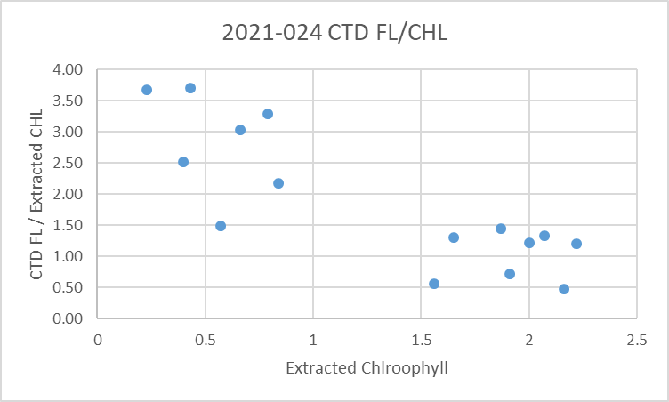

For more details see file 2021-024-bottles_vs_CTD.xlsx.

16. Other calibration checks
Sensor History – The conductivity sensor was used on 4 previous cruises since it was last serviced and salinity appeared to be slightly high but incomplete flushing could explain that. For this program there are only a few bottles from near the bottom so they are considered only a guide, not the basis for recalibration. On all 4 cruises the CTD salinity was close to bottles with estimates that salinity was within 0.003 to 0.0045psu.
The pressure sensor had been used on for 4 other cruises with no problems noted.

Historic Ranges – Temperatures were mostly within the climatology except near the surface at some sites in the northern part of the cruise where they were above the maximum and one site where temperature was below the minimum near the bottom. Salinity was frequently below the climatology minimum at the surface in the central Strait of Georgia and low at the bottom at station 24. The fact that outliers are both to the high and low side of the climatology reflects problems with using a 3-standard-deviation in this near-shore area known for large variability.

Post-cruise calibrations – None were available.

Repeat casts – The only repeat cast was at station GEO1 which was occupied at the beginning and end of the cruise. While too far apart in time to assess the repeatability of the CTD data, it clearly demonstrates the temporal variability in this region.

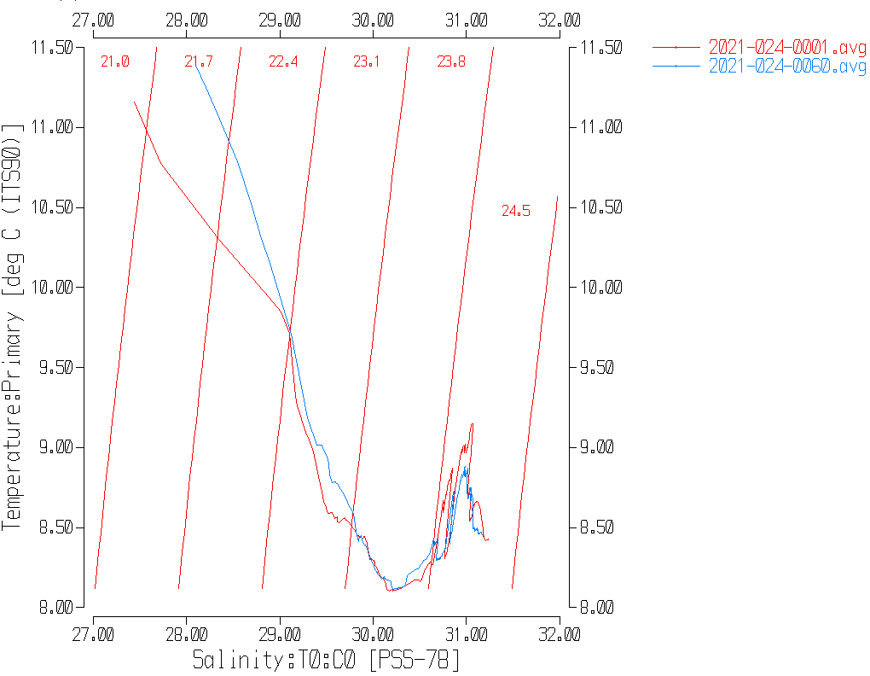

17. CALIBRATE
The pressure does not need recalibration.
There is insufficient information to recalibrate salinity.
For dissolved oxygen there is insufficient evidence upon which to base any recalibration. There was no calibration sampling; the surface saturation values are a little low on average, but not unusual for this region where saturation tends to vary greatly. See section 19 for details.

18. Fluorescence Filter
The fluorescence data was not filtered as it had little effect on the data.

19. Bin Average, Remove, Derive DO in mass units, Reorder
The files were bin averaged using 1db bins.
REMOVE was run to remove Scan_Number, Oxygen:Voltage, Descent Rate and Flag channels.

Dissolved Oxygen was derived in mass units and that was used to calculate DO saturation. Plots of near-surface saturation show a range of 83% to 109%, with the highest values from Satellite Channel and the northern Strait of Georgia. Values were <95% for most of the central Strait . When station GEO1 was occupied at the beginning and end of the cruise the values were 92% and 99%.
REORDER was used to get the 2 dissolved oxygen channels together.
CLEAN was run to update the channel table values.

20. HEADER EDIT and final checks of CTD files.
Header Edit was used to fix headers, fix formats and to add comments about processing.
A cross-reference listing was produced.
A header check and standards check were run on the CTD files. One errors was found and corrected.
The sensor history was updated.
Plots of CTD casts were examined and no problems were found.

20. Final BOT file preparation
To enable searching of bottle data, BOT casts were created that contain sample data and CTD data from the downcast at the same site. The event number will match the CTD cast. CTD data were extracted from 0.5-metre-averaged files and added to spreadsheet 2021-024-bottles_plus_CTD_6linehdr.csv. That file was converted to IOS Header files for each cast.

The time and date are present as channels as these cannot be converted directly into header entries.
CLEAN was run to add START and END time. The END TIME is identical so the START time so it will be removed later. CLEAN was also used to enter 0 flags where the flag channels are empty.
REMOVE was run to remove the DATE and TIME channels.
There was no DO sampling so no need to derive different units.
SORT was run to get entries in pressure order.
HEADEDIT was used to add comments and to remove the END time since it is the same as START TIME. The final files have extensions BOT.

The standards check was run and no errors were found.
A cross-reference list was produced and no errors were found.
A header check were run on the BOT files and no further problems were found.
Finally all data from BOT files were extracted to a spreadsheet and compared to the event log; no problems were found.

PARTICULARS:
2/3. The cruise was interrupted for about 24 hours due to a winch problem.
16. CTD came partially out of water after 10m soak so waited at surface extra 20s.
22. 2.5 minutes soak

CRUISE SUMMARY

Cruise ID#: 2021-024
Dates: Start: 5 May 2021 End: 9 May 2021
Location: Strait of Georgia Zooplankton
Chief Scientist: Young K.
CTD# | Make | Model | Serial# | Used with Rosette? | CTD Calibration Sheet Competed?
1 | SEABIRD | 25 | 456 | No | Yes

CTD CALIBRATION INFORMATION
Make/Model/Serial#: SEABIRD/SBE25/0456 Cruise ID#: 2021-024

Calibration Information
Sensor |  | Pre-Cruise |  | Post Cruise
Name | S/N | Date | Location | Date | Location
Temperature | 5130 | 12Dec2019 | Factory
Conductivity | 3500 | 17Dec2019 | Factory
ECO Fluorometer | 4185 | 11Dec2019 | Factory
SBE43 Oxygen | 3234 | 6Dec2019 | Factory
Pressure | 0573 | 1Feb2019 | Factory

