REVISION NOTICE TABLE
DATE | DESCRIPTION OF REVISION
23 March 2023 | HPLC data added. J.R.

PROCESSING NOTES
Cruise: 2021-020
Agency: OSD
Location: Strait of Georgia / Juan de Fuca Strait
Project: Strait of Georgia Water Properties Survey
Party Chief: Chandler P.
Platform: Vector
Date: 4 April October 2021 – 15 April 2021

Processed by: Germaine Gatien
Date of Processing: 27 July 2021 – 25 August 2021 2021
Number of original HEX files: 99 Number of CTD files: 99
Number of original ROS files: 45 (1 accidental) Number of CHE files: 44

INSTRUMENT SUMMARY
CTD #0443 was mounted in a rosette and attached were a Wetlabs CSTAR transmissometer (#983DR), a SBE 43 DO sensor (#3791), a SeaPoint Fluorometer (#3950), a Biospherical QSP-400 PAR sensor (#4556), an SBE pH sensor (692) and an altimeter (76341). A Biosperical QSR-2240 Surface PAR (#16504) was in use.

Seasave version 7.26.7.121 was used for CTD acquisition.
The data logging computer was Vector Laptop FC9JJD1A..
The deck unit was a Seabird model 11+, serial number 508.
The salinometer used at IOS was a Guildline model, 8400B Portasal, serial # 68572.
The oxygen kit was Scripps Titrator #1.
An IOS rosette with 24 10L bottles was used.

SUMMARY OF QUALITY AND CONCERNS
The Daily Science log had no personnel list and lacked comments about some problems such as the absence of TSG data even though the TSG serial number was entered. There was a note about a change to the SPAR parameters in the configuration file but no indication of whether this was just a correction or a different SPAR sensor. The post-cruise report mentioned problems with the TSG pump hose disconnecting. There is a note about the fluorometer cable being changed due to very high CHL values.

There was no hex file found for event #53.

The pH values were much higher than observed in previous surveys in this region. The minimum values were about 8.4 whereas we expect ~7.4. The sensor was also used during 2021-021 and high values were also found then. The data collected in 2019 and 2020 from this sensor looked normal. There are no calibration data for pH, so the pH data will not be placed in the OSD Data Archive.

No PAR:Reference data were acquired; the channel contained only noise.

The fluorometer on the CTD went off-scale during casts #86 to 91 and #94 to #104 despite having a cable change from 10X (max 15ug/L) to 3X (max 50ug/L). Off-scale values were replaced with pad values.

The altimetry values for events #2 to #9 are bad. The CTD cast for event #1 did not get close enough to the bottom to determine whether it was bad for that cast or not. There was no log note about a change to the configuration or connection of the altimeter.

Water depths were missingd in the headers for events #79 to 83 but were added based on log book entries.

The dissolved oxygen traces were unusually spiky between casts 1 and 23, particularly near the surface, but the spikes were small and two-sided; bin-averaging removed them with no noticeable improvement if a filter was applied first. Dissolved oxygen was recalibrated based on the results of the offshore section of cruise 2021-006 which followed and used the same sensor.

The SBE DO sensor has a fairly long response time so data accuracy is not as high when it is in motion as it is during stops for bottles. This will be especially true when vertical DO gradients are large. To get an estimate of the accuracy of the SBE DO data during downcasts (after recalibration) a rough comparison was made between downcast SBE DO and upcast titrated samples. Some of the difference will be due to problems with flushing of Niskin bottles and/or analysis errors, so the following statement likely underestimates SBE DO accuracy.

Downcast (CTD files) Oxygen:Dissolved:SBE data are considered, very roughly, to be:
±0.70 mL/L from 0 to 50db
±0.20 mL/L from 50 to 250db
±0.05 mL/L below 250db

While CTD fluorescence data are expressed in concentration units, they do not always compare well to extracted chlorophyll samples. It is recommended that users check extracted chlorophyll values where available.

PROCESSING SUMMARY

Seasave
This step was completed at sea; the raw data files have extension HEX.

Preliminary Steps
- The Log Book and rosette log sheets were obtained and reviewed.
- Nutrients, extracted chlorophyll, dissolved oxygen and salinity data were obtained in QF spreadsheet format from the analysts.
- The cruise summary sheet was completed.
- There were 4 variations among the configuration files and few notes to explain why.
- There is a note explaining that the fluorometer cable was switched before event #89 because of high CHL values.
- The SPAR sensor had the wrong calibration until event #66. Even with that correction there appears to be no signal, just noise.
- The altimeter offset was changed at event #4 . Using the event #4 configuration file did not produce better results for event #2 and during event #1 the CTD did not get close enough to the bottom to get an altimeter reading. The altimetry still looks bad for events #4 to #9 as though the scale was wrong but there is no note of any change between casts #9 and 10.Configuration files from events #88 and #89 were selected and saved as 2021-020-ctd1.xmlcon (for events 1-88) and 2021-020-ctd2.xmlcon (for events #89-133).
- The pressure, temperature, conductivity, transmissivity and dissolved oxygen sensors had not been used since they were last serviced.

BOTTLE FILE PREPARATION
The ROS files were created using file 2021-020-ctd1.xmlcon and 2021-020-ctd2.xmlcon.
The ROS files were converted to IOS format. They were put through CLEAN to create BOT files.
Temperature and salinity were plotted for all BOT files and no significant outliers were found.
The BOT files were bin-averaged on bottle number and the output was used to create file ADDSAMP.csv. First, the file was sorted on event number and Bottle Position order. Then sample numbers were added based on the rosette logs. There were a few irregularities noted:
- Event #73 had 5 bottles fired but only 4 in the sampling log. The extra bottle was due to 2 surface bottles being fired. The second one is presumed to have been an accident.
- Event #97 had a bottle fired but there was no sample number, no sampling log and no note in the Daily Science Log so this is assumed to have been unintentional; it was not processed further.
- Sample number161 was not used.

The ADDSAMP file was sorted on event number & sample number.
It was used to add sample numbers to the BOT files – output *.SAM.
The SAM files were bin-averaged on bottle # and called SAMAVG.
The addsamp.csv file was converted to CST files, which will form the framework for the bottle files.

Next, each of the analysis spreadsheets were examined to see what comments the analysts wanted included in the header file. These were used to create file 2021-020-bot-hdr.txt which will be updated as needed during processing.
EXTRACTED CHLOROPHYLL
Extracted chlorophyll and phaeo-pigment data were obtained in file QF2021-020chl*.xlsx. The file included comments, flags and a precision study. A simplified version of the spreadsheet was prepared and saved as 2021-020chl.csv. The csv file was ordered on sample numbers, then converted to individual CHL files.
DISSOLVED OXGYEN
Dissolved oxygen data were provided in spreadsheet QF2021-020oxy.xlsx which includes flags, comments and a precision study. Draw temperatures are available. The spreadsheet page with the final data was simplified and saved as 2021-020oxy.csv. That file was converted into individual *.OXY files.
Some bottles were flagged due to problems that will affect other samples but only nutrients were collected from those bottles. The nutrient spreadsheet was checked and those flags added where appropriate.
SALINITY
Salinity analysis was obtained in file QF2021-020SAL*.xlsx. The analyses were carried out in a temperature-controlled lab 108 to 116 days after collection. The files were simplified and saved as 2021-020sal.csv. That file was then converted to individual SAL files. There were no duplicates.
NUTRIENTS
The nutrient data were obtained in spreadsheet QF2021-020NUTS*.xlsx. This includes a precision study. The file was simplified and the saved as 2021-020-nuts.csv. The file was converted to individual NUT files. Flag 3 was added to samples 34, 35 and 193 based on notes from the dissolved oxygen analyst.
(* - indicates date of creation for the files from analysts.)

The SAL, CHL, OXY and NUT files were merged with CST files in 4 steps.
After the 4th step the files were put through CLEAN to reduce the headers to File and Comment sections only.

The merged files are ordered on sample number, but the SAMAVG files are ordered on bottle number, so one or the other set needs to be reordered in order to merge them. The MRGCLN1 files were reordered on Bottle_Number. The output files were named MRGCLN1s. Those files were then merged with SAMAVG files choosing the Bottle_Number from the SAMAVG files.

The output of the MRG files were exported to a spreadsheet and compared to the rosette log sheets to look for omissions. Cast #97 had 1 bottle fired but there was no sampling so it was removed from the bottle processing list.

Compare
Salinity
Compare was run with pressure as reference channel. There were many outliers.

When cases with standard deviation in the CTD Salinity > 0.001psu were excluded 13 of the 36 bottles were removed from the primary salinity and 10 from the secondary. There were 3 other outliers with low standard deviations for the primary and 3 for the secondary leaving 20 and 23 bottles left in the comparison. The primary salinity was higher than the bottles by a median of 0.0002psu (std.dev. 0.004psu) while the secondary was high by a median of 0.0015psu (std. dev. 0.004psu). The secondary fit is flatter with pressure than the primary but the difference may well be due to it having 3 more bottles.

All the bottles from Jarvis Inlet show the CTD to be reading lower than bottles which is what we would expect from this area since flushing of Niskin bottles is likely to be poor. The bottles from Indian Arm are also likely to be poorly flushed as well as a number of other areas where that could be true as well. Plots of descent rate were examined and 8 casts were identified where Niskin bottles are likely to be quite well flushed due to vertical motion during stops. The primary CTD salinity data were very noisy for 2 of those bottles but the average found did not vary significantly if they were included or not. The primary were found to be high by 0.0032psu (std.dev. 0.0032psu) and the secondary by 0.0039psu (std.dev. 0.0017psu).

A preliminary examination of downcast CTD salinity profiles (see §9) suggests that the 2 salinity channels grew further apart during the cruise, so a comparison was made of the 2 CTD salinity channels during bottle stops and the drift was confirmed.

The question is which sensor accounts for the drift or are both drifting. Looking at a plot of differences from bottles versus time for the 8 well-flushed casts suggests that the primary salinity may have drifted downwards since the last 2 comparisons are lower than the average while the secondary differences are close to the average. But this is far from convincing due to the scatter.

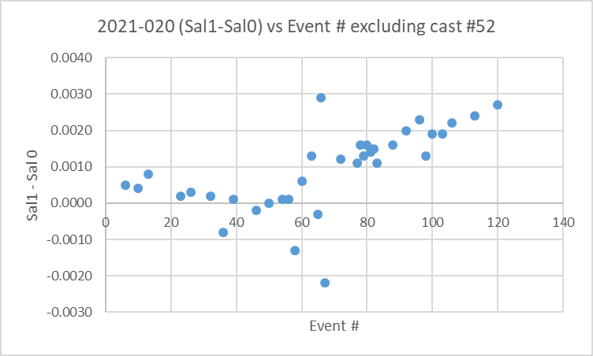
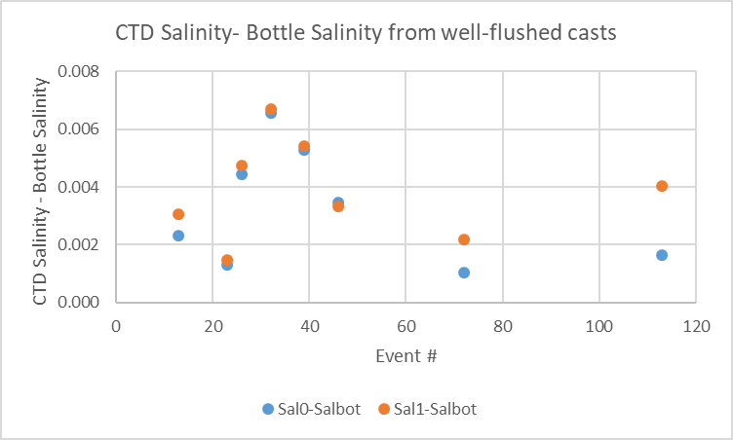
The other issue is when the changes occur. Looking at downcast profiles the differences are roughly:
- <0.001 from events 1 to 67
- ~0.0015 from events 68 to 108
- ~0.0025 from events 110 to 133
The downcast differences tend to be smaller than those seen in the upcasts towards the end of the cruise. There is a lot of noise in both salinity channels even when stopped.

The salinity samples were analyzed almost 4 months after collection, so the bottle salinity values are likely too high. That would imply that both CTD salinity channels are reading even higher than the comparison suggests. Using the estimates from Alexander and Hinrichsen (1986), bottle values might be high by about 0.0024psu after 4 months. Any flushing errors would increase the error in bottle values, though that should not be a significant error for the subset of 8 bottles. It is a little surprising that errors in newly serviced sensors should be as high as 0.004psu to 0.006psu as the secondary pair appear to be.

All of the outliers are associated with very large standard deviations in the CTD data and/or large vertical salinity gradients so the results are easily explained without assuming there was a problem with the salinity sampling or analysis. No further flags are needed.

The data from 2021-006 (May 2021) were available and there was deep salinity sampling, but that cruise also suffered from delayed salinity analysis. There was considerable scatter in the comparison with the CTD. There was only a slight increase in the difference between the 2 salinity channels during the cruise and the average difference was~0.006psu. The primary was thought to be low by about 0.0024psu compared to bottles and the secondary high by about 0.003psu. Making an allowance for bottles reading high due to delayed analysis, the primary calibration is likely good to ±0.002pus and the secondary likely high by about 0.006psu. So it is indeed likely that the secondary is high late in 2021-020.

Given that the primary salinity is closest to bottles during 2021-006 it is a reasonable guess that it was closer during 2021-020 as well. So recalibration of primary salinity will not be applied. If the secondary salinity is selected for archiving it should be recalibrated by subtracting 0.006psu for casts 68 to the end of the cruise as there appears to have been a shift in calibration. Early in the cruise it is close to the primary.

For full details for the COMPARE run see file 2021-020-sal-comp1.xls.

Dissolved Oxygen
COMPARE was run with pressure as the reference channel.
There is a lot of scatter in the plot.
The initial fit using all casts but excluding outliers based on residuals and standard deviations in the CTD DO was:
CTD DO Corrected = CTD DO * 1.0327 +0.0340 (R² = 0.87) (1)

There are 2 areas where we might expect unusual results:
- Excluding the area with extremely high chlorophyll values
CTD DO Corrected = CTD DO * 1.0306 +0.0406 (R² = 0.85) (2)
- Excluding the areas with especially steady descent rates.
CTD DO Corrected = CTD DO * 1.0338 +0.0296 (R² = 0.86) (3)

Another fit was done using the 7 casts identified as likely to have good flushing from the salinity comparison.
CTD DO Corrected = CTD DO * 1.0373 +0.019 (R² = 0.88) (4)
This fit looks likely to be the best of this group of 4.

During cruise 2021-006 that followed and had conditions likely to lead to good flushing of bottles the fit was:
CTD DO Corrected = CTD DO * 1.0515 -0.0131 (R² = 0.98) (5)
That fit was unusually tight with only 5 out of 152 bottles excluded.

The fits from 2021-020 have larger slopes if the shallow samples are excluded and that is where the flushing errors would be largest. For example the slope is 1.047 for casts #23 and 26 below 60m.
Given that the Line P fit included more areas with low DO gradient, that fit is likely more reliable. For 2021-020 there are larger average gradients and poorer flushing so the bottle contents are likely from lower in the water column where DO is generally lower. So the calibration error in the CTD DO appears to be smaller than it is in reality.

Outliers were examined. From the 7 casts in fit (4) there were none that could not easily be explained by high gradients, gradient reversals or noisy CTD data. From the other casts extreme outliers were checked and all were easily explained by either shed wakes passing through the area during the stop or large vertical gradients implying that minor flushing errors would account for the bottle values. One of the bottle samples had been flagged as having the spigot open before sampling, but flushing errors alone can easily account for the difference. No further flags are called for.

For details see 2021-020-DO-comp1.xls.
Plots of Titrated DO and CTD DO against CTD salinity were examined. No further outliers were found.

Fluorescence
COMPARE was run with extracted chlorophyll and CTD Fluorescence using pressure as the reference variable.
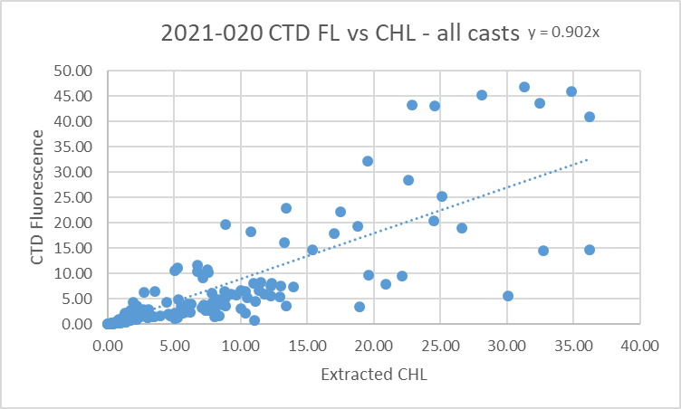
As usual the CTD fluorescence is higher than extracted CHL values when CHL values are very low, but there were few low CHL samples. We usually see fluorescence lower than CHL as CHL values rise and that is the case for casts where no off-scale values were observed. In cases where the fluorometer went off-scale, fluorescence usually read higher than the CHL despite the cut-off in values. This may be because the CHL samples are from deeper than the fluorescence with which they are being compared due to incomplete flushing.

The fluorometer went off-scale during events #86 to 91 and 93 to 104 despite the change of cable before event #89. This is seen in the downcasts but less often during upcasts.
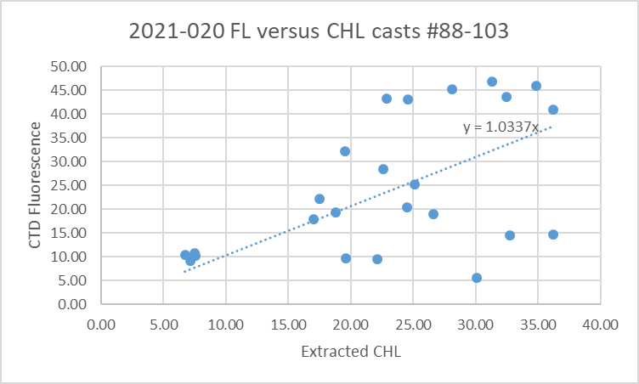
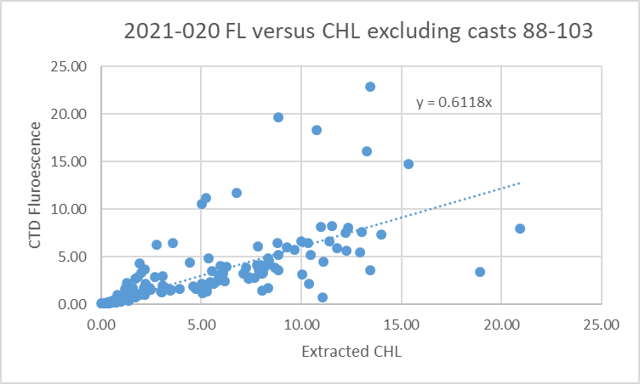
For full details of the comparison see file 2021-020-fl-chl-comp1.xls.

Conversion of Full Files from Raw Data
All files were converted using 2021-020-ctd1.xmlcon or 2021-020-ctd2.xmlcon. The Tau function was selected but not the hysteresis function as there was no deep sampling. Depth was included in the conversion.
There was no hex file for event #53.

A few casts were examined and all expected channels are present but there were many problems that appear to be related to pressure spikes, so the checks were rerun after WILEDIT.

WILDEDIT
Program WILDEDIT was run to remove spikes from the pressure, conductivity & temperature only in the
full cast files (*.CNV).
Parameters used were: Pass 1 Std Dev = 2 Pass 2 Std Dev = 5 Points per block = 50
The parameter “Keep data within this distance of the mean” was set to 0 so all spikes would be removed.
Most spikes noted before were removed successfully. In particular the spikes noted at sea in cast #94 were resolved.

Casts were examined again and some problems remain:
- SPAR values look bad – all very low even when PAR values are high. No change when calibration factors were adjusted. This sensor also worked badly during 2021-021 in June.
- PAR values look fine. Pressure spikes have been removed.
- The altimetry looks bad until event #10; there was no change to the con file, so it is assumed that a connection was adjusted. From cast #10 on the profiles look good.
- Fluorescence values went off-scale during casts #86 and #88 after which the gain cable was changed. Values still look very close to the maximum during cast #89.
- pH traces have normal profile shapes but values are much higher than usually seen. Checks were made to see if there was a new calibration done, or a different sensor was used (photo check) or if it was not mounted on the voltage channel as in the con file. No explanation was found. The values are much higher than in April 2019.
- The conductivity, temperature and transmissivity profiles look normal.
- The Dissolved Oxygen traces are very noisy but the source is mostly 2-sided spikes that may average out or may need to be filtered.

ALIGN DO
For most cruises in the North Eastern Pacific and Strait of Georgia using SBE911+ CTDs the best choice for aligning dissolved oxygen is +2.5s. Because the oxygen traces are very noisy it is a little hard to judge how well this setting worked for these data, but overall the vertical offsets between downcast and upcast are very close to those of the temperature traces.
ALIGNCTD was run on all casts using +2.5s.

CELLTM
CELLTM was run using the default setting (α = 0.0245, β=9.5) for both the primary and secondary conductivity. A few casts were checked and this step does improve the data.

DERIVE and Channel Comparisons
Program DERIVE was run on all casts to calculate primary and secondary salinity and dissolved oxygen concentration.

DERIVE was run a second time on 3 of the deeper casts to find differences between the pairs of temperature, conductivity and salinity channels.
Cast # | Press | T1-T0 | C1-C0 | S1-S0 | Descent Rate
2021-020-0037 | 320 | -0.0002 | ~0 | +0.0002 | High, F.Steady
2021-020-0082 | 550 | +0.0001 | +0.00017 | +0.0015 | High, Steady
2021-020-0117 | 375 | +0.0004 | +0.00022 | +0.0021 | High, Steady
These are shallow casts but suggest calibrations may be drifting.

Conversion to IOS Header Format
The IOSSHELL routine was used to convert SEA-Bird 911+ CNV files to IOS Headers.
CLEAN was run twice, first on all casts to add event numbers and to replace pad values in the pressure channel with interpolated values based on record number. A second run was applied to:
- casts #86-88 to replace fluorescence values >4.57ug/L with pad values.
- casts #89-93 to replace fluorescence values >49.25ug/L with pad values.

Checking Headers
The header check was run. The range of pH values is very large due to spikes; these are found in events #79, 81, 92, 94 and 96. However, all pH data look higher than expected.

The cross-reference list was printed and checked against the log book. As noted earlier there was no hex file for event ##53. A few adjustments were made to some headers:
- Two station names (#31 and 33) had asterisks in the headers because they were not at the usual position, but others with the same problem did not have asterisks. For consistency and to aid those doing searches based on station names, the asterisks were removed from the CLN files.
- Two casts (55 and 56) had file names with slightly different format from others, so these were changed.
- The station name for event #85 was 22 in the log and 20 in the header. The header is correct. No change was made.
- The station name for event #90 was 8 in the log and 18 in the header. The header was changed since the log is correct.
- The station name for event #121 was 275 in the log and 27 in the header. The header was changed since the log is correct.
- The station name for event #122 was 28 in the log and 26 in the header. The header was changed since the log is correct.
The SAM and SAMAVG files for event #56 were also corrected.

The altimeter and water depth readings from the headers of the CLN files were exported to spreadsheets.
For events #1 to 9 there was no altimetry header entry. For #1 this makes sense as the CTD did not get with 15m of the water depth recorded in the log, but for the others this was not the case. There is a signal – it just appears to have the wrong scale. There was no change to the XMLCON file and there is no log entry to explain what changed before event #10. A test conversion with the altimeter moved to a different voltage did not help.
Another problem discovered in doing the altimetry check is that the water depth had not been entered in the headers for events 79 to 83. The log entries were used to add that information.

A check was made by subtracting maximum depth sampled plus altimetry header from the water depth. Where that number exceeded ±5m the altimetry was plotted.
- For events #46, 51, 55, 78, 86, 89 and 106 the header depth entry was replaced with the log entry; for casts 46 and 78 the bottle file headers were also adjusted.
- For events #79, 81, 82 the only depth available is from the log as mentioned above. For events #104, 107 and 118 the header depth agreed with the log. The altimetry was plotted and looks very noisy near the bottom with many spikes but the values in the header entries look good.
File 2021-020-altimetry-study.xlsx records the changes made. Affected bottle files were also corrected.

The log notes that a bottle was out of the water at the beginning of cast # 67. The pressure was ~1.5db at the beginning of the cast and the distance between the top of the rosette and the CTD is about 1.6db. So the pressure reading looks reasonable if the note is referring to the top of the Niskin.

A surface check was run and shows an average surface pressure for the cruise was 2.6db which is fairly deep for the Vector. However, there was a wide range of values with the minimum being 1.2db in Indian Arm and the deepest from the exposed areas near Swiftsure Bank. There is no evidence of a problem with the pressure calibration.

Shift
Fluorescence
SHIFT was run on the SeaPoint fluorescence channel in all casts using the usual advance of +24 records. Plots show that the fluorescence offset is reasonably close to the temperature offset after this step.
Dissolved Oxygen
The Dissolved Oxygen voltage channel was aligned earlier. A few casts were checked to see if the alignment looked ok, and it did. No further alignment is needed for the DO concentration channel,
Conductivity
Tests were run on a few casts. There are a lot of unstable features that were not improved by any settings but the best overall for both channels was -0.7.
SHIFT was run twice on all SBE911 casts using that setting. Salinity was recalculated for both channels.
pH
The pH data are not expected to be archived, because values are too high though the profile shape looks ok. However, in case a correction is discovered later, the pH data were aligned with temperature by applying an advance of +35 records. This setting has been used on a previous use of this sensor and looked appropriate for these data.

DELETE
The following DELETE parameters were used:
Surface Record Removal: Last Press Min
Maximum Surface Pressure (relative): 10.00
Surface Pressure Tolerance: 1.0 Pressure filtered over 15 points
Swells deleted. Warning message if pressure difference of 2.00
Drop rates < 0.30m/s (calculated over 11 points) will be deleted.
Drop rate applies in the range: 10db to 10db less than the maximum pressure
Sample interval = 0.042 seconds. (taken from header)

COMMENTS ON WARNINGS: The only warning was for cast #81 in which there were 2 bad pressure values at scans 5446 and 5447. The 2nd record coincided with spikes in primary channels. Several routines could replace pressure values with pad values or interpolated values so a check was made of the file just after original conversion from HEX format. The problem is in that original file, so not a processing artefact. The data from scan #5445 was used to replace #5446 and the data from record #5448 was used to replace #5447. DELETE was rerun on this cast only and no further warning appeared.

Other Comparisons
Previous experience with these sensors –
The pressure, temperature, conductivity and oxygen sensors have had factory calibration since they were used last. They were used during 2021-006 which followed. Because of delayed analysis the comparison with bottles was not considered reliable but using estimates of the error caused by the delay suggested that the primary salinity had drifted very little while the secondary was reading high by ~0.006psu.The differences between the 2 estimates matches the differences found between the 2 CTD salinity channels during downcasts. Dissolved oxygen from the Line P section of cruise 2021-006 were found to have a fit of slope 1.0515 and offset -0.0131.
Historic ranges – Profile plots were made with 3-standard deviation climatology ranges of T and S superimposed. There were 2 casts with salinity higher than the range maxima. At cast #24 (Station 101) the salinity was a little high between 40 and 60db. At cast #39 (Station 56) all salinity below 70db was above the maximum. However, the salinity falls well within the climatology for the Gulf Islands rather than southern Strait of Georgia so this is assumed to reflect real conditions, not a calibration problem. The only excursions in temperature were a few cases where temperature was slightly low right at the bottom.
For casts in inlets there was no climatology available.
Repeat Casts – There were no repeat casts and nearby casts are too shallow to provide a reasonable test of repeatability.
Post-Cruise Calibration – There were no post-cruise calibrations available.

DETAILED EDITING
A general examination of T-S plots shows little difference between the 2 channel pairs. While there is lots of small-scale noise, the averaged files show no significant unstable features. There is evidence that the two salinity channels drifted apart late in the cruise. Examination of results from cruise 2021-006 indicate that the channels differ by 0.006psu during that cruise with little or no further drift. The comparison with bottles during 2021-006 suggests that the primary salinity was more accurate, so the primary sensors were chosen for editing and eventual archiving. This choice also avoids the uncertainties that would arise in deciding how to recalibrate secondary salinity.

CTDEDIT was used to remove records that appear to be corrupted by shed wakes or ship effects. Most of the data removed are from near the top and bottom of casts. Salinity was cleaned to remove unstable features that appear to be due to small misalignment or instrumental noise. Mostly this was to remove the small salinity spikes that were unusually common during this cruise.

All casts required some editing.
After editing T-S plots were examined for all casts. There are some small unstable features which could be real as they come from areas of active mixing. No further editing was applied.

Recalibration
There is no evidence of a problem with the pressure calibration.
The primary salinity does not appear to need recalibration. It is reading lower than bottles by about 0.002psu but the bottles are likely to be reading high by about that amount due to delayed analysis.

The correction for dissolved oxygen was based on observations during the cruise that followed and sampled in areas with lower DO gradients, on average, and with rough conditions likely to enhance flushing of Niskin bottles.

File 2021-020-recal1.ccf was prepared to apply the following correction to SBE Dissolved Oxygen:
CTD DO Corrected = CTD DO * 1.0515 -0.0131
This correction was first applied to the SAM and MRGCLN2 files.

COMPARE was rerun for dissolved oxygen.
Looking at the 7 casts chosen in the original run because of noisy descent rates and excluding the same points the CTD DO is higher than bottles by an average of 0.026mL/L. Below 52m the average is +0.007mL/L. So this is a reasonably good result given the fairly high vertical gradients.
See file 2021-020-DO-comp2.xls for details.

CALIBRATE was then run on the EDT files using the same recalibration file.

Final Calibration of DO
The initial recalibration of dissolved oxygen corrects for sensor calibration drift. Alignctd corrects for transit time errors. Those 2 steps may partly correct for response time errors, but to see if a further correction is needed, a comparison is made of downcast CTD data to bottle data from the same pressure. Small differences are expected due to ship drift, temporal changes, incomplete flushing of Niskin bottles and delayed response and noise in CTD data.

Downcast files were bin-averaged to 0.5m bins for the casts with DO bottle samples. Those files were then thinned and compared to the bottle values in the MRG files. COMPARE was run to study the differences between the downcast CTD DO data and the titrated samples from upcast bottles. The fit of differences versus DO_SBE was reasonably flat for DO<5. Above that level the CTD is higher than bottles.

When outliers were removed based on standard deviation in CTD DO > 0.07mL/L plus 3 points that stood out in the plot, the CTD DO was higher than the titrated samples by an average of ~0.05mL/L but the standard deviation was high at 0.18mL/L.

Based on the fit of differences against pressure Oxygen:Dissolved:SBE data are considered, very roughly, to be:
±0.70 mL/L from 0 to 50db
±0.20 mL/L from 50 to 250db
±0.05 mL/L below 250db
No further recalibration is justified. See 2021-020-dox-comp3.xlsx for details.

Fluorescence Processing
Tests were run to see if the dissolved oxygen data should be filtered. The casts with the most noise were early in the cruise. Files with and without filtering were bin-averaged and there was no significant difference, so filtering was not applied to the dissolved oxygen.

A median filter, size 11, was applied to the fluorescence channel in the COR1 files. Plots of a few casts showed that the filter was effective. (Output:*.FIL)

BIN AVERAGE of CTD files
The following Bin Average values were applied to the FIL files (output AVG):
Bin channel = pressure Averaging interval = 1.000 Minimum bin value = .000
Average value will be used. Interpolated values are NOT used for empty bins.
On-screen T-S plots were examined.
Profile plots were examined to see if there any problems. There was an unstable feature near the surface of event #39, but the descent rate was very noisy and it is not obvious which, if any, data should be removed. No further editing was applied.

Final CTD File Steps (REMOVE and HEADEDIT)
For all casts REMOVE was run to remove the following channels:
Scan_Number, Temperature:Secondary, Salinity:T1:C1, Conductivity:Secondary, Oxygen:Voltage:SBE, PAR:Reference, pH:SBE, Altimeter, Status:Pump, Descent_Rate and Flag.
A second SBE DO channel (with umol/kg units) was added.
REORDER was run to get the two DO channels together.
HEADER EDIT was used to fix formats and channel names and to add header comments about the data processing.

The Standards Check routine was run and no problems were found.
The Header Check was run; no problems were found.
Profile and T-S plots were examined. There are a few unstable features in T-S space where waters are well-mixed, but those are very small and may be real.
The sensor history was updated.

Dissolved Oxygen Study
As a final check of dissolved oxygen data, % saturation was calculated and plotted. The values ranged from ~70% to 160% with casts in inlets mostly high and those in Juan de Fuca Strait being low. There is too much variability to judge the quality of the DO sensor calibration.

Final Bottle Files
The MRGCOR1 files were put through SORT to order on increasing pressure.
For all casts REMOVE was run to remove the following channels:
Scan_Number, Temperature:Primary, Salinity:T0:C0, Conductivity:Primary, Oxygen:Voltage:SBE, PAR:Reference, Altimeter, PAR:Reference, Status:Pump, Descent_Rate and Flag.
A second SBE DO channel with mass units was added for both the CTD DO and titrated DO and REORDER was run to get the pairs of DO channels together.
HEADER EDIT was run to ensure formats and units are correct, change the channel name Bottle_Number to Bottle:Firing_Sequence and the name Bottle:Position to Bottle_Number and to add a comment about quality flags and analysis methods and a few notes about the CTD data processing.

Data were exported from the CHE files to file 2021-020-bottles-final.xls. The entries were compared with the rosette log sheets. No errors were found.

Standards check was run no problems were found.
The track plot looks ok.
Plots of each file were examined and no problems were found.
A cross-reference listing and header check were produced for the CHE files. No problems were found.

Particulars
33. West of usual site for station 61.
34. West of usual site for station 60.
36. DIC on Niskin 8 may have had 2 pumps of HGCL2.
52. Descent at half speed.
53. Cast at site IND1 in log but no HEX file found.
61. Bottles out of water at start.
63. Moved 1 cable south because of tanker anchored.
66. New SPAR values added to con file; no improvement in data.
67. Bottle out of the water for the cast start.
70. 0.06NMile south of station site because of another ship.
86/88. Fluorescence off-scale.
89. Fluorometer gain change to 3X. Values close to 50ug/L maybe off-scale.
79, 81, 92, 94, 96. Spikes in data.
96. Transmissometer not cleaned.
98. PAR out of water when archiving started.

CRUISE SUMMARY – CTD
CTD# | Make | Model |  | Serial# |  | Used with Rosette? |  | CTD Calibration Sheet Competed?
1 | SEABIRD | 911+ |  | 0443 |  | Yes |  | Yes
Calibration Information - 0443
Sensor |  |  |  |  | Pre-Cruise |  |  |  | Post Cruise
Name |  |  | S/N |  | Date |  | Location |  | Date | Location
Temperature |  |  | 4700 |  | 12Dec2020 |  | Factory
Conductivity |  |  | 3531 |  | 06Jan2021 |  | Factory
Secondary Temp. |  |  | 4888 |  | 12Dec2020 |  | Factory
Secondary Cond. |  |  | 4513 |  | 18Dec2020 |  | Factory
Transmissometer |  |  | 983DR |  | 1Oct2020 |  | Factory
SBE 43 DO sensor |  |  | 3791 |  | 22Dec2020 |  | Factory
PAR |  |  | 4565 |  | 16Mar2011 |  | Factory
pH |  |  | 692 |  | 14Jan2020
SPAR |  |  | 20518 |  | 21Mar2016
SeaPoint Fluor. |  |  | 3949
Pressure Sensor |  |  | 0443 |  | 07Jan2021 |  | Factory
Altimeter |  |  | 67341 |  |  |  | Factory

