## REVISION NOTICE TABLE

|  |  |
| --- | --- |
| DATE | DESCRIPTION OF REVISION |
|  |  |
| 18 March 2025 | Updated channel names & formats in TOB files. G.G. |
| 25 May 2022 | Added 0 to empty flag channels. G.G. |

## PROCESSING NOTES

Cruise: 2021-012

Agency: OSD

Location: WCVI

Project: La Perouse

Chief Scientist: Nelson J.

Platform: John P. Tully

Date: 8 September 2021 – 21 September 2021

Processed by: Germaine Gatien

Date of Processing: 13 December 2021 – 17 January 2022

Number of original HEX files: 109 Number of processed CTD files: 109

Number of rosette casts: 67 Number of processed CHE files: 66 (1 cast for UVIC only)

Number of original TSG files: 17 Number of processed TOB files: 14 (1 per day)

# INSTRUMENT SUMMARY

CTD #0443 was mounted in a rosette and attached were 2 Wetlabs CSTAR transmissometers (1185DR & #1883DG), a SBE 43 DO sensor on the primary pump (#3791), SeaPoint Fluorometer on the secondary pump (#3950), a Biospherical QSP-400 PAR sensor (#70613) and an altimeter (#76341).

A thermosalinograph (SeaBird 45 S/N 0620) was mounted with a Wetlabs WETStar fluorometer (#1656) and flow meter.

Seasave version 7.26.7.121 was used for acquisition.

The data logging computer WP #102.

The deck unit was a Seabird model 11+ #425.

A Guildline model 8400B Autosal serial # 68572 was used to analyze salinity samples.

An IOS rosette with 24 10L bottles was used.

# SUMMARY OF QUALITY AND CONCERNS

The Daily Science Log Book and rosette log sheets were in excellent order with comments about problems encountered and a detailed list of equipment. There was no record of personnel; this should be included.

The soak time before firing bottles was 30s below 150m and 60s from 150m to the surface with a few exceptions.

There were 2 WetLabs CStar transmissometers in use during this cruise:

Channel Transmissometer refers to sensor #1185DR (650nm - red)

Channel Transmissometer:Green refers to sensor #1883DG (530nm - green)

For comparison with other Institute of Ocean Sciences cruises, note that the transmissometer wavelength is 650nm unless otherwise stated.

While CTD fluorescence data are expressed in concentration units, they do not always compare well to extracted chlorophyll samples, especially far from shore. It is recommended that users check extracted chlorophyll values where available.

The primary conductivity and salinity were very noisy so secondary channels were selected for archiving. The secondary salinity was lower than bottles by about 0.0032psu but when likely errors due to delayed sample analysis and flushing errors are considered it was likely reading high by about 0.002psu. No recalibration was applied.

During this cruise there was a longer stop before firing Niskin bottles in the top 150m to see if this would enable better equilibration of Niskin contents to ambient values. The evidence from salinity sampling is weak since there were only 2 casts with salinity samples between 10m and 150m and neither of those were in protected waters where poor flushing is most likely. Nonetheless, it is unusual to see so many outliers with CTD salinity higher than bottle salinity. Poor flushing generally has the opposite effect. For dissolved oxygen there was more sampling at the relevant depths and there is a fairly flat fit through the top 150db when the cases with noisy CTD data are excluded, though that may be partly due to the fact that the criterion used to remove outliers may also remove data where flushing was poorest. The effect of incomplete flushing is to make the CTD DO appear to be reading too high. This is clearly the case in data from above 200m in a La Perouse cruise of September 2019. The 2021 comparison is very noisy, but nonetheless shows a more even distribution around 0 differences. This is not clear early in the cruise, perhaps because the near-surface gradients were not as large. The same criterion was used to reject outliers for both data sets. The improvement is most obvious between 100 and 150db and later in quieter waters.

SeaBird recommend waiting at least 60s for all bottles, but the improvement is likely small for deeper sampling in offshore areas. In protected waters where ship motion is low or where vertical gradients are large, it is likely that a wait of 60s or longer for all bottles would improve results.

Event #51 at station END1 had an unstable layer from about 2100m to the maximum depth sampled, 2150m.. The bottom depth was ~2200m. Temperatures fall well above the available climatology. A return to the same site later in the cruise did not have such a feature, but there was no sampling below 2075m. There was some sampling below 2100m at other sites in the END line, but no unusual temperature profiles were found in those. This unstable layer is likely due to being over a hydrothermal vent plume.

The SBE DO sensor has a fairly long response time so data accuracy is not as high when it is in motion as it is during stops for bottles. This will be especially true when vertical DO gradients are large. To get an estimate of the accuracy of the SBE DO data during downcasts (after recalibration) a rough comparison was made between downcast SBE DO and upcast titrated samples. Some of the difference will be due to problems with flushing of Niskin bottles and/or analysis errors and small mismatches in depth in the presence of large DO gradients, so the following statement likely underestimates SBE DO accuracy.

Downcast (CTD files) Oxygen:Dissolved:SBE data for this cruise are considered, very roughly, to be:

±0.40 mL/L from 0-200db except in areas of very large DO gradients

±0.15 mL/L from 200db-500db

±0.04 mL/L below 500db

The Thermosalinograph system functioned well with lots of detail in the traces. There were a few single-point spikes in salinity in the offshore portion but overall the data were remarkably free of spikes. The TSG salinity data were recalibrated by adding 0.033psu based on comparisons with CTD data and loop samples; this is close to the result for the previous cruise using this equipment.

For ease of access and plotting, the TSG data were reorganized so that there is a file for each day. There are some short gaps, mostly less than a minute, but on Sept. 11th there is an 8-minute gap. No data were acquired during an 11-hour period between September 19th and 20th. Records were removed from the beginning and end of the cruise where there was no flow and the ship was not moving. There were some sections with zero flow rate including a 11-hour section on September 13th; lab temperature, fluorescence and salinity data were padded in those sections but the intake temperature looked ok. There was another 7-hour period on September 18th to 19th,when flow rates were low but the data look reasonable so were left in place.

The TSG temperature compared well with CTD values. The TSG fluorescence was higher than the Loop CHL by a factor of from 1.5 to 3.7 when CHL was <1.5ug/L. For higher CHL the TSG fluorescence was about 50% of CHL. This is a typical relationship between CHL and fluorescence. The fit of TSG versus CTD fluorescence has a slope near 1, but the TSG instrument reads higher than the CTD fluorescence in the low chlorophyll areas that dominate the record. Where chlorophyll is high the CTD fluorometer gives higher values than the TSG fluorometer.

# PROCESSING SUMMARY

##### Seasave

This step was completed at sea; the raw data files have extension HEX.

The CTD deployment protocol was:

* The rosette was brought to the surface. Pumps were turned ON. The rosette was brought down to 10m and kept there for 30 seconds. Once back at the surface, the data started to be archived, with the rosette at the surface for 30 seconds longer. Then the cast would start.
* There was a wait for 30 seconds before closing a bottle below 150m. From 150m to the surface there was usually a wait of 60 seconds before closing. Exceptions were noted in the logs.

##### Preliminary Steps

The Log Book and rosette log sheets were obtained as well as sampling notes from the Chief Scientist.

* Nutrients, extracted chlorophyll, dissolved oxygen, salinity and NH4 data were obtained in QF spreadsheet format from the analysts.
* The cruise summary sheet was completed.
* The histories of the pressure sensor, conductivity and dissolved oxygen sensors were checked. he temperature, conductivity and dissolved oxygen sensors had been used on 5 other cruises since the last factory recalibrations. See section 14 for details.

The configuration file was checked. All parameters were correct and the file was saved as 2021-012-ctd.xmlcon.

##### BOTTLE FILE PREPARATION

The ROS files were created using files 2021-012-ctd.xmlcon.

The ROS files were converted to IOS format.

The IOS files were put through CLEAN to create BOT files.

Temperature and salinity were plotted for all BOT files to check for outliers.

The files for events 112 and 141 were opened in CTDEDIT and channel Salinity:T0:C0 was edited lightly in both. The output files were copied to *.BOT.

A preliminary header check was run and no problems were found.

The BOT files were bin-averaged on bottle number.

The output was used to create file ADDSAMP.csv. First, the file was sorted on event number and Bottle Position order. Then sample numbers were added based on the rosette logs.

The ADDSAMP file was then reordered on event # & sample #.

The ADDSAMP file was used to add sample numbers to the BOT files – output *.SAM.

The SAM files were bin-averaged on bottle # and called SAMAVG.

The addsamp.csv file was converted to CST files, which will form the framework for the bottle files.

Next, each of the analysis spreadsheets were examined to see what comments the analysts wanted included in the header file. These were used to create file 2021-012-bot-hdr.txt which will be updated as needed during processing.

Loops samples were moved from the salinity, chlorophyll and nutrient CSV files to a combined loop data file for later use.

DISSOLVED OXGYEN

Dissolved oxygen data were provided in spreadsheet QF2021-012_OXY*.xlsx which includes flags, comments and a precision study. Draw temperatures are available. The spreadsheet page with the final data was simplified and saved as 2021-012oxy.csv. That file was converted into individual *.OXY files.

Some samples in the DO file had comments starting with “ALL:” There were 6 cases where nutrient data also need flag 3 to be added and 1 salinity sample. Those flags have been added to NUT and SAL files.

EXTRACTED CHLOROPHYLL

Extracted chlorophyll and phaeo-pigment data were obtained in file QF2021-012_CHL QF*.xlsx. The file included comments and flags and a precision study. A simplified version of the spreadsheet was prepared and saved as 2021-012chl.csv. The csv file was then converted to individual CHL files.

SALINITY

Salinity analysis was obtained in file QF2021-012_SAL.xlsx which included a precision study. The analyses were carried out in a temperature-controlled lab 60 to 77 days after collection. The files were simplified and saved as 2021-012sal.csv. That file was then converted to individual SAL files.

NUTRIENTS

The nutrient data were obtained in spreadsheet QF2021-012_NUTS*.xlsx. This includes a precision study. The file was simplified, saved as 2021-012nuts.csv. The file was converted to individual NUT files.

AMMONIUM

NH4 data were obtained in spreadsheet 2021 QF NH4*.xlsx. This includes a precision study. The file was simplified and saved as QF NH4_ 2021-012.csv. This file was converted to NH4 files.

The SAL, CHL, OXY, NUT and NH4 files were merged with CST files in 5 steps.

After the 5th step the files were put through CLEAN to reduce the headers to File and Comment sections only.

The files were then put through CLEAN to reduce the headers to File and Comment sections only.

These files are ordered on sample number, but the SAMAVG files are ordered on bottle number, so one or the other set needs to be reordered in order to merge them. The MRGCLN1 files were reordered on Bottle_Number and saved as *. MRGCLN1s.

The MRGCLN1s files were then merged with SAMAVG files using merge channel Bottle_Number.

The output of the MRG files were exported to a spreadsheet and compared to the rosette log sheets to look for omissions. There was an error in event # for CHL in event #1. In the NH4 data there was a stray ? in the sample numbers, a negative value that should have been 0 and missing “6” flags. Those errors were corrected and the merges rerun.

##### Compare

Salinity

Compare was run with pressure as reference channel.

There is more scatter in the primary comparison than the secondary. Excluding outliers based on standard deviation in the CTD salinity > 0.0008psu the primary is low by an average of 0.0079 (std. dev. 0.0028psu) and the secondary is low by 0.0035 (std. dev. 0.0020psu) for the secondary. The fit against pressure is flatter in the secondary than the primary, though even the primary was fairly flat. Excluding points outside a ±0.003psu window around the average had little effect, with the average differences being -0.0077pusu and -0.0032psu; it did flatten the primary fit against pressure slightly, though the secondary remains flatter.

While some of the regions visited during this cruise are ones where flushing of Niskin bottles is expected to be poor, the only salinity sampling done in those areas were surface samples.

The fit against time in (CTD Sal-Bottle Sal) had the same slope for both channels if outliers were excluded based on the standard deviation in either CTD salinity channel being >0.0008psu. We expect bottle salinity to be too high by roughly 0.005psu due to delayed analysis, evaporation and incomplete flushing of bottles. Longer waits before firing bottles near the surface likely helped minimize the latter error. So that would suggest that the secondary salinity is high by roughly 0.002psu.

The noise level in the primary salinity is higher than in the secondary. This is due to noise in the primary conductivity. There could be a problem in the primary system. That could be an issue with sensor, pump, plumbing or flow around the inlet.

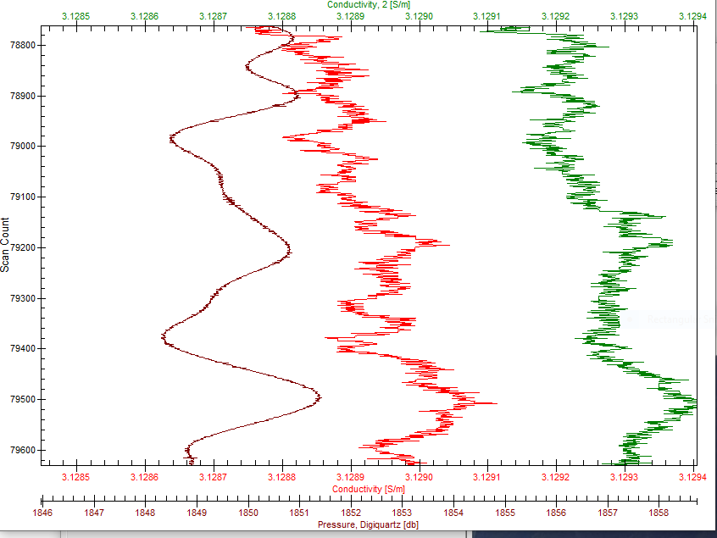

There were no outliers severe enough to justify adjusting quality flags.

The 2 CTD salinity channels differ by about 0.0044psu. There is a little pressure dependence in the differences which is explained by the fits against pressure having opposite signs.

During this cruise there was a longer stop before firing Niskins in the top 150m to see if this would allow for better equilibration of Niskin contents to ambient values. There is a fairly flat fit through the top 150db when the cases with noisy CTD data are excluded, but that may be because that criterion eliminates cases where errors due to poor flushing would be expected to be largest. Nonetheless, it is unusual to see so many outliers with salinity from CTD higher than that from bottles. Poor flushing has the opposite effect unless there is a salinity inversion nearby. There were only 2 casts with salinity sampling between 10 and 150m.

Looking at the size and sign of differences may offer some evidence of whether longer waits are useful in reducing this type of error.

* 5m samples – Most differences at 5m fall close to the general fit . Cases further off suggest the samples represent conditions at 12m, 16m, 9m. One case had the bottle value lower than the CTD. The CTD had risen above the target depth and then dropped, so the sample likely represents conditions slightly higher. These differences are lower than normally seen with 30s waits, so are encouraging.
* Cast #120 – This cast had sampling at many depths. Differences from bottles varied but examination of the full profile showed bottle values found within a few metres of the bottle stop. That is an excellent result. This is likely partly due to the CTD bouncing around, thus flushing well, but the longer wait would enhance that effect.

The evidence suggests that the longer waits helped, but there were no salinity samples from between 5m and 150m in protected waters. That would be the area likely to be most affected by poor flushing. The deep sample from cast #258 shows that flushing is an issue; that bottle was fired at the bottom of the cast, not the best choice for calibration purposes, and showed evidence of water having come from well above the firing level.

For full details for the COMPARE run see file 2021-012-sal-comp1.xls.

Dissolved Oxygen

COMPARE was run with pressure as the reference channel.

The sampling procedure was different from usual in that waits for 60s before most bottles between 150m and the surface.

When outliers were removed based on residuals the fit was:

CTD DO Corrected = CTD DO * 1.0465 + 0.0012 R2 = 0.98

This is similar to the fit for 2021-008:

CTD DO Corrected = CTD DO * 1.0445 + 0.0004 R2 = 0.95

To judge the effectiveness of the longer wait before closing Niskin bottles, the points excluded in the comparison were examined. In at least one third of the cases, there was a high standard deviation in the CTD data, so we can’t distinguish whether the bottles reflect local conditions or not. There may have been great variability. The largest outlier that was not associated with noisy CTD DO data had a bottle value that matched conditions just as the bottle stopped; the local gradient was large and the bottle value was found only 20cm above the CTD, so within the Niskin bottle depth.

The dissolved oxygen data proved more useful in assessing the longer waits and does suggest a small improvement from the longer waits, especially in the quieter, protected waters.

For full details for the COMPARE run see file 2021-012-dox-comp1.xls.

Fluorescence

COMPARE was run with extracted chlorophyll and CTD Fluorescence using pressure as the reference variable. 23% of samples had chlorophyll values <0.5ug/L and 16% were >4ug/L

Where CHL was low, CTD fluorescence was higher by up to a factor of 4.7. The ratio was highest for Haro Strait and the Juan de Fuca Strait where CHL was very low. The ratio drops rapidly and ranges from 0.15 to 0.5 for CHL>3ug/L. This pattern is typical of these sensors, though the ratios are lower than usual for both high and low CHL.

For full details for the COMPARE run see file 2021-012-fl-chl-comp1.xls.

##### Conversion of Full Files from Raw Data

File 2021-012-ctd.xmlcon was used to convert all files.

The Tau function and the hysteresis function were selected since there was deep sampling. Depth was included in the conversion.

A few casts were examined and all expected channels are present and no problems were noted. The transmissivity channels had similar shape. The altimetry looked good.

##### WILDEDIT

Program WILDEDIT was run to remove spikes from the pressure, depth, conductivity & temperature only in the full cast files (*.CNV).

Parameters used were: Pass 1 Std Dev = 2 Pass 2 Std Dev = 5 Points per block = 50

The parameter “Keep data within this distance of the mean” was set to 0 so all spikes would be removed.

##### ALIGN DO

A few casts were examined; both temperature channels were noisy during upcasts so the tests were not easy to interpret, but using +2.5s certainly improves the alignment and overall looks like a good choice for both sensors.

ALIGNCTD was run on all casts using +2.5s.

##### CELLTM

The noise in the upcast data makes tests for the best parameters for this routine very difficult to interpret. In the past when upcast data were not so noisy, the default setting of (α = 0.0245, β=9.5) was generally found to be the best choice. A few casts were checked for this cruise and the default setting does improve the data. CELLTM was run using (α = 0.0245, β=9.5) for both the primary and secondary conductivity.

##### DERIVE and Channel Comparisons

Program DERIVE was run on all casts to calculate primary and secondary salinity and dissolved oxygen concentration.

DERIVE was run a second time on 4 of the deeper casts to find the differences between the pairs of temperature, conductivity and salinity channels.

The differences were full of spikes, likely due to slight sensor misalignment.

The conductivity differences were all small with no significant time or pressure dependence.

Temperature differences are similar to previous cruises when depths are matched.

Salinity differences are a little lower than seen in the previous cruises with a little pressure dependence but no obvious time dependence. The salinity differences during stops as seen in the COMPARE step are similar to those in the downcast differences.

|  |  |  |  |  |  |
| --- | --- | --- | --- | --- | --- |
| Cast # | Press | T1-T0 | C1-C0 | S1-S0 | Descent Rate |
| 2021-020-0037 | 320 | -0.0002 | ~ | +0.0002 | High, F.Steady |
| 2021-020-0082 | 350 | +0.0001 | +0.00017 | +0.0015 |  |
| 2021-020-0117 | 375 | +0.0004 | +0.00022 | +0.0021 | High, Noisy |
| 2021-006-0020 | 375 | +0.0004 | +0.00044 | +0.0043 | High, Noisy |
|  | 1200 | +0.0002 | +0.00042 | +0.0050 | “ |
| 2021-006-0039 | 1200 | 0 | +0.00042 | +0.0049 | High, XNoisy |
| “ | 2000 | -0.0002 | +0.00044 | +0.0055 | “ |
| “ | 3000 | -0.0003 | +0.00044 | +0.0057 | “ |
| 2021-006-0052 | 1200 | 0 | +0.00043 | +0.0057 | High, XNoisy |
| “ | 2000 | -0.0005 | +0.00042 | +0.0056 | “ |
| “ | 3000 | -0.0005 | +0.00044 | +0.0060 | “ |
| 2021-006-0077 | 1200 | -0.0005 | +0.00042 | +0.0059 | High XNoisy |
|  | 2000 | -0.0007 | +0.00044 | +0.0063 | “ |
|  | 3000 | -0.0006 | +0.00045 | +0.0062 | “ |
| 2021-005-0099 | 1000 | -0.0002 | +0.00050 | +0.0058 | High, Noisy |
|  | 1900 | -0.0004 | +0.00050 | +0.0064 | High, V. Noisy |
| 2021-005-0140 | 1000 | -0.0002 | +0.00055 | +0.0065 | High, Noisy |
|  | 1900 | -0.0005 | +0.00055 | +0.0072 | F. High, NOisy |
| 2021-069-0009 | 500 | +0.0002 | +0.00040 | +0.0044 | High, Noisy |
|  | 900 | -0.0001 | +0.00040 | +0.0048 | “ |
|  | 1850 | -0.0004 | +0.00041 | +0.0054 | “ |
| 2021-008-0028 | 1000 | 0 | +0.00060 | +0.0072 | High, V Noisy |
|  | 2000 | -0.0002 | +0.00060 | +0.0076 | “ |
| 2021-008-0046 | 1000 | 0 | +0.00051 | +0.0060 | High, Noisy |
|  | 2000 | -0.0004 | +.000051 | +0.0067 | “ |
|  | 3000 | -0.0005 | +0.00053 | +0.0069 | “ |
| 2021-008-0063 | 1000 | -0.0004 | +0.00046 | +0.0059 | High, Moderate |
|  | 2000 | -0.0006 | +0.00048 | +0.0063 | “ |
|  | 3000 | -0.0007 | +0.00049 | +0.0068 | “ |
| 2021-008-0077 | 1000 | -0.0003 | +0.00043 | +0.0055 | High, Noisy |
|  | 2000 | -0.0007 | +0.00043 | +0.0060 | “ |
|  | 3000 | -0.0008 | +0.00045 | +0.0063 | “ |
|  | 4000 | -0.0009 | +0.00047 | +0.0065 | “ |
| 2021-012-0046 | 1000 | -0.0004 | +0.00035 | +0.0044 | High, Moderate |
|  | 1800 | -0.0003 | +0.00035 | +0.0048 | “ |
| 2021-012-0066 | 1000 | -0.0003 | +0.00035 | +0.0046 | High, Noisy |
|  | 1900 | -0.0005 | +0.00035 | +0.0050 | “ |
| 2021-012-0127 | 1000 | -0.0003 | +0.00033 | +0.0042 | High, Moderate |
|  | 2000 | -0.0006 | +0.00034 | +0.0048 | “ |
| 2021-012-0156 | 1000 | -0.0004 | +0.00032 | +0.0042 | High, V.Noisy |
|  | 2000 | -0.0007 | +0.00032 | +0.0047 | “ |

##### Conversion to IOS Header Format

The IOSSHELL routine was used to convert SEA-Bird 911+ CNV files to IOS Headers.

CLEAN was run to add event numbers and to replace pad values in the pressure channel with interpolated values based on record number.

##### Checking Headers

* The cross-reference check and header check were run. A few station names were changed to keep formats consistent with other casts in the same line. No other problems were found.
* Surface check was run and the average surface value was 3.3db. This is a little high and during 2021-069 it was found that pressure was high by ~0.8db. A correction will be applied later to subtract 0.8db, so the average will be +2.5db.
* Cruise tracks were plotted and added to the end of this report.
* The altimeter and water depth readings from the headers of the CLN files were exported to a spreadsheet. A check value was calculated by subtracting water depth from maximum depth sampled plus altimetry header) The value was reduced by 2 to allow for the fact that depths are believed to be too high by 0.8db and that altimetry is averaged over the bottom 2m so are likely too high by an average of 1m. 15 casts where that number was > 5 or <-5 plots were investigated. Of those there were 6 for which the log water depth entry produced better results; in some of those cases it was clear the log entry had been changed – a likely update. For the remainder there was no sign of error in the altimetry entries. Most likely the depth was recorded before the beginning of the cast and possibly before the ship had fully stopped and/or there was significant variability in the bottom depths.
* The water depth entry was changed after the DELETE stage to match the log entry in 6 DEL files: 44, 110, 115, 156, 157, 263. The correction was also applied to 3 affected SAMAVG files and the final MERGE step was repeated.

##### Shift

Dissolved Oxygen

The Dissolved Oxygen voltage channel was aligned earlier. A few casts were checked to see if the alignment looked ok, and it did. No further alignment is needed for the DO concentration channel.

Conductivity

Tests were run on a few casts to assess what settings are best to align conductivity with temperature (as judged by the effect on salinity as seen in T-S space). The settings chosen for 2021-008 were -0.6 records for the primary conductivity and -0.9 records for the secondary; those did not look as good for this cruise.

SHIFT was run twice on all SBE911 casts using -0.5 records for the primary and -1.1 for the secondary. Salinity was recalculated for both channels.

Fluorescence

SHIFT was run on the SeaPoint fluorescence channel in all casts using the usual advance of +24 records. Plots show that the fluorescence offset is reasonably close to the temperature offset after this step.

##### DELETE

The following DELETE parameters were used:

Surface Record Removal: Last Press Min

Maximum Surface Pressure (relative): 10.00

Surface Pressure Tolerance: 1.0 Pressure filtered over 15 points

Swells deleted. Warning message if pressure difference of 2.00

Drop rates < 0.30m/s (calculated over 11 points) will be deleted.

Drop rate applies in the range: 10db to 10db less than the maximum pressure

Sample interval = 0.042 seconds. (taken from header)

COMMENTS ON WARNINGS: There were no warnings.

##### Other Comparisons

Experience with these sensors since last factory service –

The pressure, temperature, and conductivity sensors were used during 5 cruises since the last factory visit:

* 2021-020 – The salinity channels started out close and gradually drifted apart. Based on information from the Line P section of cruise 2021-006 it appeared that the primary salinity did not drift much during this cruise. The drift in secondary salinity appears to have been fairly sudden and then settled down. Dissolved oxygen was recalibrated using slope/offset =1.0515/-0.0131 based on cruise 2021-006. This correction seemed high since it was first use since previous factory calibration. Pressure looked ok. No TSG.
* 2021-006 Dissolved oxygen recal slope/offset = O 1.0515/-0.0131; Primary very close to bottles selected for archive; secondary high by 0.006psu.
* 2021-005 Dissolved oxygen recal slope/offset = 1.0536/-0.0018; Primary sal high by about 0 to 0.001psu, selected for archive; secondary high by 0.005 to 0.006psu. TSG salinity low by 0.191; intake temp high by 0.02C degrees – no recal applied.
* 2021-069 Poor info for recal of DO and SAL. Used 2021-005 correction for dissolved oxygen and salinity. Primary T/S selected for archive. Pressure corrected by adding 0.8db.
* 2021-008 Salinity channels lower than bottles by 0.012psu and 0.0055psu. Estimate of errors in bottles ~0.005psu, so estimate primary low by 0.007 and secondary low by 0.0005psu. Secondary was selected for archive and was not recalibrated.

Historic ranges – Profile plots were made with 3-standard deviation climatology ranges of T and S superimposed. For Rivers Inlet there was no climatology available. There were 2 casts with low salinity in the top 10m in the Strait of Georgia. The only significant salinity excursion was at Station 46; it has been noted before that this site fits into the Gulf Islands climatology better than the Southern Strait of Georgia, as it is in an area with a very large range of possible salinity values. It looks more like Haro Strait than the Strait of Georgia. Temperature was within the climatology except for the top 15m at LB13 where it was above the maximum.

Post-Cruise Calibration – None available.

Repeat Casts – There were no repeat casts.

##### DETAILED EDITING

In the course of plotting data for the climatology it became obvious that there is a lot of noise in the primary salinity and some in the primary temperature. During 2021-008 problems were also noted in the primary channels. So the secondary were chosen for editing and eventual archiving.

All DEL files were copied to *.EDT.

CTDEDIT was used to remove records that appear to be corrupted by shed wakes. Salinity was cleaned to remove spikes that appear to be due to small misalignment or instrumental noise. All files required some editing. Notes about editing applied were added to the files.

After editing, T-S plots were examined for all casts. No further editing was found necessary.

Event #51 at station END1 had an unstable layer near the bottom, from about 2100m to the maximum depth sampled, 2150m. The bottom depth was about 2200m. The descent rate of the CTD was low and there were many complete reversals of direction that explain much of the noise in the salinity profile. However, the near-bottom temperature values are so high that they cannot be explained as being due to shed wakes; values that high are only seen above 1750m. The temperatures fall well above the available climatology but the data used for the climatology probably did not include sampling from this particular area. A return to the same site later in the cruise did not have such a feature, but there was no sampling below 2075m. There was some sampling below 2100m at other sites in the END line including a return visit to END1 (called END1b), but no unusual temperature profiles were found in those and none sampled as close to the bottom as was seen at END1. Transmissivity profiles show a slight decrease. Since the temperature variability is likely real, no attempt was made to edit data in this layer. Dissolved oxygen does not look out of line. The chief scientist believes this is likely due to being over a hydrothermal hot vent. Similar observations have been made by others in this region.

##### Corrections to Pressure, Salinity and Dissolved Oxygen Concentration

Pressure was found to be high by 0.8db during 2021-069 when many surface values were available.

All 2021 cruises were affected by delayed analysis of salinity samples and incomplete flushing of bottles, but the estimated errors in bottle comparisons due to those effects vary from cruise to cruise. Results from 3 spring cruises using this equipment suggest that the secondary salinity was high by 0.005 to 0.006psu after probable errors were considered. Cruise 2012-069 lacked reliable information to estimate calibration but suggested the secondary was high by about 0.004 to 0.005psu. The most recent cruise (2021-008) suggested a large shift in the calibration of both salinity channels, with the secondary being lower than bottles by <0.001psu after applying an estimated correction. For this cruise the secondary looks high by about 0.002psu. The differences between temperature, conductivity and salinity channels was different for this cruise compared to 2021-008 and there is some hint of drift in the temperature differences through this cruise. The difference between salinity channels is smaller than in previous cruises.

As there were clear problems with the primary channels it is likely that the changes seen in differences are due to the primary. So we might expect similar results from this cruise as from 2012-008. The results from both cruises suggest that the secondary salinity is within 0.002psu. Small errors in analysis and noise in CTD records plus likely differences in evaporation and flushing errors, this is a small difference. There is insufficient evidence to justify recalibration of salinity. The standard deviation in the fits of CTD against bottles is 0.002psu and the error estimate used is rough.

File 2021-012-recal.ccf was prepared to subtract 0.8db from the pressure and to apply the following correction to channel Oxygen:Dissolved:

CTD DO Corrected = CTD DO * 1.0465 + 0.0012

This correction was first applied to the SAM and MRGCLN2 files.

COMPARE was rerun for dissolved oxygen and shows that the correction was applied properly. When data are excluded based on using the same points as in the original fit the average is 0.0025mL/L, with a standard deviation of 0.022mL/L. See file 2021-012-DO-comp2.xls for details.

CALIBRATE was then run on the EDT files using the same recalibration file.

##### Final Calibration of DO

The initial recalibration of dissolved oxygen corrects for sensor calibration drift. Alignctd corrects for transit time errors. Those 2 steps may partly correct for response time errors, but to see if a further correction is needed, a comparison is made of downcast CTD data to bottle data from the same pressure. Small differences are expected due to ship drift, temporal changes, incomplete flushing of Niskin bottles and delayed response and noise in CTD data.

Downcast files were bin-averaged to 0.5m bins for the casts with DO bottle samples. Those files were then thinned and compared to the bottle values in the MRG files. COMPARE was run to study the differences between the downcast CTD DO data and the titrated samples from upcast bottles.

When outliers were excluded based on standard deviation in the CTD data, the CTD DO was higher than the titrated samples by an average of ~0.02mL/L (standard deviation 0.10mL/L). The recalibration is obviously effective.

To see if it was useful to wait longer before firing bottles above 150m, a comparison was made between this cruise and 2019-023 which occupied the same areas in September 2019. Many of these differences have high standard deviations in the CTD data due to large gradients (especially in 2021) and some may have only 1 CTD record in the required depth range, so the comparisons are naturally noisy and not simple to interpret. The effect of incomplete flushing is to make the CTD appear to be reading higher than bottles than it really is. This is clearly the case in the 2019 data above 200m. The 2021 data is particularly noisy but nonetheless shows a more even distribution around 0 differences. This is not clear early in the cruise, perhaps because the near-surface gradients were not as large. The same criterion was used to rejecting outliers for both data sets. The improvement is most obvious between 100 and 150db and later in the cruise.

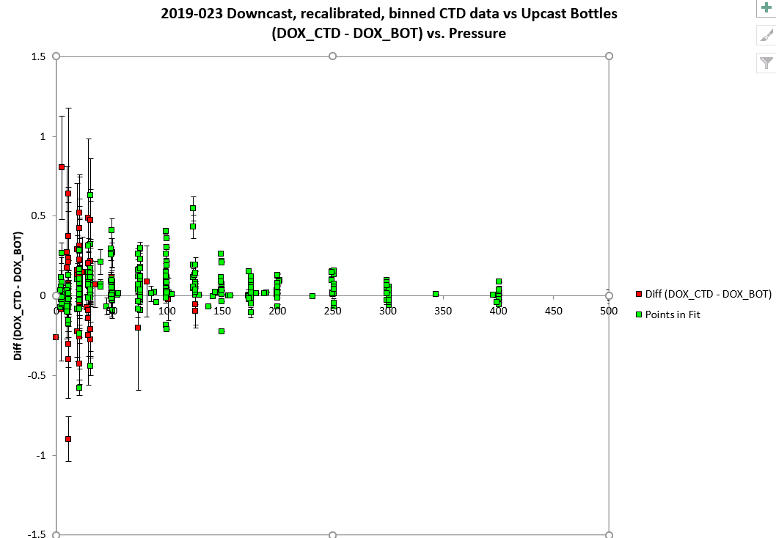

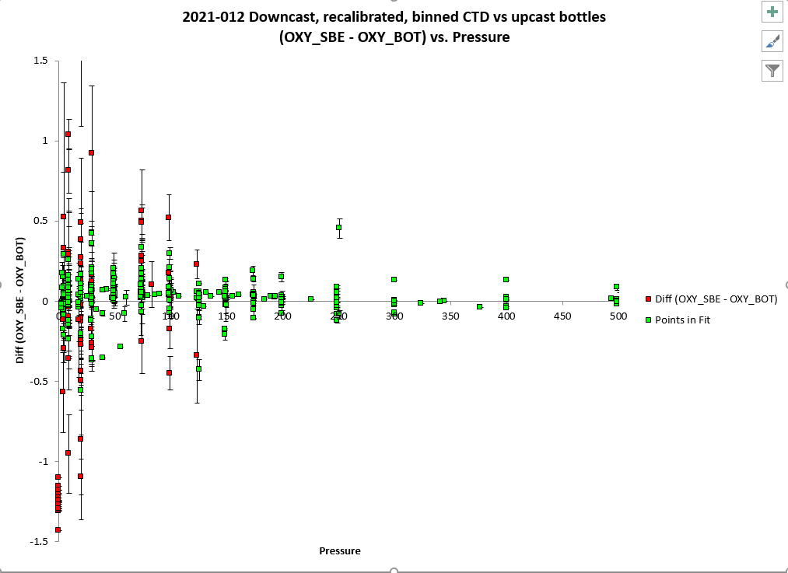

This comparison does not constitute proof but does suggest that the longer wait is effective.

Downcast (CTD files) Oxygen:Dissolved:SBE data for this cruise are considered, very roughly, to be:

±0.40 mL/L from 0-200db except in areas of very large DO gradients

±0.15 mL/L from 200db-500db

±0.04 mL/L below 500db

For more detail see file 2021-012-dox-comp3.xls.

##### Fluorescence Processing

A median filter, size 11, was applied to the fluorescence channel in the COR1 files. Plots of a few casts showed that the filter was effective. (Output:*.FIL)

##### BIN AVERAGE of CTD files

The following Bin Average values were applied to the FIL files (output AVG):

Bin channel = pressure Averaging interval = 1.000 Minimum bin value = .000

Average value will be used. Interpolated values are NOT used for empty bins.

On-screen T-S plots were examined.

Profile plots were examined. No problems were noted.

##### Final CTD File Steps (REMOVE and HEADEDIT)

For all casts REMOVE was run to remove the following channels:

Scan_Number, Temperature:Primary, Conductivity:Primary, Oxygen:Voltage:SBE, Descent_Rate, Status:Pump, Altimeter, Salinity:T0:C0 and Flag.

A second SBE DO channel (with umol/kg units) was added.

REORDER was run to get the two DO channels together.

HEADER EDIT was used to fix formats and channel names and to add the comments about processing.

The Standards Check routine was run and no problems were found.

The Header Check was run; no problems were found.

Profile and T-S plots were examined. No problems were found.

The sensor history was updated.

##### Dissolved Oxygen Study

As a final check of dissolved oxygen data, % saturation was calculated and plotted. Values at 2 to 3m ranged between ~55% to 175%. The lowest values were from Haro Strait, Juan de Fuca Strait and Rivers Inlet. The highest were found near-shore on the west coast of Vancouver Island where near-surface gradients were high. For the Endeavour casts well offshore values were tight at about 102% which is typical for that area. There is no evidence of a problem with the DO calibration.

##### Final Bottle Files

SORT was run to arrange casts in pressure order.

Scan_Number, Temperature:Primary, Conductivity:Primary, Oxygen:Voltage:SBE, Descent_Rate, Status:Pump, Altimeter, Salinity:T0:C0 and Flag.

A second SBE DO channel with mass units was added for both the CTD DO and titrated DO and

REORDER was run to get the pairs of DO channels together.

EDIT HEADERS was run to fix formats and channel names and to add comments about analyses and CTD processing.

Data were exported from the CHE files to file 2021-012-bottles-final.xlsx. The entries were compared with the rosette log sheets. A few problems were found:

* File 97 had a record for a bottle that had no samples taken from it so that record was removed and the header record 3 entry was adjusted.
* 2 salinity samples were indicated on the rosette sheet for event 131 but no samples were found in the raw salinity data for this event, so it is assumed that there was a change in plan. Since there is no bottle salinity channel in the file, no flag or comment was added.
* The NH4 entry for sample 500 was mistakenly entered as 156, so was missed in the merge process. The file for event 160 was corrected to include that sample.
* The NH4 entry for sample 501 was -0.07 but is 0 in the QF file. This was supposed to have been corrected earlier but crept back in. The CHE file was corrected.

Standards check and a header check were run. No problems were found.

The track plot looks ok.

Plots of each file were examined and no problems were found.

A cross-reference listing and header check were produced for the CHE files.

##### Thermosalinograph Data

An IOS TSG45 was used for this cruise and data were saved in 17 files. There was no flow during the first file so it will not be processed.

The IOS SBE TSG45 files were opened in EXCEL.

The files have extensions RAW but are in csv format, so the files were opened in EXCEL and combined in a single CSV file. (In opening use DELIMITED, deselect TAB, select COMMA and OTHER (*).

It is necessary to choose TEXT for the time on the 2nd page of the text import wizard.)

The spreadsheets were opened separately. For the first file, 2 header lines were added for channel names and units. Data from the other files were added to the first file. The breaks between files were generally very short, but on Sept. 12 there was an 8-minute break. There was a long break between Sept. 19 and Sept.20 but the break is not within a single file.

Adjustments were then made to the full file as follows:

* A column with pressure was added with all values set to 4.5 (to enable derivation of salinity).
* A temperature difference column was added (Lab-Intake).
* The fluorescence channel is in volts. It was moved to column M. Then a concentration value was calculated in column F using scale 14.6 as determined in the most recent factory recalibration of the fluorometer. No clean water offset value was available. During 2021-006 the offset was chosen as 0.065ug/Land that value was also found appropriate for 2021-008. That value was applied to these data as well. (See below for checks made to see if this was a good choice.)
* A file break column was filled with the cruise #-data/time info from the original file name; this will be updated later.
* The TSG was running for a while at the dock with flow off at the beginning and end of the cruise. Data were removed from those sections.
* Time and Date formats are a problem – when converting from RAW choose TEXT but once opened in EXCEL set Time Format to HH:MM:SS and save the file again.
* The file break column was completed so that new files would be created at the beginning of each day by assigned file names like 20210910-000000 except for the files from September 8 and 10 which start at times later than 000000.

At this point a quick comparison was made between the fluorescence values and CHL and the fluorometer from the CTD. The pattern is typical in that the TSG fluorometer reads higher than CHL for CHL<1ug/L, is close to CHL in the range 1 to 3ug/L and much lower for CHL>4ug/L. The TSG is closer to CHL than the CTD fluorometer but at very low CHL it reads higher than the CTD – both are high relative to CHL Given the depths of CHL sampling will not match the TSG intake depth exactly some difference is expected and at low CHL small errors can lead to large errors in ratios. A few tests were run to see if increasing the clean water offset for the fluorometer would lead to significant improvement in the correspondence with CHL; at low CHL the results are slightly better but they are worse at high CHL.

The file was then converted to IOS Header format with header info added. There are 14 IOS files, one for each day.

CLEAN was run to reset the number of records, min and max values, set the start and end times, and latitude and longitude limits.

ADD TIME CHANNEL was used to add Julian dates – i.e. Decimal Year. A record number was also added to enable averaging (for use in comparison to CTD files). Time zero was set to 31 December 2020 0:00:00. (Note that this step leads to problems plotting until REORDER is run.)

DERIVED QUANTITIES was run twice, first to derive salinity using the lab temperature and again to derive sigma-T.

REORDER was run to move the Julian date to after the Time/Date channels and to put salinity and fluorescence after the lab temperature. Also the record # was moved to the end.

a.) Plots

A track plot was added to the end of this report. There is a gap on Sept. 19/20 as mentioned above.

Time-series plots were produced.

* The salinity traces have a few large spikes on Sept 11 and 12 (Endeavour section), but those can be easily removed using CTDEDIT. Otherwise the traces look good.
* Flow was off between 1:36 and 12:57 on September 13th. Most TSG channels should be padded for that section until values equilibrate, but the positions and time can be left in place and the intake temperature might be ok. (Later in processing checks were made against CTD readings. Differences from CTD temperature were +.095, +0.065, -0.003, 0.002C° which are in line with other values differences found for other casts.) Padding of fluorescence, salinity and temperature data is most easily done in the CSV file, so a return was made to that stage and steps repeated up to REORDER. Even after flow started there was some instability so records were removed up to 13:02; since the ship was stopped there is no loss of useful data.
* There was a brief stop in flow near the end of the final file, but after it started again the flow rate was very noisy, salinity dropped suddenly, the intake temperature rose in what looks like an unnatural way and the lab temperature dropped. The data from this section will be removed; the ship was stopped during this time, so there is no point in saving the time and position data.
* The flow dropped to about 0.5L/min between ~1920 on the 18th and 0200 on the 19th. The difference between intake and lab temperature varies greatly during that period, but there is no obvious effect seen at the times that the flow rate changed suddenly. The intake temperature compares quite well with the CTD temperature at 4db for the one CTD cast that occurred during that period.
* The loop flow rates were both generally very steady at ~1L/minute with the exception of the cases mentioned above.

b.) Checking Time Channel

The CTD files were thinned to reduce the files to a single point from the downcast at or within 0.5db of 4.5db. These were exported to a spreadsheet which was saved as 2021-012-tsg-ctd-loop-rosette-comp.xlsx. The first CTD cast did not overlap with TSG data with flow turned on and there were some casts that overlapped with periods with no flow in the loop, so there are 97 points of comparison.

The TSG files were averaged over 1 minute to reduce the noise and file size. Standard deviations were included. Then required records (times, positions, temperatures with standard dev, salinity with standard dev, fluorescence with standard dev, flow rate) were exported to a spreadsheet and that file was thinned to the closest times of CTDs and added to file 2021-012-ctd-tsg-loop-rosette-comp.xlsx.. The same file was thinned to the closest times to loop files and added to the TSG-Loop comparison.

Comparisons were made of positions to check for good matches. The differences in positions are expected to be small despite the averaging because the ship was stopped at these times. The average differences were 0.000º for both latitude and longitude. There were a few differences > 0.0015º in longitude. In both cases there was a significant difference between the NMEA download and the beginning of data acquisition, so the CTD positions are less reliable. The times in the CTD files come from the System Upload time which is used in conversion of the CTD files, but positions are only available from the NMEA download which in a few cases was 10 minutes earlier.

c.) Comparisons

* Comparison of T, S and Fluorescence from TSG and CTD data

The initial comparison between TSG and CTD data using all casts was divided into 3 parts. First, all casts were included and standard deviations were very high. Then the data used were limited to the 20 casts with the lowest standard deviation in the relevant variable. The standard deviations came down markedly except for fluorescence. Finally the comparison was reduced to the casts taken well offshore on the Endeavour Line. Those casts were well mixed at the surface, so matching depths of CTD and TSG is less critical.

|  |  |  |  |  |  |
| --- | --- | --- | --- | --- | --- |
|  |  |  | Temp  (TSG Intake-CTD) | SAL  (TSG-CTD) | Fluor  (TSG/CTD) |
| All casts |  | median | 0.0361 | -0.3304 | 1.37 |
|  |  | stdev | 0.1798 | 0.7470 | 0.37 |
| 20 Low Std Dev | | median | 0.0095 | -0.3293 | 1.66 |
|  |  | stdev | 0.0210 | 0.1670 | 0.36 |
| Endeavour | | median | 0.0022 | -0.3290 | 1.93 |
|  |  | stdev | 0.0075 | 0.0119 | 0.05 |

The salinity differences show little variation among the 3 groups and are all close to results from cruise 2021-008. The TSG salinity is always lower than that from the CTD which is likely due principally to small bubbles in the loop. Calibration drift is likely to have a smaller effect.

The temperature differences for the 20 “best” casts and from Endeavour look excellent . We always see the intake temperature higher than the CTD which seems likely to be due to slight heating from the ship. The fluorescence ratio is highest for Endeavour since CHL is very low there.

Heating in the loop increases as temperature decreases, as expected. There are a few cases where temperature in the lab was lower than the intake temperature. One case was investigated and found to be due to a rapid temperature rise, so that the time delay in the loop is significant. Picking off a value from the intake temperature and adding the expected heating in the loop we find lab temperatures reaching that amount about 10 minutes later. Both data sets in the comparison were averaged over 1 minute and lab temperature is always smoother than intake temperature, but it does give a rough idea of how long it takes for water to reach the lab when the flow rate is 1L/minute.

The fluorescence ratio is highly variable and varies with chlorophyll level. At Endeavour the chlorophyll level is quite low at about 0.2ug/L; with little variability the errors due to mismatch in depths are likely very small leading to a small standard deviation. The TSG fluorescence does read higher than that from the CTD for the most part, but is lower for the highest readings and higher for the low values which dominate the record.

* Comparisons of Loop samples and TSG data

There were 8 loop salinity and chlorophyll samples, all of which were taken while underway. For 1 of the samples the flow was off in the TSG system.

The TSG salinity was lower than the Loop Salinity by a median of 0.333psu.

The TSG fluorescence was higher than the Loop CHL by a factor of from 1.5 to 3.7 when CHL was <1.5ug/L. For higher CHL the TSG fluorescence was about 50% of CHL. This is a typical relationship between CHL and fluorescence.

* Comparison of 5m Rosette samples and Loop samples

All loop samples were taken while the ship was underway so there are no rosette samples for comparison.

d.) Calibration History

* The TSG and fluorometer were recalibrated shortly before cruise 2021-001.
* During 2021-001 the TSG salinity was found to be lower than CTD salinity by a median of 0.178psu, and lower than loops by 0.181psu with no significant difference between underway and stopped samples. There was no evidence of drift through the cast. The TSG intake temperature was higher than the CTD temperature by ~0.02C° offshore but if only casts with a low standard deviation in the intake temperature are included it is high by a median of 0.009C°. No recalibration was applied as the differences were reasonably small given some differences in depth and time between the 2 data sets. The TSG fluorescence values were about 32% of fluorescence from the CTD and 74% of the loop CHL samples. Loop and rosette salinity samples compared very well, while the loop chlorophyll was about 75% of that from the rosette.
* During 2021-006 the TSG salinity was recalibrated by adding 0.183psu. TSG temperature were higher than those from co-incident CTDs by about 0.01 C°. The TSG fluorescence values were about 50% higher than those from the CTD and higher than loop CHL samples by 50 to 300%. For the cases where the CHL was in the range 0.49 to 5.0ug/L, the TSG fluorescence was higher than loop samples by 8%, but the loop chlorophyll values were lower than rosette samples.
* During 2021-005 the TSG salinity was recalibrated by adding 0.191psu. TSG temperature were higher than those from co-incident CTDs by about 0.02 C°. The TSG fluorescence values were close to those from the CTD and higher than rosette CHL samples for low CHL and about 50% of CHL when CHL>4ug/L. There were too few loop samples to conclude much but the comparisons do not suggest a problem.
* During 2021-069 salinity was low by varying amounts according to regions; it was recalibrated by adding 0.30psu but values are likely too low in the inlets. The TSG fluorescence values were reasonably close to those from the CTD fluorometer and about 50% of rosette CHL samples when CHL>4ug/L.
* During 2021-008 salinity was low by 0.346psu and temperature was higher than the CTD temperature by about 0.006C°. For the cases where the CHL was <0.5ug/L, the TSG fluorescence was higher than loop samples by a median factor of 3.5 but for the few values between 1 and 2ug/L the TSG fluorescence is close to the CHL values. Only salinity was recalibrated by adding 0.346psu.

e.) Conclusions re TSG

1. The TSG clock worked well and position information was available and reliable.

2. The flow rates were mostly steady at about 1L/minute with some exceptions with low or 0 values, including an 11-hour section with no flow and a 9-hour section with low flow. Lab temperature, salinity and fluorescence were padded for 0 flow but not the Intake Temperature. For the low-flow section the data looked reasonable so were left in place.

3. The TSG salinity was found to be lower than CTD salinity by a median of 0.330 using all casts and 0.0329psu from the Endeavour casts. Compared to loops it was low by 0.330psu. It is assumed that the low salinity is due to bubbles in the loop and/or calibration drift. The results are close to those found during 2012-008.

4. The TSG intake temperature was higher than the CTD temperature by about 0.01C using 20 casts with the lowest standard deviation in the temperature or 0.002C° using the well-mixed casts from the Endeavour stations. This is an excellent result. No recalibration is suggested.

5. The fit of TSG versus CTD fluorescence has a slope near 1, but the TSG instrument reads higher than the CTD fluorescence in the low chlorophyll areas that dominate the record. Where chlorophyll is high the CTD fluorometer gives higher values than the TSG fluorometer.

6. The TSG fluorescence was higher than the Loop CHL by a factor of from 1.5 to 3.7 when CHL was <1.5ug/L. For higher CHL the TSG fluorescence was about 50% of CHL. This is a typical relationship between CHL and fluorescence.

7. There were no loop samples during rosette casts, hence no checks on the quality of loop samples.

g.) Editing

Time-series plots were examined.

The following files had some salinity spikes removed: 11, 12

h.) Preparing Final Files

REMOVE was used to remove channel Pressure, Temperature:Difference , and record #.

i.) Calibrate

CALIBRATE was used to add 0.330psu to channel Salinity

HEADER EDIT was used to change the DATA DESCRIPTION to THERMOSALINOGRAPH and add the depth of sampling to the header and to change channel names to standard names and formats and to add comments.

A cross-reference list was prepared.

The TSG sensor history was updated.

As a final check plots were made of the cruise track and time-series and all looks fine.

P**articulars - Notes from Daily Science Log and Sampling Notes**

Deployment schemes:

CTD to surface, pumps on, down to 10m, 30s wait, up to surface, 30s wait, then cast began.

For most bottles below 150m there was a wait of 30 seconds before closing a bottle. Between 150 and the surface there was usually a 60s wait, with a few exceptions.

4. Wrong depth in header. (Fixed.)

11. Message “scan count error” kept popping up.

25. 2nd soak at 20m; temp diff poor after 1st soak.

39. Niskin 4 didn’t close; trip mechanism replaced after cast.

42. Bot. 18 fired in cast #4 didn’t trip.

46. 5 min. delay – LARS crane had no power at launch.

64. ROS file produced but no IOS sampling. Data provided to U.Vic. but not to be archived at IOS.

82. Went extra 10m down after 1st 30 sec soak, temp/sal diff high at first, 30s wait before firing >100, 1 min 0-100m.

86. Did second 10m soak because came out of water after 1st.

111, Pump not on. Stopped at 3330m, stayed in water for second attempt at LD08. Do not process.

112. 2nd cast at LD08.

120. 1 min wait for 0-150m bottles.

142. After cast problem found in tape wire wrap above termination covering in LARS. Possible top of termination exposed. Termination did not appear damaged. Repair done.

143-146 – problems with sounders, depth >2000m.

146. Alarm on CTD deck unit during upcast. Fired bottle #2 (out of order) to test.

164. Problems with sounder.

167. Problem with winch. File started but no archiving.

168. 2nd try at station LBP2.

197. Niskin 3 fired without 30s wait.

171. Few stops and starts and slow ascent as bosun adjusting LARS brake.

215, Started file at SS6 – no archiving due to termination problem.

216. Cast at SS6.

217. Sat at surface due to A-frame issue.

228. Fluorometer connections cleaned before cast.

273. Stop at 50m and 138m to correct wire angle.

**2021-012**

|  |  |  |  |  |  |  |  |  |  |  |
| --- | --- | --- | --- | --- | --- | --- | --- | --- | --- | --- |
| **CTD#** | **Make** | **Model** | | **Serial#** | | **Used with Rosette?** | | **CTD Calibration Sheet Competed?** | | |
| **1** | **SEABIRD** | **911+** | | **0443** | | **Yes** | | **Yes** | | |
| **Calibration Information - 0506** | | | | | | | | | | | |
| **Sensor** | | | | | **Pre-Cruise** | | | | **Post Cruise** | | |
| **Name** | | | **S/N** | | **Date** | | **Location** | | **Date** | **Location** | |
| **Temperature** | | | **4700** | | **12Dec2020** | | **Factory** | |  |  | |
| **Conductivity** | | | **3531** | | **06Jan2021** | | **Factory** | |  |  | |
| **Secondary Temp.** | | | **4888** | | **12Dec2020** | | **Factory** | |  |  | |
| **Secondary Cond.** | | | **4513** | | **18Dec2020** | | **Factory** | |  |  | |
| **Transmissometer** | | | **1185DR** | | **28Apr2021** | | **Factory** | |  |  | |
| **Transmissometer** | | | **1883DG** | | **28Apr2021** | | **Factory** | |  |  | |
| **SBE 43 DO sensor** | | | **3791** | | **22Dec2020** | | **Factory** | |  |  | |
| **PAR sensor** | | | **70613** | | **24Feb2021** | | **Factory** | |  |  | |
| **SeaPoint Fluor.** | | | **3950** | |  | |  | |  |  | |
| **Pressure Sensor** | | | **0443** | | **07Jan2021** | | **Factory** | |  |  | |
| **Valeport Altimeter** | | | **76341** | | **10Feb2021** | | **Factory** | |  |  | |

**CRUISE SUMMARY – CTD**

# TSG Make/Model/Serial#: SEABIRD/45/0620

|  |  |  |  |  |  |
| --- | --- | --- | --- | --- | --- |
| **Calibration Information** | | | | | |
| **Sensor** | | **Pre-Cruise** | | **Post Cruise** | |
| **Name** | **S/N** | **Date** | **Location** | **Date** | **Location** |
| **Temperature** | **0620** | **21Jan20** | **Factory** |  |  |
| **Conductivity** | **0620** | **21Jan20** | **Factory** |  |  |
| **Wetlabs WETStar Fluor.**  For depths deeper than, and including, 125 dbar, we would wait 30 seconds before closing a bottle. For depths shallower than, and including, 100 dbar, we would wait 60 seconds before closing a bottle. | **1656** | **12Mar2021** | **Factory** |  |  |

