REVISION NOTICE TABLE
DATE | DESCRIPTION OF REVISION
4 April 2023 | Added HPLC data. J.R.

PROCESSING NOTES
Cruise: 2021-004
Agency: IOS, Ocean Sciences Division, Sidney BC
Chief Scientist: Young K. Platform: Neocaligus
Location: Strait of Georgia Project: Strait of Georgia Zooplankton
Date: 11 February 2021 –15 February 2021

Processed by: Germaine Gatien
Date of Processing: 4 June 2021 – 8 June 2021
Number of original HEX files: 28
Number of CTD files: 28 Number of BOT files: 15

INSTRUMENT SUMMARY
A SeaBird Model SBE-25 CTD (s/n 0456) was used with temperature sensor #5130, conductivity sensor #3500, Wetlabs ECO Fluorometer #4185, dissolved oxygen sensor #3234 and pressure sensor 0573.

SUMMARY OF QUALITY AND CONCERNS
The log book was in good order with comments about problems encountered.
Header information was entered in the raw files in a format that enabled easy conversion into IOS Header format.

There were surface bottles fired at 15 sites; they were given separate event numbers from the CTD casts. At 5 of those sites there was also a Niskin mounted 2m or 1m above the CTD to collect near-bottom samples. In the BOT files all sample data are identified by the event number of the corresponding CTD cast.

Bottle samples were available for comparison with salinity and fluorescence. They suggest that the CTD salinity was reading a little high, but incomplete flushing of Niskin bottles may explain the differences seen so no recalibration was applied to CTD salinity. Pressure did not require recalibration and there was no calibration sampling available for SBE dissolved oxygen.

PROCESSING SUMMARY
1. Seasave - This step was completed at sea. The file names were in non-standard format.
The names were corrected after conversion to CNV format.

2. Preliminary Steps
The Daily Log and a spreadsheet of sampling done were obtained.
The cruise summary sheet was completed.

CTD Deployment method: Timer set to 2 minutes. CTD down to 10m for soak until 1m 30s mark, bought back to surface to sit until 2 minutes are up. Then full cast begins.
BOTTLES: Samples were drawn right after the cast, no more than 15minutes after the CTD was brought on deck. Bottles were deployed as follows:
1. For casts with bottom sampling a 1.7L Niskin bottle was mounted ~2m above the CTD except for casts 40 and 55 when it was ~1m above.
2. Surface sampling was done for each cast after the CTD was taken out of the water and turned off. A 5L Niskin bottle was attached to the wire, sent to the surface and triggered. A separate event number is given for the surface samples.

3. Conversion of Raw Data
The configuration file used at sea was correct. It was saved as 2021-004-ctd.xmlcon and used to convert all HEX files.
One hex file was converted as being from event #14 (Station BS-11) but should be #13. It was renamed.
An initial conversion showed that surface pressures look good with conductivity falling to ~0 when pressure is between -0.1db and +0.2db. The deep fluorescence values are about 0.05ug/L with some spikes to negative values near the bottom. All expected variables are present.
Plots show that the channels all produced reasonable values.
There is the usual steppy pressure which leads to unusual profiles.

4. WILDEDIT
The only spikes noted in the data occurred at the beginning or end of the casts or included many points, and will be removed in the normal course of editing. So WILDEDIT was not run.

5. FILTER
Normally pressure is filtered later in processing when running DELETE, but the poor resolution of this instrument means it is necessary to do this early to make sense of the other data which update more often than pressure. So program FILTER was used to apply a low-pass filter with a time constant of 0.5 seconds to pressure. The results were excellent.
Next the temperature and conductivity were examined and the usual approach of applying a cosine filter size 5 in routine WFILTER did a good job of removing small reversals.

6. ALIGNCTD
Based on tests run for other cruises in this project using the same DO sensor, ALIGNCTD was run on all casts to advance the DO channel by 2.5s. Plots were examined after this step and the results look excellent.

7. CELLTM
CELLTM was run on all casts using the SeaBird recommended parameters, (α, 1/β) = (0.04, 8).

8. DERIVE
Program DERIVE was run to calculate salinity and dissolved oxygen concentration (tau correction included). Plots were examined and confirmed that steps 5, 6 and 7 had improved the data.

9. Conversion to IOS Headers
The IOSSHELL routine was used to convert the CNV files to IOS Headers.
CLEAN was run to add event numbers and replace pad values in the pressure channel with interpolated values. Fluorescence values <0 were replaced with pad values; while most were in the soak period, some were spikes in deep water.
Plots were made to find the minimum pressure from the ends of casts and they varied from -0.2db to +0.2db, with most close to 0.

The next step is to remove the data collected during soaks at 10m. A list was made of event numbers and the number of records that need to be removed based on plots of pressure versus scan #. CLIP was run using that list and plots were again examined to ensure the best choice was made.

10. Checking Headers
A cross-reference list was produced and compared with the log book entries. There were positions missing for 2 casts due to missing hemisphere entries in the SeaBird headers. That was corrected in the SeaBird header and all steps in section 9 were repeated.
Track plots looked ok so were added to the end of this report.

HEADER CHECK was run. No problems were found.
The pressure sensor has a 2800db range so the resolution is only 0.5db and accuracy is ±2.6db so even with surface data it is difficult to assess. The surface check shows an average of 0.5db before CLIP was run. The range was from -0.1 to +1.4db.

Plots of temperature and salinity for 3 casts showed large differences between upcast and downcast. The salinity is high at the beginning of some of the downcasts. This will be examined after DELETE, which will be run in to create both up and downcast files so they can be compared.

11. SHIFT
Conductivity
Tests were run to see what shift to conductivity made the best improvement to stability in T-S space. Shifts of +0.4 records and +0.5 records both worked quite well with variation from cast to cast as to which was best, but overall +0.5 records looks like the better choice so that setting was applied to all casts.
Fluorescence
The fluorometer was not pumped, so a shift in alignment is expected to be small or unnecessary. Profile plots of temperature and fluorescence were examined and confirm that the alignment is ok.
Dissolved Oxygen
This channel was aligned earlier, but checks were made by examining plots of temperature and dissolved oxygen. No further adjustment was made.

12. DELETE
REVERSE was run on the SHFC0 files.
DELETE was run on all casts using the following parameters:
Surface Record Removal: Last Press Min. Surface Swell Pressure Tolerance: 1.0
Swells deleted. Warning message if pressure difference of 2.00
Drop rates < 0.3m/s (calculated over 5 points) was deleted from 10db to 10db above the maximum pressure.
COMMENTS ON WARNINGS: There were no warnings.
DELETE was then run on the reversed files. There were no warnings.

The upcast and downcast data were plotted – profiles and T-S plots – and the downcast data look better than the upcast data. The 3 casts with the oddest near-surface downcast data were all shallow casts.

13. DETAILED EDITING
All DEL files were copied to *.EDT so there will be a complete set of files even if some need no editing.

CTDEDIT was used to remove records corrupted by shed wakes and to clean salinity where unstable features looked likely to be caused by misalignment of T and C. 25 of 28 casts were edited, mostly near the surface and bottom.
Notes of editing details were made in the headers.
T-S plots were examined after this step. Small unstable features are common near the surface which may be real. There were some excursions that are likely “unreal” but the choice of which data are good and which bad is not obvious.

14. Initial Bottle Data Steps
There was no rosette available for this cruise. There were surface bottles fired at 15 sites; they were given separate event numbers from the CTD casts. At 5 of those sites there was also a Niskin mounted above the CTD to collect near-bottom samples.
BOT files were prepared with the sample data plus CTD gathered at the same site.
The event numbers will be those of the CTD cast at the site.

Each of the analysis spreadsheets were examined to see what comments the analysts wanted included in the header file. These were used to create file 2021-004-bot-hdr.txt which will be updated as needed during processing.
- The Tchl-a from HPLC analysis were included in the files since there was no extracted chlorophyll sampling, but full HPLC data were not yet available for inclusion.
- Salinity analysis was obtained in spreadsheet QF 2021-004 SAL*.xlsx.
- Nutrient analysis was obtained in spreadsheet QF2021-004 nuts*.xlsx.

Workbook 2021-004-bottles_plus_CTD_6linehdr. csv was created. Data from the QF worksheets were added to one sheet of the workbook. A 6-line header was prepared using entries from the event log relevant to Niskin sampling plus bottle data. Space was included for the addition of CTD data.

There are no CTD data right at the surface, so data from as close to the surface as possible were obtained. For the bottom samples data were found from the maximum depth – 1db or 2db depending on how high above the CTD the Niskin bottle was mounted. To obtain those data the EDT files were binned to 0.5db and then thinned to 1db, 2db, 3db and the levels of the 5 bottom samples (in order of maximum depth). They were extracted to a spreadsheet and reduced to the shallowest values for each cast and the appropriate pressure for the casts with deep sampling. Those data were added to the 6-line header file.

File 2012-004-bottles_CTD-comparison.xlsx was prepared to do a comparison of CTD and bottle data for salinity and fluorescence.

15. Compare
Salinity Comparison
For salinity the CTD was found to be higher than bottle salinity by a median of 0.0043psu with a range of 0.0025 to 0.0136psu for deep bottles. The largest difference came from a cast with noisy CTD data and poor duplicates for the Niskin samples. The 2 deepest casts had differences close to the median. The 2 shallow bottles had differences of -0.1162 and +0.0994psu which reflects the large salinity variations found near the surface. We would expect the CTD to be higher as the data come from 1 to 2m below the sampling depth.

The salinity from this CTD system has been found to be higher than bottles by 0.0035psu in 2 previous uses, so the median difference from this study is consistent with that. However, the noise in the comparisons and it is possible that bottles samples are somewhat low due to incomplete flushing.
For more details see the “comparisons” worksheet in file 2021-004-bottles_CTD_comparison.xlsx.

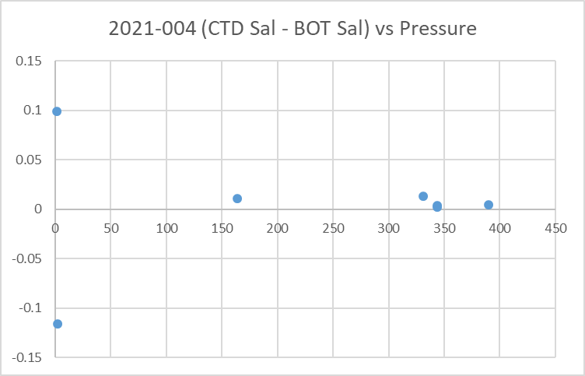

Fluorescence
The only HPLC sampling was at the surface. The median ratio of CTD fluorescence to Tchl-a was 0.84 with the highest ratios seen when Tchl-a is lowest. Given the differences in depth of sampling the correspondence is good and there is no significant relationship to depth of CTD sampling.
For more details see the “comparisons” worksheet in file 2021-004-bottle_plus_CTD.xlsx.

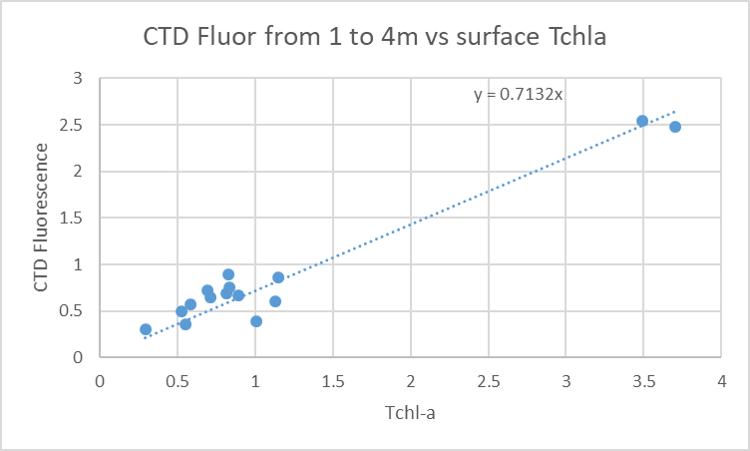

16. Other calibration checks
Sensor History – The conductivity sensor was used on 2 previous cruises since it was last serviced and salinity appeared to be slightly high but incomplete flushing could explain that. Salinity was considered ±0.003psu. The pressure sensor had been used on for 5 other cruises with no problems noted.
Historic Ranges – Temperature data in the central basin were within the historic ranges. To the north the surface waters were generally mixed to about 25db or more with temperatures below the climatology minimum and in the south the casts were mostly well-mixed to the bottom so that bottom values were below the climatology minimum. The only excursions from the salinity climatology were slightly low values around 140db for casts #25 and 31 and between 40db and 70db for cast #39.
The excursions do not appear to be indicative of calibration problems. They likely reflect the paucity of data for this season in the climatology..
Post-cruise calibrations – None were available.

17. CALIBRATE
The pressure and salinity appear to be within expected accuracy.
For dissolved oxygen there is insufficient evidence upon which to base any recalibration. There was no calibration sampling; the surface saturation values are a little low but given fairly well-mixed surface waters that may reflect real conditions. See section 19 for details.

18. Fluorescence Filter
The fluorescence data was not filtered as it had little effect on the data.

19. Bin Average, Remove, Derive DO in mass units, Reorder
The files were bin averaged using 1db bins.
REMOVE was run to remove Scan_Number, Oxygen:Voltage, Descent Rate and Flag channels.

Dissolved Oxygen was derived in mass units and that was used to calculate DO saturation. Plots of near-surface saturation show a range of 70% to 115%, with little obvious pattern in the distribution except that the highest values were from Cowichan Bay which is normal as are low values found in a few areas known to have strong vertical mixing. Most of the values are between 85% and 95%.
REORDER was used to get the 2 dissolved oxygen channels together.

20. HEADER EDIT and final checks of CTD files.
Header Edit was used to fix headers, fix formats and to add comments about processing.
A cross-reference listing was produced.
A header check and standards check were run on the CTD files and no errors were found.
The sensor history was updated.
Plots of CTD casts were examined and no problems were found.

20. Final BOT file preparation
To enable searching of bottle data, BOT casts were created that contain sample data and CTD data from the downcast at the same site. The event number will match the CTD cast. CTD data were extracted from metre-averaged files and added to spreadsheet 2021-004-bottles_plus_CTD_6linehdr.csv. That file was converted to IOS Header files for each cast.

The time and date are present as channels as these cannot be converted directly into header entries.
CLEAN was run to add START and END time. The END TIME is identical so the START time so it will be removed later. CLEAN was also used to enter 0 flags where the flag channels are empty.
REMOVE was run to remove the DATE and TIME channels.
There was no DO sampling so no need to derive different units.
SORT was run to get entries in pressure order.
HEADEDIT was used to add comments and to remove the END time since it is the same as START TIME.
The final files have extensions BOT.
The standards check was run until all errors had been corrected.
A cross-reference list and header check were run on the BOT files and no problems were found.
Plots were made of all BOT casts. No problems were found.
Finally all data from BOT files were extracted to a spreadsheet and compared to the event log; no problems were found.

PARTICULARS –
1. No CTD data acquired. Battery dead.
2. Test – no sampling.
7. Came out of water after initial soak so returned to 10m for further 30s soak; ~3 minutes data before acquisition began.
8. 5L Niskin broken at wire attachment.
16. Initial upload problem, but second attempt seemed ok.
35. May have started before 2 minute mark.
40 & 55. Niskin 1m above CTD.
65. Came out of water after initial soak so returned to 10m for further 30s soak; ~3 minutes data before acquisition began.
68. Came out of water after initial soak so returned to 10m for further 30s soak; ~3 minutes data before acquisition began.

CRUISE SUMMARY

Cruise ID#: 2021-004
Dates: Start: 11 February 2021 End: 15 February 2021
Location: Strait of Georgia Zooplankton
Chief Scientist: Young K.
CTD# | Make | Model | Serial# | Used with Rosette? | CTD Calibration Sheet Competed?
1 | SEABIRD | 25 | 456 | No | Yes

CTD CALIBRATION INFORMATION
Make/Model/Serial#: SEABIRD/SBE25/0334 Cruise ID#: 2021-004

Calibration Information
Sensor |  | Pre-Cruise |  | Post Cruise
Name | S/N | Date | Location | Date | Location
Temperature | 5130 | 12Dec2019 | Factory
Conductivity | 3500 | 17Dec2019 | Factory
ECO Fluorometer | 4185 | 11Dec2019 | Factory
SBE43 Oxygen | 3234 | 6Dec2019 | Factory
Pressure | 0573 | 1Feb2019 | Factory

