**Neocaligus Cruise IOS 2021-004**

**11-16 Feb 2021**

**Crew: Kelly Young**

**Table 1.** Sampling stations – see excel file: “[2021-004 Neo sampling-plan_v2.xlsx](2021-004%20Neo%20sampling-plan_v2.xlsx)”

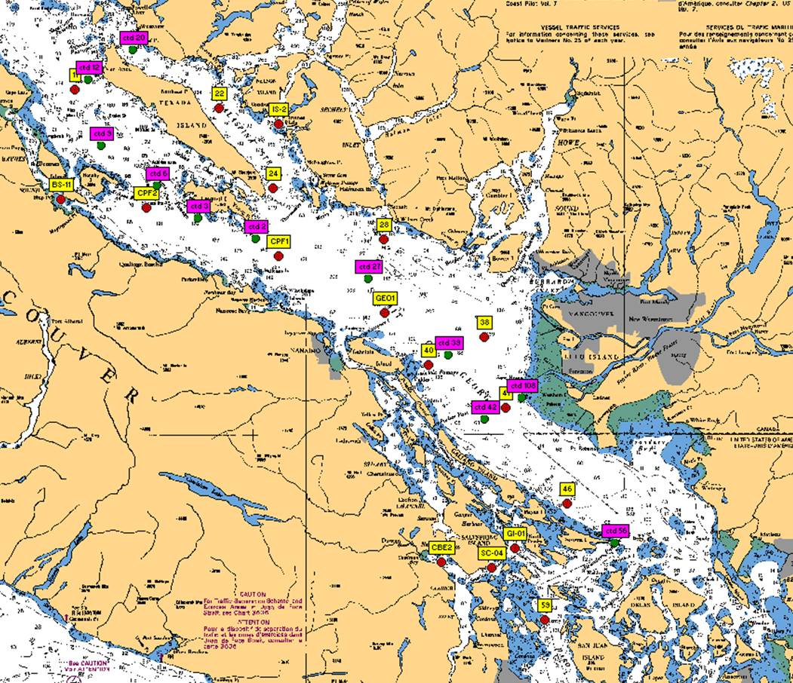

**Figure 1**. Station locations for IOS 2021-004 Strait of Georgia zooplankton survey. Yellow – CTD + zooplankton net stations; Pink – CTD stations.

**Cruise Objectives**: To conduct biological (through vertical plankton hauls and water sampling) and physical (though CTD) monitoring at 28 stations throughout the Northern Salish Sea (Strait of Georgia). To continue a monthly time series of observations to better understand plankton seasonal cycles and year-to-year variability within the Strait. These surveys will contribute to other regional DFO and external partner (eg: Universities) projects by providing baseline (prey field) data for fisheries research.

**At each zooplankton/net station, collect:**

* Full depth (10m off bottom to surface) CTD profile including oxygen and fluorometer, using SBE 25 CTD with SBE 43 DO and Wetlabs fluorometer sensors. **2 minute soak at start** (Turn on, down 10m and up, wait remaining time and start). If more time is needed at the start of the cast (attaching a bottle, etc), record how long the CTD was on before start of cast. **Note:** CTD fluorometer usually has an end cap that needs to be removed before the first cast!
* Full depth (10m off bottom to surface) zooplankton tow, using SCOR net with 236um black mesh. Sample preserved in 10% buffered formalin. Upcast speed approx. 1 m/s. Net equipped with a TSK flowmeter and an RBRSolo that logs the net casts (depth and time).

**At select stations, collect:** (see “[2021-004 Neo sampling-plan_v2.xlsx](2021-004%20Neo%20sampling-plan_v2.xlsx)” for complete summary per station).

** Record event number(s), sample number on rosette log sheets and in cruise log. Each Niskin gets unique sample number, all samples from that Niskin uses that number. Assign numbers in ascending (bottom to surface) order **

*Salinity (SAL)* – at least one deep water (>200m) salinity sample (in duplicate) per day (approx.), using 1.7 L Niskin attached approx. 1m above CTD (please measure and record in logbook!) to collect a near-bottom salinity sample during CTD cast (CTD sensor check). Record sample number, depth collected in log. All in duplicates

* If needed, to be collected at stations: 41, 38, GEO1, CPF2, 22, 24.

*HPLC –* Surface HPLC sample collected in duplicate. See “2019-045_NEO_HPLC protocols and equipment.doc” for full methods. Briefly, 620-1040mL of water (depending on phyto biomass) filtered onto 47 mm GF/F filters, the filters blotted, folded once and rolled into a cryovial, and then frozen in small dry shipper. Remember to fill out HPLC sampling/filtration log sheet.

- To be collected at stations: 59, 56, SC-04, 42, 39, 27, 2, 3, 6, 9, 12, 22, BS-11, GEO1

*~~Chlorophyll-a (chl-a)~~* ~~– Chl-a samples taken at surface everywhere HPLC is collected from same Niskin as HPLC and phyto.~~

~~Water sampled into 304ml brown bottles and filtered onto 25 mm GF/F filters (IOS standard method, 20% in duplicates). Store filter folded in half in small cryovial in small dry shipper.~~ *~~Record the sample number with the depth and volumes filtered in the cruise log~~*~~. Make sure labels have sample number and volume filtered as well.~~

~~- To be collected at stations: 59, 56, SC-04, 42, 39, 27, 2, 3, 6, 9, 12, 22, 28, BS-11, GEO1~~

No Chl-a taken on the trips this year, will use total chl-a from HPLC samples.

*Phytoplankton (phyto)* – surface phyto sample preserved with Lugol’s, collected from same Niskin used for HPLC at surface; for taxonomy. Do not rinse jars (pre-filled with Lugol’s).

* To be collected at stations: 42, SC-04, 27, 2, 22, 12 and BS-11

**Extras for Mark Hipfner (Environment Canada) <mark.hipfner@canada.ca>**

ECCC are starting a project this winter aiming to develop a food-web-leading-to-contaminants model for the Salish Sea, with gulls as the trophic endpoints. It is being funded through the TMX/PIER programs. As background, the Salish Sea is an extremely important wintering area for gulls from across the continent (e.g., Thayer’s Gulls from the eastern Canadian Arctic, Heermann’s Gulls from Baja, California Gulls from the Prairies, etc.). An important component to this project is establishing baseline information on stable isotope (C, N, S) and contaminant (legacy POPs, Hg) profiles in the prey base. Our plan is to collect mussels and sea stars at sites where we trap gulls, but we are also hoping to add euphausiids and forage fish (herring?) to the models.

* 5 ml of euphausiids (or 10 ml of a general zooplankton sample) from to be collected at stations: 59, 40, 22 and 11 (south to north), or 2020 stations with Euphs: CPF1, 28, 40
* Vials frozen at -20degC (deep freeze on board with the nutrients)

**Housekeeping**

* Run the Oziexplorer program with the GPS puck on the bridge, logging the cruise track and saving one per day. See “[Oziexplorer.docx](GPS/Oziexplorer.docx)”. If the program is set to record one track per day, it will automatically start a new file each day if left running.
* There are 2 logs to fill out (cruise log and plankton log), plus a rosette log sheet to record sampling information. Each station with water sampling will have one ‘rosette’ log sheet but may have multiple events. Please fill out the cruise log with all events that occur, and give each event a number, and record on the rosette log sheet as well. Record BE, BO and EN time (note what time zone you are using! Eg: use local time if you want, but indicate so in the log and be consistent for the entire trip). **Check that the GPS has the correct time (may need to be manually changed between Daylight ST and PST)
* Plankton log – enter information for all plankton tows.
* Update the electronic cruise log (excel file) daily. Back up all files to USB.
* Make sure the CTD laptop is set up with the correct .con file before uploading the data.
* Upload the CTD data at the end of the day. Make sure the laptop has the correct date and time before uploading. Upload the files individually (don’t do as a batch). When uploading the file, *name them with standard format names using the cruise number-event number, such as 2018-037-0001.hex*(or .xml for SBE25+) for event #1. Put location, station name, and bottom depth in the header (comments box) of the file, using the format in the “CTD Header.txt” file on the CTD laptop (the : plus N and W are needed for processing)
* View the CTD data in Seasave to make sure everything looks good (make sure your CTD config file is correct).
* Also check that the batteries have enough voltage, change if they drop below 10V (for SBE25).
* Provide the “[2021- dangerous goods.docx](2021-%20dangerous%20goods.docx)” to Captain at start of the trip