REVISION NOTICE TABLE
DATE | DESCRIPTION OF REVISION
!8 March 2025 | Updated channel names & formats in TOB and loop files. G.G. & SH
28 March 2023 | Added HPLC data. J.R.

PROCESSING NOTES
Cruise: 2021-001
Agency: OSD
Location: North-East Pacific
Project: Line P
Chief Scientist: Robert M.
Platform: John P. Tully
Date: 30 January 2021 – 18 February 2021

Processed by: Germaine Gatien
Date of Processing: 27 April 2021 – 16 June 2021
Number of original HEX files: 10 (1 test file – not processed)
Number of original CTD files: 104 Number of processed CTD files: 103
Number of rosette files: 56 (1 test, 1 to close a bottle) Number of processed CHE files: 54
Number of original TSG files: 1 Number of processed TOB files: 18

INSTRUMENT SUMMARY
CTD #0550 was mounted in a rosette and attached were 2 Wetlabs CSTAR transmissometer (1185DR & #1883DG), a SBE 43 DO sensor (#0997), SeaPoint Fluorometers (#3949), a Biospherical QSP-400 PAR sensor (#70614) and an altimeter (#75321).

A thermosalinograph (SeaBird 45 S/N 0620) was mounted with a Wetlab/Wetstar fluorometer (WS3S-953P) and flow meter.
Seasave version 7.26.7.121was used for acquisition.
The data logging computer WP #102.
The deck unit was a Seabird model 11+ #425.
A Guildline model 8400B Autosal serial # 68572 was used to analyze salinity samples.
An IOS rosette with 24 10L bottles was used.

SUMMARY OF QUALITY AND CONCERNS
The Daily Science Log Book and rosette log sheets were in excellent order with comments about problems encountered and a detailed list of equipment. The sampling notes were provided by the Chief Scientist were a great help in processing data.

There were 2 WetLabs CStar transmissometers in use during this cruise:
Channel Transmissometer refers to sensor #1185DR (650nm - red)
Channel Transmissometer:Green refers to sensor #1883DG (530nm - green)
For comparison with other Institute of Ocean Sciences cruises, note that the transmissometer wavelength is 650nm unless otherwise stated.

Studies were conducted during this cruise to determine what wait times are appropriate before firing bottles. The tests were limited in scope but suggest that longer waiting times may be advisable above 400m, with 60s waits looking best for shallow offshore waters and up to 120s waits in shallow protected waters. For details see document “Tests of Waiting Times Before Firing Niskin Bottles.docx”.
Near-bottom bottle sampling is usually done about 10m above the bottom to avoid some problems with Niskin flushing. During this cruise sampling was done 5m off the bottom in the inshore area. A study was made of some “bottom -5m” casts and it showed errors ranging from 0 to 0.01psu below 300db and 0.02 to 0.12psu above 300db. It is not clear if a longer wait would help without the rosette bouncing around and that generally doesn’t happen in inland waters. Samples from close to the bottom should be considered to reflect values in the bottom 5 to 15m; the errors involved are very small below 300db.

While CTD fluorescence data are expressed in concentration units, they do not always compare well to extracted chlorophyll samples. It is recommended that users check extracted chlorophyll values where available.

The SBE DO sensor has a fairly long response time so data accuracy is not as high when it is in motion as it is during stops for bottles. This will be especially true when vertical DO gradients are large. To get an estimate of the accuracy of the SBE DO data during downcasts (after recalibration) a rough comparison was made between downcast SBE DO and upcast titrated samples. Some of the difference will be due to problems with flushing of Niskin bottles and/or analysis errors and small mismatches in depth in the presence of large DO gradients, so the following statement likely underestimates SBE DO accuracy.

Downcast (CTD files) Oxygen:Dissolved:SBE data for this cruise are considered, very roughly, to be:
±0.20 mL/L from 0-400db except in areas of very large DO gradients (especially base of mixed layer)
±0.03 mL/L from 400db-2000db
±0.02 mL/L below 2000db

The Thermosalinograph system functioned quite well with lots of detail in the traces. The only significant problem was with the flow meter readings which were very steady offshore but started to drop in the inlet section. Tests run during the cruise suggest that the problem was with the meter rather than with the loop itself. The values are included in the TSG file so users can see when the changes occurred but the actual flow rates should not be trusted.

There were some sections with fine-scale noise in TSG temperature and salinity that occurred while the ship was underway and high winds were noted in the log. A few large single-point spikes in salinity were removed using a simple de-spike routine, but overall the data were remarkably free of spikes. There was no obvious drift in salinity or fluorescence calibration. The TSG salinity calibration is gradually drifting since the last factory service but there was no obvious drift through the cruise; the data were recalibrated by adding 0.18psu. Fluorescence values were about 75% of loop extracted chlorophyll samples. They were lower than the CTD fluorescence especially well offshore, which may be due to a difference in how the two fluorometers perform when chlorophyll values are very low. TSG intake temperatures compared reasonably well with CTD values.

PROCESSING SUMMARY

Seasave
This step was completed at sea; the raw data files have extension HEX.
The chief scientist provided a summary of sampling protocols and problems.
The deployment protocol was:
The rosette was brought to the surface. Pumps were turned ON. The rosette was brought down to 10m and kept there for 30 seconds. Once back at the surface, the data started to be archived, with the rosette at the surface for 30 seconds longer. Then the cast would start.

Preliminary Steps
The Log Book and rosette log sheets were obtained as well as sampling notes from the Chief Scientist.
- Nutrients, extracted chlorophyll, dissolved oxygen, salinity, DMS and DMSP data were obtained in QF spreadsheet format from the analysts.
- The cruise summary sheet was completed.
- The histories of the pressure sensor, conductivity and dissolved oxygen sensors were checked. The temperature, conductivity and dissolved oxygen sensors had been used on 1 other cruise since the last factory recalibrations. See section 14 for details.
Based on notes from the chief scientist some water depth and station names were changed in the raw files.

BOTTLE FILE PREPARATION
The ROS files were created using files 2021-001-ctd.xmlcon.
There was no bottle file for event #46 the BL file was empty. Scan #s were added based on a plot versus scan # to pick out a section where conductivity and pressure were quite steady for 36 scans. A ROS file was created.
The ROS files were converted to IOS format.

The IOS files were put through CLEAN to create BOT files.
Temperature and salinity were plotted for all BOT files to check for outliers.
A few files were opened in CTDEDIT
The only editing applied was to remove some spikes in salinity at the surface of cast #106.
The output file was copied to *.BOT.
A preliminary header check was run and no problems were found.

The BOT files were bin-averaged on bottle number.
The output was used to create file ADDSAMP.csv. First, the file was sorted on event number and Bottle Position order. Then sample numbers were added based on the rosette logs.
The file was used to add sample numbers to the BOT files – output *.SAM.
The SAM files were bin-averaged on bottle # and called SAMAVG.
The addsamp.csv file was converted to CST files, which will form the framework for the bottle files.

Next, each of the analysis spreadsheets were examined to see what comments the analysts wanted included in the header file. These were used to create file 2021-001-bot-hdr.txt which will be updated as needed during processing.

Loops samples were moved from the salinity, chlorophyll and nutrient CSV files to a combined loop data file for later use.

DISSOLVED OXGYEN
Dissolved oxygen data were provided in spreadsheet QF2021-001_OXY*.xlsx which includes flags, comments and a precision study. Draw temperatures are available. The spreadsheet page with the final data was simplified and saved as 2021-001oxy.csv. That file was converted into individual *.OXY files.
There were no flags in the DO file that had comments starting with “ALL:”
EXTRACTED CHLOROPHYLL
Extracted chlorophyll and phaeo-pigment data were obtained in file QF2021-001_CHL QF*.xlsx. The file included comments and flags and a precision study. A simplified version of the spreadsheet was prepared and saved as 2021-001chl.csv. The csv file was then converted to individual CHL files.
SALINITY
Salinity analysis was obtained in file QF2021-001_SAL.xlsx which included a precision study. The analyses were carried out in a temperature-controlled lab 26 to 39 days after collection. The files were simplified and saved as 2021-001sal.csv. Two samples were flagged 3 based on the Oxygen analysis. That file was then converted to individual SAL files.
NUTRIENTS
The nutrient data were obtained in spreadsheet QF2021-001_NUTS*.xlsx. This includes a precision study. The file was simplified, saved as 2021-001nuts.csv. Two samples were flagged 3 based on the Oxygen analysis. The file was converted to individual NUT files.
DMS
DMS data were obtained in spreadsheet QF2021-001_DMS*.xls which includes duplicate analysis. Details on analysis are in file 2021-001 DMS report.doc. Only 2 figures are considered significant.
DMSP
DMSP-D and DMSP-T data were obtained in file QF2021-001_DMSP_summary*.xls. The data were converted into DMSP files. Only 2 figures are considered significant.

The SAL, CHL, OXY, NUT, DMS and DMSP (DMSP-D and DMSP-T) files were merged with CST files in 6 steps.
After the 6th step the files were put through CLEAN to reduce the headers to File and Comment sections only.
The files were then put through CLEAN to reduce the headers to File and Comment sections only.
These files are ordered on sample number, but the SAMAVG files are ordered on bottle number, so one or the other set needs to be reordered in order to merge them. The MRGCLN1 files were reordered on Bottle_Number and saved as *. MRGCLN1s.
The MRGCLN1s files were then merged with SAMAVG files using merge channel Bottle_Number.

The output of the MRG files were exported to a spreadsheet and compared to the rosette log sheets to look for omissions. A few problems were resolved by renaming event numbers for some samples. At this point records were removed from SAMAVG files where there was no sampling or sampling for bulk water only. Merge was rerun after those corrections.

Compare
Salinity
Compare was run with pressure as reference channel.
When outliers were removed based on standard deviation in the CTD salinity >0.0008psu, there remained only 2 large outliers:
- Sample 525 from event 128 – CTD Sal high by ~0.12psu. This is likely due to poor flushing of the Niskin bottle which was fired close to the bottom. There was a large enough gradient near the bottom to explain this outlier. Near the bottom shed wakes can reflect upwards prolonging their effect.
- Sample 614 from event 163 – CTD Sal low by ~0.026psu. This is likely due to poor flushing of the Niskin bottle which was fired well above the bottom.

Three other bottles stood out in the comparison that were between 300 and 500db with the CTD higher than the bottle salinity. The differences were not large enough to flag but they were unusual and turned out to all have come from within 5m of the bottom of the casts. When local vertical salinity gradients are high, we expect that there will be some error due to incomplete flushing of bottles. During the upcast this generally means the CTD appears to be reading lower than it really is because the contents of the bottle are of higher salinity than ambient values during the stop. But at the bottom of the cast the opposite is true. And if sampling is done right at the bottom, there may be complications due to reflection of shed wakes, making the errors larger. For those cases the CTD will appear to be reading high.

This cruise was divided between 2 distinctive regions and the near-bottom sampling scheme varied. For the Line P casts sampling was done at least 10m off the bottom, whereas the inshore casts the sampling scheme used bottom – 5m. This appears to have made a difference though given the areas are quite different there may be differences in vertical gradients or bottom currents to consider.

The plot below does suggest that the Bottom-5 scheme is problematic. A longer wait before firing may be necessary to get good samples near the bottom except in very deep water where vertical gradients are low. However, a longer wait may not always help. For cast #128 an initial stop about 8m above bottom led to a shed wake; the CTD was then lowered further and raised slightly before the stop for the bottom-5m bottle. The contents of that bottle match the shed wake that passed through at the bottom -8m stop.

So samples from the bottom should be considered as estimates and may reflect values in the range of 5 to 15m above bottom. While this is most obvious in salinity it will affect all sampling.

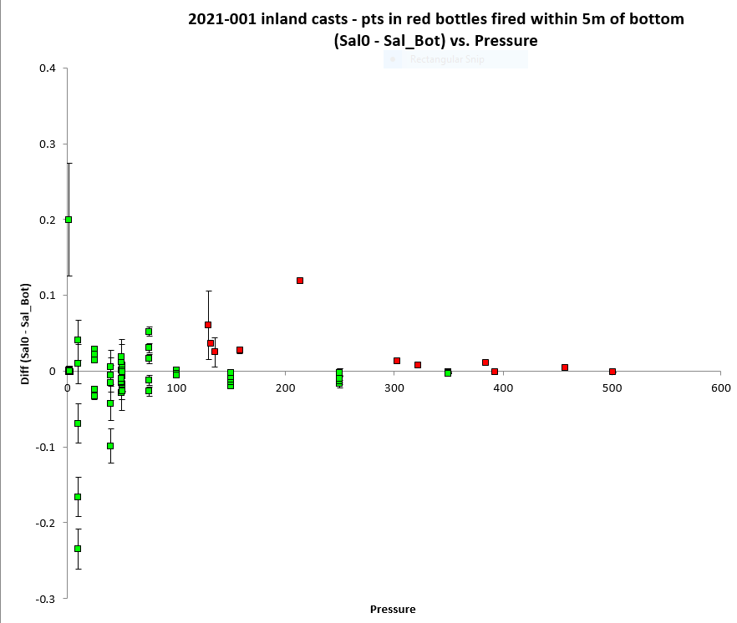

As expected, the fit of differences versus pressure is much tighter when only the Line P data are included. After removing cases with salinity standard deviation >0.0005psu, the primary CTD salinity was lower than bottles by 0.0014 and the secondary was low by 0.0004psu. There is evidence of flushing errors near the surface but they are not large.

Tests were done during this cruise to see how wait times before firing bottles affect comparisons with bottles. One of the casts was during the Line P section (event #84). So the bottles fired after waits longer than 30s were removed from the first comparison. That changed the average differences by 0.0001 in each case, so not significant.

When outliers were removed for cases where differences were greater from the average by more than 0.002psu and only the bottles fired after 30s were included for cast #84, the average differences changed very slightly to -0.0013 and -0.0003psu. The fits were much flatter with pressure after that step.

During 2021-001 tests were run at 3 sites using firing times of 30s, 60s, 90s, 120s and 150s. For the deepest bottle there was no 150s firing due to there being only 24 bottles available low and errors due to vertical distance of rosette above CTD which will have the opposite effect. Both dissolved oxygen and salinity samples were taken. A report on this experiment may be found in document “Tests of Waiting Times before Firing Niskin bottles.docx”.

For full details for the COMPARE run see file 2021-001-sal-comp1.xls.

Dissolved Oxygen
COMPARE was run with pressure as the reference channel.

For all comparisons data were excluded where the analyst had flagged bottles “4”.
When all casts were included and cases with waits longer than 30s were excluded and further outliers were removed based on residuals the fit was:
CTD DO Corrected = CTD DO * 1.0348 + 0.0209 R² = 0.94 (1)
When a similar comparison was done using only offshore casts the fit was
CTD DO Corrected = CTD DO * 1.0351 + 0.0209 R² = 0.97 (2)
The offshore casts likely have a greater influence on the full comparison because they represent all depths and a full range of DO values.

All bottles from cast #117 were outliers in this comparison but not in the salinity comparison. No obvious problem was found with this CTD cast. Bottles from cast #127 were somewhat out of line below 75db, but that cast had some DO reversals that may explain some of the outliers. The CTD DO looks like a nearby cast. The analyst could find no reason for this and padded all samples from #117 with flag 5.

The result of the tests using different wait times before firing bottles produced the following result for P25 after 60s:
CTD DO Corrected = CTD DO * 1.0398 + 0.0166 R² = 1.00 (3)
And for cast #158 at Doug26 after 60s it was:
CTD DO Corrected = CTD DO * 1.0394 + 0.0131 R² = 0.92 (4)

Fits #3 and 4 are close and involve a slightly larger correction than using the 30s fit. Fit #3 has the tightest fit and looks appropriate for the whole cruise.

To check for hysteresis the data with DO < 3mL/L were separated into above 900db and below 1000db to see how close the fits were:
CTD DO Corrected = CTD DO * 1.0409 + 0.0119 R² = 0.94 (5)
CTD DO Corrected = CTD DO * 1.0405 + 0.0161 R² = 0.84 (6)
These fits are very close so there is no significant hysteresis.

Samples flagged 4 by the analyst were investigated :
Sample 126 is way off, looks like a miss-sample – NUTS ok so not a misfire.
Sample 127 – The first rep looks much better than the 2nd. The analyst chose the 1st rep.
Sample 497 – Cast 117 is all out of line, so this particular sample seems no worse than the others. The 2nd rep would be slightly better but both are way off in the comparison.
Sample 516 – The 2nd rep is slightly better but both out of line.
Sample 569 is way out of line – looks like a miss-sample since the NUTS look ok. Looks like it is from 200m.
The analyst updated some comments based on these results.

Plots of Titrated DO and CTD DO against CTD salinity were examined. The only notable outliers were ones identified above; in particular casts #117 and #127 looked unusual.
For full details for the COMPARE run see file 2021-001-dox-comp1.xls.

Fluorescence
COMPARE was run with extracted chlorophyll and CTD Fluorescence using pressure as the reference variable.
A fit of fluorescence versus extracted chlorophyll displayed a clear division into two parts. When the data were split into Offshore and Nearshore & Inlets they each have reasonably tight fits.

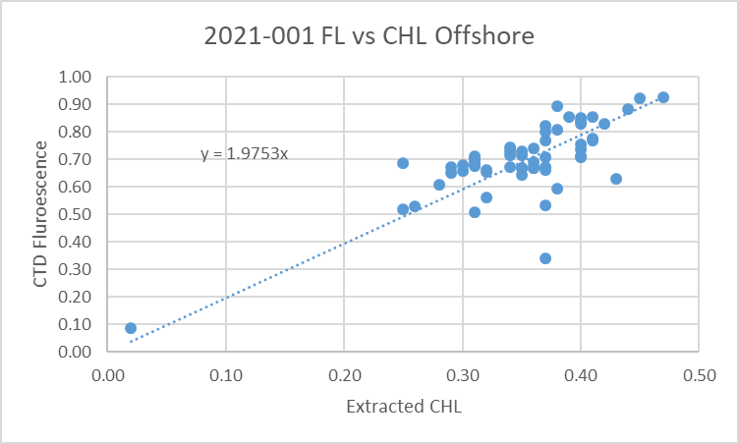

The offshore CHL values are very low, a level at which fluorescence tends to read higher than CHL.
In contrast the near-shore overall fit is close to 1 though the ratio of FL/CHL is decreasing as CHL rises.
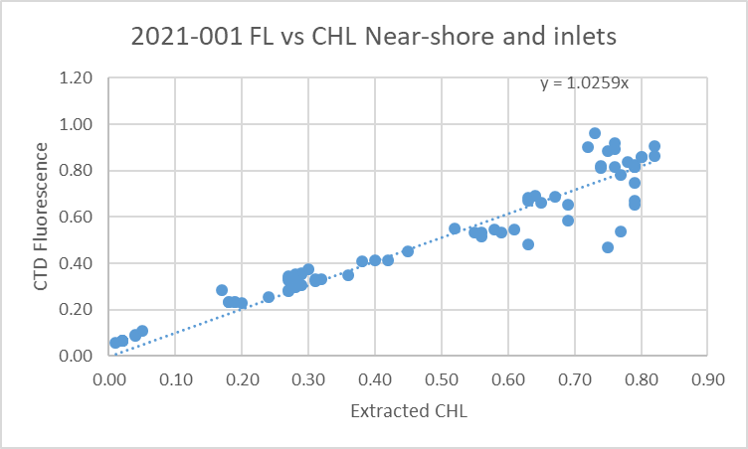

For full details for the COMPARE run see file 2021-001-fl-chl-comp1.xls.

Conversion of Full Files from Raw Data
File 2021-001-ctd.xmlcon was used to convert all files.
The Tau function and the hysteresis function were selected since there was deep sampling. Depth was included in the conversion.

A few casts were examined and all expected channels are present. The descent rate was often extremely noisy offshore but steady inshore. The T and C pairs were reasonably close during downcasts, but the primary T and C are very noisy during upcasts. PAR and Dissolved Oxygen profiles looked normal. The “Green” transmissometer was generally higher than the “Red”; the profiles had similar shapes. The altimetry looked ok even though the signal was sometimes noisy at the bottom of casts.

WILDEDIT
Program WILDEDIT was run to remove spikes from the pressure, depth, conductivity & temperature only in the full cast files (*.CNV).
Parameters used were: Pass 1 Std Dev = 2 Pass 2 Std Dev = 5 Points per block = 50
The parameter “Keep data within this distance of the mean” was set to 0 so all spikes would be removed.

ALIGN DO
A few casts were examined; both temperature channels were noisy during upcasts so the tests were not easy to interpret, but using +2.5s certainly improves the alignment and overall looks like a good choice for both sensors. That setting has worked well for many SBE DO sensors in recent years.
ALIGNCTD was run on all casts using +2.5s.

CELLTM
The noise in the upcast data makes tests for the best parameters for this routine very difficult to interpret. In the past when upcast data were not so noisy, the default setting of (α = 0.0245, β=9.5) was generally found to be the best choice. A few casts were checked for this cruise and the default setting does improve the data. CELLTM was run using (α = 0.0245, β=9.5) for both the primary and secondary conductivity.

DERIVE and Channel Comparisons
Program DERIVE was run on all casts to calculate primary and secondary salinity and dissolved oxygen concentration.

DERIVE was run a second time on 3 of the deeper casts to find the differences between the pairs of temperature, conductivity and salinity channels.
Cast # | Press | T1-T0 | C1-C0 | S1-S0 | Descent Rate
2020-031-0029 | 230 | -0.0004 | -0.00020 | -0.0015 | High, F.Steady
2020-031-0053 | 290 | -0.0005 | -0.00018 | -0.0015 | High, Noisy
2020-031-0094 | 170 | -0.0005 | -0.00010 | -0.0008 | High, F.Steady
2020-001-0052 | 1000 | -0.0011 | -0.00001 | +0.0010 | High, XNoisy
 | 2000 | -0.0006 | -0.00001 | +0.0006 | “
 | 3000 | -0.0008 | -0.00001 | +0.0010 | “
2020-001-0067 | 1000 | -0.0005 | -0.00004 | +0.0006 | High, VNoisy
 | 2000 | -0.0008 | -0.00002 | +0.0008 | “
 | 3000 | -0.0008 | -0.00003 | +0.0010 | “
2021-001-0082 | 1000 | -0.0012 | ~0 | +0.0010 | High XNoisy
 | 2000 | -0.0005 | ~0 | +0.0007 | “
 | 3000 | -0.0010 | ~0 | +0.0010 | “
 | 4000 | -0.0011 | ~0 | +0.0014 | “
The salinity and conductivity differences were all small and very noisy. There is no sign of significant temporal variation.

Conversion to IOS Header Format
The IOSSHELL routine was used to convert SEA-Bird 911+ CNV files to IOS Headers.
CLEAN was run to add event numbers and to replace pad values in the pressure channel with interpolated values based on record number.

Because there were many casts with acquisition started as soon as the CTD entered the water, CLIP was run to remove all records with pumps off, so that DELETE will not choose those records. There remains the fact that DELETE may pick records for which the pumps have just come on, but given the long time at the surface in most cases the feature to remove records to the last pressure minimum will generally lead to the selection of more appropriate data. The graphical editing feature will catch some obviously bad surface data as well.

Checking Headers
The cross-reference check and header check were run. Station names for the Douglas Channel area had inconsistent formats – all were changed to format “Doug02A” with no space or hyphen. Another station had lower case letters while the usual format and the one found in the log had upper case, so that was changed. The affected casts were mostly non-rosette casts; the only rosette cast affected had already been corrected.

Surface check was run in 2 parts as the deployment method varied. For the southern group the average surface value was 2.2db, which is reasonable for an off-shore Tully cruise (a few of the casts in this group were in protected waters.)
For the northern, inshore group the average was 0.3db which makes sense given the deployment method that started acquisition right at the surface for most casts. The lowest value recorded was -0.7db with an associated near-zero salinity. The highest pressure with salinity <1 was +0.4db. So the surface pressure appears to be ±1db.

Cruise tracks were plotted and added to the end of this report.

The altimeter and water depth readings from the headers of the CLN files were exported to a spreadsheet. A check value was calculated by subtracting water depth from maximum depth sampled plus altimetry header). Where that number was > 5 or <-5 plots of the altimetry were checked. Some casts didn’t get near the bottom so there are no altimetry headers and for many others the check value was small.

The altimetry often had spikes near the bottom but the header algorithm produced values that look to be reasonable. 31 cases were examined. For 12 the log book entry for water depth produced better results than that in the file headers, so the headers were changed. In 15 cases (1 of which had no log book depth entry) a water depth estimate based on the maximum depth sampled plus the altimetry header entry was then placed in the water depth headers. In 4 cases the differences were not large and the log entry was the same as the header and the differences were not large enough to justify a change to the check estimate. These changes were made to the CLN files and the 11 SAM files affected. The SAM files were re-binned and the merge with bottle data repeated.

Shift
Fluorescence
SHIFT was run on the SeaPoint fluorescence channel in all casts using the usual advance of +24 records. Plots show that the fluorescence offset is reasonably close to the temperature offset after this step.
Dissolved Oxygen
The Dissolved Oxygen voltage channel was aligned earlier. A few casts were checked to see if the alignment looked ok, and it did. No further alignment is needed for the DO concentration channel,
Conductivity
Tests were run on a few casts to assess what settings are best to align conductivity with temperature (as judged by the effect on salinity as seen in T-S space). For some casts there was a wide range of shifts that looked good, while for others none were great, but this likely is due to the noisy conditions offshore and quiet state inshore. The best settings overall were -0.8 records for the primary and +0.5 records for the secondary.
SHIFT was run twice on all SBE911 casts using -0.8 records for the primary and +0.5 records for the secondary conductivity. Salinity was recalculated for both channels.

DELETE
The following DELETE parameters were used:
Surface Record Removal: Last Press Min
Maximum Surface Pressure (relative): 10.00
Surface Pressure Tolerance: 1.0 Pressure filtered over 15 points
Swells deleted. Warning message if pressure difference of 2.00
Drop rates < 0.30m/s (calculated over 11 points) will be deleted.
Drop rate applies in the range: 10db to 10db less than the maximum pressure
Sample interval = 0.042 seconds. (taken from header)
COMMENTS ON WARNINGS: There were no warnings.

Surface Check was rerun were made to ensure that this process has not removed to much data and there is no evidence of it having done that.

Other Comparisons
Experience with these sensors since last factory service –
The pressure, temperature, dissolved oxygen and conductivity sensors were used during only 1 cruise since the last factory visit:
- 2020-031 – Noisy comparison but salinity channels were close with primary probably within 0.003psu and secondary within 0.002psu.. Dissolved oxygen was recalibrated using slope/offset =1.0582/-0.0015. This correction seemed high since it was first use since previous factory calibration. Pressure looked ok.
Historic ranges – Profile plots were made with 3-standard deviation climatology ranges of T and S superimposed. There were a few minor excursions. Temperature was below the range minimum near the bottom of casts at stations SRN, MT02, MT03 and MT05. The cast at CAM1 was much deeper than anything in the climatology. It is likely that there are few data in the climatology from winter in this area. The salinity was slightly low around 150db and temperature low in the top 30m for station North Ajax.
None of these excursions suggest calibration drift.
Post-Cruise Calibration – None available.
Repeat Casts – Two casts at P25 taken about 2 hours apart were compared around 1800db and differences in temperature were ~0.002C° and in salinity ~0.0003psu along lines of constant density. This is good repeatability.

DETAILED EDITING
The secondary channels were chosen for editing because there was less noise in those channels and the comparison with bottles was excellent.
All DEL files were copied to *.EDT.

CTDEDIT was used to remove records that appear to be corrupted by shed wakes. Salinity was cleaned to remove spikes that appear to be due to small misalignment or instrumental noise. All files required some editing. Notes about editing applied were added to the files.
All files except 2021-001-0019.Del required editing.
The edited files were copied to *.EDT.
After editing, T-S plots were examined for all casts. Some small unstable features remain in some casts but come from areas where such features may well be real. No further editing was done.

Corrections to Pressure, Salinity and Dissolved Oxygen Concentration
Pressure and salinity do not need recalibration. The Dissolved Oxygen fit after 60s looks most appropriate for recalibration. That correction is slightly larger than using the 30s fits but much smaller than when the sensor was last used:
CTD DO Corrected = CTD DO * 1.0582 - 0.0015
However, the earlier fit seemed oddly high for a sensor that had just been serviced. It is possible that there was some difference in the set up that affected the performance of the sensor.

File 2021-001-recal.ccf was prepared to apply the following correction to channel Oxygen:Dissolved:
CTD DO Corrected = CTD DO * 1.0398 + 0.0166

This correction was first applied to the SAM and MRGCLN2 files.

COMPARE was rerun for dissolved oxygen and shows that the correction was applied properly. When data are excluded based on using the same points as in the original fit for bottles fired after 30s waits, the CTD DO was high by an average of ~0.015mL/L. But when only the bottles from cast #84 after 60s waits were examined the CTD DO was high by an average of 0.0001mL/L. This shows that the recalibration was applied corrected. See file 2021-001-DO-comp2.xls for details.

CALIBRATE was then run on the EDT files using the same recalibration file.

Final Calibration of DO
The initial recalibration of dissolved oxygen corrects for sensor calibration drift. Alignctd corrects for transit time errors. Those 2 steps may partly correct for response time errors, but to see if a further correction is needed, a comparison is made of downcast CTD data to bottle data from the same pressure. Small differences are expected due to ship drift, temporal changes, incomplete flushing of Niskin bottles and delayed response and noise in CTD data.

Downcast files were bin-averaged to 0.5m bins for the casts with DO bottle samples. Those files were then thinned and compared to the bottle values in the MRG files. COMPARE was run to study the differences between the downcast CTD DO data and the titrated samples from upcast bottles.

The CTD DO was higher than the titrated samples by an average of ~0.4mL/L but when a few outliers were excluded the average difference was 0.19mL/L. The outliers came mainly from 1 cast which was found to be out of line in the main run of COMPARE and a number of bottles from just below the mixed layer for offshore casts. Almost all the outliers are to the high side, with CTD reading higher than bottles as would be expected in high-gradient zones due to both to slow response of the sensor and incomplete flushing of bottles. No further recalibration of SBE DO is warranted based on this comparison.
See 2021-001-DO-comp3.xls for more detail.

Fluorescence Processing
A median filter, size 11, was applied to the fluorescence channel in the COR1 files. Plots of a few casts showed that the filter was effective. (Output:*.FIL)

BIN AVERAGE of CTD files
The following Bin Average values were applied to the FIL files (output AVG):
Bin channel = pressure Averaging interval = 1.000 Minimum bin value = .000
Average value will be used. Interpolated values are NOT used for empty bins.
On-screen T-S plots were examined.
Profile plots were examined. No problems were noted.

Final CTD File Steps (REMOVE and HEADEDIT)
For all casts REMOVE was run to remove the following channels:
Scan_Number, Temperature:Secondary, Conductivity:Secondary, Oxygen:Voltage:SBE, Descent_Rate, Status:Pump, Altimeter, Salinity:T1:C1 and Flag.
PAR was removed for casts #51-63, 67-69, 75-78 and 82-92.

A second SBE DO channel (with umol/kg units) was added.
REORDER was run to get the two DO channels together.
HEADER EDIT was used to fix formats and channel names and to add the comments about processing.
The Standards Check routine was run and no problems were found.
The Header Check was run; no problems were found.
Profile and T-S plots were examined. No problems were found.
The sensor history was updated.

Dissolved Oxygen Study
As a final check of dissolved oxygen data, % saturation was calculated and plotted. Values at 2 to 3m ranged between ~70% to 100%. The deep offshore casts had values mostly ~99%. The lowest values were at the northern end of Douglas Channel, Haro Strait, Juan de Fuca Strait and Saanich Inlet.

Final Bottle Files
SORT was run to arrange casts in pressure order.
For all casts REMOVE was run to remove the following channels:
Scan_Number, Temperature:Primary, Conductivity:Primary, Oxygen:Voltage:SBE, Descent_Rate, Status:Pump, Altimeter, Salinity:T0:C0 and Flag.

Channel PAR was removed for casts 51-63, 67-69, 75-78 and 82-92.
A second SBE DO channel with mass units was added for both the CTD DO and titrated DO and REORDER was run to get the pairs of DO channels together.

EDIT HEADERS was run to fix formats and channel names and to add comments about analyses and CTD processing.

Data were exported from the CHE files to file 2021-001-bottles-final.xlsx. The entries were compared with the rosette log sheets and no problems were found.
Standards check and a header check were run. No problems were found.
The track plot looks ok.
Plots of each file were examined and no problems were found.
A cross-reference listing and header check were produced for the CHE files.

Thermosalinograph Data
An IOS TSG45 was used for this cruise. The data were delivered in 1 CSV file.
The IOS SBE TSG45 files were opened in EXCEL.
The files have extensions RAW but are in csv format, so the files were opened in EXCEL and combined in a single CSV file. (In opening I use DELIMITED, deselect TAB, select COMMA and OTHER (*).
It is necessary to choose TEXT for the time on the 2nd page of the text import wizard.)

The spreadsheets were adjusted as follows:
- 2 lines of headers were added – channel names and units.
- A column with pressure was added with all values set to 4.5 (to enable derivation of salinity).
- A temperature difference column was added (Lab-Intake).
- The fluorescence channel is in volts. It was moved to column M. Then a concentration value was calculated in column F using offset -0.044 and scale 15.8 as determined in the most recent recalibration of the fluorometer. This produced some negative values even after the flow started. The minimum voltage found was 0.039volts, so that is a better choice of offset and produced a minimum concentration of 0.0158ug/L.
Copy/Special Paste was used to save those values and then the voltage channel was removed.
- A file break column was filled with the cruise #-data/time info from the original file name.
- Time and Date formats are a problem – when converting from RAW choose TEXT but once opened in EXCEL set Time Format to HH:MM:SS and save the file again.
- The file break column was completed so that new files would be created at the beginning of each day by assigned file names like 20200210-000000 except for the first file which has a time later than 000000.
- The flow was not turned on until ~3:23 on January 31st. Entries for the temperature, salinity, conductivity and fluorescence channels were padded up to ~3:24 allowing a minute for flow to be established.
- Flow stopped at 22:39 on February 17th, so entries for the temperature, salinity, conductivity and fluorescence channels were padded for the final 5 minutes.

The file was then converted to IOS Header format with header info added. There are12 IOS files, one for each day.
CLEAN was run to reset the number of records, min and max values, set the start and end times, and latitude and longitude limits.
ADD TIME CHANNEL was used to add Julian dates – i.e. Decimal Year. A record number was also added to enable averaging (for use in comparison to CTD files). Time zero was set to 31 December 2020 0:00:00. (Note that this step leads to problems plotting until REORDER is run.)
DERIVED QUANTITIES was run twice, first to derive salinity using the lab temperature and again to derive sigma-T.
REORDER was run to move the Julian date to after the Time/Date channels and to put salinity and fluorescence after the lab temperature. Also the record # was moved to the end.

a.) Plots
A track plot was produced and added to the end of this report.
Time-series plots were produced and a few problems were noted:
- The flow rate was very steady at 0.9 to 1.0 until February 11th when it started to drop. By mid-day of the 12th it was down to 0.5. This was noted at sea. Tests done at sea by measuring output found a rate of 1.6L/min for meter rate 0.8 and 1L/min for meter rate 0.5. The flow meter was thought to be installed backwards. This will be investigated further by looking at loop samples and heating in the loop. Unfortunately the changes occurred while the ship was running from Station Papa to Hecate Strait so heating in the loop might also reflect changes in intake temperature and ambient ship temperature.
- The fluorescence values seem low. At P2 and P4 the near-surface extracted chlorophyll samples and CTD fluorescence are in reasonable agreement, but both are higher than the TSG fluorescence. This may indicate the scale factor needs increasing.
- There are a few single-point spikes in salinity that were removed by running the Simple Despike routine to replace single points with differences of >0.04psu with an average of adjacent values.
- There was fine-scale noise in the temperature and salinity between P4 and P18. Since it is not seen during station stops and there is mention of high winds in the log, this is assumed to be due to the sea-state rather than a problem in the sensors.

b.) Checking Time Channel
The CTD files were thinned to reduce the files to a single point from the downcast at or within 0.5db of 4.5db. These were exported to a spreadsheet which was saved as 2021-001-tsg-ctd-loop-rosette-comp.xlsx. All CTD casts overlapped with TSG records but 1 occurred before flow was turned on, so there are 102 records for comparison.

The TSG files were averaged over 24 records (2 minutes) on record number to reduce the noise and file size. Standard deviations were included. Then required records (times, positions, temperatures with standard dev, salinity with standard dev, fluorescence with standard dev, flow rate) were exported to a spreadsheet and that file was thinned to the closest times of CTDs and added to file 2021-001-ctd-tsg-loop-rosette-comp.xlsx.. The same file was thinned to the closest times to loop files and added to the TSG-Loop comparison.

Comparisons were made of positions to check for good matches. The differences in positions are expected to be small despite the averaging because the ship was stopped at these times. The average differences were 0.0000º for both latitude and longitude. There were 2 differences > 0.0008º in longitude. The times were checked and the match is good. In 1 case the log records ~0.4’ drift through the cast and the CTD position comes from the beginning of the casts and the loops were taken at the end. The TSG positions are not as precise as those from the CTD.

c.) Comparisons
The comparisons will be difficult to interpret because of many competing variables including near-surface vertical gradients and sea states, possible changes in flow rates in the TSG and unknown ambient ship temperatures in different areas. The offshore casts were likely well mixed to the surface and surface temperatures were relatively high. Near-shore there are higher gradients and lower intake temperatures.

- Comparison of T, S and Fluorescence from TSG and CTD data
The initial comparison between TSG and CTD data using all casts includes some large outliers.
 | TSG (int) - CTD Temp | TSG (lab)- CTD Temp | TSG Sal-CTD Sal | TSG FL/ CTD FL
min | -1.6267 | -2.0921 | -2.8849 | 0.0484
max | 0.1971 | 0.6912 | 0.4972 | 0.6034
avg | -0.0418 | 0.2554 | -0.3006 | 0.3136
median | 0.0060 | 0.2811 | -0.1782 | 0.3150
stdev | 0.2229 | 0.3217 | 0.4427 | 0.0734

A plot of temperature differences between TSG and CTD shows several regions with very high variability, but 2 sections are fairly quiet, from P4 to P12 and in the Hecate Strait/Douglas Channel area from stations SRN to KIT2.

 |  | Tint-Tctd | Tlab-Tctd | SALtsg-SALctd | FLtsg/ FLctd
Events 37-51 | median | 0.0165 | 0.3771 | -0.1788 | 0.329
 | stdev | 0.0059 | 0.0381 | 0.0006 | 0.032
Events 102-127 | median | -0.0010 | 0.2387 | -0.1750 | 0.311
 | stdev | 0.0175 | 0.0416 | 0.0111 | 0.093

The comparisons of salinity and fluorescence look similar in the 2 areas, but temperature differences do not. Looking at near-surface profiles the offshore casts look better mixed than near-shore and that the near-shore surface waters are slightly cooler at the surface than at 10m. The TSG may be drawing from a little above 4.5m which could lead to values looking slightly lower than the CTD inshore. A plot of differences through the cruise shows they generally increased as the ship moved offshore. The randomness in the plot makes any conclusions dubious. A plot of differences against reported flow rate showed more noise in the sections with low flow but most values look similar to the data from the higher-rate section.
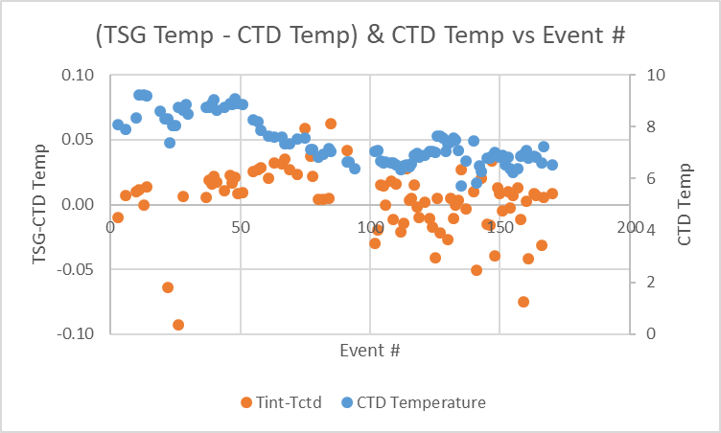

When only the 20 casts with the lowest standard deviation in the intake temperature were included the CTD temperature was high by a median of 0.007Cº and standard deviation of 0.01C0º.

The TSG fluorescence values were about 32% of CTD fluorescence with similar results in all regions except between events 126 to 134 (in central Douglas Channel) where CTD fluorescence was extremely low. We don’t expect a good match at very low CHL. The plots against event # are similar in shape.

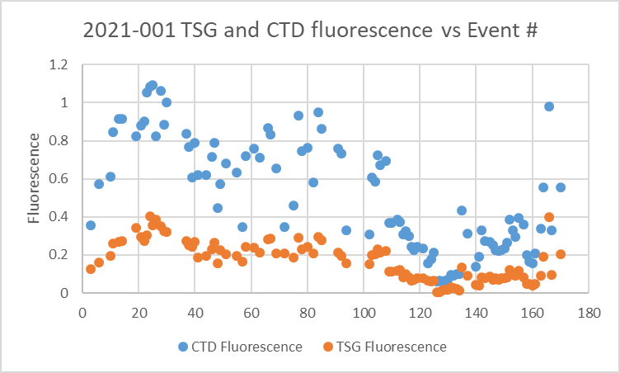

Heating in the loop (Lab Temperature – Intake Temperature) was examined carefully as it could provide evidence about flow rate variations. We expect heating to decrease as intake temperature decreases but the temperature range is too small and variability too high to judge this.
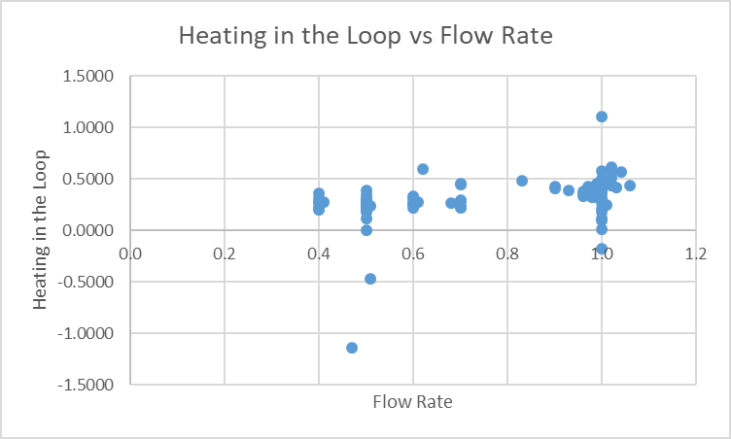
A plot against the recorded flow rate had a lot of scatter but shows less heating at low flow rates, which is the opposite to what we expect. Plots against latitude and longitude also suggest slightly less heating in the inlets. So it is very unlikely that the flow rate recorded is low; if anything the rate may have been higher in the inlets than offshore.

The TSG salinity was found to be lower than the CTD salinity by 0.179psu using all data but the standard deviation was 0.443psu. When only events #37 to 51 the same median was found and the standard deviation was very low at 0.0006psu. The differences were remarkably steady with all large outliers associated with high standard deviation in the TSG salinity over the 2-minute averaging interval.
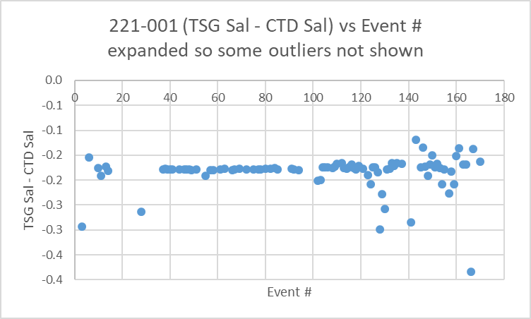

- Comparisons of Loop samples and TSG data
There were 25 loop Salinity and Chlorophyll samples of which 8 were taken while stopped and the rest while underway. Salinity and chlorophyll samples were available from the rosette for the stopped cases.
Rosette and TSG data were found to compare with the loop samples. All samples had chlorophyll <0.9ug/L. Underway samples included 4 with CHL>1ug/L.

TSG salinity was lower than loop samples by a median of 0.181psu, by 0.181psu while underway and 0.180psu while stopped. Outliers were associated with higher standard deviation in the TSG salinity. The only significant difference was the standard deviation which was much higher for the underway, doubtless because the time difference between the two data sets has little effect when stopped.

TSG fluorescence was 42% of loop CHL while underway and 85% when stopped. That difference is likely because the highest CHL values mostly occurred while underway and the FL/CHL ratios tend to be lower when CHL is higher. Plots against flow rates did not suggest any relationship.

- Comparison of 5m Rosette samples and Loop samples
There were 8 salinity and extracted chlorophyll loop samples taken during rosette casts. Salinity values were very close with the loops lower by a median of 0.0013psu (std. dev. 0.0027psu). All loop chlorophyll samples were lower than rosette samples, with a median ratio Loop/Rosette of 75% (std. dev. 0.05). All CHL values were < 0.8ug/L.

d.) Calibration History
- The TSG and fluorometer were recalibrated shortly before cruise 2020-001.
- During 2020-001 which mostly sampled offshore and with mostly well-mixed surface waters, the TSG salinity was found to be lower than that from the CTD and loops by ~0.002psu. TSG temperature was higher than the CTD by ~0.01Cº. Salinity and fluorescence traces looked good.
- During cruise 2020-028, which mostly sampled inshore, the TSG salinity was found to be lower than that from the CTD by ~0.015psu but there was a high standard deviation. TSG temperature was higher than the CTD by ~0.01Cº. Salinity and fluorescence traces looked excellent.
- During cruise 2020-005, which mostly sampled offshore, the TSG salinity was found to be lower than that from the CTD by ~0.014psu and lower than loop samples by 0.05psu. The loops were higher than rosette samples despite the fact that the latter likely came from lower in the water column. TSG temperature was higher than the CTD by ~0.03Cº though the standard deviation was high. Salinity and fluorescence traces looked excellent. TSG Fluorescence tracked the CTD trace quite well though values at the low end of the range generally looked higher than those measured by the CTD sensor. At the high end they read lower.
- During 2020-069 comparisons were of limited value due to many casts being near-shore and many in inlets. Offshore the salinity appeared to be low by about 0.06psu but in Queen Charlotte Sound it was low by ~0.30psu. The difference was thought to be more likely due to suspended sediments rather than calibration drift. The TSG intake temperature was higher than that from the CTD by about 0.13 Cº offshore and 0.20 Cº in Queen Charlotte Sound. TSG fluorescence compared reasonably well with CTD fluorescence in Queen Charlotte Strait but not in inlets. The fluorometer was not functioning well in the 1st half of the cruise.
- During 2020-008 the TSG salinity was found to be lower than CTD salinity by a median of 0.1099psu, and lower than loops by 0.1137psu when stopped. Loop salinity values were very close to rosette salinity. The comparison with CTD salinity suggests that the calibration was slowly drifting, thus complicating any analysis. Salinity was recalibrated by adding 0.11psu. The TSG intake temperature was lower than the CTD temperature by 0.006C° which is excellent correspondence given slight differences in time and depth. The TSG fluorescence values were unusually low with many small negative values. Using an offset of 0.030ug/L instead of 0.044ug/L removes all negative numbers and leads to a minimum value for about 0.1ug/L. It is likely that the scale factor should also be increased since the ratios of TSG FL to Extracted CHL and TSG FL to CTD FL both looked low. Recalibration was applied by adding 0.221ug/L to fluorescence and subtracting 0.11psu from salinity.
- During 2020-009 the TSG salinity was found to be lower than CTD salinity by a median of 0.18psu but there was some drift with time and a time-dependent correction was applied. Vertical gradients were fairly high so some of the difference might have been due to small mismatches in depth of sampling. The TSG intake temperature was higher than the CTD temperature by 0.003C° which is excellent correspondence given slight differences in time and depth. The TSG fluorescence values were believed to be low and a correction was applied that effectively reduced the offset to 0.3V to avoid negative values. After cast #103 the fluorescence data were considered unreliable and those data were removed.
- Cruise 2020-083 TSG data were not available at the time of processing.

e.) Conclusions re TSG
1. The TSG clock worked well and position information was available and reliable.
2. The flow rate as recorded by the meter was very steady offshore but much lower nearshore. However, tests run at sea suggest that it was actually much higher than the record shows. For the latter part of the cruise the reading of 0.5 is believed to correspond to about 1L/minute.
3. The TSG salinity was found to be lower than CTD salinity by a median of 0.178psu, and lower than loops by 0.181psu with no significant difference between underway and stopped samples. There is no evidence of drift through the cast. Salinity will be recalibrated by adding 0.18psu.
4. The TSG intake temperature was higher than the CTD temperature by ~0.02C° offshore but if only casts with a low standard deviation in the intake temperature are included it is high by a median of 0.009C°. In the inlet section it was found to be low by a median of 0.001C° but the standard deviation was very high. No recalibration is justified as the differences are reasonably small given some differences in depth and time between the 2 data sets.
5. The TSG fluorescence values are about 32% of those from the CTD and 74% of the loop CHL samples. Since the loop samples are about 75% of the rosette samples, the TSG fluorescence is about half the rosette samples. The CTD fluorescence was close to the CHL rosette samples in the inlets but much higher offshore. This is typical of how the CTD fluorometer works in low CHL. The TSG fluorometer appears to perform better offshore, but is a little low in the inlets.
6. Loop and rosette salinity samples compared very well, while the loop chlorophyll was about 75% of that from the rosette.

g.) Editing
Time-series plots were examined and showed no need to edit the data.

h.) Preparing Final Files
REMOVE was used to remove channel Pressure, Temperature:Difference , and record #.

i.) Calibrate
CALIBRATE was used to add 0.18psu to channel Salinity

HEADER EDIT was used to change the DATA DESCRIPTION to THERMOSALINOGRAPH and add the depth of sampling to the header and to change channel names to standard names and formats and to add comments including mention that the flow meter values are not considered reliable.
A cross-reference list was prepared.
The TSG sensor history was updated.
As a final check plots were made of the cruise track and time-series and all looks fine.

Loop File
The Chief Scientist provided file 2021-0001 Loop log.xlsx which included event numbers, sample numbers and what was sampled. Earlier in the processing the loop samples were used to study the TSG calibration. Times were added based on the log entries. For loops taken at the same time as 5m rosettes, the times were set to the ends of casts. Those data were copied to file 2021-001-tsg-ctd-loop-rosette-comp.xlsx.

A 6-line header spreadsheet was prepared using a template from previous cruises.
The sampling method column was added and filled with USW.
The columns in the loop-data file were arranged in the order required for the 6-line header used to prepare the loop file.

Next data from near-surface rosettes were obtained.
The CHE files were put through program DERIVE to obtain sigma-t.
Clip was run to choose only data between 0db and 7db.
Data from those files were exported to file 2021-001-che-surface.csv. The Oxygen:Dissolved and Oxygen:Dissolved:SBE channel in mass units were included and Draw Temperature.
The Start Time was divided into 2 columns using “Text to Columns” under the DATA tab in Excel. The times in the files are start times and the samples were actually taken near the end of the cast, so the times were edited to match the End Times in the log book.
(An alternate approach is to calculate End times from the full files (*.CLN) and export those to a spreadsheet.)
A sample method column was added. ROS was entered for the method.
That data was then added to the 6-line header.
The data were sorted on event number, sampling method and pressure.
That file was saved as 2021-001-surface-6linehdr.csv.
The file break column was filled with value 1 so all data will be in a single file when converted.

CONVERT was run to produce an IOS Header file.
CLEAN was run to get start and stop times and positions and to add flag 0 to empty flag cells.
A comment file was prepared which was essentially the same as the one used in preparing CHE files but including a description of the loop system and comments on the CTD data processing.

Header Edit was used to correct channel names and formats and to add comments. The final file was renamed as 2021-001-surface.loop. The track plots look reasonable and plots of temperature and salinity versus event numbers, latitude and longitude look reasonable.

Particulars - Notes from Daily Science Log and Sampling Notes
PAR off: 51, 55, 57, 58, 61, 63, 67, 69, 75, 77 ,78, 82, 84, 85, 91, 92
Casts with bottle fired out of order: None.
Casts with no Niskin closed: 46 (cast run only to close 5m bottle – no archiving).
Wrong depth in headers: 39, 40, 41, 49, 57, 58, 63, 67, 110, 121, 133, 140, 151, 170.
Wrong station name in headers; 6, 19, 110

Deployment schemes:
2-94 – Down to 10m, 30s wait, up to surface, 30s wait, then cast began.
102 – CTD at surface for 1min while archiving, archiving started manually, then cast began.
103-170 – CTD set to archive immediately, at surface 1 min, then cast began.

1-25. Error in cruise # in header – fixed.
1 – All bottles fired at surface – no sampling –no CTD or CHE file needed.
2. Bottles closed at surface to test integrity – no sampling.
2. TSG started after this cast at 0330.
22. Server computer corrected – was ahead by 2 minutes.
23. Header longitude looks wrong – TSG confirms log position matches system Upload Time, but header longitude matches header NMEA Time. Presume file started 10min before archiving began. Conversion to IOS SHELL adapted to always pick System Upload Time.
28. Weird Sounder and altimeter.
30. Sounder not refreshing – restarted – Good.
39. Bottle 14 leaking; top cap maybe not sitting very well - replaced with new bottle, different type lanyard. Bottle 14 not needed for CHE file.
40. Bottle 14 leaking – replaced with old lanyard. Bottle 14 not needed for CHE file.
44. Several stops due to wire angle – 1 on downcast, 2 on upcast.
46. Bottle didn’t get tripped during cast. Rosette redeployed to get the sample. Down 10 to surface, up to 5db. BL file created to enable conversion of bottle file.
51. Depth seems off – usually 3275 – this time 3229.
67. Fluorescence noisy in mixed layer; removed, dried and sprayed electrical conductivity spray on cable.
100. TSG flow rate adjusted from 0.8 to 1.0L/min.
101. Measured loop flow at sink, found 1.6L/min so adjusted flow to 0.5 on table, measured 1L/min. Measured flow 1L/min reading 0.8 on output table.
103. Stop to correct wire angle on way down.
105. Windy, corrections due to wire angle.
115, 116 – stopped short of station due to wind and current.
125. Rosette left hanging on LARS due to hydraulics line blowout. Recovered.
166. Niskins 15-24 not needed, no sampling.

2021-001
CRUISE SUMMARY – CTD
CTD# | Make | Model |  | Serial# |  | Used with Rosette? |  | CTD Calibration Sheet Competed?
1 | SEABIRD | 911+ |  | 550 |  | Yes |  | Yes
Calibration Information - 0443
Sensor |  |  |  |  | Pre-Cruise |  |  |  | Post Cruise
Name |  |  | S/N |  | Date |  | Location |  | Date | Location
Temperature |  |  | 2106 |  | 12Dec2019 |  | Factory
Conductivity |  |  | 2280 |  | 03Jan2020 |  | Factory
Secondary Temp. |  |  | 2663 |  | 12Dec2019 |  | Factory
Secondary Cond. |  |  | 2754 |  | 17Dec2019 |  | Factory
Transmissometer |  |  | 1185DR |  | Oct 2020 |  | Factory
Transmissometer |  |  | 1883DG |  | Oct 2020
SBE 43 DO sensor |  |  | 997 |  | 23Jan2020 |  | Factory
PAR |  |  | 70614 |  | 21Mar2016 |  | Factory
SeaPoint Fluor. |  |  | 3949
Pressure Sensor |  |  | 0550 |  | 09Jan2020 |  | Factory
Altimeter |  |  | 75321 |  |  |  | Factory

TSG Make/Model/Serial#: SEABIRD/45/0620
Calibration Information
Sensor |  | Pre-Cruise |  | Post Cruise
Name | S/N | Date | Location | Date | Location
Temperature | 0620 | 21Jan20 | Factory
Conductivity | 0620 | 21Jan20 | Factory
WETStar Fluorometer | 953 | 30Dec2019 | Factory

