**Revision Notice Table**

|  |  |
| --- | --- |
| **Date** | **Description of Revision** |
| 11 July 2023 | DO:Saturation converted to DO:Concentration. Fixed scientist name format.  Removed some bad data from the bottom of casts 24, 31, 32, 40. S.H. |

**RBR CTD DATA PROCESSING NOTES**

Cruise: 2020-085

Agency: OSD

Locations: Portland Inlet, Observatory Inlet, Hastings Arm, Haida Gwaii

Project: North Coast Oceanography (small boat work)

Party Chief: Page, S.

Platform: CME Anderson

Date: October 10, 2020 – October 18, 2020

Processed by: Samantha Huntington

Date of Processing: 23 June 2021 – 5 August 2021

Number of Raw files: 33 Number of Processed files: 32

**INSTRUMENT SUMMARY**

Equipment: RBR Concerto CTD (s/n 204694) with a Turner Cyclops Fluorometer (s/n 21101282) and a JFE Advantech Rinko III oxygen sensor (s/n 411).

Sampling frequency was at 8Hz.

**SUMMARY OF QUALITY AND CONCERNS**

A CTD Log Sheet was provided with times and positions of all casts.

The data looked good overall.

**PROCESSING SUMMARY**

1. **Conversion to IOS Headers**

Excel spreadsheets were exported from 204694_20201010_1454_fixed.rsk, 204694_20201012_1546_fixed.rsk and 204694_20201017_1907.rsk, using RUSKIN software. Single csv files for each profile containing all the data including event numbers and a single line of headers were exported from the spreadsheets using python function READ_EXCELrsk().

Event numbers were created by matching the profiles to the file EventLog_2020-085.pdf. Times and maximum depth were compared, while depth compared well, a time discrepancy in two of the rsk files was noted. Times correlated well for file 204694_20201017_1907.xls. For file 201694_201010_1454_fixed.xls the times are about 1 hour earlier than in EventLog_2020-085.pdf. For file 204694_20201012.xlx the times are about 1 hour and 9 minutes earlier than in EventLog_2020-085.pdf.

These individual profile csv files were then merged into a single csv file 2020-085_CTD_DATA.csv using python function MERGE_FILES(). A profile from 204694_20201010_1454_fixed.rsk with a start time of 21:14:53 and an end time of 21:19:09 with a maximum depth of 65 metres, did not match any of the events for that day on the Event Log. This profile was not processed.

A 6-line header was inserted using python function Add_6lineheader().

File “2020-085_header_merge.csv” was created based on the file EventLog_2020-085.pdf. Latitude and Longitude Data were entered into the template “Template_HeaderMerge_Reformat.xlsx” for reformatting and values were pasted into the final file.

* Column “File_Name”: entries were derived from the event number.
* Column “LOC:LATITUDE”: latitude data were taken from the EventLog.pdf and reformatted to “XX XX.XXXX N !(deg min)”.
* Column “LOC:LONGITUDE”: longitude data were taken from the EventLog.pdf and reformatted to “XX XX.XXXX W !(deg min)”.
* Column “LOC: Event Number”: entries were event numbers.
* Colmun “LOC: STATION”: station data were taken from EventLog.pdf.

Sampling sites were mapped with file “2020-085_header_merge.csv” (Figure. 1) using python function PLOT_TRACK_LOCATION() to check the location of all casts.

Corrections for zero-order holds: Prior to spreadsheet conversion, python function Plot_Pressure_Diff() was run to check the zero-order holds in pressure. Zero-order holds were found (Figure 2.) and these values were replaced with Nan using the python function Correct_Hold(). A new csv file was created 2020-085_CSV_DATA-6Linedr_corr_hold.csv and the corrected values were checked in python function Plot_Pressure_Diff(). Zero-order holds were found to be removed (Figure 3.).

CONVERT Spreadsheet files was run to produce files with IOS Header format. Header entries of “Administration”, “File” and “Instrument” were filled in this step.

Raw data were plotted and examined:

Salinity – data looks OK except for some bad data bottom of cast 24.

Temperature data - looks OK except for some bad data at the bottom of casts 24, 32, 33 and 37.

Conductivity - data looks OK except for some bad data at the bottom of cast 24.

Oxygen - data looks OK except for some bad data at the bottom of casts 24, 25 and 30.

Fluorescence – looks OK.

The routine “Merge: CSV file to headers” (Utilities > Merge: CSV file to Headers) was run to add the location headers to the IOS files.

Next CLEAN was run to add a start time and event numbers to the headers.

1. **Data processing**

* Calibration to Pressure: there were not enough negative pressures to warrant a correction.
* Data despiking: There are no significant spikes in temperature, conductivity and salinity. So there is no need to apply data despiking.
* CLIP: Pressure is steady for a variable number of scans among casts (). Initial records were removed until the downcast began as well as when the upcast ended. 2020-085_CLIP.csv was created containing event numbers, start record, and end record to be used used in the CLIP routine.
* FILTER: A Gull-winged filter, size 9, was applied to temperature, conductivity, pressure and fluorescence. Salinity will be recalculated in the next step.
* SHIFT: Based on suggested values in document “Guidelines for processing RBR CTD profiles” the following adjustments were made to conductivity and dissolved oxygen channels:
* The alignment of temperature and conductivity was correct by applying a shift of -2 scans in conductivity. Salinity was also recalculated.
* Better alignment with oxygen profiles was found by advancing it by 11 scans (1.9s). The advice given in document “Guidelines for processing RBR CTD profiles” was that an advance between 2 and 3 seconds is appropriate. T-02 plots before and after alignment were compared.
* DELETE was run to remove records with descent rate lower than 0.3m/s over 8 points. This was not applied in the top 10m to avoid loss of surface records as the CTD began its descent.
* Profile plots were examined after DELETE and confirm that plots show reasonable values for fluorescence, temperature and salinity. DO saturation values at the surface ranged from 67% to 98%. However, there was no calibration sampling and no climatology to enable a judgement about the data reliability.

1. **Final checks and header editing**

* REMOVE was run to remove the following channels from all casts: Date, TIME:UTC and Event.
* BINE AVERAGE was used to metre-average data.
* CALIBRATE was run to convert conductivity units to S/m using file 2020-085_calib_C.CCF.
* Header Edit was used to add comments about the time discrepancies using file 2020-085_HDR.TXT. Channel names and format were also fixed as listed below:
* Pressure: format F11.2 ==> F7.1
* Salinity:CTD ==> Salinity
* Fluorescence ==>Fluorescence:URU
* Oxygen ==> Oxygen:Dissolved:Saturation:RBR

ML/L==>%

F11.4==>F8.2

* Conductivity:F10.5 ==>F10.6
* CLEAN was run to reset the Maximum and Minimum values in the header.
* Header Check was run and no problems were found.
* DO concentration was not derived since there are various equations used for this purpose, so it is left to the users to choose one consistent with other data in their studies.

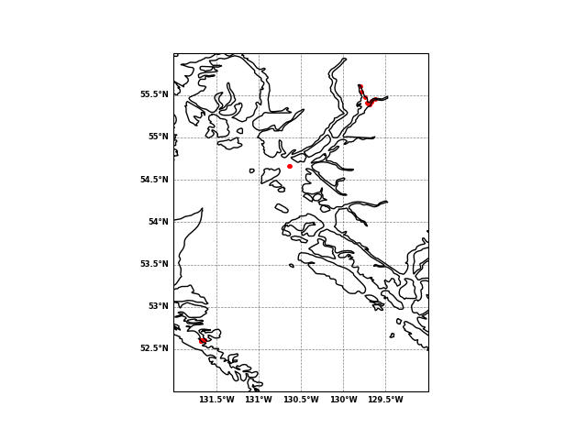

Figure 1.

Figure 2.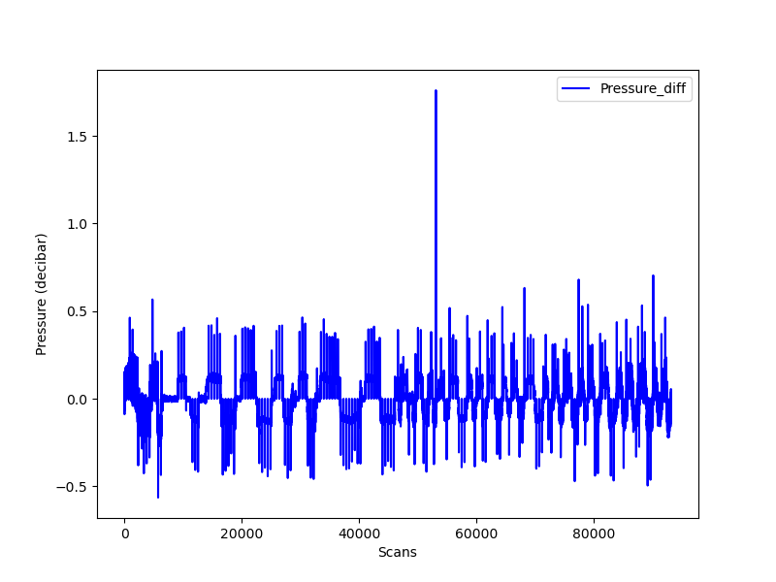

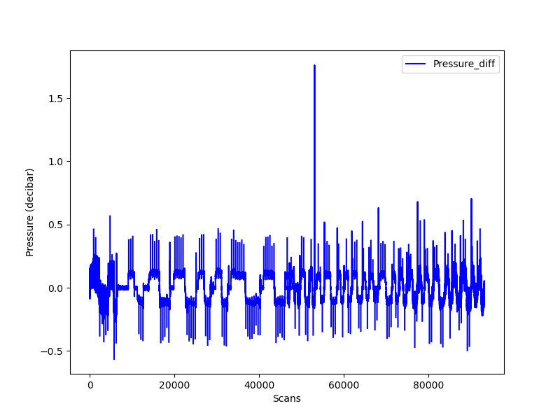

Figure 3.