Comparison of RBR and SBE casts

The following is an extraction from document 2020-083_Processing_Report.doc. It describes an experiment run during the cruise to compare an RBR Concerto CTD with an SBE 911+ CTD.

An RBR CTD was strapped to the rosette during 20 casts between events #148 and 178.
The RBR files were processed by Lu Guan. A few adjustments had to be made to enable the comparison:
- The file names had the wrong format for some files and the event numbers were sequential rather than matching those in the log book. So file names were adjusted.
- The log appears to indicate that the RBR was first attached to the SBE CTD for event #147, but the note in the log just records the RBR serial number so this may not have been intended to suggest that it was in use for this cast. In fact, the first file corresponds in depth to event #148 and if that is assumed to be the first file then renaming proceeds in reasonable order.
- A spreadsheet with positions, station names and event numbers was prepared and used to merge with the RBR file headers. Then CLEAN was used to change the file names so that the final 4 digits match the event numbers in the header.
The CTD files from the SBE processing were adjusted by deriving oxygen saturation.

Comparisons were done using COMPARE to look at the whole data set together and by comparing some individual casts.

COMPARE:
- The CTD files from both sources were thinned to <50 points.
- Data above 175db were excluded from comparisons because there was a lot of variability, likely due to small vertical offsets.
- The RBR temperature below 175db was lower than that from the SBE by an average of 0.0026C° with a standard deviation of 0.0003C°.
- The RBR conductivity below 175db was higher than that from the SBE by an average of 0.00058S/m with a standard deviation of 0.00007S/m.)
- The RBR salinity below 175db was higher than that from the SBE by an average of 0.0047psu with a standard deviation of 0.0008psu.
- Fluorescence from the RBR was generally higher, especially so near the surface. When outliers were removed that had RBR values of 0 (very close to the surface), the fit was:
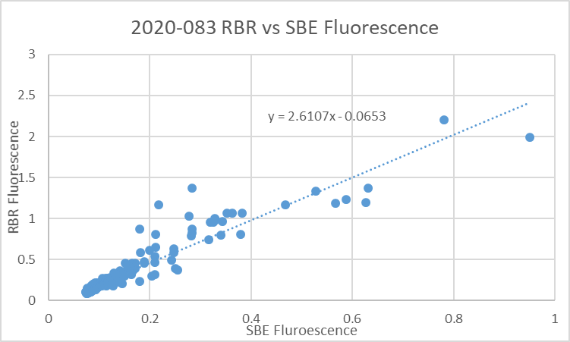

The offset is very small; setting it to 0 leads to RBR FL = 2.27 * SBE FL
Given that the SBE fluorescence was about 50% of the chlorophyll samples, the RBR values may be more reliable, though that is a matter left for chlorophyll specialists to determine.
- Comparing dissolved oxygen sampling produced an odd fit, with the RBR generally reading lower than the SBE but sometimes higher. Most of the higher cases came from a single cast, #172. While the RBR could have been in a slightly different position from the other casts the vertical offset required is too large to explain that way. The pumps were late coming on for the SBE system but once operating the temperature and salinity differences do not look different from other casts, so there does not appear to be a general pump problem with the SBE. But the dissolved oxygen looks lower than all other casts in that region, so that channel was removed from the CTD file.

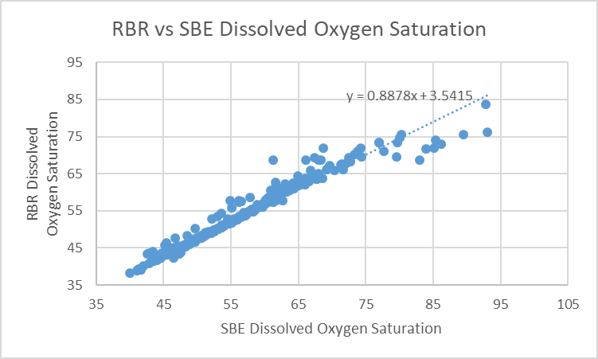
When that cast is excluded from the comparison the RBR reads lower than the SBE by an average of 2.7% below 20db and 2.2% below 175db (std. dev. 0.2%).
The dissolved oxygen values from the SBE sensor on cast #172 were found to have low values compared to all other sites in the region, so the outliers in this fit are due to the SBE and the RBR data are likely fine.
There is not clear evidence of which sensor is producing better results. The SBE sensor was recalibrated based on a previous cruise because most casts from this cruise were in areas with poor flushing of Niskin bottles.

COMPARISON OF PAIRS
Plots were made of RBR and SBE data together for individual casts to check the profile and T-S plot shapes:
- Because RBR temperature is lower and salinity higher than SBE values, the question is whether the differences are due to vertical offsets. If they are they should look the same in T-S space, but they do not. In shallow water there is too much variability but in deeper water when matching density the RBR data are generally warmer and saltier.
- Looking at profiles in pairs there is good correspondence in shapes of the profiles, but matching pressures the temperatures are lower by about 0.0025 and salinity higher by about 0.004psu, similar to results found in COMPARE. RBR Conductivity is higher by ~0.0005 S/m.

CONCLUSIONS:
- There was insufficient information to compare pressure readings since the RBR data had been averaged. Even with complete files this is difficult to judge, but it is unlikely to be a significant factor in the differences found between the 2 CTDs in deeper water.
- The RBR temperature is low and conductivity is high, both of which contribute to salinity reading high by about 0.005psu. The SBE salinity had been recalibrated by adding 0.004psu. We can conclude that either the SBE salinity required a larger correction or the RBR is reading too high. The post-cruise factory check of the SBE sensors indicated the primary salinity was low by 0.006psu in December 2020, so assuming all of that drift had occurred by the time of this cruise, the RBR would be reading high by only 0.003psu. However, the bottle comparison suggests that some of the SBE drift did occur either late in this cruise or after this cruise. So the RBR likely has salinity that is a little high (0.003 to 0.005psu) and temperature a little low (~0.0026C°).
- The dissolved oxygen values from the RBR appear to be slightly low, but there is some doubt about the accuracy of the SBE DO. The recalibration was based on previous cruises with some support from the few offshore casts from this cruise. We would normally expect that the choice made for recalibration of the SBE data is an underestimate since drift is generally towards DO values reading lower, especially since the membrane needed replacing in December 2020. There is also evidence that the near-surface oxygen saturation from the SBE is in the expected range in the offshore casts. It is likely that the RBR is reading low by 3% but that is far from certain.

