**Revision Table Notice**

|  |  |
| --- | --- |
| **Date** | **Description of Revision** |
| 11 July 2023 | DO Saturation converted to DO Concentration. Removed gain change related Fluorescence spikes from cast 155. Corrected vessel name. S.H. |

**RBR CTD DATA PROCESSING NOTES**

Cruise: 2020-083

Agency: OSD

Locations: North coast

Project: North coast oceanography

Party Chief: Stephen Page

Platform: J.P Tully

Date: October 6, 2020 – October 20, 2020

Processed by: Lu Guan

Date of Processing: 16 November 2020 – 19 November 2020

Number of Raw files: 20 Number of Processed Files: 20

# INSTRUMENT SUMMARY

Equipment: RBR Concerto CTD (s/n 204694) with a Fluorometer (Chlorophyll a Turner Cyclops s/n 848, 21101282) and oxygen sensor (JFE Advantech Rinko III BT s/n 411)

Sampling rate was at 8 measurements per second.

# SUMMARY OF QUALITY AND CONCERNS

Two Eventlog Sheets were provided with times and positions of all casts.

The data overall look good through the water column but most casts have bad data at the surface for Salinity, conductivity, fluorescence and temperature, oxygen looks OK.

# PROCESSING SUMMARY

##### Conversion to IOS Headers

204694_20201016_0852.rsk was in “Full” structure. Twenty .csv files (one .csv file for each profile) containing downcast and upcast data were exported from 204694_20201016_0852.rsk file. Ran python function MERGE_FILES() to combine all profiles into a single .csv file (2020_083_CTD_Data.csv) with all the data including event numbers and a single line of headers.

A 6-line header was inserted using python function Add_6lineheader().

Sampling sites were mapped using python function Plot_Track_Location() to check the location of all casts (Fig. 1).

CONVERT Spreadsheet Files was run to produce files with IOS Header format. Header entries of “Administration” and “File” were filled in this step.

Raw data were plotted and examined:

* Salinity, conductivity and fluorescence have bad data at surface for all casts. The data through the water column look ok.
* Temperature has bad data at surface for all casts except casts: 151, 161, 172, 175.
* Oxygen looks ok, but with some bad data at surface for casts 153.

File “2020-083_header-merge.csv” was created in order to run routine “Merge csv files to Headers”.

* Column “File_Name”: entries were derived from the event number.
* Column “LOC:LATITUDE”: latitude data was reformatted to “XX XX.XXXX N ! (deg min)”.
* Column “LOC:LONGITUDE”: longitude data was reformatted to “XXX XX.XXXX W ! (deg min)”.
* Column “LOC:Event Number”: entries were event numbers.
* Column “LOC:STATION”: entries were set equal to the event numbers.

The routine “Merge: CSV Files to headers” was run to add location headers to the IOS files.

##### Data processing

* Correction to Pressure: The RBR CTD records total pressure and a corrected pressure with atmospheric pressure removed. Estimate of air pressure provided by RBR CTD pressure sensor is reasonable. Looking at the original data, pressure reading starts from a value between 0.6db and 2.2db of every individual cast, but the pressure ends at 0.1db when the conductivity falls rapidly to near zero for all casts.

While this is not a significant error, pressure correction is not necessary.

* Data despiking: The are no significant spikes in temperature, conductivity and salinity. So there is no need to apply data despiking.
* CLIP: Pressure is steady for variable number of scans (538-1883) among casts. CLIP was used to remove bad data from the surface of all casts. For most casts between 700-1000 records were removed from the beginning of the scan. For cast 141 -1883 scans were removed, for cast 176 – 1082 scans were removed and for casts 177 and 178, 538 and 544 scans were removed respectively.
* Filter: A Gull-winged filter, size 7, was applied to temperature, conductivity, pressure and fluorescence. Salinity was NOT recalculated.
* SHIFT: Based on suggested values in document “Guidelines for processing RBR CTD profiles” the following adjustments were made to conductivity and dissolved oxygen channels:
  + The alignment of temperature and conductivity was corrected by applying a shift of -2 scans in conductivity. Salinity was recalculated. Plots (Salinity and T-S) before and after SHIFT were compared.
  + Better alignment with oxygen profiles was found by advancing it by 20 scans (3s). The advice given in document “Guidelines for processing RBR CTD profiles” was that an advance between 2 and 3 seconds is appropriate. T-O2 plots before and after alignment were compared.
* DELETE was run to remove records with descent rate lower than 0.5m/s over 4 points. This was not applied in the top 5m to avoid loss of surface records as the CTD began its descent.
* Profile plots were examined after DELETE and confirm that plots show reasonable values for temperature, salinity, and fluorescence. DO saturation values at the surface ranged from 36% to 94% However, there was no calibration sampling and no climatology to enable a judgement about the data reliability.
* CLEAN was run to add a start time to the headers.

##### Final checks and header editing

* REMOVE was run to remove the following channels from all casts: Date and Time:UTC.
* BIN AVERAGE was used to metre-average data.
* CALIBRATE was run to convert conductivity units to S/m using file 2020-083-recal2.ccf.
* REORDER Channels was run to rearrange the order of channels.
* Header Edit was used to update header information of “Instrument” and “Comments”, and to fix channel names and format as listed below:
* Pressure: format F11.2 ==> F7.1
* Salinity:CTD ==> Salinity
* Fluorescence ==>Fluorescence:URU
* Oxygen ==> Oxygen:Dissolved: Saturation:RBR

mL/L ==> %

F11.4 ==> F8.2

* Conductivity: F10.5 ==> F10.6
* DO concentration was not derived since there are various equations used for this purpose, so it is left to the users to choose one consistent with other data in their studies.

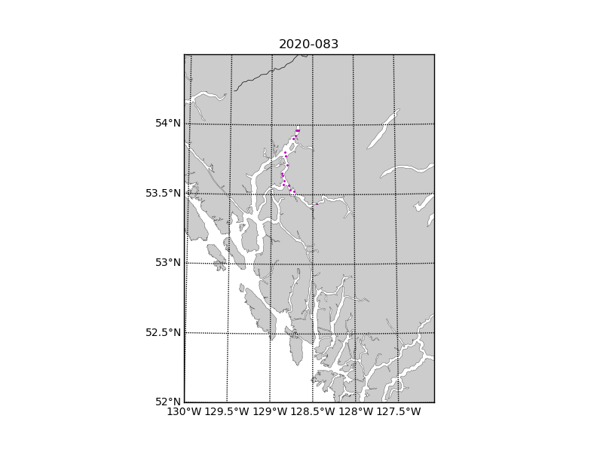

Figure 1. Map of sampling sites 1-20.