REVISION NOTICE TABLE
DATE | DESCRIPTION OF REVISION
26 Feb 2025 | Removed original Silicate & Flag:Silicate channels and renamed corrected versions of those channels. G.G.
27 March 2023 | Added HPLC data. J.R.

PROCESSING NOTES
Cruise: 2020-047
Agency: IOS, Ocean Sciences Division, Sidney BC
Chief Scientist: Young K. Platform: Neocaligus
Location: Strait of Georgia Project: Strait of Georgia Zooplankton
Date: 17 February 2020 –21 February 2020

Processed by: Germaine Gatien
Date of Processing: 28 July 2020 – 4 August 2020
Number of original HEX files: 27
Number of CTD files: 27 Number of BOT files: 17

INSTRUMENT SUMMARY
A SeaBird Model SBE-25 CTD (s/n 0334) was used with temperature sensor #5130, conductivity sensor #3500, Wetlabs ECO Fluorometer #4185, dissolved oxygen sensor #3234 and pressure sensor 0573.

SUMMARY OF QUALITY AND CONCERNS
The log book was in good order with comments about problems encountered.

File names were non-standard – just missed a hyphen between the year and cruise number.

Header information was entered in the raw files in a format that enabled easy conversion into IOS Header format. This definitely saves processing time.

The times in the log book were UTC. The file times were in PST. Processed files have UTC times.

There were some CTD instrumental problems:
- There were problems with fluorescence and dissolved oxygen data from 4 casts. The problems in DO involve 2-sided spikes that become much smaller when bin-averaged and look at least as bad during upcasts and often worse. The fluorescence spikes are mostly small and in deep water but for cast #6 they are very large. So downcast data were selected for the 4 casts but for event #6 fluorescence values between 165 and 310db were padded. The problem disappeared after connections were dried and sprayed with silicon.
- For events #31 to 42 the CTD was taken out of the water very briefly at the end of the soak period and this affected data in the top 3 to 5db of the full downcast. Upcast data were selected for those events.

There were surface bottles fired at 16 sites; they were given separate event numbers from the CTD casts. At 5 of those sites there was also a Niskin mounted 1m above the CTD to collect near-bottom samples, but in one case no CTD data were acquired. In the BOT files all sample data are identified by the event number of the corresponding CTD cast.

Bottle samples were available for salinity and fluorescence. They suggest that the CTD salinity was reading a little high, but incomplete flushing of Niskin bottles probably explains the differences seen so no recalibration was applied to CTD salinity.

Extracted chlorophyll samples were taken at the surface only and values were low so the comparison with CTD fluorometer data is not suitable to make conclusions about the sensor performance.

PROCESSING SUMMARY
1. Seasave - This step was completed at sea. The file names were in non-standard format.
The names were corrected after conversion to CNV format.

2. Preliminary Steps
The Daily Log, rosette logs and a spreadsheet of sampling done were obtained.
The deployment method used was as follows:
- The CTD was switched on, a 2-minute timer was started and the CTD was put in the water. It was taken down to 10m and after 30s returned to the surface where there was a wait until the 2 minutes were up. The full cast was then started. This method can be helpful as by removing the first 950 records the initial soak can be removed in most cases.
- Bottle deployments for most stations were taken at 0m only. For 3 stations there was sampling using a Niskin bottle mounted 1n above the CTD frame; there were notes in the log about the distance between the Niskin and CTD frame for each cast.
The cruise summary sheet was completed.
It was noted in the log that there were problems with the dissolved oxygen sensor during events 31-43 so upcast data may be needed for those casts.

3. Conversion of Raw Data
The configuration file used at sea was correct. It was saved as 2020-047-ctd.xmlcon and used to convert all HEX files..

An initial conversion showed that surface pressures look good with conductivity falling to about 0 when pressure is <0.1db. The deep fluorescence values are about 0.3ug/L though there are spikes to negative values near the bottom. The fluorescence values may be a little high but not as high as noted during some 2019 cruises in this program. This fluorometer was recently serviced. The only calibration sampling is at the surface. All expected variables are present.

Plots show that the channels all produced reasonable values.
There is the usual steppy pressure which leads to unusual profiles.

4. WILDEDIT
The only spikes noted in the data occurred at the beginning or end of the casts or included many points, and will be removed in the normal course of editing. So WILDEDIT was not run.

5. FILTER
Normally pressure is filtered later in processing when running DELETE, but the poor resolution of this instrument means it is necessary to do this early to make sense of the other data which update more often than pressure. So program FILTER was used to apply a low-pass filter with a time constant of 0.5 seconds to pressure. The results were excellent.
Next the temperature and conductivity were examined and the usual approach of applying a cosine filter size 5 in routine WFILTER did a good job of removing small reversals.

6. ALIGNCTD
Based on tests run for other cruises in this project using the same DO sensor, ALIGNCTD was run on all casts to advance the DO channel by 2.5s. Plots were examined after this step and the results look excellent.

7. CELLTM
CELLTM was run on all casts using the SeaBird recommended parameters, (α, 1/β) = (0.04, 8).

8. DERIVE
The descent rate is extremely noisy because it was derived upon conversion, before the pressure was filtered. So STRIP was run to remove that channel.
Program DERIVE was run to calculate salinity, dissolved oxygen concentration (tau correction included) and descent rate. Plots were examined and confirmed that steps 5, 6 and 7 had improved the data.

9. Conversion to IOS Headers
The IOSSHELL routine was used to convert the CNV files to IOS Headers.

CLEAN was run to add event numbers and replace pad values in the pressure channel with interpolated values. Fluorescence values <0 were replaced with pad values; while most were in the soak period, some were spikes in deep water.
The next step is to remove the data collected during soaks at 10m. Plots showed little variability in how many records occurred before the full cast. CLIP was run to remove 950 records from all casts. Plots made after this step showed that 3 casts needed to be rerun with slightly different settings for best results.

10. Checking Headers
A cross-reference list was produced and compared with the log book entries. The only error found was that a missing latitude entry for event #20 due to missing hemisphere entry in the SeaBird header. That was corrected in the SeaBird header and all steps in section 9 were repeated.

For 2 casts no data were acquired as noted in the log book.
It was also confirmed that the times in the files are in PDT so 8 hours will need to be added.

ADD TIME CHANNEL was run to add 8 hours.
Track plots looked ok so were added to the end of this report.
HEADER CHECK was run. There only negative values found appear to be spikes at the beginning and/or end of casts; most will likely be removed by DELETE. No other problems were noted.
The pressure sensor has a 2800db range so the resolution is only 0.45db and accuracy is ±2.6db so even with surface data it is difficult to assess. The surface check shows an average of 0.4db before CLIP was run. The range was from 0.05 to 1.1db.

11. SHIFT
Conductivity
Tests were run to see what shift to conductivity made the best improvement to stability in T-S space. Shifts of +0.4 records and +0.5 records both worked quite well with variation from cast to cast as to which was best, but overall +0.5 records looks like the better choice so that setting was applied to all casts.
Fluorescence
The fluorometer was not pumped, so a shift in alignment is expected to be small or unnecessary. Profile plots of temperature and fluorescence were examined and confirm that the alignment is good.
Dissolved Oxygen
This channel was aligned earlier, but checks were made by examining plots of temperature and dissolved oxygen. The alignment looks good except near the surface in files 31-42 where a problem was noted in the log. No further adjustment was made.

12. DELETE
DELETE was run on all casts using the following parameters:
Surface Record Removal: Last Press Min. Surface Swell Pressure Tolerance: 1.0
Swells deleted. Warning message if pressure difference of 2.00
Drop rates < 0.3m/s (calculated over 5 points) was deleted from 10db to 10db above the maximum pressure.
COMMENTS ON WARNINGS: There were no warnings.

REVERSE was run on all casts followed by a second run of DERIVE to produce DELREV files. This will enable a choice of upcast data for casts #31-42. The CTD came out of the water which obviously affected the dissolved oxygen data in the top 5m and it looks like this may have affected other pumped channels as well. The upcast data are quite good for this cruise due to the absence of a rosette and only one of the affected casts had a Niskin bottle. None of the casts show evidence of serious corruption by shed wakes though some mixing is likely reducing the ability to resolve small changes.

There were also problems with fluorescence and dissolved oxygen data from 4 other casts. The problems in DO involve 2-sided spikes that become much smaller when bin-averaged and look at least as bad during upcasts and often worse. The fluorescence is much better in the upcast for cast #1, but the problem is only in deep water where these data are not particularly useful and using an upcast is bad for dissolved oxygen, so the bad values will be replaced with pad values. For the other 3 casts (#18, 20 and 23) bin-averaging removes most of the problems and given the limited use made of deep values, no further editing will be applied.

13. DETAILED EDITING
All DEL files were copied to *.EDT and the *.DELREV files for casts #31 to 42 were copied to *.EDT.
So there will be a complete set of files even if some need no editing.

CTDEDIT was used to remove records corrupted by shed wakes and to clean salinity where unstable features looked likely to be caused by misalignment of T and C. 24 of 27 casts were edited lightly.
Notes of editing details were made in the headers.
T-S plots were examined after this step and no significant problems were found; there are small unstable features but this is an area where some instability is expected.
After editing the fluorescence values in event #6 were replaced with pad values between 165 and 310db.

14. Initial Bottle Data Steps
There was no rosette available for this cruise. There were surface bottles fired at 16 sites; they were given separate event numbers from the CTD casts. At 5 of those sites there was also a Niskin mounted above the CTD to collect near-bottom samples.
BOT files were prepared with the sample data plus CTD gathered at the same site.
The event numbers will be those of the CTD cast at the site.

Each of the analysis spreadsheets were examined to see what comments the analysts wanted included in the header file. These were used to create file 2020-047-bot-hdr.txt which will be updated as needed during processing. The spreadsheets for chlorophyll and nutrients include a precision study.
- Extracted chlorophyll and phaeo-pigment data were obtained in file QF 2020-047 CHL*.xlsx.
- Salinity analysis was obtained in spreadsheet QF 2020-047 SAL*.xlsx.
- Nutrient analysis was obtained in spreadsheet QF2020-047 nuts*.xlsx.

Workbook 2020-047-bottles_CTD_comparison.xlsx was created. Data from the QF worksheets were added to one sheet of the workbook. A separate sheet with a 6-line header was prepared which combined entries from the event log relevant to Niskin sampling, bottle data and CTD data at bottle depths. Another sheet was used to do a comparison of CTD and bottle data for salinity and extracted CHL. For cast #24 there were no CTD data available. Upcast data were used for events #31-42 because of poor near-surface downcasts.

To select CTD data to go with the bottle samples, a list of depths sampled in increasing order was prepared. For the deep samples there is an estimate of height above the CTD frame. CTD salinity and fluorescence data were then compared with bottle data in the Comparisons worksheet.

On one worksheet the data were organized with a 6-line header which was saved separately as a CSV file, 2020-047-bottle-plus_CTD-6linehdr.csv.

15. Compare
One sheet in workbook 2020-047-bottle_plus_CTD.xlsx was used to do a comparison between the bottles and CTD.

Salinity Comparison
For salinity the CTD was found to be higher than bottle salinity by an average of 0.002psu and range 0.002 to 0.005psu. Given that these data came from the bottom of a cast we expect that incomplete flushing of Niskin bottles would lead to bottle contents having fresher water than the ambient water measured by the CTD. A quick examination of vertical gradients in the bottom 10m indicates an average difference of 0.003psu per 10m. So the CTD salinity calibration looks good.
For more details see the “comparisons” worksheet in file 2020-047-bottles_CTD_comparison.xlsx.

Fluorescence
The only extracted chlorophyll sampling was at the surface and values during this cruise were generally low. These fluorometers tend to read higher than extracted CHL when CHL<1ug/L and the ratio usually decreases as CHL increases. The ratio FL/CHL for this cruise ranges from 0.8 to 2.5 with the highest ratio associated with the lowest CHL.

There are insufficient data and too low a range of CHL values but nothing suggests a problem with the fluorometer.
For more details see the “comparisons” worksheet in file 2020-047-bottle_plus_CTD.xlsx.

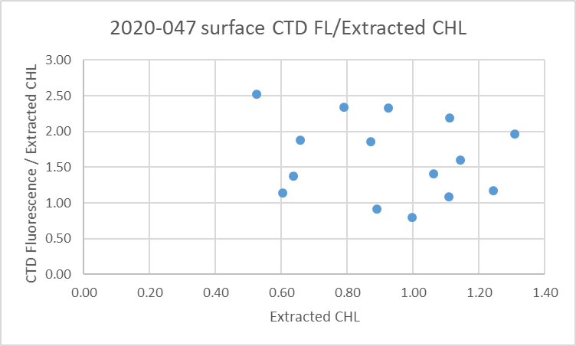

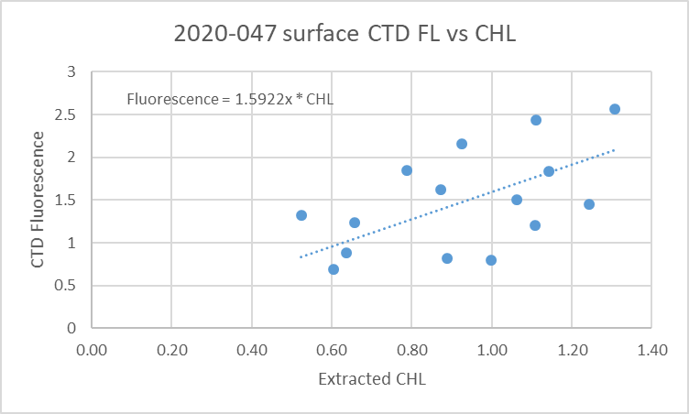

16. Other calibration checks
Sensor History – Only the pressure sensor had been used on any other cruises since the last factory service. The pressure sensor has been used for 3 other cruises with no problems noted.
Historic Ranges – Temperature data all fell within the historic range except for the Baynes Sound cast which had with slightly low values right at the surface and some low values at the bottom of the cast at station 56; the waters were very well mixed there and perhaps that is not well represented in the climatology. All salinity values were within the climatology except for 2 near-shore casts that had slightly low values right at the surface.
The excursions do not appear to be indicative of calibration problems.
Post-cruise calibrations – None were available.

17. CALIBRATE
The pressure and salinity appear to be within expected accuracy.
For dissolved oxygen there is insufficient evidence upon which to base any recalibration. There was no calibration sampling; the surface saturation values look reasonable. See section 19 for details.

18. Fluorescence Filter
The fluorescence data was not filtered as it had little effect on the data.

19. Bin Average, Remove, Derive DO in mass units, Reorder
The files were bin averaged using 1db bins.
REMOVE was run to remove Scan_Number, Oxygen:Voltage, Descent Rate and Flag channels.

Dissolved Oxygen was derived in mass units and that was used to calculate DO saturation. Plots of near-surface saturation show a range of 65 to 105%, with the lowest values coming near the Gulf Islands and one other cast where vertical mixing was strong. Most of the values between 90% and 100% come from the files that contain upcast data so this may reflect the equipment dragging deeper water with it..
REORDER was used to get the 2 dissolved oxygen channels together.

20. HEADER EDIT and final checks of CTD files.
Header Edit was used to fix headers, fix formats and to add comments about processing.
A cross-reference listing was produced.
A header check and standards check were run on the CTD files and no errors were found.
The sensor history was updated.
Plots of CTD casts were examined and no problems were found.

20. Final BOT file preparation
To enable searching of bottle data, BOT casts were created that contain sample data and CTD data from the downcast at the same site. The event number will match the CTD cast.
The values from the *.CTD files were selected for the bottle files.

The spreadsheet file 2020-047-bottle-plus_CTD-6linehdr.csv was converted to IOS Header files for each cast.

The time and date are present as channels as these cannot be converted directly into header entries.
CLEAN was run to add START and END time. The END TIME is identical so the START time so it will be removed later. CLEAN was also used to enter 0 flags where the flag channels are empty and to remove channels with only pad values.
REMOVE was run to remove the DATE and TIME channels.
There was no DO sampling so no need to derive different units.
The files were sorted on pressure.
HEADEDIT was used to add comments and to remove the END time since it is the same as START TIME.
The final files have extensions BOT.

The standards check was run until all errors had been corrected.
A cross-reference list and header check were run on the BOT files and no problems were found.
Plots were made of all BOT casts. No problems were found.
Finally all data from BOT files were extracted to a spreadsheet and compared to the rosette sheets; no problems were found.

PARTICULARS –
- All times are UTC in the log book but in PST in the files.
- CTD Deployment method: Timer set to 2 minutes. CTD down to 10m for soak until 1m 30s mark, bought back to surface to sit until 2 minutes are up. Then full cast begins.
- BOTTLES: For all stations there was a single surface bottle fired as a separate event using 1.7L bottles. During 5 of the CTD casts there was a Niskin bottle mounted 1m above the CTD frame which was fired 10m above the bottom; no CTD data were acquired for 1 of those deep bottles.

1. No CTD data acquired. Bottle did not trip.
5. Dilution experiment.
6 Fluorescence data very spiky at depth. Oxy also noisy. Both spiky around 60m.
8. Before cast checked DO/Fluoro connector for water – none found. Used compressed air to blow out any water and reconnected.
18. Fluorescence data spiky near bottom.
20. Deep bottle 1m above CTD. Fluorescence data spiky near bottom.
24. More trouble with spiky FL/DO. Before this cast dried connections and sprayed with silicon. No CTD data acquired for #24. Fluorescence problem did not recur after this cast.
29. Deep bottle 1m above CTD.
31-43. Brought CTD out of water briefly after 10m soak to check if fluoro light on. Caused problem with DO until about 10m of downcast so upcast may need to be used.
42. Deep bottle 1m above CTD.

CRUISE SUMMARY

Cruise ID#: 2020-047
Dates: Start: 17 February 2020 End: 21 February 2020
Location: Strait of Georgia Zooplankton
Chief Scientist: Young K.
CTD# | Make | Model | Serial# | Used with Rosette? | CTD Calibration Sheet Competed?
1 | SEABIRD | 25 | 573 | No | Yes

CTD CALIBRATION INFORMATION
Make/Model/Serial#: SEABIRD/SBE25/0334 Cruise ID#: 2020-047

Calibration Information
Sensor |  | Pre-Cruise |  | Post Cruise
Name | S/N | Date | Location | Date | Location
Temperature | 5130 | 12Dec2019 | Factory
Conductivity | 3500 | 17Dec2019 | Factory
ECO Fluorometer | 4185 | 11Dec2019 | Factory
SBE43 Oxygen | 3234 | 6Dec2019 | Factory
Pressure | 0573 | 1Feb2019 | Factory

