**CTD Data Processing Notes**

**Sarah Zimmermann, IOS**

**11 Mar 2021**

**Updates:**

**15 Mar 2021 – added 2020 figures after correcting oxygen.**

**Missing/To do:**

**Create CHE files when chemistry available (1 station, 3 niskin)**

**Update Arctic drive with archived files and note that data are in archive except chemistry**

**2019 text is in blue. 2020 text is in black. Question and action items in red.**

Reference:

Unahiktak Islands

CROW 2020-037

Contents

Program Summary: 1

Cambridge Bay 3

Kugluktuk 9

Paulatuk 12

Dolphin and Union Strait (Kugluktuk Patrol) May 2019 19

Preparation for IOS Archive 22

Extra Notes from the field and analysis: 23

# Program Summary:

During this program, two DFO scientist from the Institute of Ocean Sciences (Sidney, BC) went to Cambridge Bay and then to Kugluktuk. On this trip the scientists met with Rangers for training and nearby data collection. CTD casts were collected in each community.

The program was going to include a meeting with the Rangers in Paulatuk in April, however this was cancelled due to COVID-19 precautions.

This report discusses the steps followed to process oceanographic salinity, temperature, depth, oxygen and chlorophyll (CTD) data.

31 Jan to 7 Feb 2020 In Cambridge Bay (Mike Dempsey and Kristina Brown with Rangers)

10 CTD stations

7 to10 Feb 2020 In Kugluktuk (Mike Dempsey and Kristina Brown with Ranagers)

6 CTD stations

For more information regarding the program, see the cruise report: ***CROW 2020 Report.pdf***

G:\Sorted\myCROW\ODV\2020 all stations longitude Saxadjust.tif

Figure 1. All stations conducted during program.

For more figures see:

2020-37 CROW data full.pptx

N:\SHARE\DATA\2020\2020-37 CROW

# Cambridge Bay

***CTD Data:***

There are 10 stations in three data sets:

2 Feb 2020 Cambridge Bay 2 stations 065543_20200202_2045_data.txt

3 Feb 2020 Dease St 4 stations 065543_20200204_0324_data.txt

4 Feb 2020 UN Islands 4 stations 065543_20200205_0310_data.txt

Meta data are recorded in:

N:\SHARE\DATA\2020\2020-37 CROW

***Comments:***

1. UN20 station shows freezing on first and second downcast, but the third cast is fine. The new procedure of always taking 3 casts per station is excellent.
2. The RINKO oxygen was abnormally low for DS20-01, AZFP and UN10. They were 15 to 30% lower than the other stations at 95% saturation at surface. This was found to be a problem with Ruskin export software and was corrected March 2021 using the updated Ruskin software.
3. Chlorophyll sensor is dropping to 0.1 ug/l on some stations and then jumping back to the typical 0.3ug/l values. There are no phytoplankton to measure during this season, however it would be good to service this sensor.

***Equipment: Calibration Dates***

RBR Concerto 65543 w/ 6Hz sampling rate 25 Jun 2018 (RBR) new

w/ Turner Cyclops Fluorometer sensor #2102849 15 Feb 2018 (3pt-check, IOS), Jan 2013 (new)

Fluorometer set for 0 to 5 ug/l range

w/ JFE Advantech RINKO III Oxygen sensor #5 28 Feb 2019 (2pt-cal, IOS), 25 Jan 2009 (new)

Type-A foil, Reporting in % Saturation

Air thermometer SN5

Ice Auger# SN3

Downrigger# SN6

Kit# 4

***Data Collection Method:***

Follow protocol laid out in ***Ranger science manual ver7 2015.doc***

Changes to protocol:

Stations typically had a soak then three casts (RBR left in the water) per station.

***Processing:***

***2021-03-09 Update***

RBR identified and fixed the problem in Ruskin that was calculating oxygen saturation using the fixed temperature of when the CTD was turned on, not the real-time temperature.

The original *.RSK files were corrected using Ruskin 2.10.202005061945 to update the oxygen saturation value and then exported to *.TXT for further processing.

In Ruskin:

1. Changed Calibration, 5: Dissolved O2 Saturation term X7 from 0.0 to 1.0e-15
2. Clicked “Store and recompute data”
3. Export > Txt.zip

Note the *.RSK is now changed as well.

Calibration issues:

None identified

Casts:

Using Matlab, the time v. pressure data were plotted and each direction of each cast was separated and given a cast number.

For each station, the best cast was kept, typically the last downcast (ie second or third).

|  |  |  |  |
| --- | --- | --- | --- |
| **Station** | **Name** | **Cast Number Used** | **File Name** |
| **1** | CBay1 | 5 (3rd downcast) | 065543_20200202_2045 |
| **2** | West Arm | 9 (2nd downcast) | 065543_20200202_2045 |
| **3** | DS20-01 | 3 (2nd downcast) | 065543_20200204_0324 |
| 4 | DS20-03 | 11 (3rd downcast) | 065543_20200204_0324 |
| 5 | DS20-06 | 15 (2nd downcast) | 065543_20200204_0324 |
| 6 | DS20-02 | 21(2nd downcast) | 065543_20200204_0324 |
| 7 | AZFP | 5(3rd downcast) | 065543_20200205_0310 |
| 8 | UN10 | 11 (3rd downcast) | 065543_20200205_0310 |
| 9 | UN20 | 17 (3rd downcast) | 065543_20200205_0310 |
| 10 | UN30 | 21 (2nd downcast) | 065543_20200205_0310 |

Pressure:

The top 2m of data were removed from all casts. The top 2 m are influenced by proximity to the edge of the drilled ice-hole, the mix of water and ice slush. This can create falsely fresh water but also with and cooling during the cast further and beginning to freeze and reject brine this can create a density inversion along the TS freezing line.

The bottom 0.2m were removed due to poor data resulting from change of flow rate.

Temperature shift and new Salinity:

1. Applied 3 scan shift to advance temperature (typically use 2 or 3 scans).
2. Smoothed temperature and conductivity to recalculate new salinity. Conductivity smoothing only applied after first 30 scans to prevent overshooting from possible large surface salinity gradients.

Fluorometer

Processed using a low pass filter (pl66.m) with a half amplitude period of 10 scans.

Oxygen (RINKO)

RBR was configured to output percent oxygen saturation (and the unused concentration [mg/l]) and not volts. Calibration coefficients have been installed in the CTD.

Oxygen saturation was advanced by 3 seconds (18 scans) and oxygen

concentration [mL/L] was calculated from percent saturation.

Oxygen [ml/l] = full saturation concentration [ml/l] * percent saturation

Full saturation concentration was calculated using Garcia and Gordon (1992,1993) Eq.8 using coeefficients in column 1 from Table 1 (fit to Benson and Krause (1984) data) and in situ temperature.

Following correction to the RUSKIN software using RUSKIN v2.10, percent oxygen saturation and oxygen concentration [ml/l] were recalculated.

REFERENCES:

Benson, B.B., and D. Krause, 1984: The concentration and isotopic

fractionation of oxygen dissolved in freshwater and seawater in

equilibrium with the atmosphere. Limnology and Oceanography, 29,

620-632.

Garcia, H.E., and L.I. Gordon, 1992: Oxygen solubility in seawater:

Better fitting equations. Limnology and Oceanography, 37, 1307-1312.

Garcia, H.E., and L.I. Gordon, 1993: Erratum: Oxygen solubility in

seawater: better fitting equations. Limnology and Oceanography, 38,

656.

Removed all pressure reversals

Interpolated to 0.2db levels. These are NOT averages of bins but linear interpolation to 0.2 db levels using the nearest points.

Special edits:

Station Edit

All Reprocessed data with Ruskin 2.10 to correct oxygen.

Saved this cleaned dataset to matlab *.mat file and an ODV *.o4x file

2020-37_CROW_CamBay1_cleandowncasts.mat, 2020-37_CROW_CamBay1.o4x

2020-37_CROW_CamBay2_cleandowncasts.mat, 2020-37_CROW_CamBay2.o4x

2020-37_CROW_CamBay3_cleandowncasts.mat, 2020-37_CROW_CamBay3.o4x

Used script file ***p_RBR_CROW_2020_CB1.m*** for processing stations 1,2.

Used script file ***p_RBR_CROW_2020_CB2.m*** for processing stations 3 to 6.

Used script file ***p_RBR_CROW_2020_CB3.m*** for processing stations 7 to 10

***Science:***

* **Below 15m, Dease St and Unahitak Stations are all 0.5 to 1PSU fresher than 2019. These waters are the least dense of all years we’ve measured during the CROW program.**
* No chlorophyll signal as expected.
* Cambridge Bay deep water is warmer, fresher, and lower in oxygen than previous 3 years suggesting there has no (or little) overturning nor recent flushing.
* There is a higher temperature at the base of mixed layer (remnant summer heating) then in previous years, though note that these data are collected early Feb, about a month earlier than in 2019 and winter processes may cool the water further.

***Suggestions:***

Send Fluorometer sensor in for repair/examination.

Calibrate conductivity on RBR CTD.

Continue method of 3 casts per stations.

***Figures:***

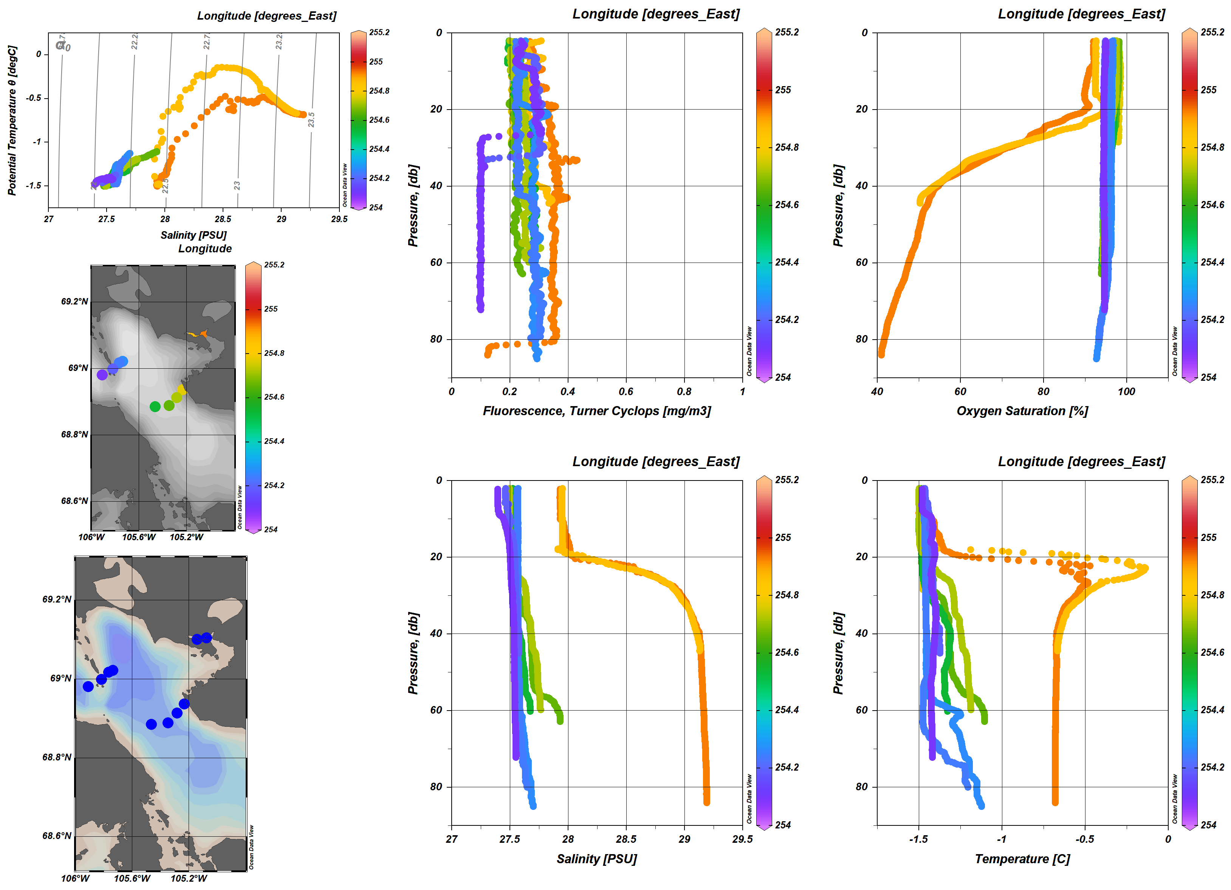

Figure 2. All stations with Cambridge Bay patrol. Oxygen data have been corrected.

G:\Sorted\myCROW\ODV\2020 all stations DeaseStArea by long.tif

**Figure 3. Dease St. and islands northwest**

G:\Sorted\myCROW\ODV\2020 Section - DeaseSt.tif

Figure 4. Dease St. Section. Oxygen has been corrected

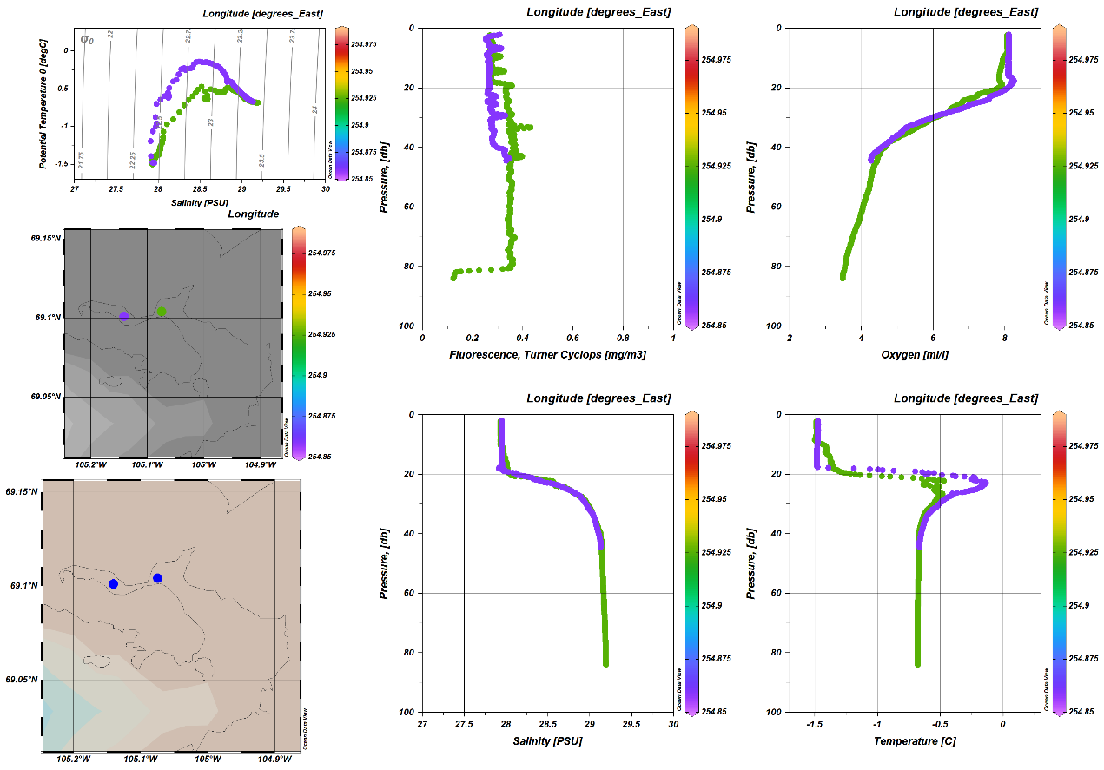

Figure 5. Just Cambridge Bay. Oxygen has been corrected.

# Kugluktuk

***CTD Data:***

There are 6 stations in 1 data set:

07 Feb 2020 Kugluktuk Bay 5 stations same file as below (all in one) 09 Feb 2020 Kugluktuk Bay 1 station w/ water samples 065541_20200209_2334.rsk

Meta data are recorded in:

N:\SHARE\DATA\2020\2020-37 CROW

***Comments:***

During the shallow KUG2 Bottle downcasts, conductivity is too low, likely due to ice on the sensor. The CTD may be freezing a film of fresh water over the sensors as it is measuring the surface 2 to 3 m of fresh water. The CTD data for the bottles are pulled from the 2nd dip of the full cast taken just before the set of 3 bottle casts.

Originally, Rinko oxygen data are much too different between the two visits to KUG2, two days apart (65%sat v. 85%sat). This leads to finding an error in Ruskin software that RBR fixes July 2020 and produces a new release of the software (v2.10). Data have been fixed and are now correct.

***Equipment: Calibration Dates***

RBR Concerto 65541 w/ 6Hz sampling rate 23 Jan 2020 (RBR), Jan 2013 (new)

w/ Turner Cyclops Fluorometer sensor #2101810 15 Feb 2018 (3pt-check, IOS), Jan 2012 (new)

Fluorometer set for 0 to 5 ug/l range

w/ JFE Advantech RINKO III Oxygen sensor #370 23 Jan 2020 (2pt cal, at IOS),

Type-B foil, Reporting in % Saturation, 25 Mar 2019 (new)

CTD has “AT” settings and coeff on board

ATTN: RBR CTD is set up for type A foil w/ RINKO. This has large affect on data. They were reprocessed with Type-B foil equation from Legacy export of Rinko Volts.

Air thermometer SN5

Ice Auger SN6

Downrigger #8

Kit #1

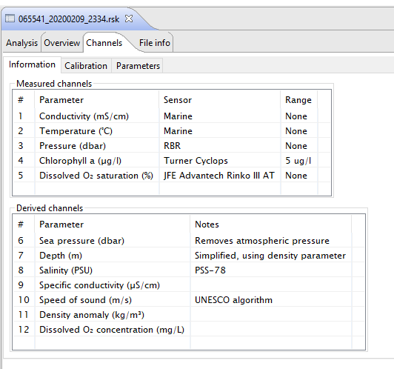

***Data Collection Method:***

Follow protocol laid out in ***Ranger science manual ver7 2015.doc***

Changes to protocol: Change from 2 to 3 casts for each station.

***Processing:***

Calibration issues:

None – CTD and 2-pt Oxygen calibration done just before program.

Casts:

Using Matlab, the time v. pressure data were plotted and each direction of each cast was separated and given a cast number.

For each station, the best cast was kept

|  |  |  |  |
| --- | --- | --- | --- |
| **Station** | **Name** | **Cast Number Used** | **File Name** |
| 11 | KUG1 | 3 (2nd downcast) | 065541_20200209_2334 |
| 12 | KUG2 | 9 (2nd downcast) | 065541_20200209_2334 |
| 13 | CBM1 | 15 (2nd downcast) | 065541_20200209_2334 |
| 14 | CBM2 | 21 (2nd downcast) | 065541_20200209_2334 |
| 15 | KUG3 | 25 (1st downcast - only cast that went full depth) | 065541_20200209_2334 |
| 16 | KUG2Bottle | 33 (2nd downcast) | 065541_20200209_2334 |

Pressure:

The top 1.2m of data were removed from all casts. Typically for CROW data the top 2 m are removed due to influenced by proximity to the edge of the drilled ice-hole, the mix of water and ice slush. This can create falsely fresh water but also with cooling during the cast, ice formation and brine rejection there can be a manufactured density inversion along the TS freezing line. However, because the river influence is so important to understand in the bay, only the top 1.2 were removed.

The bottom 0.2m of data removed from all casts. The very bottom data tends to have density inversion and/or spikes. This removes very little data but cleans up the profile.

Temperature shift and new Salinity:

1. Applied a 3 scan shift to advance temperature after confirming this was better than 2 scans.
2. Smoothed temperature and conductivity to recalculate new salinity. However, due to large surface gradient in salinity, the original conductivity was used for the first 30 scans as the filtered conductivity had artificial spikes due to the filtering ‘overshoot’.

Fluorometer

Spikes near the bottom of profiles at Kug 1 and 3 were removed by interpolation. These are likely due to re-suspended sediments.

Kug1 Cast 3 interpolation 40.5 to 43.4 dbar

Kug3 Cast 25 interpolation 66 to 69 dbar

After removal of spikes the data were processed using a low pass filter (pl66) with a half amplitude period of 10 scans.

Oxygen

RBR was configured to output percent oxygen saturation (and the unused concentration [mg/l]) and not volts. Calibration coefficients have been installed in the CTD. However, due both to the problem with the Ruskin software and that the CTD being configured to apply the Film-A equations for the Film-B sensor, it was necessary to output the raw Rinko voltage, merge the raw voltage back into the main data set and from there calculate percent oxygen saturation and oxygen concentration.

RBR identified and fixed the problem in Ruskin that was calculating oxygen saturation using the fixed temperature from when the CTD was turned on, not the real-time temperature. RBR corrected their software but this could not be used to correct this data set as the Film type setting was incorrect for the Rinko in use.

Instead

1. In Ruskin using version PRIOR to 2.10 (I believe it was 2.9) data were exported

using Legacy > Raw txt option to obtain voltage values of all sensors.

1. Load into matlab the voltage values and match the oxygen voltage to the normally used Ruskin export *.txt file, matching on time.
2. Apply voltage advancement of 3 seconds (18 scans) to correct for sensors slow response.
3. Apply JFE Advantech provided equation to convert voltage into percent saturation using the calibration coefficients and CTD pressure, temperature and salinity.
4. Further processing followed normal steps

Oxygen [ml/l] = full saturation concentration [ml/l] * percent saturation

Full saturation concentration was calculated using Garcia and Gordon (1992,1993) Eq.8 using coefficients in column 1 from Table 1 (fit to Benson and Krause (1984) data) and in situ temperature.

REFERENCES:

Benson, B.B., and D. Krause, 1984: The concentration and isotopic

fractionation of oxygen dissolved in freshwater and seawater in

equilibrium with the atmosphere. Limnology and Oceanography, 29,

620-632.

Garcia, H.E., and L.I. Gordon, 1992: Oxygen solubility in seawater:

Better fitting equations. Limnology and Oceanography, 37, 1307-1312.

Garcia, H.E., and L.I. Gordon, 1993: Erratum: Oxygen solubility in

seawater: better fitting equations. Limnology and Oceanography, 38,

656.

Salinity

No edits

Spikes at bottom of casts (KUG1,2,3) were removed when the bottom 0.2dbar of poor data were removed.

Removed pressure reversals

Interpolated to 0.2db levels. These are NOT averages of bins but linear interpolation to 0.2 db levels using the nearest points.

Bottle Casts Kug2 (Station 16 casts 31 to 44)

At Kug2 there was initially a full depth cast (3 times) followed by bottle casts to 6, 12 and 36m m. The bottle casts were shallow enough that icing became a problem due to the CTD being close to the surface’s fresh water and the CTD being colder than the freezing temperature. Although pressure appears good, salinity is too low during the short profiles due to icing. The pressure values from bottle casts were used to determine bottle depth but the CTD data are from the initial full depth casts.

The near-surface bottle is at 2.2m however this is just in the huge transition zone from the lens of freshwater down to salt water. The CTD data used may not match the water in the bottle. Ideally the salinity bottle’s value will help determine actual depth of water inside Niskin.

Special edits:

Station Edit

All Trimmed 1.2dbar from top as opposed to 1.4 typical for Kugluktuk stations.

All Only trimmed 0.2dbar off bottom of the casts as the typical value of 1dbar was not needed.

All Oxygen calculated using oxygen voltage

Kug1 (3), Kug3 (25) Spikes in Fluorescence interpolated over

Saved this cleaned dataset to a matlab *.mat files and an ODV *.o4x file

***2020-37_CROW_KugOxV_cleandowncasts.mat*** and ***2020-37_CROW_KugOxV.o4x***

Used script file ***p_RBR_CROW_2020_KugOxV.m*** for processing.

***Bottle data:***

The station KUG2 was revisited 2 days after the first survey and water samples were taken at 3 depths: 2, 10 and 35dbar where the full depth was around 50dbar.

Samples were taken for Nutrients (Nitrate+Nitrate (NO3), Silicate(SiO4), Phosphate (PO4)), Total Alkalinity, Dissolved Organic Carbon, Major Ions, Oxygen Isotope (δ18O), and Salinity.

A single 1.7L Niskin was attached to the line above the RBR CTD with the bottle center 1.2m above the pressure sensor. The CTD was lowered to the desired depth, a “messenger” was attached to the line and released, closing the Niskin. The line was pulled up and the Niskin removed and sampled before being put back on the line for the next sample. Bottle depth was determined to be the depth of the bottle stop, observed from the data, minus 1.2 m to account for the distance between Niskin and CTD sensors. The CTD data corresponding to the bottle depth was recorded in a spreadsheet along with the water sample chemistry.

To be added in Chemistry report when available:

Sample method (bottle type, rinses), storage method, analysis method (include where and when)

Table 1. CTD data at bottle stops

|  |  |  |  |  |  |  |  |  |
| --- | --- | --- | --- | --- | --- | --- | --- | --- |
| **yyyy-mm-dd hh:mm** | **Station and Cast** | **Sample No.** | **CTDPres [dbar]** | **CTDTemp [ITS-90 C]** | **CTDCond [mS/cm]** | **CTDSalt [PSS-78]** | **CTDOxy [mL/L]** | **CTDFluo [mg/m3]** |
| 2020/02/09 | KUG2 Cast | 1 | 2.2 | -0.750 | 21.515 | 25.833 | 9.28 | 0.48 |
| 2020/02/09 | KUG2 Cast | 2 | 10.2 | -1.377 | 22.446 | 27.606 | 8.54 | 0.27 |
| 2020/02/09 | KUG2 Cast | 3 | 35 | -1.042 | 22.741 | 27.673 | 8.21 | 0.21 |

***Science:***

* Clearly fresh river water was capping the 5 stations.
* Near surface chlorophyll-a increase in Kug2 and CBM1 matches percent oxygen increase. This does not appear to be an effect of Temperature and Salinity as they do not show the same relationship between stations.
* The deepest station Kug3 has the warmest and lowest oxygen values amongst all the stations below 55m.

***Suggestions:***

* Record Fluorometer SN during next use
* Update CTD/Rinko pair so they are both Film A or Film B (the CTD’s onboard oxygen equation is either “AT” or “BT” to match Rinko Film A or B)

***Figures:***

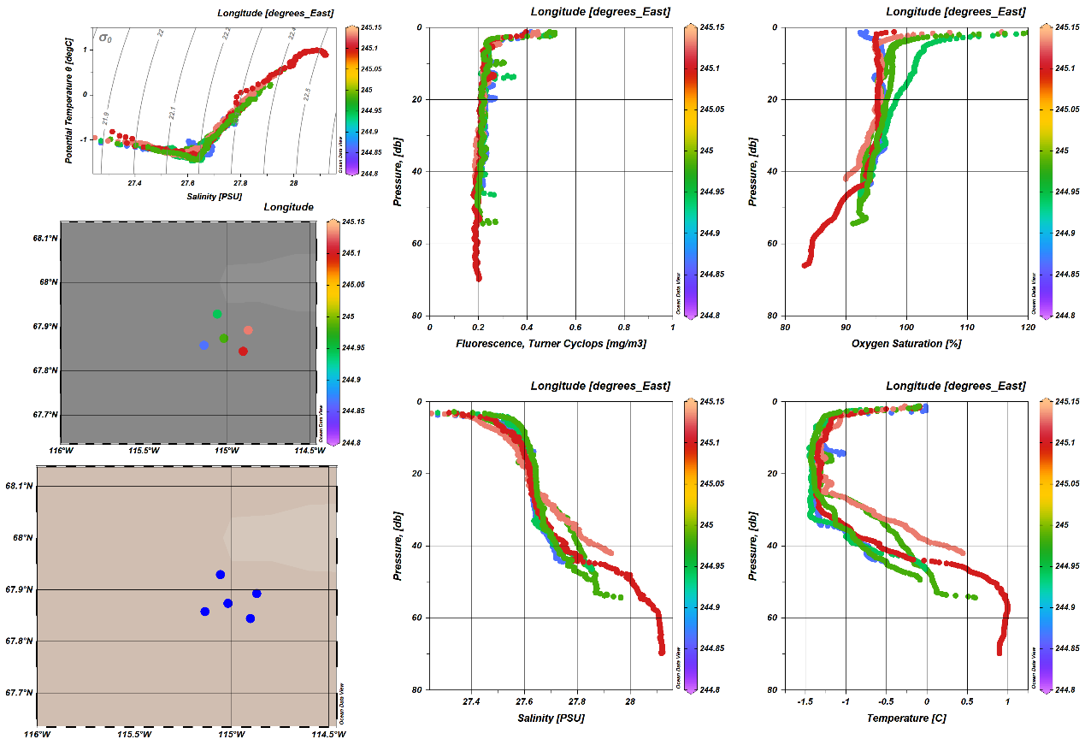

Figure 6. All stations w/ Kugluktuk patrol

G:\Sorted\myCROW\ODV\2020 all stations Kug by long top10m.tif

Figure 7. Top 10m of the Kugluktuk casts.

# Preparation for IOS Archive

Use matlab scripts from Roy Hourston to convert *.mat files to IOS header format:

C:\Users\Zimmermanns\Documents\Gmatlab\IOSarchivescripts

C:\Users\zimmermannS\Documents\Gmatlab\fromRoyHourston

Follow the set up for 2019-31 CROW which was the first program to use these scripts/method.

Use ***prntios_fmts_202037CROW_wrapper.m*** to cycle through the various CTD data sets within 2020-37 (ie Cambridge Bay, Kugluktuk). This script has a list of the needed variables and file names and then calls the function ***prntios_fmts_202037CROW_single.m*** to write the CTD files.

Using ***prntios_fmts_202037CROW_single.m***

Keep all the variables up at the top to make it easy to change for each data set

Calls (input)

*.mat The processed data in structured array with one cast per station (ie keep best dip)

*.txt The processing information that will be loaded into the IOS Shell header

*.xls Create a page that is easy to pull sensor information from (and clear for Mike to write pre-CROW)

Writes one file per cast as is custom for IOS header format files.

Variables to archive:

Pressure, Depth, Temperature, Conductivity, Salinity, Oxygen %sat, Oxygen ml/l, Fluorometer

0.2 dbar intervals

Tried to follow standard IOS variable names, units and sig figs

Bottom depth was calculated as the max depth plus 5m based on typical cast protocol.

Cruise name changed from 2020-37 to 2020-037

Made a new ODV file from the *.CTD files by making a list of filenames and running the convert program

Still to do: Black is complete and Red is still to be done

Convert chemistry to CHE files although there are no water sample data yet. They will be added as they are available.

Checklist for archive:

CTD

BOTTLE

RAW CTD

DOC

header text (CTD, Chem)

CTD processing notes (update with current figures)

Chem spreadsheet

CTD processing spreadsheet (“xxxMatlabLog”)

Program Metadata spreadsheet

Program Cruise Report

Chemistry Analysts spreadsheets (Nuts, Sal, etc) Data still to be analysed

IOSShell “CTD rpt”

Scan of Paper Logs

For more tips see ***How to Archive CROW data v2019-04-29.docx*** (in *G:\Sorted\RBR_Processing\How to put in IOS Archive*)