REVISION NOTICE TABLE
DATE | DESCRIPTION OF REVISION
25 Feb 2025 | Removed original Silicate & Flag:Silicate channels and renamed corrected versions of those channels. TSG channel names/units updated. G.G.
27 March 2023 | Added HPLC data. J.R.

PROCESSING NOTES
Cruise: 2020-009
Agency: OSD
Location: WCVI / Strait of Georgia
Project: La Perouse / WCVI / Strait of Georgia
Chief Scientist: Robert M.
Platform: John P. Tully
Date: 24 August 2020 – 8 August 2020

Processed by: Germaine Gatien
Date of Processing: 16 December 2020 – 16 March 2021
Number of original HEX files: 137 (includes 2 that need to be joined for downcast)
Number of original CTD files: 137 Number of processed CTD files: 133
Number of rosette files: 72 Number of processed CHE files: 71
Number of original TSG files: 3 Number of processed TOB files: 14 (one per day)

INSTRUMENT SUMMARY
CTD #0443 was mounted in a rosette and attached were 2 Wetlabs CSTAR transmissometer (1185DR & #1883DG), a SBE 43 DO sensor (#3791) on the secondary pump, SeaPoint Fluorometers (#3950) on the primary pump, a Biospherical QSP-400 PAR sensor (#70613), a Reference PAR (#20518) and an altimeter (#62355).

A thermosalinograph (SeaBird 45 S/N 0620) was mounted with a Wetlab/Wetstar fluorometer (WS3S-953P) and flow meter.
Seasave version 7.26.7.121 was used for acquisition.
The data logging computer WP #102 Mini Lenovo.
The deck unit was a Seabird model 11+ #425.
A Guildline model 8400B Autosal serial # 68572 was used to analyze salinity samples.
An IOS rosette with 24 10L bottles was used.

SUMMARY OF QUALITY AND CONCERNS
The Daily Science Log Book and rosette log sheets were in fairly good order with comments about problems encountered, but there were some errors in the entries. This was a very long cruise with a limited science crew due to COVID safety requirements, so it is not surprising that there were problems. The preparation of bottle files was difficult due to split casts, repeated sample numbers, errors on a few rosette sheets, misfired bottles and bottles fired without sampling. The sampling notes and hydro files provided by the Chief Scientist were a great help, but it still took many hours of work to assemble the bottle files.

There were 2 WetLabs CStar transmissometers in use during this cruise:
Channel Transmissometer refers to sensor #1185DR (650nm - red)
Channel Transmissometer2 refers to sensor #1883DG (530nm - green)
For comparison with other Institute of Ocean Sciences cruises, note that the transmissometer wavelength is 650nm unless otherwise stated.

While CTD fluorescence data are expressed in concentration units, they do not always compare well to extracted chlorophyll samples. It is recommended that users check extracted chlorophyll values where available.

The secondary salinity compared well with bottles, but the primary was poor. This was also observed during 2020-008 which preceded it, but during the next cruise, 2020-083, the comparison of bottles and CTD indicated that the primary salinity had returned to expected values. So the problem was obviously not due to calibration drift This was confirmed by a post-cruise calibration which indicted little drift. During cast #159 the secondary system performed very badly so primary values were selected and channel Oxygen:Dissolved:SBE was removed.

The dissolved oxygen sensor calibration drifted over summer/autumn 2020 and the membrane was replaced when the equipment was serviced at the factory in December 2020. There were many dissolved oxygen samples from this cruise which enable a comparison of performance in the early and late sections of the cruise. This indicated that drift during this cruise was not so large that a variable recalibration was justified.

The SBE DO sensor has a fairly long response time so data accuracy is not as high when it is in motion as it is during stops for bottles. This will be especially true when vertical DO gradients are large. To get an estimate of the accuracy of the SBE DO data during downcasts (after recalibration) a rough comparison was made between downcast SBE DO and upcast titrated samples. Some of the difference will be due to problems with flushing of Niskin bottles and/or analysis errors and small mismatches in depth in the presence of large DO gradients, so the following statement likely underestimates SBE DO accuracy.

Downcast (CTD files) Oxygen:Dissolved:SBE data for this cruise are considered, very roughly, to be:
±0.6 mL/L from 0-20db
±0.4 mL/L from 20db-100db
±0.1 mL/L from 100db-500db
±0.02 mL/L below 500db

Comparisons were made between TSG data and co-incident CTD casts, rosette samples and loop samples. The intake TSG temperature was close to CTD temperatures. TSG Salinity was lower than both CTD salinity and loop samples and was drifting with time. For the early part of the cruise the TSG fluorescence values were low but the shape of traces resembled those from CTD data. However, from August 29th onwards the TSG fluorescence data were removed because the values were climbing steadily and were way out of line with CTD fluorescence and loop samples. A time-dependent recalibration was applied to TSG salinity and a small correction was made to the TSG fluorescence offset.

PROCESSING SUMMARY

Seasave
This step was completed at sea; the raw data files have extension HEX.
The chief scientist provided a summary of sampling protocols and problems.
The deployment protocol was:
The rosette was brought to the surface. Pumps were turned ON. The rosette was brought down to 10m and kept there for 30 seconds. Once back at the surface, the data started to be archived, with the rosette at the surface for 30 seconds longer. Then the cast would start.

Preliminary Steps
The Log Book and rosette log sheets were obtained as well as sampling notes from the Chief Scientist.
- Nutrients, extracted chlorophyll, dissolved oxygen, salinity and NH4 data were obtained in QF spreadsheet format from the analysts.
- The cruise summary sheet was completed.
- The histories of the pressure sensor, conductivity and dissolved oxygen sensors were checked. The temperature, conductivity and dissolved oxygen sensors had been used during 5 previous cruises since the last factory recalibrations and several of those cruises were very long with many casts. The 2 transmissometers had been recalibrated at IOS in February 2020. See section 14 for details.
Based on notes from the chief scientist some water depth and station names were changed in the raw files.

BOTTLE FILE PREPARATION
The ROS files were created using files 2020-009-ctd.xmlcon for all casts.
The ROS files were converted to IOS format.
The IOS files were put through CLEAN to create BOT files.
Temperature and salinity were plotted for all BOT files to check for outliers.
CTDEDIT was used to clean a few points in Salinity:T1:C1 at about 10db in events #54 and 156.
The output files were copied to *.BOT.

Files 39/40 and 137/138 were parts of a single cast and needed to be combined.
- It was unclear what happened during this file as the computer crashed just as bottle #7 was fired but no record was received that it had closed. A new file was then started and bottle #1 was fired at 300db but as it was already closed the samples are not from 300db. Similarly, bottle 7 was fired at 250db but as can be seen from oxygen and salinity samples it was already closed. So the bottle #7 firing from the first file should be used, and the first two firings of the 2nd file should be removed before joining the two parts.
- Files 137 and 138 are straight-forward with no overlap in depths.
The pairs were renamed as BOTa and BOTb, using the first file name in each pair. BOTb was edited for file 138 to remove the first 2 firings.
Both pairs were then put through JOIN to create BOT files. Those were then edited to get the bottle firing order numbers arranged to suit.

A preliminary header check was run and no problems were found.

The BOT files were bin-averaged on bottle number.
The output was used to create file ADDSAMP.csv. First, the file was sorted on event number and Bottle Position order. Then sample numbers were added based on the rosette logs.

A number of problems occurred with sample number repetitions:
- Sample 234 was used twice during cast #77. Both were at 20m using Niskins #18 and 24. It is clear that the DO sample was from Niskin 24 so it was assumed that all samples came from that bottle. The record for Niskin 18 was removed from the ADDSAMP file. No adjustment is needed to analysts’ spreadsheets.
- Sample 284 was used for both events #96 and 100. The sample number for event 96 was changed to 9284. This change will affect nutrients and salinity in event 96.
- Sample 292 was used twice during cast #107 and affects only salinity. The second sample was renamed 9292 by the analyst so no change is needed.
- Sample 383 was used for both events #137 and 144. The sample number for event 137 was changed to 9383. This will affect CHL and NH4 and HPLC.

The addsamp.csv file was used to add sample numbers to the BOT files – output *.SAM.
The SAM files were bin-averaged on bottle # and called SAMAVG.
The addsamp.csv file was converted to CST files, which will form the framework for the bottle files.

Next, each of the analysis spreadsheets were examined to see what comments the analysts wanted included in the header file. These were used to create file 2020-009-bot-hdr.txt which will be updated as needed during processing.
DISSOLVED OXGYEN
Dissolved oxygen data were provided in spreadsheet QF2020-009_OXY*.xlsx which includes flags, comments and a precision study. Draw temperatures are available. The spreadsheet page with the final data was simplified and saved as 2020-009oxy.csv. That file was converted into individual *.OXY files.
At this point note was made of all comments in the DO file that had comments starting with “ALL:” so that other variables could be flagged appropriately.
EXTRACTED CHLOROPHYLL
Extracted chlorophyll and phaeo-pigment data were obtained in file QF2020-009_CHL QF*.xlsx. The file included comments and flags and a precision study. A simplified version of the spreadsheet was prepared and saved as 2020-009chl.csv. Appropriate flags were added to bottles with comments listed as “ALL” by the DO analyst. The csv file was then converted to individual CHL files.
SALINITY
Salinity analysis was obtained in file QF2020-009_SAL.xlsx which included a precision study. The analyses were carried out in a temperature-controlled lab 26 to 39 days after collection. The files were simplified and saved as 2020-009sal.csv. Appropriate flags were added to bottles with comments listed as “ALL” by the DO analyst. The file was then converted to individual SAL files.
NUTRIENTS
The nutrient data were obtained in spreadsheet QF2020-009_NUTS*.xlsx. This includes a precision study. The file was simplified, saved as 2020-009nuts.csv and converted to individual NUT files.
Appropriate flags were added to bottles with comments listed as “ALL” by the DO analyst. The file was then converted to individual NUT files.
AMMONIUM
NH4 data were obtained in spreadsheet QF_NH4_2020-009 *.xlsx. This includes a precision study. The file was simplified and saved as 2020-009NH4.csv. Appropriate flags were added to bottles with comments listed as “ALL” by the DO analyst. The file was then converted to individual NH4 files.

The SAL, CHL, OXY, NUT and NH4 files were merged with CST files in 5 steps.
After the 5th step the files were put through CLEAN to reduce the headers to File and Comment sections only.
The files were then put through CLEAN to reduce the headers to File and Comment sections only.
These files are ordered on sample number, but the SAMAVG files are ordered on bottle number, so one or the other set needs to be reordered in order to merge them. The MRGCLN1 files were reordered on Bottle_Number and saved as *. MRGCLN1s.
The MRGCLN1s files were then merged with SAMAVG files using merge channel Bottle_Number.

The output of the MRG files were exported to a spreadsheet and compared to the rosette log sheets to look for omissions. Comments with ALL were checked to ensure appropriate flags were present. A few problems were found:
- Events 4, 8 - Some records were removed from SAMAVG because there was no sampling done or indicated on rosette sheet.
- Event 43 was called 42 in the dissolved oxygen spreadsheeet so the data were missing. The merge process was repeated to capture that data.
- Event 61 had an error caused by a mistake in the addsamp file. The merge process was repeated.
- Event 65, 67, 69, 77, 85, 91, 93,115 and,161 had lines that should have been removed. Two bottles were fired at one level and only one used. SAMAVG was edited and the final Merge repeated. There were a number of errors on the rosette sheets that made it hard to determine the correct entries.
- Event 91 Oxygen sample mislabelled as event 92; relabelled & the Merge process was repeated.
- Event 137 nutrients mislabeled should be 138. Merge process repeated.
- Event 190 Oxygen sample mislabeled as 191
- Event 197 CHL sample had no event # in spreadsheet. Fixed and merge process repeated.
- One CHL sample (#166) not been flagged 3 to match the DO comment about a leak; fixed.
At this point the chief scientist’s sampling notes were checked to see if any changes needed to made to the MRG files and many records were removed due to no sampling having been planned or done.
The merge process was repeated.

Compare
Salinity
Compare was run with pressure as reference channel.
There was a lot of scatter in the fits, especially in the primary. When plotted against time the source of the scatter becomes clear as the primary CTD salinity is obvious drifting with time. The differences between the two channels as observed in the bottle comparison corresponds fairly well with the observations of the differences between channels as observed in salinity profiles. Using the same data plots against file pair numbers showed that most large differences for both salinity channels occurred at one near-shore cast on the west coast and casts from the northern Strait of Georgia.

The only outliers with differences >0.04psu were in the top 10db and had noisy CTD salinity.
When data were removed with CTD standard deviation >0.001 and bottles above 200db the primary salinity was found to be low by an average of 0.0139psu, standard deviation 0.0012psu and the secondary was found to be high by 0.0014, standard deviation 0.0015.
For full details for the COMPARE run see file 2020-009-sal-comp1.xls.

Dissolved Oxygen
COMPARE was run with pressure as the reference channel.

When all casts were included and outliers were removed based on residuals the fit was:
CTD DO Corrected = CTD DO * 1.0505 - 0.0301 R² = 0.96 (1)
The more significant outliers are associated with large standard deviations in the CTD dissolved oxygen, which suggests these samples come from high vertical gradient regions where slight mismatches in depth between the depth of the source water in the Niskin and that of the CTD stopping depth.

The slope is higher than during the previous cruise while the offset is very close:
CTD DO Corrected = CTD DO * 1.0449 - 0.0298 R² = 0.97 (2020-008)

There has been a fairly steady increase in the slope of the fits over the past 3 cruises, so the membrane is likely failing. The data were separated into 2 halves to see if the changes were large through the cruise and the differences were fairly small with slopes of 1.0501 and 1.0513. However, since the final section includes some casts that are more likely to be affected by incomplete flushing of Niskin bottles, the CTD DO values may be even lower than they appear to be, and hence the slope may be an underestimate. When only casts #170-235 were included and the offset forced to be 0.03, the slope was 1.0446. Since this difference is likely due to incomplete flushing of Niskin bottles in the presence of large vertical gradients, it is not appropriate to apply it to CTD DO from that part of the cruise. The general fit (1) is the appropriate choice for this cruise and drift through the cruise does not appear to be a source of large error.

The only significant outlier came from the level of a sub-surface oxygen maximum where the vertical DO gradient was extremely high so that both CTD response and bottle flushing errors are likely to be large.
Plots of Titrated DO and CTD DO against CTD salinity were examined. No further outliers were found.

Fluorescence
COMPARE was run with extracted chlorophyll and CTD Fluorescence using pressure as the reference variable.
The fit of CTD Fluorescence against Extracted CHL samples has the usual pattern with Fluorescence reading higher at low CHL and falling relative to CHL as the latter values increase. The fluorometer may not get as close to 0 as the CHL does so small differences lead to large values for FL/CHL. And fluorometers sense breakdown products from phytoplankton that do not affect CHL.
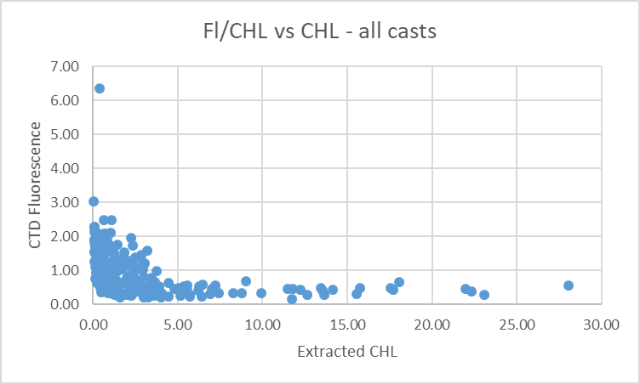
When all casts are included the CTD fluorescence is about 46% of extracted chlorophyll values.
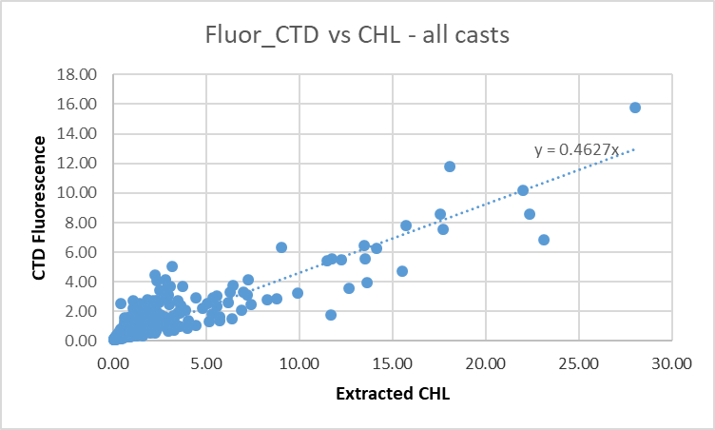

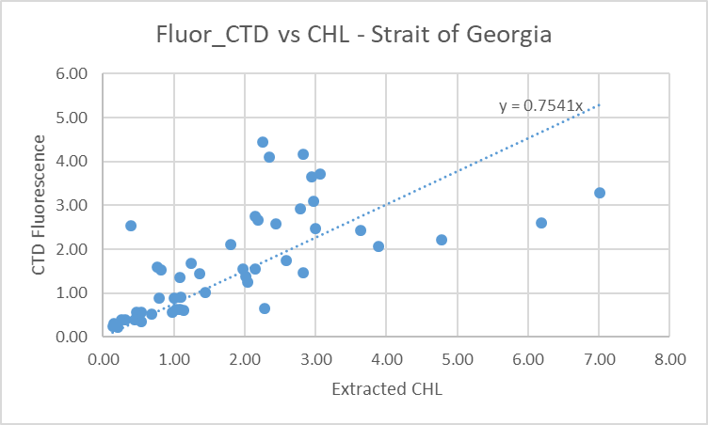
In the Strait of Georgia the flushing of Niskin bottles tends to be reduced by very steady CTD ascent rates. If vertical DO gradients are high the ratio Fluorescence/ Chloorphyll may be very high or very low depending on the depth of the CHL maximum.
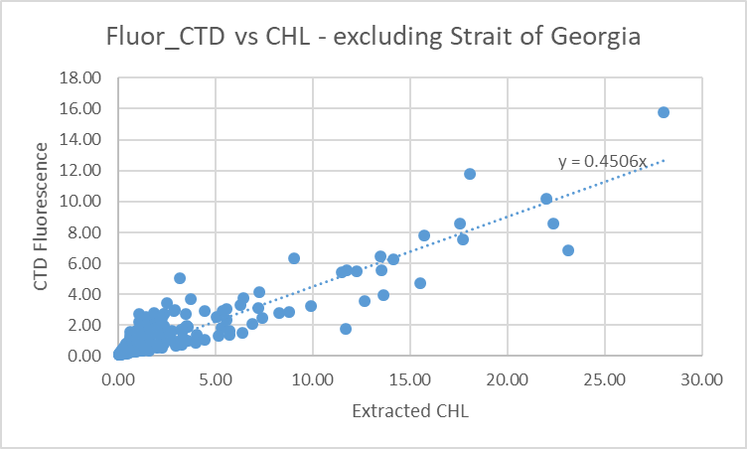
The performance of the fluorometer is typical of these sesnsors.

Conversion of Full Files from Raw Data
File 2020-009-ctd.xmlcon was used to convert all files.
The Tau function and the hysteresis function were selected since there was deep sampling. Depth was included in the conversion.
A few casts were examined and all expected channels are present. The Temperature pairs were reasonably close during downcasts with upcasts very noisy. Conductivity values were further apart than usual though profile shapes were reasonably close. Fluorescence, PAR, SPAR and Dissolved Oxygen profiles looked normal. Fluorescence has deep values <0.1ug/L. The “Green” transmissometer was generally higher than the “Red”; the profiles had similar shapes. The altimetry looked useful.

WILDEDIT
Program WILDEDIT was run to remove spikes from the pressure, depth, conductivity & temperature only in the full cast files (*.CNV).
Parameters used were: Pass 1 Std Dev = 2 Pass 2 Std Dev = 5 Points per block = 50
The parameter “Keep data within this distance of the mean” was set to 0 so all spikes would be removed.

ALIGN DO
A few casts were examined; both temperature channels were noisy during upcasts so the tests were not easy to interpret, but using +2.5s certainly improves the alignment and overall looks like a good choice for both sensors. That setting has worked well for many SBE DO sensors in recent years.
ALIGNCTD was run on all casts using +2.5s.

CELLTM
The noise in the upcast data makes tests for the best parameters for this routine very difficult to interpret. In the past when upcast data were not so noisy, the default setting of (α = 0.0245, β=9.5) was generally found to be the best choice. A few casts were checked for this cruise and the default setting does improve the data. CELLTM was run using (α = 0.0245, β=9.5) for both the primary and secondary conductivity.

DERIVE and Channel Comparisons
Program DERIVE was run on all casts to calculate primary and secondary salinity and dissolved oxygen concentration.

DERIVE was run a second time on 4 of the deeper casts to find the differences between the pairs of temperature, conductivity and salinity channels. The differences were clearly increasing so a few shallower casts were examined to see when the drift started. It may have started during the previous cruise but most of the casts were too shallow to determine that.
Cast # | Press | T1-T0 | C1-C0 | S1-S0 | Descent Rate
2020-001-0025 | 1000 | 0 | +0.00060 | +0.0075 | High, V Noisy
 | 1900 | -0.0004 | +0.00063 | +0.0080 | “
2020-005-0075 | 1000 | -0.0006 | +0.0004 | +0.0055 | High, Noisy
“ | 1900 | -0.0005 | +0.00046 | +0.0060 | “
“ | 500 | -0.0003 | +0.0004 | +0.0050 | High, X Noisy
2020-005-0140 | 1000 | -0.0002 | +0.00043 | +0.0055 | “
“ | 1900 | -0.0002 | +0.00048 | +0.0060 | “
“ | 500 | -0.0004 | +0.00042 | +0.0055 | High, Moderate
2020-005-0218 | 1000 | -0.0005 | +0.00046 | +0.0060 | “
2020-069-0043 | 1000 | -0.0006N | +0.00040N | +0.0054 | High, Mod
 | 1900 | -00002 | +0.00046 | +0.0058 | “
2020-069-0122 | 1000 | -0.0002 | +0.00051 | +0.0064 | High, Mod
 | 1900 | -0.0002 | +0.00053 | +0.0068 | “
 | 2900 | -0.0003 | +0.00055 | +0.0072 | “
2020-008-0015 | 1000 | -0.0005 | +0.00058 | +0.0073 | High, F Steady
2020-008-0027 | 1000 | -0.0003 | +0.00073 | +0.0089
2020-008-0036 | 1000 | -0.0005 | +0.00072 | +0.0095 | High, V Noisy
“ | 2000 | -0.0003 | +0.00075 | +0.097 | High, X Noisy
“ | 3000 | -0.0005 | +0.00078 | +0.0100 | “
2020-008-0060 | 1000 | -0.0004 | +0.00081 | +0.0101 | High Noisy
“ | 2000 | -0.0004 | +0.00084 | +0.0107 | “
“ | 3000 | -0.0006 | +0.00084 | +0.0111 | High F Noisy
2020-008-0078 | 1000 | -0.0006 | +0.00097 | +0.0120 | High V Noisy
“ | 2000 | -0.0005 | +0.00099 | +0.0126 | “
“ | 3000 | -0.0006 | +0.00100 | +0.0130 | High Noisy
2020-009-0033 | 1000 | -0.0006 | +0.00130 | +0.0160 | High Noisy
2020-009-0078 | 1000 | -0.0006 | +0.00128 | +0.0162 | High Mod
 | 1900 | -0.0005 | +0.00132 | +0.0165 | “
2020-009-0115 | 1000 | -0.0004 | +0.00130 | +0.0158 | High X Noisy
 | 1900 | -0.0006 | +0.00130 | +0.0164 | “
2020-009-0171 | 1000 | -0.0006 | +0.00122 | +0.0154 | High X Noisy
 | 1900 | -0.0005 | +0.00126 | +0.0160 | “
The salinity and conductivity differences are higher than at the end of the previous cruise but did not change much during the cruise. A preliminary look at cruise 2020-083 that followed showed a return to smaller differences between salinity channels. So rather than drift there may have been a problem with the primary system that started during 2020-008. There was no layover time between these 2 long cruises. There was a gap before 2020-083 when plumbing and/or sensors may have been cleaned or serviced or a pump may have been switched.

Conversion to IOS Header Format
The IOSSHELL routine was used to convert SEA-Bird 911+ CNV files to IOS Headers.
CLEAN was run to add event numbers and to replace pad values in the pressure channel with interpolated values based on record number.

A few files were eliminated from further processing at this time:
- File #40 contains only upcast data.
- File #98 was removed from cast list as it was aborted and rerun.
- File #138 contains only upcast data and no bottle sampling.
- File #168 was removed from cast list because the pumps were not on.
File #159 has bad dissolved oxygen and secondary salinity from 10 to 50db. While the primary salinity did not do as well in the bottle comparison, the difference between the primary and salinity is fairly constant, so the primary could be recalibrated.

Checking Headers
The cross-reference check and header check were run. No problems were found.
Surface check was run and found an average of 2.1db, which is a little low for the Tully, but a post-cruise calibration indicates the pressure was low by 0.4db by January 2021. Adding 0.4db would make the average 2.5db which is reasonable.

The header check shows that cast #35 recorded some negative pressures. Those occurred at the end of the cast when the pumps were still running. At about 0.35db it looks like one conductivity cell was out of water and the other in water, so this is very close to the surface. This confirms that adding 0.4db is wise. Header check also confirms that the secondary salinity was bad during cast #159.

Cruise tracks were plotted and added to the end of this report.

The altimeter and water depth readings from the headers of the CLN files were exported to spreadsheets.
Some casts did not get close enough to the bottom to have useful altimetry.
A check value was calculated by subtracting water depth from maximum depth sampled plus altimetry header -1 (since the altimetry averages over 2m the value may be high by 1m.). Where that number was > 4 or <-4 plots of the altimetry were checked. There were 36 such casts which were investigated:
- For 20 casts the check value was not very large and there clearly was some drift between start and bottom positions. The altimetry looked fine. No changes were made to the headers.
- For 5 casts the log entry produced a better result, so the header was adjusted to match the log, though the difference was usually slight.
- For 2 casts the CTD did not get near the bottom; the altimetry header derives from a spike and the header entry was removed.
- For 7 deep-water casts there was little drift during the cast and for 1 there was note of a soft bottom so the sounder result is questionable, so the header entry was changed to a calculated value = Maximum depth sampled + Altimetry – 1. The same method was applied to one cast which was patched together from 2 casts and had a large check value.
The changes were made to the CLN files and to the 9 affected MRG files; the latter were put through CLEAN again. See2020-009-altimeter.xlsx for details.

Shift
Fluorescence
SHIFT was run on the SeaPoint fluorescence channel in all casts using the usual advance of +24 records. Plots show that the fluorescence offset is reasonably close to the temperature offset after this step.
Dissolved Oxygen
The Dissolved Oxygen voltage channel was aligned earlier. A few casts were checked to see if the alignment looked ok, and it did. No further alignment is needed for the DO concentration channel,
Conductivity
Tests were run on a few casts to assess what settings are best to align conductivity with temperature (as judged by the effect on salinity as seen in T-S space). The traces were mostly extremely noisy so small differences are hard to detect. The best settings appear to be -0.2records for the primary and -1.2records for the secondary.
SHIFT was run twice on all SBE911 casts using those settings. Salinity was recalculated.

DELETE
The following DELETE parameters were used:
Surface Record Removal: Last Press Min
Maximum Surface Pressure (relative): 10.00
Surface Pressure Tolerance: 1.0 Pressure filtered over 15 points
Swells deleted. Warning message if pressure difference of 2.00
Drop rates < 0.30m/s (calculated over 11 points) will be deleted.
Drop rate applies in the range: 10db to 10db less than the maximum pressure
Sample interval = 0.042 seconds. (taken from header)
COMMENTS ON WARNINGS: There were no warnings.

Other Comparisons
Experience with these sensors since last factory service – The pressure, temperature, dissolved oxygen and conductivity sensors were used a lot during 2020.
- 2020-001 – Primary salinity was low by 0.0035 and secondary performed poorly. Dissolved oxygen was recalibrated using slope/offset =1.0242/-0.0022
- 2020-028 – Shallow sampling not trusted for recalibration. Autosal problem discovered after initial processing but result was not trusted anyway. Used 2020-005 result. Dissolved oxygen was recalibrated using slope/offset=1.0308/-0.0085. Pressure was recalibrated during 2020-028 by increasing the offset to -0.8db. The same offset was used for cruises that followed.
- 2020-005 –Primary high by 0.0026 and secondary high by 0.0086. Made small allowance for flushing error in recalibration. Dissolved oxygen was recalibrated using slope/offset=1.0308/-0.0085.
- 2020-069 – Dissolved oxygen correction 1.0369/-0.0197. Salinity comparison not trusted due to only near-bottom samples from the few deep casts; recalibration based on 2020-005.
- 2020-008 – Pressure found to be low by 0.4db (new offset should be -0.4db), 0.0018psu subtracted from secondary salinity, oxygen slope/offset = 1.0449/-0.0298. Primary conductivity looked poor – not calibration problem.
The following later cruise used this equipment and some information is available about the sensors.
- 2020-083 – Autosal problem – based on tentative correction of Autosal results the primary was low by 0.004 and the secondary high by 0.0018psu.
Historic ranges – Profile plots were made with 3-standard deviation climatology ranges of T and S superimposed. Most excursions were from casts close to shore. Excursions in temperature are all values above the historic maximum. Most salinity excursions are in the primary values only. For the secondary the few excursions are not systematic with some looking high and others low. None of these excursions suggest calibration problems in the secondary system though there clearly was a major problem during cast #159 that is likely due to flow being obstructed. There are a number of obvious problems in the primary salinity with spikes in a few casts and values that are low but would fall within the climatology after recalibration.
Post-Cruise Calibration – Post-cruise calibration information became available late in processing. One cast was studied from cruise 2020-008 using that information. The secondary temperature had drifted downwards slightly while secondary conductivity had drifted upwards; so the post-calibration secondary salinity was higher by ~0.0024psu around 177db in December. The SBE Dissolved Oxygen sensor was found to be damaged in December. The membrane was replaced during the December 2020 service.

DETAILED EDITING
The secondary channels look like the right ones to choose for archiving. But there is a big problem in the secondary salinity during cast #159. The primary channels have some spikes and an odd offset from the secondary, but the offset is fairly constant so the data could be recalibrated and for cast #159 the primary are the only choice available.
The secondary channels were selected for editing except for cast #159.
All DEL files were copied to *.EDT.

CTDEDIT was used to remove records that appear to be corrupted by shed wakes. Salinity was cleaned to remove spikes that appear to be due to small misalignment or instrumental noise. All files required some editing. Notes about editing applied were added to the files.
The edited files were copied to *.EDT.
After editing, T-S plots were examined for all casts. Some unstable features remain but come from areas where such features are near the surface or bottom of casts and may be real or where it is impossible to say which data are poor. No further editing was done.

Corrections to Pressure, Salinity and Dissolved Oxygen Concentration
Based on a post-cruise calibration the pressure was thought to be low by 0.4db.
File 2020-009-SBE911-recal.ccf was prepared to add 0.4db to pressure, add 0.0139 to channel Salinity:T0:C0, subtract 0.0018psu from channel Salinity:T1:C1 and apply the following correction to channel Oxygen:Dissolved:
CTD DO Corrected = CTD DO * 1.0505 - 0.0301
This correction was first applied to the SAM and MRGCLN2 files.

COMPARE was rerun for salinity. When the same outliers were removed as in the original comparison, the primary salinity was found to be low by an average of 0.0002 and the secondary low by an average of 0.0004psu. See file 2020-009-sal-comp2.xls for details.
COMPARE was rerun for dissolved oxygen and shows that the correction was applied properly. When data are excluded using the same points as in the original fit, the CTD DO was low by an average of 0.0001mL/L. This shows that the recalibration was applied corrected and was appropriate. See file 2020-009-DO-comp2.xls for details.

CALIBRATE was then run on the EDT files using the same recalibration file.

Fluorescence Processing
A median filter, size 11, was applied to the fluorescence channel in the COR1 files. Plots of a few casts showed that the filter was effective. (Output:*.FIL)

Final Calibration of DO
The initial recalibration of dissolved oxygen corrects for sensor calibration drift. Alignctd corrects for transit time errors. Those 2 steps may partly correct for response time errors, but to see if a further correction is needed, a comparison is made of downcast CTD data to bottle data from the same pressure. Small differences are expected due to ship drift, temporal changes, incomplete flushing of Niskin bottles and delayed response and noise in CTD data.

Downcast files were bin-averaged to 0.5m bins for the casts with DO bottle samples. Those files were then thinned and compared to the bottle values in the MRG files. COMPARE was run to study the differences between the downcast CTD DO data and the titrated samples from upcast bottles.

The CTD DO was higher than the titrated samples by an average of ~0.05mL/L when data from the top 12m were excluded, but the standard deviation was 0.15mL/L. The median difference was 0.03mL/L. The differences are small at depth and gradually rise towards the surface. There are some cases where the CTD is lower than bottles; a few of those were investigated and came from areas where there were local DO reversals. The positive differences are likely due primarily due to incomplete flushing of Niskin bottles, an error that would grow larger as local gradients increase. Another source of positive differences is response time errors in the downcast data from the SBE sensor.

An attempt was made to find some well-mixed surface water samples to determine differences in low gradients. Unfortunately, most of the casts with well-mixed surface DO did not have any DO samples. Three cases were found that were mixed to about 20db and for those the CTD DO was lower than bottle samples by 0.034mL/L, 0.025mL/L and 0.007mL/L. Looking at some casts from 2020-008 that were well-mixed to about 50m, the differences in the top 25m were on the order of 0.02 to 0.05mL/L. So after recalibration the CTD DO values appear to be reliable to within ±0.05mL/L in low-gradient areas, but in large gradient areas the errors will be larger due to response time errors.
No further recalibration of CTD DO is appropriate.

BIN AVERAGE of CTD files
The following Bin Average values were applied to the FIL files (output AVG):
Bin channel = pressure Averaging interval = 1.000 Minimum bin value = .000
Average value will be used. Interpolated values are NOT used for empty bins.
On-screen T-S plots were examined.
Profile plots were examined. No problems were noted.

Final CTD File Steps (REMOVE and HEADEDIT)
For cast #159 REMOVE was run to remove the following channels:
Scan_Number, Temperature:Secondary, Conductivity:Secondary, Oxygen:Dissolved:SBE, Oxygen:Voltage:SBE, Descent_Rate, Status:Pump, Altimeter, Salinity:T1:C1 and Flag.
For all casts except #159 REMOVE was run to remove the following channels:
Scan_Number, Temperature:Primary, Conductivity:Primary, Oxygen:Voltage:SBE, Descent_Rate, Status:Pump, Altimeter, Salinity:T0:C0 and Flag.

A second SBE DO channel (with umol/kg units) was added.
REORDER was run to get the two DO channels together.
HEADER EDIT was used to fix formats and channel names and to add the comments about processing.
The Standards Check routine was run and no problems were found.
The Header Check was run; no problems were found.
Profile and T-S plots were examined. The dissolved oxygen profile for cast #144 looked odd but bottle samples support the values. No other problems were found.
The sensor history was updated.

Dissolved Oxygen Study
As a final check of dissolved oxygen data, % saturation was calculated and plotted. Values at 2 to 3m ranged between ~60% to 150%. The extreme values were generally near shore with the lowest values at sites noted for tidal mixing. The deep offshore casts had values between 102% and 104% except for the casts on the LPB line which had highly variable values. Those values are typical for that area.

Final Bottle Files
SORT was run to arrange casts in pressure order.
For all casts REMOVE was run to remove the following channels: Scan_Number, Temperature:Primary, Conductivity:Primary, Oxygen:Voltage:SBE, Descent_Rate, Status:Pump, Altimeter, Salinity:T0:C0 and Flag.
A second SBE DO channel with mass units was added for both the CTD DO and titrated DO and REORDER was run to get the pairs of DO channels together.

EDIT HEADERS was run to fix formats and channel names and to add comments about analyses and CTD processing.

Data were exported from the CHE files to file 2020-009-bottles-final.xlsx. The entries were compared with the rosette log sheets to ensure no values had been missed. No problems were found.
Standards check and a header check were run. There were a few format problems in a few casts; no reason for them was found but they were fixed.
The track plot looks ok.
Plots of each file were examined and no problems were found.
A cross-reference listing and header check were produced for the CHE files.

Thermosalinograph Data
An IOS TSG45 was used for this cruise. The data were delivered in 3 files, but 1 contained only 5 records.
The IOS SBE TSG45 files have extensions RAW but are in CSV format. They were opened in EXCEL.
and combined in a single CSV file. (In opening I use DELIMITED, deselect TAB, select COMMA and OTHER (*). It is necessary to choose TEXT for the time on the 2nd page of the text import wizard.)

The spreadsheets were adjusted as follows:
- 2 lines of headers were added – channel names and units.
- A column with pressure was added with all values set to 4.5 (to enable derivation of salinity).
- A temperature difference column was added (Lab-Intake).
- The fluorescence channel is in volts. It was moved to column M. Then a concentration value was calculated in column F using offset -0.044 and scale 15.8 as determined in the most recent recalibration of the fluorometer. Copy/Special Paste was used to save those values and then the voltage channel was removed.
- A file break column was created. It was completed so that new files would be created at the beginning of each day by assigning file names like 20200210-000000 except for the first file which has a time later than 000000.
- There was an 8min gap between the first 2 TSG files, but no position change and there was only a 15s break between the 2nd and 3rd files, so all the data were combined in one CSV file.
- Time and Date formats are a problem – when converting from RAW choose TEXT but once opened in EXCEL set Time Format to HH:MM:SS and save the file again.
- There were no NaN entries.
- The file break column
- The flow was on throughout so no editing was applied at this stage.
The file was then converted to IOS Header format with header info added. There are 12 IOS files.
CLEAN was run to reset the number of records, min and max values, set the start and end times, and latitude and longitude limits.
ADD TIME CHANNEL was used to add Julian dates – i.e. Decimal Year. (A record number was also added to enable averaging (for use in comparison to CTD files). Time zero was set to 31 December 2019 0:00:00.
DERIVED QUANTITIES was run twice, first to derive salinity using the lab temperature and again to derive sigma-T.
REORDER was run to move the Julian date to after the Time/Date channels and to put salinity and fluorescence after the lab temperature. Also the record # was moved to the end.

a.) Plots
Time-series plots were produced. The temperature and salinity traces look good. Fluorescence traces look good until about early on August 29th around station LJ06. After that values are smoother and gradually rising, ending with values ~65ug/L at a time when 5m chlorophyll samples were <5ug/L and CTD fluorescence was ~2.2ug/L. The flow rate varied from 0.90 to 1.11 with a median value of 1.00.
A track plot was produced and added to the end of this report.

b.) Checking Time Channel
The CTD files were thinned to reduce the files to a single point from the downcast at or within 0.5db of 4.5db. These were exported to a spreadsheet which was saved as 2020-009-ctd-tsg-loop-rosette-comp.xlsx. All 133 CTD casts overlapped with TSG records with flow turned on.

The TSG files were averaged over 24 records (2 minutes) on record number to reduce the noise and file size. Standard deviations were included. Then records were extracted for the times of CTDs and added to file 2020-009-ctd-tsg-loop-rosette-comp.xlsx.

Comparisons were made of positions to check for good matches. The differences in positions are expected to be small despite the averaging because the ship was stopped at these times. A few errors were found in the choice of TSG data. Once those were corrected the average differences were 0.0000º for both latitude and longitude. There were no differences >0.0006 º.

c.) Comparisons
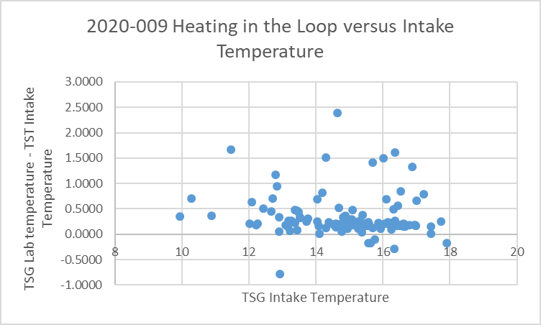
- Heating in the Loop followed the usual pattern with a rise in temperature of ~0.5Cº when intake temperatures were ~10ºC and ~0.1Cº as intake temperatures approached 18ºC. The TSG lab temperature, when all casts were included, was higher than the intake temperature by a median of 0.206 Cº (std. dev. 0.391Cº); when only the “quietest” 36 cases were included the median difference was 0.191 Cº (std dev 0.037Cº).

- Comparison of T, S and Fluorescence from TSG and CTD data
The differences between temperature and salinity from TSG and CTD were also very noisy. Data were sorted on standard deviations in the 2-minute window for temperature and salinity. The differences were studied using the 36 cases with the lowest standard deviation for each variable.
- The TSG intake temperature, when all casts were included, was higher than the CTD temperature by a median of 0.008Cº (std. dev. 0.264Cº); when only the “quietest” 36 cases were included the median difference was 0.003Cº (std. dev. 0.072Cº).
  - For salinity when all casts were included the median difference was 0.186 (std. dev. 0.340psu); when only the “quietest” 36 cases were included the median difference was 0.181 (std dev 0.022psu). When the differences were displayed against time there is obviously some drift. Excluding the late 30 casts for which the scatter in differences was very large, the differences drift from about -0.1psu to -0.2psu. Some of that drift could be due to increasing vertical gradients so that errors due to slight mismatches in depth between CTD and TSG observations become larger. The first few casts have differences close to those of 2020-008, then for about 50 casts differences are about -0.15psu and then shift lower.
  - The initial comparison between TSG and CTD data confirmed that the TSG fluorescence data are not reliable after event #103. Looking at casts #1-103 the median ratio of TSG to CTD fluorescence is ~0.4.
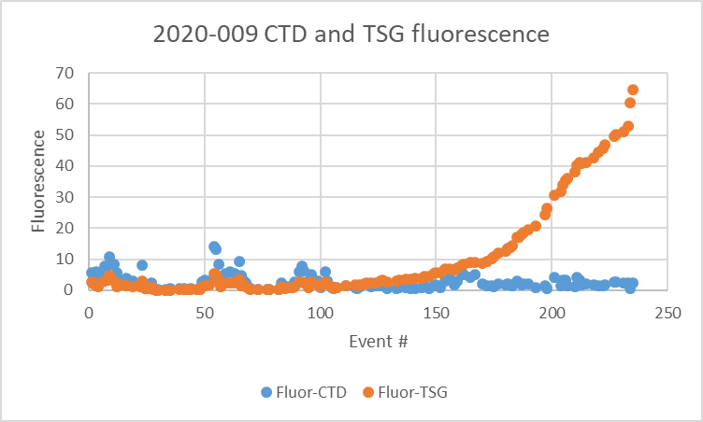

- Comparisons of Loop samples and TSG data
- There were 19 loop Salinity and Extracted Chlorophyll samples of which 7 were taken while stopped and 12 while underway. One of the “stopped” casts had pumps off so no CTD salinity or fluorescence data are available.
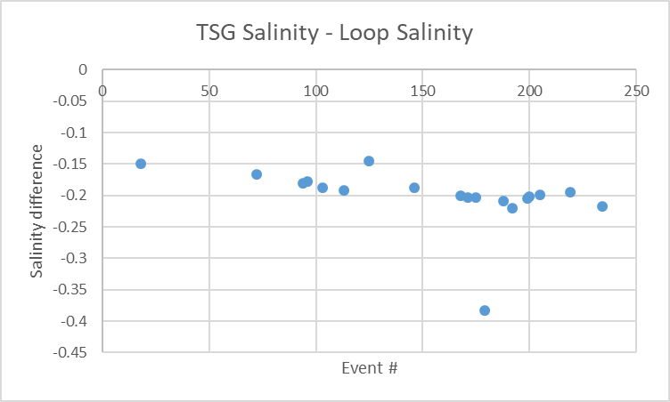

- The TSG salinity was lower than loop bottle salinity by a median of 0.20psu (std. dev. 0.05psu). The differences were slightly lower earlier in the cruise. Errors due to evaporation/desorption of samples increase with storage time so the TSG might look lower in the early stages than it really is. Such errors would slightly increase the apparent temporal drift. Differences were slightly higher while stopped than while underway. This could be because there are more bubbles in the TSG system as the ship attempts to stay on station, but there are too few samples to support that conclusion.
- The TSG fluorescence was much lower than the 5 extracted CHL loop samples for casts #18 to 103. After that values are all higher and steadily increasing until they are 77 times the loop values.
- Comparison of 5m Rosette samples and Loop samples
There were 6 salinity loop samples taken during rosette casts. The loop salinity was lower than those from the rosette by a median of 0.053psu but the standard deviation was very high at 0.290psu. The rosette samples come from about 1m below the TSG intake which can explain this variability as the local gradients vary greatly. The differences vary from the loop samples being higher by 0.008psu to being lower by 0.205psu. The largest differences were late in the cruise in areas where flushing of Niskin bottles is likely to be poor which would lead to higher salinity in rosette samples.
- Comparison of CTD data during rosette sampling and TSG Salinity and Chlorophyll
TSG salinity was lower than CTD salinity during the 5m rosette stops by a median of 0.294psu but when the nearshore casts are excluded it is low by a median of 0.201psu. The 2 extracted CHL samples collected before the TSG fluorescence started its steady increase are 40% and 60% of the CTD fluorescence during the rosette sampling.

d.) Calibration History
- The TSG and fluorometer were recalibrated shortly before cruise 2020-001.
- During 2020-001 which mostly sampled offshore and with mostly well-mixed surface waters, the TSG salinity was found to be lower than that from the CTD and loops by ~0.002psu. TSG temperature was higher than the CTD by ~0.01Cº. Salinity and fluorescence traces looked good.
- During cruise 2020-028, which mostly sampled inshore, the TSG salinity was found to be lower than that from the CTD by ~0.015psu but there was a high standard deviation. TSG temperature was higher than the CTD by ~0.01Cº. Salinity and fluorescence traces looked excellent.
- During cruise 2020-005, which mostly sampled offshore, the TSG salinity was found to be lower than that from the CTD by ~0.014psu and lower than loop samples by 0.05psu. The loops were higher than rosette samples despite the fact that the latter likely came from lower in the water column. TSG temperature was higher than the CTD by ~0.03Cº though the standard deviation was high. Salinity and fluorescence traces looked excellent. TSG Fluorescence tracked the CTD trace quite well though values at the low end of the range generally looked higher than those measured by the CTD sensor. At the high end they read lower.
- During 2020-069 comparisons were of limited value due to many casts being near-shore and many in inlets. Offshore the salinity appeared to be low by about 0.06psu but in Queen Charlotte Sound it was low by ~0.30psu. The difference was thought to be more likely due to suspended sediments rather than calibration drift. The TSG intake temperature was higher than that from the CTD by about 0.13 Cº offshore and 0.20 Cº in Queen Charlotte Sound. TSG fluorescence compared reasonably well with CTD fluorescence in Queen Charlotte Strait but not in inlets. The fluorometer was not functioning well in the 1st half of the cruise.
- During 2020-008 the TSG salinity was found to be lower than CTD salinity by a median of 0.1099psu, and lower than loops by 0.1137psu when stopped. Loop salinity values were very close to rosette salinity. The comparison with CTD salinity suggests that the calibration was slowly drifting, thus complicating any analysis. Salinity was recalibrated by adding 0.11psu. The TSG intake temperature was lower than the CTD temperature by 0.006C° which is excellent correspondence given slight differences in time and depth. The TSG fluorescence values were unusually low with many small negative values. Using an offset of 0.030ug/L instead of 0.044ug/L removes all negative numbers and leads to a minimum value for about 0.1ug/L. It is likely that the scale factor should also be increased since the ratios of TSG FL to Extracted CHL and TSG FL to CTD FL both looked low. Recalibration was applied by adding 0.221ug/L to fluorescence and subtracting 0.11psu from salinity.

e.) Conclusions re TSG
1. The TSG clock worked well and position information was available and reliable.
2. The flow rate was steady with values from 0.9L/min to 1.1L/min.
3. Variability is high in all the comparisons due to sampling in a variety of environments..
4. The TSG salinity was lower than CTD salinity by a median of 0.180psu using the 36 casts with the lowest standard deviations in TSG salinity over 2 minutes. But there was a drift with time among those casts with differences increasing from -0.15 to -020. During 2020-008 it was low by only 0.11psu though there was some drift towards a larger difference. It is possible that this cruise would have a larger difference due to slight mismatches in depth due to larger vertical salinity gradients. But it is more likely due to calibration drift since the differences from loop samples are in agreement with that trend. Given that casts were closer together in the 2nd half of the cruise than during the first half, a recalibration based on Julian time would be appropriate. Ten casts from relatively quiet sections were used to create a fit of error against Julian Time:
Sal corrected = Sal + Time Julian * 0.0073 – 1.5936
This is an estimate, but better than using a median value.
6. The TSG temperature was higher than that from the CTD by a median of 0.003C° using the 36 casts with the lowest standard deviations. During the previous cruise it was lower by 0.006C°. Both show the sensor is performing well as these values cannot be expected to be exactly the same due to small differences in time and depth.
8. The TSG fluorescence data are not reliable after cast #103 and should be removed. Before that the values are low and look especially out of line at very low values. During the previous cruise negative values were found suggesting that the offset in the conversion was a little too high. That is probably still true though values were never low enough to go negative. Decreasing the offset to 0.30 from 0.44Volts leads to concentration values increased by 0.22ug/L. This gives better results at the low end of the scale but is slight at higher fluorescence. Overall between casts #1 and #103 the TSG fluorescence is 40% of the CTD fluorescence before the offset change and 43% afterwards. If the scale is also increased we can get a better match but it requires a much bigger scale factor than would be expected in normal drift. Since the fluorescence readings are mostly low compared to loop samples as well, the problem is not in the water from the loop, but rather with the fluorometer. The question is whether these data are worth archiving. The shape of the traces look reasonable up to the end of August 28th. These sensors tend to read lower than CHL when CHL values are high as was the case for most of this cruise.
9. Recalibration will be applied to the salinity and fluorescence.

f.) Editing
No editing was required.

g.) Calibrate
CALIBRATE was used to add 0.221ug/L to channel Fluorescence:URU:Wetlabs and to apply equation “Salinity Corrected = Salinity + Time Julian * 0.0073 – 1.5936”

h.) Final Steps
REMOVE was used to remove channel Pressure, Temperature:Difference and record # from all files and Fluorescence from files after August 28.

HEADER EDIT was used to change the DATA DESCRIPTION to THERMOSALINOGRAPH and add the depth of sampling to the header and to change channel names to standard names and formats and to add comments.
A cross-reference list was prepared.
The TSG sensor history was updated.
As a final check plots were made of the cruise track and time-series and all look fine.
Particulars - Notes from Daily Science Log and Sampling Notes
PAR off: None.
Casts with bottle fired out of order: 4, 8, 40, 65, 67, 69, 77, 222
Casts with no Niskin closed: Many

2. Niskin 2 didn’t close.
3. Niskin 2 fired as test only – not needed in file.
4. Niskin 24 not needed in file.
8. Niskin 24 not needed in file.
26. Temperature difference large on upcast.
39-40: Computer froze at 300db on upcast. Niskin 7 was closed just before freeze but didn’t display on monitor. Much confusion – see hydro file to see what depth water came from. Extra sal samples taken from Niskins 7 and 8. See notes for details on sampling to figure this out. Cast 40 contains rest of upcast.
Niskin #7 was fired twice but the closing was clearly at 300db and there was no bottle closed at 250db.
59. Niskin 2 did not close.
61. Niskin 3 did not close.
64. Should have been called event 65. Fixed.
65. Niskin 6 was closed in case Niskin 2 did not close and that did happen. So use Niskin 6 for sample 188 at 30db.
67. Use Niskin 9 for sample 193 at 100db.
69. No sample 201 from 750db since both Niskins did not close.
77. No sample at 1500db. Sample 234 at 20db is from Niskin 24.
78. Spike in SAL at 1100m down.
78-end – Niskin 11 skipped for most casts. Not needed in CHE files. For some casts sampling was indicated on the rosette sheet so the record was kept but analysis results given with pad value & 9 flags.
78-161 – Niskin 2 skipped for most casts.
96/100 – Repeated sample numbers – use 292 and 9292. Niskins 1,2,3,4 closed but labels indicate otherwise.
98. Cast aborted at 27db. Not needed.
107. Repeated sample numbers – use 292 & 9292.
116. Station name wrong in header. Should be LBP6. Fixed.
122. Something in primary cell - primary signal very bad.
137/138 – crash during upcast. Niskins 1-6 in file 137, rest in file 138.
138/144 – repeated sample number 383. For cast 138 sample #9383 was used. Niskin #2 was fired & closed.
159. Bad secondary salinity 20-50m, suspicious O2 values to 60m 0 - big O2 spike at 50m. Primary may be ok but salinity calibration problematic.
161. Niskin 11 not needed.
168. Pumps off – delete cast
170 to end. Niskin 2 was fired and closed successfully on many casts. No misfires for that bottle. Niskin #11 continued to misfire.
177. Station name should be NL01. Fixed.
197. Niskin 11 not needed but samples flagged 9 by analysts so kept in file.
222. Use Niskin 24 for 250db sample, #507. Niskin 3 not needed.
223. File names wrong – fixed by operator.
227 & 228 – File names wrong. Fixed.

2020-009
CRUISE SUMMARY – CTD
CTD# | Make | Model |  | Serial# |  | Used with Rosette? |  | CTD Calibration Sheet Competed?
1 | SEABIRD | 911+ |  | 443 |  | Yes |  | Yes
Calibration Information - 0443
Sensor |  |  |  |  | Pre-Cruise |  |  |  | Post Cruise
Name |  |  | S/N |  | Date |  | Location |  | Date | Location
Temperature |  |  | 4700 |  | 11Dec2019 |  | Factory
Conductivity |  |  | 3531 |  | 12 ec2019 |  | Factory
Secondary Temp. |  |  | 4888 |  | 11Dec2019 |  | Factory
Secondary Cond. |  |  | 4513 |  | 28Jan2020 |  | Factory
Transmissometer |  |  | 1883DG |  | 8Feb2020 |  | Factory
Transmissometer |  |  | 1185DR |  | 8Feb2020 |  | IOS
SBE 43 DO sensor |  |  | 3791 |  | 7Dec2019 |  | Factory
PAR |  |  | 70613 |  | 21Mar2016 |  | Factory
SPAR |  |  | 20518 |  | 21Mar2016 |  | Factory
pH:SBE |  |  | 692 |  | 14Jan2020 |  | Factory
SeaPoint Fluor. |  |  | 3950 |  |  |  | Factory
Pressure Sensor |  |  | 0443 |  | 9Jan2020 |  | Factory
Altimeter |  |  | 20518 |  | 21Mar2016 |  | Factory

TSG Make/Model/Serial#: SEABIRD/45/0620
Calibration Information
Sensor |  | Pre-Cruise |  | Post Cruise
Name | S/N | Date | Location | Date | Location
Temperature | 0620 | 21Jan20 | Factory
Conductivity | 0620 | 21Jan20 | Factory
WETStar Fluorometer | 953 | 30Dec2019 | Factory

