REVISION NOTICE TABLE
DATE | DESCRIPTION OF REVISION
19 March 2025 | Updated channel names & formats in TOB & Loop files. G.G. & S.H.
23 March 2023 | Added HPLC data. J.R.

PROCESSING NOTES
Cruise: 2020-008
Agency: OSD
Location: North-East Pacific
Project: Line P
Chief Scientist: Robert M.
Platform: John P. Tully
Date: 12 August 2020 – 24 August 2020

Processed by: Germaine Gatien
Date of Processing: 14 December 2020 – 17 March 2021
Number of original HEX files: 38 (includes 2 that need to be joined for downcast)
Number of original CTD files: 38 Number of processed CTD files: 37
Number of rosette files: 37 Number of processed CHE files: 36
Number of original TSG files: 2 Number of processed TOB files: 12

INSTRUMENT SUMMARY
CTD #0443 was mounted in a rosette and attached were 2 Wetlabs CSTAR transmissometer (1185DR & #1883DG), a SBE 43 DO sensor (#3791) on the secondary pump, SeaPoint Fluorometers (#3640 for casts 1-50 and #3950 for casts 52-86) on the primary pump, a Biospherical QSP-400 PAR sensor (#70613), a Reference PAR (#20518) and an altimeter (#62355). An SBE pH sensor ($692) was mounted for events #1 to #24.

A thermosalinograph (SeaBird 45 S/N 0620) was mounted with a Wetlab/Wetstar fluorometer (WS3S-953P) and flow meter.
Seasave version 7.26.7.121was used for acquisition.
The data logging computer WP #102.
The deck unit was a Seabird model 11+ #425.
A Guildline model 8400B Autosal serial # 68572 was used to analyze salinity samples.
An IOS rosette with 24 10L bottles was used.

SUMMARY OF QUALITY AND CONCERNS
The Daily Science Log Book and rosette log sheets were in excellent order with comments about problems encountered. The sampling notes were provided by the Chief Scientist were a great help in processing data.

There were 2 WetLabs CStar transmissometers in use during this cruise:
Channel Transmissometer refers to sensor #1185DR (650nm - red)
Channel Transmissometer:Green refers to sensor #1883DG (530nm - green)
For comparison with other Institute of Ocean Sciences cruises, note that the transmissometer wavelength is 650nm unless otherwise stated.

The primary conductivity drifted through this cruise and during cruise 2020-009 that immediately followed it. During 2020-083 the differences between primary and secondary salinity reverted to values similar to those seen during 2020-005 and 2020-069. So the problem was not sensor calibration drift. Secondary temperature, conductivity and salinity channels were selected for archiving for this cruise.

The fluorometer used for casts #1 to 50 produced steadily higher dark values after cast #14 and compared poorly with extracted chlorophyll so those data were removed. From cast #52 onwards a different fluorometer was used and performed well.

While CTD fluorescence data are expressed in concentration units, they do not always compare well to extracted chlorophyll samples. It is recommended that users check extracted chlorophyll values where available.

ALL DMSP data for this cruise were lost due to a freezer compressor failure at IOS.

The SBE DO sensor calibration drifted significantly between June and October 2020 and during a factory service in December the membrane was replaced.

The SBE DO sensor has a fairly long response time so data accuracy is not as high when it is in motion as it is during stops for bottles. This will be especially true when vertical DO gradients are large. To get an estimate of the accuracy of the SBE DO data during downcasts (after recalibration) a rough comparison was made between downcast SBE DO and upcast titrated samples. Some of the difference will be due to problems with flushing of Niskin bottles and/or analysis errors and small mismatches in depth in the presence of large DO gradients, so the following statement likely underestimates SBE DO accuracy.

Downcast (CTD files) Oxygen:Dissolved:SBE data for this cruise are considered, very roughly, to be:
±0.4 mL/L from 0-150db except in areas of very large DO gradients
±0.1 mL/L from 150db-400db
±0.04 mL/L from 400db-600db
±0.02 mL/L below 600db

The Thermosalinograph system functioned quite well with lots of detail in the traces, no significant spiking in salinity and no obvious drift in fluorescence. However, the fluorescence values were odd with some negative values, so the calibration offset was adjusted so that all values were positive. The scale factor is likely also too low, but since most sampling was in low chlorophyll regions, there was insufficient information to enable a reliable estimate for that factor. Comparisons were made between TSG data and co-incident CTD casts, rosette samples and loop samples. The intake temperature was close to CTD values. The salinity calibration appeared to be drifting slowly and those data were recalibrated by adding 0.11psu.

The loop and rosette salinity and extracted chlorophyll samples compared well.

PROCESSING SUMMARY

Seasave
This step was completed at sea; the raw data files have extension HEX.
The chief scientist provided a summary of sampling protocols and problems.
The deployment protocol was:
The rosette was brought to the surface. Pumps were turned ON. The rosette was brought down to 10m and kept there for 30 seconds. Once back at the surface, the data started to be archived, with the rosette at the surface for 30 seconds longer. Then the cast would start.

Preliminary Steps
The Log Book and rosette log sheets were obtained as well as sampling notes from the Chief Scientist.
- Nutrients, extracted chlorophyll, dissolved oxygen, salinity and DMS data were obtained in QF spreadsheet format from the analysts.
- The cruise summary sheet was completed.
- The histories of the pressure sensor, conductivity and dissolved oxygen sensors were checked. The temperature, conductivity and dissolved oxygen sensors had been used on 4 other cruises since the last factory recalibrations. See section 14 for details.
Based on notes from the chief scientist some water depth and station names were changed in the raw files.

BOTTLE FILE PREPARATION
The ROS files were created using files 2020-008-ctd1.xmlcon for casts #1-50 and 2020-008-ctd2.xmlcon for casts #52-86.
The bottle file for cast 52/53 was saved at sea as #53 but was changed to #52 in the ROS file to match the CTD file for that site.
The ROS files were converted to IOS format.

The IOS files were put through CLEAN to create BOT files.
Temperature and salinity were plotted for all BOT files to check for outliers. No problems were found.
A preliminary header check was run and no problems were found.

The BOT files were bin-averaged on bottle number.
The output was used to create file ADDSAMP.csv. First, the file was sorted on event number and Bottle Position order. Then sample numbers were added based on the rosette logs.
The file was used to add sample numbers to the BOT files – output *.SAM.
The SAM files were bin-averaged on bottle # and called SAMAVG.
The addsamp.csv file was converted to CST files, which will form the framework for the bottle files.

Next, each of the analysis spreadsheets were examined to see what comments the analysts wanted included in the header file. These were used to create file 2020-008-bot-hdr.txt which will be updated as needed during processing.

DISSOLVED OXGYEN
Dissolved oxygen data were provided in spreadsheet QF2020-008_OXY*.xlsx which includes flags, comments and a precision study. Draw temperatures are available. The spreadsheet page with the final data was simplified and saved as 2020-008oxy.csv. That file was converted into individual *.OXY files.
There were no flags in the DO file that had comments starting with “ALL:”
EXTRACTED CHLOROPHYLL
Extracted chlorophyll and phaeo-pigment data were obtained in file QF2020-008_CHL QF*.xlsx. The file included comments and flags and a precision study. A simplified version of the spreadsheet was prepared and saved as 2020-008chl.csv. The csv file was then converted to individual CHL files.
SALINITY
Salinity analysis was obtained in file QF2020-008_SAL.xlsx which included a precision study. The analyses were carried out in a temperature-controlled lab 26 to 39 days after collection. The files were simplified and saved as 2020-008sal.csv. That file was then converted to individual SAL files.
NUTRIENTS
The nutrient data were obtained in spreadsheet QF2020-008_NUTS*.xlsx. This includes a precision study. The file was simplified, saved as 2020-008nuts.csv and converted to individual NUT files.
DMS
DMS data were obtained in spreadsheet DMS summary (2019-008)*.xls which includes duplicate analysis. Details on analysis are in file 2019-008 DMS report*.doc. Values < were changed to 0. Date were sorted on sample numbers and then converted to DMS files. Only 2 figures are considered significant.
DMSP
DMSP-D and DMSP-T data were all lost due to a fridge failure during storage. The analyst provided the data (all samples flagged 1 with comments) in file DMSP-QF summary*.xls. The data were converted into DMSP files.

The SAL, CHL, OXY, NUT, DMS and DMSP (DMSP-D and DMSP-T) files were merged with CST files in 6 steps.
After the 6th step the files were put through CLEAN to reduce the headers to File and Comment sections only.
The files were then put through CLEAN to reduce the headers to File and Comment sections only.
These files are ordered on sample number, but the SAMAVG files are ordered on bottle number, so one or the other set needs to be reordered in order to merge them. The MRGCLN1 files were reordered on Bottle_Number and saved as *. MRGCLN1s.
The MRGCLN1s files were then merged with SAMAVG files using merge channel Bottle_Number.

The output of the MRG files were exported to a spreadsheet and compared to the rosette log sheets to look for omissions. No problems were found:

Compare
Salinity
Compare was run with pressure as reference channel.
There was a lot of scatter in the fits, especially in the primary. When plotted against time the source of the scatter becomes clear as the primary CTD salinity is obviously drifting with time. The differences between the two channels as observed in the bottle comparison corresponds fairly well with the observations of the differences between channels as observed in salinity profiles.

Preliminary examination of data from the next 2 cruises using the same equipment shows differences continued to drift through 2020-009 but had reverted to ones similar to the beginning of this cruise for 2020-083; those were in line with previous cruises to this one. So the problem appears to have not been with the sensor itself.

Outliers were investigated:
- Sample 208 was flagged 3 due to loose cap– The value is a little high but there is too much variability to say that with confidence, so flag 3 looks right.
- Sample 171 is a major outlier and looks like a case of sampling from the wrong bottle. It looks like it came from 1750db.
- Sample 214 is an outlier compared to CTD. Flag 3 is appropriate.

When 2 outliers were removed plus bottles from above 500db the primary salinity was found to be low by an average of 0.0088psu, standard deviation 0.0026 and the secondary was found to be high by 0.0018, standard deviation 0.0014.
For full details for the COMPARE run see file 2020-008-sal-comp1.xls.

Dissolved Oxygen
COMPARE was run with pressure as the reference channel.
When all casts were included and outliers were removed based on residuals the fit was:
CTD DO Corrected = CTD DO * 1.0449 - 0.0298 R² = 0.97 (1)
Examination of the results show that most of the excluded values came from shallow water where vertical gradients tended to be high.

Two deep casts, #25 and 378, were compared to see if there was any evidence of temporal drift and none was found. Because the analyst noted a problem with the storage of samples from cast #44, those bottles were displayed in green together with other bottles in red and the cast did not stand out as unusual and the fit was similar to the general fit.

The only notable outlier was sample #47 from cast 12 at 9.6db. Examination of the DO profile shows that there was an extremely high gradient at that level with values matching the bottle value found at 12db and a shed wake with equally low values passed through during the bottle stop at 9.6db.

Hysteresis checks were done. There was no obvious difference between differences above and below the oxygen minimum level.

Plots of Titrated DO and CTD DO against CTD salinity were examined. The only notable outlier was the one noted above in cast 12.
For full details for the COMPARE run see file 2020-008-dox-comp1.xls.

Fluorescence
COMPARE was run with extracted chlorophyll and CTD Fluorescence using pressure as the reference variable.
The fluorometer was known to have malfunctioned and was replaced after event #50, so the data were examined in 2 sections.
For the first fluorometer the fit looks normal for the first 4 events. Cast #14 looks slightly out of line but from cast #19 -50 the fit is definitely out of line with what is expected from these sensors. We generally see a lot of variability and as the ship moves offshore this ratio does tend to rise because chlorophyll values are low. So it is not completely clear but taken with the observation of large dark values for the fluorometer there clearly was a problem.

The fluorometer was replaced after cast #50 and the comparison thereafter looks reasonable. The two samples at event 50 and 52 are both from 5m. Between the 2 casts Chlorophyll increased slightly from 0.18 to 0.21ug/L but fluorescence dropped from 1.34 to 0.30ug/L. The ratio FL/CHL dropped from 7.5 to 1.5.

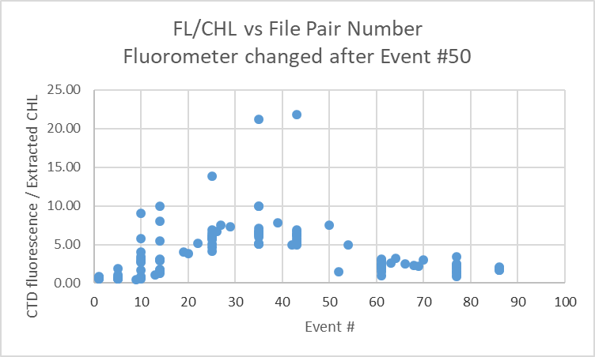

For full details for the COMPARE run see file 2020-008-fl-chl-comp1.xls.

Conversion of Full Files from Raw Data
The configuration changed when the fluorometer was replaced so 2 configuration files were needed.
File 2020-008-ctd.xmlcon was used to convert files 1-50 and 2020-008-ctd2.xmlcon was used to convert files 52-86.
The Tau function and the hysteresis function were selected since there was deep sampling. Depth was included in the conversion.

A few casts were examined and all expected channels are present. The T and C pairs were reasonably close during downcasts but the differences in conductivity did increase with time. PAR, SPAR and Dissolved Oxygen profiles looked normal. The “Green” transmissometer was generally higher than the “Red”; the profiles had similar shapes. The altimetry looked ok.

Fluorescence was problem during this cruise and the fluorometer was replaced after cast #50. Dark values during the previous cruise, 2020-069, were ~0.1ug/L in very deep water early in the cruise. Later the casts were mostly shallow and in areas where odd results might be real but most dark values were ~0.2ug/L until the final few casts in the Strait of Georgia when they were ~0.4ug/L in 300m casts. For this cruise casts 1 to 19 have deep values ~0.4ug/L and then start to increase steadily until cast #50 when it was ~0.7ug/L. The fluorometer was replaced and dark values thereafter are ~0.06ug/L. The first fluorometer also shows more variation at depth which could mean near-surface values are not out of line, but the comparison with bottles suggests that even in the top 100m the results are poor from about cast #19 until the fluorometer was replaced. So the fluorescence channel should be removed for casts #19 to 50.

WILDEDIT
Program WILDEDIT was run to remove spikes from the pressure, depth, conductivity & temperature only in the full cast files (*.CNV).
Parameters used were: Pass 1 Std Dev = 2 Pass 2 Std Dev = 5 Points per block = 50
The parameter “Keep data within this distance of the mean” was set to 0 so all spikes would be removed.

ALIGN DO
A few casts were examined; both temperature channels were noisy during upcasts so the tests were not easy to interpret, but using +2.5s certainly improves the alignment and overall looks like a good choice for both sensors. That setting has worked well for many SBE DO sensors in recent years.
ALIGNCTD was run on all casts using +2.5s.

CELLTM
The noise in the upcast data makes tests for the best parameters for this routine very difficult to interpret. In the past when upcast data were not so noisy, the default setting of (α = 0.0245, β=9.5) was generally found to be the best choice. A few casts were checked for this cruise and the default setting does improve the data. CELLTM was run using (α = 0.0245, β=9.5) for both the primary and secondary conductivity.

DERIVE and Channel Comparisons
Program DERIVE was run on all casts to calculate primary and secondary salinity and dissolved oxygen concentration.

DERIVE was run a second time on 4 of the deeper casts to find the differences between the pairs of temperature, conductivity and salinity channels. The differences were clearly increasing so a few shallower casts were examined to see when the drift started. It may have started during the previous cruise but most of the casts were too shallow to determine that.
Cast # | Press | T1-T0 | C1-C0 | S1-S0 | Descent Rate
2020-001-0025 | 1000 | 0 | +0.00060 | +0.0075 | High, V Noisy
 | 1900 | -0.0004 | +0.00063 | +0.0080 | “
2020-005-0075 | 1000 | -0.0006 | +0.0004 | +0.0055 | High, Noisy
“ | 1900 | -0.0005 | +0.00046 | +0.0060 | “
“ | 500 | -0.0003 | +0.0004 | +0.0050 | High, X Noisy
2020-005-0140 | 1000 | -0.0002 | +0.00043 | +0.0055 | “
“ | 1900 | -0.0002 | +0.00048 | +0.0060 | “
“ | 500 | -0.0004 | +0.00042 | +0.0055 | High, Moderate
2020-005-0218 | 1000 | -0.0005 | +0.00046 | +0.0060 | “
2020-069-0043 | 1000 | -0.0006N | +0.00040N | +0.0054 | High, Mod
 | 1900 | -00002 | +0.00046 | +0.0058 | “
2020-069-0122 | 1000 | -0.0002 | +0.00051 | +0.0064 | High, Mod
 | 1900 | -0.0002 | +0.00053 | +0.0068 | “
 | 2900 | -0.0003 | +0.00055 | +0.0072 | “
2020-008-0015 | 1000 | -0.0005 | +0.00058 | +0.0073 | High, F Steady
2020-008-0022 | 1000 | -0.0003 | +0.00068 | +0.0085 | High F Steady
2020-008-0027 | 1000 | -0.0003 | +0.00073 | +0.0089
2020-008-0036 | 1000 | -0.0005 | +0.00072 | +0.0095 | High, V Noisy
“ | 2000 | -0.0003 | +0.00075 | +0.097 | High, X Noisy
“ | 3000 | -0.0005 | +0.00078 | +0.0100 | “
2020-008-0044 | 1000 | -0.0005 | +0.00072 | +0.0092 | High Noisy
“ | 2000 | -0.0004 | +0.00076 | +0.0097 | “
“ | 3000 | -0.0006 | +0.00077 | +0.0102 | “
2020-008-0060 | 1000 | -0.0004 | +0.00081 | +0.0101 | High Noisy
“ | 2000 | -0.0004 | +0.00084 | +0.0107 | “
“ | 3000 | -0.0006 | +0.00084 | +0.0111 | High F Noisy
2020-008-0078 | 1000 | -0.0006 | +0.00097 | +0.0120 | High V Noisy
“ | 2000 | -0.0005 | +0.00099 | +0.0126 | “
“ | 3000 | -0.0006 | +0.00100 | +0.0130 | High Noisy
The salinity and conductivity differences are clearly rising though the cruise.

Conversion to IOS Header Format
The IOSSHELL routine was used to convert SEA-Bird 911+ CNV files to IOS Headers.
CLEAN was run to add event numbers and to replace pad values in the pressure channel with interpolated values based on record number.
Files for events 52 and 53 need to be joined into a single downcast file. (The bottle file was entirely in 53 which was renamed as 52.)
File 2020-008-0053.CLN was edited to remove 569 initial records that overlap with 2020-008-0052.CLN. The files were renamed as 52.cln1 and 52.cln2 and joined and named as 2020-008-0052.CLN

Checking Headers
The cross-reference check and header check were run. No problems were found.

Surface check was run and found an average of 2.1db, which is a little low for an off-shore Tully cruise. The lowest pressure recorded was 0.3db and the associated salinity was ~32psu which is reasonable at the surface. No problems have been noted with the pressure since the offset was adjusted in June 2020 based on tests at sea. However, a post-cruise report from early 2021 showed pressure low by ~0.4db.

Cruise tracks were plotted and added to the end of this report.

The altimeter and water depth readings from the headers of the CLN files were exported to a spreadsheet. A check value was calculated by subtracting water depth from maximum depth sampled plus altimetry header -1 (since the altimetry averages over 2m the value may be high by 1m.). Where that number was > 4 or <-4 plots of the altimetry were checked. Many casts didn’t get near the bottom so there are no altimetry headers and for many the check value was small. In 1 case the altimetry was sufficiently messy and the sounder values noisy so no better estimate could be made. For 2 the log entry proved better and for 2 the altimeter reading was bad so it was removed from the header. For others there were sounder problems and the best choice was an estimate based on maximum depth sampled plus altimetry – 1. Changes were made to CLN files. Where the same changes applied they were made to SAM files, which were averaged again and merged with bottle data files.

Shift
Fluorescence
SHIFT was run on the SeaPoint fluorescence channel in all casts using the usual advance of +24 records. Plots show that the fluorescence offset is reasonably close to the temperature offset after this step.
Dissolved Oxygen
The Dissolved Oxygen voltage channel was aligned earlier. A few casts were checked to see if the alignment looked ok, and it did. No further alignment is needed for the DO concentration channel,
Conductivity
Tests were run on a few casts to assess what settings are best to align conductivity with temperature (as judged by the effect on salinity as seen in T-S space). Since it is clear that the primary conductivity and salinity are drifting, it is unlikely they will be archived but they were put through SHIFT just in case there are problems in the secondary. The best settings were -0.4records for the primary and -1.2records for the secondary.
SHIFT was run twice on all SBE911 casts using -0.4 records for the primary and -1.2 records for the secondary conductivity. Salinity was recalculated for both channels.

DELETE
The following DELETE parameters were used:
Surface Record Removal: Last Press Min
Maximum Surface Pressure (relative): 10.00
Surface Pressure Tolerance: 1.0 Pressure filtered over 15 points
Swells deleted. Warning message if pressure difference of 2.00
Drop rates < 0.30m/s (calculated over 11 points) will be deleted.
Drop rate applies in the range: 10db to 10db less than the maximum pressure
Sample interval = 0.042 seconds. (taken from header)
COMMENTS ON WARNINGS: There were no warnings.

Other Comparisons
Experience with these sensors since last factory service –
The pressure, temperature, dissolved oxygen and conductivity sensors were used a lot during 2020
- 2020-001 – Primary salinity was low by 0.0035 and secondary performed poorly. Dissolved oxygen was recalibrated using slope/offset =1.0242/-0.0022
- 2020-028 – Shallow sampling not trusted for recalibration. Autosal problem discovered after initial processing but result was not trusted anyway. Used 2020-005 result. Dissolved oxygen was recalibrated using slope/offset=1.0308/-0.0085. Pressure was recalibrated during 2020-028 by increasing the offset to -0.8db. The same offset was used for cruises that followed.
- 2020-005 – Autosal problem discovered after processing but error very small for deep bottles used in comparison. Primary low by 0.004 and secondary high by 0.0018. Made small allowance for flushing error in recalibration. Dissolved oxygen was recalibrated using slope/offset=1.0308/-0.0085.
- 2020-069 – Dissolved oxygen correction 1.0369/-0.0197. Salinity comparison not trusted due to only near-bottom samples from the few deep casts; recalibration based on 2020-005.
The following later cruise used this equipment and some information is available about the sensors.
- 2020-083 – Autosal problem – based on tentative correction of Autosal results the primary was low by 0.004 and the secondary high by 0.0018psu.
Historic ranges – Profile plots were made with 3-standard deviation climatology ranges of T and S superimposed. There were a few minor excursions. Temperature was slightly high around P6-P9 in the 40-50db range and slightly low at P8 and P11around 150m. Salinity was slightly low at P16 and P17 around 250m. None of these excursions suggest calibration drift.
Post-Cruise Calibration – Post-cruise calibration information became available late in processing. One cast was recalibrated to see how the results compared. The secondary temperature had drifted downwards slightly while secondary conductivity had drifted upwards; so the post-calibration secondary salinity was higher by ~0.0024psu around 177db. The SBE Dissolved Oxygen sensor data is not useful since it was clear it was damaged. Poor resolution had been reported and the membrane was replaced during the December 2020 service.

DETAILED EDITING
The decision on which channels to edit is clear since the bottle comparison showed primary salinity drifting through the cruise. Preliminary results from cruise 2020-083 indicate that this was due to some instrumental problem other than sensor calibration drift.

Fluorescence data were bad below 950db in cast #52, so those points were also removed. Dissolved oxygen data was noisier than usual at depth as well but not clearly bad.

All DEL files were copied to *.EDT.

CTDEDIT was used to remove records that appear to be corrupted by shed wakes. Salinity was cleaned to remove spikes that appear to be due to small misalignment or instrumental noise. All files required some editing. Notes about editing applied were added to the files.
The edited files were copied to *.EDT.
After editing, T-S plots were examined for all casts. A few bad values remained in one cast, so CTDEDIT was run again on that cast. Some small unstable features remain in other casts but come from areas where such features may well be real. No further editing was done.

Corrections to Pressure, Salinity and Dissolved Oxygen Concentration
A post-cruise calibration became available late in processing and suggests that a small adjustment to the pressure offset is appropriate, so +0.4db was added. The slope also changed slightly but this effect is insignificant (~0.2db at 4000db).

Flushing errors for the deep casts are expected to be small offshore but the differences between samples and bottles don’t seem to stabilize until pressures are >1500db, a level at which vertical salinity gradients are generally very low. The results from those deep bottles will be used for correction of the salinity by subtracting 0.0018psu. The post-cruise calibration indicates a correction of -0.0024psu which is very close but there were 2 other very long cruises before that factory check.

File 2020-008-SBE911-recal.ccf was prepared to add 0.4db to pressure, subtract 0.0018psu from channel Salinity :T1:C1 and apply the following correction to channel Oxygen:Dissolved:
CTD DO Corrected = CTD DO * 1.0449 - 0.0298
This correction was first applied to the SAM and MRGCLN2 files.

COMPARE was rerun for salinity. When the same outliers were removed as in the original comparison, both salinity channels were found to be low by an average of 0.0001psu. See file 2020-008-sal-comp2.xls for details.

COMPARE was rerun for dissolved oxygen and shows that the correction was applied properly. When data are excluded using the same points as in the original fit for the 3 deep casts, the CTD DO was low by an average of <0.0001mL/L. This shows that the recalibration was applied corrected and was appropriate. See file 2020-008-DO-comp2.xls for details.

CALIBRATE was then run on the EDT files using the same recalibration file.

Final Calibration of DO
The initial recalibration of dissolved oxygen corrects for sensor calibration drift. Alignctd corrects for transit time errors. Those 2 steps may partly correct for response time errors, but to see if a further correction is needed, a comparison is made of downcast CTD data to bottle data from the same pressure. Small differences are expected due to ship drift, temporal changes, incomplete flushing of Niskin bottles and delayed response and noise in CTD data.

Downcast files were bin-averaged to 0.5m bins for the casts with DO bottle samples. Those files were then thinned and compared to the bottle values in the MRG files. COMPARE was run to study the differences between the downcast CTD DO data and the titrated samples from upcast bottles.

The CTD DO was higher than the titrated samples by an average of ~0.03mL/L when data from the top 12m were excluded, but the standard deviation was 0.15mL/L. The differences are small at depth and gradually rise towards the surface as the local vertical gradients increase.

Fluorescence Processing
A median filter, size 11, was applied to the fluorescence channel in the COR1 files. Plots of a few casts showed that the filter was effective. (Output:*.FIL)

BIN AVERAGE of CTD files
The following Bin Average values were applied to the FIL files (output AVG):
Bin channel = pressure Averaging interval = 1.000 Minimum bin value = .000
Average value will be used. Interpolated values are NOT used for empty bins.
On-screen T-S plots were examined.
Profile plots were examined. No problems were noted.

Final CTD File Steps (REMOVE and HEADEDIT)
For all casts REMOVE was run to remove the following channels:
Scan_Number, Temperature:Secondary, Conductivity:Secondary, Oxygen:Voltage:SBE, Descent_Rate, Status:Pump, Altimeter, Salinity:T1:C1 and Flag.
Channel Fluorescence:URU:Seapoint was removed from casts #19 to 50.
A second run of REMOVE was used to remove channel PAR for casts #36, 37, 39, 44, 52, 54, 60, 64, 66, 68, 78 and 86..

A second SBE DO channel (with umol/kg units) was added.
REORDER was run to get the two DO channels together.
HEADER EDIT was used to fix formats and channel names and to add the comments about processing.
The Standards Check routine was run and no problems were found.
The Header Check was run; no problems were found.
Profile and T-S plots were examined. No problems were found.
The sensor history was updated.

Dissolved Oxygen Study
As a final check of dissolved oxygen data, % saturation was calculated and plotted. Values at 2 to 3m ranged between ~60% to 125%. The deep offshore casts had values between 101% and 106%. The lowest values were in Haro Strait, Juan de Fuca Strait and at P1 and P2 while high values were in Saanich Inlet and at P3.

Final Bottle Files
SORT was run to arrange casts in pressure order.
For all casts REMOVE was run to remove the following channels:
Scan_Number, Temperature:Secondary, Conductivity:Secondary, Oxygen:Voltage:SBE, Descent_Rate, Status:Pump, Altimeter, Salinity:T1:C1 and Flag.
Channel Fluorescence:URU:Seapoint was removed from casts #19 to 50.
A second run of REMOVE was used to remove channel PAR for casts 36, 37, 39, 44, 52, 54, 60, 64, 66, 68, 78 and 86..
A second SBE DO channel with mass units was added for both the CTD DO and titrated DO and REORDER was run to get the pairs of DO channels together.

EDIT HEADERS was run to fix formats and channel names and to add comments about analyses and CTD processing.

Data were exported from the CHE files to file 2020-008-bottles-final.xlsx. The entries were compared with the rosette log sheets. A problem was found in cast #52. The sample numbers were missing. They were added to the CHE and SAMAVG files. The samples were in the file.

Standards check and a header check were run. No problems were found.
The track plot looks ok.
Plots of each file were examined and no problems were found.
A cross-reference listing and header check were produced for the CHE files.

Thermosalinograph Data
An IOS TSG45 was used for this cruise. The data were delivered in 2 files. There was some overlap with the files delivered with 2020-028. The Juan de Fuca data were left in both data sets for convenience of users.

The IOS SBE TSG45 files were opened in EXCEL.
The files have extensions RAW but are in csv format, so the files were opened in EXCEL and combined in a single CSV file. (In opening I use DELIMITED, deselect TAB, select COMMA and OTHER (*).
It is necessary to choose TEXT for the time on the 2nd page of the text import wizard.)

The spreadsheets were adjusted as follows:
- 2 lines of headers were added – channel names and units.
- A column with pressure was added with all values set to 4.5 (to enable derivation of salinity).
- A temperature difference column was added (Lab-Intake).
- The fluorescence channel is in volts. It was moved to column M. Then a concentration value was calculated in column F using offset -0.044 and scale 15.8 as determined in the most recent recalibration of the fluorometer. Copy/Special Paste was used to save those values and then the voltage channel was removed.
- A file break column was filled with the cruise #-data/time info from the original file name.
- There was only a 15s gap between the 2 TSG files, so the data were combined in one CSV file.
- Time and Date formats are a problem – when converting from RAW choose TEXT but once opened in EXCEL set Time Format to HH:MM:SS and save the file again.
- There were no NaN entires.
- The file break column was completed so that new files would be created at the beginning of each day by assigned file names like 20200210-000000 except for the first file which has a time later than 000000.
- The flow was not turned on until 02:19:41 on August 13 and temperature data did took about . Entries for lab and intake temperature, salinity, conductivity and fluorescence were padded up to 02:19:51 as flow was established.
- The Flow Rate was quite high (1.2–2.1) until 02:28:11 when it settled to ~1 (range: 0.8-1.2).

The file was then converted to IOS Header format with header info added. There are12 IOS files, one for each day.
CLEAN was run to reset the number of records, min and max values, set the start and end times, and latitude and longitude limits.
ADD TIME CHANNEL was used to add Julian dates – i.e. Decimal Year. A record number was also added to enable averaging (for use in comparison to CTD files). Time zero was set to 31 December 2019 0:00:00. (Note that this step leads to problems plotting until REORDER is run.)
DERIVED QUANTITIES was run twice, first to derive salinity using the lab temperature and again to derive sigma-T.
REORDER was run to move the Julian date to after the Time/Date channels and to put salinity and fluorescence after the lab temperature. Also the record # was moved to the end.

a.) Plots
A track plot was produced and added to the end of this report.
Time-series plots were produced and the only problems noted were a few discrete salinity spikes. Editing may be possible to remove those.

b.) Checking Time Channel
The CTD files were thinned to reduce the files to a single point from the downcast at or within 0.5db of 4.5db. These were exported to a spreadsheet which was saved as 2020-008-ctd-tsg-loop-rosette-comp.xlsx. All 37 CTD casts overlapped with TSG records but 1 occurred before flow was turned on, so there are 36 records for comparison.

The TSG files were averaged over 24 records (2 minutes) on record number to reduce the noise and file size. Standard deviations were included. Then required records (times, positions, temperatures with standard dev, salinity with standard dev, fluorescence with standard dev, flow rate) were exported to a spreadsheet and that file was thinned to the closest times of CTDs and added to file 2020-008-ctd-tsg-loop-rosette-comp.xlsx..

Comparisons were made of positions to check for good matches. The differences in positions are expected to be small despite the averaging because the ship was stopped at these times. The average differences were 0.0000º for both latitude and longitude. There were no differences >0.0007 º.

c.) Comparisons
- Comparison of T, S and fluorescence from TSG and CTD data
The initial comparison between TSG and CTD data includes some large outliers. The first 2 casts have higher flow rates and are in areas of large temporal variability. Excluding the first 2 casts the differences are:
 | Tint-Tctd | Tlab-Tctd | SALtsg-SALctd | FLtsg/FLctd
max | 0.3551 | 1.5847 | -0.0927 | 0.53
min | -0.6008 | -0.0963 | -0.1520 | -0.29
avg | 0.0038 | 0.3172 | -0.1118 | 0.25
median | 0.0059 | 0.2215 | -0.1099 | 0.36*
std dev | 0.1596 | 0.3087 | 0.0107 | 0.23

The TSG fluorescence values are lower than expected and examination of the data shows that the lowest voltages are lower than the offset found at the factory in December 2019. This leads to small negative values with the minimum voltage being 0.036V. A lot of the TSG fluorescence data have negative values. The lowest chlorophyll found during the cruise was 0.04ug/L and that was at 100m. The lowest CHL in the top 10m was 0.14ug/L and the lowest CTD fluorescence during bottle stops above 10m was 0.20ug/L. So assuming the minimum measured by the TSG fluorometer is 0.1ug/L seems reasonable. Setting the offset to 0.030V rather than 0.044 ensures a minimum value of 0.1ug/L in the TSG data though the values still seem lower than expected. The corresponding adjustment to TSG fluorescence is +0.221ug/L.
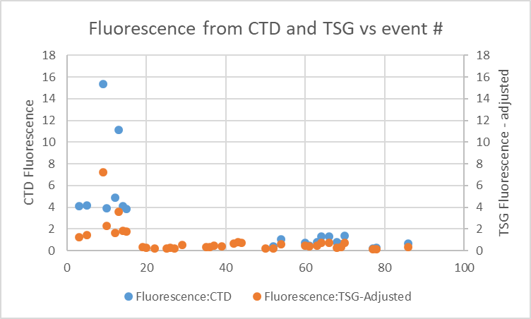

The TSG fluorescence still seems low so the scale factor may be too low. However, the fluorescence offshore was very low and the chlorophyll values at P4 were much lower on the return visit than on the outward journey. The variations are similar in shape from both systems. During 2020-005 the TSG fluorescence read higher than the CTD fluorescence at the low end of the range but the CTD sensor generally read higher at the high end of the range.

This study is complicated by the fact that the CTD fluorometer malfunctioned at about cast #14 and a new one was installed before cast #52. While there remain some doubts about all data from the first CTD sensor, the second appeared to perform well. Fluorescence values were mostly low during the time the 2nd sensor was in use. During that period the TSG fluorescence read about 50% of the CTD fluorescence.

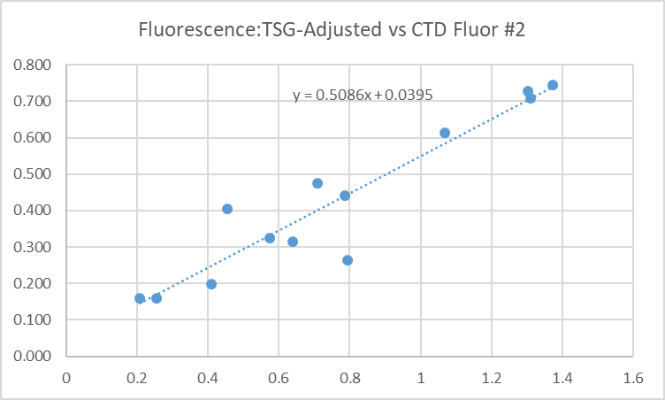
Heating in the loop (Lab Temperature – Intake Temperature) was about 0.2C for most casts except for T<14.4C when loop water warms more as expected. There was no obvious relation between flow rate and heating in the loop.
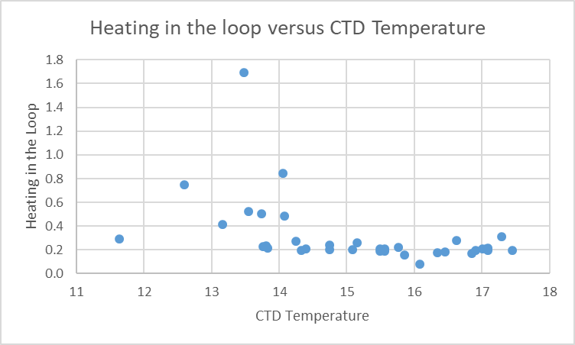

The salinity differences are larger than usual and appear to be increasing slowly with time.
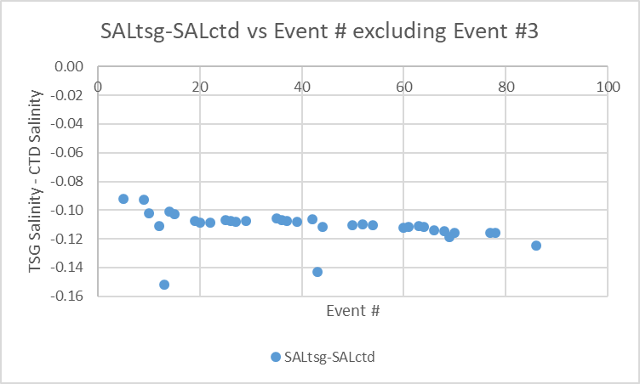
Cast #3 had a very large difference as well but of opposite sign. It was taken in Haro Strait and the standard deviation in salinity was very high.

- Comparisons of Loop samples and TSG data
There were 22 loop Salinity and Chlorophyll samples of which 8 were taken while stopped and the rest while underway. Salinity and chlorophyll samples were available from the rosette for the stopped cases.
Time was not available in the log for loop #5084 but the position was recorded, so time was found from the TSG file by matching latitude and longitude. Rosette and TSG data were found to compare with the loop samples. The samples taken while stopped all had chlorophyll <0.5ug/L. Underway samples included 4 with CHL>1ug/L.

TSG salinity was lower than loop samples by a median of 0.1166psu, by 0.1194 while underway and 0.1137 while stopped. The difference between stopped and underway may be due to lower variability while stopped, so small differences in times between loop sample drawing and TSG records are less significant. However, it is also noted that the difference between the TSG and CTD salinity increases with time from fairly steadily from 0.11psu to 0.13psu from August 14th to 24th. This is likely due to a calibration drift.

- Comparison of 5m Rosette samples and Loop samples
There were 8 salinity and extracted chlorophyll loop samples taken during rosette casts. Salinity values were very close on average though the standard deviation was 0.003psu. The rosette chlorophyll was slightly higher than the loop samples with a ratio of 1.06. All values were <0.5ug/L.

- Comparison of 5m Rosette samples and TSG Salinity
A quick check comparing TSG salinity with rosette samples was limited to the samples used in the previous section. The TSG salinity was lower than the rosette samples by a median of 0.1132psu and shows the same drift as seen from other comparisons. The adjusted TSG fluorescence is higher than the rosette samples by a factor of 1.2 to 3.0, as expected given the CHL was all <0.5ug/L..

d.) Calibration History
- The TSG and fluorometer were recalibrated shortly before cruise 2020-001.
- During 2020-001 which mostly sampled offshore and with mostly well-mixed surface waters, the TSG salinity was found to be lower than that from the CTD and loops by ~0.002psu. TSG temperature was higher than the CTD by ~0.01Cº. Salinity and fluorescence traces looked good.
- During cruise 2020-028, which mostly sampled inshore, the TSG salinity was found to be lower than that from the CTD by ~0.015psu but there was a high standard deviation. TSG temperature was higher than the CTD by ~0.01Cº. Salinity and fluorescence traces looked excellent.
- During cruise 2020-005, which mostly sampled offshore, the TSG salinity was found to be lower than that from the CTD by ~0.014psu and lower than loop samples by 0.05psu. The loops were higher than rosette samples despite the fact that the latter likely came from lower in the water column. TSG temperature was higher than the CTD by ~0.03Cº though the standard deviation was high. Salinity and fluorescence traces looked excellent. TSG Fluorescence tracked the CTD trace quite well though values at the low end of the range generally looked higher than those measured by the CTD sensor. At the high end they read lower.
- During 2020-069 comparisons were of limited value due to many casts being near-shore and many in inlets. Offshore the salinity appeared to be low by about 0.06psu but in Queen Charlotte Sound it was low by ~0.30psu. The difference was thought to be more likely due to suspended sediments rather than calibration drift. The TSG intake temperature was higher than that from the CTD by about 0.13 Cº offshore and 0.20 Cº in Queen Charlotte Sound. TSG fluorescence compared reasonably well with CTD fluorescence in Queen Charlotte Strait but not in inlets. The fluorometer was not functioning well in the 1st half of the cruise.

e.) Conclusions re TSG
1. The TSG clock worked well and position information was available and reliable.
2. The flow rate was fairly steady after an initial section with fairly high values. Most value are ~1L/min to 1.1L.
3. The TSG salinity was found to be lower than CTD salinity by a median of 0.1099psu, and lower than loops by 0.1137psu when stopped. The difference between these two results could be due to small differences in depth of sampling, but the loop salinity values were very close to rosette salinity. The comparison with CTD salinity suggests that the calibration was slowly drifting, thus complicating any analysis. Salinity will be recalibrated by adding 0.11psu. This is a larger difference than during the first half of 2020-005, but lower than during the second half when there were indications of contamination lowering salinity.
4. The TSG intake temperature was lower than the CTD temperature by 0.006C° which is excellent correspondence given slight differences in time and depth.
5. The TSG fluorescence values are unusually low with many small negative values. This implies that the offset in the recalibration has changed. Examination of CTD fluorescence and extracted chlorophyll samples through the cruise suggests that near-surface fluorescence should be at least 0.1ug/L. Using an offset of 0.030ug/L instead of 0.044ug/L removes all negative numbers and leads to a minimum value for about 0.1ug/L. It is likely that the scale factor should also be increased since the ratios of TSG FL to Extracted CHL and TSG FL to CTD FL both look low.
6. Recalibration will be applied by adding 0.221ug/L to fluorescence and subtracting 0.11psu from salinity.

g.) Editing
Files were opened in CTDEDIT; between 1 and 5 single-point salinity spikes were removed by interpolation from 9 of the 12 files.

h.) Preparing Final Files
REMOVE was used to remove channel Pressure, Temperature:Difference , and record #.

i.) Calibrate
CALIBRATE was used to add 0.221ug/L to channel Fluorescence:URU:Wetlabs and to add 0.11psu from channel Salinity

HEADER EDIT was used to change the DATA DESCRIPTION to THERMOSALINOGRAPH and add the depth of sampling to the header and to change channel names to standard names and formats and to add comments.
A cross-reference list was prepared.
The TSG sensor history was updated.
As a final check plots were made of the cruise track and time-series and all looks fine.

Loop File
The Chief Scientist provided file 2020-0005 Loop log.xlsx which included event numbers, sample numbers and what was sampled. Earlier in the processing the loop samples were used to study the TSG calibration. Times were added based on the log entries. For loops taken at the same time as 5m rosettes, the times were set to the ends of casts. Those data were copied to file 2020-005-loop-data.xlsx.

A 6-line header spreadsheet was prepared using a template from previous cruises.
The sampling method column was added and filled with USW.
The columns in the loop-data file were arranged in the order required for the 6-line header used to prepare the loop file.

Next data from near-surface rosettes were obtained.
The CHE files were put through program DERIVE to obtain sigma-t.
Clip was run to choose only data between 0db and 7db.
Data from those files were exported to file 2020-008-che-surface.csv. The Oxygen:Dissolved and Oxygen:Dissolved:SBE channel in mass units were included and Draw Temperature.
The Start Time was divided into 2 columns using “Text to Columns” under the DATA tab in Excel. The times in the files are start times and the samples were actually taken near the end of the cast, so the times were edited to match the End Times in the log book.
(An alternate approach is to calculate End times from the full files (*.CLN) and export those to a spreadsheet.)
A sample method column was added. ROS was entered for the method.
That data was then added to the 6-line header.
The data were sorted on event number, sampling method and pressure.
That file was saved as 2020-008-surface-6linehdr.csv.
The file break column was filled with value 1 so all data will be in a single file when converted.

CONVERT was run to produce an IOS Header file.
CLEAN was run to get start and stop times and positions and to add flag 0 to empty flag cells.
A comment file was prepared which was essentially the same as the one used in preparing CHE files but including a description of the loop system and comments on the CTD data processing.

Header Edit was used to correct channel names and formats and to add comments. The final file was renamed as 2020-008-surface.loop. The track plots look reasonable and plots of temperature and salinity versus event numbers, latitude and longitude look reasonable.

Particulars - Notes from Daily Science Log and Sampling Notes
PAR off: 36, 37, 39, 44, 52, 54, 60, 64, 66, 68, 78, 86.
Casts with bottle fired out of order: None, but problems with #39 – all Niskin #s off by 1
Casts with no Niskin closed: 52

1 – All bottles fired – no sampling –no CHE file needed.
9 – P1: wrong depth in the header, is 186, should be 135. Fixed.
20 – P6: wrong station name in heater, is P5, should be P6. Fixed.
26 – Fluorometer offset values steadily rising – 0.525 at 800m.
37 – P13: wrong depth in the header, is 3500, should be 2875. Fixed
39 – Scan length error during downcast at 2100db – closed a bottle on downcast
39 – P14: wrong depth in the header, is 3600, should be 3315. Fixed.
43 – Fluorometer cable changed.
44 - Salinity differences 0.009 to 0.010psu.
52 – Fluorometer replaced before this cast.
52 – P18: wrong depth in the header, is 3890, should be 3802. Fixed.
53 - Noisy FL/O2 – put original FL cable back on.
52/53 – Need to be merged for downcast. Rename bottle file #52.
69 – P25: wrong depth in the header, is <3000, should be 3890. Fixed.
70 – P35: wrong depth in the header, is >3000, should be 4170. Fixed

2020-008
CRUISE SUMMARY – CTD
CTD# | Make | Model |  | Serial# |  | Used with Rosette? |  | CTD Calibration Sheet Competed?
1 | SEABIRD | 911+ |  | 443 |  | Yes |  | Yes
Calibration Information - 0443
Sensor |  |  |  |  | Pre-Cruise |  |  |  | Post Cruise
Name |  |  | S/N |  | Date |  | Location |  | Date | Location
Temperature |  |  | 4700 |  | 11Dec2019 |  | Factory
Conductivity |  |  | 3531 |  | 12 ec2019 |  | Factory
Secondary Temp. |  |  | 4888 |  | 11Dec2019 |  | Factory
Secondary Cond. |  |  | 4513 |  | 28Jan2020 |  | Factory
Transmissometer |  |  | 1883DG |  | 8Feb2020 |  | Factory
Transmissometer |  |  | 1185DR |  | 8Feb2020 |  | IOS
SBE 43 DO sensor |  |  | 3791 |  | 7Dec2019 |  | Factory
PAR |  |  | 70613 |  | 21Mar2016 |  | Factory
SPAR |  |  | 20518 |  | 21Mar2016 |  | Factory
pH:SBE |  |  | 692 |  | 14Jan2020 |  | Factory
SeaPoint Fluor. |  |  | 3640 |  |  |  | Factory
SeaPoint Fluor. |  |  | 3950 |  |  |  | Factory
Pressure Sensor |  |  | 0443 |  | 9Jan2020 |  | Factory
Altimeter |  |  | 20518 |  | 21Mar2016 |  | Factory

TSG Make/Model/Serial#: SEABIRD/45/0620
Calibration Information
Sensor |  | Pre-Cruise |  | Post Cruise
Name | S/N | Date | Location | Date | Location
Temperature | 0620 | 21Jan20 | Factory
Conductivity | 0620 | 21Jan20 | Factory
WETStar Fluorometer | 953 | 30Dec2019 | Factory

