REVISION NOTICE TABLE
DATE | DESCRIPTION OF REVISION
18 Feb. 2025 | Fixed pH units, names of some flag channels, replaced blank flag entries with 0s. TSG channel names/units updated. G.G.
23 March 2023 | Added HPLC data J.R.

PROCESSING NOTES
Cruise: 2020-005
Agency: OSD
Location: North-East Pacific/WCVI/Strait of Georgia
Project: La Perouse Zooplankton Monitoring
Chief Scientist: Robert M.
Platform: John P. Tully
Date: 15 June 2020 – 14 July 2020

Processed by: Germaine Gatien
Date of Processing: 15 July 2020 – 18 November 2020
Number of original HEX files: 161 (includes 2 not needed)
Number of original CTD files: 159 Number of processed CTD files: 159
Number of rosette files: 92 Number of processed CHE files: 92
Number of original TSG files: 2 Number of processed TOB files: 22

INSTRUMENT SUMMARY
CTD #0443 was mounted in a rosette and attached were 2 Wetlabs CSTAR transmissometer (1185DR & #1883DG), a SBE 43 DO sensor (#3791) on the secondary pump, a SeaPoint Fluorometer (#3640) on the primary pump, a Biospherical QSP-400 PAR sensor (#70613) and an altimeter (#62355). An SBE pH sensor ($692) was mounted for events #1 to #24.

A thermosalinograph (SeaBird 45 S/N 0620) was mounted with a Wetlab/Wetstar fluorometer (WS3S-953P) and flow meter.
Seasave version 7.26.7.121was used for acquisition.
The data logging computer WP #102.
The deck unit was a Seabird model 11+ #425.
A Guildline model 8400B Autosal serial # 68572 was used to analyze salinity samples.
An IOS rosette with 24 10L bottles was used.

SUMMARY OF QUALITY AND CONCERNS
The Daily Science Log Book and rosette log sheets were in excellent order with comments about problems encountered. The sampling notes were provided by the Chief Scientist were a great help in processing data.

During this cruise there was a need for sampling undisturbed surface waters from some casts, so the 10m soak was skipped for those casts. Such soaks are done to improve the dissolved oxygen sensor data in the top 10 or 15m. For the casts without the soak the temperature and salinity data were likely sufficiently equilibrated, though that is hard to judge when temporal variability is high. The SBE dissolved oxygen values may be too high but there is no evidence of severe problems due to bubble release; high near-surface gradients make this hard to judge. For casts #234-239 the dissolved oxygen data were bad in the top 14db and values have been padded; the secondary salinity values were also way out of line so the problem is believed to have been caused by some debris in the secondary system tubing.

There were 2 WetLabs CStar transmissometers in use during this cruise:
Channel Transmissometer refers to sensor #1185DR (650nm - red)
Channel Transmissometer2 refers to sensor #1883DG (530nm - green)
For comparison with other Institute of Ocean Sciences cruises, note that the transmissometer wavelength is 650nm unless otherwise stated.

While CTD fluorescence data are expressed in concentration units, they do not always compare well to extracted chlorophyll samples. It is recommended that users check extracted chlorophyll values where available.

The SBE DO sensor has a fairly long response time so data accuracy is not as high when it is in motion as it is during stops for bottles. This will be especially true when vertical DO gradients are large. To get an estimate of the accuracy of the SBE DO data during downcasts (after recalibration) a rough comparison was made between downcast SBE DO and upcast titrated samples. Some of the difference will be due to problems with flushing of Niskin bottles and/or analysis errors and small mismatches in depth in the presence of large DO gradients, so the following statement likely underestimates SBE DO accuracy.

Downcast (CTD files) Oxygen:Dissolved:SBE data for this cruise are considered, very roughly, to be:
±0.3 mL/L from 0-50db except in areas of very large DO gradients or casts with no 10m soak
±0.1 mL/L from 50db-500db
±0.05 mL/L from 500db-1500db
±0.02 mL/L below 1500db

There was no 10m soak for the casts in Indian Arm and Jervis Inlet to enable sampling of undisturbed surface waters. The dissolved oxygen values in the top 5m are likely a little low and from 10 to 20m they are likely too high as bubbles were released from the plumbing. Because of varying surface gradients and incomplete flushing of Niskin bottles it is impossible to estimate errors in the SBE DO values for those casts with no 10m soak.

In the comparison of CTD with bottle salinity and in the comparison of TSG with loop samples, a pattern is seen where bottle salinity is higher than expected by about 0.04psu. At the surface this could be due to incomplete flushing of Niskin bottles, but it doesn’t explain the deeper samples and loops. The deep bottle salinity values for some inland casts exceed the maximum values recorded by the CTD by about 0.04psu. It is possible that there was some sort of contamination near the surface that affected the shallow samples and loops while the deeper samples might be explained if the Niskins were contaminated at the surface and did not get flushed out thoroughly before they were closed. The casts with suspicious bottles between 200 and 600db all had extremely steady descent rates.

The Thermosalinograph system functioned well with lots of detail in the traces, no significant spiking in salinity and no obvious drift in fluorescence. Comparisons were made between TSG data and co-incident CTD casts, rosette samples and loop samples. The comparisons were inconclusive with variable results from different data types. High near-surface gradients were found in many casts but even where the gradients were fairly low the comparisons were confusing. For well-mixed casts the intake TSG temperature was higher than CTD temperature by a median of 0.03C° but the standard deviation was 0.05C°. That temperature is measured near the ship so local heating may account for some of that difference. TSG Salinity was found to be lower than that from well-mixed CTD casts by a median of 0.014psu and standard deviation of 0.010psu. Comparisons with loop samples suggested salinity errors on the order of 0.05psu but as discussed above there is some suggestion that the loop samples are too high. No recalibration was applied.

TSG Fluorescence data continue to look much better than they did in 2019. The TSG fluorescence tends to be higher than the CTD fluorescence at the low end of the range but the CTD sensor generally reads higher at the high end of the range. The two traces looked similar in shape.

PROCESSING SUMMARY

Seasave
This step was completed at sea; the raw data files have extension HEX.
The chief scientist provided a summary of sampling protocols and problems.
The deployment protocol was:
The rosette was brought to the surface. Pumps were turned ON. The rosette was brought down to 10m and kept there for 30 seconds. Once back at the surface, the data started to be archived, with the rosette at the surface for 30 seconds longer. Then the cast would start.
There were some exceptions to this procedure: events #234 to 243 (JI stations) and #271, 272, 275 to 279 had “no dip”, only a ~2 min wait at the surface.

Preliminary Steps
The Log Book and rosette log sheets were obtained as well as sampling notes from the Chief Scientist.
- Nutrients, extracted chlorophyll, dissolved oxygen, salinity and ammonium data were obtained in QF spreadsheet format from the analysts.
- The cruise summary sheet was completed.
- The histories of the pressure sensor, conductivity and dissolved oxygen sensors were checked. The temperature, conductivity and dissolved oxygen sensors had been used only once since the last factory recalibrations. The 2 transmissometers had been recalibrated at IOS fairly recently.
- During the previous cruise, 2020-028, using the same equipment it was discovered that the pressure sensor was reading too high. Tests were done and the offset was adjusted in the configuration file. The corrected configuration was used for 2020-005.
- Early in cruise 2020-028 a problem was found in the secondary pump so it was replaced.

BOTTLE FILE PREPARATION
The ROS files were created using files 2020-005-ctd-pH.xmlcon for casts #1-24 and 2020-005-ctd.xmlcon for all other files.
Due to delays in chlorophyll analysis, steps were run out of the usual order.
The depths in the headers were adjusted based on the study described in section 11.

The ROS files were converted to IOS format.
The IOS files were put through CLEAN to create BOT files.

Temperature and salinity were plotted for all BOT files to check for outliers. Cast #144 was opened in
CTDEDIT. Primary salinity was cleaned very lightly around 250db.
The output file from salinity editing was copied to *.BOT.
A preliminary header check was run and no problems were found.

The BOT files were bin-averaged on bottle number.
The output was used to create file ADDSAMP.csv. First, the file was sorted on event number and Bottle Position order. Then sample numbers were added based on the rosette logs.
The file was used to add sample numbers to the BOT files – output *.SAM.
The SAM files were bin-averaged on bottle # and called SAMAVG.
The addsamp.csv file was converted to CST files, which will form the framework for the bottle files.

Next, each of the analysis spreadsheets were examined to see what comments the analysts wanted included in the header file. These were used to create file 2020-001-bot-hdr.txt which will be updated as needed during processing.

DISSOLVED OXGYEN
Dissolved oxygen data were provided in spreadsheet QF2020-005_OXY*.xlsx which includes flags, comments and a precision study. Draw temperatures are available. The spreadsheet page with the final data was simplified and saved as 2020-005oxy.csv. That file was converted into individual *.OXY files.
At this point note was made of all comments in the DO file that had comments starting with “ALL:”. The rosette sheets were checked to note what other samples were taken from the same bottle so the flags will be applied to all samples from the other csv files that are affected by the DO analysts observation.
EXTRACTED CHLOROPHYLL
Extracted chlorophyll and phaeo-pigment data were obtained in file QF2020-005_CHL QF*.xlsx. The file included comments and flags and a precision study. A simplified version of the spreadsheet was prepared and saved as 2020-005chl.csv. Flags were changed to 3 for 2 bottles noted as ALL by the DO analyst. The csv file was then converted to individual CHL files.
SALINITY
Salinity analysis was obtained in file QF2020-005_SAL.xlsx which included a precision study. The analyses were carried out in a temperature-controlled lab 13 to 25 days after collection. The files were simplified and saved as 2020-005sal.csv. That file was then converted to individual SAL files.
NUTRIENTS
The nutrient data were obtained in spreadsheet QF2020-005_NUTS*.xlsx. This includes a precision study. The file was simplified, saved as 2020-005nuts.csv and converted to individual NUT files.
The flags were changed to 3 for the samples noted by the oxygen analyst as having a problem that would affect all samples.
AMMONIUM
NH4 data were obtained in spreadsheet QF_NH4_2020-005 *.xlsx. This includes a precision study. The file was simplified and saved as 2020-005NH4.csv. This file was converted to NH4 files.

The SAL, CHL, OXY, NUT and NH4 files were merged with CST files in 5 steps.
After the 5th step the files were put through CLEAN to reduce the headers to File and Comment sections only.
The files were then put through CLEAN to reduce the headers to File and Comment sections only.
These files are ordered on sample number, but the SAMAVG files are ordered on bottle number, so one or the other set needs to be reordered in order to merge them. The MRGCLN1 files were reordered on Bottle_Number and saved as *. MRGCLN1s.
The MRGCLN1s files were then merged with SAMAVG files using merge channel Bottle_Number.

The output of the MRG files were exported to a spreadsheet and compared to the rosette log sheets to look for omissions. A few problems were found:
Event 63 –The rosette sheet has note of a nutrient sample #179 that was missing from the QF sheet. The data were in the raw sheet. The analyst provided an updated spreadsheet and the file was adjusted.
Event 229 – Chl sample 515 was misnamed as 9515. All other samples for that cast had been named with a leading 9 but not that one. The sample # was changed in the CHL file.

At this point the chief scientist’s sampling notes were checked to see if any changes needed to made to the MRG files:
- Event 28. Niskin 3 at 300m not needed – Removed.
- Event 72. Rosette sheet notes say Niskin closed at 476 so all bottles thereafter closed at wrong depth. There was apparently an error in the BTL file that led to this conclusion. The bottle file looks like it was exactly as planned.
- Event 234. Niskin 2 not used. That deletion was made earlier.

Compare
Salinity
Compare was run with pressure as reference channel.
An initial examination shows many large differences. Most are from very shallow bottles and can be explained by incomplete flushing in high vertical salinity gradients. Cast #177 has many outliers in the top 75db; there were very high vertical gradients that can account for the large differences.
Towards the end of the cruise there are many outliers including some from deep water in Jervis Inlet; the bottle values are higher than any CTD salinity found in the full profile by approximately 0.04psu.. For example, the maximum primary salinity (before recalibration) for cast #241 was 31.1920psu at 602m but the bottle fired at the bottom had a salinity of 31.2319psu. Similarly for cast #237 the maximum salinity from the CTD was 31.1967psu at 660db. The bottle from 659.1db had salinity of 31.2362psu. Flushing errors would produce low values for bottles fired at the bottom, not high.

The differences of ~0.04psu are similar to those seen at the surface throughout the cruise but not those seen at depth elsewhere. Why would those bottles have such high values? To ensure the issue was not due to a sudden shift in calibration of the CTD conductivity a quick check was made of performance during the cruise that followed. The first deep cast of 2020-069 had CTD values close to bottles. There is nothing in the Jervis Inlet profiles to suggest a shift to low salinity values near the bottom. The differences between the 2 CTD salinity channels does not appear to have varied greatly. The analyst found a few problems with loose caps and missing liners, but nothing particular about samples late in the cruise. The analysis precision was excellent. The profiles do not show any low transmissivity at the bottom that might suggest mud or biological fouling. There still could be some sort of contamination. The are other bottles from event 225 onwards, Johnstone Strait, Strait of Georgia and Indian Arm that also have higher salinity than expected. So what would affect surface bottles, all bottles in areas where we expect poor flushing and loop bottles. Could contamination come from the surface – oil or biological material – that affects surface bottles and loop bottles but gets flushed out of Niskin bottles in offshore waters but not in the inland section? These bottles were excluded from the comparison.

When outliers were removed based on standard deviation in the CTD salinity >0.0008psu, differences between bottles and CTD > 0.02 and pressure <1000db the primary CTD salinity was found to be low by an average of 0.0041psu (std.dev. 0.0017psu) and the secondary high by 0.0018psu (std dev 0.0019psu). The differences between those 2 results is 0.0059psu which is very close to the differences between the two CTD salinity channels as seen in section 9. The differences show clear variation with depth from 0 to 1000db and maybe even lower. There is likely still some effect of incomplete flushing but it should be fairly small. So we can say that both CTD channels are performing reasonably well.

Below 1500db the primary is low by 0.0031 and the secondary is high by 0.0030psu. This shows that even offshore there is some flushing errors at depth, but below 1500db the vertical gradients are generally quite low.

The only outlier that looks to be due to problems in collection was in sample #438 during cast #177. The difference is 0.023psu at 175m. This was before the section that has many large differences, but examination of the salinity just before and during the bottle stop shows very high variability, enough to lead to the result. The sample is already flagged 3 because of a loose bottle cap. No flag change is justified.
For full details for the COMPARE run see file 2020-005-sal-comp1.xls.

Dissolved Oxygen
COMPARE was run with pressure as the reference channel.

There was a lot of scatter in the plots of (CTD DO – Bottle CTD) versus CTD DO with the most severe outliers being at the high DO end where most indicate the CTD was reading higher than the bottles. Drift in CTD DO calibration usually leads to CTD DO reading low, not high, but if there is incomplete flushing of Niskin bottles it will lead to the Niskin bottles having lower DO than ambient waters, thus making the CTD DO look closer to ambient waters than it really is. The opposite is true for bottles from below the oxygen minimum zone but at those levels the vertical DO gradients are quite low, so this effect is not as significant. In some profiles there are many reversals in DO which will reduce the effect of the flushing error. These were less common in the inshore casts than offshore. The flushing error is expected to be larger during casts #225 to #295 because the descent rate of the CTD was very steady.

Fits were made using different groups of casts. Outliers were excluded by gradually by choosing ever-decreasing residual ranges. When the R² value reached at least 0.9 the process was stopped. For most cases there were many samples with very low DO values so that the offset could be determined in the fit, but for one group there were no low values so the offset was forced to =0.

When all casts were included and outliers were removed based on residuals the fit was:
CTD DO Corrected = CTD DO * 1.0306 - 0.0156 R² = 0.93 (1)
Examination of the results show that most of the excluded values came from shallow water where vertical gradients tended to be high.

When only casts #1 to #186 were included and outliers were removed based on residuals the fit was:
CTD DO Corrected = CTD DO * 1.0314 - 0.0137 R² = 0.92 (2)

When only casts #194 to #295 were included it was impossible to obtain a reasonable R² value even when subjective choices were made and offset was forced to zero.

When only 3 deep offshore casts (#72, 75 and 177) were included and outliers were removed based on residuals the fit was:
CTD DO Corrected = CTD DO * 1.0308 - 0.0085 R² = 0.97 (3)
This result is very close to the first 2 results and is an excellent fit. It is likely to be less affected by poor flushing.

Hysteresis checks were done. There was too much noise in both data sets to conclude whether there was hysteresis or not, but at most the effect is small.

Most of the outliers come from near the surface where high gradients and reversals in gradients lead to poor matches between bottles and CTD readings, so they are not considered significant. An outlier during Cast #278 at 66db was investigated and there was a large shed wake during the stop that would account for a high bottle DO value. A few other outliers were examined and it appears that the CTD sensor may not have fully equilibrated when the bottle was fired. None of the outliers are far enough out of line to justify flagging bottle values.

Plots of Titrated DO and CTD DO against CTD salinity were examined. No further outliers were found.
Problems were noted later in the CTD data in 4 casts from Jervis Inlet where there appears to have been some problem with secondary channels near the surface. For those casts there was no 10m soak but the problem is much worse than would be caused by bubble release since the surface values are extremely low. This does not show up in the bottle comparison because the upcast data look normal.

Fluorescence
COMPARE was run with extracted chlorophyll and CTD Fluorescence using pressure as the reference variable.
The fit of CTD Fluorescence against Extracted CHL samples has the usual pattern with Fluorescence reading higher at low CHL and falling relative to CHL as the latter values increase. The fluorometer likely can’t get as close to 0 as the CHL does and small differences lead to large values for the FL/CHL ratio. When comparisons were limited to CHL≥0.2ug/L the CTD fluorescence = 0.67 times the CHL values. However, at low CHL fluorescence does read higher, between 2 and 5ug/L the two values are fairly close but above 10ug/L fluorescence is ~50% - 60% of CHL. This is typical of these fluorometers.
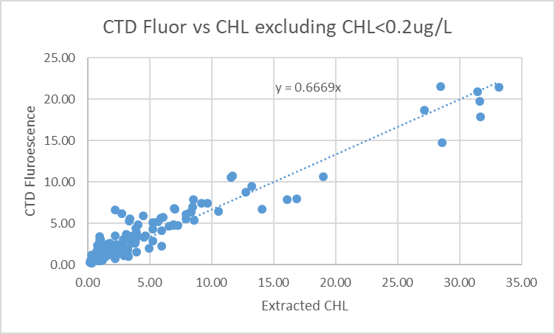

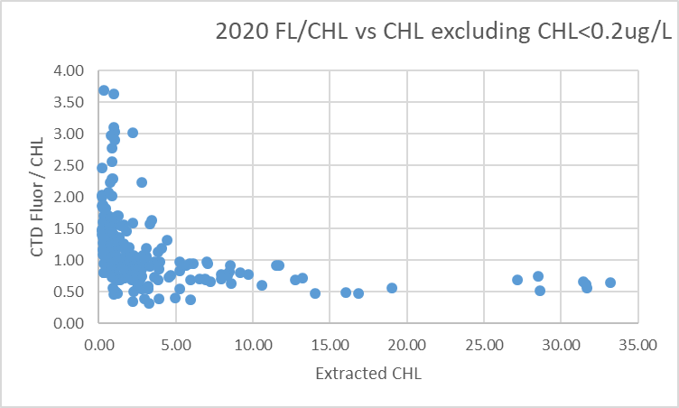
The performance of the fluorometer is typical of these sesnsors.

Conversion of Full Files from Raw Data
The configuration changed when the pH sensor was removed before event #25.
For events #1-24 files were converted using 2020-005-ctd-pH.xmlcon.
All other files were converted using 2020-005-ctd.xmlcon.
The Tau function and the hysteresis function were selected since there was deep sampling. Depth was included in the conversion.
A few casts were examined and all expected channels are present. The T and C pairs were reasonably close during downcasts with upcasts very noisy. Fluorescence, PAR, SPAR and Dissolved Oxygen profiles looked normal. Fluorescence has deep values <0.1ug/L. The “Green” transmissometer was generally higher than the “Red”; the profiles had similar shapes. The altimetry looked ok.

WILDEDIT
Program WILDEDIT was run to remove spikes from the pressure, depth, conductivity & temperature only in the full cast files (*.CNV).
Parameters used were: Pass 1 Std Dev = 2 Pass 2 Std Dev = 5 Points per block = 50
The parameter “Keep data within this distance of the mean” was set to 0 so all spikes would be removed.

ALIGN DO
A few casts were examined; both temperature channels were noisy during upcasts so the tests were not easy to interpret, but using +2.5s certainly improves the alignment and overall looks like a good choice for both sensors. That setting has worked well for many SBE DO sensors in recent years.
ALIGNCTD was run on all casts using +2.5s.

CELLTM
The noise in the upcast data makes tests for the best parameters for this routine very difficult to interpret. In the past when upcast data were not so noisy, the default setting of (α = 0.0245, β=9.5) was generally found to be the best choice. A few casts were checked for this cruise and the default setting does improve the data. CELLTM was run using (α = 0.0245, β=9.5) for both the primary and secondary conductivity.

DERIVE and Channel Comparisons
Program DERIVE was run on all casts to calculate primary and secondary salinity and dissolved oxygen concentration.

DERIVE was run a second time on 3 of the deeper casts to find the differences between the pairs of temperature, conductivity and salinity channels. The differences were extremely noisy for all except the last cast so these are very rough estimates. A deep cast from 2020-001 is included for comparison.
Cast # | Press | T1-T0 | C1-C0 | S1-S0 | Descent Rate
2020-001-0025 | 500 | -0.0003 | +0.00060 | +0.0040 | “
 | 1000 | 0 | +0.00060 | +0.0075 | High, V Noisy
 | 1900 | -0.0004 | +0.00063 | +0.0080 | “
2020-005-0075 | 500 | -0.0009 | +0.0004 | +0.0055 | High, Noisy
“ | 1000 | -0.0006 | +0.0004 | +0.0055 | “
“ | 1900 | -0.0005 | +0.00046 | +0.0060 | “
2020-005-0140 | 500 | -0.0003 | +0.0004 | +0.0050 | High, X Noisy
“ | 1000 | -0.0002 | +0.00043 | +0.0055 | “
“ | 1900 | -0.0002 | +0.00048 | +0.0060 | “
2020-005-0218 | 500 | -0.0004 | +0.00042 | +0.0055 | High, Moderate
 | 1000 | -0.0005 | +0.00046 | +0.0060
The salinity and conductivity differences are a little lower than in February.

Conversion to IOS Header Format
The IOSSHELL routine was used to convert SEA-Bird 911+ CNV files to IOS Headers.
CLEAN was run to add event numbers and to replace pad values in the pressure channel with interpolated values based on record number.

Checking Headers
The cross-reference check and header check were run. No problems were found.
Surface check was run and found an average of 2.1db, which is reasonable.
During event #92 the CTD appears to have passed through the surface at the end of the cast. The pumps turned off when the CTD was at 0.1db and within 10 scans salinity dropped to almost 0db. This suggests that the pressure calibration is good.
During event #25 the CTD was run to the surface. Transmissivity went to 0 values at pressure 0.1db and then rose very quickly to ~60%. So the surface would appear to be at ~0.1db.
The minimum pressure recorded was -0.104db and was found a few scans after the pumps turned off; the salinity is very low and transmissivity is 0%. The pressure appears to be accurate.

Cruise tracks were plotted and added to the end of this report.

The altimeter and water depth readings from the headers of the CLN files were exported to spreadsheets. A check value was calculated by subtracting water depth from maximum depth sampled plus altimetry header -1 (since the altimetry averages over 2m the value may be high by 1m.). Where that number was > 4 or <-4 plots of the altimetry were checked. In 2 cases the altimetry was sufficiently messy that it could account for the large Check Value. For most the altimetry looked ok. Then the log entry for the depth was examined and in 9 cases the log entry was found to produce a better Check Value. There remained 29 casts where the log and header entries look off, likely because of variations during the cast. Since the water depth for the deepest sampling is the most significant, entries were changed to produce a low Check Value in the CLN files and all affected ROS files.

Shift
Fluorescence
SHIFT was run on the SeaPoint fluorescence channel in all casts using the usual advance of +24 records. Plots show that the fluorescence offset is reasonably close to the temperature offset after this step.
Dissolved Oxygen
The Dissolved Oxygen voltage channel was aligned earlier. A few casts were checked to see if the alignment looked ok, and it did. No further alignment is needed for the DO concentration channel,
Conductivity
Tests were run on a few casts to assess what settings are best to align conductivity with temperature (as judged by the effect on salinity as seen in T-S space). The best settings were -0.4records for the primary and -1.2records for the secondary.
SHIFT was run twice on all SBE911 casts using -0.4 records for the primary and -1.2 records for the secondary conductivity. Salinity was recalculated for both channels.
pH:SBE
Since there was no pH channel for most casts, all SHFC1 files were copied to *.SHFpH.
For events #1 to 24, SHIFT was then run on channel pH:SBE to advance the records by 30 records.

DELETE
The following DELETE parameters were used:
Surface Record Removal: Last Press Min
Maximum Surface Pressure (relative): 10.00
Surface Pressure Tolerance: 1.0 Pressure filtered over 15 points
Swells deleted. Warning message if pressure difference of 2.00
Drop rates < 0.30m/s (calculated over 11 points) will be deleted.
Drop rate applies in the range: 10db to 10db less than the maximum pressure
Sample interval = 0.042 seconds. (taken from header)
COMMENTS ON WARNINGS: There were no warnings.

Other Comparisons
Experience with these sensors since last factory service –
The pressure, temperature, dissolved oxygen and conductivity sensors were used during 2020-001 when primary salinity was found to be low by 0.0035pus and secondary low by 0.0112. Dissolved oxygen was recalibrated using slope/offset =1.0242/-0.0022.
Historic ranges – Profile plots were made with 3-standard deviation climatology ranges of T and S superimposed. All excursions were from casts close to shore or in inlets and those were mostly near the top and bottom of casts; those areas are not well represented in the climatology. None of these excursions suggest calibration drift.
Post-Cruise Calibration – There were no post-cruise calibrations available.

DETAILED EDITING
The decision on which channels to edit is not obvious. During 2020-001 the secondary salinity had very noisy data and compared poorly with the CTD, so primary channels were selected. During 2020-028 the primary channels looked poor for the first few casts until the pump was preplaced, so the secondary channels were selected. For this cruise an initial examination showed there were some problems with the secondary channels for a few casts in Jervis Inlet. The comparison with bottles indicates that the calibration is very different from that of 2020-001, so perhaps the pump that failed during 2020-028 was malfunctioning earlier but was mounted on the secondary side rather than the primary. This would explain the secondary salinity change from being low by -.011 to high by 0.002 is surprising.

Before making a decision, the data from 2020-028 were examined. There were no deep casts during that cruise so the results of a bottle comparison are less reliable but the difference between channels is similar to that during this cruise. The differences from bottles were larger, as expected, because flushing errors are much more significant in that region than offshore.

The primary channels were selected for editing.
All DEL files were copied to *.EDT.

CTDEDIT was used to remove records that appear to be corrupted by shed wakes. Salinity was cleaned to remove spikes that appear to be due to small misalignment or instrumental noise. All files required some editing. Notes about editing applied were added to the files.
The edited files were copied to *.EDT.
After editing, T-S plots were examined for all casts. Some unstable features remain but come from areas where such features are expected and likely real or where it is impossible to say which data are poor. No further editing was done.

The plot below shows that the DO values from events #234 to 239 were very low at first and then too high at about 10db. When the bottles are compared to downcast data from other nearby profiles and compared to upcasts, it is clear that the near-surface data are bad. The secondary salinity also looks poor so the problem is assumed to have been caused by a blockage in the secondary plumbing.
CTDEDIT was run a second time on casts #234 to 239 to remove DO from the top 14db.

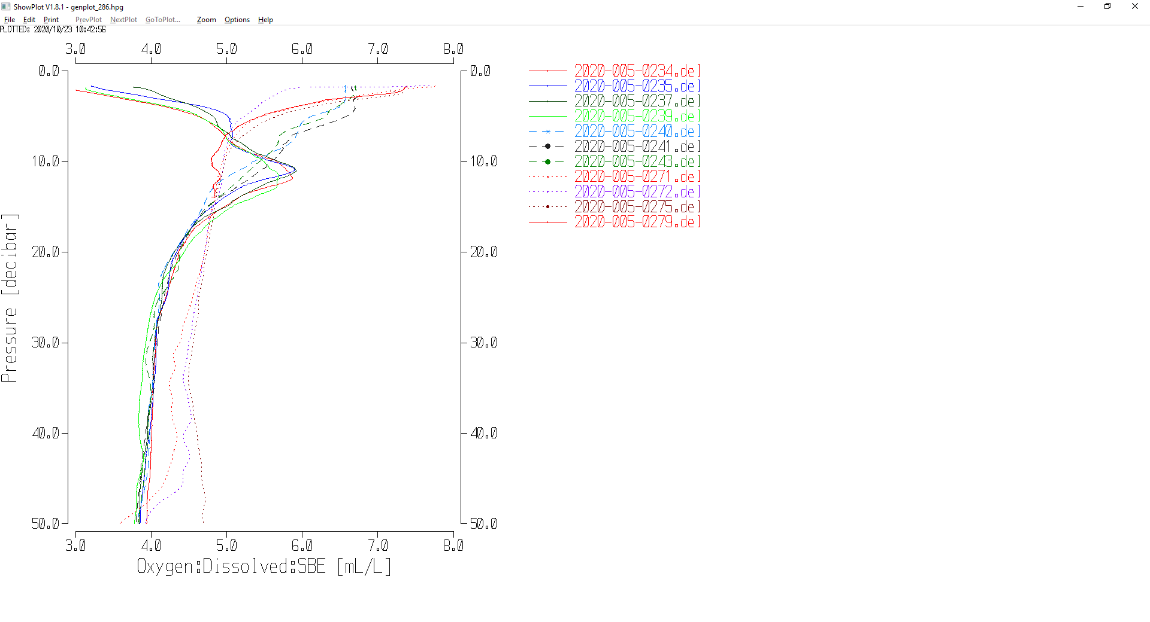

Corrections to Pressure, Salinity and Dissolved Oxygen Concentration
There is no indication of a problem with pressure calibration.

While flushing errors for the deep casts are expected to small offshore, the differences between samples and bottles don’t seem to stabilize until pressures are >1500db, a level at which vertical salinity gradients are generally very low. So the results from those depths will be used for correction of the salinity.

File 2020-005-SBE911-recal.ccf was prepared to recalibrate by adding 0.003psu to channel Salinity:T0:C0 and subtracting 0.003psu from channel Salinity :T1:C1 and to apply the following correction to channel Oxygen:Dissolved:
CTD DO Corrected = CTD DO * 1.0308 - 0.0085
This correction was first applied to the SAM and MRGCLN2 files.

COMPARE was rerun for salinity. When the same outliers were removed as in the original comparison, both salinity channels were found to be low by an average of 0.0012psu making a small allowance for small flushing errors in the deep bottles. See file 2020-005-sal-comp2.xls for details.

COMPARE was rerun for dissolved oxygen and shows that the correction was applied properly. When data are excluded using the same points as in the original fit for the 3 deep casts, the CTD DO was low by an average of <0.0001mL/L. For casts #1-186 excluding outliers based on residuals the average difference was 0.004mL/L compared to -0.101mL/L before recalibration. This shows that the recalibration was applied corrected and was appropriate. See file 2020-005-DO-comp2.xls for details.

CALIBRATE was then run on the EDT files using the same recalibration file.

Final Calibration of DO
The initial recalibration of dissolved oxygen corrects for sensor calibration drift. Alignctd corrects for transit time errors. Those 2 steps may partly correct for response time errors, but to see if a further correction is needed, a comparison is made of downcast CTD data to bottle data from the same pressure. Small differences are expected due to ship drift, temporal changes, incomplete flushing of Niskin bottles and delayed response and noise in CTD data.

Downcast files were bin-averaged to 0.5m bins for the casts with DO bottle samples. Those files were then thinned and compared to the bottle values in the MRG files. COMPARE was run to study the differences between the downcast CTD DO data and the titrated samples from upcast bottles.

The CTD DO was higher than the titrated samples by an average of ~0.04mL/L when data from the top 12m were excluded, but the standard deviation was 0.10mL/L. The differences are small at depth and gradually rise towards the surface. There are some cases where the CTD is lower than bottles. A few of those were investigated and came from areas where there were local DO reversals. These differences are likely due primarily due to incomplete flushing of Niskin bottles, growing larger as local gradients increase. The response time errors have a similar pattern but given the 30s wait before bottles were fired it is unlikely that those errors are on the same scale as flushing errors.

A check was made by looking at the 3 deep casts. The CTD looks high by < 0.02mL/L below 500m with larger and more variable differences above that. The DO gradient at the surface was very low for casts #72 and 75. The average difference in the top 20m for those casts was -0.002mL/L with a standard deviation of 0.014mL/L. So the CTD DO is likely reading within 0.02mL/L.
No further recalibration of CTD DO is appropriate.

To see if the lack of a 10m soak had a significant effect on the dissolved oxygen values from the sensor, a plot was made comparing bottles from above 50m with downcast SBE DO. Points in green are from the inlet casts excluding the 4 casts where there were equipment problems. There is a lot of scatter which is at least partly due to incomplete flushing and that would vary with surface gradients. The inlet CTD data look lower than results from other casts at 2m and 5m which could be due to the sensor not having fully equilibrated. By 10m the opposite is true which fits the release of bubbles. By 20m to 30m the CTD DO might be slightly high but that is far from clear. Oddly at 50m the CTD DO looks high for 3 casts but they all come from Indian Arm where there were reversals in the DO gradient around 50m, so the correction of SBE DO would not be appropriate there.

Fluorescence Processing
A median filter, size 11, was applied to the fluorescence channel in the COR1 files. Plots of a few casts showed that the filter was effective. (Output:*.FIL)

BIN AVERAGE of CTD files
The following Bin Average values were applied to the FIL files (output AVG):
Bin channel = pressure Averaging interval = 1.000 Minimum bin value = .000
Average value will be used. Interpolated values are NOT used for empty bins.
On-screen T-S plots were examined.
Profile plots were examined. No problems were noted.

Final CTD File Steps (REMOVE and HEADEDIT)
For all casts REMOVE was run to remove the following channels:
Scan_Number, Temperature:Secondary, Conductivity:Secondary, Oxygen:Voltage:SBE, Descent_Rate, Status:Pump, Altimeter, Salinity:T1:C1 and Flag.
For casts #72 channel PAR was also removed.

A second SBE DO channel (with umol/kg units) was added.
REORDER was run to get the two DO channels together.
HEADER EDIT was used to fix formats and channel names and to add the comments about processing.
The Standards Check routine was run and no problems were found.
The Header Check was run; no problems were found.
Profile and T-S plots were examined. No problems were found.
The sensor history was updated.

Dissolved Oxygen Study
As a final check of dissolved oxygen data, % saturation was calculated and plotted. Values at 2 to 3m ranged between ~60% to 180%. The extreme values were generally near shore. The deep offshore casts had values between 103% and 110% except for the casts on the LPB line which had DO inversions and saturations between 180% and 195%. The values for the offshore are a little higher than usually seen but fluorescence values are also higher so this is more likely a sign of biological activity than having DO calibrations too high.

Final Bottle Files
SORT was run to arrange casts in pressure order.
For all casts REMOVE was run to remove the following channels:
Scan_Number, Temperature:Secondary, Conductivity:Secondary, Oxygen:Voltage:SBE, Descent_Rate, Status:Pump, Altimeter, Salinity:T1:C1 and Flag.
For casts #72 channel PAR was also removed.
A second SBE DO channel with mass units was added for both the CTD DO and titrated DO and REORDER was run to get the pairs of DO channels together.

EDIT HEADERS was run to fix formats and channel names and to add comments about analyses and CTD processing.

Data were exported from the CHE files to file 2020-005-bottles-final.xlsx. The entries were compared with the rosette log sheets. No problems were found.
Standards check and a header check were run. No problems were found.
The track plot looks ok.
Plots of each file were examined and no problems were found.
A cross-reference listing and header check were produced for the CHE files.

Thermosalinograph Data
An IOS TSG45 was used for this cruise. The data were delivered in 2 files. There was some overlap with the files delivered with 2020-028. The Juan de Fuca data were left in both data sets for convenience of users.

The IOS SBE TSG45 files were opened in EXCEL.
The files have extensions RAW but are in csv format, so the files were opened in EXCEL and combined in a single CSV file. (In opening I use DELIMITED, deselect TAB, select COMMA and OTHER (*).
It is necessary to choose TEXT for the time on the 2nd page of the text import wizard.)

The spreadsheets were adjusted as follows:
- 2 lines of headers were added – channel names and units.
- A column with pressure was added with all values set to 4.5 (to enable derivation of salinity).
- A temperature difference column was added (Lab-Intake).
- The fluorescence channel is in volts. It was moved to column M. Then a concentration value was calculated in column F using offset -0.044 and scale 15.8 as determined in the most recent recalibration of the fluorometer. Copy/Special Paste was used to save those values and then the voltage channel was removed.
- A file break column was filled with the cruise #-data/time info from the original file name.
- There was only a 11s gap between the 2 TSG files, so the data were combined in one CSV file.
- Time and Date formats are a problem – when converting from RAW choose TEXT but once opened in EXCEL set Time Format to HH:MM:SS and save the file again.
- There were no NaN entires.
- The file break column was completed so that new files would be created at the beginning of each day by assigned file names like 20200210-000000 except for the first file which has a time later than 000000.
- The flow was on until a few minutes before the end.

The file was then converted to IOS Header format with header info added. There are 22 IOS files.
CLEAN was run to reset the number of records, min and max values, set the start and end times, and latitude and longitude limits.
ADD TIME CHANNEL was used to add Julian dates – i.e. Decimal Year. (A record number was also added to enable averaging (for use in comparison to CTD files). Time zero was set to 31 December 2019 0:00:00.
DERIVED QUANTITIES was run twice, first to derive salinity using the lab temperature and again to derive sigma-T.
Time-series plots were produced and the only problems noted were some discrete salinity spikes and a short section at the end during which the flow was probably off. Both issues can be addressed by editing.
REORDER was run to move the Julian date to after the Time/Date channels and to put salinity and fluorescence after the lab temperature. Also the record # was moved to the end.

a.) Plots
A track plot was produced and added to the end of this report.
Time –series plots were examined and the only problem noted was at the end of the last file when the flow was turned off. The last 22 records were edited in the CSV file to enter pad values for temperature, salinity, conductivity, sigma-T and fluorescence. The first steps were then repeated.

b.) Checking Time Channel
The CTD files were thinned to reduce the files to a single point from the downcast at or within 0.5db of 4.5db. These were exported to a spreadsheet which was saved as 2020-005-ctd-tsg-loop-rosette-comp.xlsx. All 159 CTD casts overlapped with TSG records with flow turned on.

The TSG files were averaged over 24 records (2 minutes) on record number to reduce the noise and file size. Standard deviations were included. Then records were extracted for the times of CTDs and added to file 2020-005-ctd-tsg-loop-rosette-comp.xlsx..

Comparisons were made of positions to check for good matches. The differences in positions are expected to be small despite the averaging because the ship was stopped at these times. The average differences were 0.0000º for both latitude and longitude. There were no differences >0.0007 º.

c.) Comparisons
- Comparison of T, S and fluorescence from TSG and CTD data
The initial comparison between TSG and CTD data includes some large outliers.

 | TSG Tint-Tctd | TSG Tlab-Tctd | SALtsg-SALctd | FLtsg/FLctd
max | 2.0906 | 3.8221 | 0.4819 | 3.118
min | -0.3903 | -0.1394 | -9.1879 | 0.272
avg | 0.1964 | 0.7415 | -0.6648 | 1.102
stdev | 0.4493 | 0.7516 | 1.5135 | 0.556
median | 0.0552 | 0.4433 | -0.0273 | 0.942

Many of the casts were in inlets or very close to shore where vertical gradients are often large so that matching CTD and TSG sampling depths is important. Also CTD data may be affected by ship effects. So reducing the number of casts to those with low standard deviations in temperature and salinity over the 2 minutes in the averaged TSG data can reduce the impact of small mismatches in depths and reduce the errors introduced by ship effects since the surface waters tend to be better mixed.

When only the records with TSG standard deviations in intake temperature <0.01Cº, TSG salinity <0.001psu and fluorescence <0.01ug/L were included the differences were:
 | TSG Tint-Tctd | TSG Tlab-Tctd | SALtsg-SALctd | FLtsg/FLctd
max | 0.2749 | 0.6236 | 0.0084 | 3.1180
min | -0.0450 | 0.2895 | -0.0427 | 0.7219
avg | 0.0431 | 0.3783 | -0.0163 | 1.4611
stdev | 0.0527 | 0.0745 | 0.0104 | 0.7213
median | 0.0289 | 0.3649 | -0.0141 | 1.1682

This approach may not work well for fluorescence since it will tend to remove data where those values are high. A fit of TSG fluorescence versus CTD fluorescence depends on which data are selected. That comparison is very complex with the TSG fluorescence generally higher than that from the CTD when values are low but lower at the higher end of the scale.

Based on the 33 casts with low standard deviations the intake temperature is higher than the CTD temperature by about 0.03Cº and salinity is lower by about 0.014psu. This could be due to the TSG sampling slightly higher in the water column than the level of the CTD stop.

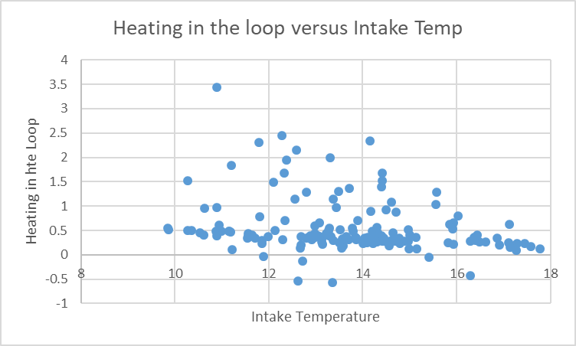

Heating in the loop followed the usual pattern with a rise in temperature of about 0.5Cº when intake temperatures were ~10ºC and approaching 0 Cº as intake temperatures approached 18ºC.

The TSG fluorescence reads higher than the CTD fluorescence at the low end of the range but the CTD sensor generally reads higher at the high end of the range. The variations are similar in shape from both systems.

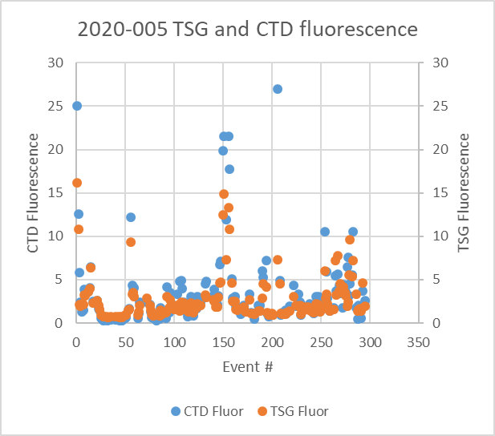

- Comparisons of Loop samples and TSG data
There were 36 loop Salinity samples of which 13 were taken while stopped and the rest while underway. There were 27 CHL samples of which 9 were taken while stopped.
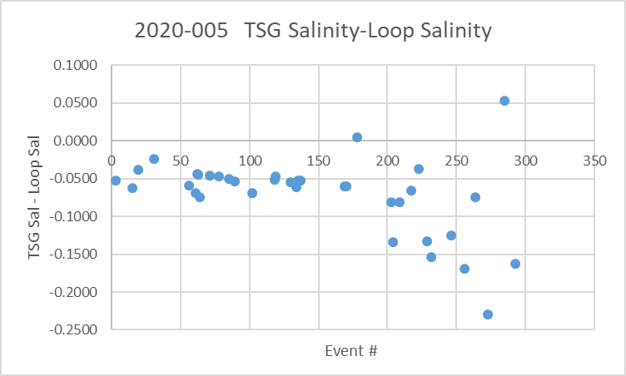
The TSG salinity was lower than loop bottle salinity by a median of 0.06psu with a standard deviation of 0.05psu. The results between events 1 and 90 show slightly smaller differences and much lower variability at ~ -0.05psu and a standard deviation of 0.01psu. The differences are much larger from event #203 to the end of the cruise at ~-0.13psu. The differences were compared between when the ship was stopped and underway.

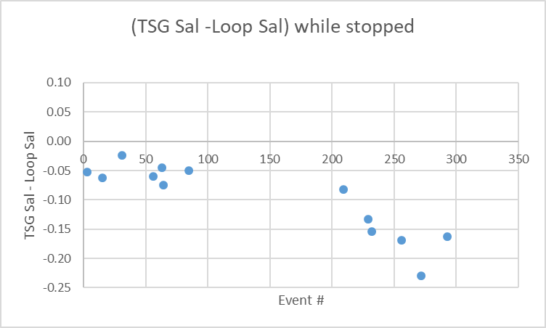
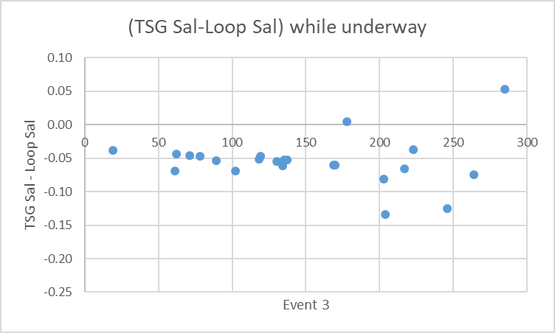

The underway differences are somewhat smaller; possibly there are more bubbles during stops due to thrusters being on to keep the ship on station. Standard deviations are high, especially while stopped.

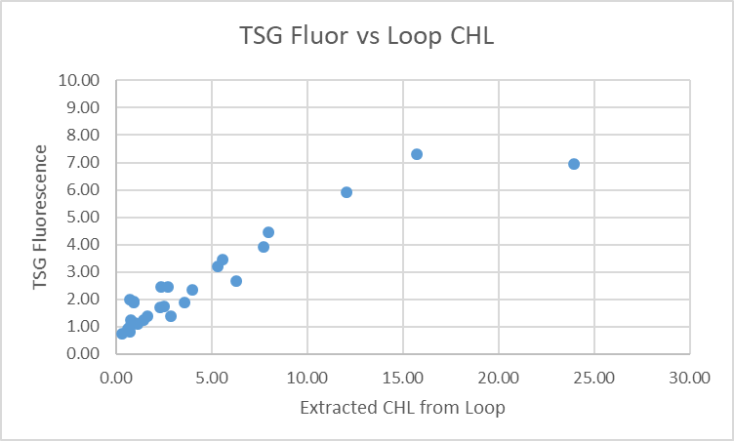
The TSG fluorescence is somewhat lower than the loop chlorophyll samples but there is a lot of variability. It is clear from the salinity comparison that the events offshore provide a more reliable comparison with much less variability presumably due to lower near-surface gradients. Using those 11 casts the fluorescence is a little higher than chlorophyll. This is likely because the average chlorophyll values are 2.5ug/L in the west coast waters and 6.2ug/L in the Strait of Georgia and Queen Charlotte Sound. The sensors tend to read higher when CHL is low. It appears that the TSG fluorometer never gets close to 0ug/L. It is frequently noted that fluorometers read high when CHL is low. Past attempts to apply an offset based on the values at low CHL did not work well for the rest of the fit. Frequent cleaning of the TSG fluorometer might improve the TSG fluorescence.

- Comparison of 5m Rosette samples and Loop samples
There were 10 salinity loop samples taken during rosette casts. The variability in the differences was very large with the loop values fairly close to the rosette samples in the offshore region but much lower in the Strait of Georgia. The latter is readily explained by high vertical salinity gradients and poor flushing of Niskin bottles. For the offshore the loop salinity was higher than the rosette salinity by a median of 0.01 but there were only 5 points of comparison with a range from -0.002 to +0.031psu. 3 of the differences were within ±0.002psu. We usually find the loop salinity to be a little lower than the rosette samples.

- Comparison of 5m Rosette samples and TSG Salinity
A quick check comparing TSG salinity with rosette samples was limited to the samples used in the previous section. The TSG salinity was lower than the rosette samples by a median of 0.05psu and standard deviation of 0.01psu for the 5 offshore casts. This suggests that the loop is drawing water from a little higher than the rosette firing levels.

d.) Calibration History
- The TSG and fluorometer were recalibrated shortly before cruise 2020-001.
- During 2020-001 which mostly sampled offshore and with mostly well-mixed surface waters, the TSG salinity was found to be lower than that from the CTD and loops by ~0.002psu. TSG temperature was higher than the CTD by ~0.01Cº. Salinity and fluorescence traces looked good.
- During cruise 2020-028, which immediately preceded this cruise and mostly sampled inshore, the TSG salinity was found to be lower than that from the CTD by ~0.015psu but there was a high standard deviation. TSG temperature was higher than the CTD by ~0.01Cº. Salinity and fluorescence traces looked excellent.

e.) Conclusions re TSG
1. The TSG clock worked well and position information was available and reliable.
2. The flow rate was steady with values from 1L/min to 1.1L/min.
3. Variability is high in all the comparisons due to high near-surface vertical and horizontal gradients near-shore, especially in Queen Charlotte Strait and the Strait of Georgia.
4. The TSG salinity was lower than CTD salinity by a median of 0.02psu when all casts were included and by 0.014 when 33 casts were used that had low standard deviation in TSG salinity over 2 minutes. This difference could be due to small differences in the level of sampling or bubbles in the loop lowering the TSG salinity.
5. The TSG salinity was lower than loop samples by 0.05psu in areas with low near-surface salinity gradients. The differences were somewhat larger when the ship was stopped than when underway which could be due to either more bubbles or ship effects stirring up the near-surface waters which could randomize the results somewhat. The loop salinity samples are higher than rosette samples by a median of ~0.01psu in the offshore area but by much more in the Strait of Georgia. We expect that the rosette samples contain water from deeper than 5m so that loop salinity should be somewhat lower than those from the rosette, though given low vertical gradients this is not expected to be a large difference.
6. So why does the TSG salinity compare better with the CTD than with loops? We expect the TSG to read somewhat low due to small bubbles and bottle samples tend to read slightly high due to evaporation and desorption though those effects should be small for this cruise due to quick analysis. The rosette bottle salinity is expected to read higher than ambient waters due to incomplete flushing and that is likely a major factor for the inland and near-shore sampling. The only thing that seems out of line are the Loop bottles which read slightly higher than the rosette bottles and significantly higher than the TSG salinity. Loop bottles were analyzed in random order with the rosette bottles so analysis doesn’t seem to be an issue. While the CTD salinity could be reading low due to ship effects or not waiting long enough after the 10m soak, those effects are expected to be small offshore since the vertical gradients are low. Could there be something in the loop water that affects salinity analysis but not TSG salinity? There were also suspicious rosette bottles from the bottom of deep casts in Jarvis Inlet where the descent rate was extremely low. Perhaps some sort of contaminant was present near the surface, affecting loop water and some near-surface rosette samples. If so, then such contamination appears to have been flushed out of Niskin bottles during the downcast for most casts, but in areas like Jarvis Inlet it may not have been flushed.
7. The TSG temperature was higher than that from the CTD by a median of 0.029C° but the standard deviation was 0.053C° based on 33 casts with low standard deviation in the TSG data.
8. Since the last servicing of the TSG sensors, the fluorescence traces have looked much better than observed in 2019. TSG Fluorescence tracks the CTD trace quite well though values at the low end of the range generally look higher than those measured by the CTD sensor. At the high end they read lower.
9. No recalibration will be applied.
- The near-surface variability is very high and the salinity comparisons are too confusing to interpret. The comparison with the CTD salinity suggests TSG salinity is good to ~0.02psu where near-surface gradients are low.
- The intake temperature appears to be high by ~0.01C°; it is generally the case that the intake temperature is a little higher than CTD temperatures. This likely means that there is some slight warming at the entrance to the loop, perhaps from the pump. Shallow CTD data are not reliable enough to warrant recalibration of temperature based on this evidence.

g.) Editing
The only editing required was done earlier.

h.) Preparing Final Files
REMOVE was used to remove channel Pressure, Temperature:Difference , and record #.

HEADER EDIT was used to change the DATA DESCRIPTION to THERMOSALINOGRAPH and add the depth of sampling to the header and to change channel names to standard names and formats and to add comments.
A cross-reference list was prepared.
The TSG sensor history was updated.
As a final check plots were made of the cruise track and time-series an all looks fine.

Particulars - Notes from Daily Science Log and Sampling Notes
PAR off: 72.
pH on: 1-24 only
Casts with bottle fired out of order: None, but some skipped.
Casts with no Niskin closed: Many

1-79. Wrong cruise # in header. Computer on local time. Switched to UTC for rest of cruise. This was not corrected in the SeaBird headers since the IOS Header files will have correct header information.
17. Saved with wrong event #. (Fixed at Derive step.)
24. pH sensor removed after this cast. Lots of squid.
28. Niskin 3 at 300m not needed. Removed.
34. LB16 – file not needed. NOT PROCESSED.
64. Samples #178-179 used in previous cast. Sample #s adjusted.
72. Rosette sheet notes say Niskin closed at 476m so all bottles thereafter closed at wrong depth and there is no 5m sample. But the Rosette file did not show any closing at 476 and does have a 5m closing. Salinity and DO match downcast values at 400m. No change made. Rosette sheet amended.
76. Niskins 2 and 3 closed at non-wanted depths, not needed in CHE file. Removed.
117. Anoxic.
126. Not needed –cast was interrupted and 127 is the full cast. NOT PROCESSED.
147. Stopped at 43m to correct wire angle.
160. Stopped at 184m to correct wire angle.
171. Wrong depth in header – 2501 should be 1250. FIXED
173. Wrong depth in header – 1400 should be 1271. FIXED
190. Lot of phyto.
207. Wrong cast # should be 206. FIXED
205. Stopped @83m to adjust wire angle.
227. Wrong depth in header 143 should be 123. FIXED
229. Samples 501-514 already used on cast #225; renamed 9501-9514.
234. Niskin 2 not used.
249. Wrong depth in header 189 should be 168. FIXED
272. Event number on rosette log is 273 so loop taken is called 5273 but it should be event 272 Loop 5272. Fixed
234-243 and 271, 272, 275-279. No 10m soak; kept at surface for ~2minutes before cast.

2020-005
CRUISE SUMMARY – CTD
CTD# | Make | Model |  | Serial# |  | Used with Rosette? |  | CTD Calibration Sheet Competed?
1 | SEABIRD | 911+ |  | 443 |  | Yes |  | Yes
Calibration Information - 0443
Sensor |  |  |  |  | Pre-Cruise |  |  |  | Post Cruise
Name |  |  | S/N |  | Date |  | Location |  | Date | Location
Temperature |  |  | 4700 |  | 11Dec2019 |  | Factory
Conductivity |  |  | 3531 |  | 12 ec2019 |  | Factory
Secondary Temp. |  |  | 4888 |  | 11Dec2019 |  | Factory
Secondary Cond. |  |  | 4513 |  | 28Jan2020 |  | Factory
Transmissometer |  |  | 1883DG |  | 8Feb2020 |  | Factory
Transmissometer |  |  | 1185DR |  | 8Feb2020 |  | IOS
SBE 43 DO sensor |  |  | 3791 |  | 7Dec2019 |  | Factory
PAR |  |  | 70613 |  | 21Mar2016 |  | Factory
SPAR |  |  | 20518 |  | 21Mar2016 |  | Factory
pH:SBE |  |  | 692 |  | 14Jan2020 |  | Factory
SeaPoint Fluor. |  |  | 3640 |  |  |  | Factory
Pressure Sensor |  |  | 0443 |  | 9Jan2020 |  | Factory
Altimeter |  |  | 20518 |  | 21Mar2016 |  | Factory

TSG Make/Model/Serial#: SEABIRD/45/0620
Calibration Information
Sensor |  | Pre-Cruise |  | Post Cruise
Name | S/N | Date | Location | Date | Location
Temperature | 0620 | 21Jan20 | Factory
Conductivity | 0620 | 21Jan20 | Factory
WETStar Fluorometer | 953 | 30Dec2019 | Factory
