REVISION NOTICE TABLE
DATE | DESCRIPTION OF REVISION
19March 2025 | Updated channel names & formats in TOB & Loop files. GG & SH
5 Sept 2024 | Added DOC/TOC data. SH
20 January 2021 | Transmissivity:Green recalibrated to correct an error in the original conversion. S.H.
27 March 2023 | Added HPLC data. J.R.

PROCESSING NOTES
Cruise: 2020-001
Agency: OSD
Location: North-East Pacific
Project: Line P
Chief Scientist: Robert M.
Platform: John P. Tully
Date: 7 February 2020 – 25 February 2020

Processed by: Germaine Gatien
Date of Processing: 2 June 2020 – 30 September 2020
Number of original HEX files: 76 Number of CTD files: 76
Number of rosette files: 75 Number of bottle casts processed: 75
Number of original TSG files: 3 (1 empty) Number of processed TSG files: 17 (1 per day)

INSTRUMENT SUMMARY
CTD #0443 was mounted in a rosette and attached were 2 Wetlabs CSTAR transmissometer (1185DR & #1883DG), a SBE 43 DO sensor (#3791) on the secondary pump, a SeaPoint Fluorometer (#3640) on the primary pump, a Biospherical QSP-400 PAR sensor (#70613) and an altimeter (#62355).

A thermosalinograph (SeaBird 45 S/N 0620) was mounted with a Wetlab/Wetstar fluorometer (WS3S-953P) and flow meter.
Seasave version 7.26.7.107 was used for acquisition.
The data logging computer was the Tully Laptop - Silver.
The deck unit was a Seabird model 11+ #425.
A Guildline model 8400B Autosal serial # 68572 was used to analyze salinity samples.
An IOS rosette with 24 10L bottles was used.

SUMMARY OF QUALITY AND CONCERNS
The Daily Science Log Book and rosette log sheets were in excellent order with comments about problems encountered. The sampling notes were provided by the Chief Scientist were a great help in processing data.

Changes were made to water depth for some casts based on the sum of the maximum depth sampled plus the altimetry header value. The altimetry was often noisy at the bottom; most values appear to be within ±2m but the altimetry header was removed from a few casts as the values looked unreliable.

There were 2 WetLabs CStar transmissometers in use during this cruise:
Channel Transmissometer refers to sensor #1185DR (650nm - red)
Channel Transmissometer2 refers to sensor #1883DG (530nm - green)
For comparison with other Institute of Ocean Sciences cruises, note that the transmissometer wavelength is 650nm unless otherwise stated.

While CTD fluorescence data are expressed in concentration units, they do not always compare well to extracted chlorophyll samples. It is recommended that users check extracted chlorophyll values where available.

The SBE DO sensor has a fairly long response time so data accuracy is not as high when it is in motion as it is during stops for bottles. This will be especially true when vertical DO gradients are large. To get an estimate of the accuracy of the SBE DO data during downcasts (after recalibration) a rough comparison was made between downcast SBE DO and upcast titrated samples. Some of the difference will be due to problems with flushing of Niskin bottles and/or analysis errors and small mismatches in depth in the presence of large DO gradients, so the following statement likely underestimates SBE DO accuracy.

Downcast (CTD files) Oxygen:Dissolved:SBE data for this cruise are considered, very roughly, to be:
±0.3 mL/L from 0-250db except in areas of very large DO gradients
±0.2 mL/L from 250db-400db
±0.04 mL/L below 400db

The Thermosalinograph system functioned well. There were some noisy sections in the salinity traces between P16 and P26 that are likely related to rough conditions leading to bubbles in the loop. Otherwise the salinity traces are smooth. Comparisons were made between TSG data and co-incident CTD casts, rosette samples and loop samples. The TSG temperature was higher than the CTD temperature by about 0.011C° in the offshore area. It was closer inshore but with a large standard deviation. The intake temperature generally is a little higher than the CTD and this may indicate that there is some ship effect at the intake. The TSG salinity was within 0.002psu both inshore and offshore and compared to loop samples.

Fluorescence data look much better when this equipment was last used in 2019. The traces closely resemble those from the CTD in shape and detail, but there is an offset in values with the TSG fluorescence reading higher than that from the CTD by between 0.3 and 0.6ug/L. The sensor had been serviced recently, so the offset is more likely due to contamination than calibration drift. Loop samples agreed reasonably well with samples from the rosette, so it does not seem that the loop water itself is the problem, but there could possibly be some problem in the fluorometer tubing. No attempt was made to recalibrate the fluorescence data since no pattern could be found for the variability that would lead to a reasonable correction. The data look useful for relative values but absolute values should not be trusted.

PROCESSING SUMMARY

Seasave
This step was completed at sea; the raw data files have extension HEX.

Preliminary Steps
The Log Book and rosette log sheets were obtained.
- Nutrients, extracted chlorophyll, dissolved oxygen, salinity, DMS and DMSP data were obtained in QF spreadsheet format from the analysts.
- The cruise summary sheet was completed.
- The histories of the pressure sensor, conductivity and dissolved oxygen sensors were checked. The temperature, conductivity and dissolved oxygen sensors had not been used since the last (and recent) factory recalibrations. The 2 transmissometers had been recalibrated at IOS recently.
- Sample raw files from the CTD and TSG were sent from sea. The calibration file for the CTD was checked and all parameters were correct. The file was saved as 2020-001-ctd.xmlcon.
- Conversion of a test file showed that the 2 salinity channels were further apart than expected from newly-serviced sensors.
- There were 2 transmissometers mounted on the CTD. For several 2019 cruises the configuration file did not match the way the sensors were actually mounted. A decision was made to always have the Red sensor above the Green and the Red listed first in all files. That was done correctly for this cruise.

The chief scientist provided a summary of sampling protocols and problems. For most casts acquisition started after the CTD was returned to the surface from the 10m soak. For casts 89 to 120 there was no 10m soak but the CTD was kept at the surface with data acquisition for 30 to 60s. Problems with the sounder were addressed by occasionally updating the value entered for “constant speed of sound”.

BOTTLE FILE PREPARATION
The ROS files were created using files 2020-001-ctd.xmlcon.
The ROS files were converted to IOS format.
The IOS files were put through CLEAN to create BOT files.

Temperature and salinity were plotted for all BOT files to check for outliers. A few casts were opened in
CTDEDIT. Primary salinity was cleaned very lightly around 125db in cast #98 and some records were removed from the surface in cast #106 due to shed wake corruption.
The output files from salinity editing were copied to *.BOT.
A preliminary header check was run and no problems were found.

The BOT files were bin-averaged on bottle number.
The output was used to create file ADDSAMP.csv. First, the file was sorted on event number and Bottle Position order. Then sample numbers were added based on the rosette logs.
The file was used to add sample numbers to the BOT files – output *.SAM.
The SAM files were bin-averaged on bottle # and called SAMAVG.
The addsamp.csv file was converted to CST files, which will form the framework for the bottle files.

Next, each of the analysis spreadsheets were examined to see what comments the analysts wanted included in the header file. These were used to create file 2020-001-bot-hdr.txt which will be updated as needed during processing.

DISSOLVED OXGYEN
Dissolved oxygen data were provided in spreadsheet QF2020-001_OXY*.xlsx which includes flags, comments and a precision study. Draw temperatures are available. The spreadsheet page with the final data was simplified and saved as 2020-001oxy.csv. That file was converted into individual *.OXY files.
At this point note was made of all comments in the DO file that had comments starting with “ALL:”. The rosette sheets were checked to note what other samples were taken from the same bottle so the flags will be applied to all samples from the other csv files that are affected by the DO analysts observation.
EXTRACTED CHLOROPHYLL
Extracted chlorophyll and phaeo-pigment data were obtained in file QF2020-001_CHL QF*.xlsx. The file included comments and flags and a precision study. A simplified version of the spreadsheet was prepared and saved as 2020-001chl.csv. Flags were changed to 3 for 2 bottles noted as ALL by the DO analyst. The csv file was then converted to individual CHL files.
SALINITY
Salinity analysis was obtained in file QF2020-001_SAL.xlsx which included a precision study. The analyses were carried out in a temperature-controlled lab 13 to 25 days after collection. The files were simplified and saved as 2020-001sal.csv. That file was then converted to individual SAL files.
NUTRIENTS
The nutrient data were obtained in spreadsheet QF2020-NUTS*.xlsx. This includes a precision study. The file was simplified, saved as 2020-001nuts.csv and converted to individual NUT files.
The flags were changed to 3 for the samples noted by the oxygen analyst as having a problem that would affect all samples.
DMS
DMS data were obtained in spreadsheet DMS summary (2020-001).xls. Details on analysis are in file 2020-001 DMS report.doc which includes duplicate analysis. The file was sorted on sample #. Values < were changed to 0. This file was converted to DMS files.
DMSP
DMSP data were obtained in spreadsheet QF2020-001_dmsp QF summary.xls. This file was simplified by removing blank lines, sorted on sample #. The spreadsheet was separated into 2 separate files for DSMP-D and DMSP-T and converted to DMSPD and DMSPT files.

The SAL, CHL, OXY, NUT, DMS and DMSPD and DMSPT files were merged with CST files in 7 steps.
After the 7th step the files were put through CLEAN to reduce the headers to File and Comment sections only.
The files were then put through CLEAN to reduce the headers to File and Comment sections only.
These files are ordered on sample number, but the SAMAVG files are ordered on bottle number, so one or the other set needs to be reordered in order to merge them. The MRGCLN1 files were reordered on Bottle_Number and saved as *. MRGCLN1s.
The MRGCLN1s files were then merged with SAMAVG files using merge channel Bottle_Number.

The output of the MRG files were exported to a spreadsheet and compared to the rosette log sheets to look for omissions. A few problems were found in how the DMSP data were added so that was repeated and some CHL samples were that were missing from the QF sheet were added by the analyst. The spreadsheet was updated and no further problems were found.

Compare
Salinity
Compare was run with pressure as reference channel.

There is a lot of scatter in the fits above 200db, but if data above 200db are excluded the fits are reasonably flat. When cases with noise levels in the CTD salinity are high (std dev >0.0008psu) and 2 obvious outliers were also excluded the primary salinity is found to be high by an average of 0.0035psu and the secondary high by 0.0112psu. The standard deviation in both channels was 0.0026psu. The difference between the 2 results is similar to the differences between channels during downcasts as reported in section 9.

Outliers that are not explained by high standard deviation in the CTD data were studied:
- Event 46 – Sample 289 had been flagged by the analyst due to replicates being outliers. Rep A is a better match to the CTD than Rep B though neither are really close. The analyst chose the A sample and the flag changed to 2.
- Event 57 – This case looks like the Niskin bottle may not have flushed completely.
- Event 61 – The bottle value is higher than the CTD by 0.01psu and the way the CTD was bobbing around would make poor flushing seem unlikely. The analyst added flag 3 and a comment about it being an outlier in the comparison.
- Event 63 - The bottle value is higher than the CTD by 0.01psu and the way the CTD was bobbing around would make poor flushing seem unlikely. The analyst added flag 3 and a comment about it being an outlier in the comparison.
- Event 95 – The Niskin bottle was fired at the bottom of the cast and the CTD data show a very large shed wake arriving during the stop, so the Niskin likely contains water from well above bottom.
- Event 99 – Another bottom bottle. There is no obvious shed wake but conditions were very quiet so the Niskin may not have flushed well.
- Event 110 - The Niskin bottle was fired at the bottom of the cast and the CTD data show a very large shed wake arriving during the stop, so the Niskin likely contains water from well above bottom.
- Event 116 – Another bottom bottle, poor flushing likely and there was a very large gradient at 30m.

A fit against time below 200db excluding 2 outliers shows a similar slight decrease in differences with time for both sensors; that change is slightly smaller in the primary salinity. When only bottles from 3000db were plotted the differences both got larger with time, but that is based on few bottles – the slope was identical for the 2 channels.

The analyst noted that there may have been some problems with seals since electric tape had to be used instead of caps for many samples and this could have led to some evaporation. The tape was replaced with caps during the analysis period and analysis was done promptly. There were just a few obvious outliers that might be accounted for by this issue, but there could be some small effects as well. So a correction of -0.0025 for the primary and -0.0102psu for the secondary will be applied to the data, thus allowing for bottle values measured being high by an average of 0.001psu. Given the most out-of-line samples were not included in the comparison the error due to seals is unlikely to be larger than that.

For full details for the COMPARE run see file 2020-001-sal-comp1.xls.

Dissolved Oxygen
COMPARE was run with pressure as the reference channel.
When outliers were removed based on residuals the fit was:
CTD DO Corrected = CTD DO * 1.0242 - 0.0022 R² = 0.9175
When the samples from near-shore at the end of the cruise were excluded there was little difference:
CTD DO Corrected = CTD DO * 1.0247 - 0.0035 R² = 0.9138

Hysteresis checks were done. Data were compared above and below 1000db with DO in the range 0 to 3mL/L. Including higher DO values is not appropriate because the linear fit is not great in high gradient zones, which for these data is mostly in the 4 to 6mL/L range.
The fit below 1000m with DO between 0 and 3mL/L was:
CTD DO Corrected = CTD DO * 1.0361 - 0.023 R² = 0.8645
The fit above 1000db that have DO between 0 and 3mL/L was:
CTD DO Corrected = CTD DO * 1.0368 - 0.0149 R² = 0.8956
Those two fits are very close so hysteresis does not appear to be a significant problem.

For the fit of all data the outliers were examined and most were from Saanich Inlet where such results are normal due to the extremely high vertical dissolved oxygen gradient. The only other significant outliers had high standard deviations in the CTD DO.

Plots of Titrated DO and CTD DO against CTD salinity were examined. No further outliers were found.

Fluorescence
COMPARE was run with extracted chlorophyll and CTD Fluorescence using pressure as the reference variable.
When all casts are included the fit of CTD Fluorescence against Extracted CHL samples has data falling into 2 groups.
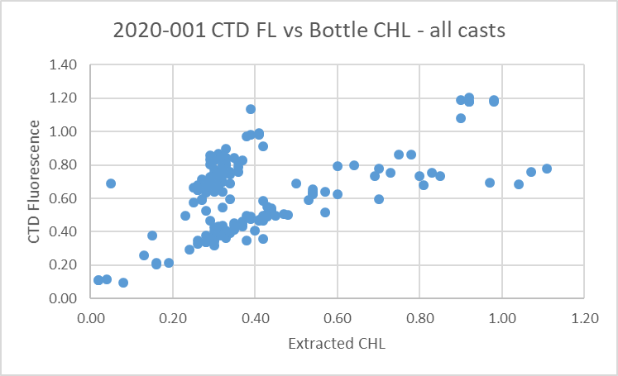

Dividing the data into offshore (west of P4) and inshore groups clears up the confusion:
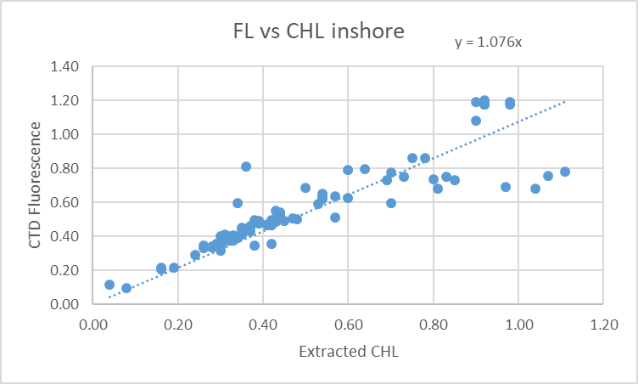

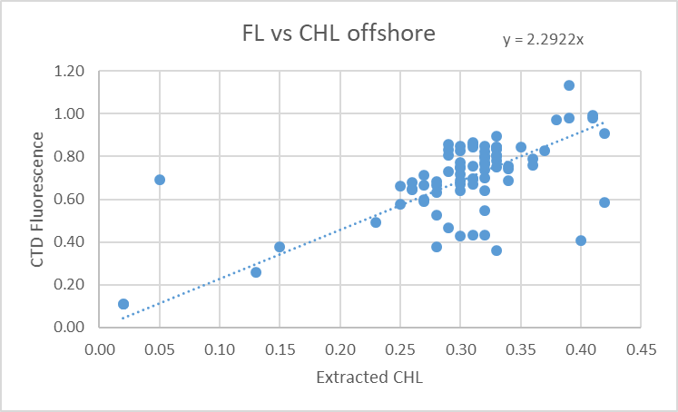
The ratio FL/CHL appears to be falling as CHL increases, but there are no high CHL values so this isn’t clear.

Conversion of Full Files from Raw Data
All files converted using 2020-001-ctd.xmlcon. The Tau function and the hysteresis function were selected since there was deep sampling. Depth was included in the conversion.
A few casts were examined and all expected channels are present. The T and C pairs were reasonably close during downcasts with upcasts very noisy, even more than usual due to very noisy descent/ascent rates. Fluorescence, PAR and Dissolved Oxygen profiles looked normal. The “Green” transmissometer was generally higher than the “Red”; the profiles had similar shapes. The altimetry looked like there could be problems as there are some spikes at the bottom.

WILDEDIT
Program WILDEDIT was run to remove spikes from the pressure, depth, conductivity & temperature only in the full cast files (*.CNV).
Parameters used were: Pass 1 Std Dev = 2 Pass 2 Std Dev = 5 Points per block = 50
The parameter “Keep data within this distance of the mean” was set to 0 so all spikes would be removed.

ALIGN DO
A few casts were examined; both temperature channels were noisy during upcasts so the tests were not easy to interpret, but using +2.5s certainly improves the alignment and overall looks like a good choice for both sensors. That setting has worked well for many SBE DO sensors in recent years.
ALIGNCTD was run on all casts using +2.5s.

CELLTM
The noise in the upcast data makes tests for the best parameters for this routine very difficult to interpret. In the past when upcast data were not so noisy, the default setting of (α = 0.0245, β=9.5) was generally found to be the best choice. A few casts were checked for this cruise and the default setting does improve the data. CELLTM was run using (α = 0.0245, β=9.5) for both the primary and secondary conductivity.

DERIVE and Channel Comparisons
Program DERIVE was run on all casts to calculate primary and secondary salinity and dissolved oxygen concentration.

DERIVE was run a second time on some of the deeper casts and 1 shallow cast late in the cruise to find differences between the pairs of temperature, conductivity and salinity channels. As this was the first use since the last factory service of these sensors no comparison was made with previous cruises. The differences are extremely noisy for all except the last shallow case. The differences in salinity should be considered ±0.001.

Cast # | Press | T1-T0 | C1-C0 | S1-S0 | Descent Rate
2020-001-0025 | 500 | -0.0003 | +0.00060 | +0.0040 | “
 | 1000 | 0 | +0.00060 | +0.0075 | High, V Noisy
 | 1900 | -0.0004 | +0.00063 | +0.0080 | “
2020-001-0057 | 500 | -0.0020 | +0.00050 | +0.0070 | High, XX Noisy
“ | 1000 | -0.0005 | +0.00057 | +0.0070 | “
“ | 1900 | -0.0007 | +0.00060 | +0.0080 | “
 | 2900 | -0.0029 | +0.00062 | +0.0085 | “
 | 3900 | -0.0008 | +0.00062 | +0.0085 | “
2020-001-0071 | 500 | -0.0004 | +0.00054 | +0.0070 | High, X Noisy
 | 1000 | -0.0012 | +0.00052 | +0.0076 | “
 | 1900 | -0.0007 | +0.00060 | +0.0080 | “
“ | 2900 | -0.0008 | +0.00061 | +0.0084 | “
“ | 3900 | -0.0009 | +0.00062 | +0.0085 | “
2020-0001-0088 | 500 | -0.0005 | +0.00055 | +0.0065 | High, Moderate

While there is pressure dependence in the conductivity and salinity differences this may be partly due to alignment since the salinity gradients are quite high down to 1500db and then slowly reduce until they are quite low at 3000db.

The difference between conductivity channels is at least 3 times what I would expect from freshly serviced sensors and that is consistent through the whole profile.

Examination of a few casts suggests that the secondary sensors reacted more severely to shed corruption, this may improve when alignment steps are taken later.

Conversion to IOS Header Format
The IOSSHELL routine was used to convert SEA-Bird 911+ CNV files to IOS Headers.
CLEAN was run to add event numbers and to replace pad values in the pressure channel with interpolated values based on record number.

Checking Headers
The cross-reference check and header check were run. No problems were found.

Surface check was run and found an average of 2.1db which is a little shallow for the Tully but many of the casts were near-shore with very low values while the offshore casts tended to be deeper.
One cast was found for which the CTD was very close to the surface with the pumps on. Conductivity drops significantly at about -0.1db and at -0.25db one sensor appears to be in water and the other out, so this must be very close to the surface. The would be some delay in registering very low conductivity, but the surface appears to be between 0 and 0.3db which is well within the specifications of the gauge.

Cruise tracks were plotted and added to the end of this report.

Shift
Fluorescence
SHIFT was run on the SeaPoint fluorescence channel in all casts using the usual advance of +24 records. Plots show that the fluorescence offset is reasonably close to the temperature offset after this step.
Dissolved Oxygen
The Dissolved Oxygen voltage channel was aligned earlier. A few casts were checked to see if the alignment looked ok, and it did. No further alignment is needed for the DO concentration channel,
Conductivity
Tests were run on a few casts to assess what settings are best to align conductivity with temperature (as judged by the effect on salinity as seen in T-S space). The best settings were -0.3records for the primary and -1.2records for the secondary though no setting produced very good results for the latter.
SHIFT was run twice on all SBE911 casts using -0.3 records for the primary and -1.2 records for the secondary conductivity. Salinity was recalculated for both channels.

DELETE
The following DELETE parameters were used:
Surface Record Removal: Last Press Min
Maximum Surface Pressure (relative): 10.00
Surface Pressure Tolerance: 1.0 Pressure filtered over 15 points
Swells deleted. Warning message if pressure difference of 2.00
Drop rates < 0.30m/s (calculated over 11 points) will be deleted.
Drop rate applies in the range: 10db to 10db less than the maximum pressure
Sample interval = 0.042 seconds. (taken from header)
COMMENTS ON WARNINGS: There were no warnings.

Water depth and Altimetry Headers Check
The altimeter and water depth readings from the headers of the CLN files were exported to a spreadsheet.
A check value was calculated by subtracting water depth from maximum depth sampled plus altimetry header. The following adjustments were needed:
- The altimetry header was removed from casts 48, 59 and 88 because the signal was too noisy for a reasonable estimate.
- For casts 18, 37, 39, 42, 46, 61 and 63 the log book depths look wrong based on comparison with maximum pressure sampled plus the altimeter reading at the bottom and based on other casts at the same site during this cruise and/or a cruise from 2019.
- The same changes were made to SAM files, as appropriate. Also the altimetry header was removed from SAM files for casts #16, 24, 31, 41 and 53 as the bottle samples came only at the surface so suggesting the bottle was fired near the bottom may be misinterpreted.

Other Comparisons
Experience with these sensors since last factory service –
This was the first use of the pressure, temperature, dissolved oxygen and conductivity sensors since they were last serviced.
Historic ranges – Profile plots were made with 3-standard deviation climatology ranges of T and S superimposed. Some shallow salinity values were lower than the minimum in the climatology in the top 25 to50m near shore and at the base of the mixed layer offshore. Salinity fell within the climatology for most of the inshore casts. All temperature values were within the climatology offshore, but inshore they look better mixed and frequently fall outside the climatology at mid-depths. Since this area has not been sampled much this may mean the sites are not well represented in the climatology. Also the climatology is old. None of these excursions suggest calibration drift.
Post-Cruise Calibration – There were no post-cruise calibrations available.

DETAILED EDITING
The primary channels were selected for editing because there was more noise in the secondary channels and more unstable features in T-S space and the salinity compared better with bottles..
All DEL files were copied to *.EDT.

CTDEDIT was used to remove records that appear to be corrupted by shed wakes. Salinity was cleaned to remove spikes that appear to be due to small misalignment or instrumental noise. All files required some editing. Notes about editing applied were added to the files.
The edited files were copied to *.EDT.
After editing T-S plots were examined for all casts. The only unstable features found were from well-mixed near-shore casts where such features are expected and likely real. No further editing was done.

The DELETE file for event #2 was incomplete. The problem was found to have arisen during alignment; something must have interrupted the operation. The alignment steps and DELETE were rerun and the output was fine.

Recalibration
There is no indication of a problem with pressure calibration.

File 2020-001-SBE911-recal.ccf was prepared to recalibrate by subtracting 0.0035psu from channel Salinity:T0:C0 and 0.0112psu from channel Salinity :T1:C1 and to apply the following correction to channel Oxygen:Dissolved:
CTD DO Corrected = CTD DO * 1.0242 - 0.0022
This correction was first applied to the SAM and MRGCLN2 files.

COMPARE was rerun for salinity to ensure that corrections were appropriate and they were. When the same outliers were removed as in the original comparison, the both salinity channels were found to be low by an average of 0.0003psu. See file 2020-001-sal-comp2.xls for details.
COMPARE was rerun for dissolved oxygen and shows that the correction was applied properly. When data are excluded using the same points as in the original fit, the CTD DO was low by an average of 0.0001mL/L. This shows that the recalibration was done correctly. See file 2020-001-DO-comp2.xls for details.

CALIBRATE was then run on the EDT files using the same recalibration file.

Final Calibration of DO
The initial recalibration of dissolved oxygen corrects for sensor calibration drift. Alignctd corrects for transit time errors. Those 2 steps may partly correct for response time errors, but to see if a further correction is needed, a comparison is made of downcast CTD data to bottle data from the same pressure. Small differences are expected due to ship drift, temporal changes, incomplete flushing of Niskin bottles and delayed response and noise in CTD data.

Downcast files were bin-averaged to 0.5m bins for the casts with DO bottle samples. Those files were then thinned and compared to the bottle values in the MRG files. COMPARE was run to study the differences between the downcast CTD DO data and the titrated samples from upcast bottles.

When bottles from Saanich Inlet and some cases of high standard deviation in CTD DO were removed the CTD DO was higher than the titrated samples by an average of ~0.0001mL/L but the standard deviation was 0.12mL/L and plots show a lot of variability from one cast to another, likely due to variations in vertical gradients.

The plot against pressure shows a lot of variability in the top 400m, principally due to high vertical DO gradients. Imperfect matches in pressure and slow response in the DO sensor will limit the accuracy of this comparison. Downcast (CTD files) Oxygen:Dissolved:SBE data for this cruise appear, very roughly, to be:
±0.3 mL/L from 0-250db except in areas of very large DO gradients
±0.2 mL/L from 250db-400db
±0.04 mL/L below 400db

Fluorescence Processing
A median filter, size 11, was applied to the fluorescence channel in the COR1 files. Plots of a few casts showed that the filter was effective. (Output:*.FIL)

BIN AVERAGE of CTD files
The following Bin Average values were applied to the FIL files (output AVG):
Bin channel = pressure Averaging interval = 1.000 Minimum bin value = .000
Average value will be used. Interpolated values are NOT used for empty bins.
On-screen T-S plots were examined.
Profile plots were examined to see if there any problems. No problems were noted.

Final CTD File Steps (REMOVE and HEADEDIT)
For all casts REMOVE was run to remove the following channels:
Scan_Number, Temperature:Secondary, Conductivity:Secondary, Oxygen:Voltage:SBE, Descent_Rate, Status:Pump, Altimeter, Salinity:T1:C1 and Flag.
For casts #37, 42, 46, 48, 50, 53, 54, 57, 61, 62, 63 and 71 channel PAR was also removed.

A second SBE DO channel (with umol/kg units) was added.
REORDER was run to get the two DO channels together.
HEADER EDIT was used to fix formats and channel names and to add the comments about processing.
The Standards Check routine was run and no problems were found.
The Header Check was run; no problems were found.
Profile and T-S plots were examined. No problems were found.
The sensor history was updated.

Dissolved Oxygen Study
As a final check of dissolved oxygen data, % saturation was calculated and plotted. Values at 2 to 3m ranged mostly between ~85% to 102%. The lowest was in Haro Strait, which is normal. All but one of the offshore casts were between 99% and 102% which suggests that the dissolved oxygen data from the CTD are reasonably well calibrated. Near-shore casts had lower saturations as expected in well-mixed waters. Cast #71 from P26 was examined since it had a lower value than expected. Temperature and salinity look ok at the surface, but the dissolved oxygen is a little low. The descent rate of the CTD shows that there was a lot of vertical motion so the oxygen readings may reflect data from a little deeper in the water column.

Final Bottle Files
For all casts REMOVE was run to remove the following channels:
Scan_Number, Temperature:Secondary, Conductivity:Secondary, Oxygen:Voltage:SBE, Descent_Rate, Status:Pump, Altimeter, Salinity:T1:C1 and Flag.
For casts #37, 42, 46, 48, 50, 53, 54, 57, 61, 62, 63 and 71 channel PAR was also removed.
A second SBE DO channel with mass units was added for both the CTD DO and titrated DO and REORDER was run to get the pairs of DO channels together.

Data were exported from the CHE files to file 2020-001-bottles-final.xlsx. The entries were compared with the rosette log sheets. No problems were found.
Standards check and a header check were run. No problems were found.
The track plot looks ok.
Plots of each file were examined and no problems were found.
A cross-reference listing and header check were produced for the CHE files.

Thermosalinograph Data
An IOS TSG45 was used for this cruise. The data were delivered in 3 files but 1 contained only 1 record so was not processed.
The IOS SBE TSG45 files were opened in EXCEL.
The files have extensions RAW but are in csv format, so the files were opened in EXCEL and combined in a single CSV file. (In opening I use DELIMITED, deselect TAB, select COMMA and OTHER (*).
It is necessary to choose TEXT for the time on the 2nd page of the text import wizard.)

The spreadsheets were adjusted as follows:
- 2 lines of headers were added – channel names and units.
- The file break column was populated with file names based on date, so separate files could be produced for each day.
- A column with pressure was added with all values set to 4.5 (to enable derivation of salinity).
- A temperature difference column was added (Lab-Intake).
- The fluorescence channel is in volts. It was moved to column M. Then a concentration value was calculated in column F using offset -0.044 and scale 15.8 as determined in the most recent recalibration of the fluorometer. Copy/Special Paste was used to save those values and then the voltage channel was removed.
- A file break column was filled with the cruise #-data/time info from the original file name.
- There was only a 10s gap between the 2 TSG files, so the data were combined in one CSV file.
- Time and Date formats are a problem – when converting from RAW choose TEXT but once opened in EXCEL set Time Format to HH:MM:SS and save the file again.
- There were no NaN entires.
- The file break column was completed so that new files would be created at the beginning of each day by assigned file names like 20200210-000000.
- The flow was off at the beginning of the cruise, so temperature, conductivity, salinity and fluorescence data were replaced with pad vales for all records with flow rate = 0 and for the first few records after the flow began.

The file was then converted to IOS Header format with header info added. There are 17 IOS files/
CLEAN was run to reset the number of records, min and max values, set the start and end times, and latitude and longitude limits.
ADD TIME CHANNEL was used to add Julian dates – i.e. Decimal Year. (A record number was also added to enable averaging (for use in comparison to CTD files). Time zero was set to 31 December 2019 0:00:00.
DERIVED QUANTITIES was run to derive salinity using the lab temperature.
Time-series plots were produced and the only problems noted were some discrete salinity spikes and a short section at the end during which the flow was probably off. Both issues can be addressed by editing.
REORDER was run to move the Julian date to after the Time/Date channels and to put salinity and fluorescence after the lab temperature. Also the record # was moved to the end.

a.) Plots
A track plot was produced and added to the end of this report.

b.) Checking Time Channel
The CTD files were thinned to reduce the files to a single point from the downcast at or within 0.5db of 4.5db. These were exported to a spreadsheet which was saved as 2020-001-ctd-tsg-loop-rosette-comp.xlsx. There were 76 CTD casts that overlapped with TSG records with flow turned on.

The TSG files were averaged over 24 records (2 minutes) on record number to reduce the noise and file size. Standard deviations were included. Then records were extracted for the times of CTDs and added to file 2020-001-ctd-tsg-loop-rosette-comp.xlsx..

Comparisons were made of positions to check for good matches; one error was found and corrected. The differences in positions are expected to be small despite the averaging because the ship was stopped at these times. The average differences were 0.0000º for both latitude and longitude. There were 2 fairly large differences in longitude (-0.0016 º and +0.0013 º); all other latitude and longitude differences were ≤0.0005 º. The 2 differences that were largest were associated with high standard deviations in the TSG longitude; the ship was obviously moving more than usual during stops from P8 to P12, likely due to rough sea conditions.

c.) Comparisons
- Comparison of T, S and fluorescence from TSG and CTD data
The initial comparison between TSG and CTD data includes some large outliers.

 | Tint-Tctd | Tlab-Tctd | SALtsg-SALctd | FLtsg-FLctd | FLtsg/FLctd
median | 0.0090 | 0.6632 | -0.0014 | 0.3915 | 1.6891
average | -0.0111 | 0.6429 | -0.0747 | 0.4037 | 1.7404
stdev | 0.0941 | 0.2012 | 0.5349 | 0.0656 | 0.3080
max | 0.0426 | 1.3256 | 1.6544 | 0.6120 | 2.5802
min | -0.7179 | -0.4799 | -4.0569 | 0.2740 | 1.2398

When 4 large outliers were removed differences were:
 | Tint-Tctd | Tlab-Tctd | SALtsg-SALctd | FLtsg-FLctd | FLtsg/FLctd
median | 0.0093 | 0.6753 | -0.0005 | 0.3885 | 1.6708
average | 0.0065 | 0.6684 | -0.0082 | 0.3991 | 1.7335
stdev | 0.0182 | 0.1476 | 0.2668 | 0.0601 | 0.3089
max | 0.0426 | 1.3256 | 1.6544 | 0.6060 | 2.5802
min | -0.0669 | 0.1745 | -1.2063 | 0.2740 | 1.2398

Finally, the casts were divided into offshore and inshore casts, excluding the 4 outliers:

 |  | Tint-Tctd | Tlab-Tctd | SALtsg-SALctd | FLtsg-FLctd | FLtsg/FLctd
offshore | median | 0.0107 | 0.7159 | -0.0005 | 0.3820 | 1.5300
 | stdev | 0.0073 | 0.0615 | 0.0148 | 0.0715 | 0.3092
inshore | median | 0.0006 | 0.6029 | 0.0019 | 0.3970 | 1.8217
 | stdev | 0.0242 | 0.2047 | 0.4242 | 0.0415 | 0.2555
Offshore includes events #13 to 80. Inshore includes events #88, 89, 92-99, 101-123.

The TSG intake temperature is higher than that from the CTD by a median of 0.0107 offshore but by only 0.0006 nearshore. However, the standard deviations are much smaller offshore which is to be expected because the surface waters were mostly well mixed offshore. So errors in matching levels of TSG and CTD sampling are likely not so significant for the offshore casts. Close to shore there was great variability in the vertical gradients near the surface, with many very well-mixed and others having significant vertical gradients of variable signs.

Similarly, the standard deviation in TSG salinity is extremely high inshore where the near-surface gradients are occasionally high with cool, fresh water coming in from nearby rivers. The TSG salinity in the offshore areas is very close to the CTD salinity though the standard deviation is 0.015psu.

The intake temperature offshore is higher than the TSG lab temperature by a median of 0.7159C° with standard deviation of 0.0615C°. Inshore the apparent heating in the loop is a little lower, at 0.6029C°, but the standard deviation is very high aby 0.2047 C°. Using all data the heating in the loop is ~0.67C°, but given variability nearshore, the offshore value is likely more reliable. Variations in the flow rate and intake temperatures would generally suggest that there should be more heating nearshore because temperatures were lower and flow rates lower overall. The standard deviation in the temperature in the lab was higher in the inshore area which may mean the lab itself was colder due to more frequent stops so doors were open more. This could reduce heating in the loop.

The fluorescence traces from the TSG look much better than during 2018 when they were often very smooth and out of step with the CTD fluorescence. For this cruise there is an obvious offset but the traces have the same shape. 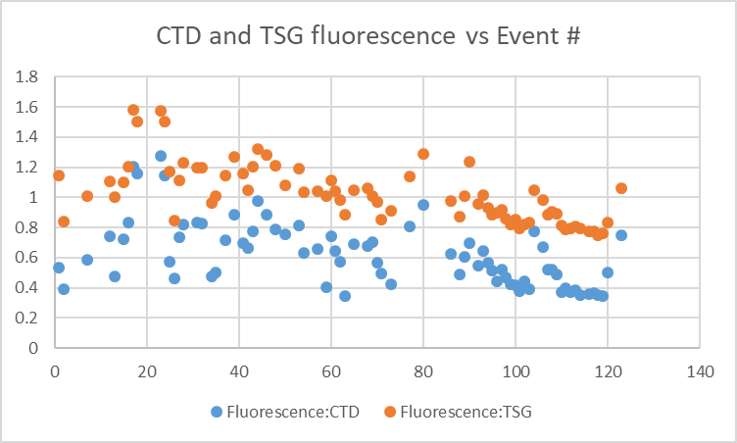
A plot of TSG fluorescence vs CTD fluorescence shows a reasonably linear fit but with an offset of ~0.5ug/L.
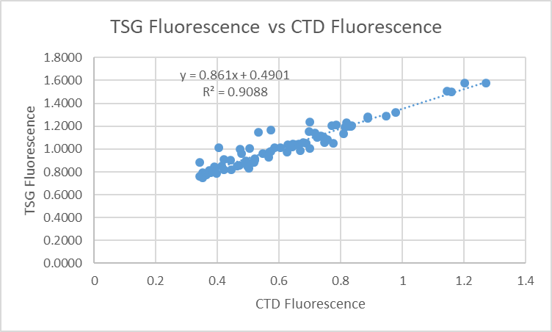
The median difference between the TSG and CTD fluorescence was somewhat smaller than the offset from the fit at 0.39ug/L, with little difference between offshore and inshore.

The TSG sensor had been recalibrated recently, so the offset is unlikely to be a calibration problem. Fortunately, there are many loop CHL samples, though the values are low at which level the fluorometer generally reads higher than CHL.

- Comparisons of Loop samples and TSG data
There were 22 loop Salinity and CHL samples of which 5 were taken while underway.

The TSG salinity was lower than loop bottle salinity by a median of 0.002psu with a standard deviation of 0.057psu. When 4 cases are excluded that had high standard deviation in the TSG salinity over 2 minutes, the TSG salinity is also lower by a median of 0.002psu but the standard deviation is then 0.005psu.

The loop CHL samples all have low values and fluorometers generally read higher than CHL for CHL<1ug/L. The only case with CHL>1 ug/L has fluorescence at 1.1 and CHL at 1.26 which is about what we expect. If we assume that the fluorometer really has an offset of 0.5ug/L (as suggested by the fit of TSG vs CTD fluorescence) and subtract that amount from the TSG readings we get a better match to the CHL samples at low values but it is poorer at higher values and does not look typical of this type of fluorometer. So it is likely that the fluorometer is reading correctly. However, the loop samples compare quite well with the rosette samples; see details below. So it would seem that chlorophyll is being added at some point beyond where the loop sample was taken.

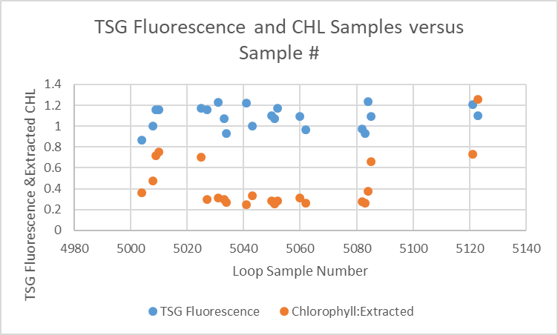

- Comparison of 5m Rosette samples and Loop samples
There were 9 CHL and salinity loop samples that overlapped with 5m rosette samples. The TSG salinity was higher than the rosette salinity by 0.0012psu with a standard deviation of 0.0016psu. The CHL loop samples were lower than the rosette samples by a median value of 0.018ug/L with a standard deviation of 0.158ug/L. There was a large range with the final near-shore sample having the largest difference likely due to slight mismatch in height in the presence of a large vertical gradient.

- Comparison of 5m Rosette samples and TSG Salinity and Fluorescence
A quick check comparing TSG salinity and chlorophyll with rosette samples was limited to the samples used in the previous section. The TSG salinity was lower than the rosette samples by a median of 0.005psu and standard deviation of 0.011psu. The ratio of TSG Fluorescence to Rosette Chlorophyll shows the usual pattern of ratios being high for low CHL and gradually falling to 1.3 for the highest CHL value which was 0.8ug/L.

d.) Calibration History
- The TSG and fluorometer were recalibrated shortly before this cruise; there is no history of use since it was serviced.

e.) Conclusions re IOS TSG
1. The TSG clock worked well and position information was available and reliable.
2. The flow rate was quite steady with values from 0.9L/min to 1.1L/min for most of the cruise with short sections with no flow at the beginning and end with some spikes early and late in the cruise.
3. The TSG temperature is higher than the CTD temperature by about 0.011C° in the offshore area with a standard deviation of 0.007 C°. Inshore the TSG is high by only 0.001 C° but the standard deviation is 0.024C°. That could be caused by the TSG drawing water from higher in the water column where temperatures were lower at some inshore casts. That explanation is supported by the fact that for those inshore casts with fairly well mixed surface waters the TSG temperature was higher by 0.007C°.
4. Heating in the loop was ~0..72C° offshore with a standard deviation of 0.016C° and ~0.60C° inshore with a standard deviation of 0.205 C°. We would normally expect that heating would have been higher inshore as intake temperatures were a little lower, but possibly the lab temperature was lower as well due to more frequent stops for sampling.
5. In the offshore the TSG salinity is lower than the CTD salinity by <0.001psu (std dev 0.015) and inshore it is higher by ~0.002psu (std dev 0.42psu). If the TSG were drawing water from a little higher in the water column, then that might make the TSG salinity look lower than the CTD since salinity was increasing with depth. That does appear to be the case for casts with significant near-surface vertical salinity gradients. However where gradients were very low the TSG salinity is generally higher than the CTD salinity inshore. The differences are too small and variability too high to conclude more than that the TSG salinity appears to be close to CTD salinity. TSG salinity was lower than loop samples by 0.002psu; the standard deviation was large at 0.057psu but if 4 outliers were excluded it was 0.005psu. The TSG salinity was lower than rosette samples by 0.005psu but those samples likely came from a little deeper in the water column.
6. The TSG fluorescence trace looks much better than was seen in 2019. It tracks the CTD trace quite well. The fit of CTD fluorescence versus TSG fluorescence is tighter than usual and approximately linear but there is a large offset, between 0.3ug/L and 0.6ug/L, median ~0.4ug/L. Recalibration by subtracting that offset produces unusual fits against extracted CHL samples from the loop. It produces values close to the loop samples, but this type of fluorometer generally reads higher for very low CHL and lower for high CHL. The loop samples are close enough to rosette samples to suggest that the problem is not due to contamination of the loop water itself. It may be due to the introduction of chlorophyll in the tubing or the fluorometer itself.
7. No recalibration will be applied.
- The salinity appears to be within 0.002psu based on a variety of comparisons.
- Temperature appears to be high by ~0.01C°; it is generally the case that the intake temperature is a little higher than CTD temperatures, with the largest differences seen in winter. This likely means that there is some slight warming at the entrance to the loop and heating would be more significant when the ambient waters are colder. Further, shallow CTD data are not reliable enough to warrant recalibration of temperature based on this evidence.
- TSG Fluorescence appears to be high by between 0.3ug/L and 0.6ug/L. A simple correction by subtracting the median difference produces unusual results so will not be applied.

g.) Editing
The only editing needed was to replace data at the end of the final file when the flow was <0.5. This was done doing a text editor. There are some noisy patches in salinity when sea conditions were rough and there are occasional spikes within those patches of size ≤0.2psu. Editing in these patches was not attempted as all values are like affected by bubbles.

h.) Preparing Final Files
Derived Quantities was run to derive sigma-T.
REMOVE was used to remove channel Pressure, Temperature:Difference , and record #.

HEADER EDIT was used to change the DATA DESCRIPTION to THERMOSALINOGRAPH and add the depth of sampling to the header and to change channel names to standard names and formats and to add comments.
A cross-reference list was prepared.
The TSG sensor history was updated.
As a final check plots were made of the cruise track and time-series an all looks fine.

Loop File
The Chief Scientist provided file 2020-0001 Loop log.xlsx which included event numbers, sample numbers and what was sampled. Earlier in the processing the loop samples were used to study the TSG calibration. Times were added based on the log entries. For loops taken at the same time as 5m rosettes, the times were set to the ends of casts. Those data were copied to file 2020-001-loop.xls.

A 6-line header spreadsheet was prepared using a template from previous cruises.
A column was added for the channel Transmissivity:CTD:Green.
The sampling method column was added and filled with USW.
The columns were arranged in the order required for the 6-line header used to prepare the loop file.

Next data from near-surface rosettes were obtained.
The CHE files were put through program DERIVE to obtain sigma-t.
Clip was run to choose only data between 0db and 7db.
Data from those files were exported to file 2020-001-che-surface.csv. The Oxygen:Dissolved and Oxygen:Dissolved:SBE channel in mass units were included and Draw Temperature.
The Start Time was divided into 2 columns using “Text to Columns” under the DATA tab in Excel. The times in the files are start times and the samples were actually taken near the end of the cast, so the times were edited to match the End Times in the log book.
(An alternate approach is to calculate End times from the full files (*.CLN) and export those to a spreadsheet.)
A sample method column was added. ROS was entered for the method.
That data was then added to the 6-line header.
The data were sorted on event number, then pressure.
That file was saved as 2020-001-surface-6linehdr.csv.
The file break column was filled with value 1 so all data will be in a single file when converted.

CONVERT was run to produce an IOS Header file.
CLEAN was run to get start and stop times and positions and to add flag 0 to empty flag cells.
A comment file was prepared which was essentially the same as the one used in preparing CHE files but including a description of the loop system and comments on the CTD data processing.

Header Edit was used to correct channel names and formats and to add comments. The final file was renamed as 2020-001-surface.loop. The track plots look reasonable and plots of temperature and salinity versus event numbers, latitude and longitude look reasonable.

Particulars - Notes from Daily Science Log and Sampling Notes
PAR off: 37, 42, 46, 48, 50, 53, 54, 57, 61, 62, 63, 71.
Casts with bottle fired out of order: 23, 86, 104
Casts with no Niskin closed: 7
Computer time was in PST.

1. Error in station name – fixed.
16, 34, 44, 46 & 50. Wrong file name in header – fixed.
57. Change to constant speed of sound of 1490m/s for sounder.
59. Bulk water sampling from 5m bottle
60. Loop sample 5060 found with no insert or top – discarded.
71. Change to constant speed of sound of 1493m/s for sounder.
80, 88, 89, 90, 92 – station names wrong format – fixed.
88. Touched bottom.
89-120 – No 10db soak.
115. Boat cast - Samples out of order- no #940.

2020-001
CRUISE SUMMARY – CTD
CTD# | Make | Model |  | Serial# |  | Used with Rosette? |  | CTD Calibration Sheet Competed?
1 | SEABIRD | 911+ |  | 443 |  | Yes |  | Yes
Calibration Information - 0506
Sensor |  |  |  |  | Pre-Cruise |  |  |  | Post Cruise
Name |  |  | S/N |  | Date |  | Location |  | Date | Location
Temperature |  |  | 4700 |  | 11Dec2019 |  | Factory
Conductivity |  |  | 3531 |  | 12 ec2019 |  | Factory
Secondary Temp. |  |  | 4888 |  | 11Dec2019 |  | Factory
Secondary Cond. |  |  | 4513 |  | 28Jan2020 |  | Factory
Transmissometer |  |  | 1883DG |  | 8Feb2020 |  | Factory
Transmissometer |  |  | 1185DR |  | 8Feb2020 |  | IOS
SBE 43 DO sensor |  |  | 3791 |  | 7Dec2019 |  | Factory
PAR |  |  | 70613 |  | 21Mar2016 |  | Factory
SeaPoint Fluor. |  |  | 3640 |  |  |  | Factory
Pressure Sensor |  |  | 0443 |  | 9Jan2020 |  | Factory
Altimeter |  |  | 62355 |  |  |  | Factory

TSG Make/Model/Serial#: SEABIRD/45/0620
Calibration Information
Sensor |  | Pre-Cruise |  | Post Cruise
Name | S/N | Date | Location | Date | Location
Temperature | 0620 | 21Jan20 | Factory
Conductivity | 0620 | 21Jan20 | Factory
WETStar Fluorometer | 953 | 30Dec2019 | Factory

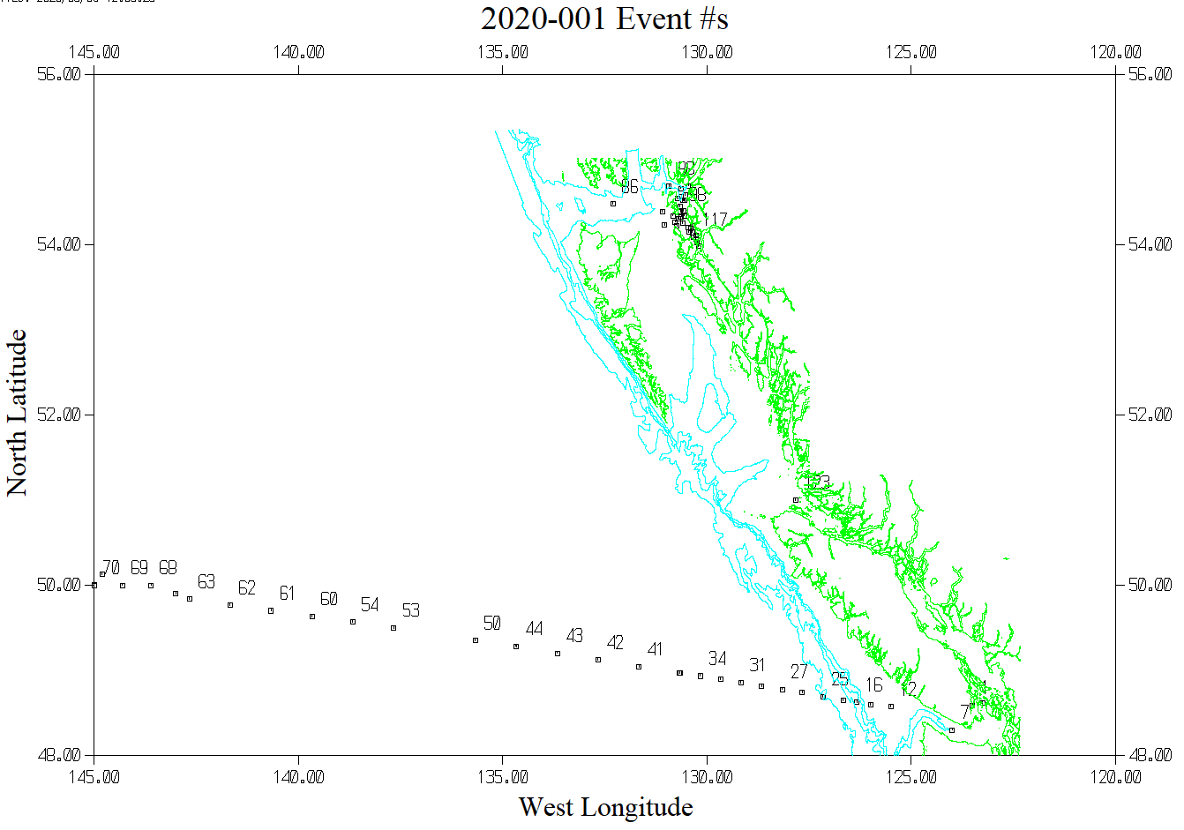
The following is an expanded display for events 82 to the end of the cruise. cruise.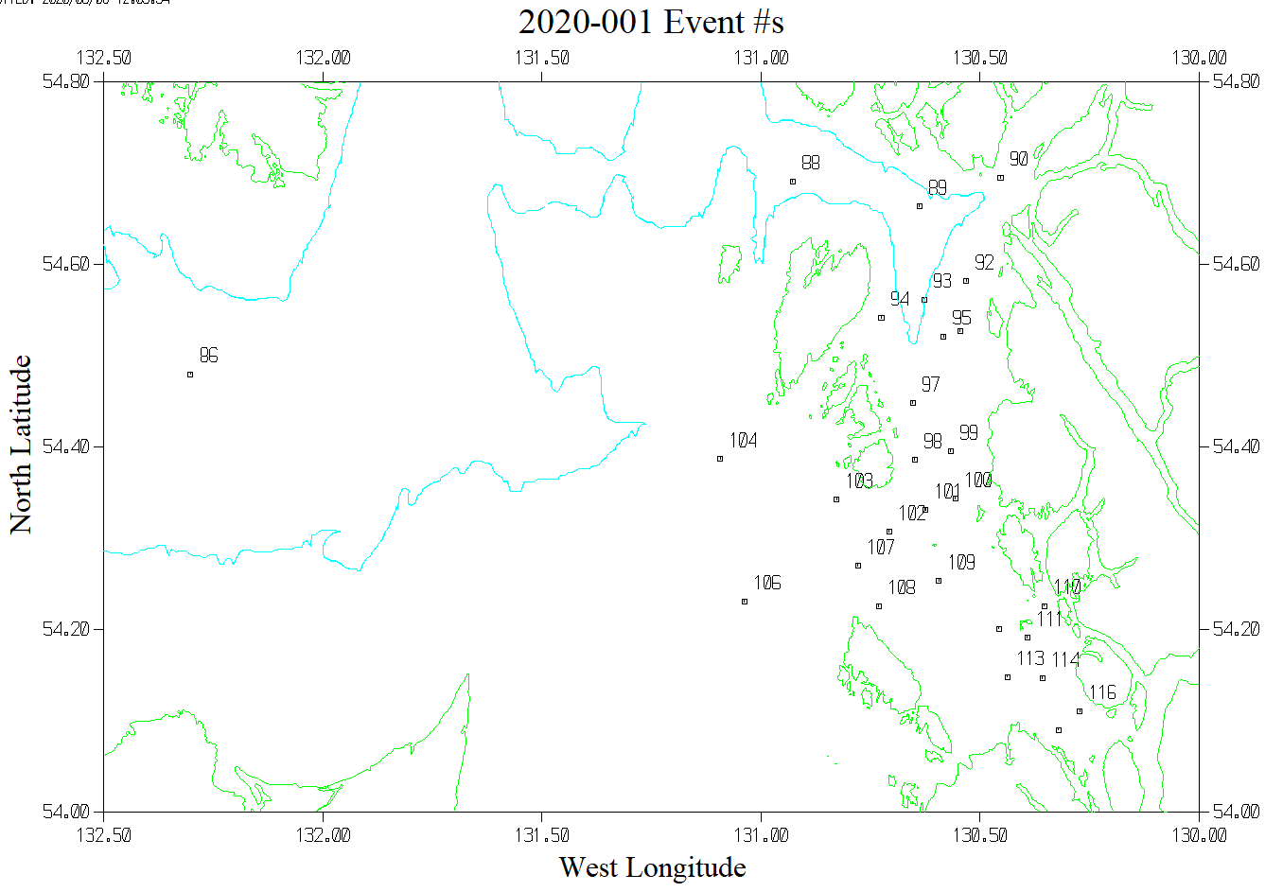
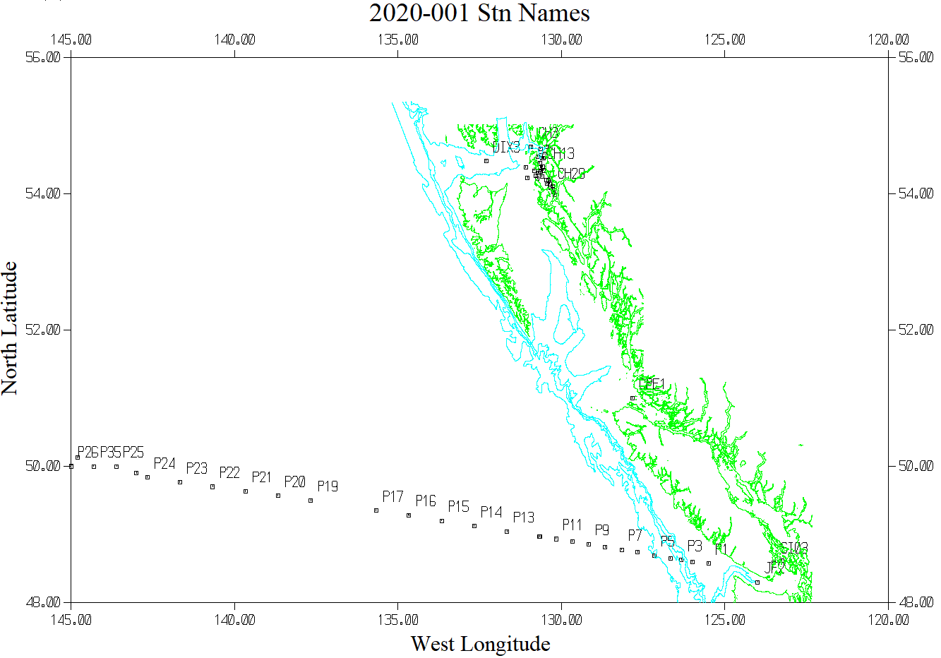
The following is an expanded view of Events #82 to the end of the cruise.
