# PARR Weather Station Installation Field Report

CruiseID: 2019-113

Glenn Cooper

November 29, 2019

# Overview:

In support of the Program for Aquaculture Regulatory Research (PARR), a weather stations network was established February 2019 at four locations in the Queen Charlotte Strait region. In collaboration with Mowi, stations were installed on or near their fish farms sites which provided power and internet access for the Davis weather stations. Initially stations were installed at: Bull Harbour farm, Duncan Island farm, Robertson Bay farm and on one of the Browning Islands. In August 2019 the network was expanded by 3 sites: Shelter Passage farm, Shelter Bay farm, Gordon Islands (Doyle farm).

All but two of the sites have internet connections. Browning Island lacked power and internet and Shelter Bay lacked internet access so collected weather data was internally archived which has a 100 day storage capacity. Since the logger was about to reach its storage capacity, Chris Clarke and Glenn Cooper revisited the region from November 25th to 28th to download the archived data and to perform routine maintenance on all other weather stations in the region. A vessel was chartered from the Gwa’sala-’Nakwaxda’xw nation to provide water transportation in the region.

# Field Objectives:

1. Download Browning Island and Shelter Bay archived data and migrate systems to be online if the infrastructure exists.
2. Perform routine maintenance on all other sites. Replace batteries in both weather stations and repeaters so as to ensure systems had good power through the winter months. Get offline sites data downloaded and back online.
3. Robertson Farm site to be shut down and removed by January 2020 so was instructed to remove our weather station and components.
4. Perform a CTD cast with a RBR Concerto at farm sites that have installed weather stations.

# Objective Results:

* 1. Browning Island: Archived data was successfully downloaded. The weather station console is located in the Marsh Bay farm feed barge which had just acquired power and internet, so this site was migrated to an online system. Before departure, it was confirmed that weather station was transmitting live data to the Davis server. Anemometer at 6o True, adjusted back to True North.
  2. Shelter Bay Farm: Archived data was successfully downloaded. Unfortunately Shelter Bay was still without internet upon our arrival. This site was to have internet access by this point but ongoing issues have delayed its installation. So for now the data continues to be archived. Through a brief discussion with David Gibbs, site manager, it sounded that the site would be getting internet within the next few weeks. This site will have to be re-visited in February 2020 to download the archived data.

1. Remainder of sites were visited. Anemometer orientation was checked and reset back to True North if required. All weather station and repeater batteries were replaced. Console batteries were also replaced if required (Table 1).
   1. Bull Harbour: Was been offline since November 16. Data downloaded successfully and reset system to get back online.
   2. Doyle Farm: Site in good condition. Minor adjustments with repeater guy wires.
   3. Duncan Island Farm: Was offline since November 16. Data downloaded successfully and reset system to get back online.
   4. Shelter Passage: Anemometer found to be at 353o True. Corrected back to True North. Minor repairs to bracket system.
2. Robertson Bay Farm: Weather station has been offline since September 10th. Repeated attempts to get it back online were not successful. Downloaded stored data but a significant gap in the data set. Site is in the process of being shut down and removed, so had to remove the weather station and all components. Site will not be reinstated as it is too exposed to weather.
3. A RBR Concerto CTD (s/n#: 066024) with a Turner Cyclops fluorometer (s/n#: 300), and a JFE Andvantech oxygen sensor (s/n#: 848) was used for vertical water column profiling. CTD casts were performed off of fish farm pens at: Bull Harbour, Duncan Island, Shelter Bay, Shelter Passage Robertson Bay (Table2). Cast were to a depth of 85 meters or 1 meter off the bottom, whichever was less.

# Problems and Issues:

Only a few minor issues were encountered during the trip. The most significant was our delayed departure on November 27 due to a line fouling a prop, putting our vessel out of commission. Thankfully the charter company, k’awat’si Marine, was able to find a solution that worked for both parties and we were able to resume our work for the day.

Unfortunately Shelter Bay still did not have internet at the time of this visit. I was under the assumption that it would be in place by this point. According to the site manager it should be in place when I return to the site to download the internally stored data. This will have to occur by the last week of February 2020 to avoid any data loss.

# Conclusions:

Overall the trip was successful. Good weather meant we could travel quickly and efficiently in the area, allowing us to cover significant ground. Also there weren’t any significant issues with the systems to deal us. This meant we were able to complete all of the work a day earlier than initially expected.

Finally I would like to thank Chris Clarke for his excellent work and attention to detail. Also would like to thank our boat captain, Wes Walkus of k’awat’si Marine, for safely transporting us in the area and getting us on and off rock cliffs. His knowledge of the farms and area was very beneficial.

**Figure 1. PARR weather station network.**

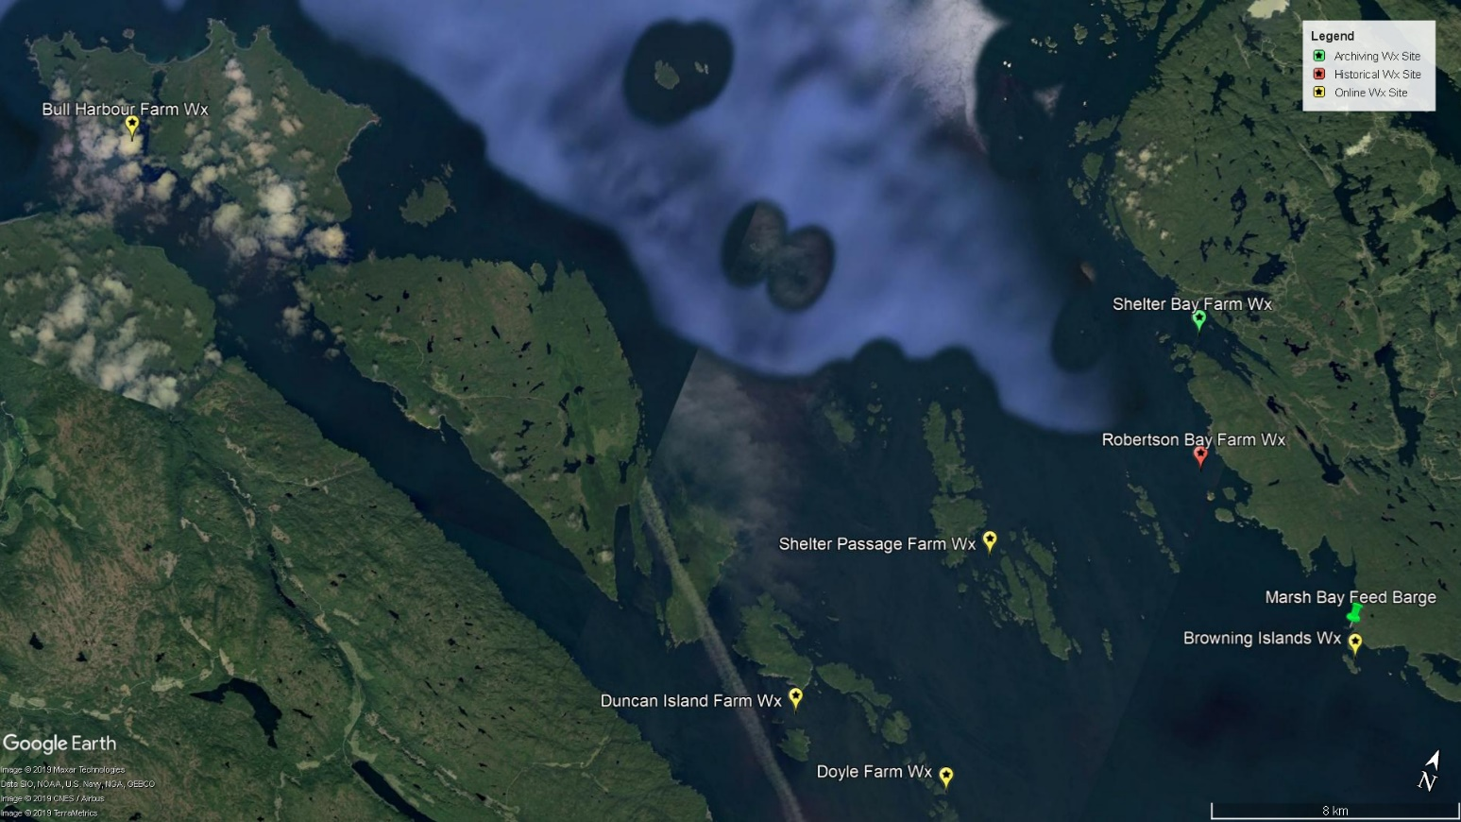

|  |  |  |  |  |  |  |  |  |  |  |  |
| --- | --- | --- | --- | --- | --- | --- | --- | --- | --- | --- | --- |
|  | **Table 1. Summary of PARR weather station network site** | | | | | | | |  | |  |
| Station Name | | ISS Channel | Repeater (y/n) | Repeater Channel | Latitude | Longitude | Data Logger | Archive Interval | |
| Bull Harbour | | 8 | Yes | D | 50° 53.989 | 127° 56.282 | WeatherLinkIP | 15 minute | |
| Duncan Island | | 3 | Yes | C | 50° 49.320 | 127° 33.419 | WeatherLinkIP | 15 minute | |
| Browning Island | | 3 | Yes | G | 50° 53.912 | 127° 19.838 | WeatherLinkIP | 15 minute | |
| ~~Robertson Bay~~ | |  |  |  | ~~50° 55.894~~ | ~~127° 25.738~~ |  | Site removed | |
| Shelter Bay | | 8 | No |  | 50° 58.044 | 127° 27.206 | USB | Hourly | |
| Shelter Passage | | 3 | Yes | C | 50° 53.118 | 127° 30.172 | WeatherLinkIP | 15 minute | |
| Doyle | | 3 | Yes | G | 50° 49.058 | 127° 28.782 | WeatherLinkIP | 15 minute | |

**Table 2. 2019-113 CTD casts.**

|  |  |  |  |  |  |
| --- | --- | --- | --- | --- | --- |
| Event# | Station Name | Latitude (N) | Longitude (W) | Cast Date (UTC) | Cast Start Time (UTC) |
| 1 | Bull Harbour | 50° 53.988 | 127° 56.289 | 26-11-2019 | 1757 |
| 2 | Shelter Bay | 50° 58.058 | 127° 27.201 | 26-11-2019 | 1950 |
| 3 | Robertson Bay | 50° 55.895 | 127° 25.739 | 26-11-2019 | 2322 |
| 4 | Duncan Island | 50° 49.312 | 127° 33.408 | 27-11-2019 | 1932 |
| 5 | Shelter Passage | 50° 53.141 | 127° 30.122 | 27-11-2019 | 2101 |