**Revision Notice Table**

|  |  |
| --- | --- |
| **Date** | **Description of Revisions** |
| 10 July 2023 | DO Saturation converted to DO Concentration. Bad data removed from the bottom of casts 1, 14, and 19. Spike in S, C removed from cast 31. SH. |

**RBR CTD DATA PROCESSING NOTES**

Cruise: 2019-112

Agency: OSD

Locations: Clayoquot Sound

Project: Meteorology Network

Party Chief: Glenn Cooper

Platform: CME Anderson

Date: October 29, 2019- November 1, 2019

Processed by: Samantha Huntington

Date of Processing: September 21, 2021 – September 26, 2021

Number of Raw files: 31 Number of Processed Files: 31

**Instrument Summary**

Equipment: RBR Concerto CTD (s/n 66024) with a Turner Cyclops Fluorometer (s/n 848) and a JFE Advantech Rinko III oxygen sensor (s/n 300).

Sampling frequency was at 6Hz.

**Summary of Quality and Concerns**

A cast list was provided, 2019-112CTDLogFile.xlxs. Event 2 is incomplete because a predator net interfered with the cast. Event 8 was halted at 87 meters to fix the sounder, Pressure is steady for approximately 2 minutes at this section. Cast 13 only goes to 7m.

Casts 5, 6, 7 and 30 show a negative pressure spike towards the end of the upcast.

**Processing Summary**

1. **Conversion to IOS Headers**

File 066024_20191102_0011.rsk contained 31 profiles and profile csv files were extracted using python function EXPORT_FILES().

A single file (2019-112_CTD_Data.csv) with all the data including event numbers and a single line of headers was prepared using python function MERGE_FILES().

A 6-line header was inserted using python function Add_6Lineheader_2().

File “2019-112_header-merge.csv” was created, based on the information provided by the chief scientist.

* Column “File_Name”: entries were derived from the event number.
* Column “LOC:LATITUDE”: latitude was provided and reformatted to “XX XX.XXXX N !(deg min)”.
* Column “LOC:LONGITUDE”: longitude was provided and reformatted to “XX XX.XXXX W !(deg min)”.
* Column “LOC: Event Number”: entries were event numbers.
* Column “LOC: STATION”: stations were derived from the notes column.

The sampling site was mapped (Figure 1) using from “2019-112_header-merge.csv” using python function Plot_Track_Location() to check the location of all casts.

Prior to conversion to IOS header format, the presence of zero-order holds were checked using Python function Plot_Pressure_Diff(). Zero-order holds were found (Figure 2.) and these values were replaced with Nan using the python function Correct_Hold().

A new csv file was created “2019-112_CSV_DATA-6Linedr_corr_hold.csv” and the corrected values were checked in python function Plot_Pressure_Diff(). Zero-order holds were found to be removed (Figure 3.).

CONVERT Spreadsheet Files was run to produce files with IOS Header format. Header entries of “Administration”, “File” and “Instrument” were filled in this step.

The routine “Merge:CSV Files to headers” was run to add location headers to the IOS files.

Raw data were plotted and examined:

* A negative pressure spike appears at the end of the upcast for casts 5, 6, 7 and 30.
* Cast 1 does not have good alignment between the downcast and upcast, Salinty, Conductivity and Dissolved Oxygen values decrease towards the end of the downcast.
* Salinity looks good overall, Cast 14 has some bad data at the bottom and Cast 31 has a small spike at aroud 80m..
* Temperature has bad data at the surface of all casts and some at the bottom of cast 23.
* Conductivity looks good with some bad data at the bottom of cast 14.
* Oxygen has some bad data at the surface of most casts.
* Fluorescence has some spikes in casts 1 and 20, and bad data at the top of cast 16 and 30.

Next CLEAN was run to add a start time and event numbers to headers.

Then REORDER was run to reorder the channels in all files.

1. **Data processing**

* Correction to Pressure: although there were negative pressures spikes seen in the raw data, they were at the end of the upcast for casts 5, 6, 7 and 30. The corresponding Conductivity was found to be less than 0.2 mS/cm, so pressure was not calibrated.
* Data despiking: There are no significant spikes in temperature, conductivity and salinity. So there is no need to apply data despiking. There are a few spikes for Fluorescence in Casts 1, 10, and 20 but despiking was not applied.
* CLIP: Pressure is steady for a variable number of scans. Initial records were removed until the downcast began using file “2019-112_CLIP.csv”.
* Filter: a Gull-winged filter, size 5, was applied to temperature, conductivity, and pressure. Salinity will be calculated in the next step.
* SHIFT: Based on suggested values in document “Guidelines for processing RBR CTD profiles”, the alignment of temperature and conductivity was corrected by applying a shift of -2 scans in conductivity.
* SHIFT: Better alignment with Oxygen profiles was found by advancing it by 11 scans. The advice given in document “Guidelines for processing RBR CTD Profiles” was that an advance between 2 and 3 seconds is appropriate. T-O plots before and after alignment were compared.
* The descent rate of the CTD was quite slow so DELETE was run only to remove swells, however it should be noted that the results were the same as running DELETE to remove records with a descent rate of lower than 0.3m/s over 6 points from 10m down.
* Profile plots were examined after DELETE and confirm that plots show reasonable values for salinity and conductivity and fluorescence. Cast 1 shows decreasing values for Salinity, DO, and Conductivity towards the end of the downcast. DO saturation levels at the surface ranged from 1% to 106%. However there was no calibration sampling and no climatology to enable a judgement about the data reliability.

1. **Final checks and header editing**

* REMOVE was run to remove the following channels from all casts: Date, Time:UTC and Event.
* BIN AVERAGE was used to metre-average data.
* CALIBRATE was run to convert conductivity units to S/m using file 2019-112-recal2.ccf.
* Header Edit was used to fix channel names and format as listed below:
* Pressure: format F11.2 ==> F7.1
* Salinity:CTD ==> Salinity
* Oxygen==> Oxygen:Dissolved:Saturation:RBR
* mL/L==> %
* Fluorescence ==> Fluorescence:URU
* F11.4==>F8.2
* Conductivity: F10.5 ==> F10.6
* Header Check was run and no problems were found.

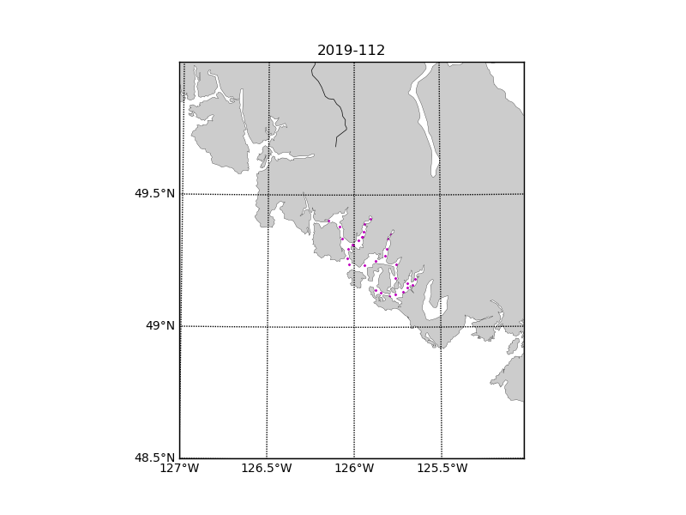

Figure 1 – location of casts. 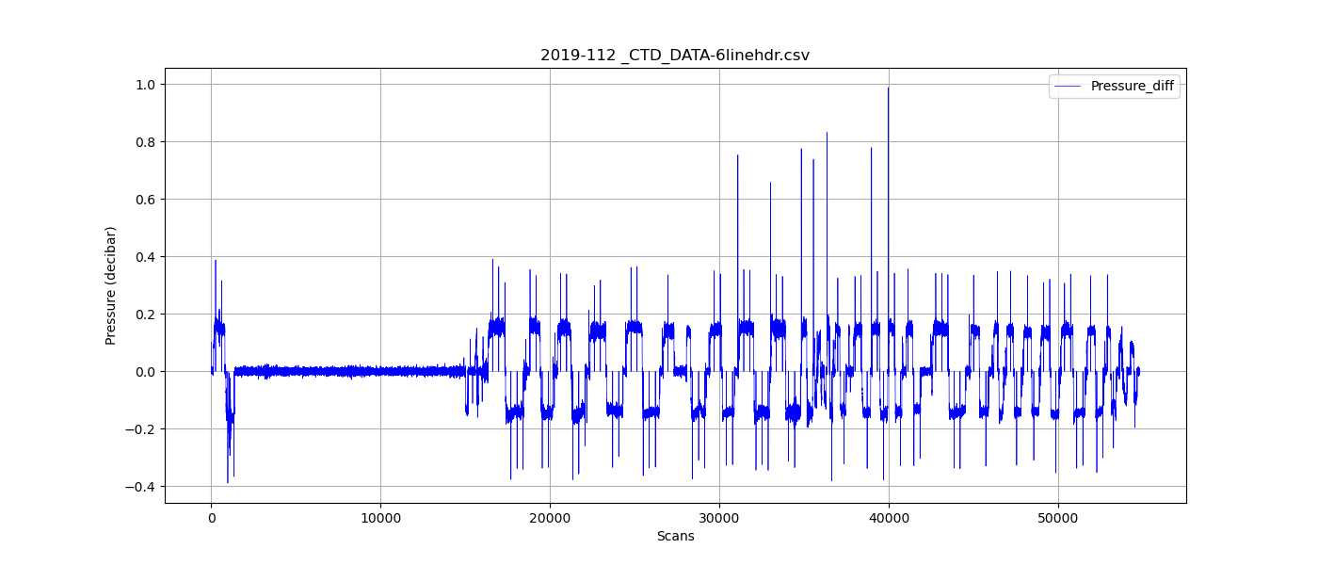

Figure 2 – zero-order holds

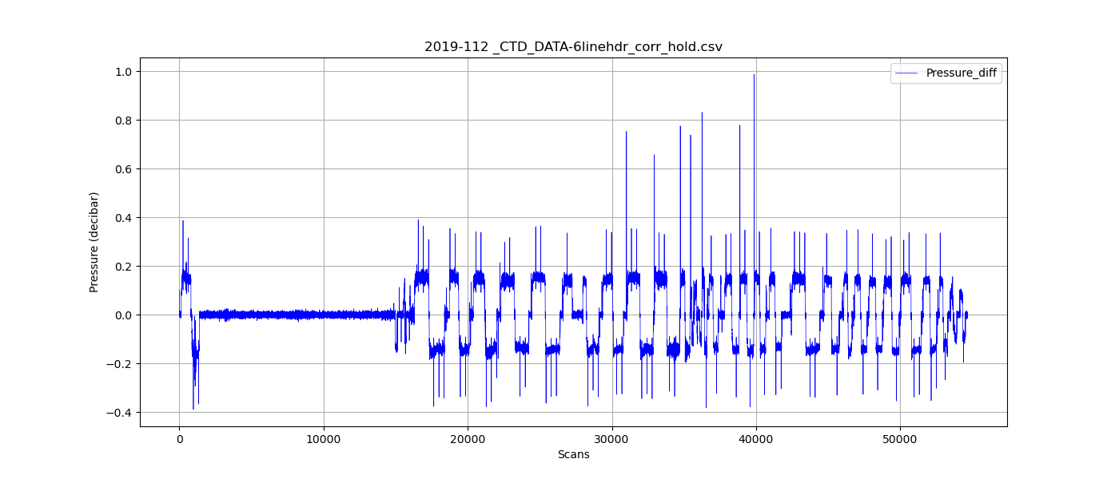

Figure 3 – zero order holds removed