# Nootka Sound Weather Station Field Report

CruiseID: 2019-109

Glenn Cooper

September 30,2019

# Overview:

In the continuing support of providing meteorological data for the Finite-Volume primitive equation Community Ocean Model (FVCOM), Glenn Cooper (OSD) and Krzysztof Witkowski (CHS) travelled to Nootka Sound and Esperanza Inlet to service installed Davis weather stations from September 9-13th, 2019. All the weather stations have been integrated with Grieg Seafood fish farms (Figure 1) which provide power and internet access for our equipment. The OSD vessel, CME Anderson, was taken to provide transportation in the region, allowing us the flexibility and autonomy to perform all of the mission objectives.

**Figure 1. OSD’s Weather Station Network in Nootka Sound and Esperanza Inlet.**

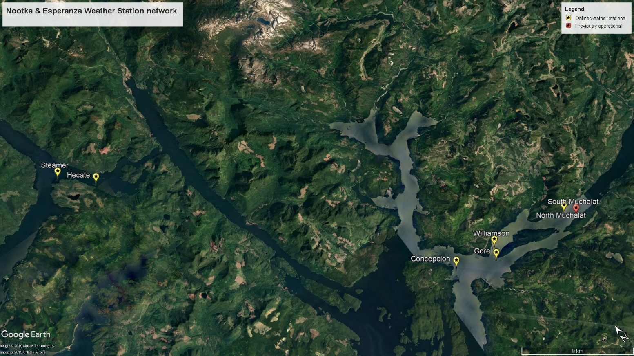

# Field Objectives:

1. Perform necessary maintenance on all weather stations.
2. Determine the cause of Gore’s weather station connectivity issues and make the necessary upgrades or replacements to ensure a more consistent internet connectivity.
3. Upgrade sea surface temperature probe transmitter boxes with ones that have been retrofitted with solar panels to increase operational time.
4. Perform vertical profile CTD casts along channels and inlets where fish farms and weather stations are located.
5. Deploy 8 Surface Current Trackers (SCT) in the region. Deploy in SCTs in pairs and in proximity to fish farms in both the Nootka sound region and Esperanza Inlet. If possible try to recover any SCTs that had run aground or trapped in a location for an extended period of time, and redeploy to extend data collection.

# Objectives Result:

1. All fish farms that have a weather stations installed were visited. Consoles, integrated sensor suites (ISS) and sea surface temperature (SST) probe transmitters received new batteries for all sites. Any damaged temperature probes and conduit were replaced. Anemometer orientation was noted and if necessary corrected back to True North. Summary of changes is noted in Table 1.
2. The Gore site has been problematic whereby it would lose connectivity to the internet and would need to undergo a hard reset to re-establish connectivity. However it is not always possible to get timely assistance from the farm site manager to perform the reset procedure and as a result data has been lost. Upon arrival I was able to download a significant amount of archived data but there is a large gap of missing data spanning from 15/07/2019 to 15/08/2019. Data ports, data loggers and internet connectivity all tested fine. Analysis of the downloaded data indicated that there were regular instances of complete signal loss between the ISS and console. To improve the connectivity between the two units a repeater was installed on Pen#4. Signal strength was greatly improved by this addition and to date there has been no loss of connectivity.
3. Two sites had SST transmitters replaced with modified solar powered versions to increase their operational time. A third solar panel SST transmitter was taken, and although it passed bench testing, it proved problematic in the field and was not installed. Several locations had damaged conduit and/or temperature probes. These were all repaired and/or replaced. There were significant communication issues at the North Muchalat site which took a significant time to troubleshoot. Summary of changes is noted in Table 1.
4. A RBR Concerto CTD (s/n#: 066024) with a Turner Cyclops fluorometer (s/n#: 300) and a JFE Andvantech oxygen sensor (s/n#: 848) was used for vertical water column profiling. The focus was to measure oxygen levels in the deep inlets and passages where fish farms were located. A total of 39 CTD casts were performed in: Muchalat Inlet, King Passage, Williamson Passage, Hanna Channel, Zuciarte Channel and Hecate Channel (Figures 2, 3 and Table 2). For CTD casts #18 to 23 the oxygen sensor cap was left on, so the oxygen data is not valid. Oxygen values for all casts after CTD cast#23 look reasonable.
5. A total of 8 SCTs were deployed during the mission. SCTs were deployed in pairs, with 2 of the pairs released across from fish farms in Nootka Sound and the other 2 pairs across from farms in Esperanza Inlet (Table 3). We were able to recovery 2 of the SCTs (#1018 and 1020) which had run aground but could only redeploy #1020 as the 1018 Spot had been damaged and beyond repair. SCT #1019 and 1082 had also run aground but could not be found as they were dragged up into the bush, presumably by black bears in the area. Drift data for the SCTs is managed and can be obtained from Roy Hourston (Roy.Hourston@dfo-mpo.gc.ca).

# Problems and Concerns:

1. Significant repairs were required to the SSTs at all weather station sites except for Gore. Broken conduit, damaged probes, and communication issues between the transmitter box and the console, were the common problems. All of these took a considerable amount of time and effort to resolve. Consideration should be made on the importance of this data. If it is not critical to the model development or utilized, then we should consider removing these SCTs to increase efficiency and reduce costs.
2. The vessel’s VHF radio was tested before departing IOS but when performing a radio check in Gold River it failed long range transmissions. The VHF could still be used for short range transmissions and there were two spare handheld VHF radios onboard as well, so there were limited safety issues or concerns. However this should be dealt with before the vessel is further used.

# Conclusions:

Overall the trip was successful with a significant amount of work accomplished. The OSD vessel, CME Anderson, provided us with the flexibility and autonomy to complete the necessary objectives. It is an excellent platform for this particular type of work. By having our own boat we were able to retrieve SCTs that had run aground, redeploy them, increasing there operational time and data collection. We could also work on weather station sites on our own time schedule.

I would like to thank Marlene Jefferies and Denny Sinnott from CHS Tides, for allowing me to borrow their technician Krzysztof Witkowski. A second individual with particular skill sets was required for this mission and all capable technicians in OSD were unavailable. Without his assistance the mission would not have occurred. Finally I would like to give a big thanks specifically to Krzysztof for all of his hard work during the trip. Weather condition were not always ideal but still able to accomplish all of the objectives.

# Appendix:

**Table 1. Summary of anemometer orientation and SST repairs and modifications.**

|  |  |  |
| --- | --- | --- |
| Station Name | Anemometer Orientation  (° True) | SST repairs |
| North Muchalat | 0° | Replaced SST transmitter and temperature probe. Changed broadcasting channel which resolved communication issues. |
| Gore | 0° | None required. |
| Williamson | 8° | Replaced SST transmitter, temperature probe and conduit. |
| Concepcion | 352° | Replace SST probe conduit. |
| Hecate | 0° | Installed solar panel SST transmitter and replaced probe. |
| Steamer | 355° | Installed solar panel SST transmitter. |

**Figure 2. Hecate Channel CTD cast locations.**

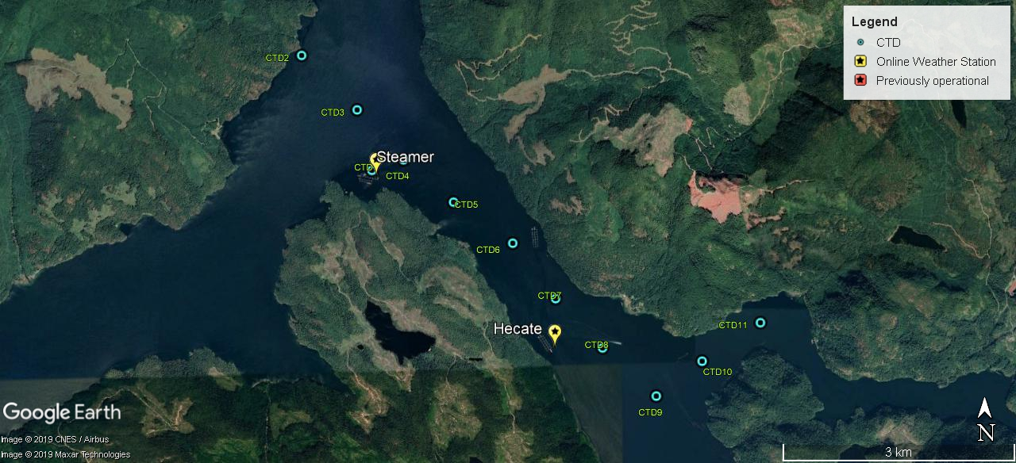

**Figure 3. Nootka Sound region CTD cast locations.**

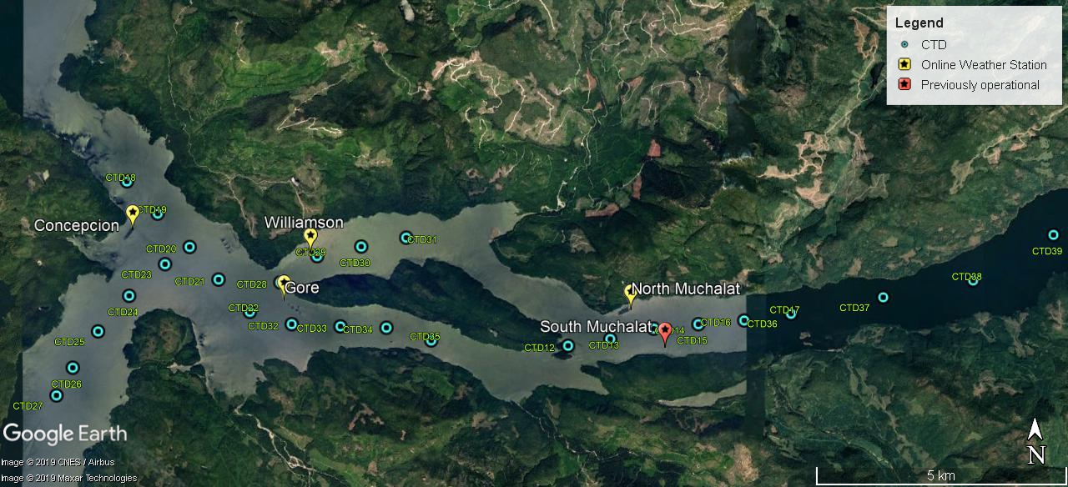

**Table 2. Latitude and Longitude of CTD casts.**

|  |  |  |  |  |  |  |
| --- | --- | --- | --- | --- | --- | --- |
| **Date (UTC)** | **Event Time (UTC)** | **Cast** | **Event Type** | **note** | **latitude** | **longitude** |
| 10-09-19 | 20:38:32 | CTD | BE | CTD1 | 49.8878 | -126.7904 |
| 10-09-19 | 20:50:43 | CTD | BE | CTD2 | 49.9016 | -126.8036 |
| 10-09-19 | 20:58:43 | CTD | BE | CTD3 | 49.8950 | -126.7932 |
| 10-09-19 | 21:09:58 | CTD | BE | CTD4 | 49.8891 | -126.7846 |
| 10-09-19 | 21:20:36 | CTD | BE | CTD5 | 49.8841 | -126.7754 |
| 10-09-19 | 21:28:53 | CTD | BE | CTD6 | 49.8792 | -126.7646 |
| 10-09-19 | 21:40:18 | CTD | BE | CTD7 | 49.8727 | -126.7568 |
| 10-09-19 | 21:52:08 | CTD | BE | CTD8 | 49.8670 | -126.7483 |
| 10-09-19 | 22:03:19 | CTD | BE | CTD9 | 49.8614 | -126.7387 |
| 10-09-19 | 22:12:31 | CTD | BE | CTD10 | 49.8654 | -126.7303 |
| 10-09-19 | 22:19:02 | CTD | BE | CTD11 | 49.8699 | -126.7197 |
| 11-09-19 | 23:12:23 | CTD | BE | CTD12 | 49.6393 | -126.3575 |
| 11-09-19 | 23:21:31 | CTD | BE | CTD13 | 49.6405 | -126.3458 |
| 11-09-19 | 23:36:12 | CTD | BE | CTD14 | 49.6423 | -126.3337 |
| 11-09-19 | 23:49:49 | CTD | BE | CTD15 | 49.6431 | -126.3213 |
| 12-09-19 | 0:04:47 | CTD | BE | CTD16 | 49.6437 | -126.3086 |
| 12-09-19 | 0:18:51 | CTD | BE | CTD17 | 49.6448 | -126.2956 |
| 12-09-19 | 15:43:32 | CTD | BE | CTD18 | 49.6692 | -126.4798 |
| 12-09-19 | 15:52:24 | CTD | BE | CTD19 | 49.6634 | -126.4712 |
| 12-09-19 | 16:01:51 | CTD | BE | CTD20 | 49.6573 | -126.4623 |
| 12-09-19 | 16:11:59 | CTD | BE | CTD21 | 49.6515 | -126.4543 |
| 12-09-19 | 16:22:36 | CTD | BE | CTD22 | 49.6456 | -126.4457 |
| 12-09-19 | 16:39:28 | CTD | BE | CTD23 | 49.6543 | -126.4692 |
| 12-09-19 | 16:52:36 | CTD | BE | CTD24 | 49.6486 | -126.4791 |
| 12-09-19 | 17:04:11 | CTD | BE | CTD25 | 49.6422 | -126.4877 |
| 12-09-19 | 17:12:32 | CTD | BE | CTD26 | 49.6357 | -126.4947 |
| 12-09-19 | 17:20:47 | CTD | BE | CTD27 | 49.6308 | -126.4993 |
| 12-09-19 | 18:37:30 | CTD | BE | CTD28 | 49.6509 | -126.4372 |
| 12-09-19 | 18:44:36 | CTD | BE | CTD29 | 49.6556 | -126.4270 |
| 12-09-19 | 18:53:49 | CTD | BE | CTD30 | 49.6573 | -126.4147 |
| 12-09-19 | 19:01:30 | CTD | BE | CTD31 | 49.6589 | -126.4022 |
| 12-09-19 | 19:14:19 | CTD | BE | CTD32 | 49.6434 | -126.4340 |
| 12-09-19 | 19:21:40 | CTD | BE | CTD33 | 49.6430 | -126.4205 |
| 12-09-19 | 19:28:52 | CTD | BE | CTD34 | 49.6427 | -126.4078 |
| 12-09-19 | 19:34:56 | CTD | BE | CTD35 | 49.6404 | -126.3954 |
| 12-09-19 | 19:52:01 | CTD | BE | CTD36 | 49.6449 | -126.2957 |
| 12-09-19 | 20:10:47 | CTD | BE | CTD37 | 49.6477 | -126.2700 |
| 12-09-19 | 20:27:00 | CTD | BE | CTD38 | 49.6506 | -126.2450 |
| 12-09-19 | 20:44:40 | CTD | BE | CTD39 | 49.6587 | -126.2226 |

**Table 3. SCT deployment, recovery and re-deployment locations.**

|  |  |  |  |  |  |  |
| --- | --- | --- | --- | --- | --- | --- |
| **Date (UTC)** | **Time (UTC)** | **Event** | **Event Type** | **SCT ID#:** | **latitude** | **longitude** |
| 10-09-19 | 14:44:31 | SCT Drifter | Deploy SCT | 1017 | 49.6416 | -126.3418 |
| 10-09-19 | 14:44:48 | SCT Drifter | Deploy SCT | 1018 | 49.6417 | -126.3419 |
| 10-09-19 | 15:11:16 | SCT Drifter | Deploy SCT | 1019 | 49.6546 | -126.4640 |
| 10-09-19 | 15:11:41 | SCT Drifter | Deploy SCT | 1020 | 49.6546 | -126.4641 |
| 10-09-19 | 18:32:46 | SCT Drifter | Deploy SCT | 1082 | 49.8698 | -126.7540 |
| 10-09-19 | 18:33:09 | SCT Drifter | Deploy SCT | 1083 | 49.8698 | -126.7540 |
| 10-09-19 | 18:42:21 | SCT Drifter | Deploy SCT | 1084 | 49.8955 | -126.7928 |
| 10-09-19 | 18:42:38 | SCT Drifter | Deploy SCT | 1085 | 49.8956 | -126.7928 |
| 11-09-19 | 14:58:38 | SCT Drifter | Recover SCT | 1018 | 49.6534 | -126.3876 |
| 12-09-19 | 15:21:47 | SCT Drifter | Recover SCT | 1020 | 49.6692 | -126.4695 |
| 12-09-19 | 15:42:21 | SCT Drifter | Re-Deploy SCT | 1020 | 49.6688 | -126.4795 |