**Revision Table**

|  |  |
| --- | --- |
| **Date** | **Description** |
| 1 April 2025 | Corrected temperature units format. G.G. |
| 7 July 2023 | DO:Saturation converted to DO:Concentration. S.H. |

**RBR CTD DATA PROCESSING NOTES**

Cruise: 2019-109

Agency: OSD

Locations: Nootka Sound and Hecate Channel

Project: Meteorology Network

Party Chief: Glenn Cooper

Platform: CME Anderson

Date: September 10, 2019- September 12, 2019

Processed by: Samantha Huntington

Date of Processing: September 24, 2021 – September 28, 2021

Number of Raw files: 39 Number of Processed Files: 39

**Instrument Summary**

Equipment: RBR Concerto CTD (s/n 66024) with a Turner Cyclops Fluorometer (s/n 848) and a JFE Advantech Rinko III oxygen sensor (s/n 300).

Sampling frequency was at 6Hz.

**Summary of Quality and Concerns**

A cast list was provided, 2019-109CTDLogSheet.xlxs. The cap on the Oxygen Sensor was left on accidentally for casts 18-23. The Oxygen channel was removed from these files.

**Processing Summary**

1. **Conversion to IOS Headers**

File 066024_20190913_1433_CTD_Data.rsk contained 39 profiles and profile csv files were extracted using python function EXPORT_FILES().

A single file (2019-109_CTD_Data.csv) with all the data including event numbers and a single line of headers was prepared using python function MERGE_FILES().

A 6-line header was inserted using python function Add_6Lineheader_2().

File “2019-109_header-merge.csv” was created, based on the information provided by the chief scientist.

* Column “File_Name”: entries were derived from the event number.
* Column “LOC:LATITUDE”: latitude was provided and reformatted to “XX XX.XXXX N !(deg min)”.
* Column “LOC:LONGITUDE”: longitude was provided and reformatted to “XX XX.XXXX W !(deg min)”.
* Column “LOC: Event Number”: entries were event numbers.
* Column “LOC: STATION”: stations were derived from the event numbers.

The sampling site was mapped (Figure 1) using from “2019-109_header-merge.csv” using python function Plot_Track_Location() to check the location of all casts.

Prior to conversion to IOS header format, the presence of zero-order holds were checked using Python function Plot_Pressure_Diff(). Zero-order holds were found (Figure 2.) and these values were replaced with Nan using the python function Correct_Hold().

A new csv file was created “2019-109_CSV_DATA-6Linedr_corr_hold.csv” and the corrected values were checked in python function Plot_Pressure_Diff(). Zero-order holds were found to be removed (Figure 3.).

CONVERT Spreadsheet Files was run to produce files with IOS Header format. Header entries of “Administration”, “File” and “Instrument” were filled in this step.

The routine “Merge:CSV Files to headers” was run to add location headers to the IOS files.

Raw data were plotted and examined:

* Temperature looks OK with some bad data at the top of Cast 2.
* Oxygen has some bad data at the top of casts 2,24, 26, 32, 33, and 34, some bad data at the bottom of cast 15. Casts 18-23 have bad Oxygen data.
* Conductivity looks good with some bad data at the top of cast 2.
* There are some small spikes in Fluorescence at the bottom of casts 2, 9 and 38.
* Salinity looks OK.

Next CLEAN was run to add a start time and event numbers to headers.

Then REORDER was run to reorder the channels in all files.

1. **Data processing**

* Correction to Pressure: Several casts had negative pressures with corresponding Conductivity measurements over 30 mS/cm. Pressure was calibrated with file 2019-109_recal1.ccf to add 0.1 to the pressure and depth channels.
* Data despiking: There are no significant spikes in temperature, conductivity and salinity. So there is no need to apply data despiking.
* CLIP: Pressure is steady for a variable number of scans. Initial records were removed until the downcast began using file “2019-109_CLIP.csv”.
* Filter: a Gull-winged filter, size 5, was applied to temperature, conductivity, and pressure. Salinity will be calculated in the next step.
* SHIFT: Based on suggested values in document “Guidelines for processing RBR CTD profiles”, the alignment of temperature and conductivity was corrected by applying a shift of -2 scans in conductivity.
* SHIFT: Better alignment with Oxygen profiles was found by advancing it by 11 scans. The advice given in document “Guidelines for processing RBR CTD Profiles” was that an advance between 2 and 3 seconds is appropriate. T-O plots before and after alignment were compared.
* DELETE was run to remove records with a descent rate of lower than 0.3m/s over 6 points from 10m down to avoid losing surface data.
* Profile plots were examined after DELETE and confirm that plots show reasonable values for salinity and conductivity and fluorescence. DO saturation levels at the surface ranged from 90% to 120%. However there was no calibration sampling and no climatology to enable a judgement about the data reliability.

1. **Final checks and header editing**

* REMOVE was run to remove the following channels from all casts: Date, Time:UTC and Event.
* BIN AVERAGE was used to metre-average data.
* CALIBRATE was run to convert conductivity units to S/m using file 2019-109-recal2.ccf.
* Header Edit was used to fix channel names and format as listed below:
* Pressure: format F11.2 ==> F7.1
* Salinity:CTD ==> Salinity
* Oxygen==> Oxygen:Dissolved:Saturation:RBR
* mL/L==> %
* Fluorescence ==> Fluorescence:URU
* F11.4==>F8.2
* Conductivity: F10.5 ==> F10.6
* REMOVE was re-run on casts 18-23 to remove the Oxygen channel.
* Header Check was run and no problems were found.

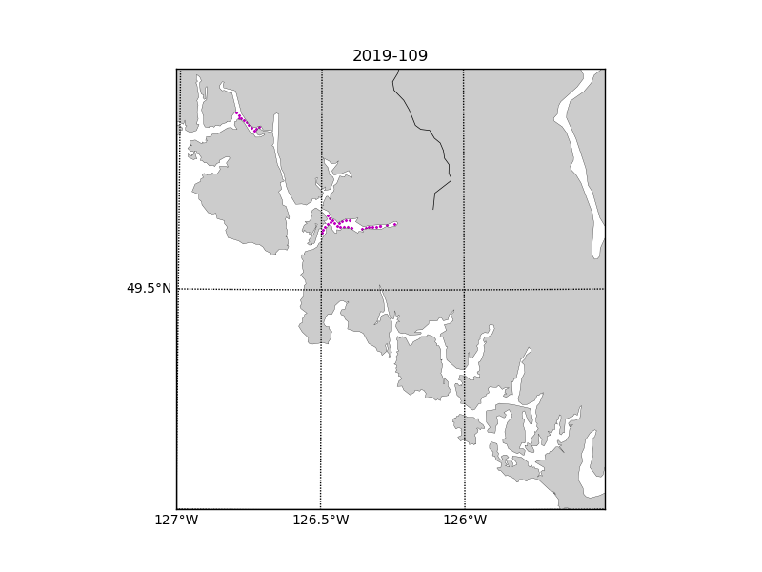

Figure 1 – location of casts.

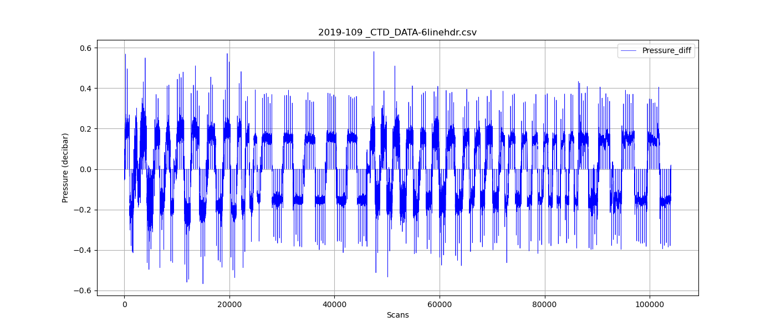

Figure 2 – zero-order holds

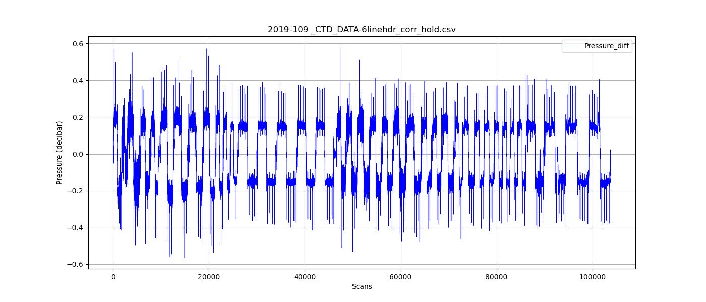

Figure 3 – zero order holds removed