PARR Weather Station Installation Field Report
CruiseID: 2019-107

Glenn Cooper
August 26, 2019

Overview:
In support of the Program for Aquaculture Regulatory Research (PARR), a weather stations network was established February 2019 at four locations in the Queen Charlotte Strait region: Bull Harbour, Duncan Island, Robertson Bay and Browning Islands. Initially a fifth site was identified (Mowi Heath Point fish farm) but upon arrival the site had been completely decommissioned and therefore impossible to install a weather station. Prior to this trip (CruiseID: 2019-107) the Program leader, Laura Bianucci, and myself proposed 3 new locations to expand the weather network to compensate for the loss of the Heath Point location (Figure1). If possible, weather stations were to be installed at exposed locations on or near Mowi fish farms so as to utilize their infrastructure so as to provide real time data.
The Browning Island site lacks power and internet infrastructure and therefore data is internally archived with the data logger having a 100 day storage capacity. Since the logger was about to reach it’s capacity, Kenny Scozzafava and Glenn Cooper revisited the region from August 19th to 22th to download the Browning Island data, perform routine maintenance on installed systems, and expand the weather station network. Water transportation in the region was provided by Mowi as a contribution in kind to the program.

Field Objectives:
- Install Davis Vantage Pro2 weather stations at 3 new proposed sites: Doyle, Shelter Passage and Shelter Bay. Integrate our system with Mowi’s internet infrastructure so weather data is in real time.
- Download Browning Island archived data and migrate to online system if the infrastructure exists.
- Perform routine maintenance on all other sites.
- Perform a CTD cast with a RBR Concerto at farm sites that have installed weather stations.

Objective Results:
- All 3 new sites were visited and time was spent determining the best installation location to maximize weather exposure, yet still provide access to the internet and power (Figure2). Davis Vantage Pro2 weather station (Davis6162) were installed and their anemometers were oriented to True North. In some cases repeaters were necessary to propagate the signal from the integrated sensor suite (ISS) to the console (Table 1).
  - Doyle Farm: The Doyle farm is fairly sheltered but there was an exposed point in close proximity to the farm house barge. This location provides good exposure to winds from northwest down Gordon Channel, and to the southeast from Queen Charlotte Strait (Images 1&2). A repeater was required to propagate the signal from the weather station to the console. Before departure, it was confirmed that weather station was transmitting live data to the Davis server.
  - Shelter Passage Farm: The initial proposed location was deemed not suitable as the station would have been completely shield from winds ranging from the W to NE. However, farm pens extended much further into Shelter Passage than originally thought by looking at satellite images. A weather station was installed on Pen#11 of the farm which provides good exposure. Signal strength between the station and console was strong enough so a repeater was not required. The data logger could be connected to Mowi’s router and before departing it was confirmed that weather station was outputting live data to the Davis server.
  - Shelter Bay Farm: The weather station was attached to the outermost exposed pen (Images 3&4). Although the site has both power and internet, discussions with David Gibbs, (site manager) advised me of significant changes to occur in 4 weeks. These changes meant that we could not reliably connect to the internet. So as to ensure that data would be collected reliably and uninterrupted, it was decided to internally log the data until farm had implemented the new changes. This site will have to be re-visited by the last week of November 2019 to download archived data or to prevent any loss.
- Browning Islands: Archived data was downloaded with no issues and the system was in good condition. Prior to this trip’s departure, I had been in regular contact with the Marsh Bay fish farm and was told they were in the process of getting power and internet to the site. However upon arrival, this infrastructure was still not in place. Data continues to be internally logged at an 1 hour archive intervals and battery powered. As per the Shelter Bay site, this site will have to be re-visited by the last week of November 2019 to download archived data or to prevent any loss.

- Remainder of sites were visited. Anemometer orientation was checked and all found to be at True north. All repeater batteries were replaced. Weather station and console batteries were replaced if required (Figure 2).
  - Bull Harbour: Everything in excellent condition, no action required.
  - Duncan Farm: This site had been offline for considerable amount of time and through discussions with the site manager, it was explained that the feed barge had been replaced and that the console had been transferred to the new barge. He also mentioned was that they were having internet connectivity issues and that is why the station was not online. What he failed to mention that they had not even powered on the console which resulted in a loss of data from 11/07/2019 to 21/08/2019. Signal strength between the ISS and console’s new installation location was very low and therefore required the installation of a repeater to boost signal strength. Upon departure of the area the Duncan farm weather station was online and uploading data to the Davis server.
  - Robertson Bay Farm: Everything in excellent condition, no action required. Site is being removed in January 2020. Will be advised in advance so we can retrieve components.

- A RBR Concerto CTD (s/n#: 066024) with a Turner Cyclops fluorometer (s/n#: 300), and a JFE Andvantech oxygen sensor (s/n#: 848) was used for vertical water column profiling. CTD casts were performed off of fish farm pens at: Shelter Bay, Robertson, Bull Harbour, and Duncan (Table2). Cast were to a depth of 85 meters or 1 meter off the bottom, whichever was less.

Problems and Issues:
Only a few minor issues were encountered during the trip. The most significant was finding the Duncan Bay console laying in a box and not connected to a power source or internet, so it was unable to log data from the weather station. Unfortunately this was never convey to me by the site manager during our correspondence. The result is the loss of over a month of data. However, we were able to get the unit now operational and back online.
Ideally the new 3 sites were to be real time but unfortunately Shelter Bay will be undergoing significant changes. Luckily while working on the site I was told of these changes so we could adapt and ensure no loss of data.
Lastly, I was given the impression that the feed barge, in which the Browning Island weather station console is located, would have power and internet by the time of my arrival. Unfortunately it is still lacking this infrastructure and I have not given any further information on what is planned for this site.

Conclusions:
Overall the trip was successful and the weather network has expanded with 3 new units. The region will need to be revisited in late November to download archived data. Hopefully at that point changes will have been made to Browning and Shelter Bay so they can be transitioned to online systems. A decision will have to be made if we should remove Robertson on this trip or wait until January when the farm is to be decommissioned.
Finally I would like to give a huge thanks to Kenny Scozzafava for his excellent work and attention to detail. He also played a significant role in assisting me getting all the equipment constructed and tested before heading out into the field. Also would like to thank our boat captain Ed Fellbaum. He safely got us around the area and on and off rock cliffs. His knowledge of the farms and area was very helpful in the final decision for the weather station placements.
Figure 1. Proposed new Davis weather stations sites.
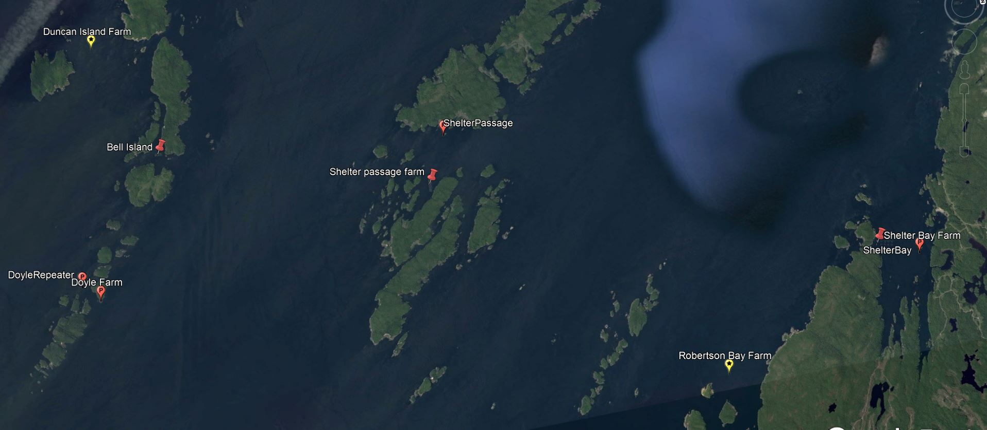

Figure 2. PARR weather station network.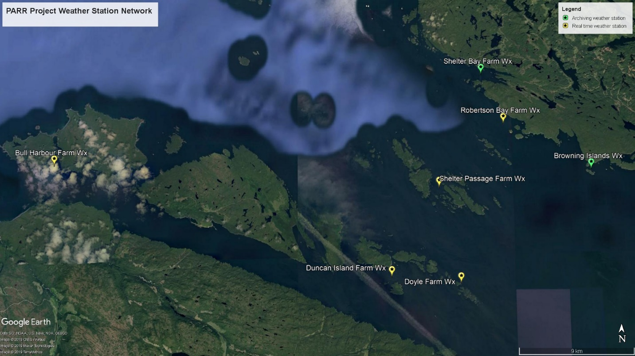

 | Table 1. Summary of PARR weather station network
Station Name |  | ISS Channel | Repeater (y/n) | Repeater Channel | Latitude | Longitude | Data Logger | Archive Interval
Bull Harbour |  | 8 | Yes | D | 50° 53.989 | 127° 56.282 | WeatherLinkIP | 15 minute
Duncan Island |  | 3 | Yes | C | 50° 49.320 | 127° 33.419 | WeatherLinkIP | 15 minute
Browning Island |  | 3 | Yes | G | 50° 53.912 | 127° 19.838 | USB | Hourly
Robertson Bay |  | 8 | Yes | D | 50° 55.894 | 127° 25.738 | WeatherLinkIP | 15 minute
Shelter Bay |  | 8 | No |  | 50° 58.044 | 127° 27.206 | USB | Hourly
Shelter Passage |  | 3 | Yes | C | 50° 53.118 | 127° 30.172 | WeatherLinkIP | 15 minute
Doyle |  | 3 | Yes | G | 50° 49.058 | 127° 28.782 | WeatherLinkIP | 15 minute

Table 2. 2019-107 CTD casts
Event# | Station Name | Latitude (N) | Longitude (W) | Cast Date (UTC) | Cast Start Time (UTC)
1 | Shelter Bay | 50° 58.044 | 127° 27.206 | 20-08-19 | 1703
2 | Robertson Bay Farm | 50° 55.887 | 127° 25.758 | 20-08-19 | 1731
3 | Bull Harbour | 50° 53.988 | 127° 56.285 | 20-08-19 | 2230
4 | Duncan | 50° 49.326 | 127° 33.427 | 21-08-19 | 1517

Image 1. Doyle weather station looking north west up Gordon Channel. 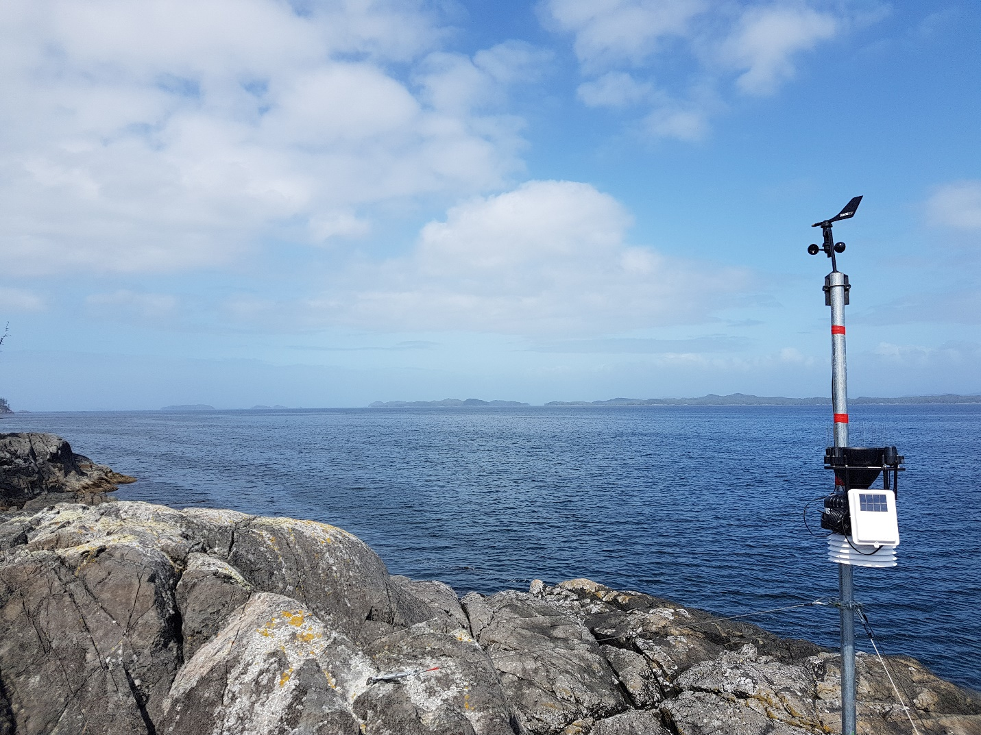

Image 2: Doyle weather station looking south east down Queen Charlotte Strait.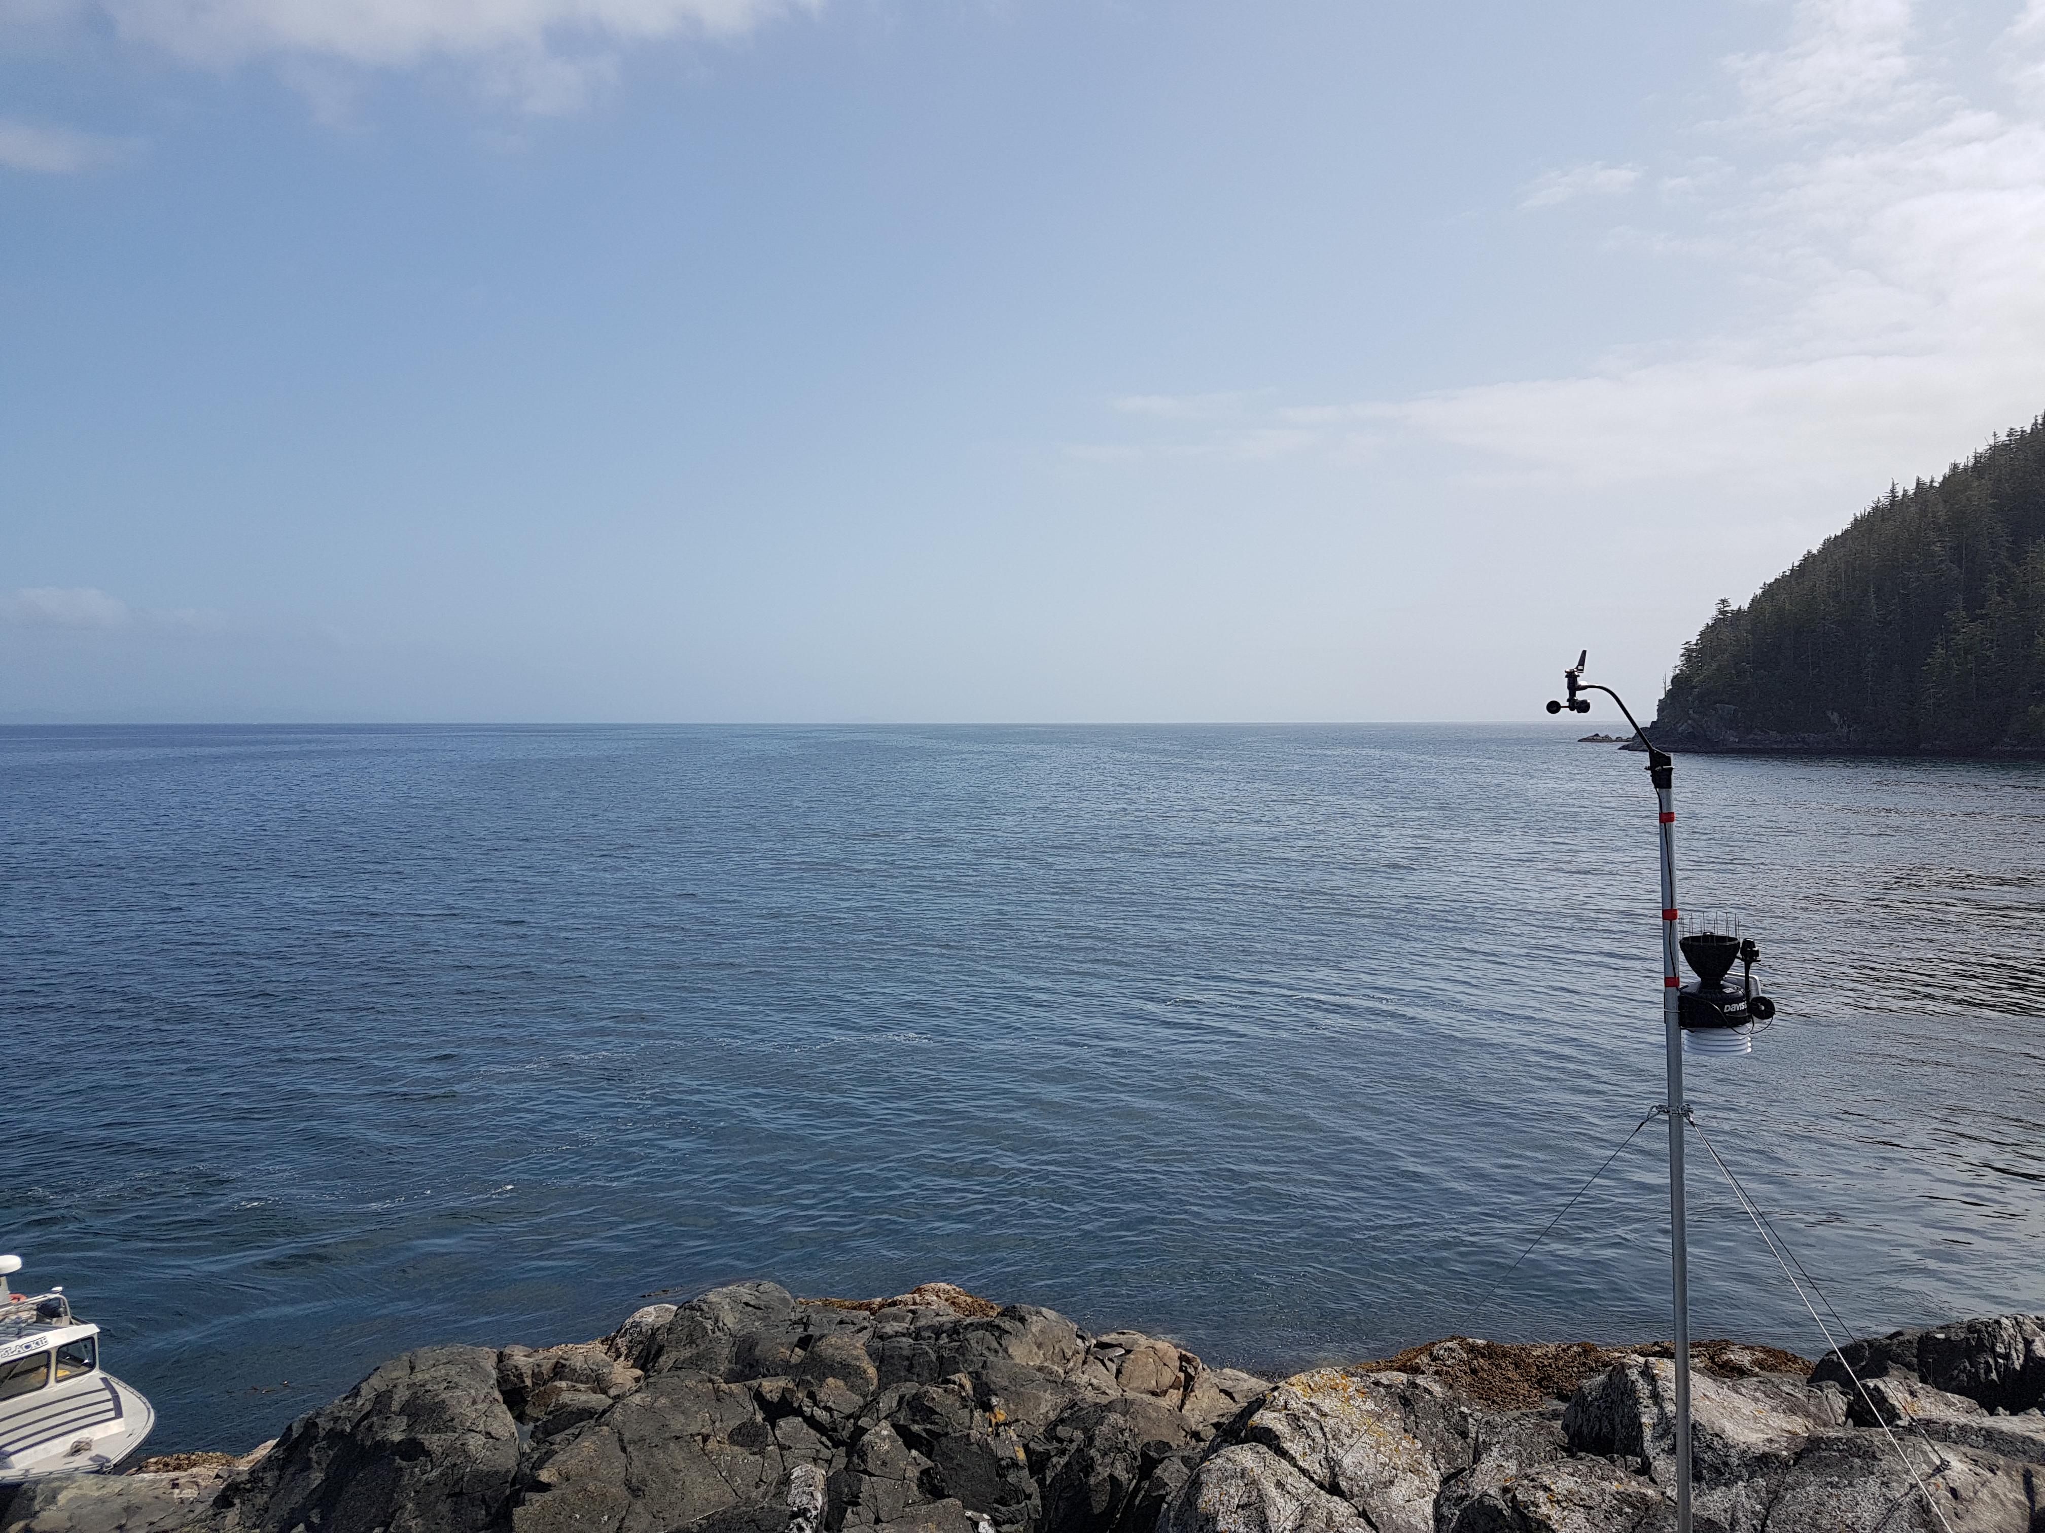
Image 3: Shelter Bay weather station looking south west. 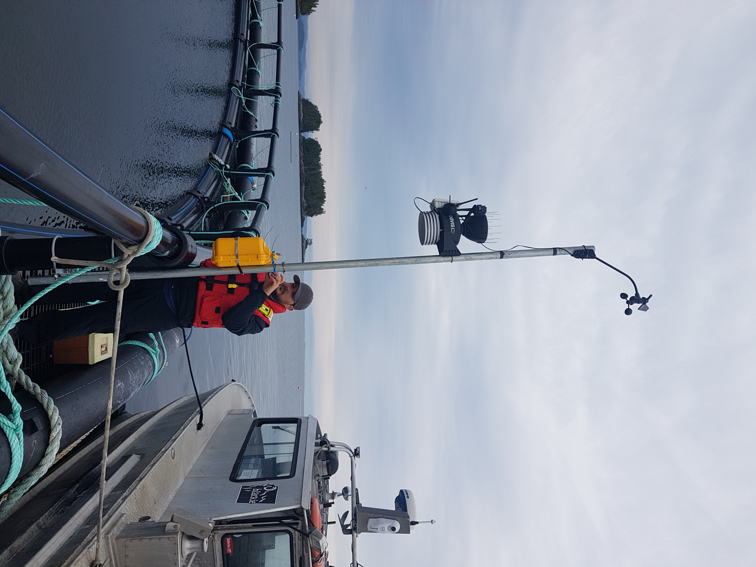

Image 4: Shelter Bay weather station looking north east.
