**REVISION NOTICE TABLE**

|  |  |
| --- | --- |
| **DATE** | **DESCRIPTION OF REVISION** |
| 7 July 2023 | DO Saturation converted to DO Concentration. S.H. |

**RBR CTD DATA PROCESSING NOTES**

Cruise: 2019-107

Agency: OSD

Locations: Shelter Bay, Robertson Bay Farm, Bull Harbour, Duncan

Project: Program for Aquaculture Regulatory Research (PARR)

Party Chief: Cooper G.

Platform: Fish farm

Date: August 20, 2019 – August 21, 2019

Processed by: Lu Guan

Date of Processing: 15 July 2020 – 12 August 2019

Number of Raw files: 4 Number of Processed Files: 4

# INSTRUMENT SUMMARY

Equipment: RBR Concerto CTD (s/n 066024) with a Fluorometer (Chlorophyll a Turner Cyclops s/n 848) and oxygen sensor (JFE Advantech Rinko III BT s/n 300)

Sampling was at 6Hz.

# SUMMARY OF QUALITY AND CONCERNS

A CTD Log Sheet was provided with times and positions of all casts.

The data looked good overall.

# PROCESSING SUMMARY

##### Conversion to IOS Headers

One csv file, containing downcast and upcast data of all casts, was exported from 066024_20190823_0915_CTD_data.rsk by applying python function Export_Files().

A single file (2019_107_CTD_Data.csv) with all the data including event numbers and a single line of headers was prepared.

A 6-line header was inserted using python function Add_6lineheader().

Sampling sites were mapped (fig. 1) using python function Plot_Track_Location() to check the location of all casts.

CONVERT Spreadsheet Files was run to produce files with IOS Header format. Header entries of “Administration” and “File” were filled in this step.

Raw data were plotted and examined:

* Salinity looks ok, but with some bad data at bottom for casts: 1, 2, 4.
* Temperature looks ok.
* Conductivity looks ok, but with some bad data at bottom for casts: 1, 2, 4.
* Oxygen looks ok.
* Fluorescence looks ok.

File “2019-107_header-merge.csv” was created, based on the information in file “2019-107CTD_DataLogSheet.xlsx”, in order to run routine “Merge csv files to Headers” (Utilities > Merge: CSV file to Headers).

* Column “File_Name”: entries were derived from the event number.
* Column “LOC: LATITUDE”: latitude data was reformatted to “XX XX.XXXX N ! (deg min)”.
* Column “LOC:LONGITUDE”: longitude data was reformatted to “XXX XX.XXXX W ! (deg min)”.
* Column “LOC: Event Number”: entries were event numbers.
* Column “LOC: STATION”: entries were set equal to the event numbers.

The routine “Merge: CSV Files to headers” was run to add location headers to the IOS files.

Next CLEAN was run to add a start time and event numbers to the headers.

##### Data processing

* Corrections for zero-order holds: Python function Plot_Pressure_Diff() was run to check the zero-order holds in pressure. There is no evidence that pressure has regular repeats.
* Correction to Pressure: The RBR CTD records total pressure and a corrected pressure with atmospheric pressure removed. Estimate of air pressure provided by RBR CTD pressure sensor is reasonable. In a previous use of this sensor the corrected pressure was found to be low by ~0.1db (see 2019-100_Processing_Report.doc). Looking at the original data, it appears that the conductivity is over 35 when the pressure is roughly -0.1db for every individual cast. So file 2019-107-recal1.ccf was prepared to add 0.1 to the pressure and depth channels. While this is not a significant error, it removes most negative pressures.
* Data despiking: The are no significant spikes in temperature, conductivity and salinity. So there is no need to apply data despiking.
* CLIP: Pressure is steady for variable number of scans among casts (20-173). Initial records were removed until the downcast began and that corrupted data were removed from the bottom of casts.
* Filter: A Gull-winged filter, size 9, was applied to temperature, conductivity, pressure and fluorescence. Salinity will be recalculated in the next step.
* SHIFT: Based on suggested values in document “Guidelines for processing RBR CTD profiles” the following adjustments were made to conductivity and dissolved oxygen channels:
  + The alignment of temperature and conductivity was corrected by applying a shift of -2 scans in conductivity. Salinity was recalculated and the results were shown in figure 9.
  + Better alignment with oxygen profiles was found by advancing it by 11 scans (1.9s). The advice given in document “Guidelines for processing RBR CTD profiles” was that an advance between 2 and 3 seconds is appropriate. T-O2 plots before and after alignment were compared.
* DELETE was run to remove records with descent rate lower than 0.5m/s over 3 points. This was not applied in the top 5m to avoid loss of surface records as the CTD began its descent.
* Profile plots were examined after DELETE and confirm that plots show reasonable values for fluorescence, temperature and salinity. DO saturation values at the surface ranged from 80% to 93%. However, there was no calibration sampling and no climatology to enable a judgement about the data reliability.

##### Final checks and header editing

* REMOVE was run to remove the following channels from all casts: Date and Time:UTC.
* BIN AVERAGE was used to metre-average data.
* CALIBRATE was run to convert conductivity units to S/m using file 2019-107-recal2.ccf.
* Header Edit was used to update header information of “Instrument” and “Comments”, and to fix channel names and format as listed below:
* Pressure: format F11.2 ==> F7.1
* Salinity:CTD ==> Salinity
* Fluorescence ==>Fluorescence:URU
* Oxygen ==> Oxygen:Dissolved: Saturation:RBR

mL/L ==> %

F11.4 ==> F8.2

* Conductivity: F10.5 ==> F10.6
* RORDER Channels was run to rearrange the order of channels.
* Header Check was run and no problems were found.
* DO concentration was not derived since there are various equations used for this purpose, so it is left to the users to choose one consistent with other data in their studies.

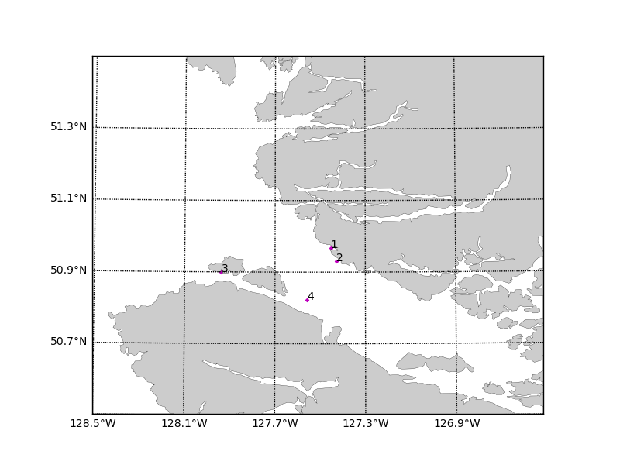

Figure 1. Map of sampling sites (1: Shelter Bay; 2: Robertson Bay Farm; 3: Bull Harbour; 4: Duncan).