Clayoquot Sound Weather Station Servicing Post Field Report

Glenn Cooper
April 24, 2019

Overview:
In collaboration with Cermaq, a meteorological network was established in the Clayoquot Sound in December of 2017. Davis Vantage Pro2 weather stations with sea surface temperature probes were installed on six of Cermaq’s fish farm: Bare Bluff, Rant Point, Plover Point, Bedwell Sound, Bawden Point and Fortune Channel (Figure 1). Cermaq site are undergoing significant changes with sites either being shut down, in the process of being moved, or have moved to a new location. The Fortune system had been towed and installed at Saranac Island and were told that the Fortune weather station and logging console were still on the now Saranac site. Rant Point site had been shut down and hasn’t had power or internet access for sometime as it was about to be moved to Binns Island (Figure 2)
During the period of March 25 to 29th, Kenny Scozzafava and myself visited the Clayoquot area to deal with the changes at the Cermaq sites. While there we also took the opportunity to service all weather station sites, deploy Surface Current Trackers (SCTs) and collect physical oceanographic data from areas on interest in the Sound. In order to complete all of this work efficiently and economically we towed then launched the OSD small boat, CME Anderson, which we operated in the region.
Figure 1: Initial Installation of Weather Station in Clayoquot Sound
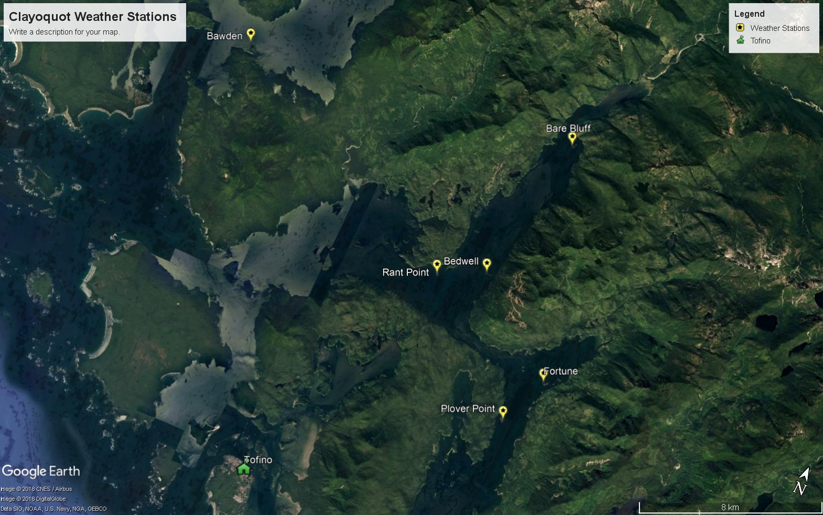

Figure 2: Present Weather Station Sites in Clayoquot Sound (April 2019)

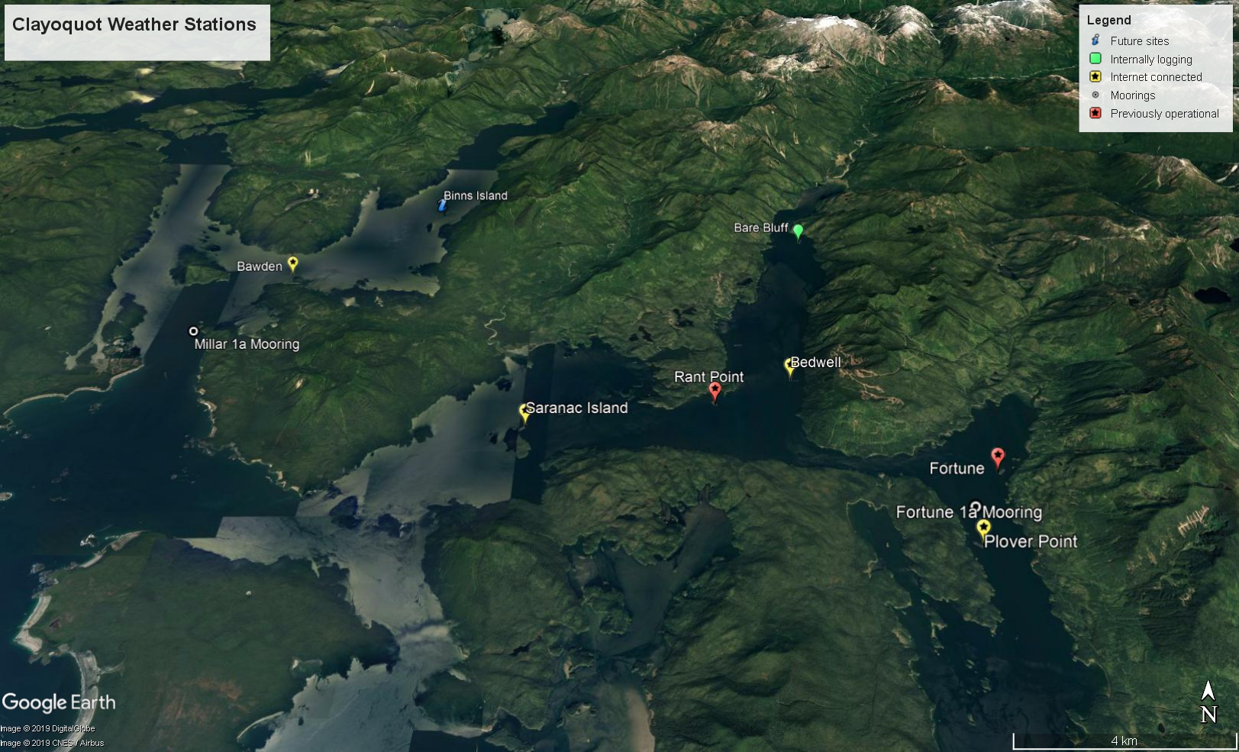

Field Objectives:
- Visit Saranac Island site to download Fortune’s internally logged data. Move weather station, if necessary, to a more exposed location and correctly orientated the anemometer to True north. Replace 1 meter sea surface temperature probe transmitter with solar powered transmitter. Transition from internally logging data to the WeatherLinkIP real time system.
- Download internally logged Rant Point data. Remove weather station and consoles as site has been shut down and to be moved to Binns Island.
- Visit the remaining farms to perform any preventative maintenance and check anemometer orientation.
- Deploy 10 SCTs in the region. If possible deploy pairs of SCTs at start of an ebb tide in the following locations: Bare Bluff, Plover Point, Millar Channel, South of Gibson Cove in Herbert Inlet and West of Megin River in Shelter Inlet.
- Perform CTD casts across the river mouths of Bedwell, Moyeha and Megin Rivers. Run a line of CTD casts across Bedwell Sound south of the Bare Bluff fish farm.

Objective Results:
- Upon arrival to Saranac Farm, the formally Fortune channel weather station could not be found. Removed the Rant site weather station and installed it on the Saranac site. Installed a 1 meter below surface temperature probe. WeatherLinkIP logger was successfully installed and was communicating with the Davis server upon site departure. Site operational on March 26. 2019 @ 1000 PST.
- Rant site is being moved to Binns Island in the coming months so the weather station and sea surface temperature probe were removed. There was no power at the site so the internet connected console was found to be dead. The internally logging USB backup logger was still operational and collecting data. Data was downloaded and but unfortunately the archive interval was at 1 minute instead of 1 hour.
- Servicing performed on the remaining weather stations is summarized in Table 1. All anemometer orientations were found to be at True north.
- Ten surface current trackers (SCTs) were deployed. While working in the region, their location was tracked and if a SCT stopped working, washed ashore or trapped in a fish farm, the SCT was recovered and redeployed to increase its operational time and data collection (Table 2).
- A total of 51 CTD casts were performed using a RBR Concerto CTD (s/n 066024) with a Fluorometer (Chlorophyll a Turner Cyclops) and oxygen sensor (JFE Advantech Rinko III BT). A list of locations and depths are listed in Table 3. A visual representation for CTD start cast locations for Herbert Inlet, Shelter Inlet and Bedwell Sound are shown in Figures 3 to 5 respectively.
Table 1. Clayoquot Sound Weather Station Servicing Summary for March 2019 Trip
Station Name | Servicing Summary
Bare Bluff | Downloaded hourly archived data. Removed internet logger as site is unstable and about to move location.
Rant Point | Site closed down. Weather station removed. Archived data downloaded.
Saranac Island | Installed and online March 26, 2019 @ 1000 PST. Formerly Rant point weather station and WeatherLinkIP.
Bedwell Sound | Replaced ISS battery. Updated SST transmitter with solar panel and replaced battery.
Plover Point | Everything in good condition, no servicing required.
Bawden Point | Replaced ISS and console batteries. Updated SST transmitter with solar panel.

Table 2. Locations of Deployment, Recovery and Redeployment of SCTs
SCT ID# | Event Date (UTC) | Time (UTC) | Latitude | Longitude | Notes
973 | 2019-03-26 | 23:12:42 | 49.33294 | -125.806 | Bare bluff deployment
974 | 2019-03-26 | 23:13:00 | 49.33296 | -125.806 | Bare bluff deployment
975 | 2019-03-26 | 23:42:31 | 49.21226 | -125.76 | Fortune channel deployment
976 | 2019-03-26 | 23:43:01 | 49.21232 | -125.76 | Fortune channel deployment
977 | 2019-03-27 | 14:30:25 | 49.36352 | -126.073 | Miller channel deployment
978 | 2019-03-27 | 14:31:05 | 49.36341 | -126.072 | Miller channel deployment
979 | 2019-03-27 | 14:49:52 | 49.42599 | -126.089 | Shelter Inlet deployment
980 | 2019-03-27 | 14:50:23 | 49.42593 | -126.089 | Shelter Inlet deployment
981 | 2019-03-27 | 15:33:28 | 49.369 | -125.945 | Herbert Inlet deployment
982 | 2019-03-27 | 15:33:53 | 49.36888 | -125.945 | Herbert Inlet deployment
976 | 2019-03-28 | 15:16:37 | 49.24299 | -125.772 | Recovery - trapped in bay north of Maltby Islets
975 | 2019-03-28 | 15:17:19 | 49.24284 | -125.773 | Recovery - trapped in bay north of Maltby Islets
975 | 2019-03-28 | 15:23:19 | 49.23774 | -125.798 | Redeployment mid point of Matlset Narrows
976 | 2019-03-28 | 15:23:59 | 49.23772 | -125.799 | Redeployment mid point of Matlset Narrows
973 | 2019-03-28 | 15:36:01 | 49.2367 | -125.813 | Recovered from rocks
973 | 2019-03-28 | 16:01:57 | 49.25251 | -125.828 | Redeployment confluence of Bedwell Sound & Matlset narrows
982 | 2019-03-28 | 20:29:37 | 49.32056 | -126.044 | Recovered rocks
981 | 2019-03-28 | 20:43:35 | 49.32469 | -126.047 | Recovery from Ross Bay fish farm
981 | 2019-03-28 | 20:56:22 | 49.34907 | -126.069 | Redeployed Miller channel
982 | 2019-03-28 | 20:56:38 | 49.34912 | -126.069 | Redeployed Miller channel
978 | 2019-03-28 | 21:03:43 | 49.36176 | -126.081 | Recovered from rocks
978 | 2019-03-28 | 23:08:04 | 49.42535 | -126.085 | Redeployment in Shelter Inlet

Table 3. CTD cast locations and depths.
Event# | Event Date | Event Time | Cast Depth | Latitude | Longitude
1 | 2019-03-27 | 15:56:21 | 11 | 49.40930 | -125.91264
2 | 2019-03-27 | 16:01:42 | 88 | 49.40854 | -125.91130
3 | 2019-03-27 | 16:08:54 | 106 | 49.40781 | -125.90926
4 | 2019-03-27 | 16:16:22 | 125 | 49.40710 | -125.90742
5 | 2019-03-27 | 16:27:17 | 84 | 49.40639 | -125.90587
6 | 2019-03-27 | 16:35:29 | 64 | 49.40574 | -125.90409
7 | 2019-03-27 | 16:43:04 | 36 | 49.40496 | -125.90302
8 | 2019-03-27 | 16:54:56 | 16 | 49.41600 | -125.90821
9 | 2019-03-27 | 16:59:50 | 94 | 49.41277 | -125.90853
10 | 2019-03-27 | 17:06:29 | 104 | 49.40949 | -125.90886
11 | 2019-03-27 | 17:13:47 | 127 | 49.40625 | -125.90905
12 | 2019-03-27 | 17:31:28 | 139 | 49.40306 | -125.90914
13 | 2019-03-27 | 18:12:05 | 144 | 49.38469 | -125.93873
14 | 2019-03-28 | 14:37:50 | 97 | 49.21314 | -125.76650
15 | 2019-03-28 | 14:46:50 | 90 | 49.21553 | -125.76662
16 | 2019-03-28 | 16:31:49 | 22 | 49.35916 | -125.78418
17 | 2019-03-28 | 16:35:53 | 70 | 49.35857 | -125.78316
18 | 2019-03-28 | 16:42:28 | 72 | 49.35787 | -125.78221
19 | 2019-03-28 | 16:48:29 | 70 | 49.35724 | -125.78081
20 | 2019-03-28 | 16:53:58 | 71 | 49.35682 | -125.77976
21 | 2019-03-28 | 17:00:37 | 64 | 49.35598 | -125.77850
22 | 2019-03-28 | 17:06:52 | 30 | 49.35538 | -125.77737
23 | 2019-03-28 | 17:14:53 | 10 | 49.35978 | -125.77863
24 | 2019-03-28 | 17:17:57 | 44 | 49.35919 | -125.77952
25 | 2019-03-28 | 17:23:00 | 60 | 49.35844 | -125.78046
26 | 2019-03-28 | 17:28:06 | 65 | 49.35775 | -125.78120
27 | 2019-03-28 | 17:33:05 | 67 | 49.35703 | -125.78221
28 | 2019-03-28 | 17:38:24 | 69 | 49.35644 | -125.78315
29 | 2019-03-28 | 17:44:45 | 69 | 49.35508 | -125.78477
30 | 2019-03-28 | 17:50:31 | 70 | 49.35399 | -125.78647
31 | 2019-03-28 | 17:56:38 | 43 | 49.35288 | -125.78840
32 | 2019-03-28 | 18:01:10 | 76 | 49.35146 | -125.78982
33 | 2019-03-28 | 18:59:27 | 25 | 49.32725 | -125.81013
34 | 2019-03-28 | 19:03:18 | 54 | 49.32658 | -125.80672
35 | 2019-03-28 | 19:09:14 | 58 | 49.32593 | -125.80337
36 | 2019-03-28 | 19:14:57 | 58 | 49.32518 | -125.79999
37 | 2019-03-28 | 19:20:36 | 50 | 49.32436 | -125.79669
38 | 2019-03-28 | 19:27:26 | 12 | 49.32363 | -125.79323
39 | 2019-03-28 | 21:22:20 | 33 | 49.42942 | -126.06747
40 | 2019-03-28 | 21:29:26 | 78 | 49.42932 | -126.07292
41 | 2019-03-28 | 21:37:32 | 70 | 49.42953 | -126.07801
42 | 2019-03-28 | 21:49:41 | 91 | 49.42962 | -126.08349
43 | 2019-03-28 | 21:57:33 | 110 | 49.42967 | -126.08860
44 | 2019-03-28 | 22:05:52 | 69 | 49.42945 | -126.09391
45 | 2019-03-28 | 22:13:46 | 96 | 49.42974 | -126.09905
45 | 2019-03-28 | 22:29:13 | 14 | 49.43577 | -126.08439
46 | 2019-03-28 | 22:32:45 | 65 | 49.43312 | -126.08476
47 | 2019-03-28 | 22:38:48 | 95 | 49.43052 | -126.08427
48 | 2019-03-28 | 22:49:45 | 153 | 49.42824 | -126.08531
49 | 2019-03-28 | 22:59:12 | 157 | 49.42549 | -126.08510
50 | 2019-03-28 | 23:12:56 | 121 | 49.42296 | -126.08527
51 | 2019-03-28 | 23:21:41 | 14 | 49.42026 | -126.08513

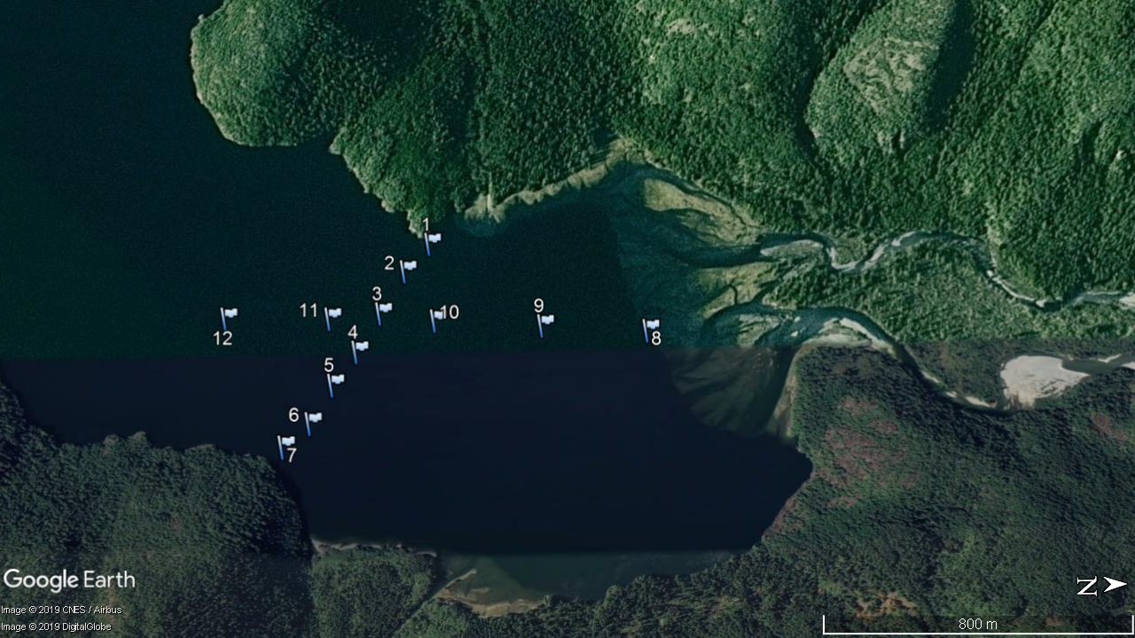
Figure 3. CTD casts at the mouth of Moyeha River in Herbert Inlet.

Figure 4. CTD casts at the mouth of Megin River in Shelter Inlet. 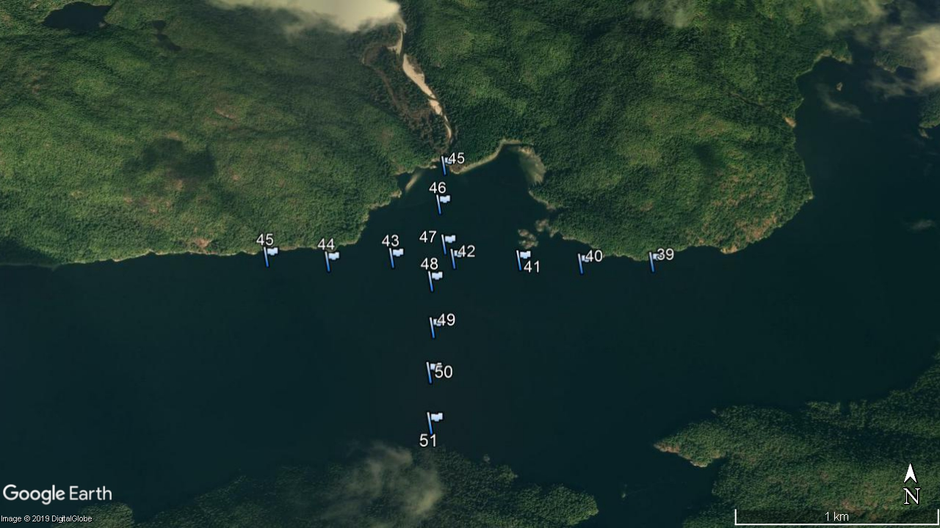
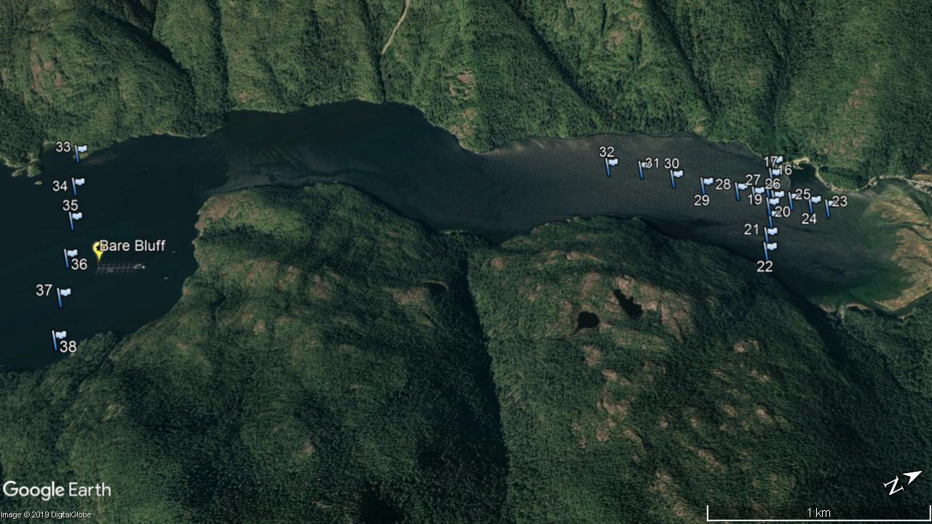
Figure 5. CTD casts an the mouth of Bedwell river and Bare Bluff in Bedwell Sound.

Problems and Concerns:
The only problem encountered on the trip was the Fortune farm weather station and console, that was internally logging data, could not be found. We were told that is was on the Saranac site but upon our arrival it was not anywhere on the system. We searched several other possible locations but still could not find the equipment. This is an unfortunate loss of data. I have talked with area Manager and has no explanation for its disappearance.
The OSD vessel, CME Anderson, performed flawlessly and provided us with the flexibility and autonomy to complete the necessary objectives. It is an excellent platform for this particular type of work. By having our own boat we were able to retrieve SCTs that had run aground, redeploy them, increasing there operational time and data collection.
I was advised that both the Bare Bluff and Bedwell farms will be moving to the opposite side of Bedwell Sound. This it to occur sometime during the months of July and August of this year. It would be advisable to return to the area and remove the weather station from these sites, download stored data, to avoid them potentially being damaged or lost as with the Fortune farm unit.
The Rant farm will be towed to its new site just north of Binns Island. While working in Herbert Inlet we had the opportunity to look at the site location which is very exposed to both the North/South direction. It might be a worth considering installing a weather station once all of the infrastructure has been put into place.

Conclusions:
Overall trip was a complete success with all of the objectives being met. Lastly, I am extremely thankful for all the hard work and assistance by Kenny Scozzafava during the trip and assisting with the preparation before the trip.

