2019-78 SWL

Underway measurements
Sarah Zimmermann (DFO-IOS)
P.I.s: John Nelson (DFO-IOS)
v. 2020-04-20

Underway measurements summary

This section describes measurements taken at frequent regular intervals throughout the cruise. These measurements include:

- The seawater loop system:
  - Continuous sensor measurements from the thermosalinograph (TSG) of salinity, temperature (inlet and lab), and fluorescence for Chlorophyll-a,
  - Continuous measurements for pCO₂.
  - Unlike in prior years, there was no “blue cooler” making continuous measurements with a gas tension device and oxygen sensor.
  - Water samples were drawn for salinity, chlorophyll-a, Cesium-137, and just a couple samples for dissolved inorganic carbon and alkalinity.

- The Scientific Computer System (SCS) was used to log
  - From the GPS: NMEA strings (GPGGA, GPZDA, GPVTG and HEHDT and for a portion of the trip GPRMC) that include position, time, speed and heading
  - AVOS weather observations of: air temperature, humidity, wind speed and direction, and barometric pressure
  - 50 and 200kH sounder reported depth
  - 12 kH sounder reported depth
  - Speed and course over ground.
  - Calculated true wind direction and speed
  - TSG data from the sea-water loop system.

Seawater Loop

The ship’s seawater loop system draws seawater from below the ship’s hull at 5 m using a 3” Moyno Progressive Cavity pump Model #2L6SSQ3SAA, driven by a geared motor. The pump rated flow rate is 10 GPM. It supplies seawater to the forward lab, where a manifold distributes the seawater to instruments. This system allows measurements to be made of the sea surface water while underway. The water is as unaltered as possible coming into a sea-chest without marine-paint where inlets lead to the sea-water loop, and two to the potable drinking water makers (reverse osmosis and evaporator).
The forward lab’s manifold has sensors off three of the arms. On one of the manifold arms is a vortex debubbler, installed inline to remove bubbles in the supply to the SBE-21 thermosalinograph (TSG). Another arm delivers water to the pCO2 system. A third arm supplies water to a Seapoint chl-a fluorometer. Control of the pump from the lab is via a panel with on/off switch and a Honeywell controller. The Honeywell allows setting a target pressure, feedback parameters and limits on pump output. However, for simplicity the pump is being run at a fixed frequency.

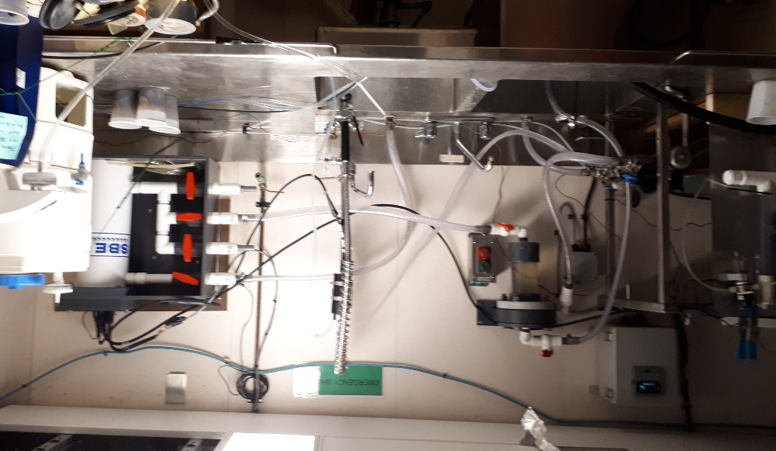
Figure 1. Seawater loop system. Manifold and debubbler on the left, SBE TSG unit on the right. The seawater loop provides uncontaminated seawater from 5m depth to the science lab for underway measurements.

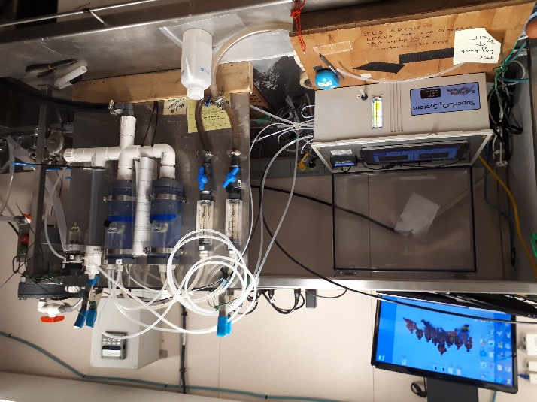

Figure 2. pCO2 system, just to the left of the seawater manifold.

Pump speed / water flow
The pump ran at 18Hz (set in the Engine Control room).
Flow rate to the fluorometer was measured at
2.31 L/min 14 Jul 2019
1.88 L/min 21 Jul 2019
Flow rate to pCO2 system was 1.0 gallon/min (using the system’s intergrated flowmeters)
Flow rate could not be measured on the TSG as it’s a closed loop system with the outflow going directly to the drain.

Water Samples
Discrete water samples were collected for salinity (IOS), chlorophyll-a (Varela and Cooper), Cesium-137 (Cullen) and DIC/Alkalinity (IOS) via the fluorometer outflow. The salinity will be used to calibrate the conductivity sensor if needed.

Autonomous measurements

- SeaBird Inc. SBE38 Inlet Temperature

Serial number : 0271, Calibrated on : 28 Dec 2018
The sensor was installed in-line, approximately 4m from pump intake in the engine room. This is the closest measurement to actual sea temperature. These readings are integrated into the SBE-21 data stream.

- SeaBird Inc. SBE21 Seacat Thermosalinograph
Instruments used in the TSG were:
Temperature and Conductivity s/n 3274, Both calibrated on : 10-Jan-2019
A/D voltage 0, Fluorometer, Seapoint SCF3652, new Jun 2014
Gain setting : 10 x, (0-15 µg/l) for files 1 to 4; 3x (0 to 50ug/l) for files 5+

The fluorometer was plumbed off a separate manifold output from the TSG Temperature and Conductivity sensors without debubbling.

GPS was provided to the SBE-21 data stream using the “NMEA from PC” option rather than the interface box. GPS came via LAN from the ship’s GPS via the science server.

Data were sampled at 5 second intervals.

- SunBurst, SuperCO2 pCO2 system
This system measures the partial pressure of carbon dioxide (pCO2) in the seawater. The system was configured with a double barrel showerhead equilibrator and Peltier water trap for the sample flow. The system measured atmosphere and three gas standards (0, 384 and 1138 CO2 ppm) every 4 hours running between 90 to 120 seconds each to calibrate the sample values.
Water flow to the system was 0.5 gallons per minute to each showerhead for total of 1.0 gpm.

SCS Data Collection System

The ship uses the Shipboard Computer System (SCS) v.4.9 written by the National Oceanographic and Atmospheric Administration (NOAA), to collect and archive underway measurements. This system takes data arriving via the ship’s network (LAN) in variable formats and time intervals and stores it in a uniform ASCII format that includes a time stamp. Data saved in this format can be accessed by other programs or displayed using the SCS software. The SCS system is on a shipboard computer called the “Science server”.

The RAW files were set to contain a day’s worth of data, restarting around midnight.

Following is a description of the collected data strings:

Meteorological data from AVOS (Automatic Voluntary Observing Ships System) - $AVRTE
The AVOS system is mounted above the bridge and is operated and serviced annually by Environment Canada. The temperature/relative humidity sensor is mounted on the port side, about 12’ above the bridge-top. The RM Young mechanical anemometer is mounted near the top of the mast, starboard side, next to the ship’s ultrasonic RM Young anemometer used for bridge’s navigation display. The anemometers are approximately 50’ above the bridge-top.
Barometer – not sure where this is mounted.

Description of *.RAW file string
TCOM08-AVRTE_20160717-000200.RAW

07/17/2016,00:02:00.790,$AVRTE,160717,000202,00290,CGJK,31.2,217,348,,,,1015.55,,7.1,99,,,8.24,32.3,,228.4,236.9,14.0*6F
07/17/2016,00:02:01.806,$AVRTE,160717,000203,00290,CGJK,30.8,217,349,,,,1015.50,,7.1,99,,,8.24,32.3,,228.3,236.9,14.1*67
07/17/2016,00:02:02.822,$AVRTE,160717,000204,00290,CGJK,30.8,218,349,,,,1015.55,,7.1,99,,,8.24,32.3,,228.3,237.0,14.1*62

Time interval is 1 sec
Comma delimited column after string name
    - Date UTC: YYMMDD
    - Time UTC: hhmmss
    - Region?
    - Ship’s Call Sign
    - Relative wind speed, knots
    - Apparent wind direction, degrees true north
    - Relative wind direction, degrees where ship’s bow is “North”
    - Space for 2nd wind sensor, not installed
    - Space for 2nd wind sensor, not installed
    - Space for 2nd wind sensor, not installed
- Barometric pressure, Mbar (same as mmhg)
- Space for 2nd barometer, not installed
- Air temperature, degrees C
- Relative Humidity, %
- And 16) Space for 2nd temperature and humidity sensors
- Sea Surface Temperature, degrees C (this is NOT the same as the sea water loop TSG intake reading – different source, slightly warmer)
- Wind gusts, knots
- Blank space for 2nd wind sensor gust
- Heading ($HEHDT) direction, “Compass 1”, degrees
- AVOS fluxgate compass direction, “Compass 2”, degrees
- AVOS battery voltage

Ship’s Heading - $HEHDT
Time interval is 1 second

Description of *.RAW file string
TCOM09-HDT-RAW_20160717-000200.Raw
07/17/2016,00:02:01.071,$HEHDT,228.35,T*11
07/17/2016,00:02:02.087,$HEHDT,228.35,T*11
07/17/2016,00:02:03.103,$HEHDT,228.32,T*16

Comma delimited column after string name
    - Ship’s heading – True North

Position - $GPGGA
Position information
Time interval is 1 second

Description of *.RAW file string
TCOM11-GGA-RAW_20160717-000200.Raw
07/17/2016,00:02:01.087,$GPGGA,000204,6805.6463,N,16737.5853,W,2,10,00.8,28.1,M,03.5,M,07.0,0135*4C
07/17/2016,00:02:02.103,$GPGGA,000205,6805.6445,N,16737.5914,W,2,10,00.8,28.1,M,03.5,M,07.0,0135*4B
07/17/2016,00:02:03.119,$GPGGA,000206,6805.6428,N,16737.5975,W,2,10,00.8,28.1,M,03.5,M,04.0,0135*47

Comma delimited column after string name
1) Time HHMMSS
2) Latitude
3) Latitude N or S
4) Longitude
5) Longitude E or W
8) Horizontal dilution

Course and Speed Over Ground - $GPVTG
Track made good
Time interval is 2 seconds

Description of *.RAW file string
TCOM13-VTG-RAW_20160717-000200.Raw
07/17/2016,00:02:00.478,$GPVTG,232,T,216,M,10.4,N,19.3,K,D*2E
07/17/2016,00:02:02.712,$GPVTG,232,T,217,M,10.4,N,19.3,K,D*2F
07/17/2016,00:02:04.541,$GPVTG,232,T,217,M,10.4,N,19.2,K,D*2E

Comma delimited column after string name
1) Course made good, true north
3) Course made good, magnetic north
5) Speed made good, Knots
7) Speed made good, Km?

Position, Time, Date, Speed and Course over ground - $GPRMC
Time interval 1 second

07/14/2019,00:02:01.068,$GPRMC,000211.00,A,6155.22654,N,17446.01495,W,11.23,302.38,140719,5.0,E,D,S*62
07/14/2019,00:02:02.069,$GPRMC,000212.00,A,6155.22823,N,17446.02044,W,11.21,302.52,140719,5.0,E,D,S*6A
07/14/2019,00:02:03.069,$GPRMC,000213.00,A,6155.22998,N,17446.02602,W,11.25,302.72,140719,5.0,E,D,S*68

Comma delimited column after string name
        - Time HHMMSS.S
        - Status A= Active, V=Void
        - Latitude
        - Latitude N or S
        - Longitude
        - Longitude E or W
        - Speed over ground in knots
        - Course over ground in degrees (True)
        - Date DDMMYY
        - Magnetic variation in degrees
        - Checksum data, always begins with *

Depth - $SDDPT
50 or 200kHz sounder, whichever has been selected on the bridge. If the bridge switches between sounders, the selected sounder’s output is put into the string.
The sounders report depth under hull (ie add 5 m for full water depth) and the sounders are always using a soundspeed of 1500m/s. Apply the correct soundspeed to improve accuracy.
Time interval is 1 second.

Description of *.RAW file string
TCOM16-SDDPT-RAW_20160717-000200.Raw
07/17/2016,00:02:00.462,$SDDPT,0047.6,-0.0,0050*66
07/17/2016,00:02:01.478,$SDDPT,0048.1,-0.0,0050*6E
07/17/2016,00:02:02.494,$SDDPT,0047.5,-0.0,0050*65

Comma delimited column after string name
1) Depth in Meters

Depth from Knudsen 12kHz- $SDDBT
The output of the 12kHz sounder, with its deck unit mounted in the electronics lab. The sounder is reporting depth under hull (add 5m for full water depth). Time interval is 1 second.

Description of *.RAW file string
TCOM18-Knudsen12kHz-Sounder_20190714-000200.Raw

07/06/2019,00:02:01.587,$SDDBT,06072019,000156,Metres,,,,12.0kHz,3183.22,0,1465,051.065324,-133.873438
07/06/2019,00:02:02.587,$SDDBT,06072019,000202,Metres,,,,12.0kHz,3185.88,0,1465,051.065461,-133.873906
07/06/2019,00:02:03.587,$SDDBT,06072019,000202,Metres,,,,12.0kHz,3185.88,0,1465,051.065461,-133.873906

Comma delimited column after string name ($SDDBT).
1) Date ddmmyyyy (UTC)
2) Time hhmmss (UTC)
3) Units
7) kHz system
8) Depth in Meters
9) Sound speed (m/s) used to find depth
10) Latitude (not working)
11) Longitude (not working)

True Wind Direction and Speed - $TRUE-WIND
True wind and speed calculated w/in SCS (see section 3.5.6.5)using algorithm in “Establishing More Truth in True Winds”, second revision, Shawn R. Smith et al. in Journal of Atmospheric and Oceanic Technology as well as being posted on Florida State University’s COAPS web site.
Time interval is 1 second.

Description of *.RAW file string
True-wind-from-AVOS-and-HEHDT-DRV_20160717-000200.Raw
07/17/2016,00:02:00.587,$TRUE-WIND,19.81,209.75,29.7,349,10.4,232,228.37,
07/17/2016,00:02:01.603,$TRUE-WIND,21.37,208.81,31.2,348,10.4,232,228.35,
07/17/2016,00:02:02.619,$TRUE-WIND,20.9,210.12,30.8,349,10.4,232,228.35,

Comma delimited column after string name
1) True Wind Speed, Knot
2) True Wind Direction, Deg True
3) Relative Wind Speed, Knot
4) Relative Wind Direction, Deg
5) Speed over ground, Knot
6) Course over ground, Deg True
7) Heading, Deg True

Time and Date - $ZDA
Time and date information in UTC.
Time interval is 4 seconds.

Description of *.RAW file string
TCOM12-ZDA-RAW_20160717-000200.Raw
07/17/2016,00:02:00.681,$GPZDA,000203,17,07,2016,07,00*4A
07/17/2016,00:02:04.744,$GPZDA,000207,17,07,2016,07,00*4E
07/17/2016,00:02:08.400,$GPZDA,000211,17,07,2016,07,00*49

Comma delimited column after string name
1) Time UTC, hhmmss
2) Day UTC, dd
3) Month, mm
4) Year, yyyy

Seawater Loop (TSG)
Sea surface properties from sea water loop. Intake is ~4m below waterline.
Time interval is 5 seconds.

Description of *.RAW file string
TCOM10-TSG_20160717-000200.Raw
07/17/2016,00:02:04.603, 199.00216 -167.6267 68.0940 522028927 49194 3.3173 7.8464 7.5590 31.8932 0.28 0.09
07/17/2016,00:02:09.604, 199.00222 -167.6272 68.0938 522028932 49195 3.3172 7.8439 7.5636 31.8945 0.27 0.09
07/17/2016,00:02:14.604, 199.00228 -167.6277 68.0937 522028937 49196 3.3171 7.8421 7.5674 31.8949 0.29 0.10

Comma delimited column after string name
1) Julian day
2) Longitude, Deg E
3) Latitude, Deg N
4) NMEA seconds
5) Scan number
6) Sea Surface Conductivity in lab, S/m
7) Sea Surface Temperature in lab, Deg C
8) Sea Surface Temperature at intake, Deg C
9) Sea Surface Salinity, PSU
10) Sea Surface Fluorescence (Chlorophyll-a), ug/L
11) Fluorometer voltage, V

Issues with the underway system and data

TSG:
TSG pump was down for half a day with worn pins needing replacement. Engineering department made the repair with spare pins that were conveniently taped to the side of the pump. So no TSG data from 13 July 17:44 to 14 July 00:55 (UTC)
Data file before break was TSG-2019-078-0003 and after fix was TSG-2019-078-0004.
See 2019 SWL Converting TSG data v2019-11-05.docx for preliminary processing summary of TSG data.
See 2019 SWL TSG Underway Log.xls for water sampling record.

pCO2:
This is still a new system for us and after initial shakedown we hope there may be useable data this year. There was a leak in the 0ppm CO2 standard so there were only 2 standards for most of the program.

SCS:
The 12kHz sounder was only running from July 4 to 10th as water after the 10th was shallow and could be logged by the ship’s 30 or 200kHz sounder.

The GPRMC string was enabled/set up starting July 13th as it was needed for the bird observer’s logging software who joined the ship in Dutch Harbor.

