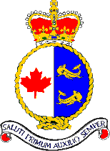
Cruise Report C3O/DBO 2019

Pacific Region Vessel CCGS Sir Wilfrid Laurier

FROM: 3 July 2019 TO: 23 July 2018

CRUISE NUMBER: 2019-78

CHIEF SCIENTIST: R. John Nelson

INTRODUCTION/PROGRAM BACKGROUND:
This cruise is a combined effort of the Distributed Biological Observatory (DBO), and the Canada’s Three Oceans project (C3O) which, taken together, are part of an international effort designed to make time series oceanographic observations at stations the Bering and Chukchi seas. This collaborative research cruise is carried out with participation of DFO-IOS, the University of Maryland Center for Environmental Science, Clark University, NOAA, the University of Washington, the US Fish and Wildlife Service, and the University of Victoria.

CRUISE OBJECTIVES:
The over arching objective of this cruise aboard the CCGS Sir Wilfrid Laurier is to collect data on the physical and geochemical properties of marine ecosystems and the organism that inhabit them. The data collected forms part of a time series stretching back to the late 1990s that will allow for increased understanding of the linkages between organisms and their habitat, and how they may be changing over time. This in turn allows for fact based management, and assessment of climate-change driven effects.

Specific research activities included:
- Water column profiles of water temperature, salinity were obtained with a Seabird conductivity, temperature and depth (CTD) rosette (water sampler) system deployed vertically port side, with attached additional sensors that collected data on fluorescence, optical clarity, dissolved oxygen, and photoactive radiation (light). The rosette water sampler was used to obtain water samples from discrete depths that are then used for measurement of a broad suite of biological and geochemical parameters, for collection of organisms for genetic analysis, and for use in assessment of primary productivity.
- While underway from Victoria to Dutch Harbor an Oceanscience underway CTD system (UCTD) was deployed twice daily to assess temperature and salinity down to approximately 400 m depth.
- Benthic sampling using a Van Veen grab sampler was used for assessment of bentic fauna.
- Collection of cores was done with a HAPS corer for assessment of oxygen consumption which reflects the amount of active marine life present on the surface and in the sediment.
- While on station, direction and speed of current was assessed with an RDI Longranger 150 kHz Acoustic Doppler Current Profiler (ADCP). This instrument was mounted to a strut lowered over the side from the port side of the well deck except at stations that were CTD only or on stations along the transit to Dutch Harbor from Victoria..
- Zooplankton samples were collected in vertical hauls by bongo-nets lowered to 100 m or from bottom depth minus 7 m in waters shallower than 107 m.
- Seawater was continuously pumped from 5 m below the surface to on board sensors measuring temperature, salinity, fluorescence, while underway and on station. Also, water samples were collected from this system at intervals from Victoria to Pt. Barrow for assessment of the distribution of isotopes produced from the Fukoshima Nuclear disaster
- Onboard primary productivity experiments were performed in incubators located on the helicopter deck.
- Seabird and marine mammal observations were made between Dutch Harbor and Pt. Barrow, and east and north of Pt. Barrow after the end of work at specific stations.
- At most stations, measurements of the optical properties of the upper ocean were made via deploying and instrument (C-OPS) from the well deck.
- Benthic samples were collected and preserved in ethanol for analysis of genetic biodiversity
- Continuous plankton recorder (CPR) collections were done in the Bering and Chukchi seas.

DAYS ALLOCATED: 21 DAYS OF OPERATION: 21

OVERALL NARRATIVE
This year the ship started its transect across the NE Pacific from Victoria on the afternoon of July 3rd joining the great circle route to Dutch Harbor. Along the transit from Victoria to Dutch Harbor twice daily CTD/rosette and bongo net stations were carried out at 0800 and 1800 with CTD/rosette casts to 1000 m except station NP 7 which went to 2000 m. Underway CTD cast were also done at 0200 and 1400 daily during the transit . Five ARGO floats were deployed on the way to Dutch Harbor. The ship arrived in Dutch Harbor the afternoon of July 10 and departed for the SLIP stations at 1515 on July 11. Work began at the SLIP (DBO1 line) at 1800 on July 13 and was completed at 2025 on July 14th. The DBO2 set of stations were started at July 15 at 0700 and completed at 0500 on July 16 at which time the ship transited north to work at three stations in Bering Strait to arrive at the first station of DBO3 at 2000 on July 16 then completing UTN 1, 2, 3, 4 and 6.After completion of work at UTN6, the ship steamed towards the coast to give the science crew a break prior to starting the SEC line. The SEC line was started at 2250 on July 17 to and completed along with the last UTN stations at 2100 July 18. After completing the UTN stations a transit to the DBO4 line was begun that included towing the continuous plankton recorder to just prior to arrival at DBO4.6. The DBO 4 line was started at 0330 on July 20 and completed at 2100 July 20. There was a 10-hour overnight steam to arrive at the BarC line at 0700 on the July 21with the last station on the line completed at 0200 on July 22. A slow overnight steam was done eastward of Barrow to set up for an opportunistic marine mammal and bird survey. Demobilization occurred while steaming the opportunistic marine mammal and sea bird observation track and all science personnel disembarked at Pt. Barrow, Alaska July 23

SCIENTIFIC PERSONNEL: Six scientists embarked July 3rd in Victoria, BC. Another 10 scientists embarked in Dutch Harbor July 10th. All science personnel disembarked at Pt. Barrow, Alaska July 23rd. See Table 1 for a complete list of participants.
Table 1. Scientific Personnel, their roles and affiliations

SUMMARY of RESULTS:
- Without slowing down the ship 16 UCTD casts were done across the NE Pacific from the coast of Vancouver Island to shortly before Unimak Pass.
- Five Argo floats were deployed.
- Continuous monitoring of surface water properties with electronic sensors from the seawater loop in the main laboratory (temperature, salinity, chlorophyll, while problems with the instrument precluded collection consistent pCO₂ data)
- Seabird and marine mammal observations from Dutch Harbor to Barrow and east of Barrow).
- 43 water samples from the seawater loop were collected for Cesium-137 analysis.
- Meteorological and ship position data from ship sensors was continuously collected.

At the 61 science stations in the Bering and Chukchi Seas, the following science tasks were completed
- 44 Rosette casts,
- 60 CTD casts,
- 40 150 kHz ADCP deployments,
- 38 Bongo plankton net hauls,
- 41 Benthic grab
- 18 HAPS core samples
- 41 Benthic video-camera recordings
- 5 stations that were sampled for primary productivity incubation experiments.
- 38 stations were sampled for apparent optical properties (C-OPS).

AREAS OF OPERATION:
North East Pacific, Bering Sea, Chukchi Sea, Barrow Canyon. Figure 1 shows the ships track, and figures 2 to 4 shows the science stations occupied along the route. A list of these science station locations, dates and activities is included in the Appendix. The total distance travelled from Victoria to Barrow was about 3600 nautical miles

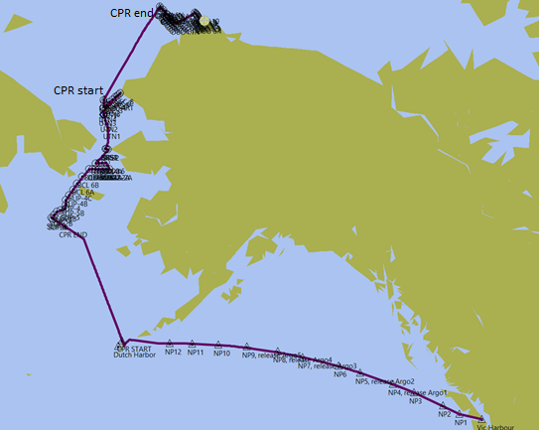
Figure 1. Map showing SWL ship track (dark line) for leg 1 2019. Note start and end for the continuous plankton recorder deployment from just north of Dutch Harbor to just south of the start of the SLIP stations.
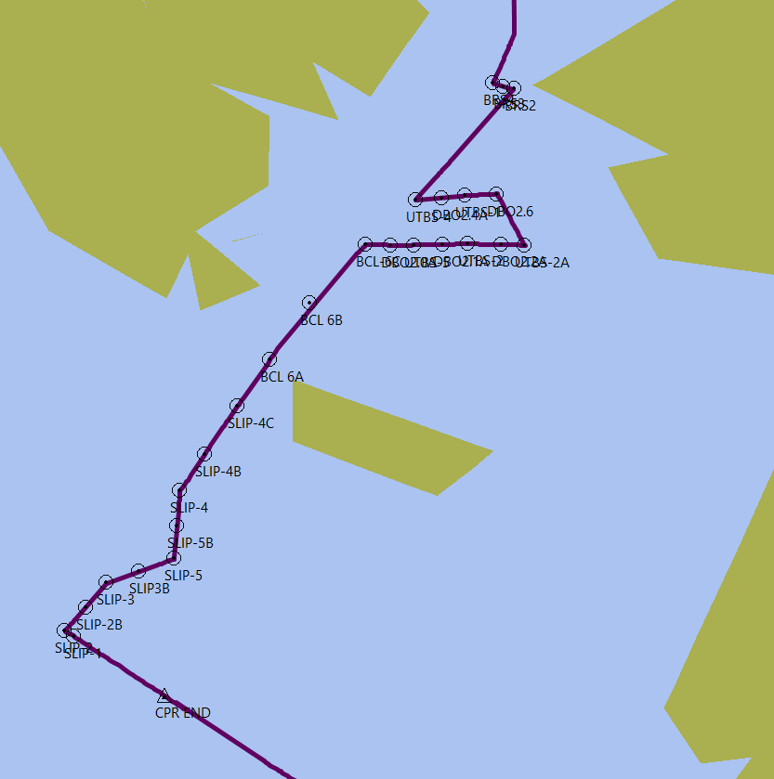
Figure 2. Detail of science stations occupied in the northern Bering Sea to Bering Strait.

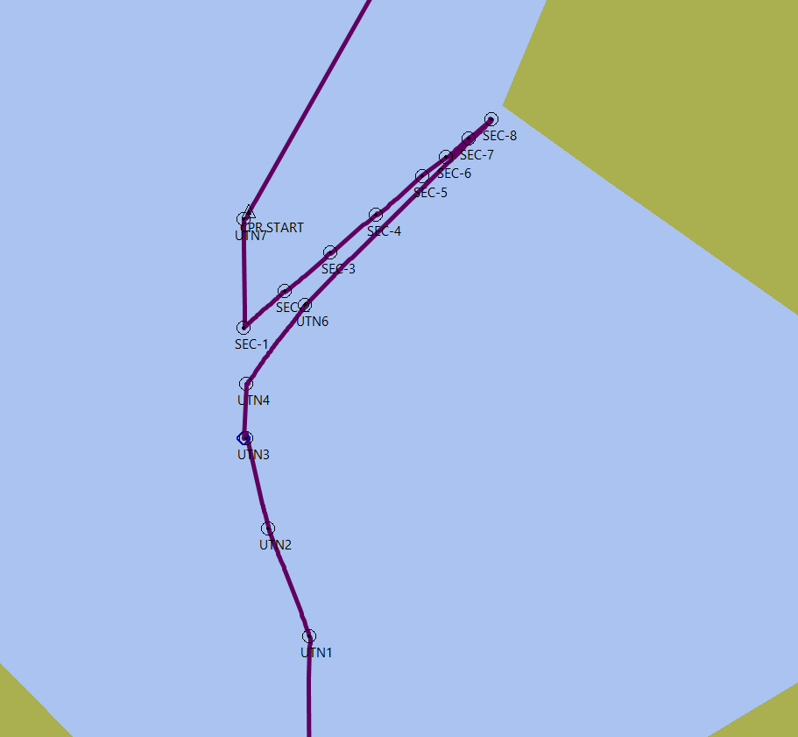
Figure 3. Detail of science stations occupied in the southern Chukchi Sea.
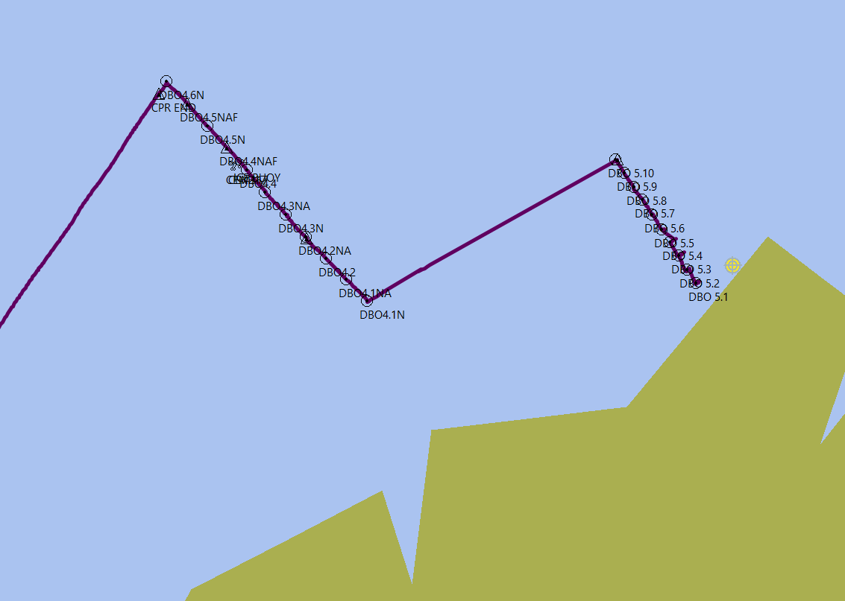
Figure 4. Science stations occupied in the eastern Chukchi Sea.

FIELDWORK:
Science activities aboard the CCGS Sir Wilfrid Laurier for the July leg of the program covered two distinct segments:
- Across the North Pacific from Victoria, BC to Dutch Harbor
- Temperature, salinity, chlorophyll-a florescence, and CO2 were continuously assessed throughout via pumping water from 5 m below the surface to the laboratory-based sensors. Sampling and filtering of water from the seawater loop for Cesium-137 analysis was also carried out. Twice Along the transit from Victoria to Dutch Harbor twice daily (0800 and 1800) CTD/rosette and bongo net stations were carried out with CTD/rosette casts to 1000 m except station NP 7 which went to 2000 m. In between the CTD/rosette net stations underway, CTD cast were also done at 0200 and 1400. Also, along the way to Dutch Harbor five ARGO floats were deployed.

- Bering/Chukchi seas from the Aleutian Islands to Barrow, Alaska, 61 repeat stations were occupied as outlined in the Appendix. At these locations some or all of the following science tasks were accomplished:
- CTD with or without Rosette (Figure 5) casts were done to get samples from the overlying water column for the physics, biology and geochemistry groups;
- A Bongo plankton net haul was done at most stations (Figure 6),
- ADCP 150 kHz backscatter data and current profiles were collected from an instrument deployed first and recovered last at all full rosette stations (Figure 7). (During CTD only stations the time on station is too short (~15 minutes) to warrant ADCP deployments.)
- Van Veen mudgrabs (between 2 and 5 grabs per station) were collected at most stations.
- HAPS coring (between 3 and 5 per station)
- Water was collected and filtered at a number of depths at most stations.
- Primary productivity incubation experiments where conducted using water from a subgroup of stations.
- An Optical instrument package (C-OPS) was lowered over the side during daylight hours to measure the apparent optical properties of the upper ocean (Figure 7).
- 5 Argo floats deployed along the great circle route in the NE Pacific.

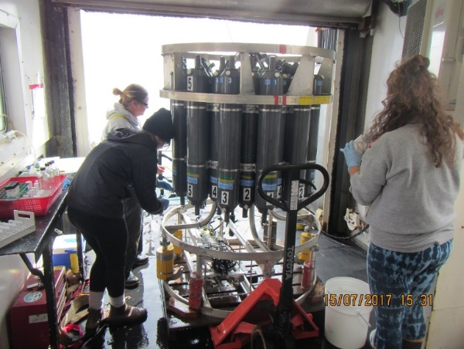
Figure 5. CTD/Rosette system with 24, 10 liter Niskin bottles deployed over the side.

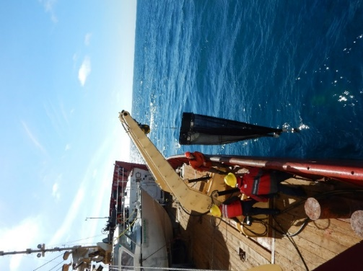
Figure 6. Vertically towed bongo nets deployed over the side for collection of zooplankton.

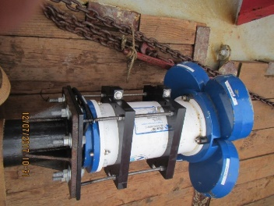
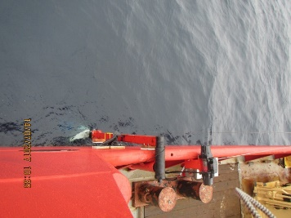

Figure 7. 150 kHz Acoustic Doppler Current Profiler (ADCP) deployed over the side at most CTD/Rosette stations for measurements of currents every 4 m from 5 m below the ship to the bottom.

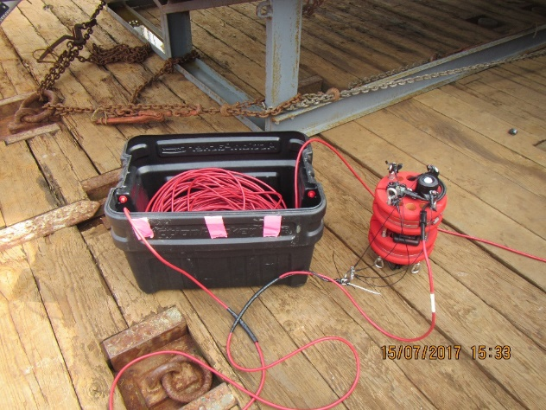
Figure 8. Optical property package (C-OPS) that was lowered over the side of the ship.

Shipboard labs_______________________________________
The forward (main lab) was used to filter water samples collected from the rosette, as well as for oxygen titrations (between Victoria and Dutch Harbor only). The starboard-side boat deck container was used to filter seawater for analysis of Fukushima radiation content. The forward (well deck) container was used for preservation of zooplankton and benthic samples which were stored for subsequent analysis back at IOS.

Deck space was used by science for the launch and retrieval of equipment and instrumentation, including CTD/rosette for profiling & water sampling and for the launching and recovery of the underway CTD (UCTD) system. The ADCP was deployed port side of the well deck (Figure 7). The zooplankton bongo nets and the Van Veen grab, and the HAPS corer were deployed and recovered using the A-frame on the starboard side of the well deck.

The container labs are well suited for lab duties, outfitted with counter space, shelving, simple sink, heat and power for instruments. Both are hooked up to electrical power for lights and heat, and had phone, ship’s intercom and network connections.

CTD/rosette system_______________________________________________________
A Seabird SBE-9 profiling CTD was used with a custom built compact 24-bottle rosette water sampler. The CTD was equipped with the standard suite of pressure, temperature and conductivity sensors, and additional external sensors: a fluorometer to measure chlorophyll-a concentration, a transmissometer to measure water clarity, a dissolved oxygen probe, and an acoustic altimeter to get accurate height above the bottom.
The 24-bottle rosette system (Figure 3) was equipped with a Seabird carousel pylon to remotely trigger the 10-litre Niskin sample bottles. An SBE-11 deck unit was used with Seasave software to acquire real-time data from the CTD and to close the bottles at depths selected before and/or during the cast. The deck unit included a NMEA board to automatically add GPS position into the header of the data file. This system worked very well during the trip.

Plankton nets_______________________________________________________________________
Single bongo plankton net hauls to a depth of water-depth minus 7 m were done at most stations (Figure 6). These casts were done right after the CTD/rosette casts while water was being sampled from the rosette Niskin bottles.

Benthic sampling___________________________________________________________________
Up to five 0.1 m2 van Veen grab deployments were made at each science station for collections of surface sediment chlorophyll, organic carbon/nitrogen content, grain-size, and benthic macrofaunal population structure. Up to two HAPS cores were collected to allow for measurements of oxygen consumption.

ADCP/Backscatter sonar___________________________________________________________
A 150 kHz Teledyne RDI Acoustic Doppler Current Profiler (ADCP) was mounted at the end of a pole on the port side of the well deck. This pole was lowered into the water using an electric winch when stopped at each rosette sampling station between Dutch Harbor and Barrow (Figure 7). This package was the first to be deployed at each science station and the last to be recovered. Data from this instrument gives current profiles below the ship to a maximum depth of 500 m and a measure of plankton layers in the water column down to approximately 100 m.

Underway CTD system__________________________________________________________
The UCTD system was successfully used to collect temperature and conductivity (salinity) data from the surface down to a maximum depth of 400 m while the ship was moving at cruising speed. Across the Pacific the probe was deployed every 12 hours. This is an excellent method to collect high quality water property data from the ship without interfering with speed and ship operations.

Cs-137 isotope collection________________________________________________________
As part of the UVIC lead InFORM project, surface seawater was collected to characterize the distribution of Fukushima derived radionuclides 137-Cesium, and 134-Cesium. This information will help to determine how well predictions of the progression of ocean borne contamination across the Pacific Ocean match with observations. This provides important information on the impact of this contamination on the health of the Pacific ecosystem for the North American public that rely on the ocean for their food, livelihood and recreation. The evolution of the contaminant plume in time and space also helps the scientific community to better understand ocean mixing which is a key parameter toward understanding the oceans role in mitigating atmospheric greenhouse gas increases and climate change.

Compact Optical Profiling System (C-OPS)_________________________________________
C-OPS is a radiometer system for determining apparent optical properties in the ocean. It consists of two radiometers: one measuring in-water upwelling radiance, and the other either downward irradiance or upward irradiance. Both radiometers are equipped with 19 wavebands covering wavelengths in the UV and PAR (250 – 800 nm) measuring at 15 Hz. The surface reference is mounted with a clear view of the sky in a location where shadow is non-existent. The C-OPS radiometer is always deployed towards the sun to avoid ship shadow.

Continuous Plankton Recorder.
The continuous plankton recorder collects plankton at approximately 5m depth along the ship’s track. Figure 9 shows the CPR being recovered after deployment off the port side stern. The two lines of the CPR are indicated along the ships track in Figures 1.

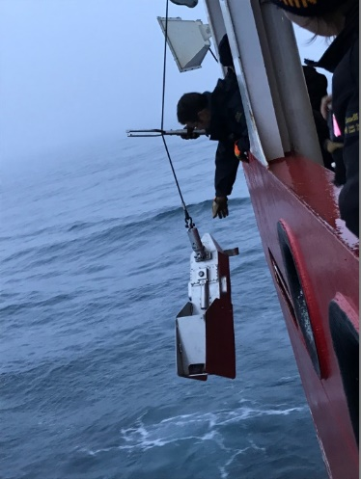
Figure 9. Recovery of the continuous plankton recorder.

SUCCESSES AND PROBLEMS [SCIENTIFIC]:
The data collected will be combined with data collected in earlier years to investigate how physical and geochemical parameters influence biological systems and how they may be changing over time. It is quite valuable to have the long time series that this program encompasses as it allows for assessment of long-term trends and identification of the key drivers that are changing over time.
All the scientific equipment performed well throughout the trip with the exception of the pCO₂ system which continued to have issues. More work was planned for this trip than in previous cruises and due to consistently good weather, no mechanical issues, and a good working relationship amongst the crew and science, more data was collected (station x activities) than previous C3O/DBO cruises.

PROBLEMS [SHIP’S EQUIPMENT/OPERATIONS/PLATFORM SUITABILITY]:
The ship is very well suited for this type of oceanographic work and there were no ship-related issues.

SUCCESSES [SHIP]:
The support of officers and crew in getting our equipment onboard, up and running, and during all station operations and data collection is invaluable and greatly appreciated. The professionalism of the Canadian Coast Guard became obvious to the whole science team during this trip. More work was planned for this trip than in previous cruises. Due to consistently good weather, no mechanical issues, and a good working relationship amongst the crew and science, more data was collected (station x activities) than previous C3O/DBO cruises.

DAYS LOST DUE TO WEATHER:
none

DELAYS [OTHER THAN WEATHER]:
none

SAFETY CONCERNS:
No safety concerns were reported.

SUMMARY/FINAL COMMENTS:
We want to express our gratitude for all the help and support we received from Commanding Officer Don Gibson and his officers and crew onboard CCGS Sir Wilfrid Laurier resulting in a highly successful trip and the collection of significant amount of interesting and valuable scientific data and samples. All national and international collaborators have commented on how great a platform SWL is for the type of science we are doing.

For additional information on this report contact John Nelson
John.Nelson@dfo-mpo.gc.ca
Institute of Ocean Sciences 9860 West Saanich Road, Sidney BC Canada V8L 4B2
Science Stations
Station | Lat (N) | Long (W) | Depth (m) | Tasks | Start Time (PDT)
Dutch Harbor | 53.888 | -166.527 |  |  | 11-Jul 15:15
SLIP-1 | 62.010 | -175.060 | 76 | ADCP/ROS/NET/CAM/C-OPS*/MUD*5/HAPS*2/ADCP | 13-Jul 18:00
SLIP-2 | 62.050 | -175.210 | 83 | ADCP/ROS/NET/CAM/C-OPS*/MUD*5/HAPS*2/ADCP | 13-Jul 20:57
SLIP-2b | 62.219 | -174.877 | 78 | CTD | 14-Jul 00:41
SLIP-3 | 62.390 | -174.570 | 75 | ADCP/ROS/NET/CAM/C-OPS*/MUD*5/HAPS*2/ADCP | 14-Jul 02:27
SLIP-3b | 62.468 | -174.083 | 70 | CTD | 14-Jul 06:09
SLIP-5 | 62.560 | -173.550 | 68 | ADCP/ROS/NET/CAM/C-OPS*/MUD*5/HAPS*2/ADCP | 14-Jul 08:09
SLIP-5b | 62.787 | -173.500 | 71 | CTD | 14-Jul 11:26
SLIP-4 | 63.030 | -173.460 | 71 | ADCP/ROS/NET/CAM/C-OPS*/MUD*5/HAPS*2/ADCP | 14-Jul 13:05
SLIP-4b | 63.280 | -173.080 | 66 | CTD | 14-Jul 17:40
SLIP-4c | 63.604 | -172.591 | 55 | CTD | 14-Jul 20:15
BCL-6a | 63.920 | -172.100 | 54 | ROS | 14-Jul 23:04
BCL-6b | 64.291 | -171.497 | 48 | CTD | 15-Jul 02:24
BCL-6c | 64.672 | -170.644 | 47 | ADCP/ROS/NET/CAM/C-OPS*/MUD*5/ADCP | 15-Jul 07:00
DBO2.0a | 64.671 | -170.264 | 47 | CTD | 15-Jul 09:30
UTBS-5 | 64.670 | -169.920 | 48 | ADCP/ROS/NET/CAM/C-OPS*/MUD*5/ADCP | 15-Jul 10:48
DBO2.1a | 64.675 | -169.472 | 47 | CTD | 15-Jul 13:10
UTBS-2 | 64.680 | -169.100 | 45 | ADCP/ROS/NET/CAM/C-OPS*/MUD*5/ADCP | 15-Jul 14:31
DBO2.2a | 64.675 | -168.597 | 45 | CTD | 15-Jul 17:21
UTBS-2a | 64.670 | -168.235 | 38 | ADCP/ROS/NET/CAM/C-OPS*/MUD*5/ADCP | 15-Jul 18:31
DBO2.6 | 65.000 | -168.657 | 45 | CTD | 15-Jul 22:09
UTBS-1 | 64.990 | -169.140 | 48 | ADCP/ROSpp/NET/CAM/C-OPS*/MUD*5/ADCP | 15-Jul 23:47
DBO2.4a | 64.975 | -169.488 | 48 | CTD | 16-Jul 02:45
UTBS-4 | 64.960 | -169.890 | 48 | ADCP/ROS/NET/CAM/*/MUD*5/ADCP | 16-Jul 04:11
BRS-2 | 65.667 | -168.399 | 52 | ROS/NET | 16-Jul 11:07
BRS-3 | 65.681 | -168.566 | 52 | ROS/NET | 16-Jul 12:12
BRS-4 | 65.699 | -168.715 | 52 | ROS/NET | 16-Jul 13:04
UTN-1 | 66.710 | -168.400 | 34 | ADCP/ROS/NET/CAM/C-OPS*/MUD*7/ADCP | 16-Jul 20:00
UTN-2 | 67.050 | -168.730 | 46 | ADCP/ROS/NET/CAM/C-OPS*/MUD*5/HAPS*2/ADCP | 17-Jul 00:20
UTN-3 | 67.331 | -168.907 | 51 | ADCP/ROS/NET/CAM/C-OPS*/MUD*5/HAPS*2/ADCP | 17-Jul 04:02
UTN-4 | 67.500 | -168.910 | 51 | ADCP/ROSpp/NET/CAM/C-OPS*/MUD*5/HAPS*2/ADCP | 17-Jul 07:02
UTN-6 | 67.740 | -168.440 | 50 | ADCP/ROS/NET/CAM/C-OPS/MUD*5/HAPS*2/ADCP | 17-Jul 11:30
SEC-8 | 68.299 | -166.938 | 35 | ADCP/ROS/NET/CAM/C-OPS/MUD*2/ADCP | 17-Jul 22:50
SEC-7 | 68.242 | -167.122 | 43 | ADCP/ROS/NET/CAM/C-OPS/MUD*2/ADCP | 18-Jul 00:52
SEC-6 | 68.185 | -167.308 | 49 | ADCP/ROS/NET/CAM//MUD*2/ADCP | 18-Jul 02:55
SEC-5 | 68.128 | -167.495 | 51 | ADCP/ROSpp/NET/CAM//MUD*2/ADCP | 18-Jul 04:43
SEC-4 | 68.013 | -167.867 | 54 | ADCP/ROS/NET/CAM/C-OPS/MUD*5/ADCP | 18-Jul 07:49
SEC-3 | 67.898 | -168.235 | 60 | ADCP/ROS/NET/CAM/C-OPS/MUD*5/HAPS*2/ADCP | 18-Jul 10:15
SEC-2 | 67.783 | -168.602 | 51 | ADCP/ROS/NET/CAM/C-OPS/MUD*5/HAPS*2/ADCP | 18-Jul 13:45
SEC-1 | 67.671 | -168.930 | 51 | ADCP/ROS/NET/CAM/C-OPS/MUD*5/HAPS*2/ADCP | 18-Jul 16:15
UTN-7 | 68.000 | -168.930 | 59 | ADCP/ROS/NET/CAM/C-OPS/MUD*5/HAPS*2/ADCP | 18-Jul 21:06
DBO4.6n | 71.851 | -162.159 | 43 | ADCP/ROS/NET/CAM/C-OPS/MUD*5//ADCP | 20-Jul 03:30
DBO4.5na | 71.785 | -161.967 | 45 | CTD | 20-Jul 06:00
DBO4.5n | 71.720 | -161.774 | 43 | ADCP/ROS/NET/CAM/C-OPS/MUD*5/HAPS*2/ADCP | 20-Jul 07:03
DBO4.4na | 71.654 | -161.591 | 44 | CTD | 20-Jul 09:06
DBO4.4n | 71.588 | -161.402 | 45 | ADCP/ROSpp/NET/CAM/C-OPS/MUD*5/HAPS*2/ADCP | 20-Jul 10:05
DBO4.3na | 71.521 | -161.230 | 48 | CTD | 20-Jul 12:30
DBO4.3n | 71.454 | -161.039 | 48 | ADCP/ROS/NET/CAM/C-OPS/MUD*5/HAPS*2/ADCP | 20-Jul 13:29
DBO4.2na | 71.382 | -160.841 | 47 | CTD | 20-Jul 15:55
DBO4.2n | 71.323 | -160.657 | 48 | ADCP/ROS/NET/CAM/C-OPS/MUD*5/HAPS*2/ADCP | 20-Jul 16:47
DBO4.1na | 71.258 | -160.464 | 52 | CTD | 20-Jul 19:00
DBO4.1n | 71.194 | -160.270 | 57 | ADCP/ROS/NET/CAM/C-OPS/MUD*5/HAPS*2/ADCP | 20-Jul 19:54
BarC-10 | 71.620 | -157.925 | 64 | ADCP/ROS/NET/CAM/C-OPS/MUD*2/ADCP | 21-Jul 07:00
BarC-9 | 71.578 | -157.838 | 72 | ADCP/ROS/CAM/C-OPS/MUD*2/ADCP | 21-Jul 08:45
BarC-8 | 71.537 | -157.753 | 70 | ADCP/ROS/CAM/C-OPS/MUD*2/ADCP | 21-Jul 10:21
BarC-7 | 71.500 | -157.672 | 73 | ADCP/ROS/NET/CAM/C-OPS/MUD*2/ADCP | 21-Jul 11:54
BarC-6 | 71.455 | -157.583 | 91 | ADCP/ROS/CAM/C-OPS//MUD*2/ADCP | 21-Jul 13:41
BarC-5 | 71.410 | -157.490 | 130 | ADCP/ROSpp/CAM/C-OPS/MUD*5/ADCP | 21-Jul 15:30
BarC-4 | 71.372 | -157.415 | 117 | ADCP/ROS/NET/CAM/C-OPS/MUD*2/ADCP | 21-Jul 17:39
BarC-3 | 71.330 | -157.332 | 95 | ADCP/ROS/CAM/C-OPS/MUD*2/ADCP | 21-Jul 20:10
BarC-2 | 71.288 | -157.248 | 58 | ADCP/ROS/CAM/C-OPS/MUD*2/ADCP | 21-Jul 22:23
BarC-1 | 71.247 | -157.165 | 50 | ADCP/ROS/NET/CAM/C-OPS/MUD*2/ADCP | 22-Jul 00:19

