2019-78 SWL

CTD/Rosette Report
Sarah Zimmermann, Sarah Ann Quesnel (DFO-IOS)
P.I.: John Nelson (DFO-IOS)
v.2020-04-20

CTD/Rosette set-up

A Seabird SBE-9+ profiling CTD was used with a 24-bottle rosette water sampler. The CTD was equipped with the standard suite of pressure, temperature and conductivity sensors, and additional external sensors: a fluorometer to measure chlorophyll-a concentrations, a transmissometer to measure water clarity, a dissolved oxygen probe, a PAR (photosyntheically active radiation) sensor to measure the light available to phytoplankton and an acoustic altimeter to get accurate height above the bottom. A surface PAR reference sensor mounted on the wheeldeck above the CTD launch area, connected to the CTD deck unit, was integrated into the CTD data for all casts.
Unique for 2019, were the additions of two more dissolved oxygen sensors that will be used for a comparison study between the three designs and performance parameters.

The 24-bottle rosette system was equipped with a Seabird Carousel water sampler to remotely trigger the 10-litre Niskin sample bottles, equipped with internal stainless steel springs. A SBE-11+ deck unit was used with Seasave software (v. 7.26.7.107) to acquire real-time data from the CTD and to close the bottles at depths selected before and/or during the cast. The GPS position and time were integrated into the CTD data header via a NMEA feed coming via a LAN connection from the ship’s GPS via the Science Server.

The CTD is lowered using a wire rope (.316) with 1 internal conducting wire that carries power and communication to the CTD. The winch and drum are located above the “CTD shack” and the CTD is extended away from the ship using a telescoping boom. The winch operator stands aft of the shack with view of the water and the CTD operator.

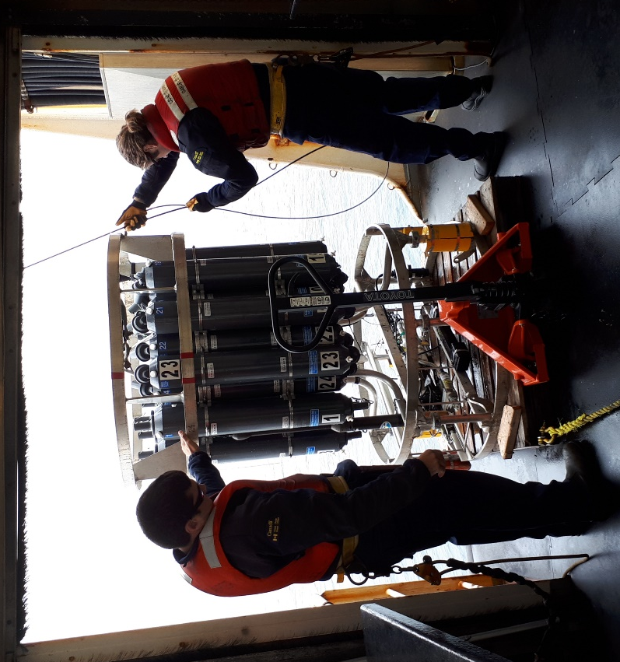

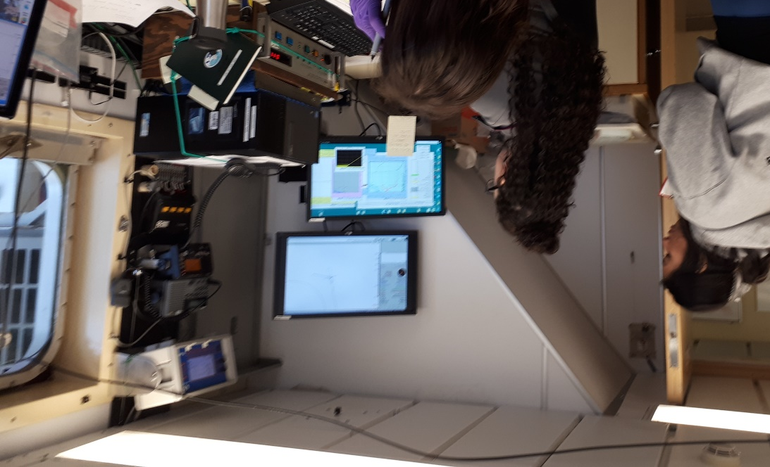

CTD sensors:

Primary Temperature, Seabird SBE3T
Serial number : 5048, Calibrated on : 07-Dec-18

Primary Conductivity, Seabird SBE4C
Serial number : 3579, Calibrated on : 12-Dec-18

Pressure, Digiquartz with TC
Serial number : 131733, Calibrated on : 06-Apr-2015
Offset : 0.00000

Secondary Temperature, Seabird SBE3T
Serial number : 5073, Calibrated on : 08-Dec-18

Secondary Conductivity, Seabird SBE4C
Serial number : 3581, Calibrated on : 13-Dec-18

A/D voltage 0, Fluorometer, Seapoint, pumped flow in-line with secondary TC pair.
Serial number : 3575, Calibrated on : tested 15-Feb-18
Gain setting : 3 x, 0-50 µg/l

A/D voltage 1, Transmissometer, WET Labs C-Star, 0.25m pathlength
Serial number : 1666, Calibrated on : 04-June-2019

A/D voltage 2, Oxygen, SBE 43, pumped flow inline with primary TC pair
Serial number : 1117, Calibrated on : 19-Jan-19

A/D voltage 3, Altimeter, Datasonics
Serial number : 40853, Calibrated on : 12 Feb 2007

A/D voltage 4, PAR/Irradiance, Biospherical model QSP-2300
Serial number: 70123, Calibrated on: 4 Apr 2016 (factory)

A/D voltage 6, User Polynomial, Sensor name: Rinko III ARO-CAV
Serial number : 370, Calibrated on : 2019-03-25

A/D voltage 7, User Polynomial, 2, Sensor name: Optode- Approx mL/L only!! Rough calc
Serial number : 016, Calibrated on : 2018

SPAR voltage, SPAR/Surface Irradiance, Biospherical model QSR-2200

A/D voltage 5 is free

Pumps, Seabird SBE05 sn55043 (primary) and sn 55248 (secondary)
CTD Seabird SBE9+, Serial Number 941
Deck Unit Seabird SBE11+, Serial Number 0800
Water Sampler, Seabird SBE32, Serial Number 452
10-L Niskins bottles: OceanTest Equipment Inc.

Typical station

Two crew members would cycle through all deployments starting and ending with the ADCP. The CTD cast was performed after the ADCP deployment, followed by the camera, C-Ops (if casts being performed), vertical net tows, multiple mud grabs, and HAPS cores (select stations). The mud grabs were last due to the plume of sediment the grabs created in the water. At the end of the station, the ADCP would be recovered.

Typical CTD cast

On deck, the transmissometer sensor windows were cleaned with a lint-free wipe prior to each deployment. The CTD/Rosette was lowered to 10 m and pumps turned on. This soak cools the sensors to ambient sea water temperature and removes bubbles from the plumbing. After 3 minutes the package was brought up to just below the surface to begin a clean cast, lowered at 30 m/min to within 5m of the bottom. The package was stopped at the bottom for at least 30 seconds as bottom information was recorded. Niskin bottles were closed on the upcast after 30 second stops.

Sensors have not yet had post-cruise calibrations or comparisons to water sample salinity. Seabird specifications are:

SBE 3plus temperature sensor

Range -5.0 to +35 °C
Resolution 0.0003 °C at 24 samples per second
Initial Accuracy ± 0.001 °C
Response Time [sec.] 0.065 ± 0.010 (1.0 m/s water velocity)
Self-heating Error < 0.5 sec. to within 0.001 °C

SBE4c conductivity sensor

Measurement Range 0.0 to 7.0 Siemens/meter (S/m)
Settling Time 0.7 seconds to within 0.0001 S/m
Initial Accuracy 0.0003 S/m
Stability 0.0003 S/m/month
Time Response 0.060 seconds (pumped)

Digiquartz pressure sensor

Measurement Range Pressure 0 to 6800m (10,000 psi)
Accuracy 0.018% of full scale
Resolution (at 24 Hz) Pressure 0.001% of full scale
Time Response Pressure 0.015 second

Performance notes

Water Sampler
An unusual problem was found with the water sampler where Niskins 14 and 15 would both trip when either of the Niskins were fired. This did not affect the program as we never needed all 24 niskins at different depths.

CTD
Jellies were commonly ensnared by the rosette or wire for the SLIP stations and SEC 5 to 8. SEC-5 (event 187) was rerun due to jelly strand getting stuck in secondary TC duct at start of cast.

Event 50, SLIP 1 (DBO 1.1) a jelly was sucked into the primary TC duct. Use the secondary sensors for this cast and set oxygen to -9.

There were a few “Computer Overflow” errors where the deck unit’s red overflow light came on and the computer acquisition froze. After wiggling the cables in the back of the deckunit to confirm they were tight the system unfroze and data collection continued normally. The ship’s e-tech, Alex, found us a couple locking screws to fasten the modem cable to the deckunit.

CTD Wire
The wire was terminated before being loaded onto the ship, however once onboard and the wire brought to the CTD the electrical termination failed. This was remade and tested before the start of the program.
No other problem was experienced, however “computer overflow” error described above may actually be associated with a wire issue, not the computer cable?

Fluorometer and Oxygen
The pumps were working well, however due to the flow through time lag and water dynamics around the package there is commonly an offset between down and upcast readings. When comparing water sample data to CTD measurements it is good to keep this in mind and use the CTD data associated with the bottle stop. In high gradient areas however, even waiting 30 seconds before the bottle closure, this may not have been enough time for the water around the CTD and bottle to stabilize giving higher than normal variability.

Surface PAR
Before the start of the program there was first an issue with the configuration file not having SPAR selected which then turns the interface off in the deckunit, with resulting blank LED panel when thumbwheel position selected for SPAR. After this was fixed, the cable failed. The cable was swapped for that from the FROSTI’s system and all worked fine for the full cruise.

Niskins
Many of the Niskins have chips in the bottom of the bottles, however in general the o-rings securely prevented any water leaking and they passed the vent/spigot bottle checks before sampling. Niskin 3 and 7 were swapped with Niskins 23 and 21 respectively as positions 23 an 21 are rarely sampled.

To do / suggestions for next year
Water sampler repair.

