REVISION NOTICE TABLE
DATE | DESCRIPTION OF REVISION

PROCESSING NOTES
Cruise: 2019-078
Agency: OSD
Location: North Pacific / Bering Sea / Chukchi Sea
Project: Canada’s Three Oceans / Distributed Biological Observatory
Party Chief: Nelson J.
Platform: Sir Wilfrid Laurier
Date: July 3, 2019 - July 23, 2019

Processed by: Germaine Gatien
Date of Processing: 16 June 2023 – 2 April 2026
Number of CTD HEX files: 75 (cast 1 test only) Number of CTD files: 74
Number of ROS files: 58 (cast 1 no sampling) Number of CHE files: 57
Number of TSG HEX files: 8 Number of TOB files: 8

INSTRUMENT SUMMARY
A SeaBird Model SBE 911+ CTD (#0941) was used for this cruise. It was mounted in a custom-built compact 24-bottle rosette sampler and attached were a Wetlabs CSTAR transmissometer (#1666), an SBE 43 DO sensor (#1117), a SeaPoint Fluorometer (#3575), a Biospherical QSP-200L4S PAR sensor (#70123), a Biospherical Surface PAR (#20281) and an altimeter (#40853).
24 Ocean Test Equipment 10L bottles equipped with internal stainless steel springs were mounted on the rosette.

A thermosalinograph (SeaBird 21 S/N 3274) was mounted with a fluorometer (SCF3654) and a remote temperature sensor #0271.

The data logging computer was the WGBCIOS104876.
The data acquisition program was Seasave 7.26.7.107 for the CTD and the TSG.
The deck unit was a Seabird model 11+ (#800).
The salinometer used at IOS was a Guildline model 8400B Autosal, serial # 69086. Bottles were analyzed between 18 January 2019 and 21 January 2019.

SUMMARY OF QUALITY AND CONCERNS
There was a gap of almost 3 years between beginning to process these data and receiving final sample analysis results and required metadata. It is recommended that processing start when “in-house” analyses are all available. Data from other agencies can be added later.

The Daily Science Log Book and rosette log sheets and TSG log as well as spreadsheets detailing sampling were provided.

The raw file names had a 2-digit cruise number; the names were changed to the usual 3-digit cruise number format.

Deployment method: On deck, the transmissometer sensor windows were cleaned with a lint-free wipe prior to each deployment. The CTD/Rosette was lowered to 10 m and pumps turned on. This soak cools the sensors to ambient sea water temperature and removes bubbles from the plumbing. After 3 minutes the package was brought up to just below the surface to begin a clean cast, lowered at 30 m/min to within 5m of the bottom. The package was stopped at the bottom for at least 30 seconds as bottom information was recorded. Niskin bottles were closed on the upcast after 30 second stops.

In the offshore area there was a lot of small-scale noise in the salinity and temperature. Some noise looks like corruption due to shed wakes, even when descent rates were >0.5m/s. Often salinity is affected more than temperature, so there may be some effect on flow rates to the conductivity cell which leads to spikes in salinity where temperature gradients are fairly high. Whatever the cause the data are noisier than usual and the highly variable descent rate is likely a factor. Editing of such noise is subjective and was limited to areas with significant unstable features. Once the ship was in the Bering Sea the descent rate was less variable and the noise in salinity was less significant.

The pressure offset in the configuration file was updated (to -0.4db) based on a post-cruise calibration and observations made at sea.

The post-cruise calibrations indicate significant drift in the primary conductivity since the previous calibration. However, there is good evidence that no significant drift occurred during this cruise. The differences between temperature and salinity channels were small and salinity compared well with bottles. Similarly the post-cruise calibration of the dissolved oxygen sensor indicated significant damage that was not seen during this cruise. The comparison of dissolved oxygen with titrated samples indicates the SBE dissolved oxygen sensor was reading low by about 3.6% which is likely due to a combination of calibration drift and sensor response.

The dissolved oxygen data were recalibrated based on the bottle comparison. No correction was applied to pressure or salinity other than an update to the pressure offset based on the post-cruise calibration and observations at sea.

The CTD salinity channels were a little noisier than usual, but the noise was 2-sided.

The SBE fluorometer reads a little higher than CHL samples at low CHL values, but as CHL rises the fluorescence drops fairly steeply until it is about 50% of the CHL values. This is a typical pattern for these fluorometers.

The thermosalinograph traces were marked by drop-outs in salinity, likely to be caused by bubbles. Large single-point spikes were removed using a despike routine. Small spikes were too frequent to be removed by graphical editing.

Comparisons of TSG data and co-incident CTD casts and loop samples were done. The intake temperature was higher than the CTD temperature by more than usual, but this is likely due to where it was mounted. Salinity compared well with CTD values during the deeper offshore casts. In other areas large near-surface gradients produce highly variable comparisons. Salinity appears to be good to within 0.003psu early in the cruise except where there are small spikes to lower values that are likely caused by bubbles in the loop water. There is insufficient evidence to know if there was drift during the cruise. The TSG fluorescence data compares reasonably well with the CTD fluorometer.

PROCESSING SUMMARY

Seasave
This step was completed at sea; the raw data files have extension HEX.
Files had 2-digit cruise numbers so those were changed to the standard format 2019-078-****.

Preliminary Steps
The Daily Science Log Book and rosette log sheets were obtained. A post-cruise report is available.
Spreadsheet 2019-078_SWL_Chem and Logs.xlsx contains a sampling log with details on bottles fired and results of analyses.
The cruise summary sheet was completed.
There was no history available for the pressure, conductivity and DO sensors; this was the first cruise on which most sensors were used after the last factory calibration.

The configuration files did not change through the cruise.
The calibration constants were checked for all instruments. No errors were found.
During the cruise the pressure at the end of the cast was recorded and the average was 0.49db. The post-cruise calibration had an offset of -0.4db. Given this evidence the offset was changed in the configuration file used during the cruise to have an offset of -0.4db.
A file with that correction was saved as 2019-078-ctd.xmlcon.

BOTTLE FILE PREPARATION
The ROS files were converted including bottle number, bottle position, oxygen concentration and salinity.

The files were then converted to IOS Header files and then put through CLEAN to add event numbers.
Temperature and salinity were plotted for all BOT files.
As noted in the log there are large differences between the 2 salinity channels during cast #50 during the upcast.
There was considerable noise in both salinity channels, but only a few significant outliers.
CTDEDIT was used to clean salinity lightly in BOT files #7, 10, 18, 45, 50, 104, 142, 162, 193 and 296. The ED1 files were copied to *.BOT.

There are two files from event #213. The cast was rerun because some bottles had not closed properly. The file named 213B was renamed 9213 in processing up to this point. It was selected for further processing, so the files from the first cast were removed and those from the second cast were renamed as 2019-078-0213.

The BOT files were averaged on bottle number and those files were used to prepare an ADDSAMP file.
The ADDSAMP file was sorted on Event # and Niskin #. Sample #s were then added.

Entries were checked against the rosette log files. Some items or discrepancies were noted:
- Event 1 – bottles fired but no sampling. Do not process further.
- Event 57 – No samples were collected from Niskin 14, sample 205,so this record could be dropped from bottle file. **
- Event 79 – the firing order is wrong in the rosette sheet – 6 is entered twice. AV1 file is correct.
- Event 118 – Niskin# 23 was the 14th bottle fired but in the rosette sheet that was not entered and all entries after the 13th are wrong in the firing order on the rosette sheet. The file entries are ok.
- Event #133 – Niskins 7 & 8 were fired twice – Sample # padded – remove recordsr. **
- Event #162 – Niskins 11 & 12 not sampled – remove records. **
- Event #169 - No samples were collected from Niskin 10 but sample 9468 assigned, so this record should be dropped from bottle file. **
- Event #175 – Niskins 11 & 12 were fired but probably no samples – remove records **.
- Event #181 – Niskin 11 & 12 were fired but probably no samples – remove records **.
- There are others with bottle samples but no sampling – those will be checked later.
- Event 822 – called 821 in the rosette log but 822 in the daily log. Left unchanged.

Many casts had bottles fired out of order but the sorting method ensured the correct sample numbers were assigned.

The ADDSAMP file was then reordered on Event # / Sample #.
The ADDSAMP file was used to add sample numbers to the BOT files, creating SAM files. Those were bin-averaged on bottle number to create SAMAVG files.
**At this point the changes noted above with ** were made to the SAMAVG files. Channel limits were updated to reflect the changes.
The SAMAVG files were sorted on sample number and saved as SAMAVGSORT

Next, text file 2019-078-bot-hdr.txt was prepared to add an explanation of quality flags and some general comments from analysts.

Final analysis data were found in a general spreadsheet, 2019-078_SWL_Chem and Logs_2020-05-06b.xlsx. The data were simplified and saved as Samples.csv. Corrections made to channel names, and where there were 2 flags they were combined without a comma.
Comments were edited slightly and combined so there is only one per sample.
There were some channels that had no flags or comments included.
The Samples.csv file was converted into individual cast files with extension CHEM.
MERGE was run to merge the CHEM files to the SAMAVGSORT files using sample # as merge channel. Some unnecessary channels in the SAMAVGSORT files were not included.
The log file from this process turned up 2 problems:
File 213 did not have sample numbers in the SAMAVGSORT file. There were problems with this cast in acquisition. Sample #s were added at this stage, the records were sorted on sample # and the channel limits for sample # were updated. The CHEM file also needed to be sorted.
File #322 had no CHEM file; the bottle samples had been misnamed as #321, so the CHEM file was corrected.

There is no simple way to exclude the records where there was no sampling. It would require either padding sample #s in the SAMAVG files or removing records. It could be done in a spreadsheet and then reconverted to IOS Header format but then header information would need to be added, another chance of error. Where there is no salinity bottle data there is usually no other sampling, but that is not always the case.
No attempt was made to remove records where just one bottle is skipped, but where there are groups of records (2 or more) skipped at the end of files, they were removed. That was done using a text editor and the # of records were adjusted. A few may have been missed, but this does produce simpler files.

CLEAN was run to add zero values to any quality flags with no entry. Output:MRGCLN1.

Data were extracted to a spreadsheet. Spot checks were made to see if the proper sampling was included, and no problems were found.
Event #213 was entered as event #9213; this was changed in the header. (This was a repeat cast originally called 213B.)

Header Check was run to check for problems. There were no unreasonable negative values. The primary salinity was bad during cast #50.

Compare
Oxygen ( bottle sampling only between casts #4 and 42)
There was a lot of noise in the comparison above 55db. All casts had a subsurface maximum with sharp gradients so small vertical mismatches between the CTD and samples will lead to large differences. When those data were removed as well as 5 significant outliers below that level, the fit was:
Bottle DO = 1.0362*Oxygen:Dissolved:SBE +0.0168
There were samples from the OMZ so the offset is expected to be reliable.
The outliers were from:
- Event 4 – 101db (bottom sample – CTD DO slowing decreasing while stopped so out of line with upcast sampling where CTD DO is slowly increasing during stops)
- Event 7 – 99db (fairly high DO gradient)
- Event 22 – 152 and 500db (look like incomplete flushing)
- Event 38 –202db (area of local DO reversals seen in downcast and upcast)
None of the outliers had been flagged by the analyst and there is no evidence to justify adding a flag.

As the outliers indicate, some of the fit is likely correcting for slow response of the CTD DO as well as calibration drift.

For more information see file 2019-078-oxy-comp1.xls.

Salinity
Compare was run with pressure as reference channel.
Using the deep casts from the initial part of the cruise (events 4-45) provides the most useful calibration data. There was a lot of scatter in the top 155db due to high vertical salinity gradients and some gradient reversals. This leads to large salinity difference caused by small differences in depth between the CTD stopping depth and the depth from which Niskin contents derive. There was 1 other outlier that has a very high standard deviation in the CTD salinity during the 10s window, and the CTD salinity profile looks odd at that depth. So the sample may be fine but the CTD data are not reliable, so that record was removed from the comparison.

The standard deviations in both CTD salinity channels are higher than usual. Many of the data would normally be rejected in doing a comparison but the noise looks 2-sided, so the differences should be reliable with the exception of the 1 outlier noted above which had a very high standard deviation than other samples.

Using the 67 salinity samples that remain the primary salinity was found to be high by 0.0014psu (std.dev. 0.0020psu) and the secondary was high by 0.0013psu (std dev 0.0021psu). The 2 channels are remarkably close. In a plot against cast order there is a slight increase in both channels with time but it is very small, especially given the noisy CTD salinity.

There is little drift early in the cruise, but that leaves a question about the Arctic section of the cruise where sampling was very shallow. Fortunately, the gradients are quite low between 25 and 45db and salinity was less noisy. When all data are included except where absolute differences were >0.01psu or standard deviations >0.0008psu, the fits are extremely flat with time for both channels, with a very slight decrease. This does suggest minimal drift through the cruise.
No recalibration is justified given the evidence available..

For more detail see file 2019-078-comp1.xls.

Extracted Chlorophyll versus CTD Fluorescence
COMPARE was run using Chlorophyll: Extracted and SBE Fluorescence. When a fit of fluorescence against extracted chlorophyll is forced through the origin had a slope of 0.53.

The SBE fluorometer reads a little higher than the CHL samples at low CHL values, but as CHL rises the fluorescence drops fairly steeply until it is about 50% of the CHL values. This is a typical pattern for these fluorometers.
One outlier was removed because of an obvious spike in CTD fluorescence in a profile plot.

It is typical behaviour for the CTD fluorometers to read high when CHL is very low and read low when CHL is high.
See 2019-078-fl-chl-comp1.xls for more detail.

Conversion of Full files from Raw Data
All files were converted using 2019-078-ctd.xmlcon. The hysteresis correction was selected since there were some deep casts. The Tau correction was applied.

All channels were plotted for a few casts to check for problems in the conversion. All channels were present. There were some small spikes in the primary conductivity and the SPAR channel was full of large spikes.

WILDEDIT
Program WILDEDIT was run to remove spikes from the pressure, conductivity & temperature only.
Parameters used were: Pass 1 Std Dev = 2 Pass 2 Std Dev = 5 Points per block = 50
The parameter “Keep data within this distance of the mean” was set to 0.
A few small conductivity spikes were removed by this routine.
A test run was made to see if the spikes in SPAR could be removed but this was unsuccessful

ALIGN DO
Fine-tuning of the DO sensor alignment is difficult when there are so many stops for bottles, some very sharp gradients and most casts are very shallow. For other cruises using this type of sensor settings between +2.5s to +3.5s worked quite well with 2.5s providing the best results in most cases but a higher setting working best for shallow casts.
ALIGN was run on all casts using an advance of +3.5s.

CELLTM
As for ALIGNCTD tests are not helpful with so many stops and high variability, so settings were used that are always found reasonable, and often the best choice.
CELLTM was run using (α = 0.0245, β=9.5) for both the primary and secondary conductivity.

DERIVE
Program DERIVE was run on all casts to calculate primary and secondary salinity and dissolved oxygen concentration (using the Tau correction).

Tests
A check was made of 3 casts using the post-cruise calibrations to see if there are significant differences.
Cast # | Press | T1-T0 | C1-C0 | S1-S0 | Descent Rate
2019-078-0007 | 500 | +0.0003 | -0.00016 | -0.0007 | High, Mod
 | 980 | +0.0004 | -0.00010 | -0.0004 | “
2019-078-0025 | 500 | +0.0001 | -0.00005 | -0.0007 | High, Mod
 | 1000 | 0 | -0.00005 | -0.0007 | “
 | 1900 | -0.0002 | -0.00006 | -0.0005 | “
2019-078-0045 | 500 | +0.0007 | -0.00002 | -0.0007 | High, Mod
 | 1000 | +0.0002 | -0.00002 | -0.0001 | “
The differences are small but variable with differences slightly lower offshore than nearshore

Conversion to IOS Headers
The IOSSHELL routine was used to convert Sea-Bird 911+ CNV files to IOS Headers.
This step failed for 2 casts which had long periods at the bottom (>8 minutes) which caused an overflow in the altimetry header algorithm. The altimetry channel was removed from casts #118 and 243 using routine STRIP. The files were then converted to IOS Header format. A header entry was inserted with a value based on plots.

CLEAN was run to add event numbers and to replace pad values in the pressure channel with interpolated values based on record number.

Checking Headers
The header check was run.
Fluorescence did go off scale during two casts (13 and 118), but those spikes occurred during bottle stops, so will not affect the downcast files.

File CLIP.csv was prepared based on a list provided by Sarah Zimmerman.
CLIP was run and refinements were made to the settings for 3 casts after examining plots.

Surface check was run and shows an average surface pressure for the cruise was +0.17db before running CLIP and 1.4db after running CLIP. These pressures look reasonable so the offset applied in conversion is appropriate.

The altimeter readings and bottom depths from the headers of the CLN files were exported to spreadsheets. To see if the altimetry and/or bottom depth entries are reasonable a check value was calculated:
Check Value = Water Depth – (Altimetry -1)– Max Depth Sampled
The altimetry value is calculated with an algorithm taking data from the bottom 2db sampled. All values were between -4.1m and +3.0m. This is a good result showing both altimeter and water depth entries are reasonably reliable.. Perfect values are not expected since water depths can vary through a cast. (See 2019-078-altimeter-ctd.csv.)

The cruise tracks with event #s was plotted and added to the end of this report. No problems were found.

Shift
Fluorescence
The fluorometer was pumped. There is too much noise and too many bottle stops to make a good estimate of the shift needed. The usual setting applied to 911+ CTDs with pumped fluorescence was applied.
SHIFT was run on all casts advancing the SeaPoint fluorescence channel by +24 records. The results look much improved.

Conductivity
Choosing alignment corrections is difficult because the salinity is extremely noisy. Descent rates are variable and some unstable features are clearly due to shed wake corruption, but that doesn’t explain much of the noise. Some of the noise looks like is it is due to mis-alignment in the presence of high vertical gradients. Unstable features between 2 layers are common in the Bering Sea region.

Tests were run on some deep and shallow casts. Settings of -0.3 records for the primary conductivity and -0.7 for the secondary made slight improvements.
SHIFT was run twice applying those 2 corrections.

DELETE
The following DELETE parameters were used:
Surface Record Removal: Last Press Min
Maximum Surface Pressure (relative): 10.00
Surface Pressure Tolerance: 1.0 Pressure filtered over 15 points
Swells deleted. Warning message if pressure difference of 2.00
Drop rates < 0.30m/s (calculated over 11 points) will be deleted.
Drop rate applies in the range: 10db to 10db less than the maximum pressure
Sample interval = 0.042 seconds. (taken from header)
COMMENTS ON WARNINGS: The only warning pertained to the end of a cast so is of no relevance to the downcast.

Other Comparisons
Previous experience with these sensors – This was the first known use of the temperature, conductivity and dissolved oxygen sensors since the previous factory calibration.
Post-Cruise Calibration – Post-cruise calibrations were available so a check was made to see if there was a significant change during the cruise. Cast #25 was compared at about 9.4db. The pressure sensor had not been recalibrated.
- Both pre-cruise temperature channels were lower than post-cruise by only 0.0001C degrees.
- The pre-cruise primary conductivity was lower by 0.2793.
- The pre-cruise secondary conductivity was lower by 0.0037.
- The pre-cruise primary salinity is lower than the post-cruise by 2.9221psu.
- The pre-cruise secondary salinity is lower than the post-cruise by 0.0034psu.
- The post-cruise primary salinity is much higher, with unbelievable values. There is no evidence of a large change in the comparison with samples. There is no note of damage in the post-cruise entry in the calibration spreadsheet, but the amount of drift suggests there was damage to the sensor after this cruise.
Those are small differences especially given that there were other legs of this cruise before the factory checks.
- The pre-cruise Oxygen:Dissolved was higher by 1.7% - 1.9% which is a typical amount of drift but drift upwards is unusual. The comparison of titrated samples with CTD DO indicates that, as usual, the sensor was reading low. So it is likely there was either some damage to the sensor after this cruise or some repair to the sensor during the post-cruise service that affected the calibration.
Other differences were larger.
- The pre-cruise primary conductivity was lower by 0.27933 which is huge. That sensor was obviously working badly when delivered to the factory.
- The pre-cruise primary salinity was lower by 2.7404psu, no doubt due to the primary conductivity drift.
A study was made to see if that change in conductivity occurred during this cruise. The difference between the primary and secondary conductivity channels was very low during cast #25 (~0.0001S/m at 1900m) and during cast #332 (<0.0001S/m at 40m) at the end of the cruise. So whatever went wrong with the primary conductivity sensor must have happened after this leg of the Laurier 2019 program.
So there is no evidence of conductivity calibration problems during this leg.
Historic ranges – Local climatology was not available.

DETAILED EDITING
The primary channels were selected for editing and eventual archiving since the salinity compared well with bottles and the data look more stable than those from the secondary. These data present challenges in editing.
- In the offshore area there was a lot of small-scale noise in the salinity and features in both T and S. Many resemble shed wake corruption even when descent rates were >0.5m/s, but the descent rate was highly variable with changes from 1.8m/s to 0.7m/s seen over a 4 or 5m section. This may lead to complex wakes around the rosette package with some corruption of data even though the descent rate was not <5m/s. But often salinity is affected more than temperature, so there may be some effect on flow rates to the conductivity cell which leads to spikes in salinity where temperature gradients are fairly high. Whatever the cause the data are noisier than usual and the highly variable descent rate is likely a factor. Editing of such noise is subjective and was limited *1.0362
- to areas with significant unstable features.
- Once the ship was in the Bering Sea the descent rate was less variable and the noise in salinity was less significant.
- For cast #50 the primary salinity is clearly bad; the secondary is much better than the primary, so editing was applied to the secondary channels. The output file was *.edv.

CTDEDIT was used to remove records corrupted by shed wakes. Salinity data were cleaned by interpolation or removed from some sections, mostly in areas with high temperature gradients including some areas where the CELLTM adjustment leads to salinity excursions at the top and bottom of the thermocline. Many unstable features remain but most are small and some may be real. All casts required some editing.

Plots were made to see if further editing was required. Many unstable features remain but most are small-scale or would require removal of data where there is no obvious instrumental effect. These were mostly from shallow casts near Bering Strait.
The EDU and EDV files were copied to *.EDT.

Initial Recalibration
The only recalibration that is required for these data is to the SBE dissolved oxygen channel.

CALIBRATE was first run on the MRGCOR1 and SAM files using file 2019-078-recal1.ccf to apply the following dissolved oxygen correction:.
SBE DO Corrected = 1.0362*Oxygen:Dissolved:SBE +0.0168

COMPARE was rerun on the output files (MRGCOR1 and SAMCOR1) to see if this correction worked well and it did. File 2019-078-dox-comp2.xls shows a flat fit of differences versus SBE DO. The SBE DO was found to be low by an average of -0.0009 mL/L (std. dev. 0.0070) when the bottles excluded from the original fit were also excluded from this fit.

CALIBRATE was then run on the edited CTD files using file 2019-078-recal1.ccf.

Final Calibration of DO
The initial recalibration of dissolved oxygen corrects for sensor calibration drift. Alignctd corrects for transit time errors. Those 2 steps may partly correct for response time errors, but to see if a further correction is needed, a comparison is made of downcast CTD data to bottle data from the same pressure. Small differences are expected due to ship drift, temporal changes, incomplete flushing of Niskin bottles and delayed response and noise in CTD data.

Downcast files were bin-averaged to 1m bins for the casts with DO bottle samples. Those files were then thinned and compared to the bottle values in the MRG files. COMPARE was run to study the differences between the downcast CTD DO data and the titrated samples from upcast bottles.

The downcast CTD DO was higher than the upcast titrated samples by an average of ~0.015mL/L (standard deviation 0.078mL/L) when the same samples were excluded as in the original comparison using upcast SBE sensor data. But there is variability with depth. In the top 50m the SBE DO looks slightly low while below that the SBE DO is reading more significantly high. These are both likely due mostly to incomplete flushing of Niskin bottles. There are low gradients above 50db and mostly higher ones between 50 and 150db. There is a reversal in gradient sign at about 50db for most of the casts as well. The effect of incomplete flushing is smaller near the surface AND of the opposite sign. Errors due to slow sensor response will offset those effects but are likely small.

For the top 50m the sample values are likely to be a little too high due to incomplete flushing and the CTD from the downcast a little too low due to slow response. From 50m to 150m the samples are likely to be too low and the SBE sensor from the downcast too high.

Based on a plot of differences versus pressure a very rough estimate of SBE DO accuracy is:
±0.30 mL/L from 0-150db
±0.20 mL/L from 150db to 500db
±0.01 mL/L below 500db.
This is likely an underestimate of accuracy.

Special Fluorometer Processing
A median filter, fixed size=11, was applied to the fluorescence channel in the COR1 files to reduce spikiness. A few casts were examined before and after this step and showed that the filter was effective.

BIN AVERAGE of CTD files
The following Bin Average values were applied to the FIL files (output AVG):
Bin channel = pressure Averaging interval = 0.5 Minimum bin value = .000
Average value will be used. Interpolated values are NOT used for empty bins.

After averaging, page plots were examined on screen. Some unstable features remain in the Bering Strait section. These are small and may well reflect real conditions. No further editing was applied.

Final CTD File Steps (REMOVE and HEADEDIT)
REMOVE was run on the AVG files to remove the following channels (Output *.REM):
Scan_Number, Temperature:Secondary, Salinity:T1:C1, Conductivity:Secondary, Oxygen:Voltage:SBE, Altimeter, Status:Pump, Descent_Rate and Flag
For event #50 the secondary channels were removed.

Change Units was run to derive dissolved oxygen in mass units.
Oxygen Saturation was derived and plots made of surface values which ranged from 80% to 160%. In the Pacific Ocean section where near-surface waters are likely well-mixed, they ranged from 95% to 105%. Those values look reasonable. The lowest and highest values occurred in the Bering Strait.

REORDER was run to get the 2 DO channels together.
HEADER EDIT was used to fix formats and channel names and to add comments:

The Standards Check routine was run and a few problems were identified and fixed.
The Header Check was run and no problems were found.
The cross-reference list was produced and no problems were noted.
The final files were named CTD.

Profile plots were made. All variables look reasonable.
The track plot looks fine

Final Bottle Files
The MRGCOR1 files were put through SORT to order on increasing pressure.

REMOVE was run on the MRGSORT files (except for #50) to remove the following channels (Output *.MRGREM):
Scan_Number, Temperature:Secondary, Salinity:T1:C1, Conductivity:Secondary, Oxygen:Voltage:SBE, Altimeter, Status:Pump, Descent_Rate and Flag.
REMOVE was run on the MRGSORT file for #50 to remove the following channels (Output *.MRGREM):
Scan_Number, Temperature:Primary, Salinity:T0:C0, Conductivity:Primary, Oxygen:Voltage:SBE, Altimeter, Status:Pump, Descent_Rate and Flag.
For events 1-49 4 empty flag channels with no associated samples were also removed:
- Flag;Carbon:Dissolved:Inorganic
- Flag;Alkalinity:Total
- Flag;Alkalinity:Total
- Flag;Ammonium

Change Units was run to add Oxygen:Dissolved:SBE in mass units. Output: MRGOX1
A second run was required for events #4 to 49 to add Oxygen:Dissolved in mass units using Temperature:Draw. All MRGOX1 files were copied to *.MRGOX2 so there will be a complete set of MRGOX2 files.
Then Change Units was run on MRGOX1 files for events 1-49 with output MRGOX2.
REORDER was to rearrange the channel order.

EDIT HEADERS was run to fix formats and units, fix a few headers, change the channel name Bottle_Number to Bottle:Firing_Sequence and the name Bottle:Position to Bottle_Number, and to add a comment about quality flags and analysis methods and a few notes about the CTD data.

For a final check the CHE bottle data were exported to a spreadsheet and compared to the rosette sheets.
See 2019-078-bottles-final.xlsx. (This summary reflects state of files when produced, but corrections or additions might be made later.)
No problems were found.
Profile plots were made of a few variables to look for any obvious outliers and no significant ones were found. As expected, chlorophyll values are higher than fluorescence except where CHL<1ug/L.

A Header Check was run and no problems were found.
A cross-reference list turned up no errors
The track plot was produced on screen and no errors were found.

Thermosalinograph Data
Date were provided in 8 hex files.
The file names were changed to standard format.
There was an intake thermistor but no flow meter installed.

a.) Checking calibrations
The fluorometer gain setting was changed from 10X to 3X between files 5 and 6.
The first configuration was saved as 2019-078-tsg1.xmlcon and the second as 2019-078-tsg2.xmlcon.
The calibrations were checked and no problems were found.

b.) Conversion of raw files.
Configuration file 2019-078-tsg.xmlcon1 was used to convert files 1-5.
Configuration file 2019-078-tsg.xmlcon2 was used to convert files 6-8.

The files were then converted to IOS HEADER format.
CLEAN was run to add End times and Longitude and Latitude minima and maxima to the headers.
ADD TIME CHANNEL was used to add Time and Date channels based on the Julian time.
This step was later repeated for file #1 to subtract 10 minutes from times in records and a text editor was used to fix the times in the header.

Time-series plots were produced.
- There are large discrete spikes in salinity and many small spikes likely to be produced by bubbles. All spikes are towards low values so bubbles are likely the cause.
- Fluorescence has some noisy sections. Some are likely worth keeping while others may need to be removed. There is no fluorescence signal in file #4 and a new sensor was used for file 5.
- Both temperature sensors have clear signals except for the initial lab temperature needs a few records removed.
The track plot looks fine. It was added to the end of this file.

c.) De-spiking
All files were put through program Simple Despike to replace simple spikes in salinity of size >0.1psu with the average of adjacent values. This worked well at removing the large spikes.

d.) Bin-averaging
The files were bin-averaged over 6 scans for the purpose of comparing to CTD data.

e.) Checking Time Channel
The CTD data were thinned to reduce the files to a single point from the downcast at or within 0.5db of 5db. Those data were exported to file 2019-078-tsg-ctd-comp.xlsx.
The averaged TSG files were opened in EXCEL and reduced to the times of CTD files.
There were 71 matches.

To check for problems in the TSG clock or bad matches of TSG and CTD data, the differences between latitudes and longitudes were found. There were 2 outliers with differences between 0.003° and 0.009° (CTD casts #7 and 10). Those casts were before a correction was made to the computer time. When they were excluded the average differences were 0° with maximum differences of 0.0004° in latitude and 0.0013° in longitude. This is good agreement.

This spreadsheet was then used in step (f) to compare temperature (intake and lab), salinity and fluorescence from the CTD and TSG.

f.) Calibration Checks
- T1 vs T2
The lab temperature is higher than the intake temperature by an average of ~0.197C° which is typical of this ship when operating in this region. The intake thermometer was in the engine room about 4m from the intake, so it is likely a little higher than ambient condition so the lab temperature is higher than the CTD by about 0.32C°. When only the offshore casts (13-45) were included the median difference was slightly lower, as expected when ambient ocean temperatures are closer to the ambient ship temperatures. The later casts are in areas of higher near-surface gradients which explains the high variability in colder water.

- TSG vs CTD The spreadsheet comparing CTD and TSG files was examined to find the differences between the salinity, fluorescence and temperature channels for the CTD and the TSG.
 | Tint-Tctd | SALtsg-SALtsg | FLtsg/FLctd | Tlab-Tint | Tlab-Tctd
max | 6.9365 | 0.4400 | 3.3578 | 0.2734 | 7.0918
min | -0.5023 | -0.8639 | 0.4603 | 0.1461 | -0.3562
stdev | 1.6165 | 0.1912 | 0.5769 | 0.0306 | 1.6090
median | 0.2333 | -0.0220 | 1.1716 | 0.1974 | 0.4449
average | 0.9875 | -0.0870 | 1.3754 | 0.2056 | 1.1805

When only the offshore casts (#13-45) were included the temperature and salinity differences are much smaller, reflecting lower near-surface gradients. In particular, the salinity of the TSG is lower than the CTD by only 0.0016psu. We expect slightly lower salinity due to bubbles in the loop water.
The lab temperature is higher than the CTD temperature by about 0.32C°.
 | Tint-Tctd | SALtsg-SALtsg | FLtsg/FLctd | Tlab-Tint | Tlab-Tctd
max | 0.7357 | 0.0186 | 1.4707 | 0.2561 | 0.9113
min | -0.0406 | -0.1108 | 0.7116 | 0.1756 | 0.2155
stdev | 0.2927 | 0.0384 | 0.2129 | 0.0232 | 0.2786
median | 0.1225 | -0.0016 | 1.1262 | 0.1912 | 0.3137
average | 0.2362 | -0.0114 | 1.1077 | 0.1985 | 0.4347

The salinity difference varies greatly through the cruise, but it is notable that those in the Pacific offshore area are similar to those in the last few casts in the Arctic.

The TSG fluorometer readings are higher than those from the CTD fluorometer by a median of 17% but when values are high the CTD fluorescence is higher than the TSG fluorescence..

- Loop Bottle - TSG Comparisons
There were 8 salinity loop samples. TSG data were found in the averaged files to match the time. For the 3 casts in the Pacific open waters the differences were -0.19psu, +0.012psu and 0.008psu. This may be as close as we can expect. Once the ship was in the Bering Strait area the differences are mostly much larger. These results are not useful.

- No post-cruise calibration was available.

- Calibration History
The TSG primary temperature and conductivity were recalibrated in early 2019.
No other data have been processed from cruises using this TSG after this cruise.

Conclusions
1. The TSG clock appears to have worked well once the time was corrected..
2. Based on Pacific offshore casts the intake thermistor worked well and looks reasonably accurate though higher than CTD temperature due to not being mounted right at the intake.
3. Based on the Pacific offshore casts, the TSG lab temperature reads higher than the CTD by a median of 0.19Cº during events #13-45 but the range was from 0.0.22Cº, to 0.91Cº, so this only a rough estimate. The median difference is 0.31Cº.
The TSG intake temperature reads higher than the CTD by a median of 0.12Cº during events 13-45 but the range was from -0.0.04Cº, to +0.74Cº.
When all casts are included the standard deviations are 5 times as high, due to high near-surface gradients.
4. The TSG Salinity was found to be reading lower than the CTD by a median of 0.022psu when all casts are included but by only 0.0016psu in the Pacific offshore casts. The presence of bubbles may account for this difference. The comparison with loops was too confusing to help assess salinity error; the differences vary greatly in sign and magnitude.
5. Fluorescence from the TSG was higher than that from the CTD when values were low, but the CTD read a little higher when values were >1.5ug/L.

g.) Recalibration
No recalibration is justified. Bubbles do lower the salinity but the effect is highly variable. The largest spikes in salinity were removed with Despike.

h.) Graphical Editing
There remain some small spikes in salinity but too many to be removed by graphical editing.

The only editing applied was to some records from the beginning of file #1 during which flow had obviously not been started or was just equilibrating. A return was made to the *.IOS stage and a text editor was used to remove the first 26 records until data suggested equilibrium had been established. CLEAN, Add Time Channel and Despike were rerun. The header start time was fixed.

An error was noted in file #5; the wrong configuration file was used so fluorescence values were wrong. The steps up to this point were repeated for that file. The file was very short and no data from it were used in the comparisons.

i.) Preparing Final Files
REMOVE was used to remove the following channels from all files: Scan Number, Temperature:Difference and Flag.

REORDER was run to get the 2 temperature channels together with the intake temperature before the lab temperature.
HEADER EDIT was used to correct channel names and formats, to add header comments and to add the depth of sampling to the header.
Those files were saved as TOB files.

As a final check plots were made of the cruise track and time-series and all look fine.
The cruise plot was added to the end of this report.

Particulars

TSG
Document “2019-78 Underway measurement SZ v2020-04-20.docx” provides details on sampling and problems with the TSG.
- The intake thermistor was in the engine room about 4m from the intake.
- The computer time was reset by -10 minutes at 5 July 17:23. This would have been between files #1 and #2, so file #2 appears to start before file #1 ended. This will have some effect on the comparisons for file #1 as the water was collected 10 minutes earlier than it appears.
- TSG pump was down starting at 13 July 17:11, and no data were collected from 13 July 17:44 to 14 July 00:55 (UTC). The break is between files 3 and 4.
- The fluorescence gain setting was changed between files 5 and 6.

CTD
General
- Niskins 14 and 15 would both trip when either of the Niskins were fired. This did not affect the program as never needed all 24 Niskins at different depths
- Many Niskins have chips in bottom of bottles. All passed the vent/spigot bottle checks.
- Jellies commonly ensnared by rosette or wire for SLIP stations and SEC 5 to 8.

1. Victoria Harbour
10. Bottom depth variable 2000-2300m– near sea mounts probably affecting sounder.
22/25/32. 1 minute stop for bottles when DO sampling.
50. SLIP 1 – jelly sucked into primary TC duct at bottom of the cast. All primary upcast bad. Use secondary and not DO. Plumbing flushed well after cast.
63. Jelly tendrils sucked into both TC ducts.
71. Jelly landed in the pylon and covered bottles. TC ducts flushed well after sampling.
79. Water coming out the side of ship close to rosette while sitting at surface for surface Niskins. Lots of jelly fish during cast and giant one floating on top of rosette while sitting at surface before firing surface Niskins.
85. PAR sensor cap was not on between event 85 and 86.
88. Lanyard lengthened on Niskin 7. Water column completely mixed. Strong current. Sharp transition in TSG data.
96. Acquisition left running on deck.
118. Large FLUOR peak ~30ug/L
123. Spike at bottom due to slowing CTD; not on upcast.
133. Went back down to fire Niskins 1 and 2. Other problems with Seasave freezes.
169. Jellyfish are back.
175. Only a little jelly on rosette, but seem them swimming.
187. Odd profile due to jelly blob in secondary TC ducting. Removed and redeployed as 187B.
123. Problems with Niskins – emptied and re-cocked – cast redeployed – few minutes in air to re-position.
213. Cast repeated as 213B due to Niskin problems. File 213 was deleted & 213B was renamed as 213.
241. Huge CHL peak at 32 m ~36ug/L.
301. Discrepancy between ship’s sounder reading and bottom water pressure + altimeter. So went to 0.8m off bottom.. Then lifted rosette 4m for 1 min soak at bottom before firing Niskin 1 and 2.

Institute of Ocean Sciences

CRUISE SUMMARY
CTDs
CTD# | Make | Model | Serial# | Used with Rosette? | CTD Calibration Sheet Competed?
1 | SEABIRD | 911+ | 0941 | Yes | Yes

Calibration Information CTD #941
Sensor |  | Pre-Cruise |  | Post Cruise
Name | S/N | Date | Location | Date | Location
Temperature | 5048 | 7Dec2018 | Factory | 9Nov19 | Factory
Conductivity | 3579 | 12Dec2018 | Factory | 7Jan20 | Factory
Secondary Temp. | 5073 | 8Dec2018 | Factory | 8Nov19 | Factory
Secondary Cond. | 3581 | 13Dec2018 | Factory | 3Dec19 | Factory
Transmissometer | 1666 | 14Jun2019 | Laurier |  | Laurier
SBE 43 DO sensor | 1117 | 12Jan2019 | Factory | 13Nov19 | Factory
SeaPoint Fluorometer | 3575 | Tested  15 Feb18
PAR | 70123 | 4Apr2016 | Factory
Surface PAR | 20281 | 4Apr2016
Pressure Sensor | 131733 | 6April 2015 | Factory
Altimeter Datasonics | 40853 | 12Feb2007

TSG Make/Model/Serial#: SEABIRD/21/3274
Calibration Information
Sensor |  | Pre-Cruise |  | Post Cruise
Name | S/N | Date | Location | Date | Location
Temperature | 3274 | 10 Jan 2019 | Factory |  | Factory
Conductivity | 3274 | 10 Jan 2019 | Factory |  | Factory
Temperature SBE38 | 0271 | 28 Dec 2018 | Factory |  | Factory
SeaPoint Fluorometer | 3652 | June 2014 | Factory

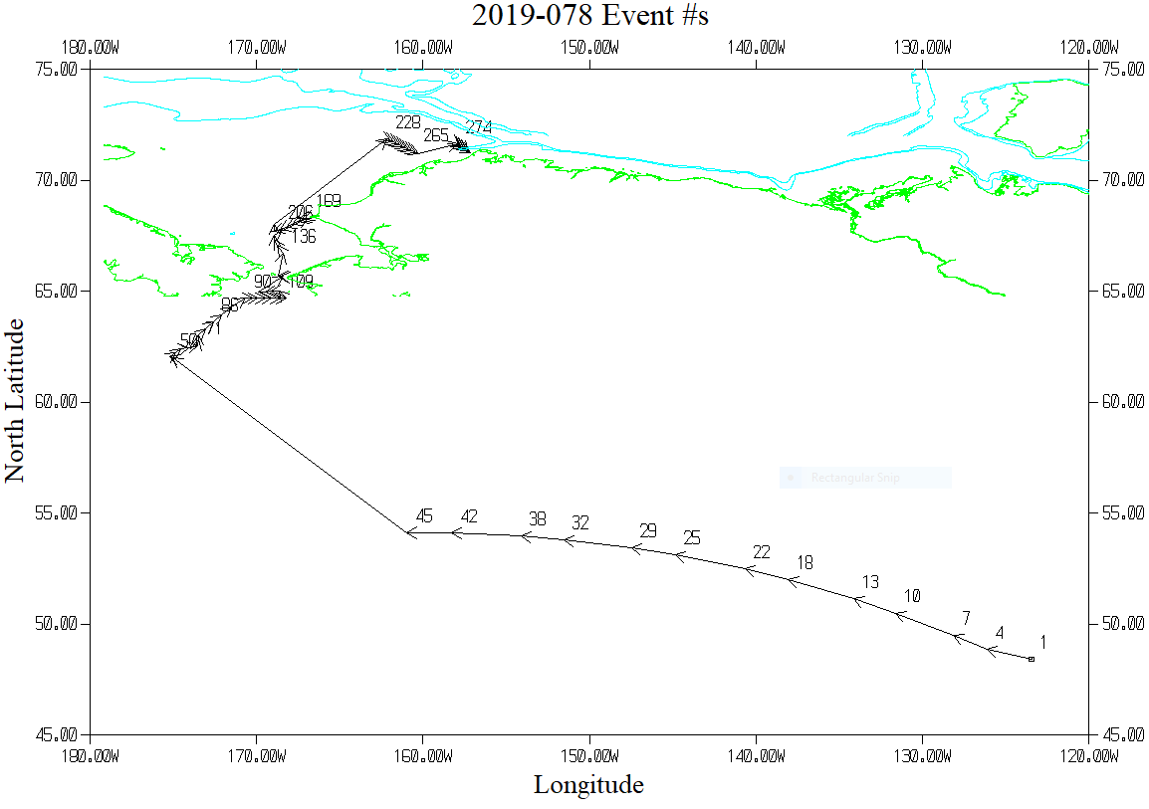

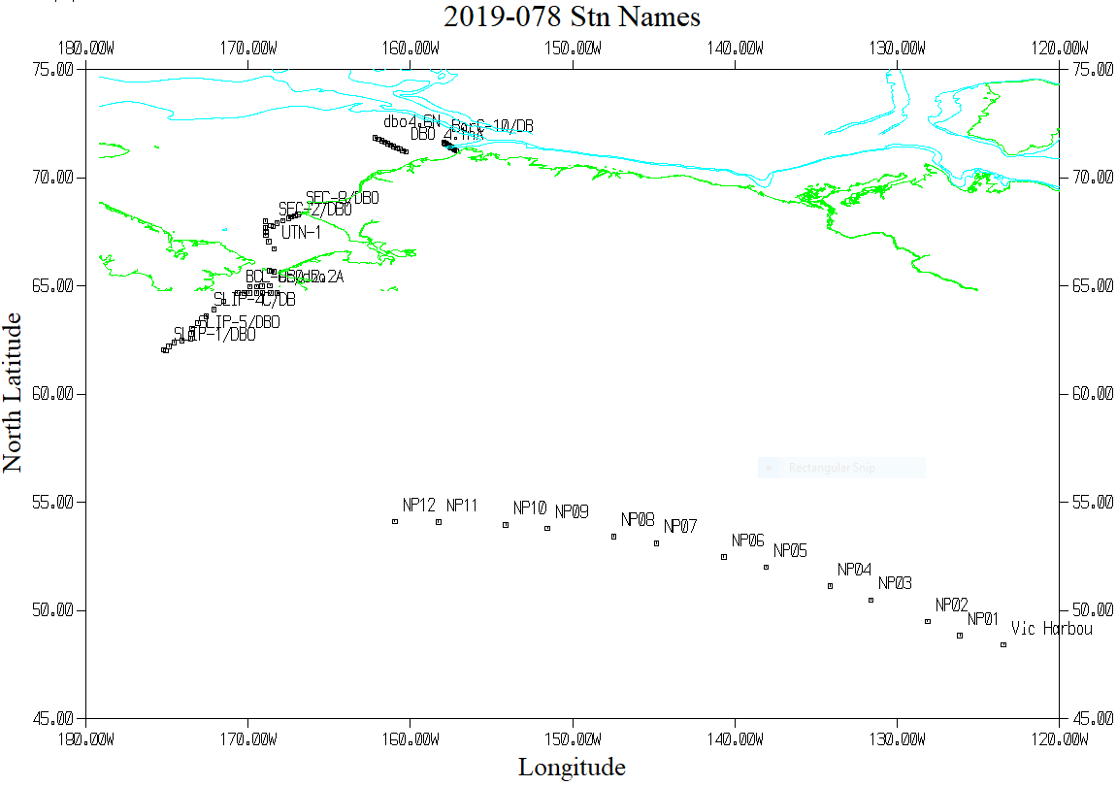

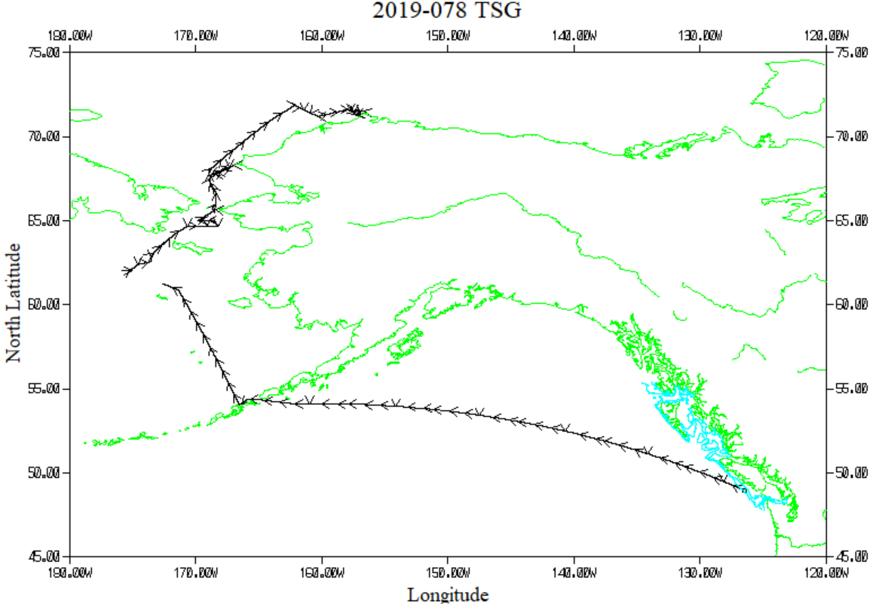

TSG Plot - 4 hours between arrows

